
Skills for the Workplace
Module Assignment Submission
Student Name: | Sam Lloyd
Student Number: | 2012879
Module No: | BMSK4007
Module Title: | Digital Skills and Personal Branding

Statement of Confirmation of Authenticity
By the act of making this submission, the student declares that this is the work of the student named above. The work has not, in whole or in part, been knowingly presented elsewhere for assessment, or where assessment has been built on a previous assessment, this has been identified. Where materials have been used from other sources it has been properly acknowledged. If this statement is untrue, the student acknowledges that an assessment offence has been committed.
Attention is drawn to the plagiarism and unfair practice policies of both the University and of ILM.

Contents
Introduction 3
Section 1: Impact of modern technology in the workplace 4
1.1: What technology is used in the workplace? 4
1.2: What technology is used in my industry? 5
1.3: What technology is used in my workplace? 5
1.4: Gap analysis of technology in the workplace 5
Section 2: Social Media 7
2.1: What is social media? 7
2.2: What is the impact of social media on recruitment and employability? 7
2.3: Online safety and security 8
Section 3: LinkedIn 9
3.1: My LinkedIn Profile 9
3.2: Analysis of my LinkedIn profile 9
3.3: Comparison to other platforms 10
Section 4: Personal Branding 11
4.1: What is personal branding? 11
4.2: How do you create your own brand? 11
4.3: Promoting and maintaining your brand? 12
4.4:What is the impact of personal branding on employability? 13
Conclusion 13
References 14

Digital Skills and Personal Branding

Introduction

Over the years, technology has improved and become a more integral part of the modern workplace. From the introduction of the internet, to Wi-Fi, personal computers, mobile phones, social media, streaming platforms, etc. technology has helped improve the functioning and development of a business. It has increased the number of communication channels between employers, employees, customers, suppliers etc. which in turn has then led to a greater productivity, a greater workflow.
Technology is an important part of the modern workplace; it is used in numerous ways to improve a business, including business efficiency, branding, day to day running, security and safety (of both the business and its customers). Also, technology is used today to improve personal branding and employability of an individual. Both employers and employees used technology within a business, and personally.
The introduction of technology to the workplace has also led to an introduction of new risks, meaning the enforcement of new laws for data protection, protection of information, the protection of personal information. Although technology has made an improvement to the modern business, it also has its negatives.
In this report will be explaining both the positives and the negatives of technology in the workplace, online information, social media platforms and the development and importance of personal branding. I will also be analysing the importance of technology, digital skills and personal branding within the modern-day workplace, and how these can be used to increase skills leading to greater employability, how it has changed and improved the modern-day workplace, how personal branding is developed and improved across different platforms for employability and developing a business. Another important point to look at is safety and security; how safe is the information online, data protection (what is it and why is it important?).

Section 1: Impact of modern technology in the workplace

Before the introductions of computers in the workplace, information was still passed between phonelines, word of mouth, any communication channel possible, unfortunately this would take time and slow down productivity. Since the introduction information can be passed via email, instant messaging, video call, cloud documents, shared documents, and many more options. By information being passed instantaneously this has increased productivity; orders can be sent from customers to business directly, employers can contact employees with updates, etc. By shorting the time in which information can be passed from one place to another increases the entire overflow of a business.

1.1: What technology is used in the workplace?

There are several technologies used in a workplace for employees, management, administration, customers.
We use some technology for security to ensure safety of the employees, customers and the business including all products. Security technology has greatly improved for businesses, both in-store businesses and online, for example for in-store businesses, security cameras; body cameras; CCTV; alarm systems; coded doors; security tags; personalised employee cards/ ID with scanning codes; radios. Online businesses will have antivirus software, and virus alert systems that stop the business from being hacked and having a loss in productivity.
For employees, including administration and management, clocking-in machines (to ensure the employee is having their hours logged correctly, so they can be paid accordingly); work phones/ mobiles; employee cards for scanning; workplace tablets/ computers/ laptops; tills with personal log ins. This type of technology is important to create another pathway between employees and employers, for example requesting time off, sick leave can be done by mobile phones, email, or by a clocking in system where these requests can be logged.
For customers, music systems; visual media displays; scanning codes for offers; cash machines; bank card readers. A lot of these technologies are used for customer comfort, and the passing of information from business to customer, offer updates are an important one share with customers, new products. Technologies help a business get this information in a more casual, eye catching, visual way, for example televisions in stores showing the latest offers, personal store radios playing music and sharing offer to make the customer more relaxed whilst shopping or browsing.

1.2: What technology is used in my industry?

Within my industry of security most of the technology used fits the same criteria, for example security cameras; personal body cameras; communication radios; mobile phones able for instant messaging; recording devices (visual and vocal). Within the security industry its important to have up to date technology capable of maintaining, recording and saving real time footage. Its also important to have technology that creates more communication channels with law enforcement/ emergency services in times of an emergency or an elevated situation.

1.3: What technology is used in my workplace?

Within my personal workplace we use real time recording technology, this is in both the form of cameras, (both personal body cameras and site cameras), personal radios with earpieces for quick communication to other team members on site, personal phones in case of the need of emergency services. Besides this my workplace works very one on one with residents, all reports are still written by hand and filed correctly. We also have an on-site computer which is used for management updates, (training, resident information, contact information), and emails.

1.4: Gap analysis of technology in the workplace

What tech is used in your workplace now | What is it used for | What it could be used for | Improvement suggestions (for increase efficiency, effectiveness, marketing, profitability, etc.)
Radios | Communication | Communication | Up to date radios with an ability of using multiple frequencies to reach emergency services. This would create a more secure line of communication when necessary. Meaning emergency services would have an efficient response time, reducing the time of incident, with quicker control of situation.
Body cameras | Recording and security | Security | Having body cameras that were able to record to both a memory card and to a cloud storage would ensure all evidence is captured. This would make them more effective, also in the long run save money on continuously buy memory cards for storage.
Site cameras | Recording and security | Security | Once again being collected by cloud storage offsite, ensuring all the data was secure.
Voice recorders | Recording and security | Securing | Cloud storage.
Mobile phones | Communication | Communication | Instead of using personal phones have work phone with instant messaging apps, or a work app installed that would update automatically. With a form of personal charger to ensure that the phones were able to be charged and used for long periods of time, this would increase the communication channel between management and employees, it would also make employees more assessable to newest updates from management.
On-site computer | Communication | Communication, information storage. | Instead of using the pen and paper filing system, we could use the computer to keep an up-to-date record of all the residents, using cloud storage that can be seen by both management, the county council and social workers, with an option of updating with any footage of antisocial behaviour within the reports. This would show employers that the company is more professional and modern. With an interface that is accessible to them.

Section 2: Social Media

2.1: What is social media?

Social media is a platform for providing information to a group, or a wider public about you or your business, this platform can be free or low cost, that is easily accessible, popular, with the option of advertisement. Social media is a useful interface, where a business can communicate directly to its customers to provide information, but also receive feedback of goods, products and/ or services that the customer has used. Social media is a powerful tool used by businesses for promotion, it gives them a platform in which to tell a customer who they are, what the customer is to gain, what services that are available to them, it gives the business an image and a location where the customer can find them. Social media also allows the business to attract new customers, for example, on the social media platform Facebook, there is option of creating a business page instead of a personal page, with this page you can have targeted advertising by selecting a particular demographic; all genders, ages 25-35, with interests in selective areas. Another option is to have an open or public page, this means that anyone can access it and see your business and products. Social media platforms also allow you to build greater relationships with customers, it creates another window of communication, allows them access to the newest/latest offers, keeps them updated on changes, where they can also receive personal automated messages making them feel valued. Another advantage of social media is that its easy, it does not require a large knowledge of IT skills to be able to have access to it, anyone with access to the internet and a device can set up a profile and make an online presence.
Unfortunately, there are risks to social media, in some cases it can be a detriment, where time and money is being spent on creating and maintaining an online image but with no interaction to customers, no returns or truly little return, it becomes a loss on profits rather then an advertising tool. Another risk is the spread of the wrong type of information, poor posting, poor social media presence or updates, inappropriate online content, poor reviews from customers. All of these can faulter a business rather than supporting it. It is important to set up safe-guarding measurers and strategies to ensure that these types of poor marketing take place. (Reece, 2010)

2.2: What is the impact of social media on recruitment and employability?

Social media has both positive and negative impacts on the recruitment and employability process.
In terms of recruitment, social media can be used to offer job positions to a wider range of applicants, where they can write down their information, provide evidence, previous experience, essential where they can have their first interaction with the employers through messaging at a time available to them. Social media platforms can also make the recruitment process simpler by filtering applicants, for example you can filter applicants who have a certain number of year experience in that field of work, applicants with certain qualifications. Social media platforms allow the employer to have a first impression of an applicant before an interview, they also allow for a profile to be set up of the business to attract applicants. However, negatively, if the correct information of the position is not advertised then it can lead to little, none or the wrong type of applicants for the position.
For employability social media can both support and hinder an application process. Now days most employers will screen potential employees, and current employees, using their social media. During the application process employers will often screen an applicant’s social media platforms for anything that could be a fault, or issue within the workplace. For example, an applicant could have many years’ experience, the right qualifications, but on their social media be posting racial, sexist or offensive material, this would make them undesirable as a potential employee. It is important to have a good social media presence that will not affect employability, social media acts as a first impression, when the employers will get their first impression of you as a person by what you put on your social media. This can be from images posted, events attended, any opinions shared, and who and where they have been shared to. Positively as it is a first impression you can ensure you have a professional email, the correct first impression, all up to date qualifications and information, maybe even with a professional or clean accompanying photo, that is all accessible in one place for the employer and increase employability.

2.3: Online safety and security

When online, on any form of social media platform, it is always important that all information, personal or business information is safe and secure. As a business it is important to know and comply with all data protection laws. Data protection is the assurance that people can trust you or your business with their information, and that you will handle it fairly and responsibly.
‘The UK data protection regime is set out in the DPA 2018, along with the GDPR (which also forms part of UK law). It takes a flexible, risk-based approach which puts the onus on you to think about and justify how and why you use data.​The ICO (2018) regulates data protection in the UK. They offer advice and guidance, promote good practice, carry out audits and advisory visits, consider complaints, monitor compliance and take enforcement action where appropriate.​’ (ICO , 2018)
GDPR stands for the general data protection regulations, these are enforced laws. Once information has been placed in you care, it is your responsibility, and you must be extremely careful what you do with it. At all times you must comply with the data protection laws. (The national Archives, 2018).
Of course, with information being online there is always a great threat of information being attained by hackers, persons illegally getting personal information by bi-passing security systems or finding faults in security systems to steal this information. This will continue to be a threat, so it is important to check all online security systems often for any faults.
‘Another major threat to privacy is the raise of so-called hackers and crackers which break into computer systems’ (Benjamin, 1991)

Section 3: LinkedIn

3.1: My LinkedIn Profile
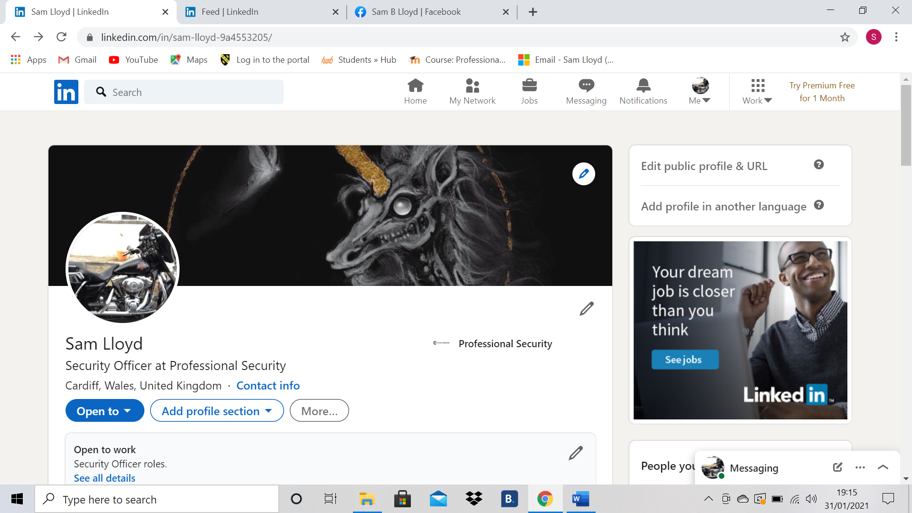

3.2: Analysis of my LinkedIn profile

I did not make my LinkedIn profile very personal, as I myself do not use social media, I wanted to keep my profile straight forward with my basic information. The profile images use outline both my hobby and my mode of transport. I other image used is my favourite piece of artwork, it shows another part of my personality that would not be evident within an interview. This second image also shows another part of my personality that employers would not see during the recruitment process. I did keep my profile very simple as I didn’t find the controls very user friendly for first time users, as I am still new to social media I became overwhelmed by the number of prompts and uncomfortable with the amount of information it was continuously asking for. I do prefer a more face to face meeting where I’m able to explain myself rather then an online account, I find my social media skills lacking and unable to express or show who I am when it comes to the recruitment process.

3.3: Comparison to other platforms
LinkedIn Platform
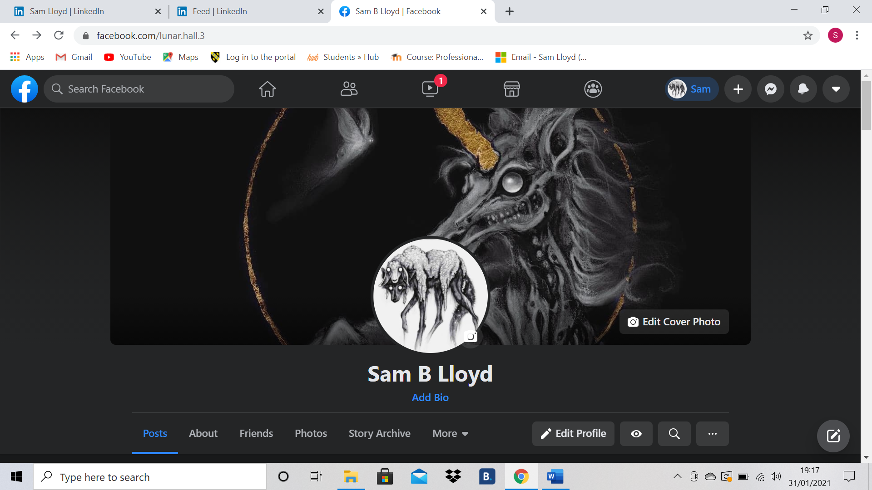
Facebook Platform
Compared to the LinkedIn platform, the Facebook platform was a lot more user friendly, again as a new user I felt it was easier to set up, add the information I wanted and had more access to privacy. However, the Facebook platform is used for a lot more social connections rather than employability connections, although I could make the Facebook platform more personal to me. I found that the LinkedIn platform was a lot more employability orientated, but incredibly formal, I could use only one format, for more options I would have needed to pay a fee and update to a premium account. The Facebook platform was free to sign up, I felt comfortable and protected with my information. Working in security I am always conscious of the security of my information especially online, on the Facebook platform I felt I had more control over this.

Section 4: Personal Branding

4.1: What is personal branding?

A personal brand is a statement of not what you are but who you are. Your personal image, what skills you have in a particular area, how you behave, what reputation you hold, and your values and beliefs. Your personal brand is about who you are. Persona branding however, is about the consistent presentation of an individual, that individual is authentic to who they are and mindful of the impression they make in a first meeting, the first impression they are creating, this first impression will be the mould to which all other meeting will be developed on. A first impression is important, it creates an everlasting impression within the first four minutes, from then on it cannot be changed. Its this first impression where your best qualities and values are seen upfront. (Labrecque, et al., 2011)

4.2: How do you create your own brand?

Personal branding is developed by strategy, these are steps, an individual takes in order to deliver their personal brand and developing metrics to get them to where they want there brand to be.
The main steps to developing you brand is firstly knowing where are you now? How are you perceived? How would other describe you now? How do you feel about who you are now? what do you represent? Knowing the answer to these questions you know what your brand is right now at this point. From there you can draw a line to what do you want your brand to be? What do you want to be or how you want others to see you? Knowing where you are and where you want to go you can then draw up metrics, these are objectives you create to develop your brand, for example, I want to be physically strong, so I will need to start going to the gym, eating correctly, working out more, being more active, so I can get from where I am now to being strong. It is important to know what is driving you to have this as your personal brand, for example I want to be physically strong because it would be beneficial in my job and future job applications. By knowing the driving forces of what you want your brand to be creates a plan on how to develop your brand. It is also important to understand any resistances or blockages that might be in your way, for example gyms being closed due to corona virus, finances stopping from buying the correct food or home equipment, time management between work, university and working out. (Lewin, 1947)
This is the same for a business point of view, taking the brand that you are, knowing where you want that brand to be and why? And what may stop or hinder the development of your brand.

4.3: Promoting and maintaining your brand?

Promoting and maintaining your brand is especially important, it is important to hold on to your brand and let others know what your brand is without it changing, this is what makes your brand popular and reliable. This can be done by communicating your values and beliefs and setting up important networks. However, it is important how you communicate your values and beliefs, Gibson et al (Gibson, et al., 2009), found that there are generational differences that develop over time in the values and beliefs held. They studied the differences between baby boomers, Gen X and Gen Y.​ It is necessary to be aware of these differences when developing your brand and communicating it to people in different generational groups.​ What works for one generation may alienate an older/younger generation. ​What we think are valid values and beliefs may not be shared by others. However, values permeate our lives, and influence our actions.​ If we wish to influence others “to do business with us” then we should be aware of how we are perceived by others.​
Networking is the most effective way of promoting your brand, it is essential to create sustainable networks when building a personal brand. Your network is others who you are in contact with, who know you and your brand well, your network will then pass on your brand to other, expanding your network and making your brand more reliable. Your network will continue to promote your brand, it is important to have advocates of your brand, advocates are members of your network that that will talk about your brand to others, make your brand known. Supporters (both active and passive in promoting your brand) are important, these are people who will stick with your brand because they trust it. It is important to have strong and stable relationships in your network also, these relationships provide free advice when you think your brand is struggling or you want to expand your network further, also you can find mentors within your network from other promoting their brand and learn from them.
A way in which to maintain a brand is by developing an action plan, a perfect example of an action plan is the SMART (Doran, 1981) model; SMART (Doran, 1981) is an acronym each letter criteria for setting out an objective witch is Specific to the goal that you are aiming of is selected; Measurable with a specific criteria that measures your progress towards accomplishment of the goal you have set; Achievable the goal set is possible; Realistic it must be not out of your reach; and Time Bound, where it must be achieved within a time limit. Having this action plan you can continuously go back to it and change time limitations to something more realistic when blockages and resistance appears, finding new way to reach your end goal.

4.4:What is the impact of personal branding on employability?

By having a reliable brand, something that you can show, with a large network, it increases employability. It gives you and your brand credibility and shows professionalism. Credibility is that the brand is reliable, believable, trustworthy, well known, inspires confidence. But to also be professional is important, this shows skill, a high level of competence and knowledge in your skill. Its these that an employee will look for and having an established brand that is both credible and professional increases employability. It is important to build credibility as well as maintain professionalism, credibility is built through trust and respect. However, depending on a person’s belief system you cannot make yourself credible to everyone, it is about how they perceive you. (Huang & Kwok, 2013)

Conclusion

From this report there are some main points that can be understood. Technology is always developing and changing, within a business it is important to embrace new technology that can be beneficial to improving the business, that make faster communication pathways, without it having an impact on employees. We all use technology daily, whether inside or outside of the workplace, we can use it to develop our business.
One of the ways we can use technology is by using social media platforms as a powerful tool, social media can help to promote a business, give it a name and promote a brand, whilst also helping the recruitment process. Social media can also be used to increase employability, by creating a personal brand and a network that promotes who you are, which becomes favourable to future employers.
Presentation and information of all branding, personal and business branding, is important, all information presented online must adhere to all data protection laws.
In conclusion, our image and how is perceives and how technology has helped express our imagines outside of interviews can make large affects on how employable we are or how reliable our business image is perceived. We must always make a good first impression as this is what mould every other reaction we will have afterwards.

References

Benjamin, L. M., 1991. Privacy, Computers, and Personal Information: Toward Equality and Equity in an Information Age. Communications and the law , Issue 3, p. 7.
Doran, G. T., 1981. There's a S.M.A.R.T. Way to Write Management's Goals and Objectives. Management Review, 70(1), pp. 35-36.
Gibson, W. j., Greenwood, R. A. & Murphy Jr, E. F., 2009. Generational Differences In The Workplace: Personal Values, Behaviors, And Popular Beliefs. Journal of Diversity Management (JDM), 4(3), pp. 1-8.
Huang, Y. K. & Kwok, L., 2013. Information sources for trust judgments in managerial relationships over time: A conceptual analysis. Journal of Behavioral and Applied Management, 14(2), pp. 140-160.
ICO , 2018. Introduction to Data Protection. [Online]
Available at: https://ico.org.uk/for-organisations/guide-to-data-protection/introduction-to-data-protection/some-basic-concepts/
[Accessed 25 01 2021].
Labrecque, L. I., Markos, E. & Milne, G. R., 2011. Online Personal Branding: Processes, Challenges, and Implications,. Journal of Interactive Marketing, 25(1), pp. 37-50.
Lewin, K., 1947. Channels of Group Life; Social Planning and Action Research. Frontiers in Group Dynamics, 1(2), pp. 5-41.
Reece, M., 2010. Real-Time Marketing for Business Growth: How to Use Social Media, Measure Marketing and Create a Culture of Execution. First ed. New Jersey: Pearson Education.
StudyMode Research , 2013. Pluses and minuses of mobile phones. [Online]
Available at: studymode.com/essays/Pluses-And-Minuses-Of-Mobile-Phones-39132580.html
[Accessed 17 01 2021].
The national Archives, 2018. Legistration.gov.uk. [Online]
Available at: https://www.legislation.gov.uk/ukpga/2018/12/contents/enacted
[Accessed 25 01 2021].

