Effective Team Working and Communication
2020
Lecturer: Toyin Adisa
BMSW 4002
Leila Kanfoudi (1914911)
Contents

Introduction…………………………………………………..2
Contract Services Tower Hamlets……………………………2
Communication………………………………………………3
What is Effective Communication…………………………...4
The Shannon-Weaver Mathematical Model of 1949………..5
The Berlo’s Model…………………………………………..6
The 7 Habits of Highly Effective People……………………7
Contract Services Communication Problem………………...8
Conclusion…………………………………………………...9
References……………………………………………………10

Introduction

The report that I am writing today will show a detailed description about the effective team working and communications methods that is available. I will also be briefly analysing the communications methods available in my workplace at children services within the brough of Tower Hamlets Council and what communication problems they may have and how best to help improve their communication but using what we learned in class with the help of our lecturer Mr Toyin Adisa and all the methods that is available. I will start by giving you a brief background of my workplace and what they provide as a company and then I will give a detailed report about the different methods of communication and effective team working available.

Contract Services Tower Hamlets

My place of employment is Contract Services at Tower Hamlets Council which is a non-profit organisation that works inside the councils Children, Schools and Families (CSF) department. As stated on their web site (Towerhamlets, n.d) CSF Contract Services also known as (CSFCS) not only supply catering but also cleaning services to schools and many more institutions across the brought, In addition they are also responsible and provide a Meals on Wheels which is for the adult health and wellbeing.
The schools within the brough manage their own catering budgets which entails them to select provider of their own choice, in doing it this way it gives them the power to continuously make changes to help improved their service.

Communication

What is communication to you and how would you describe it? Well that is an excellent question seeing as most people around both at university and at work do not think too much about it but for people to interact with other`s whether it be for educational, employment and social gathering, What we do not realise that it is subconsciously there. How would you communicate to the person at work or to a family member in another country, would you write them a letter, send them a memo, send a report, send them a text message, call them over the phone, send an email, well all of this is a form of communication.
In order for you to understand communication you need to have a clear understanding that not just humans communicate with each other but also animals and most surprisingly to some people plants also communicate- this is something I learned back in secondary school,
Cossins, (2013) wrote that “PLANTS COMMUNICATE AND INTERACT WITH EACH OTHER, BOTH ABOVEGROUND AND BELOW, IN SURPRISINGLY SUBTLE AND SOPHISTICATED WAYS “
Grant, (2018) meets with a man who explains that Some are calling it the ‘wood-wide web,’” says Wohlleben
Adisa, (2020) also showed us a YouTube video shown how buffalos communication and effectively work as a team to save their young from being eaten. First, I have to get you to understand the types of communication approaches and methods available. (Adisa, 2020) taught us in class the approach to communicating by having a;
- Sender: is someone who formulates what they want to say;
- Message: as you have formed your words and now have to think about how you wish to send this informant though the;
- Channels of Communication: which are Verbal, Telephone, Voicemail, Email, Online, Letters and Media for example: television, radio, WhatsApp and Facebook.
- Receiver: now they will decode the message and formulate a
- Feedback: in which you can confirm they received the message as the cycle of communication cannot be complete until it has been sent, received and a feedback has been given for example: thank you, messaged received et cetera.

What is Effective Communication?
Adisa, (2020) showed us a video by Grayson Riegel, Deborah, (2011) on The Importance of Body Language in Presentations she talks about how body language is every bit important as the words you use and the way you use them combined. She also goes on the describe if your body language is hostile, defensive or even closed off then your audience will copy that feeling. This is also the same if you were to have a positive, powerful and polished body language then the audience will believe what you are saying, this is non-verbal communication which is used in both university and in any business organization. The five areas which she talks about is:
- Posture- People’s opinions of you starts the moment they see you so you must always be professional in your attire.
- Gestures and Movement- By crossing your arms it makes people think you have built up a wall so by opening your hands it makes you more trustworthy and by walking and standing with confidence it will help bring energy to your presentation.
- Eye Contact- try to keep eye contact with someone for 3-6 seconds before you move onto the next person so that you can make a Connexion with your audience.
- Facial Expressions- By expressing a good smile it will capture your audience and it will put both them and yourself at ease.
- Dress- the way you dress everyday shows what type of person you are and what company you are representing.
So you must be wary of your body language when you communicate with people, so always Practise before your presentation to make sure your delivery is clear, replay what you're going to say to someone else or recorded to see if you know and understand what you are saying, when you have affectively your communication your audience will understand what you are saying by giving your feedback for you informing you that they have understood.

The Shannon-Weaver Mathematical Model of 1949

Drew,(2020) wrote ‘The Shannon and Weaver Model of Communication argues that communication can be broken down into 6 key concepts: sender, encoder, channel, noise, decoder, and receiver. A later version of the theory by Warren Weaver added a 7th concept (‘feedback’) which changed the model from a linear to cyclical model.’
This model explains how messages can misinterpreted and mixed up in the process of sending and receiving said message.
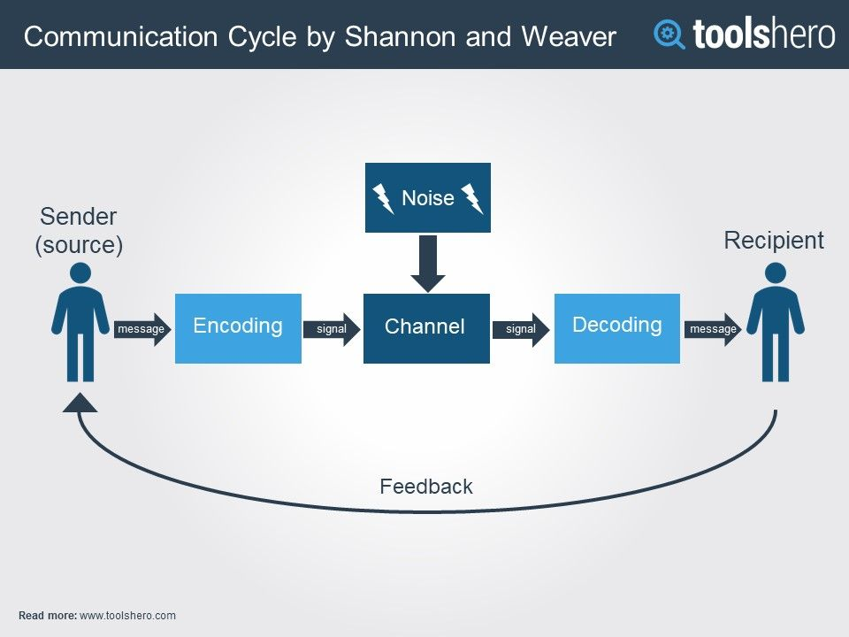

The Noise Elements: this part can affect the messages that is sent through the channel. What is means is that the message may have got affected or even distracted by physical noise for example thunder, crowed noise or even horn signals during the transmission process which has affected the flow or may have not even received the correct message.

The Berlo’s Model

David Berlo’s SMCR Model of Communication represents the process of communication in its simplest form. The acronym SMCR stands for Sender, Message, Channel, and Receiver. Berlo’s SMCR Model of Communication describes the different components that form the basic process of communication. Because this communication tool also emphasises the coding and decoding of the message, it can be used for more efficient communication.
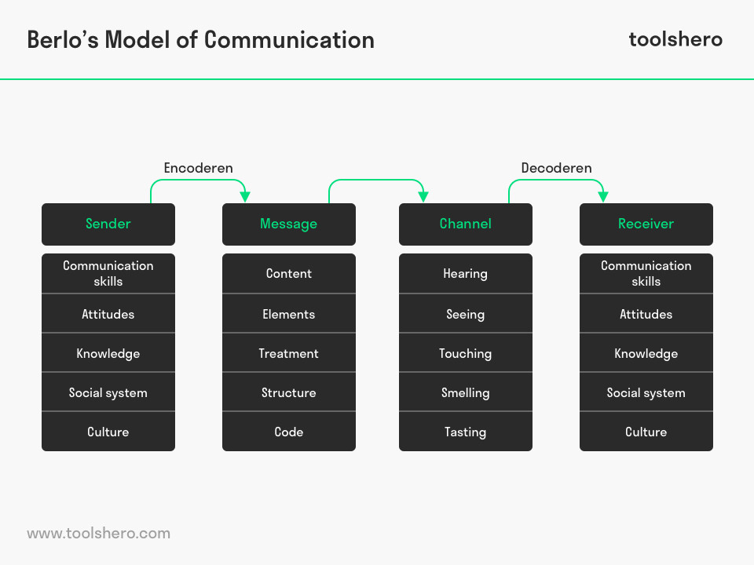

These are the type of skills that some people use as they are important to have at university for it teaches us ways to learn and inform us on information that we may be lacking. If I was to follow the examples of and the Berlo’s Model then a cycle of communication is not complete until it has been sent, received and a feedback has been given. I have these methods which I use in my everyday life whether it is taking the kids to school, attending university or just communication with people, However I believe there is always room for more improvement not just within myself but as a society in general. Now when you think about the ways people communicate and how they communicate you think about these models and their methods when it comes to talking and writing.
Effective team working and communication is important because you cannot work on your own in any organization for example a lecturer can not teach with his or her students and vice versa. Even if you run your own company you cannot be both the owner and the customer which is why you need a team in order for this to work.

The 7 Habits of Highly Effective People

If you ever get the time to read The 7 Habits Of Highly Effective People by (Covey, 1989) it explains the 7 habits one should have in order to be able to work within a team and communicate with them effectively, they are:
- Be Proactive by that he means one needs to be on top of their game and take charge by accepting responsibilities in your life.
- Begin with an end in mind. by this don’t just go and work at any job, try to work towards a future you truly can take pleasure in.
- First things first. take things one step at a time and to prioritize on what is important to help you achieve the future that you have envisioned for yourself.
- Think win-win. to Achieve the right negotiation with other people from other companies try to look for a fair share that will benefit everyone and will in the long run work to your advantage.
- Seek first to understand then to be understood. by this he means take a step back and really try to understand the situation first stopping you from giving the wrong advice or receiving the wrong information which in tails leads you to making the wrong recommendations.
- Synergise. when working together as a team is better then working by oneself.
- Sharpen the saw. The ability to work effectively in achieving your goals but also allows you the time to spend

Contract Services Communication Problem

For any communication to work well you also have to think about the culture difference which is something that Contract Services my place of employment has to look at as it is a catering service to a diverse community, Furthermore in order for us to know what we need to do we rely solely on the school to communicate with both us who works in the kitchen and with Contract Services informing us of any students who may have an Allergy to any of the ingredients that we use and also any religious students. In order for us in the kitchen to receive these information we would rely on 2 methods of communication the first is telephone and the second is via internal post which meant when on the phone to communicate with them we had to rely on someone being on the Receiving ends of the telephone, in order for us to make our orders on food products that we needed which would always be wrong and the noise from the kitchen and the surrounding areas would affect the message from being received properly and would make the process longer.
The other mode of communication would be a written form though the internal mail which would be collected and delivered by a driver which runs the risk of the mail not being decoded by receiver and we do not get a feedback.
The way we could improve this would to have a tablet which would give us a direct line to the company main system and it would allow us to put through directly to the suppliers, this would intel guarantee from start that both the sender and the receiver and we could also reduce the noise element in order to guarantee that the receiver receives the information by decoding the information correctly, we also minimises miscommunication and can greatly increase the guarantee of a feedback.

Conclusion

In starting this report, I was struggling how to best go about it and truth be told it is still a difficult report to write as the communication between the lecturer also known as the (sender) and me also known as the (receiver) was not quite the same for many factors, a big part in this was for starters we started this course in class with a clear channel of communication with the lecturer which was a clear why for the sender to see if the students understood the communication that was being sent by our facial expression and the noise element was dramatically reduced. The lectures turned from in class also known as a Seeing form of channel to in home also known as a Hearing form of channel due to the Covid 19 worldwide lockdown. Therefore, the Noise element increased as did the lecturer as well as many of the students who come from different countries therefore the accent became more powerful. What this report should tell you is that communication is always changing Based on the methods of communication that is available at the time, wherever it may be at work or at university, in the United Kingdom or Nigeria, where it is over the phone or online.
We can still to be able to communicate as long as you keep the basic elements in mind and also taking into fact culture too.
From this student (the sender) to yourself the lecturer (the receiver) I look forward to you feedback as you greatly said this ‘cycle of communication is not complete until it has been sent, received and a feedback given’ (Adisa,2020)

References

Chris Drew, PhD, (2020)Shannon-Weaver Model of Communication | 7 Key Concepts (2020)[online]available from https://helpfulprofessor.com/shannon-weaver-model/ (accessed 4 May 2020)
Communication Theory, (n.d)Shannon and Weaver Model of Communication[online]available from https://www.communicationtheory.org/shannon-and-weaver-model-of-communication/ (accessed 4 May 2020)
Dan Cossins, (2013) Plants Talk [online]available from https://www.the-scientist.com/features/plant-talk-38209 ,(2020) (accessed 4 May 2020)

D.G.Riegel, (2011)The Importance of Body Language in Presentations[online]available from https://www.youtube.com/watch?v=IqqiDw58NSE (accessed 4 May 2020)
Image (n.d) Shannon and Weaver Model of Communication[online]available from https://www.pinterest.co.uk/pin/537406168031529019/ (accessed 4 May 2020)
Richard Grant, Smithsonian Magazine (2018)Do Trees Talk to Each Other?[online]available from https://www.smithsonianmag.com/science-nature/the-whispering-trees-180968084/ (accessed 4May 2020)
Sarah Moriarty, (2016)Get The 7 Habits Of Highly Effective People in 3 Minutes by S.R.Covey[online]available from https://www.blinkist.com/magazine/posts/read-seven-habits-highly-effective-people-3-minutes (accessed 4 May 2020)
Toolshero.com, (2020)BERLO’S SMCR MODEL OF COMMUNICATION[online]available from https://www.toolshero.com/communication-skills/berlos-smcr-model-of-communication/ (accessed 4 May 2020)
Tower Hamlets, (n.d)School catering[online]available from https://www.towerhamlets.gov.uk/lgnl/education_and_learning/schools/school_services/school_catering/school_catering.aspx (accessed 2020)
Toyin Adisa. (2020) Effective team working and Communication. Holborn campus. London. [online]available from Microsoft Teams (accessed 4 May 2020)

