University of Wales Trinity Saint David
BA (Hons) Leadership and Management Skills for the Workplace
Module: understanding and engaging in the customer experience
Module code: BMSW_5103
Assignment title: Individual project report with practical (oral) performance.
Name: Ridwan Dahir 1714111.
Lecturer’s Name: Yohan Mendis

1) Introduction:
The report covers the ethical and sustainable initiatives that have been taken by Sky, British Telecom (BT) & Green ISP. The report has also analysed three different Customer Relationship Management (CRM) models and the same have been applied on Sky, BT and Green ISP. Appropriate recommendations have been provided based on the above aspects.
2) Ethics By Broadband Networks:
The concept of ethics in itself has numerous definitions and similar is the case with business ethics. Th business ethics are generally concerned with acceptability of different actions that are taken by employees, leaders of the organisation and overall actions of management. Salehi, Saeidinia & Aghaei (2012), has provided a systematic definition of business ethics and it is given as ‘systematic study’ of different type of moral issues ranging from beliefs, values, norms to attitudes occurring in everyday business and the associated behaviours of organisations and people. It has been highlighted by Salehi, Saeidinia & Aghaei (2012) that any company that operates at a global scale need to establish an internal environment that promotes ethical behaviour and if this is not done the overall profitability of the organisation will decrease in near future because of falling brand reputation. The biggest problem that the organisation face today is in relation to the fact that how ethical values are communicated effectively to the employees. Meyers (2004) has highlighted that whether an organisation follows an ethical or unethical behaviour is dependent on both contextual and individual characteristics. Among all the factors, the culture that is followed in the organisation plays an important role. In organisations where ethical business is conducted the employees themselves have sense of accountability towards the actions that they take. Also leadership in such organisations plays an important role, as effective leaders can model the behaviours of others and help organisation overall to follow model business ethics.
Considering the competition level and tightening regulations in today’s world, it is important that businesses today are both ethical and profitable parallelly. Even if following particular ethics leads to fall in overall profitability, it would be beneficial for the company to keep following the ethics.
British Telecom (BT) has been continually ranked as one of the worst broadband service providers in UK (Statista, 2017). The company has been known for troubling the customers with poor service, no-response to customer complaints and even willingly delaying the response process to more than two months in some cases. Accrding to Russon (2021), the company has seldom overcharged it’s loyal customers and when this was highlighted in 2017, the company till now has failed to pay-back the customers. Such unethical behaviour can not only cause the company to lose its existing customers, but there will be numerous legal suits too that will threaten overall operations of the company. Also the leadership of the company has been questioned as the CEO of the company has been linked with various illegal tax avoidance scheme which can also threaten the overall reputation of the company (Williams, 2018). According to Sabbagh (2020), BT has also demonstrated unethical behaviour by lobbying directly with the UK government for certain technologies. The company in recent times, has been adopting unethical employee policies where some of the employees are being made redundant and majority of the employees are being provided reduced pay structures. Such unethical human resource management policy will also have negative effect on brand reputation of BT.
Sky in relation to human management has a better policy then BT. According to Paterson (2014), the company provides numerous benefits to employees that keep them motivated for work. Neither there has been any major strike against the company. Sky broadband has been on numerous times flagged for overcharging the customers and in some cases even asking for payments from customers even when the customers had moved to other network provider (Brignall, 2018). This has led to greater media criticisms of such unethical actions. Also Sky group overall has been charged with lobbying the government for favours in regards to certain commercial policies. The company is a giant in terms of broadband network and hence Sky should take ethical approach in all areas of its business which can be beneficial for the company in long run.
According to Strange (2019), Green ISP is a company that receives no negative markings in terms of ethical ranking. The company is known for being a not-for-profit organisation and charges way-less than some of the big competitors. As the company is small in terms of size, the growing demand has led to closure of further connections and the company plans to further expand in this regard. Also in terms of servicing the customers, the company guarantees a response in two hours and it is due to this fact that even customers have been attracted to Green ISP. Also as the company is still small, neither it takes advantage of any tax havens or is among any lobbying groups of UK. Green ISP has bright potential in the UK market, but needs to expand its services to cater to growing demand.
2) Sustainability By Broadband Networks:
Sustainability can be defined as an aspect where organisations takes long term strategic approach and takes action to reverse the trends of any negative impacts that the business is having and making contributions to society on one hand while creating value for all the stakeholders on the other (Dalvi et. al, 2019). It has been ascertained that even the general environment and customers are a part of ‘stakeholders’ of organisation and hence organisation is bound to take actions for removing any negative impacts on these stakeholders. Initially the sustainability aspect was only focused on the social or environmental improvement but now there has been growing demand of linking sustainable practices with the business ethical practices. Corporations who are engaged in sustainable initiatives have a better brand reputation, brand image and profitability (Dalvi et. al, 2019). Sustainability in today’s competitive world is also seen as the area through which competitive advantage can be achieved by adequate promotion of sustainable initiatives through dedicated marketing campaign. Recently, sustainability has been also linked with increase in efficiency of resources, development of positive organisation culture and overall attractiveness among the customers (Dalvi et. al, 2019). Effective leadership is essential for organisations, which can help the organisations in continuous improvement in terms of sustainability initiatives. It is a well-known fact that effective vison and mission of the organisation is essential for achieving long-term business gains and combining this with the sustainability concept can help the organisation to achieve distinctive competitive advantage. There are four pillars of sustainability that can be adopted by any organisation and these are human (improving access to services), social (preserving social capital), economic (efficient use of assets) & environment (protection of natural capital). In terms of customer service too, all the four pillars can be focused to address the issue of sustainability.
According to Energuide (2021), the usage of internet approximately accounts for 4% of the greenhouse gas emissions. Hence it becomes important to understand the sustainable initiatives that are being taken by the broadband companies. Sky is the first media company that has become carbon neutral (Sky, 2021a). The company has created digital platforms so that the access to customer services can be improved for all the customers. In terms of environment, The company has set a scientific target of becoming net zero carbon by 2030. In terms of economic use of assets, the company even engaged its 24 million customers to various campaigns that ultimately lead to environment sustainability. Also the company has started to use internal assets such as transport network and buildings that have minimum or no carbon emissions.
Similarly BT has created its own digital platform to offer customer services to the customers easily without any hassles. Not only that, to boost its sustainability initiative the company is aiming to empower 10 million people by providing them necessary knowledge of the digital platforms (BT, 2021). The company has also launched initiatives to tackle climate change and greenhouse gas emissions. Though compared to Sky, the company is slow in implementing such measures and hence BT aims to be carbon neutral by 2045. The company is also creating technologies in such a way for its customers that there is an overall reduction in carbon emissions. Though the company wants to cut, carbon emission in its operations, the wastage of resources particularly in case when BT doesn’t provide customer service to the customer for more than 2 months is huge. This also goes against the company’s aim of empowering the customer.
BT and Sky both have adopted various measures to address the sustainability concept, but these have been only done when appropriate legislations and regulations have been introduced in UK. Instead a company such as Green ISP is engaged in sustainable initiatives since 2003. Even the formation of Green ISP and overall of vison and mission of the company surrounds the sustainability concept only. According to Green ISP (2021a), the company is an innovative service provider and this is due to the fact that innovative solutions to sustainability aspect has been implemented by the company. Not only is the company carbon neutral as of now, but is increasingly turning itself towards carbon positive aspect. The company uses solar electricity in all the operations and it is interesting to note that even the web hosting systems of the company are powered by hydro-electricity. The data centre that the company has addressed various needs of the customers in less than seconds and this overall helps the company to solve any issue with the customer’s internet in less than 2 hours. For every connection that the customers take with Green ISP, a tree is planted to absorb further Carbon Dioxide. It can be concluded that three of the service providers Green ISP, BT and Sky have implemented various ethical and sustainable initiatives and in this regard there are various shortcomings particularly in relation to BT and Sky.
4) CRM – 3 Models:
According to Buttle (2004), the concept of customer relationship management emerged in 1970’s and the idea behind CRM was that it will lead to better optimisation and management of sales-force. According to King & Burgess (2007), CRM has become a popular tool for information management and such information management does not only help in sales-force management but also in terms of effective interaction with the customers. CRM has been also explained in great detail by Chen & Popovich (2003) by linking various processes to CRM. CRM is essentially integration of different processes, technologies and even human capital and the aim of such an integration is to understand the customer of the company and appropriately retain and make relationship with such a customer. The goal of CRM is attracting and retaining those customers which are economically valuable to the organisation and the one’s which add no value to the economy of company should be left aside. In an environment where the trends are changing rapidly, consumer demands are changing rapidly and even competition is growing day-by-day it becomes important that ‘modern companies’ understands the importance of CRM to succeed with the overall strategies. The strategic foundation and goal of any organisation is to have long-term growth in a sustainable manner and such a long-term growth can be achieved when the needs of customers are met and customer satisfaction is achieved through proper customer service and this is possible by following an ‘effective’ CRM technique.
There have been various research conducted in regards to whether following an appropriate model of CRM will lead to overall success of the organisation or not. According to Joo (2007), customer-centric focus in any CRM model will lead towards greater customer loyalty. Similarly, according to Shane & Ulrich (2004) following an appropriate CRM strategy has direct impact on satisfaction of customers, customer loyalty and hence overall financial profitability of the company. Also CRM allows the organisation to integrate and manage the customer’s data and records which makes overall identifying of the target market for future campaigns easy and marketing strategy more effective.
There are various models of CRM management that can be used by various broadcasters to improve the quality of services offered. IDIC model which has been developed by Peppers & Rogers (2004) has been depicted in Fig. 1. IDIC model relies on four step process which can help any organisation in building of one-to-one relationship with the customers. The four steps are: identifying, differentiating, interacting and customizing. In the identification process it is important to understand who the customers are for the organisations. Without building of adequate understanding of the customers it would be impossible to identify different needs and customizing according to the changing needs. Sky is an organisation that has clearly identified the customers and the overall products and services has been offered through such identification. While Sky has done the identification of customers easily, Green ISP can really work on improving the identification aspect. In terms of differentiation, it is essential that organisations identifies which customers provide most value to the organisation. Differentiation according to Peppers & Rogers (2004) should be done based on the fact that what are the needs of different customers and what value they bring for the organisation. Sky again has differentiated the services according to customer needs and values. For example the company provides speed guarantee and even wi-fi range guarantee for those customers who have opted for superfast or ultrafast contract with ‘Boost’ option (Sky, 2021b). Even though Green ISP has provided different speed options to customers, it is highly confusing and there is no sort of guarantee even with the highest package (Green ISP, 2021a). In terms of identification and differentiation, Green ISP can further boost its ‘sustainable’ image by attracting and retaining customers appropriately. In terms of interacting, it is important that the companies understand the expectations of the customers particularly in relation to the interactions that takes place between the brand and customer. Effective customer interactions are required for gaining insights and solving any problem of the customer. Customer interactions also play a main role in increasing the brand loyalty also unsatisfied customers will ultimately lead to poor financial performance in future as lot of customers will readily switch to other competitive brands. For BT and Sky the customer interactions are highly criticised and this can be also ascertained by the ‘very poor’ reviews available on Trustpilot (2021a) (for Sky) & Trustpilot (2021b) (for BT). The reviews highlight how the interactions with customer service team of both the established brands are highly ineffective and for some of the customers the problem in their broadband’s have continued for more than two months even after highlighting the issue with the company. Such ineffective interactions bring a bad name for the brands. In comparison, Green ISP offers highly personalised interactions with guarantee of ‘initial’ response to the customer in less than two hours also the client testimonials highlight the effectiveness of such interactions (Green ISP, 2021).
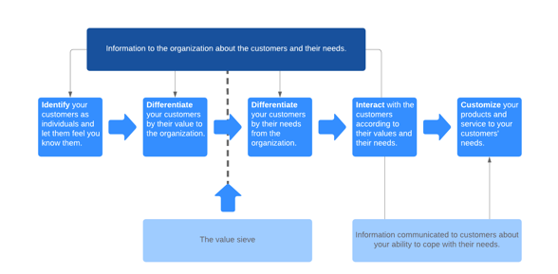
Fig. 1 IDIC model

In terms of customization, expectations of customers should be met with effective offers and communications. For example Sky has created customised offerings such as different plan for people who want to stream videos or who want play games compared to customers who want to just shop, email or do banking services. Also customers who have opted for certain type of ‘boost’ services are entitled to faster action on complaints and even ‘money-back’ guarantees. In case of Green ISP, such customized services are not offered as the company fails itself in the first identification stage and hence for offering customised services it would be essential to identify and differentiate the customers, which in combination with interaction of Green ISP can provide competitive advantage to the company.
Although IDIC is a simplified model with just four steps where streamlining of all the steps can lead into better customer service delivery but neither of the steps puts focus on the organisation’s own internal environment, leadership skills or even information technology skills. Also such an model doesn’t offer any capability ‘rating’ which can help the organisation to streamline its existing customer servicing operations by analysing the rating scores.
Forrester Research model is a CRM model that is an improvement to the existing Gartner model. The model proposed by Forrester, is a simplified model and suited for firms that are finding it hard to implement CRM strategies with the existing capabilities of the organisation. As the model also has a CRM performance scorecard, firms can easily analyse the areas where they are lacking in terms of CRM performance and accordingly measures can be undertaken. Fig. 2 highlights Forrester model where the model has been grouped into four different types.
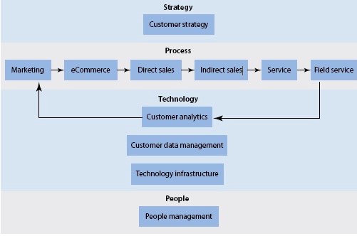
Fig. 2 Forrester model

According to Roe (2012), it has been estimated by Forrester that many of the firms that struggle with the CRM techniques is due to the four crucial elements which are people, technology, process and strategy. Without focus on all the four elements it will be highly impossible to achieve competitive advantage, customer loyalty and retention through existing CRM techniques. In terms of strategy there should be a set CRM strategy with defined business requirements, objectives in regards to CRM and organizational alignment. For Green ISP, there is a set objective of responding to the complaints through dedicated channels within 2 hours. The strategy of Green ISP is to reduce the delay between complaint received and action taken and hence accordingly the organisational alignment has been done. For company such as BT, the strategy of the company is to have significant cost savings in its customer servicing operations and hence the company is relied on individuals which are present in different continent for customer service (Employee, 2021). Such outsourcing and cost-savings has brought bad name to the company due to significant delays in servicing the customers. In terms of process, in all the processes that support the overall company work there should be integration. For example for company such as Sky, e-commerce process is one of the best as customer can directly set up a sky account and order for broadband services from comfort of home. The sales and offers on the e-commerce platform of Sky also improves the quality of service. In comparison, Green ISP though had an online ordering system, but due to increasing capacity on their network, new connections are only given on case to case basis and that too after registering through dedicated customer helpline (Green ISP, 2021b). So, in terms of overall process Green ISP requires immediate upgrade otherwise it will be difficult for the company to function in near future. In terms of technology, any deficiencies in regards to technology such as data problems, inadequate technology platform and lack of required skills can also impact the quality of CRM. This can be easily understood by the fact that company such as Sky has a dedicated ‘live chat’ facility and also interactive website that attracts the consumers whereas company such as Green ISP has a very ‘dull’ website where even going through some of the services that are offered by the company becomes difficult. Also neither Green ISP has a ‘live chat’ facility which could have improved the overall quality of CRM. People play a main role in implementation of CRM techniques and hence when there is inadequate training or slow user adoption or even poor organization culture then the quality of CRM automatically decreases. This can be perfectly understood by the case of BT where Davies (2016) has highlighted the fact that BT was ranked the worst in broadband industry due to the fact that the respondents in India for call-centres of BT were not adequately trained to handle even basic problems.
Even though the Forrester model highlighted some of the important aspects of CRM, it failed to divide the components between primary and secondary CRM components. Also the model didn’t focus on leadership or other factors such as procurement which can also have important effects on CRM.
According to Buttle (2004), CRM value chain model can be followed by organisations when developing effective and appropriate CRM strategies. The model has been designed in such a way that even practical requirements of business in regards to CRM can be satisfied. The model ensures that long-term relationship is built by the organisation with its customers. The model has been highlighted in Fig. 3.
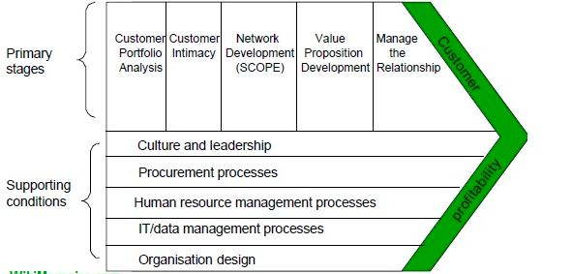
Fig. 3 CRM Value Chain Model

In terms of Portfolio analysis, it is essential that the company identifies which type of customers the company has and which are the set of customers that the company should focus on. According to Buttle (2004), the customers can be grouped as ‘cost-magnets’, ‘benchmarks’, ‘inspirations’ and ‘high life-time value’. For Sky as defined earlier there are three different type of customers based on usage: simple contract (for emails, shopping, banking), superfast contracts (for gaming, streaming) or ultrafast contracts (for more number of devices). Even though Green ISP also has such a segmentation, but the plans and overall benefit of such plans is highly confusing. In terms of customer intimacy, brands develop connection with the clients by accessing information from them. Though such data is taken to improve customer service, it is essential that such data is stored properly by the companies. For example – According to Sonu (2020), Britishers that have provided data to BT are highly prone to data breach and this overall effects the reputation of the company that has taken the data from its customers. In terms of value proposition development, it becomes important that more efficient and effective solutions are developed for customer problems, which are a key to successful CRM. Especially in relation to BT, it is important that the continuous problems that the customers face are solved and even people are trained to handle such situations. According to Statista (2017), BT is the most complained broadband service in UK and it is due to the fact that customers regularly face the same technical problems time and again. The same has been shown in Fig. 4.
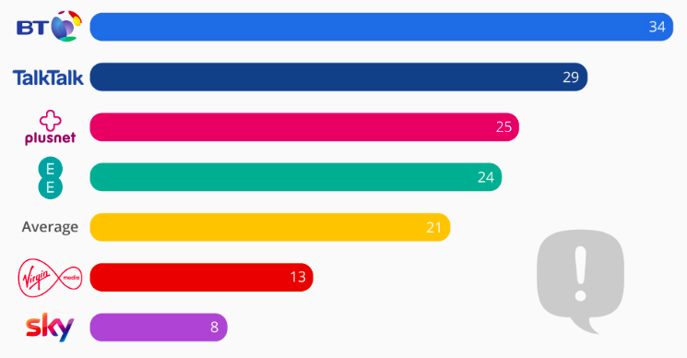

Fig. 4 Most complaints in terms of broadband.

5) Conclusion:
In conclusion, in both ethical and sustainable initiatives it is the Green ISP that is well ahead of BT and Sky. Green ISP is a small organisation and hence it suffers from the overall capacity aspect where it is not able to provide customer service to large amount of customers. Both BT and Sky can take important learnings from the ethical and sustainable initiatives of Green ISP. In terms of appropriate usage of resources, BT has to adequately use human resources so that the quality of customer service can be improved. For Sky, the use of technological advancement should be done to ensure that there is no overcharging of customers which is highly unethical and can bring bad name to the company.
6) Recommendations:
The following can be recommended by overall analysis:
- Both BT and Sky should adopt some of the ethical measures from Green ISP. Particular in relation to lobbying, tax avoidance and over charging. Green ISP has garnered immense interest because of adequate use of resources for its customer management especially of the digital complaint system. BT which has been ranked as the worst broadband in terms of customer experience and service must use both human and IT resources to focus on this aspect.
- Similarly in case of sustainability scenario, BT and Sky should follow Green ISP model where the company has become carbon neutral already and both BT and Sky are aiming for zero emissions in years to come. For delivering of services, sustainable components to be used such as renewable electricity, renewable powered hosting systems and even transportation system (for engineers) that are run on electricity.
- Green ISP can look to further expand its hosting capacity so that additional customers can be added to the company. Also in terms of customer experience, website design has to be made more appealing.
7) References:
- BT (2021) Tackling climate change and environmental challenges. Available at: https://www.bt.com/about/digital-impact-and-sustainability/tackling-climate-change (Accessed: 24/March/2021).
- Brignall, M. (2018) ‘Why did Sky keep charging me when I changed provider?’, The Guardian, 20 June. Available at: https://www.theguardian.com/money/2018/jun/20/sky-bt-landline-broadband-switch-overcharge (Accessed: 24/March/2021).
- Buttle, F. (2004) Customer Relationship Management. Oxford: Elsevier Butterworth-Heinemann.
- Chen, I. J., & Popovich, K. (2003) ‘Understanding customer relationship management (CRM) People, process and technology’, Business Process Management Journal, 9(5), pp. 672–688.
- Dalvi, M., Singh, A., Rambabu, P., Murthy, N. & Gosavi, N. (2019) ‘Business Sustainability - A Study of Most Sustainable Corporations’, Environmental Management and Sustainable Development, 8, pp. 130-150.
- Davies, R. (2016) ‘BT hires 1,000 UK staff after complaints over Indian call centres’, The Guardian, 18 January. Available at: https://www.theguardian.com/business/2016/jan/18/bt-hires-1000-uk-staff-after-complaints-indian-call-centres (Accessed: 24/March/2021).
- Employee (2021) BT in contact centre passage back from India. Available at: https://engageemployee.com/bt-in-contact-centre-passage-back-from-india/ (Accessed: 24/March/2021).
- Energuide.be (2021) Do I emit CO2 when I surf the internet? Available at: https://www.energuide.be/en/questions-answers/do-i-emit-co2-when-i-surf-the-internet/69/ (Accessed: 24/March/2021).
- Green ISP (2021a) Home Broadband. Available at: https://www.greenisp.net/home-broadband/ (Accessed: 24/March/2021).
- Green ISP (2021b) Important Notice. Available at: https://www.greenisp.co.uk/signup-Suspended_2020_demand/index.php (Accessed: 24/March/2021).
- Joo, J. (2007) ‘An empirical study on the relationship between customer value and repurchase intention in Korean internet shopping malls’, The Journal of Computer Information Systems, 48(1), pp. 53–62.
- King, S. F., & Burgess, T. F. (2007) ‘Understanding success and failure in customer relationship management’, Industrial Marketing Management, 37(4), pp. 421–431.
- Paterson, J. (2014) Sky uses benefits to keep employees connected. Available at: https://employeebenefits.co.uk/issues/june-2014/sky-uses-benefits-to-keep-employees-connected/ (Accessed: 24/March/2021).
- Peppers, D & Rogers, M. (2004) Managing Customer Relationships. New York: John Wiley & Sons.
- Roe, D. (2012) Forrester: Customer Experience Management and 13 Emerging CRM Trends. Available at: https://www.cmswire.com/cms/customer-experience/forrester-customer-experience-management-and-13-emerging-crm-trends-014749.php (Accessed: 24/March/2021).
- Russon, M. (2021) BT faces £600m lawsuit over 'overcharging'. Available at: https://www.bbc.com/news/business-55699033 (Accessed: 24/March/2021).
- Salehi, M., Saeidinia, M. & Aghaei, M (2012) ‘Business ethics’, International Journal of Scientific and Research Publications, 2(1), pp. 1-4.
- Shane, S. A., & Ulrich, K. T. (2004) ‘Technological innovation, product development, and entrepreneurship in management science’, Management Science, 50(2), pp. 133–144.
- Sky (2021a) Sky Zero. Available at: https://www.skygroup.sky/sky-zero/mobilising-millions-to-gozero (Accessed: 24/March/2021).
- Sky (2021b) Broadband. Available at: https://www.sky.com/broadband (Accessed: 24/March/2021).
- Soni, J. (2020) Over half of British consumers faced a data breach last year. Available at: https://www.techradar.com/news/over-half-of-british-consumers-faced-a-data-breach-last-year (Accessed: 24/March/2021).
- Statista (2017) BT is the Most Complained about broadband service. Available at: https://www.statista.com/chart/10058/bt-is-the-most-complained-about-broadband-service/ (Accessed: 24/March/2021).
- Strange, R. (2019) Ethical Broadband. Available at: https://www.ethicalconsumer.org/technology/shopping-guide/broadband (Accessed: 24/March/2021).
- Trustpilot (2021a) Skybroadband. Available at: https://www.trustpilot.com/review/skybroadband.ie (Accessed: 24/March/2021).
- Trustpilot (2021b) BT. Available at: https://www.trustpilot.com/review/bt.com (Accessed: 24/March/2021).
- Williams, C. (2018) New BT chief Philip Jansen linked to illegal tax avoidance scheme, The Telegraph, 28 October. Available at: https://www.telegraph.co.uk/business/2018/10/28/new-bt-chief-philip-jansen-linked-illegal-tax-avoidance-scheme/ (Accessed: 24/March/2021).

