Component 2 - Research Report
Student Name: Fatima Al Hassan
Student Number: 2129080
Lecturer Name: Robert Nartowski
LCHS4002_BIRM
Digital Skills and Research Methods.

Table of Contents
1. Introduction 3
2. Research design 3
2.1. Research Question 3
2.2. Method 3
2.3. Ethical Considerations 4
3. Results 4
4. Discussion 10
5. Conclusion 11
6. Reference List 12
7. Appendix A – A blank copy questionnaire. 14

Introduction
The UK has a high number of people who cannot effectively use technology. According to the Office for National Statistics (2022), 8% of the country’s population do not have technological knowledge. This portion may include students at UWTSD. Notably, technology has high usage at the institution as many activities involve the use of technology. Students at the University use Google Scholar, Microsoft teams, and Moodle in their study activities. Some of the learning activities are done online and they have a lot of impact in learning. Collaboration in using digital skills is a crucial skill for students Coletti & Landoni, (2018). Digital skills help students to enhance their collaboration. Technology may be a barriers to access to education. According to Shahmoradi et al (2018), technology is a disadvantage to students who lack the knowledge of using various technological platforms. McDonald et al (2018), proposes that some students need to be trained on how to use some technologies. This research seeks investigate whether there is need to offer training on how to use technology to collaborate at UWTSD and the impact of digital learning on students’ confidence at the university.

Research design

Research Question
UWSTD has high usage of technology in learning and ensuring collaboration in students. Digital learning is used to provide learning almost in every students. However, it is not known whether all student have the knowledge of using technology or not. The research question ‘is there any need to provide students with training on to use technology to collaborate at the UWSTD?’ Moreover, it is assumed that digital learning impacts the confidence of the students as students use various technologies such as Google Scholar and Microsoft teams. But does digital technology have a good impact on the confidence of students?

Method
The research is based on primary research. Questionnaires were used to primary research. Questionnaires were used to collect data from students of UWSTD. See the black questionnaire at the appendices. The research was designed to be objective. Questionnaires were given to the Students within the UWSTD. Using random sampling method, a sample size of 12 participants who completed the study was used in the study. The questions asked included getting the consent from the participant first and then investigating whether the student uses digital platforms in learning. The questions also included investigating the platform that is use by the highest number of participants. Moreover, questions were designed to determine the platform that is easy to use and the one that is difficult to use. Moreover, the research question was designed to investigate whether a significant number of students find it difficult to use digital technology in learning and whether digital learning has a positive impact on their confidence.
Participants who did not fill the questionnaire were excluded from the research. Only the 12 questionnaires that were filled completely were used in data analysis. The discussion of the analysed data involved using both the results of quantitative data and secondary sources to inform the concepts of the results. To ensure validity and credibility, sources of information were peer-reviewed articles. Only valid and reliable sources were used in the research. To ensure that there is social responsibility, the research results will be shared with the participants.
Quantitative research was used in the study. Quantitative research was used to avoid human bias that could be involved while using qualitative research (Cooksey, 2020). Notably, quantitative research involved statistical and mathematical analysis and helps to avoid subjectivity in research. The advantage of quantitative research is that a larger data could be analysed using software (Samuels, 2020). The data collected from the questionnaires was organized in an excel file and analysed using Microsoft Excel. Charts were produced to make the information understandable to the users of the research report.

Ethical Considerations
Ethics were highly upheld in the research. To ensure confidentially and privacy, the names of the participants were not disclosed in the research. The questionnaire did not ask participants from indicating their names. Every participants was told the purpose of participating in the research.Moreover, the consent of participants was obtained before filling any questionnaire and they were free to withdraw from the participation. A filled questionnaire from a participant was not shared with any other participant.
- Results
The questionnaires were filed by 12 participants. All the participants completed the questionnaires and we received a 100% responses as shown below.
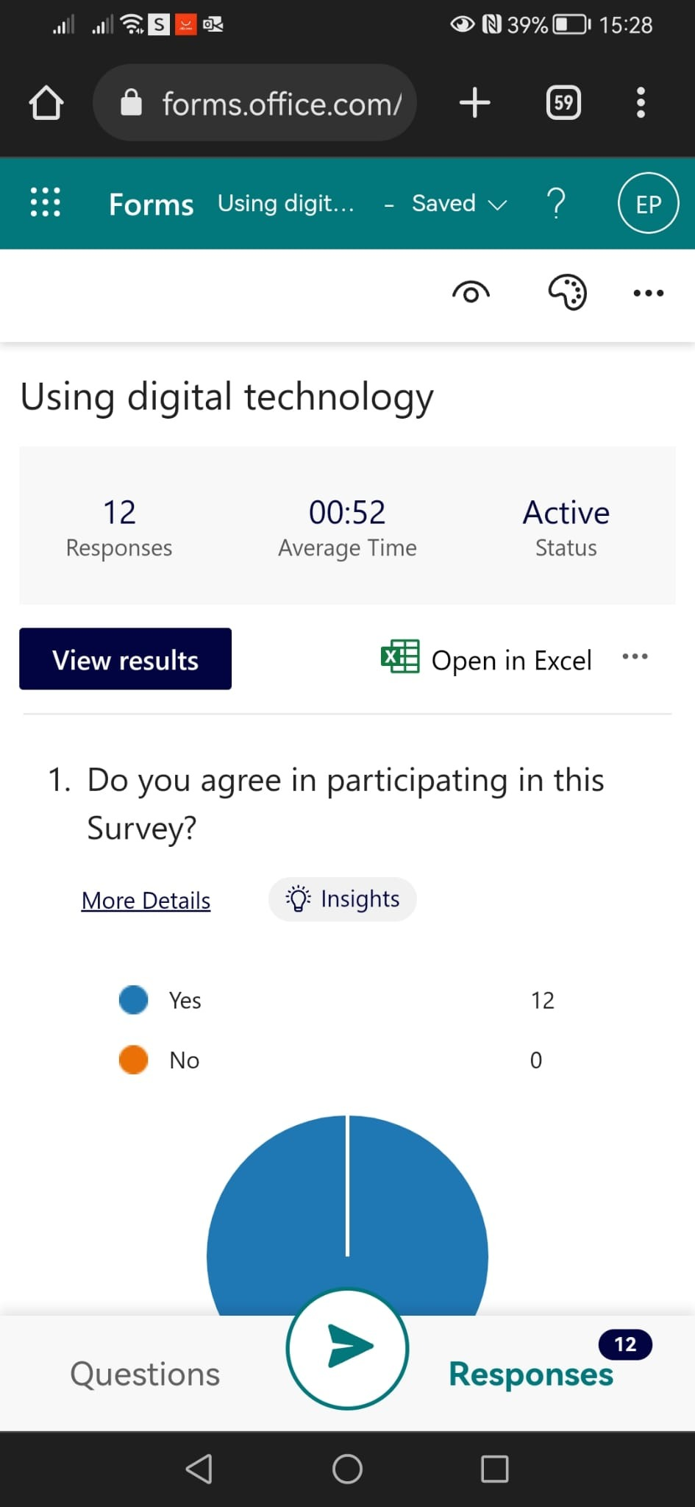

The study investigated the age group of the participants and most participants, 58.3% of the participants, were between 26-40 years. The lowest number of participants were between 18 and 25 years. The results were analysed as shown.

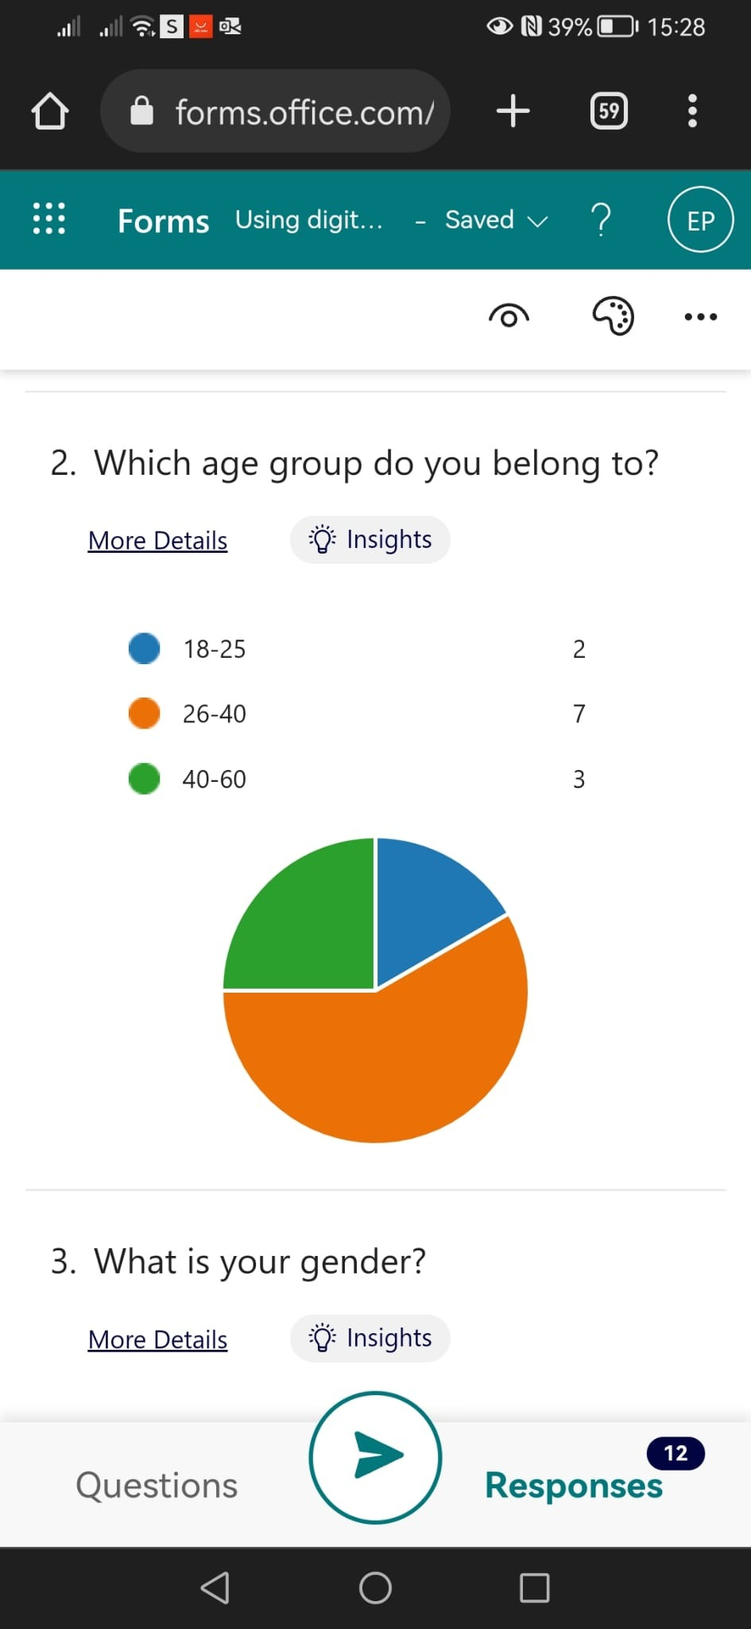

The highest number of participants were female. Female participants represented a 58.3% of all participants while the rest were male participants. The data was analysed and results presented as shown.

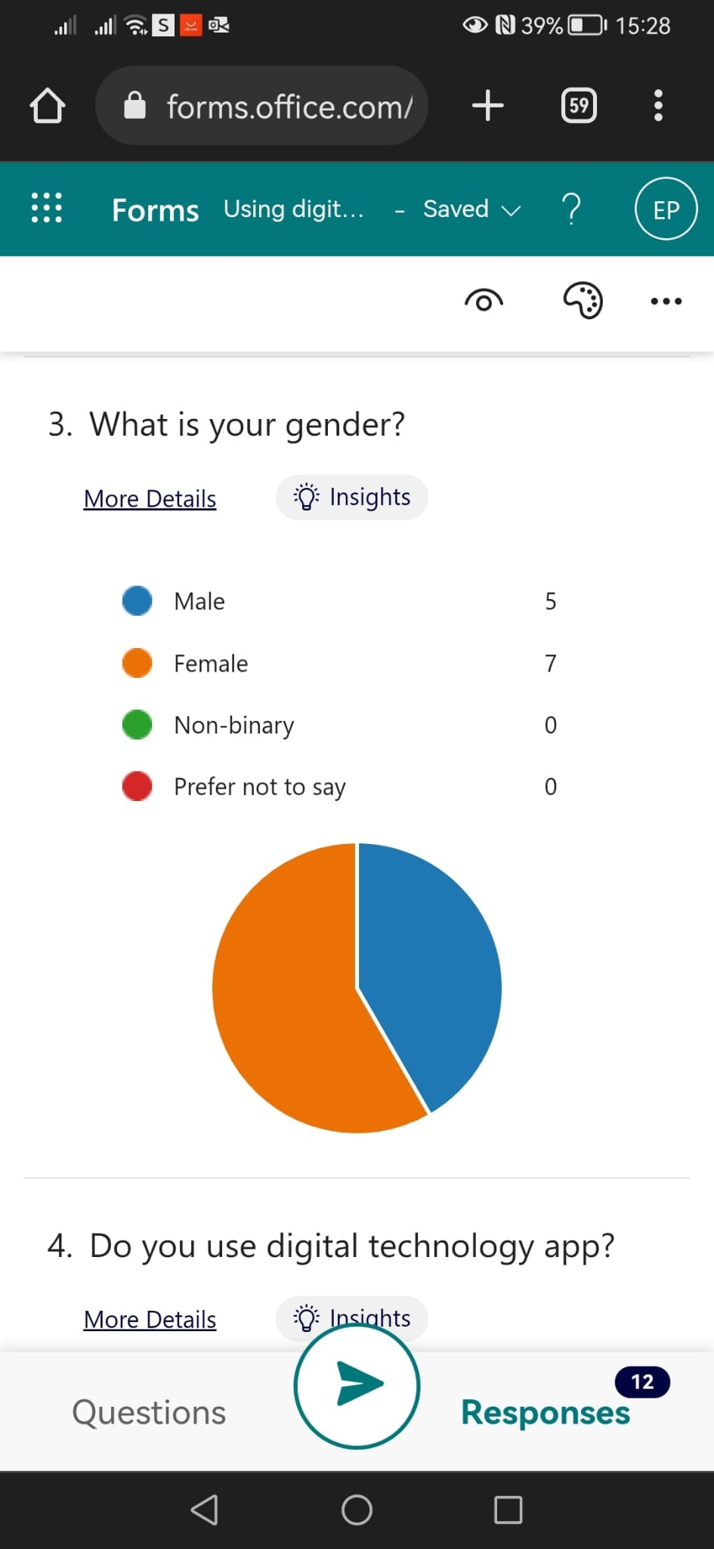

Data analysis shown that all participants used digital technology. The results are presented as show below.
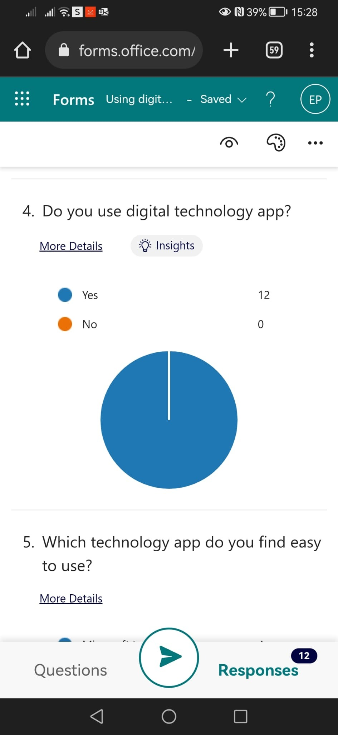

The results showed that the app that technology app students find easy to use is moodle while the library is the most difficult app to use. The results were presented as shown.
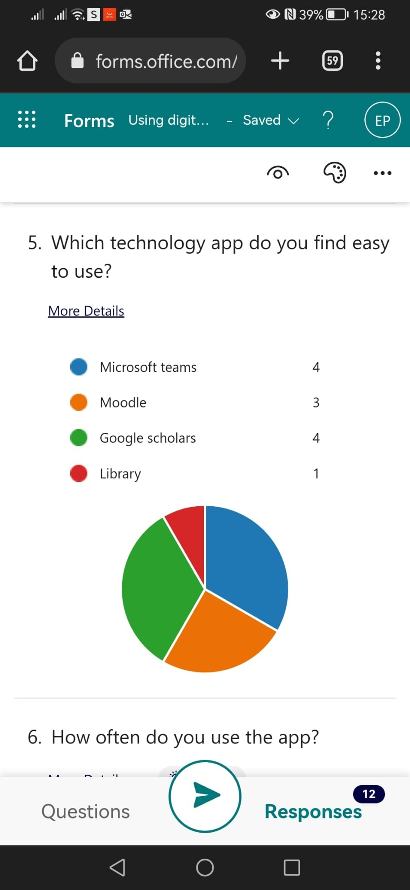

Half of the respondents used a digital app on daily basis while the other half used the app weekly. The results are as shown.
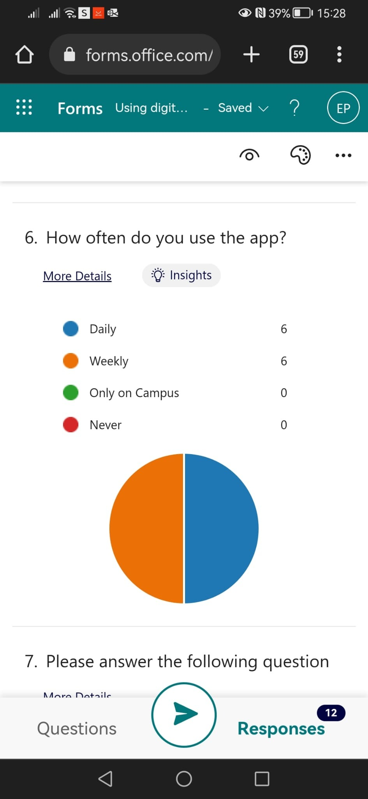

All respondents agreed that they are confident using the digital technology.

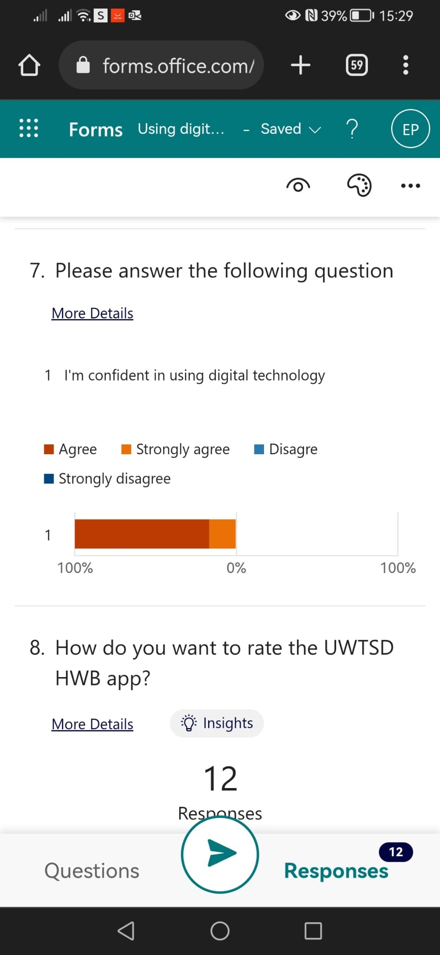

Only 5 respondents out of 12 respondent that they do not need technological training. The results of whether respondents need training are analysed as follows. This indicates that more than 41% of respondents need training.

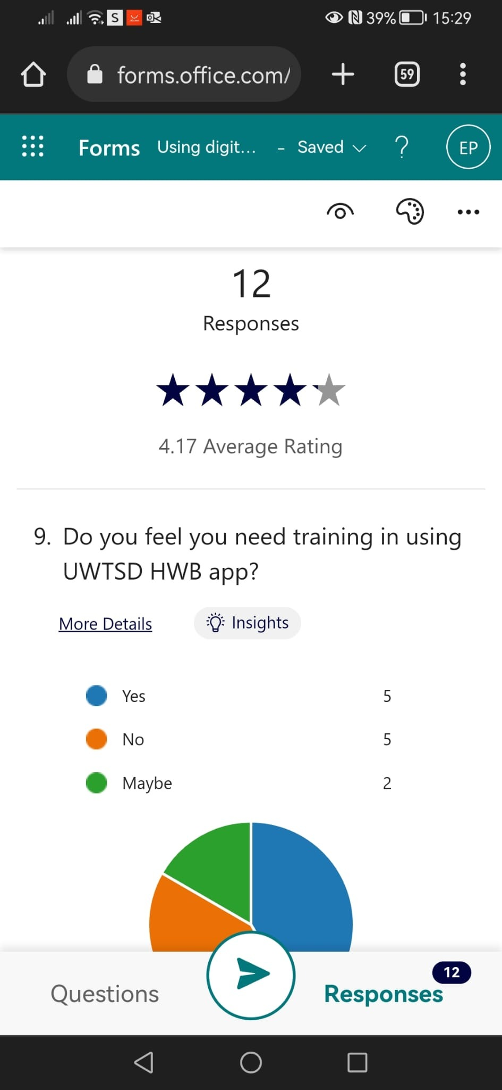

Discussion
All students in UWTSD use technology. The study shows that 100% of the respondents used technology either on daily basis or on weekly basis. With such frequent use of technology in learning, it indicates that the knowledge of technology is crucial among students. It is an indication that students need technology to learn and they should have a good knowledge of technology to avoid being disadvantaged by technology in their learning. This results confirms the suggestions of Shahmoradi et al., (2018), that technological knowledge is crucial among University students due to the frequent uses of technology in their learning.
Previous studies had indicated that technological training in school is important. The result of this study confirms that some students of the UWTSD are disadvantaged. Moreover, More than 40% of the students need training on some technological apps. Notably, when students join the institution, they are introduced to technological apps without proper training on how to use them. UWTSD is an international institution recruiting students from all parts of the world. some students from disadvantage background with little or less access to digital technology may find it extremely difficult to learn in the UWTSD due to the high use of technology in the University.
The highest number of students at UWTSD fall in the age group of 26-40 years. This is the age group which has the best knowledge of the use of technology in the UK. However, this study indicated that the students still find it difficult to use the technology. Technological knowledge should be a general knowledge that should not be graded as other skills and knowledge in specific models. However, this general knowledge has been a disadvantage to several students. More than 40% is a significant number and this confirms hypothesis that students need training on how to use technology in their collaboration.
Proficiency in using technology varies from one app to another. A student can be proficient in using a certain technological app but find it difficult in using another app. An investigation on the app that is simpler to use and the one that is difficult to use was crucial in the current study. It is an indication of the areas that trainers should emphasise on when training students on how to use technology. Notably, training should not be generalised by should focus on areas that students find it difficult to use (Maatuk et al., 2022). The study indicated that 33.3% of students find it easy to use Google Scholar while another 33.3% find it easy to use Microsoft Teams.
Almost all learning activities and students’ information are accessed through the moodle app. Ironically, only 25% of students find it easy to use this app. This indicates that most students in the university are disadvantaged by using the technology at UWTSD. The library is the most difficult app to use in UWTSD. The current study indicates that only 8.3% of the students’ population find it easy to use the library app. It is an indication that more than 91% of students need some training on how to use this app.
Training is the best way to give students knowledge of how to use various technologies used at UWTSD. In any app, two thirds of the students’ population or more find it difficult to use the app. Students need a lot of training in using the library app but training is also required on using every other technological app.
The world has changed significantly, and graduates need to be confident in using technology both in their studies and in their future jobs. It was crucial to investigate whether students are confident in using digital technology. The study confirmed that most students are confident in using digital technology. The institution should thus continue using technological apps but training is required to avoid having disadvantaged students because they cannot use the technologies used in UWTSD.
The high number of students who find it difficult to use some apps and that requires training indicates that the institution has not sought to understand technological needs for its key customers. It is important to design training programs in the University.
- Conclusion
The research was designed to investigate whether there is need to offer training on how to use technology to collaborate at UWTSD and the impact of digital learning on students’ confidence at the university. The data was then collected from students of UWTSD using questionnaires. It was found that most students find it difficult in using one of the apps, but the library app was the most difficult app among students. Technological training is required on all apps used in UWTSD. It can be concluded that before students start using the technologies used in the University, training is required. The highest number of students cannot use the library app. Training is required on every app. The use of technology has high impact of digital learning on students’ confidence at the university. Most students agree that it has positive impact of their confidence, and thus, the institution should continue using technology. The task of how the institution should train its students lies on UWTSD’s management but the fact that training is required cannot be ignored.

- Reference List
Coletti, M., & Landoni, P. (2018). Collaborations for innovation: A meta-study of relevant typologies, governance and policies. Economics of Innovation and New Technology, 27(5-6), 493-509.
Cooksey, R. W. (2020). Illustrating statistical procedures: Finding meaning in quantitative data. Springer Nature.
Maatuk, A. M., Elberkawi, E. K., Aljawarneh, S., Rashaideh, H., & Alharbi, H. (2022). The COVID-19 pandemic and E-learning: challenges and opportunities from the perspective of students and instructors. Journal of Computing in Higher Education, 34(1), 21-38.
McDonald, E. W., Boulton, J. L., & Davis, J. L. (2018). E-learning and nursing assessment skills and knowledge–An integrative review. Nurse education today, 66, 166-174.
Samuels, P. (2020). A really simple guide to quantitative data analysis.
Shahmoradi, L., Changizi, V., Mehraeen, E., Bashiri, A., Jannat, B., & Hosseini, M. (2018). The challenges of E-learning system: Higher educational institutions perspective. Journal of education and health promotion, 7.

Blank copy of questionnaire

- Do you agree in participating in this survey?
Yes
No
- Which age group do you belong to?
18---- 25
26-----40
40-----60

- What is your gender?
Male
Female
Non-binary
Prefer not to say

- Do you use digital technology app?
Yes
No

- Which technology app do you find easy to use?
Microsoft teams
Moodle
Google scholars
Library

- How often do you use the app?
Daily
Weekly
Only on campus
Never

- Please answer the following question
Agree
Strongly agree
Disagree
Strongly disagree

- How do you want to rate the UWTSD HWB app?
1 star
2 stars
3 stars
4 stars
5 stars

- Do you feel you need training in using UWTSD HWB app?
Yes
No
Maybe
Appendix A – A blank copy questionnaire.
Using Digital Technology
- Do you agree participating in this survey?
Yes
No
- Which age group do you belong to?
18-25
26-40
40-60
- What is your gender?
Male
Female
Non-binary
Prefer not to say
- Do you use digital technology app?
Yes
No
- Which Technology app do you find easy to use?
Microsoft teams
Moodle
Google Scholars
Library
- How often do use the app?
Daily
Weekly
Only on Campus
Never
- Please answer the following question.
I am confident using digital technology
Agree
Strongly agree
Disagree
Strongly disagree
- How do you want to rate the UWTSD app?
- Do you feel you need training in using UWTSD HWB app?
Yes
No
Maybe

