

LOCATION: Swansea | LLEOLIAD: abertawe
LEVEL 7 | LEFEL 7
EXAMINATION PERIOD | CYFNOD ARHOLIADAU
JUNE 2020 | Mehefin 2020

MODULE CODE: ACCA7017
IMPLEMENTING IP ROUTING
PRACTICAL TEST 2 RESIT

Name :

Student ID :

Date & Time :

This is an individual practical lab-test, held under examination conditions. You will be assigned four Routers; you should configure these Routers based on the following specifications.

The routers that you will configure are Rome, London, Paris and ISP.

This paper is marked out of 100.

You will have 3 hours to complete this task.

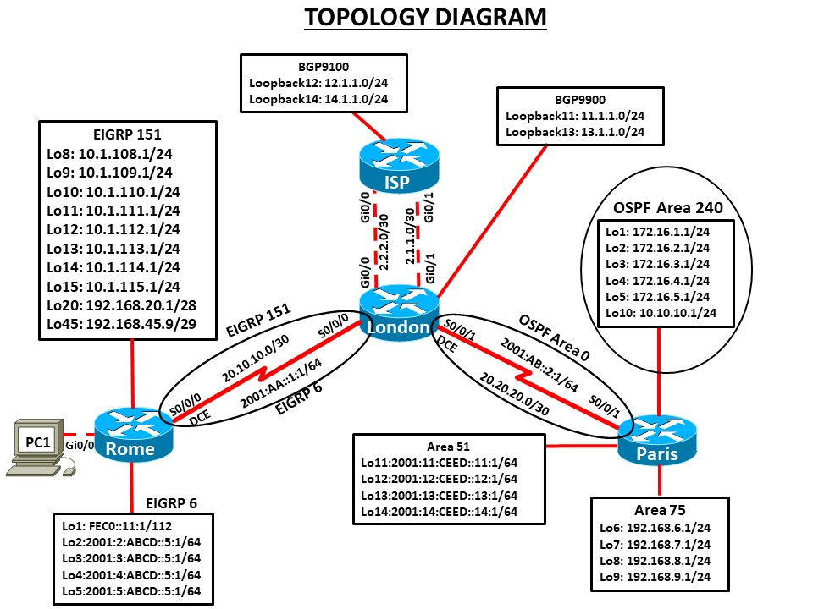

Task 1 – Network Connections

- Create the topology on Cisco Packet Tracer.

Task 3 – Configure Routing (90 marks)

- Configure all devices with hostname and interfaces with the IP addresses shown in the topology diagram. Set the bandwidth to 128 kbps on the links between Rome, London and Paris, set the clock rate on the DCE connections as appropriate.

- On IPv6 interfaces, configure global unicast and Link Local address.
- Configure Rome router as DHCP server with following details: DHCP pool (Pool name: RomeLAN) for the subnet 192.168.254.0/24, default router 192.168.254.254, dns server 192.168.254.253, domain name: soac.com and exclude address range 192.168.254.240 to 192.168.254.254
- Configure the routers Rome and London to be in EIGRP AS 151. Add all networks as shown in the diagram. Ensure that your network statements are as specific as possible. Disable automatic summarisation.
- Configure OSPF Area 0 on the link between London and Paris as shown in the diagram. Ensure that your network statements are as specific as possible.
- Configure OSPF Area 240 and add all networks as shown in the diagram. Ensure that your network statements are as specific as possible.
- Configure OSPF Area 75 and add all networks as shown in the diagram. Ensure that your network statements are as specific as possible.
- On all routers, configure all loopbacks and LAN interfaces in passive state.
- Configure a manual summarization on Rome’s serial 0/0 interface for all loopbacks 8 to 15 in EIGRP 151. Use the most efficient mask.
- Change the network type for the loopback interfaces to point-to-point so that they are advertised with the correct mask in OSPF.
- Configure summarization of area 240 into a single inter-area route. Use the most efficient mask.
- Configure EIGRP links to use MD5 authentication between Rome and London routers. Use password "cisco".
- Configure OSPF interfaces to use MD5 authentication between London and Paris routers. Use password "class".
- Configure mutual redistribution between EIGRP and OSPF with default metrics.
- Make the link between London and Paris to have hello timers and dead timers that are double the default values.
- Make the link between London and Paris have a cost of 500.
- Make the link between Rome and London to have hello interval of 2 seconds and hold interval of 8 seconds.
- Change the intra-area distance to 105, inter-area distance to 115, and external routes to 175 on Paris.
- Enable EIGRP 6 for IPv6 networks on Rome and London and advertise the loopbacks and serial interfaces as shown on the topology.
- Enable OSPF 6 Area 0 for IPv6 networks on London and Paris and advertise the serial interfaces as shown on the topology.
- Enable OSPF 6 Area 51 for IPv6 interfaces on Paris router.
- Configure mutual redistribution between EIGRP for IPv6 and OSPFv3 with default metrics.
- Configure the London router to be in BGP AS 9900. Peer the ISP router on both Gigabit-Ethernet links.
- Configure the ISP router to be in BGP AS 9100. Peer the London router on both fast-Ethernet links. Disable automatic summarisation.
- Configure the ISP router with a static default route to London router on both Fast-Ethernet links. Make sure these route acts a back-up to BGP.
- Make the London router prefer the 2.1.1.0 /30 link to the ISP for outbound and inbound traffic by modifying the Local Pref and MED attributes. See note below.
- Configure London router with inbound filter to remove BGP advertised network 14.1.1.0/24. See note below.
- Configure Rome router to filter updates from Rome to London, allowing only the EIGRP summary route and loopback 45 and loopback 20 to be advertised. Use more specific prefixes. See note below.
Note: Packet Tracer do not support commands for steps 26 to 28. Type your configuration here.

Task 3 – Network Connectivity (10 marks)

- Verify DHCP configuration: PC1 IP address________________________ (Include screenshot)
- Ping from PC to loopback interface on OSPF and EIGRP networks. Is it successful? _______________ (Include screenshot)

Submission Requirement

The packet tracer file should be saved as “studentname_id” and uploaded on Moodle. In addition to packet tracer file, you must also submit

• The output of show running-configuration command in a text file for all devices configured.
• This document with configuration for steps 26 to 28 and Task 3 completed.

All documentation for your solution should be submitted electronically on Moodle. It is your responsibility that you submit all the outputs and files correctly.

