Computer Networks and Security
Research on current security technologies and Penetration testing on a Live Website

Liam Blunt
P149891
Table of Contents

I. Introduction 3
II. Research on current technological advances in Network and Cyber Security 3
I. Cloud-Based Security Issues 3
II. Internet of Things and Smart City security issues 6
III. Penetration testing on a live website 8
I. Reconnaissance 9
II. Active Attacks 11
I. Error-Based SQL Injection 11
II. Brute Force Login Attack 14
III. XSS Iframe Exploit 16
IV. Conclusion 17
V. Appendix 18
VI. Bibliography 21

Introduction

In relatively recent years the increase of cybersecurity-related attacks has shown that for the most part, the majority of the country are not prepared for the future trends of cybersecurity. Whilst this is a problem in of itself, as the businesses of the world rely more and more on internet service such as cloud computing, internet communications and the Internet Of Things(IoT), this lack of subsequent cybersecurity is only going to grow in potential severity. This document comes in two sections; research on recent technological advancements in cybersecurity as well as a penetration test on a live environment sequentially. The first section will focus on two topics regarding security; Cloud Environments and the Internet of Things in Smart City Implementation.

Research on current technological advances in Network and Cyber Security

Cloud-Based Security Issues

A current trend in computing is the move from dedicated on-site computer usage to that of a cloud-based system, due to the ever more efficient cost associated with them. This has allowed many businesses to have a much greater computer environment that they could afford otherwise, not to mention the increase in efficiency via remote-working and timed backups, should those options be available. Technically speaking a ‘cloud’ computer is just a network of remote severs, usually in massive server farms to maximise the efficiency per dollar, of which then can be used by users who pay for an allocated section or number of servers. Unfortunately like any other computer system, cloud services, despite being hosted by multi-billion-dollar companies, they are still vulnerable to security threats. Whilst this is certainly no surprise due to the increasing amount of news stories covering cloud data breaches, it is a fact often overlooked by people and corporations alike.
As of the time of writing, one of the most common threats to cloud services are data breaches as a result of unauthorised access, whilst technically more akin to a symptom of multiple threats, they are none the less the most common. A data breach is basically an unauthorised 3rd party gaining access to data, be it sensitive or otherwise. According to a 2019 survey 42% of organisations list unauthorised access as their number one threat in the public cloud[1]. The most common cause of these types of breaches are poor security practices, such as weak credentials and poor authentication, these types of weak security are often cracked via the traditional password cracking software or stolen if stored insecurely, such as unencrypted or stored locally on storage devices that were insufficiently wiped before being discarded. These types of attacks are most commonly done either via hacking or social engineering, according to a Verizon report[2], likely due to the fact that statistically the users are the weakest link in security[3]. Now, the extent of such a data breach would depend on the privileges the user had, if it were a standard user with little access to sensitive data, then the damage would be minimal, if an admin account were breached, then, depending on how dependant the company is on the cloud storage, it could be a worst case scenario. As such users should be restricted “by configuring information system(s) to provide only essential capabilities”[4]. In addition, the use of strong authentication and preferably two factor authentication when trying to access the cloud, or in some cases if the company has it set up, restricting access to the company cloud via the company VPN would also help in securing communications.
The second threat to cloud computing, like any computer, is malware. While we do not have the space here to discuss every malware, so we will focus on or two major threats; ransomware and cryptojacking.
Ransomware is becoming increasingly popular throughout cybersecurity as it can completely encrypt a person’s computer and then hold it for ransom, giving the attacker financial incentive, at least most commonly, some just encrypt computer systems, but they are less common.[6] In addition, as it is normally done via cryptocurrency such as bitcoin, it is very difficult to track it back to the attacker. As you can imagine, a malware that can propagate throughout a computer and its associated network is an absolute nightmare, and that opinion is shared by thousands of businesses worldwide; 76% of businesses see “ransomware as a significant business threat.”[7] Now, if ransomware was able to infect a cloud datacentre, such as it did in New York 2019[8] then it could possibly infect hundreds of servers at once, as well as the fact that it is more likely that the businesses will have the money to pay than if the attackers were to target individuals, or for simply damaging the company.
A cryptojacking attack on the other hand, is a relatively new form of malware that uses the computational resources of a system to ‘mine’ cryptocurrency such as bitcoin or monero[9], the resulting bitcoins being sent to the creator of the malware, and due to cryptocurrency being next to untraceable by design, it is difficult to track the attacker. Whilst this type of attack is increasingly popular due to the rise of cryptocurrency and can affect any computer system from mobile devices to home computers, cloud environment/servers are a very enticing target. As you can imagine, the servers of a cloud environment are allotted to a company and as such the company pays for the resources. Essentially a business would hopefully pay for enough computing resources for their business, but of course it will not always be running at 100%, the cryptojacking essentially uses the computing power to mine cryptocurrency, slowing down the infected servers significantly. On the other hand, some cryptojackers, rather than slow down the system, will use enough unused resources as to not slow the system down, allowing them to stay undetected longer. The reason these types of attacks are gaining popularity is that whilst mining cryptocurrency can be lucrative, the equipment and power consumption costs eat upwards of ~70% of the total profit, so by using someone else’s’ resources the attacker can keep all the profit and shift the costs to the business and/or cloud service provider. It has even been documented that some cryptojackers have worm-like capabilities meaning they can duplicate over networks[10], as well as increased adaptability by downloading files to suit the architecture of the present system. Arguably the biggest threat from cryptojackers is the fact that they can be quite easily executed either via a victim clicking on an infected link, executing the code, or simply viewing an infected advertisement, from there it can then propagate through the infected PC’s network. Add to this the fact that often cryptojackers have a method of reboot persistence and kill prevention, making them a very real and very dangerous threat to current and future cloud environments. Arguably the danger here is the fact that this type of malware can severely reduce the lifespan of infected servers resulting in service disruptions, loss of data or loss of services.
Lastly, another large security issue with cloud environments are system vulnerabilities, which are present on both the provider and user side. Whilst vulnerabilities are present in any system, whether or not they are patched is another story. Who is responsible for this depends on the type of cloud service, for example take Amazon Web Services, a cloud provider that runs on the shared responsibility model[11]. Basically anything within the cloud is the customer/company’s prerogative, including operating system, network and firewall configuration, data, network traffic protection, etc. On the other hand, the provider, Amazon in this case, is in control of the physical infrastructure as well as any software running ‘beneath’ the cloud environment available to the customer. Therefore the provider will update and apply any patches available to them to the section they control, but anything on the customer’s side is their responsibility to update, and this is where the problems lie. As mentioned previously, many companies put too much faith in cloud providers to provide security, of which they do, but that security will not work if the environment it is defending is full on vulnerabilities itself. According to Version’s 2019 data breach report, 34% of reported vulnerabilities remain unpatched, and even then companies may not use said patch, a good example of this is Equifax’s massive data breach in 2017 which was caused by an unpatched “exploit in the open source Apache Struts framework [allowing for] arbitrary code execution”[12]. Apache discovered this exploit and patched it six months earlier, and despite a direction about the exploit and how to fix it by US homeland security[13], they still did not fix it until it was too late, causing for 200 million consumers’ sensitive data to be stolen across both America and Europe, not to mention the financial implications due to legal action and rebuilding. Whilst it may be an over-the-top example, it is still a very good example of how stubborn some businesses can be to apply patches to exploits and how damaging they can be.

Internet of Things and Smart City security issues

In relatively recent years, the concept of the Internet of Things and subsequent smart city implementations of said IoT is becoming increasing popular as it moves from science-fiction to real world application. Currently, as of the time of writing, the IoT is surging in technological improvements and popularity, with new devices being released very often as the technology and their design improves. As the technology improves, as does the price, both factors making their usage in a smart city environment more and more appealing.
Now, what exactly is the Internet of Things? The IoT is the networking “of physical objects that contain embedded technology to communicate and sense or interact with their internal states or the external environment.”[14]. The main target of an IoT world is “the formation of smart environments and self-conscious/ autonomous devices: smart transport, smart items, smart cities, smart health, smart living,”[15] etc.
The concept of a smart city is much the same as IoT except localised to a singular or multiple cities, using IoT devices to monitor and collect data of which can then be acted upon to improve aspects of said city. For example, using sensors on roads or the vehicles themselves, a smart city can theoretical notice patterns in traffic, and alter the timings on junctions accordingly or prioritise public transport, moving more people at once, some estimates predicting cuts to travel time of 20-30%[16]. Another popular example would be that of utilities such as water, not only do ‘smart’ technology allow for utility companies to measure how much water each household is using, but via sensors in the main pipes themselves, they can much more easily find problems in the pipes such as leaks or loss of pressure, so that they can be fixed before they become a much bigger problem, such as the pipe bursting.
Now, why is the concept of a smart city so important? Currently the world in general is facing an ever-growing urbanisation trend, whereby more and more people move into urban centres for the opportunities they provides such as jobs and improved standard of living. As such there is more and more pressure on said cities to be able to provide the necessary resources for their increasing population. Whilst some resources can be scaled, the mediums by which they are transferred do have a limit. So, rather than waste resources by everscaling them, rather use them more efficiently.

The aim of this document’s perspective on IoT and smart cities is that of security, and as such will be the main focus point. As is with any computer system and network, IoT devices in general tend to have their fair share of security flaws, of which only become more apparent when put in just a large project such as that of a smart city. For the most part, due to the competitive nature of the IoT market currently, ultimately security is a low priority in a lot of devices, as it drives up costs significantly, reducing the device’s ability to compare on a cost-based comparison to its competitors. Therefore a large majority of IoT devices on the market currently are “not designed to handle the security and privacy attacks [resulting in increases in] security and privacy issues in the IoT networks such as confidentiality, authentication, data integrity, access control, secrecy, etc.”[17].
Whilst this writer would like to believe that any developer of a smart city network would opt for the more expensive yet more secure option, seeing as an IBM evaluation on current smart cities reports multiple low level security vulnerabilities in many IoT devices used, there is still a worrying amount of insecure IoT devices being used by cities[18]. Many of these devices in question were cracked with manufacturer-assigned default passwords, authentication bypasses, simple SQL injections or interception of communications as they were done so via unencrypted plaintext format. Whilst it is understandable due to the additional costs, ultimately should someone take advantage of those security flaws to the extent of damaging or disrupting the network or its connected devices, the money lost would very likely outweigh the money saved by buying insecure devices. A good example of this would base a case of a power company in Spain, after installing smart meters to better monitor power usage, they were found to be quite insecure as people cracked them to underreport the amount of electricity used or even charge their energy use to someone else’s account via ID spoofing, costing the company millions of euros in lost revenue, not to mention the costs associated with developing and replacing a more secure replacement smart meter.[19] Another case in point is to do with cars, as they become more internet-friendly with features such as internet connectivity and wireless connectivity become quite common in newer cars, they open themselves to the security vulnerabilities that come as standard with internet access. Take for example Fiat; in 2015 security researchers in the US managed to remotely disable the brakes and steering of a car whilst on the highway, “via Uconnect, the car's information and entertainment dashboard”[20]. Whilst Fiat recalled 1.4 million cars to fix the vulnerability, it was a vulnerability present none-the-less. Now, what if it had not been security researchers who had found and taken advantage of the vulnerability, of whom have legal and moral guidelines, what if it had been a malicious 3rd party? This is just a small example to show that whilst a lack of IoT security has high financial hosts, it could also include casualties, especially so should the rising trend of self-driving cars become exploitable.
Another reason that IoT devices are generally insecure is because there is no legal reason to improve it, although the manufacturer makes an IoT device, technically they have no reason to secure it if people will buy it anyway. As of the time of writing there is a voluntary code of practice for IoT devices that the larger manufacturers will follow, but it is doubtful whether or not all manufacturers follow suit. Luckily the law is catching up, case-in-point in California USA, as of January 2020 legislation was introduced restricting what can be defined as an IoT device, and should it be classed as an IoT device, it must be built “with a reasonable security feature or features that are appropriate to the nature and function of the device, appropriate to the information it may collect, contain, or transmit, and designed to protect the device and any information contained therein from unauthorized access, destruction, use, modification, or disclosure, as specified”[21]. Whilst there is a UK law of the same kind, it is currently in draft and is unlikely to become law in 2020.
Additionally, with all these IoT devices creating information, it must be processed to be interpreted and used by the subsequent programs. This is where cloud computing comes into play, providing the computational infrastructure a smart city needs. This comes with even more points of opportunity for attackers and can make the running of the city infrastructure vulnerable to the same security issues of cloud computing as mentioned previously in this document.
In conclusion, the Internet of Things and subsequent implementation into a smart city environment will come with their own set of challenges, ranging from security, to legal, to financial. None the less, with the ever-growing trend of urbanization, it is an inevitability and as such will likely see wide-place implementation within our lifetime. Along with this, the technological improvements to IoT devices and subsequent technologies, will make the adoption of smart city technology all the more enticing. Whether or not it will be done so securely, is another matter, and we can only wait and see.

Penetration testing on a live website

The purpose of this section is to a black box penetration test against the website https://tevelcyber.com/ , of which we have been given permission to do so. A black box penetration test, meaning that we are external testers and have no information on the target network, only what we can find ourselves. Along with this permission are a set of guidelines and rules, listed below;
- Do not modify any contents of the website.
- Produce details of any vulnerabilities found as well as the exploit method, giving information for further testing and validation
- Make a good faith effort to avoid privacy violations, destruction of data, and interruption or degradation of our services
- Do not use found vulnerabilities to find other vulnerabilities
- No accessing, downloading, or modifying data you are not privy to
- No Denial Of Service attacks or Distributed DOS attacks
- No use of malicious software
- No sending of social engineering to gain access such as unsolicited emails
- No Testing that would result in service degradation
- Must stick to scope of website, no targeting integrated or 3rd party services.
Now, before any sort of attempt can be made towards the website, a contingency plan must be made in order to comply with the aforementioned guidelines and rules.
The first point will rule out any type of attack that interferes with the website content such as stored cross-site scripting and any sort of DNS attack such as spoofing, amplification or cache poisoning. Whilst it is possible to check whether or not the website is vulnerable to said attacks, it is a fine line. In addition, any sort of attack will use a non-malicious payload, for example if running an SQL injection, using [‘ or 1=1’--] as opposed to [DROP TABLES], whilst basic, one simply gives an error and one deletes content if successful. In addition, the use of user-attacking attacks such as clickjacking will not be used as that would attack a user of the site rather than the site itself.
In terms of DOS limitations, the computer running the attacks will be using Parrot OS, similar to Kali Linux and therefore this writer can simply not use DOS attacks, but just to make sure, the PC will be limited on the network card as well as the switch port to 5MB/s, as that is more than enough for even the most intense scans, even after being routed through a VPN. Technically speaking though, this writer does not have the bandwidth or computing power necessary to perform any DOS attack of significant value, at least of the brute force kind, that being said; the limit is to confirm this.
Any other limits will simply affect what tools are used, and for the most part they each have a specific use, and as such are very unlikely to go outside the rules or scope assigned by TevelCyber.
It is worth noting beforehand that whilst the assignment called for penetration testing against a vulnerable website, due to this writers’ ineptitude in timing, what was once a ‘vulnerable’ server has yet been patched and/or restored to a more secure configuration, making testing much more difficult.
Software/tools used in penetration testing:
Nmap/Zenmap | Parrot OS
Nikto | Burp Suite
WPScan | OWASP ZAP
Damn Vulnerable Web Application | NordVPN
Firefox

Reconnaissance

Now, seeing as this is a black box penetration test, the first step of this test is reconnaissance, finding out information on the target to better understand what we are dealing with. The first step is to activate the VPN, whilst we do have permission, using a VPN when penetration testing a remote target should be standard practice, and in this instance, the VPN used has a network kill switch, meaning that the computer will not connect to the internet unless through the VPN tunnel.
The first tool here will be Censys.io, whilst technically a website rather than a tool, it does allow us to get information on the target and a few of the ports and the services running on them. The results can be seen at https://censys.io/ipv4/192.185.39.52 . Here we can see the geographical location where the server is hosted, the name of the host, the decoded port banners, port services, etc. While this is a webpage, meaning the information may change as the server does, it gives us real-time data, as opposed to relying on a scan giving information from a singular point in time.
The next tool to be used here is be Nikto, a “web server scanner which performs comprehensive tests against web servers”[22], and this will provide us with a useful amount of information on the target, including the IP address, DNS authority, the issuer as well as possible points of attack. As you can imagine this may have some overlap with Censys, but the additional information may be useful. Unfortunately, the downside to this tool is that it is not stealthy, therefore should the website have an IDS (Intrusion Prevention System), then it will be detected and logged. Whilst it is not ideal, between running the different attacks, this writer will be changing the VPN exit node, just to be sure the IDS/IPS does not have a singular IP address to identify the attacks by.
Now that we have preliminary information about the target, we can use Zenmap to identify ports used by the web server, worth noting that Zenmap is just Nmap with a GUI, making it easier to display results. For this scan to get the most information from the web server, this writer will be using the ‘slow comprehensive scan’ preset, using the command;
[nmap -sS -sU -T1 -A -v -PE -PP -PS80,443 -PA3389 -PU40125 -PY -g 53 –script “default or (discovery and safe)” 192.185.39.52]
This scan uses three protocols, Transmission Control Protocol (TCP), User Datagram Protocol (UDP) and Stream Control Transmission Protocol (SCTP). The rest of the command includes scan parameter such as probes to use (-PE,-PP,etc.), the type of scan to run (-sS=stealth scan), as well as the script to run and the ending IP is the target, derived from the previous Nikto scan. Technically the only alteration made to the default preset is the speed of the scan, from -T4 to -T1, whilst the scan may be a lot slower to run, turning a thirty minute scan into an eight hour scan, although it is much more likely to not provoke or be logged by the IDS. The results can be seen below.
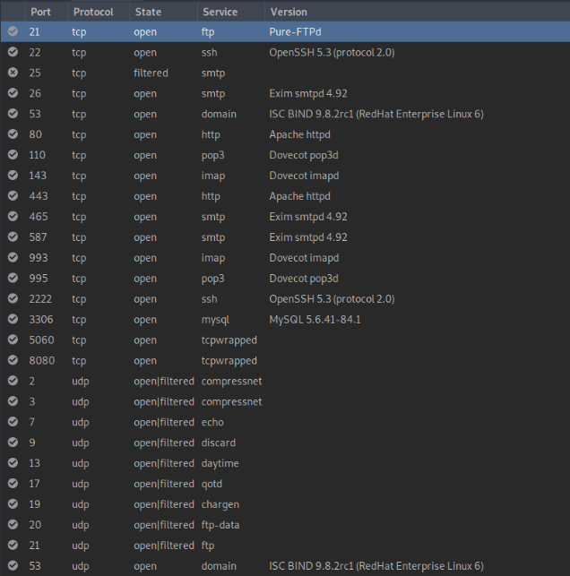
Figure 1- Zenmap Port Scan
Another separate program to collect data at this point is OWASP ZAP, a web application security scanner developed and maintained by the Open Web Application Security Project. This tool will give additional possible points of attack from the web-application side, as opposed to Nmap which is more suited towards port-based services. Worth noting beforehand that whilst this software technically does perform attacks, they are placeholder attacks used only to test vulnerabilities as part of the scanning process, and as such it can be classed as reconnaissance. The main difference set to the automatic scan is depth, instead of the default of 5, it is set to 0 (unlimited) to scan the entirety of the site in order to find any sort of potential exploit. The total result of the scan can be seen below, with different sections of exploit being assigned different severities, individual entries will be referred to in later sections of the report.
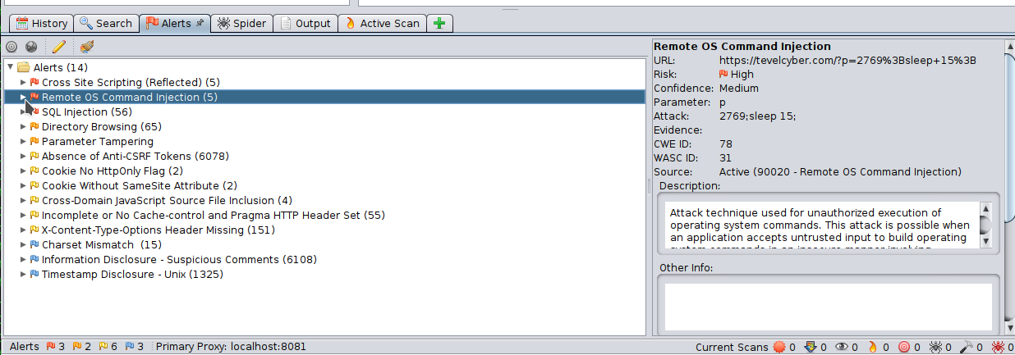
Figure 2- OWASP ZAP Attack Results
Now, the last independent reconnaissance scan will be WPScan, a server scanner made for WordPress installations. Whilst a WordPress port is not open as detailed by the previous Nmap scan, it is still a point of interest in the Nikto report and may act as another possible point of entry, as it is the management system that controls the website.
For the WPScan and Nikto scans, they can be found in the appendix, due to their length.

Active Attacks

Error-Based SQL Injection

When it comes to the attacking process, first we will start with a relatively simple URL Error-Based SQL injection on the website, checking whether or not it can deal with it. Here we will be using the URL [https://tevelcyber.com/p?’ or 1=1’--], which should create an error.
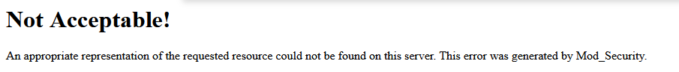
Figure 3- TevelCyber Error Response
Here we see the error produced, and whilst it technically did give an error, it was one generated by Mod_Security, a web application firewall used by open source web servers, in this case from Apache, as we can see in the Zenmap Scan. This is due to the fact that Apache noticed the proposed SQL injection in the URL and created this generic error, preventing the server from showing any useful information. In a “successful” case it would show a 403, 404 or 500, all of which are internal server errors of varying degrees. This type of attack is more of a preliminary attack, checking the web server’s susceptibility to simple SQL injections.
Whilst on the subject, the firewall used by Apache helps defend against cross-site scripting, path traversal, SQL injections, session hijacking, link injectors, malware and Denial of Service attacks and others. From a company’s perspective this is great, it helps defend against the most common threats to a web server, from a pentester’s perspective, it is a high hurdle to jump.
Vulnerability | Attack Tool | Protocols Used | How attack was performed | Successful?
Error-Based SQL Injection | Firefox | HTTP, SQL | Firefox URL | False

Now that we know the website can possibly be attacked via SQL injection, although a good number of them will be deterred by the web firewall of Apache. Therefore here we will refer to the results of OWASP ZAP to find a possible injection point.
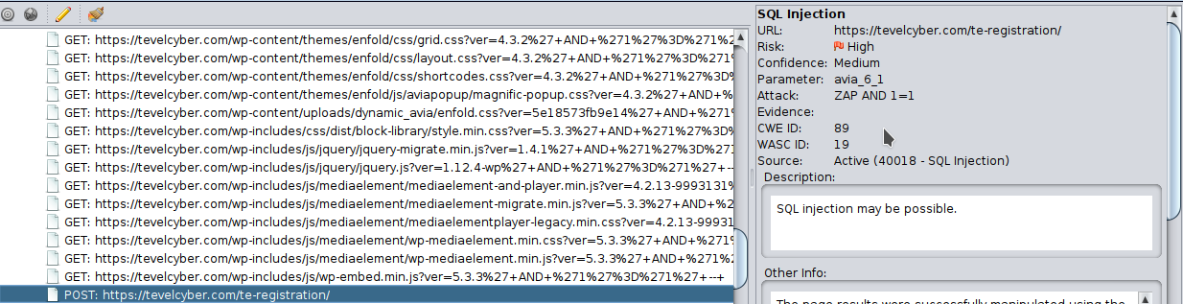
Figure 4- TevelCyber Registration Page Inject Guidance
As you can see, the entry shows us the URL and exact variable that may be open to SQL injection as well as how possible it may be. Therefore variable 6_1 of the registration page will be the target. For this attack we will be using Burp Suite, a tool that, in this case, acts as a proxy for internet browsers, allowing us to intercept and edit outgoing headers, as long as interception is enabled. So here we will fill out the form with fake information and intercept the header to check what information is linked to what variable. Below can be seen the information that predated the editing in burp suite.
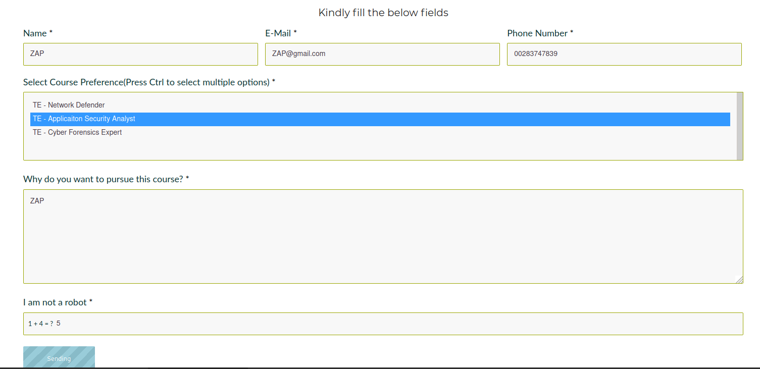
Figure 5- TevelCyber Registration Placeholder Variables
Now, this is essentially using the same details ZAP did when it did active attacking, interesting to note is that whilst there are six forms, the sixth cannot be injected as it is a human authentication and is required to send the information. Therefore we turn to the header.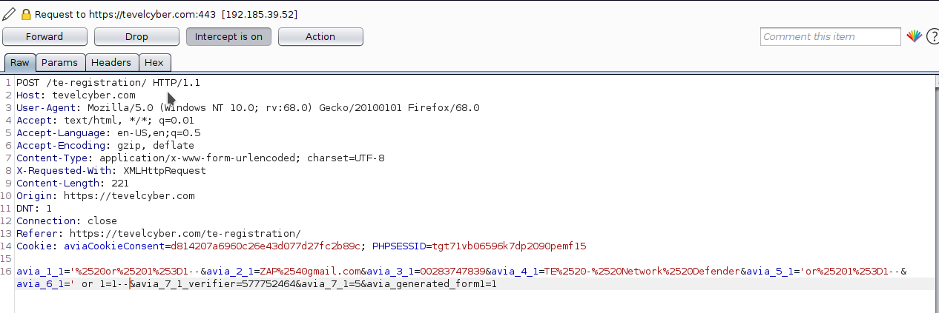
Figure 6- Analysis of Request Variables
As we can see in the above picture, variable 6 is in fact a hidden variable. In this example this writer replaced both variable 1_1 and 6_1 with [‘ or 1=1--], therefore we should get an error, of which we did, but only when variable 6 was edited, when any other variable was edited in the same way the server accepted the input, likely as can be seen in the request header, the input is encoded beforehand meaning the SQL language isn’t actually used as it the injection is designed for server side. Editing variable 6 on the other hand produced an error in the form of a blank page as can be seen below. It is most likely that variable 6_1 is a Captcha that appears after a certain number of failed attempts.

Figure 7- TevelCyber Unexpected Error
As you can see this error produces no sort of information that can be used, even the return header has little information apart from plugins and scripts used in the website, and whilst they may be taken advantage of, it is much above this writer’s level of programming knowledge.
Whilst on the subject, the rest of the possible SQL attacks recommended by ZAP are URL-based and as such are blocked in a similar manner to the first attack.
Vulnerability | Attack Tool | Protocols Used | How attack was performed | Successful?
Blind SQL Injection | Firefox, Burp Suite, OWASP ZAP | HTTP, SQL, PHP, HTML | Filling of registration form, interception by Burp Suite proxy, allowing for header editing before forwarding to server | False

__________________________________________________________________________________
At this stage in testing, the permission to perform penetration testing against Tevelcyber has since been revoked. As such, testing from this point on will be performed on a Virtual Machine running Damn Vulnerable Web Application, an application designed as a target for penetration testing.
Worth noting that this writer’s attacking device’s VPN exit nodes were all based in mainland Europe.

Brute Force Login Attack

This next attack is a form of brute forcing a login form, as they are common on many a website, this attack particularly takes advantage of the weak credentials people often use for their accounts. For this we will be using Burp Suite against the admin login page of DVWA. Technically speaking this attack is more of a wordlist attack than a traditional brute force as a traditional brute force attack could take from weeks to months. Below we can see the login page we will attack.
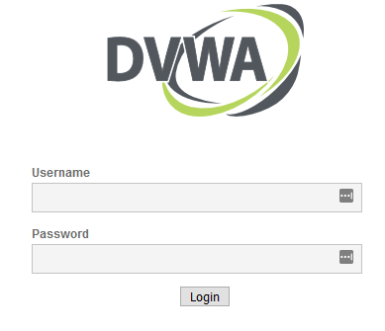
Figure 8- DVWA Brute Force Login Page
As you can see it is rather simplistic, here we will use the burp suite proxy to intercept the login request. Once the request has been intercepted, we can use the Intruder plugin to assign the variables of which should be modified upon request. In particular we will be using the cluster bomb approach; this allows us to assign and modify multiple variables per payload. As can be seen below, out of the two selected variables, the username and password will be what is modified.
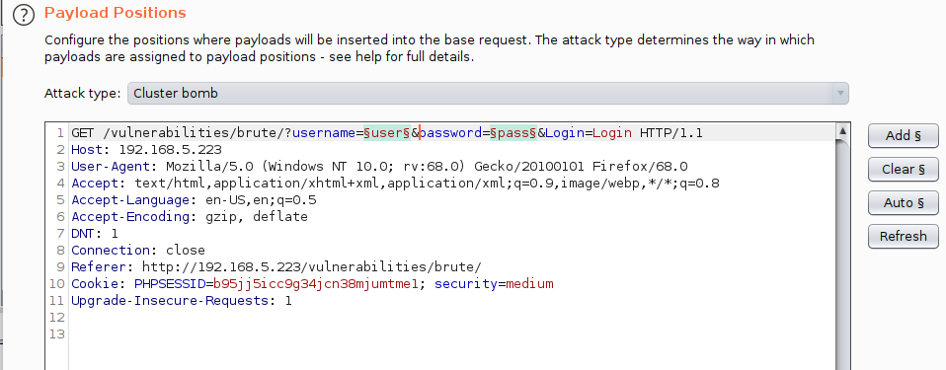
Figure 9- Brute Force Cluster Bomb Payload
Each variable will then be assigned a wordlist sourced from the GitHub Seclist repository of millions of common usernames and passwords. Whilst there is an option for a file containing 10 million passwords, due to time constraints as well as those imposed by the demo version of Burp Suite, we will be using the most common usernames and passwords. Here the assigned positions can be seen by the § Section symbols.
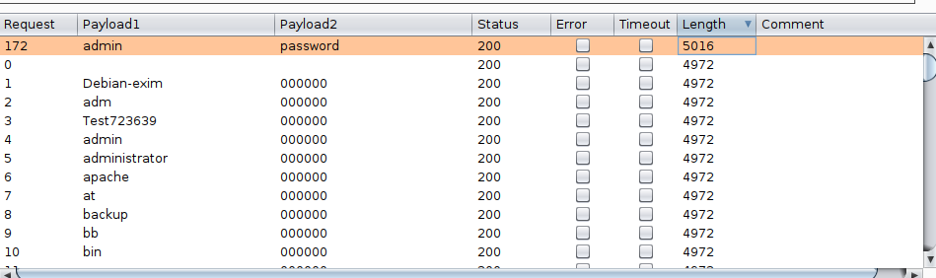
Figure 10- Successful Brute Force Attempt
As we can see, it found the credentials out of a possible 2352, the difference in length being the successful login compared to a failed login. As you can imagine, this type of attack can be performed quite easily and rather extensively should the attacker use longer wordlists in addition to computers with stronger processing power. Of course, there are ways of defending against such an attack such as the use of Captcha that has become common or blocking the attack after a certain number of failed attempts. Of course there is the option of using a strong username and password, having said that, using both methods is preferable. In addition, there is also the use of Anti-Cross Site Registry Forgery tokens (Anti CSRF), whilst there are different types, their overall use is generally the same; they stop cross site scripting, by acting as authentication of communications between the browser and the web server.
Vulnerability | Attack Tool | Protocols Used | How attack was performed | Successful? | Possibility of success against professional website?
Brute Force Login | Burp Suite | HTTP | Burp Suite Cluster Bomb & Seclist Wordlists | True | Low  See paragraph above

XSS Iframe Exploit

The next attack is an XSS exploit, or cross site scripting, as seen on the OWASP ZAP, there was a possibility of using it to attack TevelCyber but here we will be using the same DVWA as previously. Here, using the XSS section of DVWA, by filling out and submitting the below form;
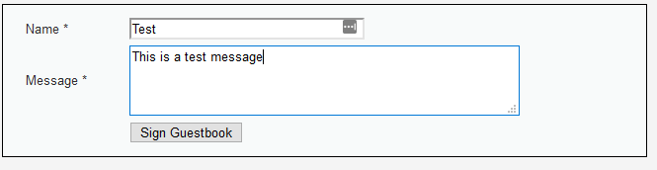
Figure 11-Standard Message
We get this as a result;
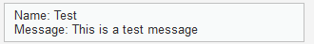
Figure 12- Standard Message Display
This is a basic XSS script, but what if instead we used the input field to show a script, in this case in an Iframe? An iframe is a HTML instance embedded into a website, similar to an advertisement, that connects to, and shows another website. Technically speaking, this has a 50-character limit, which can be overcome by editing the “maxlength” variable as done so below in the inspect element;
Figure 13- Variable editing via Inspect Element
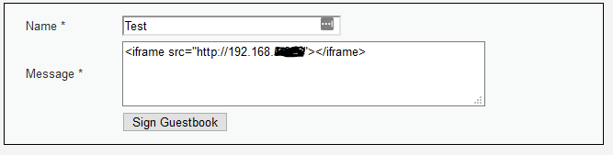
Figure 14- Iframe Code
Therefore this, using an iframe code snippet, turns into this;
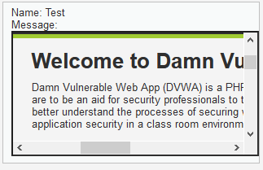
Figure 15- Iframe Code Display
For test’s sake, this simply points back to the first page of DVWA, but this could instead point to malicious pages that inject malware, or by altering the height and width, make the iframe cover the entire page, and set up a fake login page, allowing the attacker to intercept all login information. Another example is setting the height and width to 0, and linking to a server hosting the Metasploit module BrowserPwn, allowing the attacker to exploit the browser and gaining shell access, all the while, as the user cannot see the iframe, they likely do not even know they’ve been infected. By successfully ‘implanting’ such code into a webpage, everyone who accesses that webpage will possibly be affected by whatever the attacker has designed the XSS script to do.
Vulnerability | Attack Tool | Protocols Used | How attack was performed | Successful? | Possibility of success against professional website?
XXS Exploit- Iframe | DVWA, Firefox | HTML | Unsanitized user input, allowing for attacker to input their own code | Yes | Low, unsanitized inputs are uncommon due to their ability to be used maliciously

Conclusion

As you can imagine, due to the circumstances about the live penetration testing, it is quite difficult to recommend security improvements, seeing as all of this writers’ attempts failed. That being said, the use of a proper Web Application firewall is a very good idea as it protects against a multitude of common attacks, not to mention in this sense, Apache, the tool that it belongs to, also includes load balancing capabilities to lessen the effect of high traffic or DDOS attacks. That being said, like any tool that needs configuration, without proper set up it can become a vulnerability in of itself. From the Zenmap, Nikto and WPScan scans we can see that whilst there are open ports, they are minimal at best and each having a version update within the past 3 months, as possible version vulnerabilities would have likely been picked up by Nikto or would’ve come up as results during internet searches.

Appendix
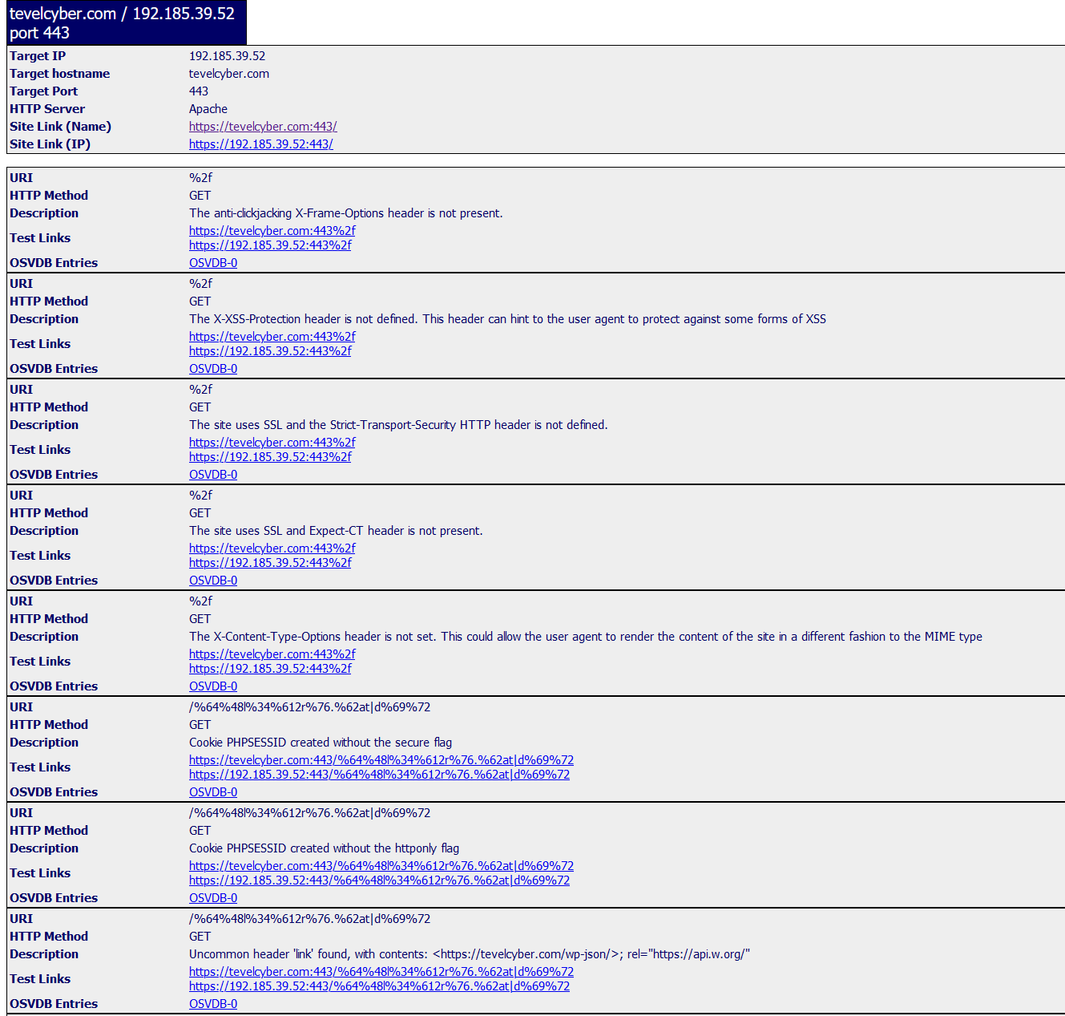
Figure 16- Nikto Scan Part 1
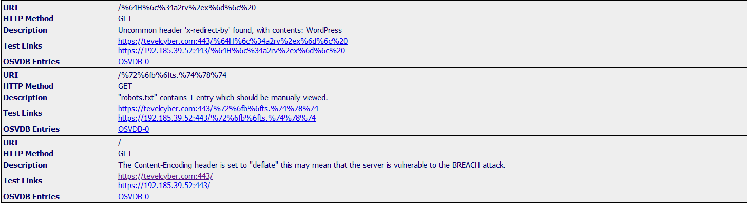
Figure 17- Nikto Scan Part 2
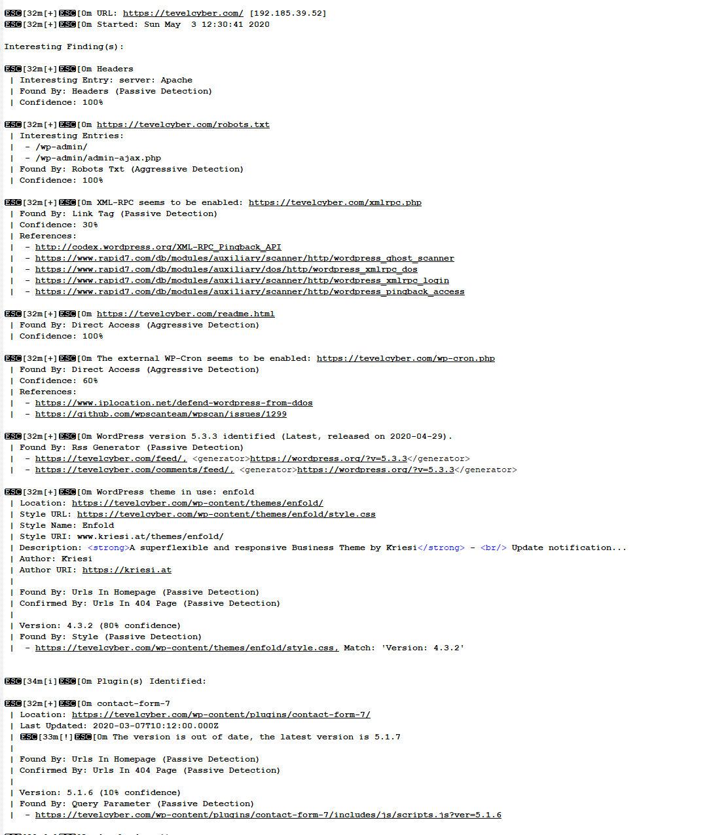
Figure 18- WPScan Part 1
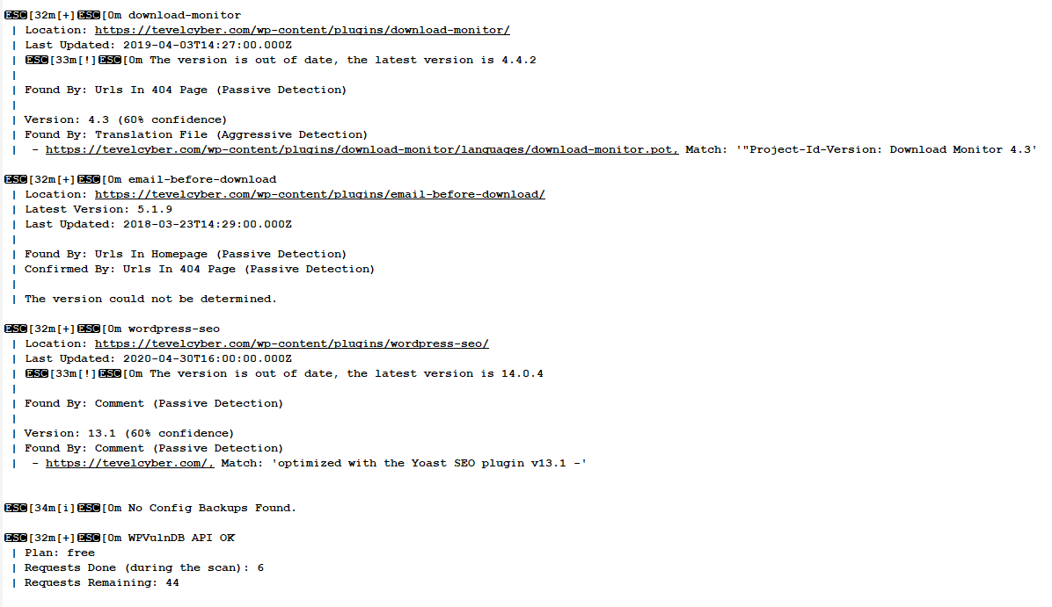
Figure 19- WPScan Part 2
Listed here are attacks that whilst attempted against Tevelcyber, failed, and gave nothing in terms of information. Therefore were not included in main text
Vulnerability | Attack Tool | Protocols Used | How attack was performed | Successful?
SSH Server  (Attacked ports 22 and 2222) | Metasploit SSH User Enumeration | SSH | Using wordlist against SSH server in attempt to see users in system | False, All attempted usernames gave false positives, including completely randomised examples
SSH Server  (Attacked ports 22 and 2222) | Metasploit SSH_login module | SSH | Using Seclist wordlists of both username and password fields in attempt to find possible weak passwords in SSH server | False, use of SSH authentication disconnected session after certain number of failed logins.  Use of Hydra software attempted, same result.
SSH Server  (Attacked ports 22 and 2222) | Metasploit SSH Version Scanner | SSH | Scanned SSH server version to find exploits related to that version | True, server is up to date, no reported vulnerabilities to be taken advantage of
WordPress | Metasploit XMLRPC ghost vulnerability scanner | HTTP | Use of Metasploit module to target subsequent port | False, port had been closed in time between scan and attack  Success unlikely, vulnerability patched in 2015

Bibliography
[1] C. Insiders, “Security Report,” Security, vol. 7, no. October, pp. 1–15, 2019.
[2] E. Summary, “Verizon: 2019 Data Breach Investigations Report,” Comput. Fraud Secur., vol. 2019, no. 6, p. 4, 2019.
[3] L. Spitzner, “This is Why The Human is the Weakest Link,” SANS Security Awareness, 2019. [Online]. Available: https://www.sans.org/security-awareness-training/blog/why-human-weakest-link.
[4] R. Ross, P. Viscuso, G. Guissanie, K. Dempsey, and M. Riddle, “Protecting Controlled Unclassified Information in Nonfederal Information Systems and Organizations,” NIST Spec. Publ. 800-171, pp. 1–34, 2014.
[5] S. Gibbs and A. Hern, “What is WannaCry ransomware and why is it attacking global computers?,” The Guardian, 2017. [Online]. Available: https://www.theguardian.com/technology/2017/may/12/nhs-ransomware-cyber-attack-what-is-wanacrypt0r-20.
[6] K. Savage, P. Coogan, and Symantec, “The evolution of ransomware,” 2015.
[7] iSMG I. Security and CheckPoint Software Technologies, “Ransomware Defense Survey,” 2017.
[8] D. Swing, “Learning from a ransomware attack,” datacenterdynamics.com, 2020.
[9] Hewlett-Packard, “CryptoJacking, The threat to businesses and how to protect the network,” 2019.
[10] F. Dominguez, “AT&T Alien Labs analysis of an active cryptomining worm,” AT&T Alien Labs, 2020. [Online]. Available: https://cybersecurity.att.com/blogs/labs-research/att-alien-labs-analysis-of-an-active-cryptomining-worm.
[11] AWS Marketplace, “Network Protection for Advanced Threats & Malware AWS Shared Responsibility Model Get Started with Network Protection in AWS Marketplace,” 2018.
[12] CyNation and T. Ranger, “The Equifax Data Breach Explained,” CyNation, 2017.
[13] J. Thomas, “A Case Study Analysis of the Equifax Data Breach 1 A Case Study Analysis of the Equifax Data Breach,” no. December, 2019.
[14] Cisco, “Internet of Things,” Cisco, 2016. [Online]. Available: https://www.google.com/url?sa=t&rct=j&q=&esrc=s&source=web&cd=2&ved=2ahUKEwinm4L1-__fAhXNy4UKHSVSAxUQFjABegQIChAC&url=https%3A%2F%2Fwww.cisco.com%2Fc%2Fdam%2Fen%2Fus%2Fproducts%2Fcollateral%2Fse%2Finternet-of-things%2Fat-a-glance-c45-731471.pdf&usg=AOvVaw.
[15] M. Abomhara and G. M. Koien, “Security and privacy in the Internet of Things: Current status and open issues,” 2014 Int. Conf. Priv. Secur. Mob. Syst. Prism. 2014 - Co-located with Glob. Wirel. Summit, no. May, pp. 1–8, 2014.
[16] E. Hannon, S. Knupfer, S. Stern, B. Sumers, and J. T. Nijssen, “An integrated perspective on the future of mobility, Part 3: Setting the direction toward seamless mobility,” McKinsey Q., vol. 2019, no. 1, 2019.
[17] M. Abdur, S. Habib, M. Ali, and S. Ullah, “Security Issues in the Internet of Things (IoT): A Comprehensive Study,” Int. J. Adv. Comput. Sci. Appl., vol. 8, no. 6, 2017.
[18] IBM X-Force Red, “The Dangers of Smart City Hacking,” 2018.
[19] M. Ward, “Smart meters can be hacked to cut power bills,” BBC News, 2014. [Online]. Available: https://www.bbc.co.uk/news/technology-29643276.
[20] J. Bogage and A. Peterson, “Fiat recalls 1.4 million cars vulnerable to being hacked,” Washington Post, 2015. [Online]. Available: https://www.washingtonpost.com/news/the-switch/wp/2015/07/24/fiat-recalls-1-4-million-cars-vulnerable-of-being-hacked/.
[21] H.-B. Jackson, “Bill Text - SB-327 Information privacy: connected devices.,” no. 327, p. Senate Bill No. 327, 2018.
[22] Kali, “Nikto,” Kali Tools, 2014. [Online]. Available: https://tools.kali.org/information-gathering/nikto.

