

University of Wales Trinity Saint David
Analyzing, Ethically Hacking and Securing an Enterprise Network

Ataur Rahman
Advanced Cybersecurity
Dr. Nitheesh Murugan Kaliyamurthy
Due Date
6th October 2025

Abstract
This task mainly focuses on the network configuration of two virtual machines which have been provided for the network test task which a network topology has also been provided to understand each machine purpose in this network. This document will show visual steps with importing the virtual machines and conducting a series of test to ensure that the correct IP addressing, connectivity and to all machines in the topology are working. The test will be conducted by using the command line interface for both Windows and Linux machines which will allow test to be carried out. Evidence of successful configuration and connectivity which will be documented with timestamped screenshots. In cases of a test results that deviate, they will repeated with the supporting evidence for troubleshooting or be backed by evidence that show why the test result has deviated. This progressive task will shape foundational skills in network verification, troubleshooting and systematic documentation which will aid on the progressive portfolio for the this network topology.

Task 1 – Networking Test

S-DC
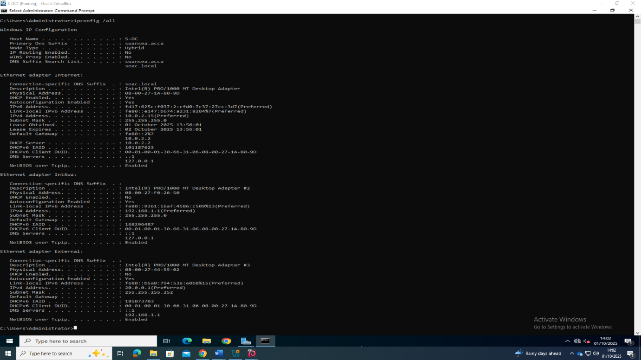
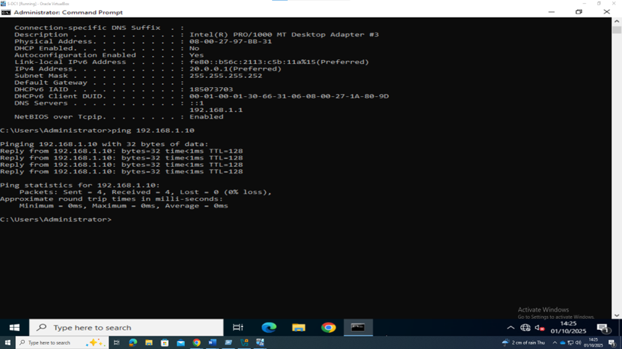

Figure 1 - IPCONFIG /ALL: Confirm the IP address matches the topology provided.
Figure 2 - ping 192.168.1.10 Successful

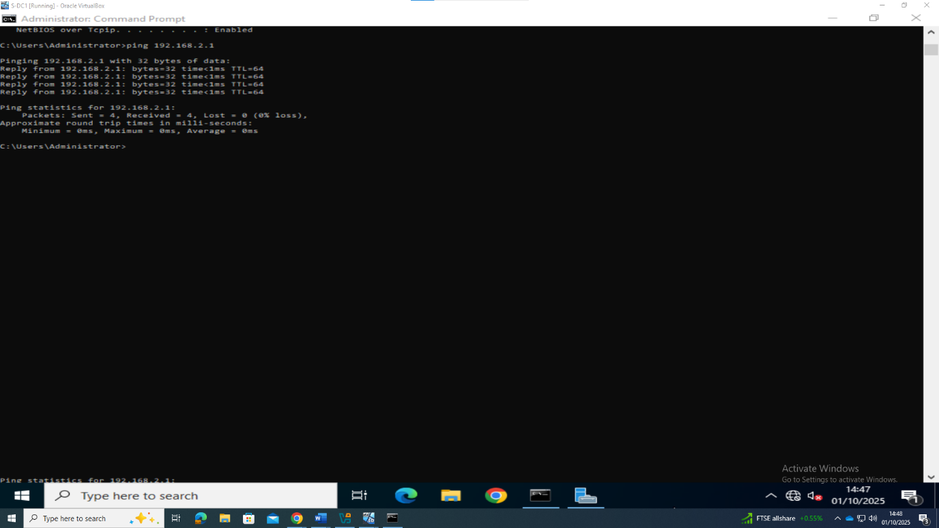

Figure 3 - Ping 192.168.2.1 Successful
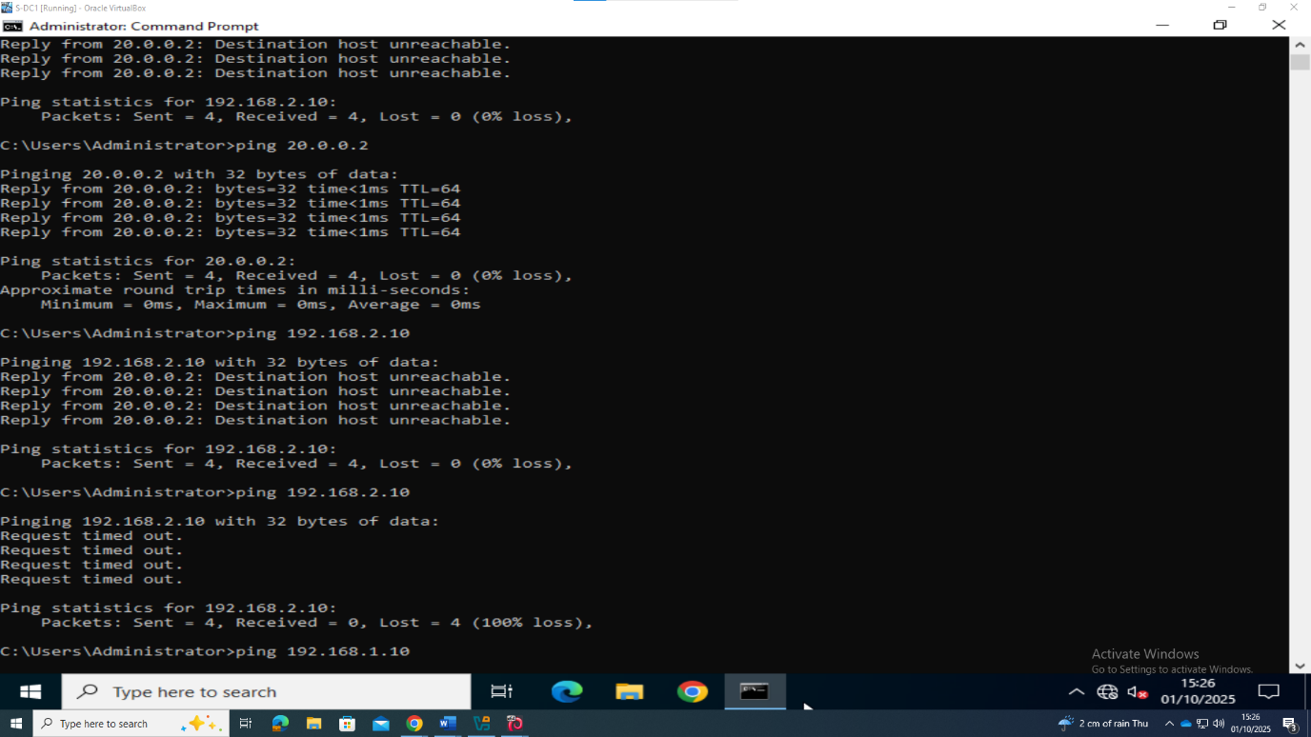
Figure 4 - ping 192.168.2.10 failed due to firewall on ClientL1.

L-CD

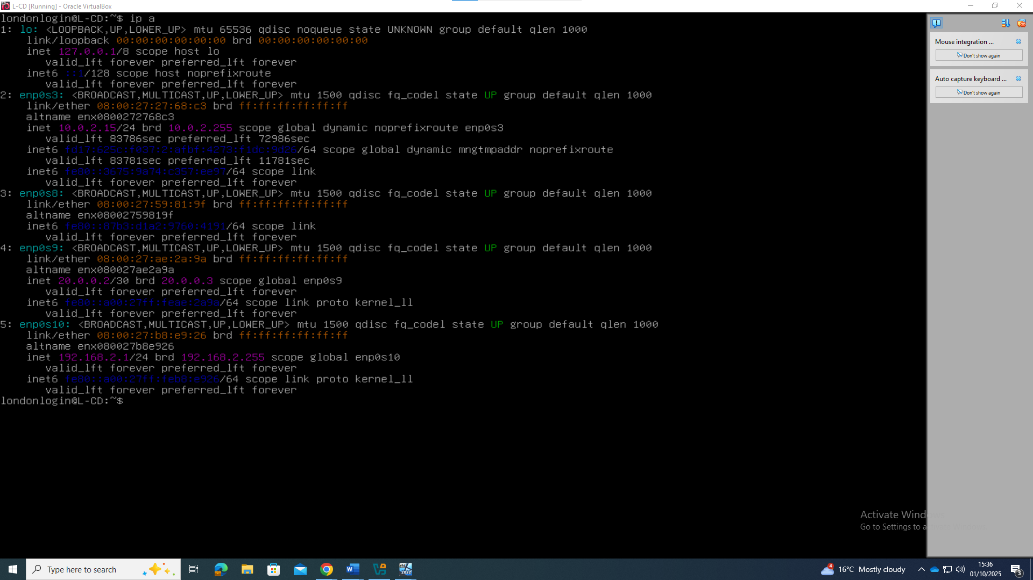
Figure 5 – ip all successful
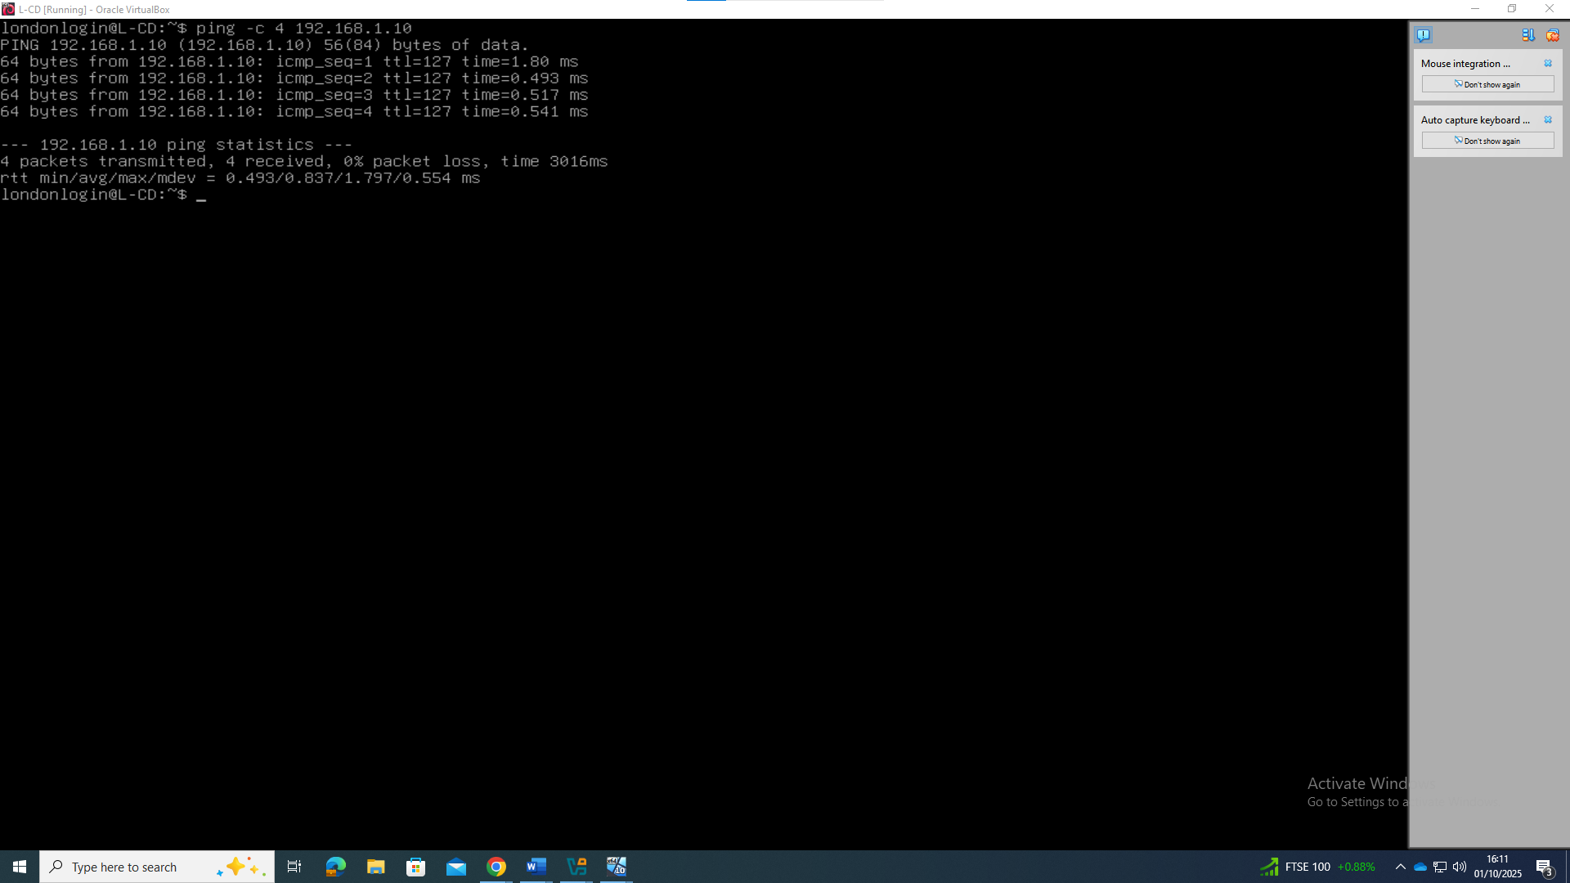
Figure 6 -ping 192.168.1.10 Successful.
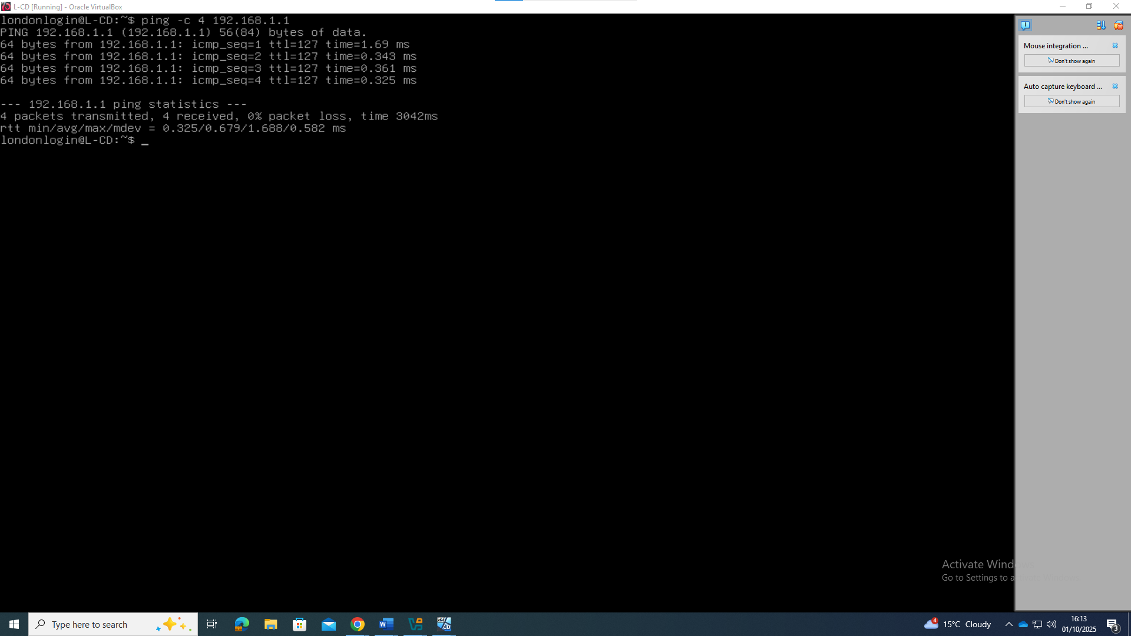
Figure 7 - ping 192.168.1.1 Successful.
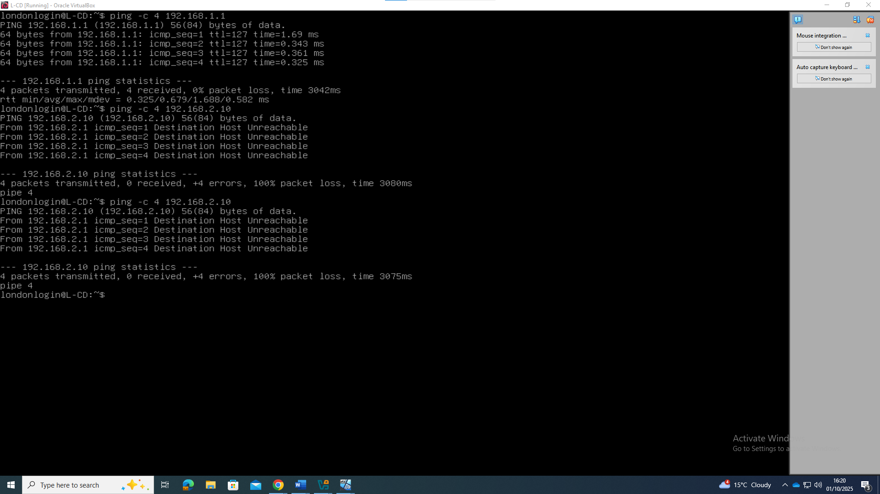
Figure 8 - ping 192.168.2.10 was unsuccessful due to firewall issues.
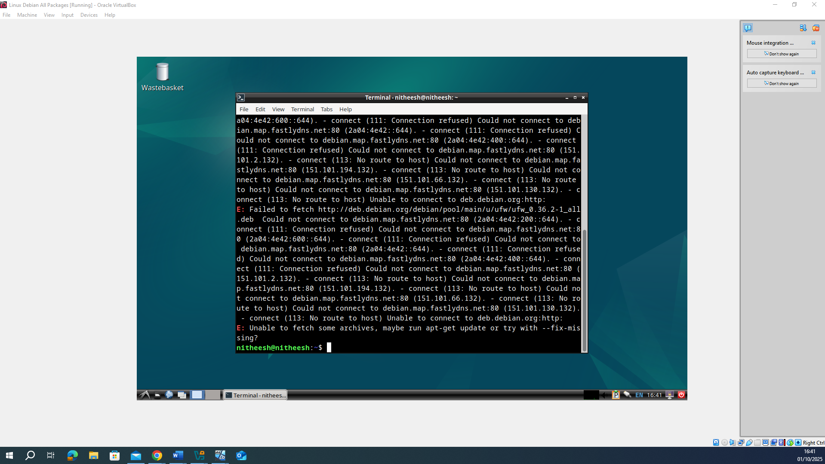
Figure 9 - Missing firewall packages and unable to install this package.

