Effective team work and communication
Coursework: Assignment 1

University of Wales
BMSW4002
Name: Beatris Gelkova
Student number:21179554
Module Tittle: BMS4002_BIRM
Lecture name: Akash Puranik

M
Executive Summary of the Report

Why is teamwork and communication so important in business? Why have you been assigned a "group project" in some of your classes? We believe of ourselves as individuals, each hired or chosen for our unique expertise, talents, and experience, but we are frequently asked to collaborate on assignments and projects with others. Why? Because when we work together, we can accomplish so much more. This report will investigate the team differences and, why companies use them, why they succeed, and why they fail. We'll look at the critical role communication plays in helping businesses achieve their goals and objectives, as well as some of the challenges they face when using electronic communication, as part of our examination of teamwork.
Why is teamwork and communication so important in business? Why have you been assigned a "group project" in some of your classes? We believe of ourselves as individuals, each hired or chosen for our unique expertise, talents, and experience, but we are frequently asked to collaborate on assignments and projects with others. Why? Because when we work together, we can accomplish so much more. This report will investigate the team differences and, why companies use them, why they succeed, and why they fail. We'll look at the critical role communication plays in helping businesses achieve their goals and objectives, as well as some of the challenges they face when using electronic communication, as part of our examination of teamwork.
Why is teamwork and communication so important in business? Why have you been assigned a "group project" in some of your classes? We believe of ourselves as individuals, each hired or chosen for our unique expertise, talents, and experience, but we are frequently asked.

Contents Page

- Introduction to Teamwork Communication

- Overview of Working as a Team

- Models of Team Development

- Team Roles

- Conclusion and Further Discussion

- Refferences

Introduction to Teamwork Communication
This report aims to investigate and explore the different ways of managing teamwork and the results that can be expected according to each method applied. This report will evaluate the definition of a team and the structures behind it. It will provide a clear explanation on the contributions that are expected from different team members, to achieve the goals set at the very beginning of any collaboration or project.
On the other hand, the exchange of information or ideas with other people is referred to as communication. Our concept of team communication includes how team members engage with one another, accepted social behaviours of a team (such as expressing ideas, voicing opinions and concerns, offering help, and resolving conflict), and communication methods. To collaborate effectively, you must master all aspects of group communication.
Communication in group work will differ depending on industry and role, but there are generally two formats: written or verbal. Each team has its own unique combination of the two formats, delivered through various channels in the way that best suits their needs.
Verbal:
Video or phone calls, team meetings, 1:1s, and casual water-cooler conversations are all examples of verbal communication in a team. Nonverbal communication is important in these interactions because others can read your body language and facial expressions.
Written:
Emails, team chats (such as Slack), and paper or electronic forms of documentation are all examples of written communication. Because written communication is open to interpretation, quality communication is even more important in a written format; take special care to assess whether the reader might misinterpret your words.

Overview of Working as a Team
Being a part of a team is the most obvious way to improve your teamwork abilities! However, it is a little more complicated than simply being a member of the group. The ability to collaborate is what distinguishes a good team from a bad one. You've most likely worked as part of a team in the past, so consider what went well and what didn't. If you don't have much experience working in a team, why not volunteer or do an extra endeavour at work?
On the other hand, you can take a quiz to determine which role you typically play on a team, and then use that information to improve your skills in other areas or strengthen your position.
It can be difficult to prove your teamwork skills in a situation such as an interview because you are usually alone, so you must rely on examples of your experience to show the employer you are good at working with others people. If you have an assessment centre or a group interview, this is a great opportunity to demonstrate your teamwork abilities, but there are many other ways to demonstrate them.

Models of Team Development
When it comes to forming a team there are several ways that can help in organizing that matter. Obviously, different individual will end up using different methods hence why we have a few examples that can help you understand the varieties out there.
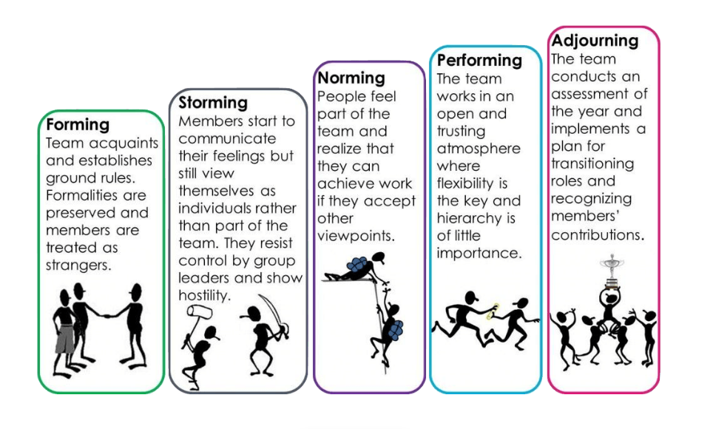
In 1965, Bruce Tuckman publicly released the Forming-Storming-Norming-Performing (FSNP) model, which depicted the sequential stages of group development. According to the professor, these phases are all necessary and unavoidable for the team to grow and achieve maximum effectiveness. He and Mary Ann Jensen added the fifth stage to the model in 1977, adjourning, which occurs when the team completes the current project. Despite the fact that this is the most widely used model today, some other studies exposed its flaws and proposed their own alternatives and modifications.

Back in 1977, Rubin, Plovnick, and Fry were among the first to publish the team effectiveness model. This is referred to as the GRPI Model, which stands for Goals, Roles, Processes, and Interpersonal Relationships as important aspects of collaboration. Because of its simplicity the model is commonly used in the team creation process, as well as in the resolution of problems in teamwork caused by various factors. The GRPI model, like Tuckman's and any widely used model, has some restrictions.
- Image Source: https://www.youthemployment.org.uk/teamwork-an-overview/

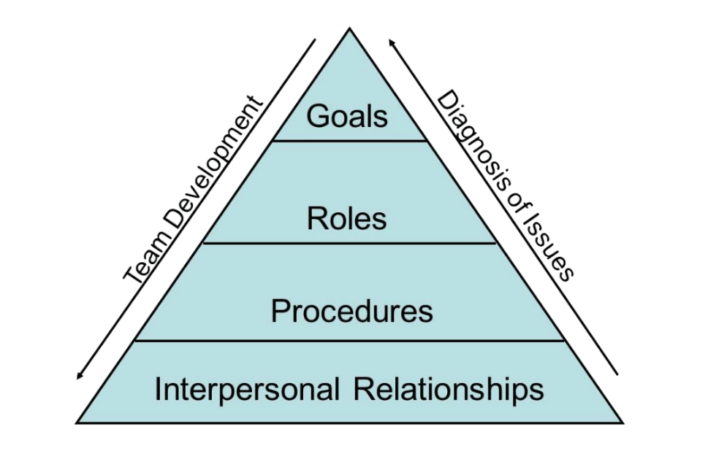

- Image Source: https://www.youthemployment.org.uk/teamwork-an-overview/

As you can see, there are numerous models, both well-known and unknown. In addition to the examples given above, we can identify other models of effective teamwork by:

- (1987), Driskell, Salas, and Hogan;

- Salas (1992), Dickinson (1992), Converse (1992), and Tannenbaum (1992).

- (1992), Tannenbaum, Beard, and Salas;

- (1995), Cannon-Bowers, Tannenbaum, Salas, and Volpe;

- Jones and Klimoski (1995) and others.
At first glimpse, they appear to be very similar and are based on obvious principles. But, when you get down to it, each of them reveals a new aspect of effective management and collaboration, allowing you to better understand your own team and solve a variety of problems with it. Each model is based on numerous studies of successful (and not so successful) collaboration in various industries. The presence of various models is explained by the variety of teams and working conditions.

Team Roles
When we are talking about team roles it is pretty much impossible not to mention the Belbin structure of the different team members, that any group should and might have accommodated. This is a very important key in creating a balanced and well maintained work environment and trustworthiness. There are 8 roles that we are going to explore according to Belbin.
1. Shaper
They are team members who propel their colleagues forward. They are action-oriented, motivating themselves and others in the face of adversity. Shapers are natural leaders and excel in management positions. When a crisis occurs, these people act quickly to find a solution.
2.Implementer
Implementers are responsible for getting things done. They are also task-oriented and can turn discussions and ideas into practical activities.
Implementers are conscientious people who want things done correctly. They are very practical and organised, which explains their ability to complete tasks. Implementers, on the other hand, can be stubborn and resistant to new ideas and ways of doing things. They frequently prefer to stick to tried-and-true methods rather than embrace change and innovation.
3. Finisher finisher
The completer finishers are the last of the action-oriented team roles. Completer finishers, as the name implies, are heads-down individuals who notice fine details and strive for perfection. These team members may be more introverted, but they are valuable in the workplace because they encourage team members to produce high-quality work.
4.Coordinator
The Coordinator is frequently a calm, positive, and charismatic team member who is very people-focused.
Coordinators assume leadership or chairperson roles by clarifying goals and objectives and assisting in the distribution of roles, responsibilities, and duties within the group. Coordinators have strong interpersonal skills and can effectively communicate with team members through active listening, verbal and nonverbal communication.
5. Monitor assessor
The monitor evaluator is another thought-provoking team role. This personality type is a rational thinker who can set aside their emotions to solve problems. Monitor evaluators excel when projects necessitate advanced knowledge and strategic planning. They evaluate ideas to see if they are valuable and viable, and then take the necessary steps to move those ideas forward.
6. The Expert
The Expert or the Specialist is the final thought-oriented team role. Specialists are experts in their field and prefer to contribute to one area of expertise. Specialists, like all other thought-oriented team roles, work best alone rather than in groups. Although this person is more self-sufficient, their specific skill set adds a lot of value to the team.
7. Plant
This is a thoughtful team member who is innovative and creative in her thinking. Although plants contribute to team balance, they prefer to brainstorm and solidify their own ideas before sharing them with the rest of the team. Plants may prefer to work alone, but even if they aren't as vocal as other team members, they provide valuable input.
8. Collaborator/Teamworker
They are also people-oriented. Their outgoing personalities enable them to work well with others and listen to their teammates. These team members can easily adapt to changes in their environment and know how to resolve conflicts. When one team member has too much on their plate, or another has a family emergency, teammates are the first to step in and help.
9. Resource Investigator
The resource investigator is the final of the nine team roles. Such people-oriented individuals love exploring new possibilities, such as locating potential marketing opportunities for the company or meeting with stakeholders for a new product launch. Their upbeat demeanour makes them an excellent networker or facilitator of new business.

Conclusion and Further Discussion

The opportunities that come with teamwork and relationships are endless due to the endless variety of individuals around us. This is a manifest of creativity, but there are some certain rules that it is always good to keep our heads up for. It is critical to treat your entire team with dignity and to value their abilities. You can use your strengths to your advantage here, maximising both yours and their abilities. To be successful, it goes without saying that 'treat others as you would like to be treated' must be highly regarded within your team and followed by all.
On the other hand, it is important to remember that there is no human that can do it all. Working in a team is often required, but working well in a team is optional - the onus is on you to put this into practise. Learning how to use it effectively and utilising all of the above amongst your workmates is the best way to guarantee that you are on track to meet your objectives while also creating a positive working atmosphere.

References

- V.Ryan, (2017), “Introduction to Teamwork”, Available at: https://technologystudent.com/prddes_2/team1.html

- Carly Gail, (2022), “Team Communication: Effective Group Collaboration & Teamwork”, Available at: https://www.crystalknows.com/blog/team-communication

- Youth Employment UK, (2016), “Teamwork – An Overview”, Available at: https://www.youthemployment.org.uk/teamwork-an-overview/

- Riter, (2018), “8 Models of Team Effectiveness”, Available at:
https://medium.com/@RiterApp/8-models-of-team-effectiveness-3a3b84efb3ae

- Team Asana, (2021), “9 types to create a balanced team”, Available at:
https://asana.com/resources/team-roles

