Using one of the establishments visited examine the strengths and weaknesses of their collection rationale.
I have chosen to examine the St Fagans National Museum of History, whose purpose as part of the National Museum of Wales is to display the history and archaeological collections as well as act as an open air museum for Welsh buildings. This acts as part of a large national museum, focusing on these disciplines and therefore has a large collection of items important to Wales. The size of the collections and the museum’s status should mean that it has got a clear collection rationale which can then be evaluated, a task easier to complete in a national museum than a small institution (Lord et. al. 1989, p.xxi). St Fagans is also currently attempting to digitise items in their collection and this means that the nature of the collections can also be inferred from those records available (National Museum of Wales 2018). The museum collections are also continuing to undergo a redevelopment scheme which seeks to change the items on display to be more representative of modern Wales and to rationalise their collections which reflects earlier developments such as the changing name of the museum and the separation of the St Fagans collections from the main collections in the National Museum in Cardiff. (Ibid, 2018) This makes the site focussed in academic areas as the new redevelopment allows for education and research programmes. St Fagans also uses the archaeological record to create interpretations of ancient buildings showing more than a straightforward portrayal of Wales’ recent past.
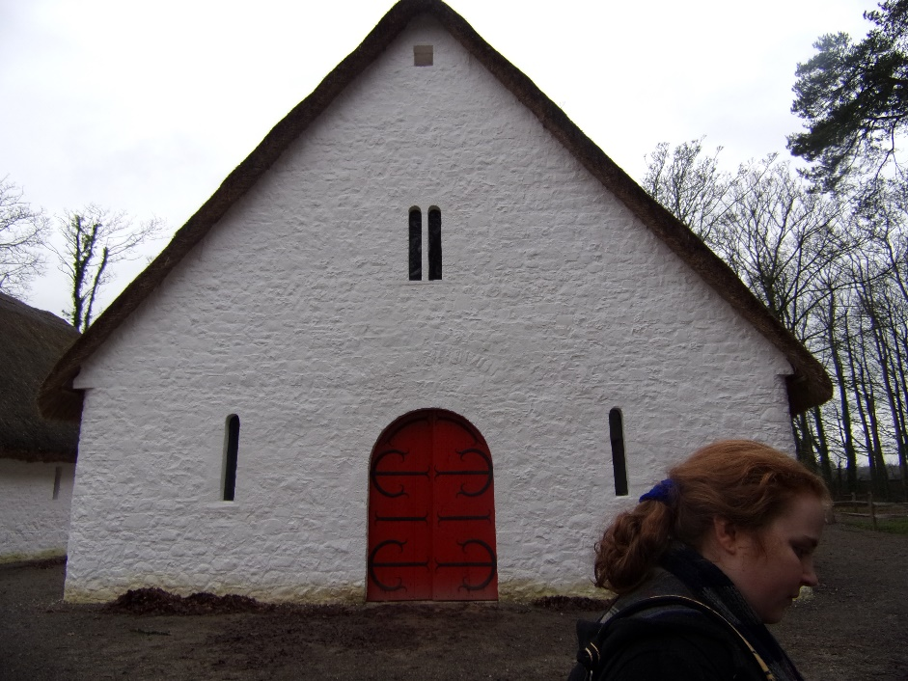
(Llys Llywelyn, a interpretation of archaeological remains showing the efforts of the curatorial staff to accurately represent the building. Photo credit mine.)
One of the main factors in the collection rationale of St Fagans relates to the open air structures which are mostly buildings dismantled from their original locations and rebuilt on-site. The collection regulations for St Fagans dictate that all the buildings are those immediately threatened by demolition. Ordinarily the curatorship team favours a more ‘in-situ’ technique, with structures maintained and protected in the communities; the museum authorities will only take structures offered to them, rather than seeking buildings to take on (Mason, 2011, p.247) This can act as both a strength and weakness of their rationale; their strength in that they wish to preserve buildings as long as possible in the communities that know them and appreciate them; and their weakness in a potential bias that means that some communities, unaware of this, may not offer buildings that the museum would cover under their rationale, and so chances are unmet. St Fagans’ collection now includes over 30 buildings including cottages, shops and mills, though most of their collection tends towards the traditional rural picture of Wales with farmhouses and barns (National Museum of Wales, 2018). This bias means the museum has been accused of not accurately demonstrating the realities of modern Welsh culture. (Mason, 2011, p.250) This itself is changing with their rationale, with more industrial and modern buildings such as a post-war prefab and the Vulcan Hotel, which would have been largely ignored under the previous Welsh Folk Museum’s collection policy of rural pre-industrial Welsh culture.
One of the major strengths of St Fagan’s collection is that is evolving and changing to better reflect Welsh culture, responding to the criticisms of the past, for example the assertion that it was ‘devoid of politics and… a static, closed history’ and that it represents only a ‘predominantly welsh-speaking white, rural based culture’ (ibid). In recent years the collection has been moulded to reflect more a ‘nation in miniature’ aiming to better represent Welsh culture. Industrial buildings and exhibitions have been added to better represent the lives of the majority of Welsh people, displays reorganised and galleries created to demonstrate a more diverse, multifaceted history than the old museum. Mason asks ‘If St Fagans is the Museum of Welsh life, should it also seek to represent Somali, Italian and Asian heritage as it exists in Wales?’ (Ibid) Since its redevelopment, this is exactly what it intends to do: represent groups and communities in Wales by working with ‘numerous individuals, organisations and communities across Wales’ (National Museum of Wales, 2018) The galleries created are supposed to allow visitors to ‘explore the history of Wales, to shape it, and share it with others’ (Ibid). St Fagans is seeking to better represent Welsh national identities, starting by recognising that there is more than one clear-cut Welsh identity as many people like to claim and representing history from different perspectives and that these perspectives can change and revise historical discourse.
Another strength is that St Fagans it seeks to represent the way ‘the people of Wales lived, worked, and spent their leisure time over the last five hundred years’ (National Museum of Wales, 2001). St Fagans especially focuses on the lives of ordinary people, despite the fact that collections are often predisposed to preserve higher-class objects as these are more likely to be preserved. In the Wales Is… Gallery, the country’s history is explored from the earliest human remains of 230,000 years ago, to ongoing current issues such as Brexit, in an interactive way that allows families to engage with the exhibition. Visitors are asked for their opinions on issues relating to the exhibition materials on boards, becoming themselves part of the collection and the history of Wales, how current Welsh thinking is perhaps different from those of the past, on issues such as devolution. Over time the gallery will show new displays, organised with groups and communities to accurately portray various parts of Wales’ past. The Life Is… gallery additionally takes ‘the ordinary stuff of all our lives and shows it to be extraordinary’, a highly interactive display for families to enjoy. This display covers many different aspects of life from clothes, to food, to recreation for the varied populations of Wales. This gallery also deals with death across Welsh history from early Celtic monuments to a Victorian hearse, a contrast with the rest of the gallery and its focus on Welsh lives. The third of the new galleries is Gweithdy, which represents Wales’ craftsmen with examples ranging from the typical metalwork and carpentry, to wicker work and quilting, and allows people to try examples of the crafts such as putting together tiles and joints to ‘learn the crafts’. Using this space, the museum also offers various crafting workshops, which as well as giving paying visitors the opportunity to learn traditional crafts it also brings in much needed revenue for the museum, which can be used to continue with their changes.
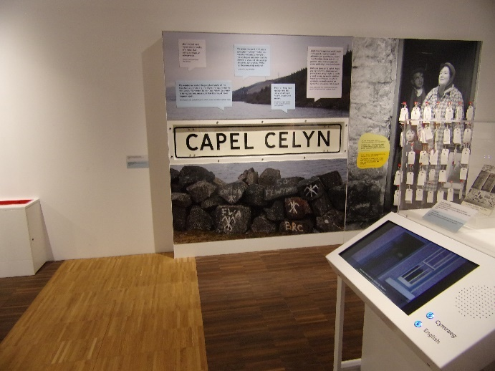
(The Wales Is… Gallery display of Capel Celyn which continues to be a hot issue in Wales covers the ongoing impacts. Photo credit mine.)
Whilst the museum at St Fagans is changing, arguably for the better, there are still areas which could be improved. The main strengths lie in that these changes are intended to portray different views of history to make it accessible to a modern Welsh audience, to portray ‘welshness’. But there are also weaknesses; some result from those parts of the museum which have not been revolutionised as the rest of the museum, but other weaknesses stem from the concept of the museum as a whole, or have persisted in spite of the changes.
One specific flaw with St Fagans was pointed out in 1986, when a report claimed that the remit of the Welsh Folk Museum, as it then was, should be changed.
‘It should be accepted that its is impracticable for it to attempt to cover all aspects of the history of the Welsh people, their way of life and their culture. The aim of should perhaps become more limited; to be a museum of traditional Welsh rural life.’ (Brown, 1986, p.92)
The museum naturally disputed this assertion, and has attempted to expand into covering as much of history as possible from different points of view, and from the 1980s also giving a greater representation of industrial Wales. This is the Wales that the majority of the population lives, and the make-up of South Wales – where St Fagans is. However covering so many representations of the Welsh past and the more modern multi-cultural additions to the culture, can create a collection that can come across a confusing and grows exponentially at a time when museums are having tighten their collection rationales and even consider disposal or long-term loans. Having St Fagans also as a history and archaeology arm of the National Museum of Wales means that it has those items that simply didn’t fit within the other arms of the Museum regardless of their value, simply because they are from the past. In some ways the museum has a collection spanning far outside its remit, and this contributes to the high running costs and necessitates the use of offsite storage. However the attempt by the National Museum of Wales to create a space where multi-layered history can be explored and displayed.
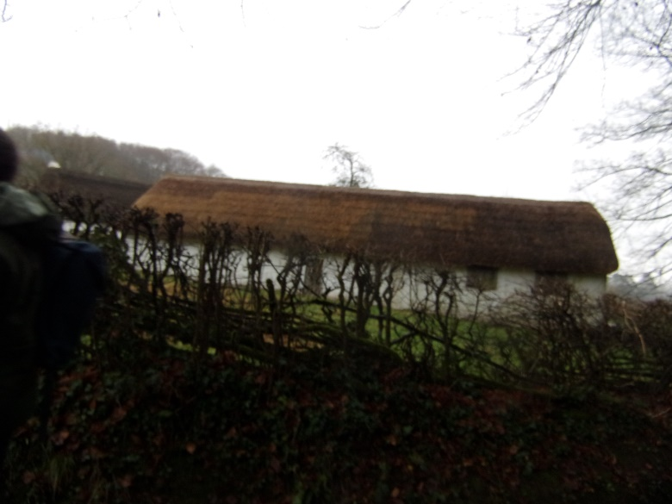
(One of the rural farmhouses in the St Fagans open air museum. Photo Credit mine)
Museum collections in general face criticism for being overly large and deliberately kept from the general public when they could be used on display or given to private collections. It is argued that museum collections ‘build collective memories and public histories’ but how can they do this if they are destined never to be on display, or will only ever be seen by occasional researchers and museum staff (Keene, 2005. P.28). St Fagans limits the amount of their “hidden” collections through education programmes for all ages, which makes use of specific education collections, and through rotation of displayed items rather than long-term static displays (National Museum of Wales, 2018). The National Museum of Wales is also undergoing a digitisation scheme with some 500,000 items currently digitised with pictures and this is still ongoing. This allows for some greater exposure of unseen items than closed storage, however, 500,000 items is a small percentage of items and it will likely never be completed (National Museum of Wales, 2018) Whilst the collection rationale is being tightened to only accept Welsh items and to evaluate the importance of those items carefully, the collection is still growing and makes things difficult.
Lastly, with the tightened collection rationale, who is to say that items accepted by the museum are truly important to Welsh history, or that items turned down by the museum are not? Welsh identity, and therefore the culture and history addressed by the museum are carefully constructed by the curators, but different individuals and communities have different views. St Fagans doesn’t shy away from controversial history for example a display of items from Capel Celyn, and another on Brexit; both ongoing and heated issues in Welsh recent history, but other issues are little covered, though there are some plans to engage with these such as Wales’ recent developments, such as the past of immigration and other facets of modern identities. This can be considered a weakness in that whilst some people can welcome that “their” history is being presented, others can feel that their own version of history is under-presented, or is perhaps being deliberately ignored. Communities can feel alienated, as some felt with the museum when it presented a very specific rural view, and as a result sections of society stop visiting the museum. Visitors from outside of Wales can get a skewed view of Welsh identity.
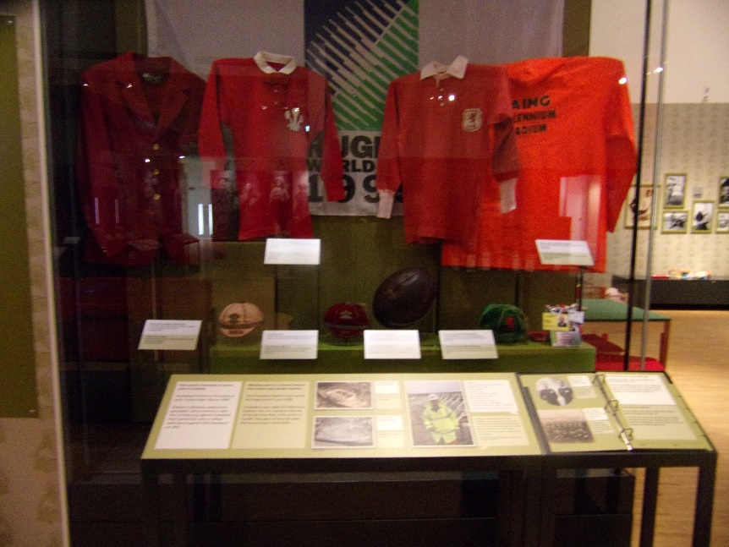
(A symbol of Welshness, a collection of Welsh rugby memorabilia in the Life Is… Gallery. Photo Credit mine).
In conclusion, the collection rationale of St Fagans has a number of strengths and weaknesses. One major strength lies in the admission of the curatorial staff to recognise weaknesses picked up on in the past and the changes made to alleviate this through the creation of new galleries which are more interactive and reflect the modern faces of Wales’ culture. Another strength lies in the museum’s digitisation efforts which aims to bring items from the closed collection more into the public eye, and for education projects. However there are still some weaknesses that can continue to be addressed. Critics continue to claim that the museum is skewed towards the rural welsh-speaking population and that they ignore the modern influences on the Welsh population such as immigration.
Bibliography
Brown, J., (1986) ‘Increasing the Visitor Appeal of the Welsh Folk Museum: A Strategy for Presentation, Interpretation, Management and Marketing, Prepared for the NMW and the Welsh Tourist Board by John Brown Tourism Services’.
Keene, S. (2005). Fragments of the world: Uses of Museum Collections. Oxford: Elsevier.
Lord, B., Lord, G. and Nicks, J. (1989). The Cost of Collecting: Collection Management in UK Museums. London: Her Majesty's Stationery Office.
Mason, R., (2011). Representing Wales at the Museum of Welsh Life in National Museums: New Studies from Around the World: Ed. Knell, S.J., (2011). Routledge, Abingdon.
National Museums and Galleries of Wales (2001) Museum of Welsh Life Visitor Guide. Cardiff: NMGW.
National Museum of Wales website (accessed 31/12/18) https://museum.wales/stfagans/

