

Student name: Antonio Joseph
Student ID number: 2113837
Module: Digital Surveying
Module code: ACBA4002
Assignment Title: Essay
Lecturer: Dr Jamiu A. Dauda

Table of Contents

Introduction……………………………………………………………………………………………………………………………….1
Definition…………………………………………………………………………………………………………………………………..1
Classification of Surveying………………………………………………………………………………………………………1-2
Brief History……………………………………………………………………………………………………………………………….3
Listed Building Surveying………………………………………………………………………………………………………..5-6
References…………………………………………………………………………………………………………………………………7

Introduction

The purpose of this report is to provide a definition of surveying. Here, we will look at the origins of surveying and the history of how the profession began as time has progressed into the modern era. It will demonstrate how surveying has evolved over time and by using a real-life example of a listed building and the surveying techniques used in it, it aims to examine how digital surveying techniques are used to produce reports.

Definition
Surveying is defined as a process of determining the relative location of natural and manufactured characteristic on or beneath the earth’s surface, the representation of this information can be in the form of graphically plans or numerically tables, which also involve the use measurement, calculations to determine specific locations on the earth’s surface.

Surveying Categories

In general, surveying can be classified into different categories:

- Primary classification of surveying
- Classification of surveying based on field nature
- Classification of surveying based on purpose
- Based on Instruments classification of surveying
Primary Classification

- Plane surveying - In plane surveying, a limited area is surveyed and it is presumed that the ground's surface is a plane and so the earth's curvature does not need to be corrected.
- Geodetic Surveying - Besides determining the size and shape of the earth, geodetic surveying provides a highly precise framework for other surveys to be controlled. Precision is of the highest importance since large areas must be considered when analysing the effects of earth curvature.

Classification of surveying based on field nature

- Topographic Survey: A topographic survey involves measuring and mapping the physical characteristics of the earth which are both natural and manufactured.
- Cadastral Surveys: In Cadastral Surveys, property boundaries are measured, defined, mapped, and recorded.
- Hydrographic Surveys: are those made for deciding the state of the lower part of lakes, streams, harbours, and seas. They additionally incorporate the estimation of the progression of water in streams and the assessment of water assets.
- Astronomic Surveys - Astronomic Surveys are studies made to decide the scope, longitude, and azimuth from perceptions to the stars

Classification of surveying based on purpose
- Mining Surveys - are those made to decide overview control for the improvement of both surface and underground mines inside the mining industry, and the assurance of volumes in mine generation.

- Engineering Surveys: The field of engineering surveys includes surveys undertaken prior to, and during, engineering work, including road construction, railways, pipelines, etc.

- Geological Surveys – aid in the investigation about soil composition. It helps to decide the course of action of diverse strata on the earth.

Based on Instruments classification of surveying
- Aerial Surveys: are made from planes, and for the reason of mapping the landscape, the control for such an outlines are obtained from ground overviews, but the points of interest are acquired from aerial photos. This incorporates making estimations and interpretation from photos.

- Chain Surveys - is the most straightforward type. The rule of chain surveying is triangulation. In this studying strategy, we just measure direct estimations. Additionally, it is reasonable for smaller regions. The regions are partitioned into triangles and the sides of the triangles are estimated. The chain reviewing utilizes instruments like chains, bolts, stakes, going bars, and so on.
- Plane table survey - is probably the quickest strategy for surveying. It is a graphical strategy where we can handle perception and plot concomitantly. Ideal in attractive regions where compass reviewing is unachievable. In addition, we can check blunders and errors by utilizing check lines.
- Theodolite surveying - Theodolite is an instrument that evaluates flat and vertical points. It is one of the most accurate techniques. This kind of surveying assists with tracking down the level contrast, setting out, dragging out survey lines, and so forth of the area.

A Brief history of surveying

The history of surveying dates to antiquated times, with a recorded land enlist in Egypt in 3000BC, and re-establishment of cultivate boundaries taking after surges of the Nile River and development of the Extraordinary Pyramid of Giza recorded approximately the same time. Under the Romans, land surveying were accepted as a profession and land surveyors set the essential estimations under which the Roman Empire was sunder, such as a charge enlist of prevailed lands (300AD).
In eighteenth century Europe, a strategy of surveying known as triangulation, which depended on the estimation of angles, was utilized to construct a pecking order of systems to permit point situating inside a nation.
Within the early days of British colonisation of Australia and Modern Zealand much of the survey work attempted to open the nation and give land possessions to pioneers was carried out utilizing Gunter’s chains, measuring wheels, circumferentor, Kater’s compass and even pacing where estimation sufficed as so long as the corners of the arrive were clearly staked and checked by the surveyor, the exactness's of estimation and course were cleared out to chance. (Hallmann 1994, 2.3)
Over time, Gunter’s chain was supplanted by steel bands and invar tapes, and afterward by Electromagnetic Distance Measurement (EDM) hardware, and in this way Global Positioning System (GPS) gadgets, each in turn progressed productivity and more noteworthy accuracies of estimation than the previous configuration. Moreover, compasses were supplanted by transits, afterward by theodolites and after that Total Stations, which combined precise and distance estimation in a single survey instrument.

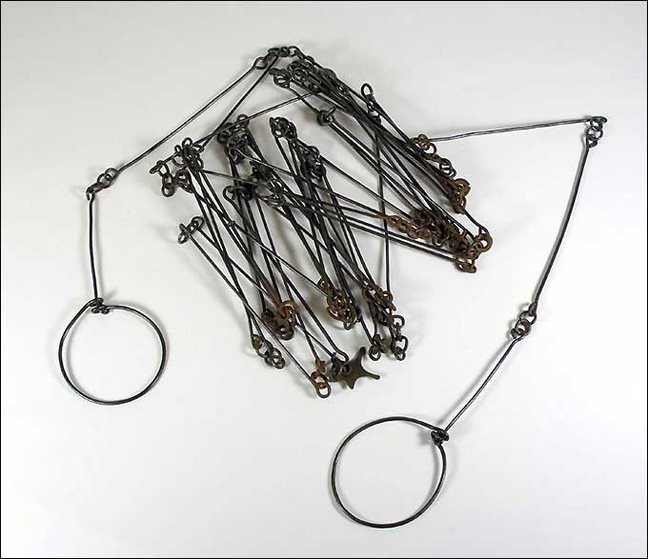
Pyramid of Giza Gunter’s chain

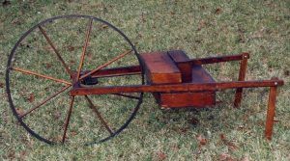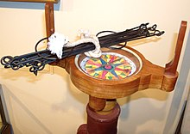
measuring wheels circumferentor

Listed Building Survey

What Is a Listed Building Survey?

Numerous individuals adore the thought of making a memorable building their residence. For this reason, there is a tremendous advertise for more seasoned buildings, a few of which are of such verifiable or architectural significance that they are listed was kept to a certain level of preservation. These properties require a particular kind of property survey for the buyer to decide what repairs are required, how much they will fetched and whether it would be a commendable venture.
A building may be listed for several reasons. Notable Britain highlight buildings constructed before 1700 that is kept in a sensible condition will be recorded, as are most structures between 1700 and 1840 that are in furthermore extraordinary condition. In any case, a few buildings may moreover be listed in case they are considered of notable significance, although these are usually at slightest 30 a long time of age.
Listed buildings are separated into grades which decide precisely how they ought to be treated. Grade I buildings are the foremost secured, taken after by Grade II*. Nevertheless, 91.7% of buildings are recorded as Grade II. Numerous surveyors may not be qualified or experienced sufficient to recognize the specific dangers and concerns relating to pro or more seasoned properties, so an experienced surveyor who specialises in Historic Building Studies ought to be contacted

Why do we survey the listed building?

Working with an assessor who practices and comprehends Historic and listed buildings will permit you to comprehend the singular subtleties of these kinds of properties. By having a contracted assessor that is licensed by RICS and comprehends the regulation that encompasses these buildings, you give yourself inner harmony that all that has been considered before buying. If the assessor is an individual from the Institute of Historic Building Conservation (IHBC) the assessment is guaranteed.

On a basic level, your surveyor will be undertaking a Level 3 Building Study which is comparable to the type that they would attempt on any other bizarre or more seasoned property. In any case, with their knowledge, they will be able to allow you a much way better thought of the issues that happen with exceptionally ancient properties and, most imperatively, make suggestions based on the review of the listed building and the prerequisites related with owning one.

What Happens during the Survey of a listed building

During the study, the sanctioned assessor will visit the property and attempt an investigation of the components which make it up. This will incorporate taking a gander at the construction, the materials it is made of, its pass and its improvement after some time. As this is a complete overview, the assessor will take a gander at each part of the structure starting from the roofing to any data they can accumulate about the foundation. Any significant issues with these will then, at that point, be featured and deliberation will be given on how they might be fixed and how much this could cost.

The following sequence of steps are commonly followed when carrying out a survey

Inspection/Observation
Actual examination for most overviews would be considered physical with the guide of optics and/amplifying glass (Binoculars) for every noticeable surface, examination by non-damaging testing or opening of construction, materials, and condition. Examination of regularly not noticeable parts beyond what many would consider possible uses a 3m stepping stool, lifting covers, entering voids for better visibility.

Recording
Recording of the actual assessment is typically upheld by itemized note-taking and visual recording. The motivation behind the records is to empower the assessor to recreate post-survey the degree of the actual data accessible to an individual leading actual examination at the time of survey. Subjective evaluations are required to tailor the sum of detail collected to the informational.

Further Investigation
Expert evaluations are especially valuable for memorable and remarkable structures and antiquities. X-Rays, magnetic resonance, infra-red, thermal, and other expert imaging techniques that the assessor would use to get a functioning information on the utilizations and use of such expert procedures to instruct clients on expert overview strategies which are past the restriction of their ability, however needed for the appropriate satisfaction. The assessor would be relied upon to inform the customer in the obtainment concerning expert actual evaluations and decipher the outcomes for the customer's legitimate comprehension of the results.

Reporting
In reporting the discoveries, the assessor ought to incorporate an emphasis of the brief and any concurred varieties from it and the constraints that unfolded through the work area studies and review processes. The impact of any restrictions on the customer's goals should be noted and the discoveries of each mark of enquiry set out legitimately, to lead the pursuer. The assessor ought to recognize realities from assessment, and allude to the sources depended on in forming opinion and suggestion emerging from each point, including whether further examination or monitoring is suggested and guidance on the acquisition of extra examination.

Data collection and storage
There is no legal least period for the capacity of information. The assessor's expert reimbursement protection normally determines the period for which records ought to be held, which is regularly founded on the legally binding obligation of the assessor and surveying firm. This contention with best practice in protection, as narrative proof gathered during reviews and tasks keeps on being helpful long after the authoritative commitments of the gatherings have been satisfied. It is thusly prudent to guarantee that records which could add to the comprehension of destinations and antiques are not discretionarily annihilated. Then again, setting reports into long haul documents might repudiate the assessor's authoritative commitments for privacy. In all cases, the customers and guarantors assent ought to be looked for distribution, chronicling or obliteration of records.

Observation equipment on listed building survey

When at the perception phase of listed building survey a digital camera would be utilized for photography in building recording, here a permanent archived record is being created nonetheless; concerns remain over the admittance to digital images. The suggested initial step while making a visual record of a structure is consequently to contact the document where the record will be stored and affirm their approach. As an enhancement to any file rules the accompanying area gives a base standard to progressed digital image capture. Least norms for film photography are likewise given underneath, for anybody looking to store a record with a document that requires this.

What Does the Report Look Like?

In the report, you will see a summary of the relative multitude of areas of the structure that have been examined. Close to these, the assessor will remark on the state of these components just as offering guidance on any clear issues, how you might approach curing them.
The report might give a thought of the conceivable expense of certain sorts of fixes, however many costs will be hard to precisely survey or may require further examination, and the report will let you know if you ought to have any further examinations done or acquire formal assessments for any fixes.

REFERENCES

https://www.dtwd.wa.gov.au/sites/default/files/teachingproducts/BC016_CCBY.PDF

https://vincivilworld.com/2021/07/19/classification-of-surveying/

https://www.icsm.gov.au/education/fundamentals-land-ownership-land-boundaries-and-surveying/surveyors-and-surveying

https://www.comparemymove.com/advice/surveying/listed-building-survey

https://www.samconveyancing.co.uk/news/house-survey/listed-building-surveys-building-surveyor-and-survey-cost-8757
https://civillearners.com/2021/07/25/classification-of-surveying/
https://dailycivil.com/types-of-surveying/

