


EXPERIMENTAL COMPARISON OF ENSEMBLE APPROACH FOR PREDICTIVE MAINTENANCE IN THE MANUFACTURING INDUSTRY

Trushita Narapati
Supervisor Name: Dr. Seena Joseph

Project submitted as part of the requirements for the award of MSC Data Science & Analytics

January - 2025

Declaration of Originality

I, Trushita Narapati declare that I am the sole author of this Project; that all references cited have been consulted; that I have conducted all work of which this is a record, and that the finished work lies within the prescribed word limits.

This work has not previously been accepted as part of any other degree submission.

Signed: Trushita Narapati

Date: 2025/06/01

FORM OF CONSENT

I, Trushita Narapati hereby consent that my Project, submitted in candidature for the master’s degree, if successful, may be made available for inter-library loan or photocopying (subject to the law of copyright), and that the title and abstract may be made available to outside organisations.

Signed: Trushita Narapati

Date: 2025/06/01

Copyright Acknowledgement

I comprehend that the University of Wales Trinity Saint David, Swansea, owns the copyright to this project report and any other products created because of the project.

ABSTRACT/SYNPOSIS

Predictive maintenance (PdM) is an important part of the industrial processes, providing cost savings through reduced downtime and increasing the dependability of equipment. Typical approaches to maintenance management include reactive maintenance, preventive maintenance, etc., which do not help in managing failures that occur without warning or are related to over or under utilization of resources. As a result of Industry 4.0 and the increased availability of big data from machines, predictive maintenance has become an exciting application of ML. However, each of the conventional ML models including the Random Forest (RF), Support Vector Machine (SVM), and Logistic Regression (LR) has specific drawbacks. Thus, this work has focused on the assessment of the performance of ensemble methods in enhancing the predictive maintenance of industrial machinery and equipment using bagging, voting, and stacking. Some well-known individual models such as KNN (K-Nearest Neighbours), LR, SVM, and RF are also used and compared with ensemble techniques to establish the best approach for predictive maintenance problems. The findings show that the Ensemble models, especially Stacking and Bagging, are more efficient with an accuracy of 99% and efficient than single models in class-wise performance. On the other hand, individual models like Random Forest also outperform with an accuracy of 99% while models such as LR, KNN and SVM show a slightly lower accuracy due to complex decision surfaces. The Voting Classifier is somewhat less efficient than Stacking and Bagging albeit with a decent accuracy of 97%. The findings confirm that the incorporation of ensemble learning approaches into the PdM frameworks can enhance decision-making. This is much useful to industries which are in the process of developing effective PdM models to enhance their organizational productivity by reducing on breakdowns on machines.

Table of Contents
Contents
Copyright Acknowledgement iii
CHAPTER 1: INTRODUCTION 11
1.1 Research Background 11
1.2 Research Problem Statement 15
1.3 Research Aim 16
1.4 Research Objectives 16
1.5 Contribution of the Study 16
1.6 Structure of the Project 17
CHAPTER 2 : REVIEW OF LITERATURE 18
2.1 Evolution of Maintenance Strategies 18
2.2 Predictive Maintenance 20
2.3 Predictive Maintenance Analysis based on Machine Learning Models 21
2.4 Predictive Maintenance Analysis based on Ensemble models 24
2.5 Ensemble Model Framework 27
2.6 Literature Summary 28
2.7 Chapter Summary 29
CHAPTER 3: RESEARCH METHODOLOGY 30
3.1 Research Design 30
3.2 Research Model 33
3.2.1 Data collection 33
3.2.2 Data preprocessing 34
3.2.3 Exploratory Data Analysis (EDA) 34
3.2.4 Train-test split 34
3.2.5 Implementation, hyperparameter tuning and evaluation of base model 34
3.2.5.1 Logistic Regression 34
3.2.5.2 Support Vector Machine (SVM) 36
3.2.5.3 K-Nearest Neighbors (KNN) 37
3.2.5.4 Random Forest 38
3.2.6 Implementation, hyperparameter tuning and evaluation of Ensemble Techniques 40
3.2.6.1 Bagging (Bootstrap Aggregating) 40
3.2.6.2 Voting 41
3.2.6.3 Stacking 42
3.2.7 Comparative analysis 43
3.2.8 Approach selection 43
3.3 Dataset Description 44
3.3.1 Variables 44
3.4 Evaluation Metrics 45
3.4.1. Accuracy 45
3.4.2 Precision 45
3.4.3 Recall 45
3.4.4 F1-score 45
3.5 Materials 46
3.6 Chapter Summary 46
CHAPTER 4: DESIGN & IMPLEMENTATION 47
4.1 Research Overview 47
4.2 Implementation 47
4.2.1 Data Collection 48
4.2.2 Data Preprocessing 48
4.2.3 Data Visualization 50
4.2.4 Label Encoding 52
4.3 Splitting into Training and Testing Sets 53
4.4 Implementation of Base Models 53
4.4.1 Random Forest 53
4.4.2 Logistic Regression 54
4.4.3 Support Vector Machine (SVM) 54
4.4.4 K-Nearest Neighbors (KNN) 54
4.5 Implementation of ensemble models 55
4.5.1 Voting Classifier 55
4.5.2 Stacking Classifier 55
4.5.3 Bagging Classifier 55
4.6 Chapter Summary 56
CHAPTER 5: RESULTS & DISCUSSIONS 58
5.1 Overall Comparison of Individual and Ensemble Models 58
5.2 Comparison of Classification report of all models 60
5.3 Confusion Matrix of all models 61
5.4 Chapter Summary 65
CHAPTER 6: CONCLUSION & RECOMMENDATIONS 66
6.1 Conclusion 66
6.2 Limitations and Future Enhancement 67
6.3 Reflection 67
6.4 Chapter Summary 68
REFERENCES 69
PROJECT MANAGEMENT 75
ETHICS FORM 76

LIST OF FIGURES
Figure 1: Potential failure diagram of inspection intervals and of predictive maintenance [3] 11
Figure 2: Evolution of the maintenance strategies in the course of time [31] 19
Figure 3: General framework of ensemble learning [58] 28
Figure 4: Research Design 31
Figure 5: Research Model 33
Figure 6: Logistic Regression [66] 36
Figure 7: SVM working principle [68] 37
Figure 8: KNN working principle [68] 38
Figure 9: Random Forest [68] 40
Figure 10: Bagging 41
Figure 11: Voting procedure 42
Figure 12: Stacking Technique 43
Figure 13: Predictive maintenance dataset structure 48
Figure 14: Identification of missing values 49
Figure 15: Identification of duplicates 49
Figure 16: Data types of attributes 50
Figure 17: Distribution of output class 51
Figure 18: Pair plot visualizations 52
Figure 19: Results of individual ML models 59
Figure 20: Results of ensemble models 60
Figure 21: Confusion Matrix of all models 63
Figure 22: Gantt Chart 75

LIST OF TABLES
Table 1: Parameters of models by GridSearchCV method 56
Table 2: Overall performance comparison of individual and ensemble models 58
Table 3: Classification report of all models 60
Table 4: Critical Comparison of this research with existing literatures 64

ACKNOWLEDGEMENTS

I want to express my sincere gratitude to Dr. Seena Joseph, my supervisor, for her constant support, wise counsel, and inspiration during this project. Her knowledge and commitment were crucial in determining the course and result of this endeavour.
Additionally, I am grateful to the University of Wales Trinity Saint David for offering the tools and learning environment I needed to finish my MSc in Data Science & Analytics. I would especially like to thank the instructors and staff who helped me learn and develop during this program.
I want to express my sincere gratitude to my family and friends for their unwavering understanding and support during this journey's difficulties. Their confidence in me served as a continual inspiration.

CHAPTER 1: INTRODUCTION

1.1 Research Background
Predictive maintenance (PdM) is a new preventive maintenance technique which incorporates techniques to maximise the manufacturing process while extending the equipment's life and guaranteeing sustainable use [1]. It is also a type of scheduled maintenance in which the outcomes of data analysis of the machinery and the procedures involved serve as the foundation for the maintenance procedure. To do preventative maintenance a bit early and at the appropriate time, PdM aims to identify probable failure points in the equipment's operating cycle [2].

Figure 1 states that, by identifying potential problems early on, PdM helps prevent failures, which lowers preventable equipment downtime, extends the equipment's lifespan, lowers maintenance costs, and boosts organizational productivity.
.
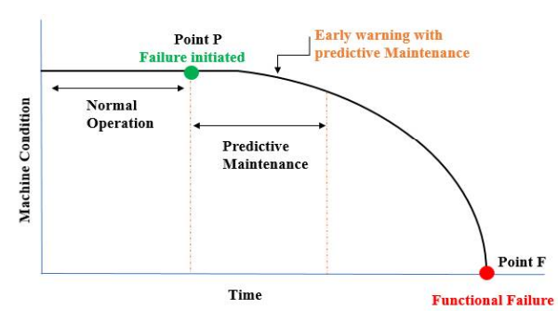
Figure 1: Potential failure diagram of inspection intervals and of predictive maintenance [3]
Pdm varies from preventative maintenance, which performs repairs whether they are necessary or not on a regular basis, and repair and maintenance, which provides a repair when a fault is discovered. [4]. This is accomplished by determining how long the failing components will still be functional and by offering remote, real-time equipment failure monitoring. The method employed in down to the origin to solve problems is known as proactive maintenance [5]. This type of maintenance which is very useful when combined with preventive maintenance is becoming more and more popular.

The conventional predictive maintenance approaches include Run-to-Failure (RTF), Condition-Based Maintenance (CBM), and Time-Based Maintenance (TBM) [6]. TBM is a form of equipment maintenance whereby the maintenance is done at certain time intervals without regards to the state of the equipment. This results in either excessive maintenance which is quite wasteful or inadequate maintenance which exposes the organization to risks of breakdowns [7]. CBM is a method of maintenance that carries out the maintenance at a predefined system state or limit. Even though CBM is less passive than TBM, it can be time-consuming and expensive, since it involves regular checking and interpretation of data. Moreover, it cannot give the right indication of failures sometimes particularly for complicated machines [8]. The Run-to-Failure (RTF) approach is a failure-based approach where equipment is used until it fails then repair or replacement is done. This method is very dangerous because it can cause a lot of downtime, contribute to loss in production time, and pose risks to the people working the machines [9]. New technologies like ML and big data analysis are being employed to improve predictive maintenance's consistency and dependability to get beyond these limitations.

The performance of PdM is encouraging when combined with an artificial intelligence (AI) ML algorithm. The efficiency of the ML method is considered in terms of its capability to process large data within a short time. ML enables machines to directly access a vast amount of example data. Agent-based systems also incorporate code into its core machine engine to identify patterns and trends, which in turn trigger alarms and stops based on tasks, products, and boundaries. It analyses the relationship between a given data record and its tagged output, like failures, and then builds a model to predict future results. This can recognise past events and forecast or prevent failures based on a breakdown of the underlying reasons [10]. An AI-based approach can significantly enhance failure prediction when compared to traditional condition monitoring or other maintenance techniques, including usage-based exchange. Some of the commonly used ML algorithms for predictive maintenance are LR, SVM, KNN, and RF. Such models can be learned from historical maintenance data that may comprise of equipment sensor data, operation conditions and the maintenance schedules [11]. Through this, these models can identify the patterns and interrelations between this data to foresee failures and schedule maintenance.

Ensemble learning is one of the most successful ML techniques, which combines several separate models to create a more effective and efficient predictive model [12]. Training many learners (base learners) and then integrating their results to get the final prediction is the fundamental concept behind ensemble learning. This way allows to eliminate the drawbacks of individual models, decrease variance and minimise bias [13]. When different models give the predictions, they usually have different kinds of errors. Thus, when these models are integrated the ensemble can minimize the different errors and offer more consistent and generic predictions. Among the most popular ensemble techniques are stacking, boosting, and bagging [14].

Bagging is a technique to construct multiple models based on bootstrapping of the training data and then making ensemble predictions to enhance the stability of the model and prevent overfitting. Several subsets of the original training data are produced at random using replacement in this method. Every subset is used to train a distinct model, usually using various data sets and the same learning process. The final phase, known as the ensemble step, combines the predictions of the various models to get the final prediction of the model. This can be done either by regression, where the mean of the forecasts is determined, or by classification, where the most popular prediction is selected [15]. Random Forest is the best-known example of the bagging technique which involves constructing several decision trees on different bootstrap samples and then aggregating the results [16]. This method improves forecast accuracy by assessing the contribution of various variables to equipment failures, thereby providing significant insights into the reasons of these failures.

Stacking (stacked generalization) is a form of ensemble learning in which the final prediction of the meta-learner is made based on the predictions of the base learners. The base learners often consist of alternative models that validate themselves through distinct attributes of the data space, whereas the meta-learner's objective is to ascertain the optimal method for integrating these predictions. To make the final prediction, a higher-level model (meta-learner) uses the basic models' initial predictions from the training data as input [17]. In predictive maintenance, stacking has been used to integrate the advantages of neural network techniques, decision trees, and support vector machines. Put this way, when the outputs of various models that are integrated into stacking are merged, they can outcompete one another. By learning the best weights to combine the predictions, the meta-learner—typically a linear model or similar powerful learner—improves overall predictive ability [18]. This method can capture the intricate relationships between multiple models and is usually more effective than basic ensemble techniques.

Voting is an ensemble method of decision making in which the base models are constructed, and the output is determined by most the base models’ predictions. Voting operates over a set of models in diverse ways to improve the accuracy and reliability of the models. It can utilize hard voting, soft voting, or weighted voting methods [12]. Hard voting is a technique by which the most frequent class is chosen from the predicted classes of the individual models. Whereas the Soft Voting strategy uses probability estimates from the given models and assigns the class label with the highest probability to the sample. Weighted voting is a technique that assigns certain weights to different models and provides these models with more weights in the event of their having higher precision. Each of these methods uses multiple learning algorithms at once to improve the system's prognostic performance [19].

It is impossible to overestimate the significance of predictive maintenance in the manufacturing sector since it is essential for lowering downtime, enhancing equipment dependability, and maximizing maintenance expenses. Traditional practices such as Time-Based Maintenance (TBM), Condition-Based Maintenance (CBM), and Run-to-Failure (RTF) are either non-proactive or very risky as opposed to PdM that applies machine learning to predict and forestall failure. Moreover, ensemble learning becomes a very effective method in this area, which constructs multiple individual models to generate more effective and precise predictive systems. Ensemble learning can be used to train a few base learners and combine their predictions through methods such as boosting, bagging and stacking to reduce the individual model errors, variance and to give more consistent results [20]. Thus, this research focuses on enhancing the effectiveness of the predictive maintenance models for industrial machines and equipment by utilising ML techniques. It will contrast the results of the ensemble learning models; Bagging, Voting, and Stacking with common classifiers such as LR, SVM, KNN and RF. These methods can analyse large volumes of data in a short time, recognize subtle patterns and send alerts on probable equipment failure thus allowing organizations to minimize on downtime, minimize on maintenance costs and increase overall productivity.

1.2 Research Problem Statement
Predictive maintenance (PdM), a useful technique that addresses equipment breakdowns proactively, has gained popularity recently, and maintenance is becoming a crucial component of organizational planning [21]. The traditional techniques of maintenance such as time-based or condition-based maintenance are unable to address the complexities of the modern industrial systems. These traditional approaches typically result in one of two scenarios; an overuse of maintenance resources, or a catastrophic failure that causes financial losses and downtime [22]. Ensemble learning techniques have successfully addressed these issues by utilising many ML models to create better and more dependable prediction models.

Ensemble-based techniques such as voting [23], bagging [24], and stacking [25] have been widely explored in different fields including manufacturing industries. However, a rigorous comparative study of these ensemble methods that is targeted for predictive maintenance in manufacturing organizations has not been well provided in the current literature [26] and [27]. Moreover, there is a significant gap exists regarding the understanding of how different ensemble techniques function in the context of predictive maintenance for a particular system [28], [29] and [30]. This work intends to address this research gap by implementing a thorough comparison of ensemble techniques (bagging, voting, and stacking) with individual ML models like LR, SVM, KNN, and RF, that may help manufacturers to identify the best ensemble learning strategies for predictive maintenance.

1.3 Research Aim
This study compares various ensemble strategies, including bagging, voting, and stacking, to determine the optimal ensemble model for predictive maintenance in the industrial sector.

1.4 Research Objectives
- To critically analyse the existing literature to identify the current trends in predictive maintenance with a special focus on machine learning and ensemble-based approach in the manufacturing sector.
- To implement various ensemble learning methods, such as bagging, voting, and stacking for predictive maintenance in the manufacturing industry.
- To compare and evaluate the performance of the developed models using benchmark datasets and well-known evaluation metrics.

1.5 Contribution of the Study
This work enhances the knowledge of predictive maintenance by presenting an empirical study of the application of ensemble learning methods – bagging, voting, and stacking – to enhance the accuracy and trustworthiness of predictive maintenance models for industrial equipment. Through a comparative analysis with traditional ML models including LR, SVM, KNN and RF, the research work establishes the best techniques for applying ensemble methods in predictive maintenance challenges. Furthermore, the research focuses on the importance of hyperparameter tuning to improve the performance of the predictive maintenance models and provides real world recommendations on increasing the number correct predictions, reducing the number of false positives (FP) and false negatives (FN), and improving the F-measure of the model. This work not only offers a broad insight into the implementation of ensemble methods in predictive maintenance, but also offers a practical and valuable approach to industries for the minimization of downtime, increase in efficiency of resources and the assurance of reliability of machinery in data centric manufacturing systems.

1.6 Structure of the Project
- The report's background overview is highlighted in Chapter 1, which also outlines the purpose and research goal that are necessary for a good study outcome.
- The second chapter focuses on earlier research and literature to give a summary of previous studies that this study can address.
- To streamline the study process, Chapter 3 describes the research approach, design, materials, and data collection instruments.
- The concept and implementation of the development-based project, in which machine learning models are created using predictive maintenance data, are explained in Chapter 4.
- The outcomes from the design and execution stage are explained in Chapter 5, which also assesses the findings in relation to earlier research.
- The main conclusions of the study are summed up in Chapter 6, which also offers suggestions for more research and highlights the study's practical consequences and reflections on the completed work.

CHAPTER 2 : REVIEW OF LITERATURE
To determine their current state, the literature study concentrates on ensemble-based models and predictive maintenance studies. In line with this, it provided details on PdM tactics, their advantages, and disadvantages, with a focus on manufacturing. The effectiveness of several ensemble approaches for enhancing predictive maintenance was also examined in the review, which also identified unexplored areas for further study. Lastly, it emphasizes how important it is to compare the ensemble approaches of the selected algorithms that are focused on the goal of predictive maintenance in industrial settings.

2.1 Evolution of Maintenance Strategies
Maintenance is an essential factor of the industrial sector because the costs associated with it can be a substantial part of an enterprise’s production costs. Good maintenance plans do not allow for sudden breakdowns, cut down costs, and even enhance the expected life of industrial equipment [31]. For these reasons, maintenance approaches have undergone changes due to the concern and efforts of researchers, engineers, technicians as well as experts.

Initially in Figure 2, corrective maintenance (CM), often referred to as "run-to-failure," was employed, where part is replaced or repaired only when it fails, and the equipment can no longer function without it. Because of the high costs that are incurred in the event of unanticipated production halts, CM progressed to preventive measures. The first approach that appeared was the Preventive maintenance (PM) which consists in conducting regular checks by experts and the replacement of components before a catastrophic failure [32]. This replacement is made in equal-spaced periods of time or after some working cycles which are usually given by the equipment producer. This can cause an earlier or a later change of components. In the first case, the parts that are still in good condition and capable of performing a much greater number of working cycles are replaced, thereby raising the costs of maintenance; On the other hand, the second scenario may have severe consequences since a CM action has to be carried out [33].

The concept of the industry 4.0, and the development of the IoT made it possible to adopt the CBM (Condition-based maintenance) approach in maintenance. To conduct inspections, technicians and specialists used sensors and devices that could measure, track, and process information—such as acoustic signals, current, voltage, temperature, force, vibration, etc.—that are indicative of the physical condition of industrial equipment. Using this approach, it is possible to develop interventions that are based on sensors’ values and actions can be activated when a value is outside the set limits [34]. Advanced and more comprehensive strategies emerged from the CMB including the PdM, which combines the concepts of IoT and CPS with knowledge in data analysis, information technology, engineering, and automation to estimate the failure and then set the time for maintenance [35]. In contrast, PdM goes one step further because it relies on the predictions made to make relevant suggestions on how to address the failure mode and enhance the remaining useful life (RUL). For example, through the bearing temperature, PdM will predict when the equipment is likely to fail while prescriptive maintenance may recommend a speed reduction to increase its RUL [36].

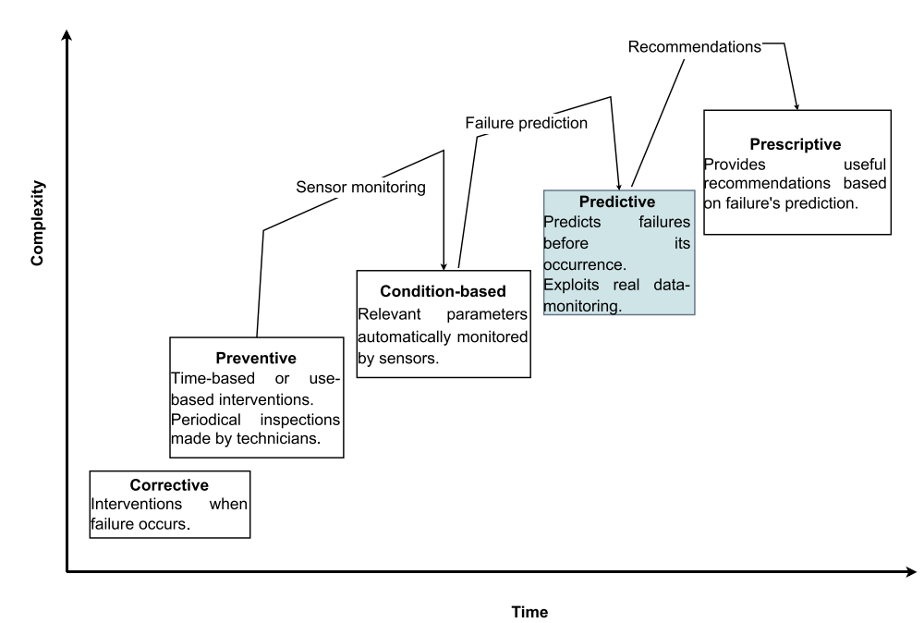
Figure 2: Evolution of the maintenance strategies in the course of time [31]

2.2 Predictive Maintenance
Predictive maintenance is a comprehensive approach to process and equipment management that uses data analysis tools to track and anticipate machinery failure [37]. PdM aims to identify failure mode deviations from normative characteristics in equipment operation by utilizing real-time sensor data and features such as ambient variables and equipment maintenance records history. The potential to reduce several operating expenses while simultaneously enhancing the equipment's dependability and speed is what makes PdM relevant in various industries [38]. PdM, permits the selected execution of maintenance tasks since it is contingent upon the actual condition of the machinery, which helps to reduce maintenance costs and maximize the machinery's useful life.

Condition-Based Maintenance methods have been extensively analysed in Jardine, et al. [39], however, PdM has received particular attention as a crucial manufacturing area. PdM in manufacturing reduces downtime, increases productivity, and improves equipment reliability. Additionally, PdM enables producers to identify potential trouble spots ahead of time, preventing production interruptions and preserving efficiency.

It is important to emphasize that the benefits of using PdM in manufacturing extend well beyond the goals of lowering costs and minimizing downtime. PdM also aids in the efficient management of maintenance resources, including both human and material, since it suggests that maintenance should only be performed when necessary. As a result, it improves maintenance efficiency while also saving money and time. Furthermore, because the machinery is always in good condition, its improved performance and dependability aid in the production of high-quality goods. This consistency is crucial because it guarantees that the quality of the products produced remains constant, which is necessary to guarantee that clients are completely satisfied and that the business can successfully compete with other firms in the market [40]. Furthermore, PdM helps industrial companies achieve their sustainability goals by minimizing the damage caused by failures and poor maintenance practices.

2.3 Predictive Maintenance Analysis based on Machine Learning Models
Machine learning models have popular because they can sort through vast volumes of data and identify complex associations that traditional statistical methods might miss, models have gained popularity in predictive maintenance. Data from several sensors and monitors is continuously produced by the constituent assets of manufacturing settings. It is nearly impossible to do a quantitative examination of this volume of data using conventional statistical methods. Predictive maintenance benefits from the use of ML models since they can handle large amounts of data with ease. These models improve the accuracy and dependability of maintenance predictions by capturing minute details and temporal dependencies in the data [41]. These ML-based predictive maintenance solutions are also useful because of their capacity for ongoing learning. ML models could learn from the fresh data they come across, whereas other models have parameters that remain constant during their use. Because operating conditions and equipment behaviour might fluctuate in complicated manufacturing settings, this is helpful. The best ML models are always produced using methods like online learning and transfer learning, which allows maintenance choices to be made using the most recent data [42].

Butte, et al. [43] presented a ML based predictive maintenance approach. Four categories of ML models including generalized linear models, RF, GB and DL were presented. In this work, ML based PdM approach was also applied to the equipment data and the models resulting from the different methods were compared. It was suggested that a cross validation-based ensemble model approach PdM should be used. The observation made indicated that while choosing single best performing model may give better fit, but they are usually sensitive to any changes in the underlying production environment. This means that it gives a poor performance when it is used in practical applications for estimating the unobserved values.

Susilo, et al. [44] proposed the use of parameter evaluation technique for bearing fault diagnosis using multi-class SVM classification. The diagnosis of the bearing states has been classified using one-against-one method multi-class SVM in the diagnosis process. Three types of kernel functions were applied in the SVM classification including: linear, polynomial, Gaussian RBF. In this research, four ball bearing conditions have been detected; Inner and outer race faults, inner and outer race faults, and normal bearing. To anticipate the bearing conditions data, the classification performance of multiclass SVM with five selected features as the parameter demonstrates exceptional results for all types of kernel functions. Based on results, the accuracy of the SVM models using all the features and only five features are the same, 100%. However, the testing accuracy was dropped to when all features are used with linear (73%) and Gaussian RBF kernels (67%).

Çınar, et al. [45] proposed a ML architecture for Predictive Maintenance using Random Forests. By designing the data collecting and system analysis, applying the ML approach, and comparing it to the simulation tool, the suggested system was verified on an actual industry scenario. Data is sent to a Data Analysis Tool hosted on the Azure Cloud architecture after being collected from a variety of sensors, machine PLCs, and communication protocols. An initial analysis of the results indicates that the approach does a good job in identifying the different machine states with considerable precision. The proposed PdM methodology enables the integration of dynamical decision rules into the maintenance management which is done by using a RF Approach on Azure Machine Learning Studio. The initial results demonstrate that the technique performs correctly in predicting various machine states with an accuracy of 95% using the data set of 530731 data readings in 15 different machine features that were obtained in real time from the tested cutting machine.

Gohel, et al. [46] aimed at designing and implementing a ML algorithm for nuclear infrastructure maintenance. The prediction will be carried out using SVM and LR algorithms. These ML algorithms have been used to study and contrast the occurrence of the rare events that occur in the nuclear systems. For both these algorithms listed above, the authors conducted parameter optimization also. The features that have the most effect on the label is chosen for the application of the ML algorithms. Highest accuracy of 95% is obtained by the ML algorithms, SVM and LR.
Khalil and Rostam [47] developed a semi-automated fault diagnosis system for rotating machinery utilizing historical vibration measurements for early fault detection eliminating an unplanned downtime. The process used Fast Fourier Transform (FFT) spectrums to extract energy features and label them based on machine conditions to train machine learning models. Datasets utilized from 2016 – 2023 with conditions normal, unbalanced rotor, bearing defect and combined faults. During data preprocessing, the data was labelled and resampled to tackle the class imbalances. Several ML algorithms such as SVM, ensemble methods, Bagging and AdaBoost, and Multi-Layer Perceptron (MLP) have been used. These evaluation metrics include accuracy, precision and F1 score, and results showed that, on ensemble models, accuracy of 93.1% was achieved.

Farooq, et al. [48] stated to optimize predictive maintenance for ball bearing systems through ML methods to decrease downtime and increase industrial efficiency. Four ball bearing vibration signals were used to evaluate and compare different ML and DL models such as LR, SVM, RF, Extreme Gradient Boost (XGBoost) and Long Short-Term Memory (LSTM). Tasks consisted of performing data preprocessing and feature extraction, which was used to identify useful patterns from vibration signals critical for fault detection. Accuracy, precision, recall, F1 scores and computational requirements were the basis of evaluation. The result showed the best performance of XGBoost with accuracy of 96.61% and training time of 0.76s.

Elkateb, et al. [49] focused on solving the problem of unplanned outages in textile industry using a predictive maintenance system. Machine speeds and steps obtained from different knitting machines are included in the dataset, which were pre-processed to be used by our model. Furthermore, the Ada Boost ML algorithm was used to classify 6 types of machines stops with 92% accuracy on the test set. Grid search, cross validation, feature selection, and hyperparameter tuning were used to refine the model. It was demonstrated that the model could correctly categorise machine pauses and enable prompt maintenance to increase operational effectiveness. However, some stop categories faced fewer samples which resulted in lower precision and recall on some of these categories.
Gawde, et al. [50] focused on the development of an Explainable PdM strategy for the fault detection and diagnosis of faults in rotating machines using multi-sensor data fusion. Low-cost Fast Fourier Transform raw data from vibration, temperature and current sensors was utilized. Multi-fault classification study applied multi-class classification algorithms, such as Random Forest, and Local Interpretable Model-agnostic Explanations (LIME). The results exhibited very high accuracy of multi fault detection, on the fault detection algorithm achieving 100% of accuracy with better fault prediction performance by multi sensor fusion. It uncovered that faults are interdependent, and location of the sensor is crucial in industrial settings.

2.4 Predictive Maintenance Analysis based on Ensemble models
Ensemble learning is a process that combines several separate models to enhance the model's performance. The theory is that, even if each model might not be the best one on its own, when combined in an ensemble approach, they might produce predictions that are strong. The general idea is based on the observation that, particularly when dealing with vast, complicated, along with noisy data, aggregating the output of multiple models might produce better results than each model alone. Ensemble approaches have been used to improve prediction accuracy and address issues like volatility and overfitting [51].

Wang, et al. [52] suggested a new ensemble clustering-based fault diagnosis approach, ECFD, is proposed for fault diagnosis of rotating machinery. The features are extracted by different methods, while the traditional features are obtained in the time-domain, frequency-domain, and time-frequency domain while the deep representation features are obtained from the gated recurrent units-based autoencoders. Then, the adaptive group regularization approach is used to capture the heterogeneous and complementary relation in these features and to generate high quality feature subsets for the base learners of the ensemble clustering. Lastly, the clustering results of each base learner are aggregated by a simple weighted voting procedure. The efficiency of the proposed ECFD was assessed on the real-world bearing vibration signals dataset. The experimental studies reveal that the proposed ECFD can discover the heterogeneity and complementarity of the different types of features and benefits from the ensemble clustering, which is more effective than other conventional benchmark clustering approaches in the fault diagnosis without labels.

Beretta, et al. [53] suggested a new and effective approach to predictive maintenance utilizing Ensemble Learning and applying it to information from SCADA systems in wind turbine farms. This methodology allows reducing set-up times and has fewer strict conditions than the current predicting algorithms. The approach presented is an unsupervised one as it does not include the task of assigning labels to the work orders logs data. The ML algorithms employed are Gradient boosting and Isolation Forest. Results of these interpretable algorithms that are designed to identify certain patterns of main bearing failures are combined to generate a single health status index using Ensemble Learning techniques. The findings demonstrate that the outcomes are more interpretable than those of black box techniques, which try to tackle the issue with a single, intricate algorithm. A dataset spanning over two years of operations from two onshore wind farms, totalling 84 turbines, was used to test the suggested methodology. All four types of main bearing failures can be predicted at least one month before they are encountered in practice. The results demonstrated that combining multiple indicators into one improves performance, as evidenced by the figure below, which shows an average accuracy of 95.1%, precision of 24.5%, and F1 measure of 38.5%. Positive features that make this method an excellent option for any online monitoring system deployed on one or more wind farms are the intriguing results, the lack of labelled data, and the flexibility and scalability of the suggested solution.

Hung [54] suggested a new calculation technique for predictive maintenance analytics that combines adaptive learning and ensemble learning algorithms to improve the decision tree model. This paper applies manufacturing data analytics to two categories of machine data: blister packing machine data and semiconductor machine data. Predicting yield problems during a semiconductor manufacturing process is made possible by the former data. Data from blister packing machines is used to forecast the quality of product packaging. Using a new approach, the authors examined boosting decision trees and decision jungles. The bagging methodology of ensemble learning is the source of the decision jungle ensemble method. The ensemble learning technique called boosted based was used for the boosted decision tree module. As a result, the outcome of the suggested approach was contrasted with the outcomes of decision trees and boosted decision trees. When compared to the single learning technique in both situations, the results show that the ELA achieves above 95% accuracy in both the blister packing machine and semiconductor cases.

Hung [55] provided a complete workflow by using edge data that was sent to the cloud for data analysis, PdM deployment notifications, and data from computerised sewing machines at the production location. The ELA was applied in this work to extract features in the PdM of the textile production industry. The data collected from the e-Form and the desired quality of textile products—whether defective or non-defective—were used as inputs in this study. It assessed the novel method's prediction effectiveness in comparison to modules that were single- and ensemble-based and used the traditional decision tree algorithm, RF, decision jungle, and LightGBM. The study conducted in this work showed that the ELAs had moderate level of accuracy. Based on the outcome of data analytics it was found that the proposed approach to improving the ensemble learning algorithm has an accuracy and precision of more than 98% for identifying defective products. The evaluation of the dispatching approach also reveals that data can be successfully sent to the appropriate resource with an appropriate notification to users.

Akanni [56] says the usage of various ML techniques for the predictive maintenance. This work involves the evaluation of six different approaches of ML and the methods applied were logistic regression, Naïve Bayes classifier, KNN, Linear SVM, Bagging and Boosting methods of Ensemble learning. For each method, four different models were developed, models with all the features in the data, models with features selected from the information gain, RF and lasso regression. These methods were compared based on five key evaluation parameters which include Accuracy, Precision, Recall, F1 score and Area Under ROC curve. Comparisons of models within methods and between the methods were made. It is also clear that all the models are accurate, but the bagging method of ensemble learning had the best performance in terms of accuracy with 99.74% and the KNN model followed closely with 99.67%. With respect to the measures of precision and recall, the Linear SVM model achieved the best results with a precision of 91.30%, while the KNN model achieved a precision of 90.14%. The NB model was the best as it had the highest recall was highest with recall score of 90.10% followed by Bagging model with the recall score of 77.22%. The results proved that the ensemble learning techniques have a higher value of evaluation metrics than other ML approaches.

Sharma and Sangal [57] developed and validated the effectiveness of new and enhanced fault prediction models using product and process metrics with ML classifiers and ensemble models. A comprehensive three phased approach was proposed by authors: (i) Metrics Selection (ii) Experimentation and Design of Base ML Classifiers and Ensembles (iii) Performance and Cost Analysis. 32 projects from the PROMISE, BUG, and JIRA data sets have been analysed. The study's findings show that developing advanced fault prediction models through ensemble methods yields better predictive capabilities and cost considerations, with an overall median F-score ranging from 76.50% to 87.34% and a ROC (AUC) of 77.09% to 84.05%.

2.5 Ensemble Model Framework
The ensemble-based system for Multiple predictive models are used to provide predictive maintenance, which should result in a more precise and useful maintenance prediction. To build an ensemble model, several models – different and typically less accurate (weak models) – are trained on the training data to identify patterns in the data by utilizing their specific algorithm. The results of the classification are then integrated through a combination or a voting technique to form the final prediction. This framework has number of advantages for ML methods such as scalability to other methods, enhancing the detection performance, and usability flexibility [58].

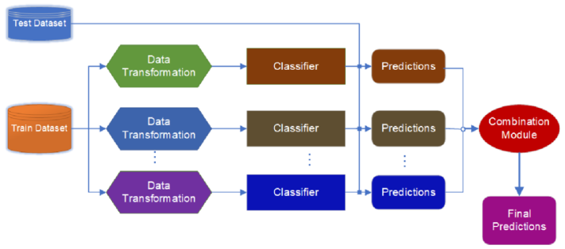
Figure 3: General framework of ensemble learning [58]

2.6 Literature Summary
It is evident from the current study's literature evaluation that significant advancements have been made in the field of predictive maintenance, particularly using machine learning and ensemble-based models. It is crucial to remember that the main benefit of applying the concept of predictive maintenance is that it has proven to be beneficial to manufacturing industries in the modern world. This includes reducing the amount of time that spare parts are used, improving the dependability of the machinery and equipment used in these industries, and saving money. It has been demonstrated that preventive models in service industries that use big data to train machine learning algorithms and look for trends indicating equipment failure are quite successful. In a similar vein, ensemble-based models overcome the limitations of single-model systems by combining numerous unique models to enhance predicted results and reliability.

All things considered, it describes how ensemble approaches have the potential to enhance the robustness and performance of prediction-based maintenance techniques. The research that applies all three types of ensembles learning techniques—bagging, voting, and stacking—in the context of predictive maintenance, however, is noticeably lacking. Comparing all three approaches in PdM is still new, even if a large portion of previous research has examined individual approaches or a combination of them [57]. This raises the possibility of further research into the combined use of bagging, voting, and stacking to anticipate maintenance, which will improve the predictive maintenance techniques already in use. To increase the precision and dependability of predictive maintenance models for industrial machinery and equipment, this study intends to examine the efficacy of several ensemble strategies (bagging, voting, and stacking). This study aims to determine the best strategy for predictive maintenance applications by contrasting the effectiveness of these methods with that of individual ML models. This study will also investigate how hyperparameter adjustment affects these ensemble models' performance.

2.7 Chapter Summary
This chapter provides the background to maintenance strategies and the role of predictive maintenance in the manufacturing context. It also describes the usefulness of PdM in identifying the shortcomings of traditional corrective and preventive maintenance strategies to improve schedules and decrease costs. Using ML models for PdM is on the rise because it can analyse the Big Data collected from the sensors to find correlations that may not be seen otherwise. The chapter then looks at ensemble learning approaches where multiple individual models are used to make a single prediction. Bagging, voting, and stacking are all discussed with examples. It has been established that ensemble techniques are effective for PdM, and this chapter explores several works that have effectively implemented ensemble learning to PdM problems. Finally, the chapter stresses that while there are numerous studies that focus on individual ensemble method or a combination of two of them, there is no study that compares all three techniques, bagging, voting, and stacking for PdM. This is a research gap that could be used in future research to determine the advantages of using all the three combinations of ensemble methods for predictive maintenance.

CHAPTER 3: RESEARCH METHODOLOGY
The research methodology, which is a thorough framework and methodical approach to answering the research objectives, is supplied by this study. This starts by choosing LR, SVM, KNN and RF as base models as they are quite diverse and applicable to classification. Bagging, voting and stacking methods are presented, to increase accuracy and reliability. The approach is designed with the purpose of systematic processing, implementation, and evaluation of the data with robust metrics.

3.1 Research Design
The research model for this work is anchored on the research onion, which is a visual representation of the layers involved in a research project and walks through the framework of a research work in a sequential manner [59]. Figure 4 shows the research on ensemble techniques in predictive maintenance, the layers of the research onion can be adapted as follows:

Figure 4: Research Design
- Philosophy: The research uses positivism approach because it uses quantitative data analysis and aims at testing hypotheses related to the performance of the various ensemble techniques in predictive maintenance tasks. Positivism focuses on empirical and measurable data, which is in line with the research’s quantitative focus [60].
- Approach: This research uses the deductive approach in order to test hypothesis regarding the effectiveness of ensembles (bagging, voting, stacking) versus individual machines learning algorithms. Since the approach begins with existing theories and, the comparison can be made using such parameters as accuracy, precision, recall, and F1-score, which is in line with the study objective of determining the most suitable ensemble strategy for predictive maintenance [61].
- Strategy: This study uses an experimental design since it involves applying and comparing several machine learning models and ensemble methods to a predictive maintenance dataset [62]. The evaluation measures which are used in the experiments include accuracy, precision, recall, and F1 score.
- Choice: This research uses a quantitative research design that involves the use of numerical data and statistical analysis to assess the effectiveness of various predictive maintenance models [63]. This approach is ideal for this research since it makes it possible to compare various ML algorithms quantitatively based on performance indicators.
- Time Horizon: The research is cross-sectional in nature with respect to the time dimension since the research is based on data of a specific time frame. Such approach is relevant for the works aimed at model assessment and comparison within the specified time frame [64].
- Techniques and Procedures: The research uses data cleaning methods such as dealing with missing values, removing duplicates, and unnecessary attributes, as well as methods for implementing models. It includes grid search optimization for ensemble strategies and measures the performance of models by using accuracy, precision, recall, and F1 score. Operations like data cleaning are performed with the help of libraries like scikit-learn for Python.
This structured approach makes it easy to follow the research methodology and to ensure that the methodology is sound and systematic, and that it corresponds to the goals of the research which is to assess and improve the ensemble learning approaches for predictive maintenance.

3.2 Research Model

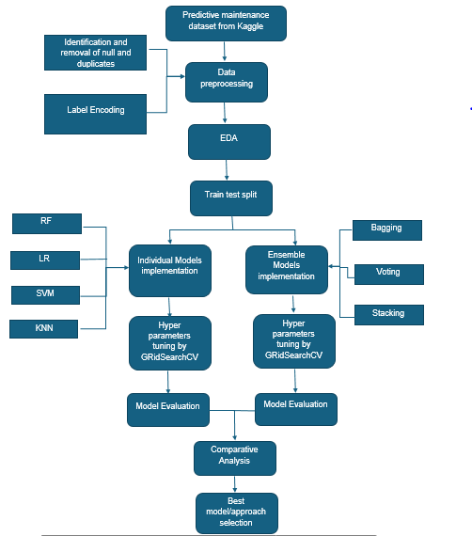
Figure 5: Research Model

3.2.1 Data collection
The predictive maintenance dataset provided by Kaggle with features such as machine operating condition, sensor readings and failure labels is utilized in this research.

3.2.2 Data preprocessing
The collected data set will be preprocessed by identifying and removing missing values and duplicate records. The categorical data in the predictive maintenance dataset called “Type” and “Failure Type” are encoded with labels to transform the text values into numerical values for the sake of applying machine learning algorithms.

3.2.3 Exploratory Data Analysis (EDA)
The visualization of the Predictive Maintenance dataset will be done using Matplotlib and Seaborn with the aim of exploring the distribution of the “Target” column and the relationship between numerical variables in the dataset. A count plot will be used to visualize the target variable while pair plots will be used to visualize the relationships between features and patterns including features such as torque and rotational speed having positive correlation.

3.2.4 Train-test split
The pre-processed dataset will be divided into test and train sets using 70:30 i.e., Training – 70% & Testing – 30%.

3.2.5 Implementation, hyperparameter tuning and evaluation of base model
The base models used in this research are LR, SVM, KNN and RF.

3.2.5.1 Logistic Regression
LR is a method of binary classification (output takes one of two forms) where output is categorical (i.e. ‘black’ or ‘white’, ‘yes’ or ‘no’, ‘pass’ or ‘fail’). The probability of an event (equipment failure) occurs is modelled by applying the logistic function [65]. Due to its simplicity, it computes fast, therefore it can be used for initial analysis and baseline comparison. The reason for Logistic Regression to be included in this research is to act as baseline model that gives a clear picture of the data and makes it easy to compare these results with the more complicated algorithms and ensemble techniques. One of the advantages of its usage is that it can provide probabilistic predictions, making it important for the assessment of probability of the equipment failure in predictive maintenance [73].

The equation of LR is (assuming a binary classification problem),
log(p / (1 - p)) = b0 + b1x1 + b2x2 + ... + bn*xn
where:
- p: Probability of machine failure (between 0 and 1)
- b0: Intercept term (bias)
- b1, b2, ..., bn: Coefficients for each feature (x1, x2, ..., xn)
- x1, x2, ..., xn: Features of the machine (e.g., sensor readings, operating conditions, age)
To find the probability of failure:
p = 1 / (1 + exp(-(b0 + b1x1 + b2x2 + ... + bn*xn)))
This equation describes the dependency between the parameters of the machine and the possibility of the failure. The coefficients namely b0, b1, b2, … are learned by the logistic regression model during training phase [74].

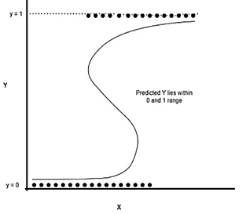
Figure 6: Logistic Regression [66]

3.2.5.2 Support Vector Machine (SVM)
SVMs are effective in the case of nonlinear relationships and high dimensional datasets, which often characterize predictive maintenance. It divides data points into distinct classes by finding the hyperplane that best separates them. With a suitable kernel selection, SVM can perform much better [67]. SVM is applied in this research to examine the robustness of differentiating machine states in the presence of noisy and complex data which qualifies it as a good model for ensemble learning.

The equation for a linear SVM for binary classification is represented as,
f(x) = sign(w^T * x + b)
where:
- f(x): The predicted class label (+1 or -1) for a given input feature vector 'x'.
- w: The weight vector, representing the coefficients associated with each feature.
- x: The input feature vector.
- b: The bias term (intercept).
- w^T * x: The dot product of the weight vector 'w' and the input vector 'x'.
- sign(): A function that returns +1 if the argument is greater than or equal to 0, and -1 otherwise.
The above equation identifies the decision boundary which is a hyperplane in the feature space. Each hyperplane has two classes on each side of a hyperplane where all the data points on one side of it belong to one class and on the other side belong to the other class. The SVM algorithm focuses to finding the best hyperplane that can give the maximum distance between the two classes [75].

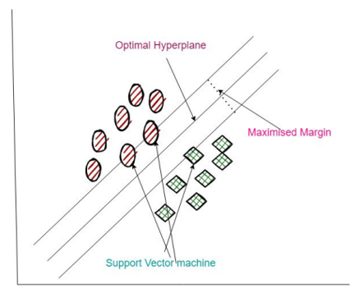
Figure 7: SVM working principle [68]

3.2.5.3 K-Nearest Neighbors (KNN)
KNN is one of the instance-based learning algorithms which assigns class label to any example based on the class label of the majority of its KNN in the feature space [69]. The approach does not require a specific functional form for the data and is adaptive to different data distributions. KNN is very useful in predictive maintenance because for datasets where similar instances (e.g. similar machinery configuration) tend to have the same outcomes (e.g. frequent failures), it can identify patterns or clusters of similar instances within a dataset. As a non-parametric instance-based learner, KNN classifies instances based on their proximity in the feature space, brings a unique perspective. When the predictive maintenance tasks involve clustered or sparse data, it is very useful. The distance between the query point (the new data point to be classified) and all other points in the training dataset is calculated using,
Euclidean distance: √(∑(x_i - y_i)^2)
Based on the estimated distances between the query point and every other data point in the training set, KNN initially determines the query point's k-nearest neighbours. The method then identifies the most common class label among these k nearest neighbours. The query point is then given this most common class label as its projected class [76].

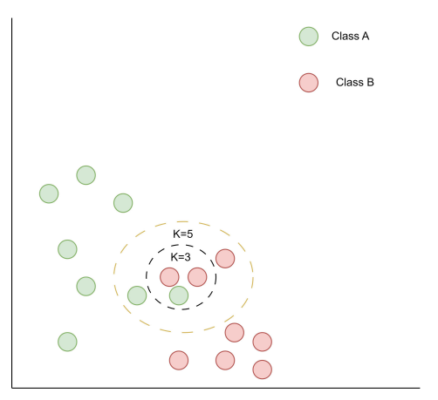
Figure 8: KNN working principle [68]

3.2.5.4 Random Forest
RF is an ensemble learning which is essentially creating lots of decision trees (DT), and then combine the results of these DT to provide a good and reliable answer. It can deal with big data with high dimensional features and at the same time moderates overfitting [70]. The reason to include Random Forest is to benefit from its ensemble nature to build a benchmark against other ensemble methods like voting, stacking, and bagging for predictive maintenance tasks. Its mechanism of feature importance helps to recognize important variables that can affect equipment health in line with the objective of the research to make sure the reliability and precision of PdM. The mathematical equation for RF:
For a Random Forest with T trees, the final prediction ŷ is,
ŷ = 1/T * Σ(t=1 to T) ht(x)
Where:
- T is the number of trees in the forest
- ht(x) is the prediction of the t-th tree
- x is the input feature vector
- 1/T represents the averaging of predictions across all trees [77]
The combination of base models offers diversity with respect to algorithmic approach so that the strengths and weaknesses of the various approaches can be comprehensively compared. SVM and Logistic Regression give robust, theory backed classifiers whereas KNN and Random Forest are versatile and robust to different data structures and noise levels. This is critical for an effective ensemble framework as it allows utilizing complementary strengths across different models building blocks to a solid base for PdM in the manufacturing industry.

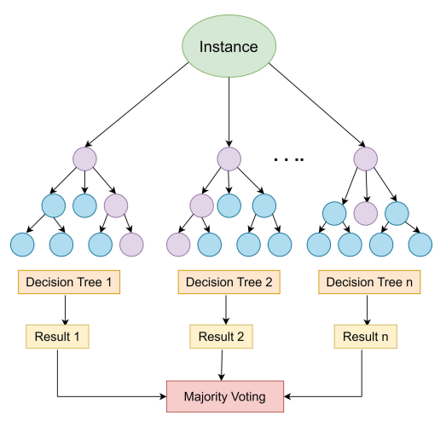
Figure 9: Random Forest [68]

These base models - LR, SVM, KNN and RF will be trained by using training dataset. Each model will be hyper tuned using grid search cross validation to find the right hyper parameters. Then each base model will be evaluated on testing set in terms of accuracy, precision, recall and F1score.

3.2.6 Implementation, hyperparameter tuning and evaluation of Ensemble Techniques
Following the implementation of individual models, ensemble methods (bagging, voting and stacking will be implemented to enhance predictive performance.

3.2.6.1 Bagging (Bootstrap Aggregating)
Bagging (short for Bootstrap Aggregation) is an ensemble technique meant to reduce variance and make machine learning models more robust. It is the one that trains several models (like decision trees) on bootstrapped subsets of the training data, and then aggregating their predictions through majority voting for the case of classification tasks [15]. In predictive maintenance, bagging can improve the reliability of the predictions by making use of the strength of the multiple learners.

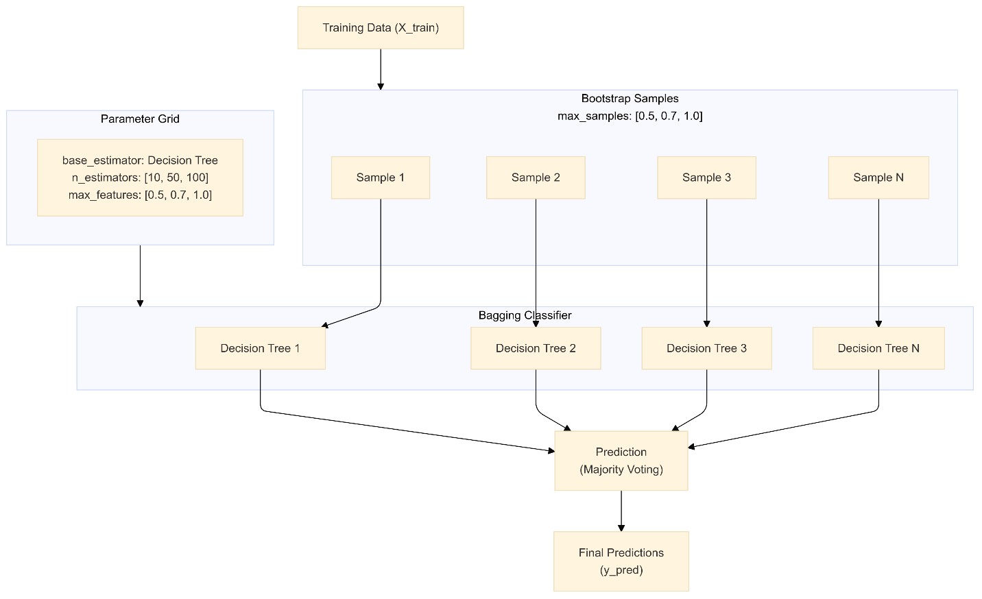
Figure 10: Bagging

3.2.6.2 Voting
Voting is an ensemble method which creates a unified result from the predictions of different base learners to increase classification accuracy [71]. Voting provides this research with the strengths of individual models, e.g. SVM, LR and RF, and in a way these errors can be corrected by others. This approach is helpful for predictive maintenance, to strike a trade-off between precision and recall.
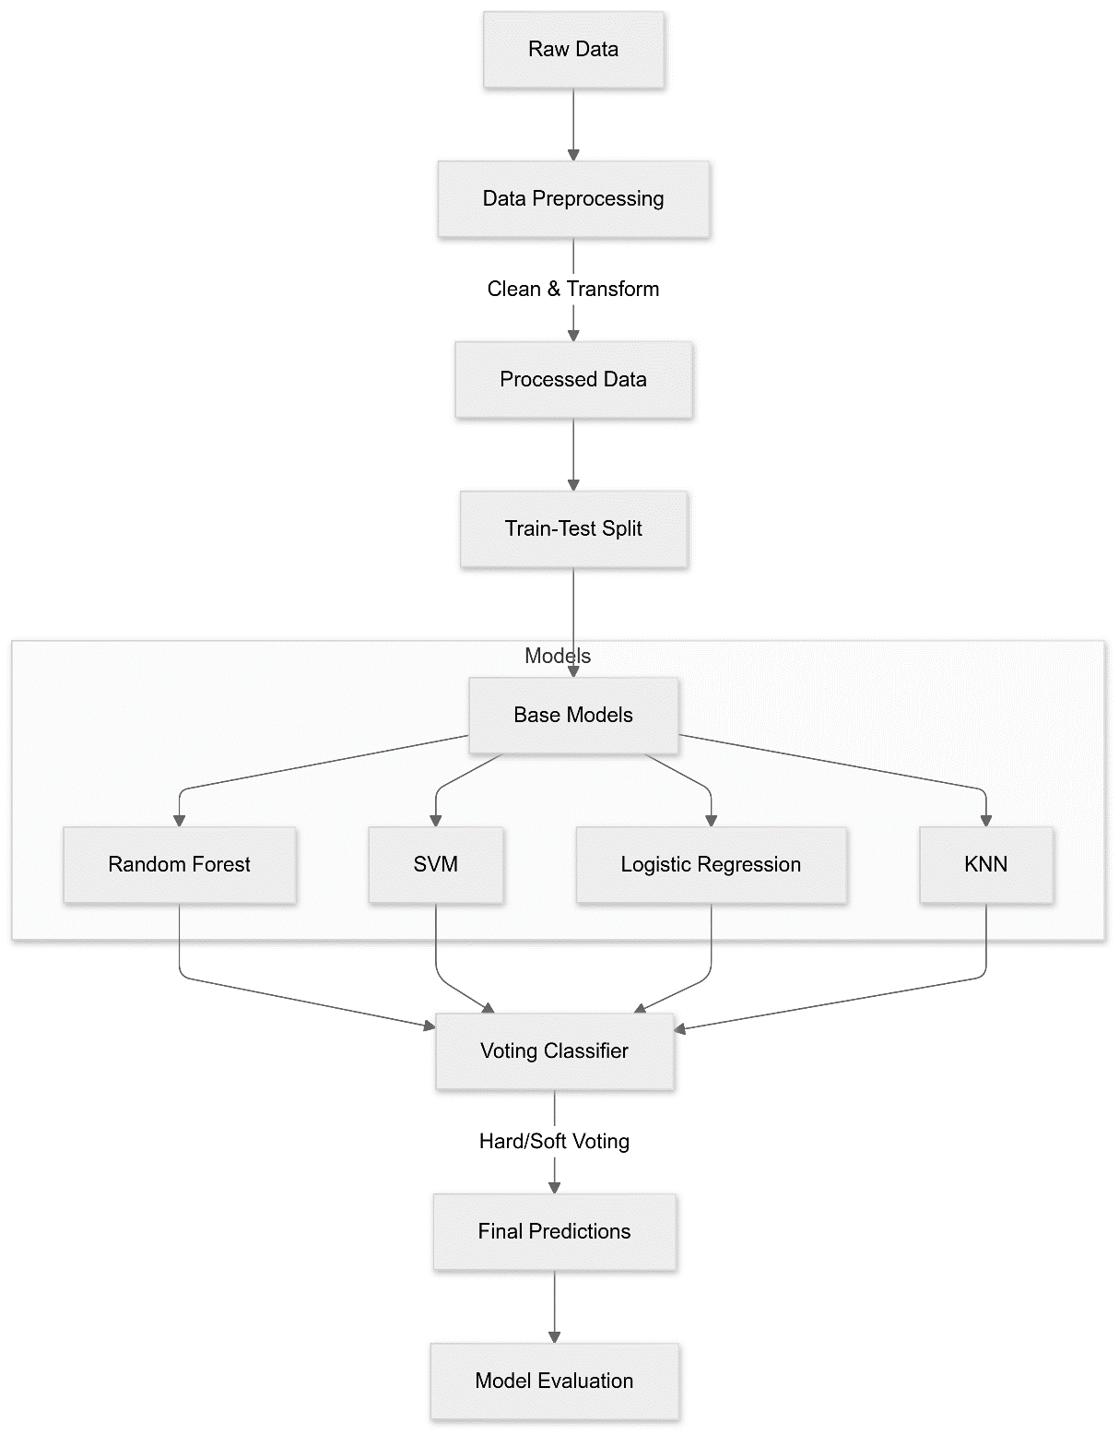
Figure 11: Voting procedure

3.2.6.3 Stacking
Stacking is a sophisticated ensemble technique which utilizes several base models to do predictions and combine them together by a meta model for the final prediction. It allows for numerous basis learners of various sorts and benefits from the synergy of those complementary strengths [72]. Stacking is highly flexible and powerful for predictive maintenance applications which require capture of diverse data patterns.

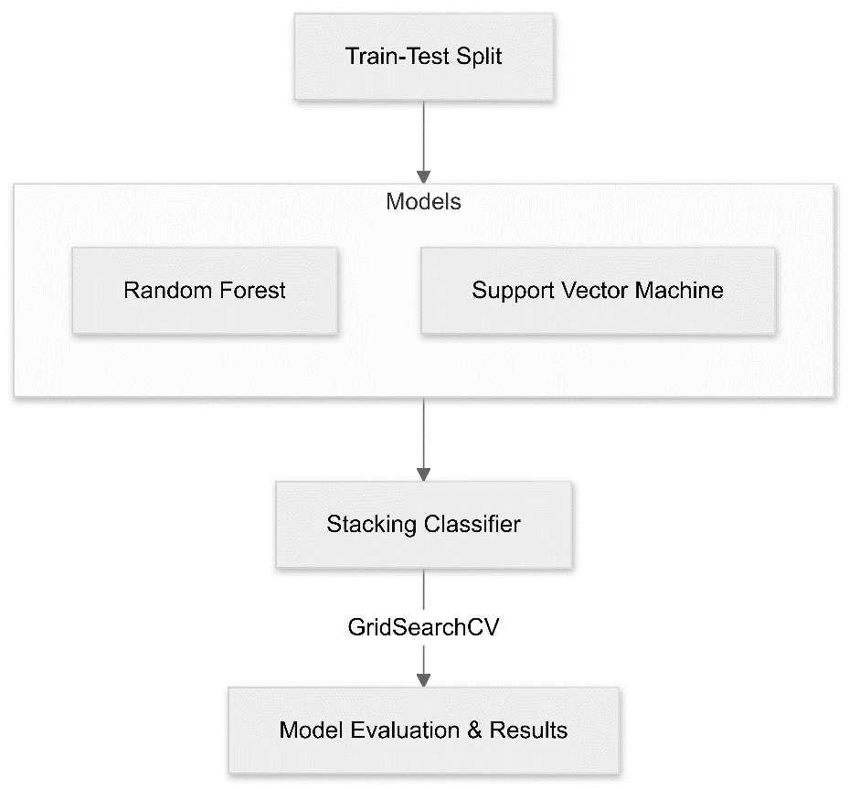
Figure 12: Stacking Technique
These ensemble models will be hyper tuned using grid search cross validation to find the right hyper parameters for each model. They will be evaluated on the test set using accuracy, precision, recall and F1score.

3.2.7 Comparative analysis
The results obtained by both the individual and ensemble models will be compared in terms of accuracy, precision, recall, and F1-score.

3.2.8 Approach selection
The approach with superior performance for predictive maintenance will be identified as the best approach by comparing ensemble techniques against individual models.

3.3 Dataset Description
The Machine Predictive Maintenance Classification dataset is an artificially generated dataset inspired by actual PdM problems. It consists of 10,000 data points which are characterized by 10 features: product details, air and process temperature, rotational speed, torque, and tool wear. The dataset also includes two target variables: a binary “Failure or Not” flag indicating overall machine failure, and a “Failure Type” variable identifying the type of failure. This dataset is helpful for developing and validating machine learning solutions for predictive maintenance applications, which aims at predicting when a failure may occur and at setting proper time for equipment maintenance [78].

3.3.1 Variables
- UID: ID ranging from 1 to 10000.
- productID: The first position can take one of the letters L, M or H to represent low (50% of all products), medium (30%) and high (20%) respectively for product quality and the second position is a variant specific serial number.
- air temperature [K]: obtained in the random walk fashion which was then scaled to have the standard deviation of 2 K around 300 K.
- process temperature [K]: To the air temperature with a 10 K offset, a random walk procedure with a 1 K standard deviation was used.
- rotational speed [rpm]: This signal is obtained by multiplying the reference signal with a 2860 W power and adding a normally distributed random variable.
- torque [Nm]: The torque values are locally distributed with an average value of 40 Nm and standard deviation of 10 Nm and the values cannot be negative.
- tool wear [min]: The quality variants H/M/L increase tool wear of the used tool in the process by 5/3/2 minutes respectively. The label "machine failure" indicates whether any of the following failure modes apply to this specific data point.

- There are two Targets:
- Target: Failure or Not
- Failure Type: Type of Failure

3.4 Evaluation Metrics

3.4.1. Accuracy
The frequency with which a model's predictions come true is a measure of its accuracy. The general accuracy equation is,
Accuracy= $\frac{TP+TN}{TP+TN+FP+FN}$

Where:
TP = True Positives: The number of correctly predicted positive cases.
TN = True Negatives: The number of correctly predicted negative cases.
FP = False Positives: The number of incorrectly predicted positive cases.
FN = False Negatives: The number of incorrectly predicted negative cases.

3.4.2 Precision
The accuracy with which a model can correctly identify only the pertinent events (true positives) among all the cases it anticipated to be positive is a measure of its precision.
Precision= $\frac{TP}{TP+FP}$

3.4.3 Recall
A model's recall quantifies its capacity to accurately identify every pertinent incident. The recall's general equation is,
Recall= $\frac{TP}{TP+FN}$

3.4.4 F1-score
F1-score is the harmonic mean of precision and recall. It offers a single point measure which captures both precision and recall in a unified manner. The F1-score of 1 means that precision and recall are 100% while the score of 0 mean that there are no true positive or all the positives are wrongly predicted.
F1-score = 2 * (Precision * Recall) / (Precision + Recall)

3.5 Materials
The model is implemented in Python, a language that has become popular in Data Science and Machine Learning. The main libraries are Scikit-learn that is an open-source library for data analysis and machine learning, Pandas that helps in data handling and data analysis, NumPy that is used for numerical computing, Matplotlib that is used for plotting distribution and relationship of data and Seaborn for creating statistical graphics and data visualizations. The Integrated Development Environment (IDE) for this work is Jupyter Notebook that is suitable for processing data and creating ML models due to the availability of a user-friendly interface.
Regarding the hardware aspect, the implementation needs a multi-core processor of an Intel i5 to compute calculations.16 GB of RAM is used for comfortable working with big data and training models. The computer also requires a Solid-State Drive (SSD) of 512 GB storage for data storage and managing reading and writing. The operating system which is used in the proposed implementation is Windows 11 to ensure that the software and tools run optimally.

3.6 Chapter Summary
In this chapter, a complete framework to implement and evaluate predictive maintenance models is proposed through individual and ensemble techniques. The way of proceeding step by step guarantees transparency and replicability in data preprocessing, model development and performance evaluation. The metrics selected allow for a complete comparison of model efficiency in several cases. The selected dataset will be used as the focus of the next chapter, Experimentation, to operationalize these methods for practical application and to provide empirical analysis.

CHAPTER 4: DESIGN & IMPLEMENTATION
In this chapter, the research design and how it was put into effect is explained. It also includes the data collection from Kaggle, data cleaning and data exploration to understand the data and relationships between variables, handling of categorical data through label encoding, train/test split of the dataset, implementing of the individual algorithms (RF, LR, KNN, SVM) and the ensemble algorithms (Voting Classifier, Stacking Classifier, Bagging Classifier) with the optimization of the parameters using GridSearchCV and the assessment metrics used in analysis of the models.

4.1 Research Overview
This research aimed to accomplish a comprehensive analysis of the effectiveness of ensemble techniques in predictive maintenance. It starts with collecting the Predictive Maintenance dataset from Kaggle (an Open repository) and preprocessing it to enhance the data quality. Next, individual ML models such as LR (Logistic Regression), SVM (Support Vector Machine), KNN (K-Nearest Neighbors), RF (Random Forest) will be implemented for predictive maintenance task. Thereafter, different ensemble methods including bagging, voting and stacking will be implemented and the hyperparameters of each will be tuned to enhance performance. The efficiency of the individual and ensemble models will be measured by metrics such as accuracy, precision, recall, and F1-score. Finally, the results of the two models (individual and ensemble models) will be contrasted to ascertain which is most suited for PdM implementation.

4.2 Implementation
This research focusses on acquiring data from Kaggle and preprocessing and visualising it to forecast the likelihood of a device failure in the manufacturing sector. Further, the implementation of traditional ML models such as RF, LR, KNN, SVM Classifiers and ensemble models such as bagging, voting and stacking classifiers have been detailed in this session.

4.2.1 Data Collection
The dataset used in this work contains the data about different parameters of industrial equipment performance including temperature, rotational speed, torque and tool wear. Each data point corresponds to one operation of a machine, and the target variable shows whether a failure happened. Furthermore, the data set contains the information of Product ID, Product type, and Failure type. It has 10000 rows and 10 columns. Out of 10 columns, one column ‘Target’ is the output column, and it contains the value 0 and 1. The value ‘1’ indicates that the device is failure and value ‘0’ indicates that the device is non-failure. This data set is very useful to develop and test ML algorithms for predictive maintenance, to anticipate failure of the equipment and manage maintenance in order to reduce the downtime and enhance the overall dependability of the plant equipment.

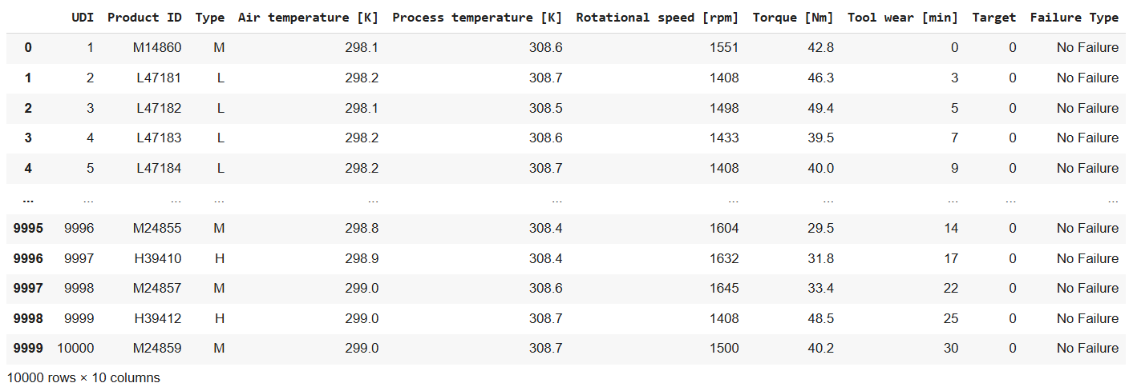
Figure 13: Predictive maintenance dataset structure

4.2.2 Data Preprocessing
Initially, the dataset is preprocessed by finding the missing values in the dataset. The illustration of the output of finding the missing values is stated in figure 14.
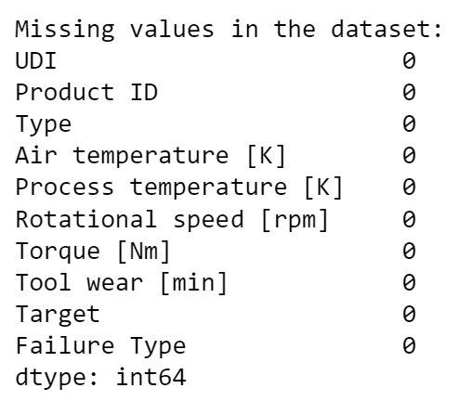
Figure 14: Identification of missing values
From the above, it is inferred that all the columns in the dataset do not contain any missing values in the dataset. Further, the dataset has been investigated for finding the duplicate rows in the dataset.
Figure 15 illustrates the output of finding the duplicate.
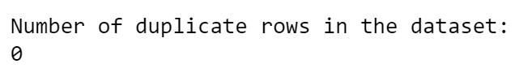
Figure 15: Identification of duplicates
From the above, it inferred that there are no duplicate rows in the dataset.

Further, the basic information of the dataset is in figure 16.
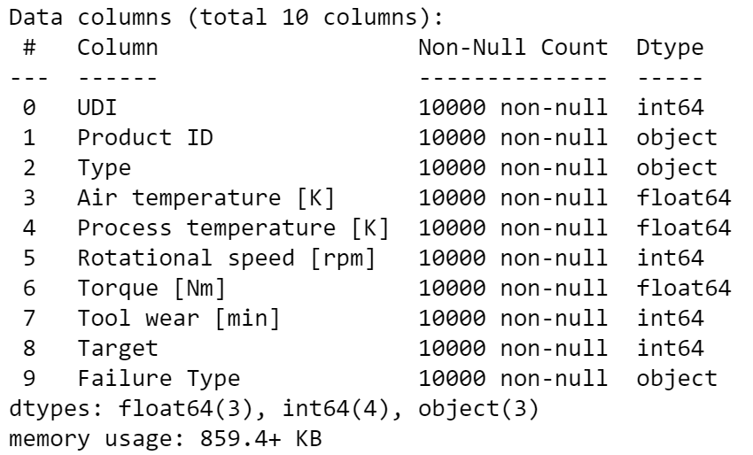
Figure 16: Data types of attributes
It is clear from the above that there are three columns of object data type, four columns of integer data type, and four columns of floating data type.

4.2.3 Data Visualization
The Predictive Maintenance dataset has been visualized by using data packages such as Matplotlib and Seaborn. To examine the distribution of the values in the datasets "Target" column, the output column has been visualised using a count plot. The values in the 'Target' column are distributed in figure 17.
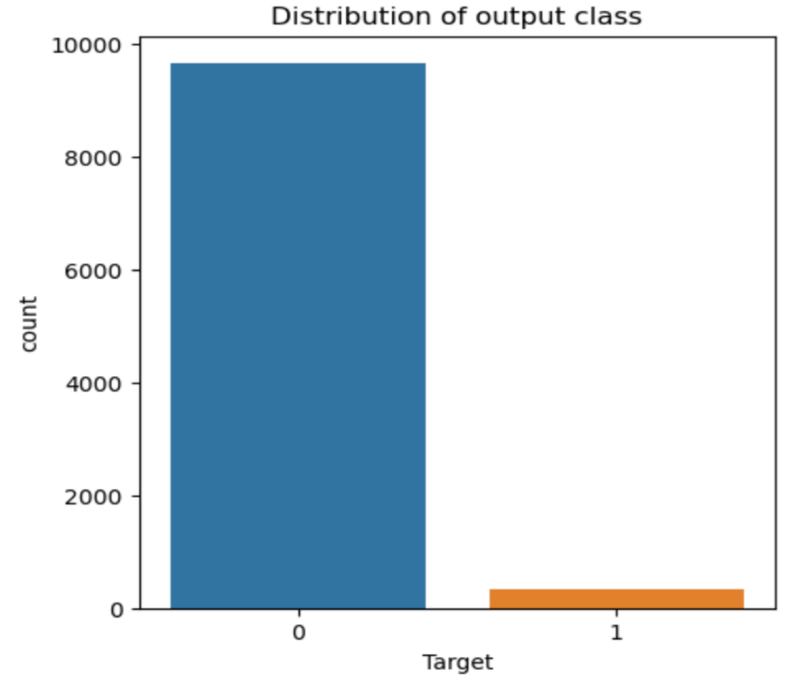
Figure 17: Distribution of output class
It is evident that the value ‘0’ contains the maximum count of data and value ‘1’ contains minimum count of data. This implies that most of the data points are associated with the machines that have not failed (value 0) compared to the machines that have failed (value 1). Further the pairwise relationships between the numerical features of the dataset have been visualized using pair plot and visualization.
Figure 18 provides insight into how different numerical features correlate with each other and how they relate to the output column ‘Type’. Every subplot is a pair of features and demonstrates the distribution of features and their relationships and possibilities of clustered patterns. The distributions of the features such as rotational speed, torque and tool wear look reasonably Gaussian, the temperature features are slightly skewed. Some characteristics like rotational speed and torque indicate a positive relationship where torque is often high at high rotational speeds.
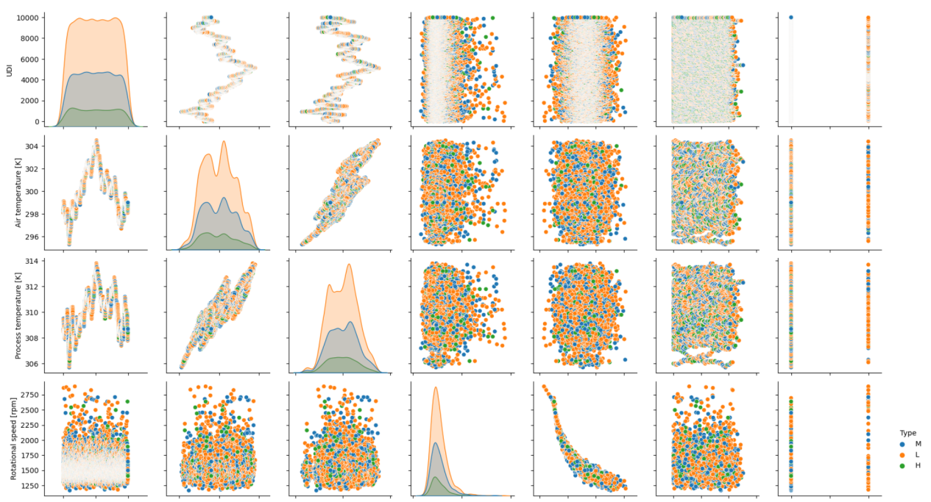
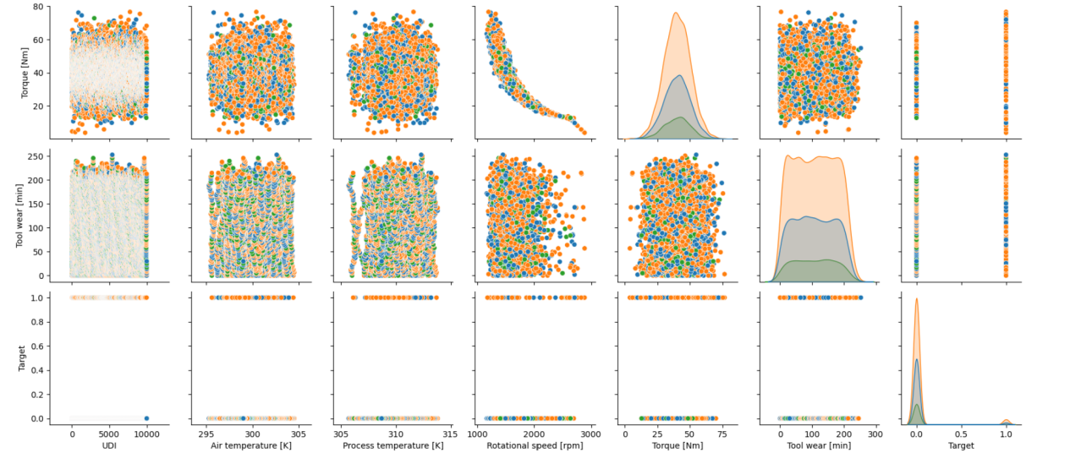
Figure 18: Pair plot visualizations

4.2.4 Label Encoding
In the predictive maintenance dataset, the features, "Type" and "Failure Type" are categorical in nature. These columns must hold text values (for example, ‘L’, ‘M’, ‘H’ for product classification and failure type also has 2 classes like “No failure” and “failure”). Most of the ML algorithms are well suited to work with numerical information therefore label encoding is performed to transform these fields into numerical values.

4.3 Splitting into Training and Testing Sets
After all preprocessing, the data has been split for training and testing purposes. The dataset has been split into 70:30 i.e., Training – 70% & Testing – 30%, a simple and effective approach in machine learning is to divide the dataset into training and testing subsets. A 70:30 split helps in ensuring a majority of data is used for training and 30% testing on unseen data. This leads to a large training set so that it allows the model to learn some meaningful patterns and relationships in the data. Moreover, the testing set is also large enough that the model can be evaluated in terms of generalizability and the computation of reliable performance metrics, e.g. accuracy, precision, recall, confusion matrices, etc. Also, splitting in this way reduces the danger of undertraining or overfitting the model, and therefore poor performance on new data. If the dataset is smaller, a different split like 80:20 might be considered to maximize the training data. In this case, 30% of the data is enough to make the evaluation metrics robust and unbiased.

4.4 Implementation of Base Models
After the data has been split, the data has been trained using various individual ML models such as RF, LR, KNN and SVM classifiers have been implemented & evaluated.

4.4.1 Random Forest
The implementation of RF model starts with setting up a parameter grid for hyper parameter tuning using parameters such as criterion, max_depth, max_features, and n_estimators. A systematic search of the parameter space is then performed using GridSearchCV and the best set of parameters is chosen based on 2-fold cross-validation. Next, an RF classifier is built with the best hyperparameters on the train data set. Finally, the trained model is then used to predict on the test set and the performance of the model can be measured by metrics such as accuracy, classification report and confusion matrix.

4.4.2 Logistic Regression (LR)
The Implementation of LR model starts with the hyperparameter tuning using GridSearchCV. The options for the regularization penalty ('l2', 'l1', 'elasticnet', or None), regularization strength (C values of 0.01, 0.1, 1, 10, 100), and solvers ('liblinear', 'newton-cg', 'lbfgs', 'saga') are included in the parameter grid. The best combination of hyperparameters is recognized through 2-fold cross-validation (cv=2). Then, the model is trained on the training data, and the optimal parameters are displayed. Next, prediction is carried out on the test set, and the accuracy, a classification report, and a confusion matrix are computed to evaluate the performance of the model at predicting and on various classes.

4.4.3 Support Vector Machine (SVM)
To develop a SVM classifier for failure prediction of machines, initially a GridSearchCV object is created to tune the hyperparameters of SVM model to find the best set of parameters values. These hyperparameters include cost parameter (C), kernel, degree of the polynomial kernel and class weights (class_weight). The GridSearchCV uses cross-validation (cv=2) to estimate the best set of hyperparameters which will minimize the risk of overfitting. Then the model is fine-tuned with the best hyper parameters and then applied on the training dataset. Once trained, the model is used for predicting test data. In addition, the model’s accuracy, classification report and confusion matrix are used to assess the model’s performance.

4.4.4 K-Nearest Neighbors (KNN)
First, GridSearchCV specifies grid of hyperparameters to explore number of neighbors (n_neighbors), distance weighting scheme (weights), and neighbor search algorithm (algorithm). This returns the best hyperparameter combination via 2-fold cross-validation. From there, the KNN model is trained with the optimal hyperparameters. Following this, the trained model assigns labels to the test data and the performance of the model is evaluated with the help of accuracy, classification report and confusion matrix.

4.5 Implementation of ensemble models

4.5.1 Voting Classifier
This Voting Classifier ensemble model for predictive maintenance combines four individual machine learning models: RF, SVM, LR and KNN. The voting strategy, either “hard” or “soft”, is selected by means of a grid search with cross-validation. The ensemble model is then trained on the training data set after the best voting mechanism has been identified. Ultimately, the acquired model is used to forecast the class labels of the fresh test data. The model's ability to detect machines that are likely to fail soon is measured using metrics including accuracy, precision, recall, and F1-score.

4.5.2 Stacking Classifier
The Stacking Classifier for predictive maintenance task is implemented using RF and SVM as base models. It starts by setting certain hyperparameters for the RF and SVM models after which a Stacking Classifier is built to include these base models. The GridSearchCV is used to fit the parameters and in this case, it has tuned the 'stack_method' parameter as auto, predict_proba, decision_function, and predict to experiment with. Once the best hyperparameters are selected and the model is fitted to the training data, the model provides predictions of the test set.

4.5.3 Bagging Classifier
A Bagging Classifier is implemented with a DT as a base estimator, alongside an elaborate hyperparameter tuning procedure with the help of GridSearchCV. Following the creation of a Bagging Classifier using a DT Classifier, a comprehensive parameter grid that investigates numerous hyperparameters is defined: decision tree hyperparameters like min_samples_split, min_samples_leaf, and max_depth; Max_samples, which indicates the percentage of samples to be drawn in each estimator, max_features, which indicates the maximum number of features to be drawn in each tree, and n_estimators, which indicates the number of base estimators, are the bagging hyperparameters. Iterating through the above-specified parameter space with GridSearchCV and a cross-validation technique yields the best combination. An accuracy score, a confusion matrix, and a classification report that gives precision, recall, and F1-score for each class are used to evaluate the model's performance both quantitatively and qualitatively after the test set is predicted using the best parameters found during this exhaustive search.

Table 1 presents the selected parameters of each ML model.
Table 1: Parameters of models by GridSearchCV method
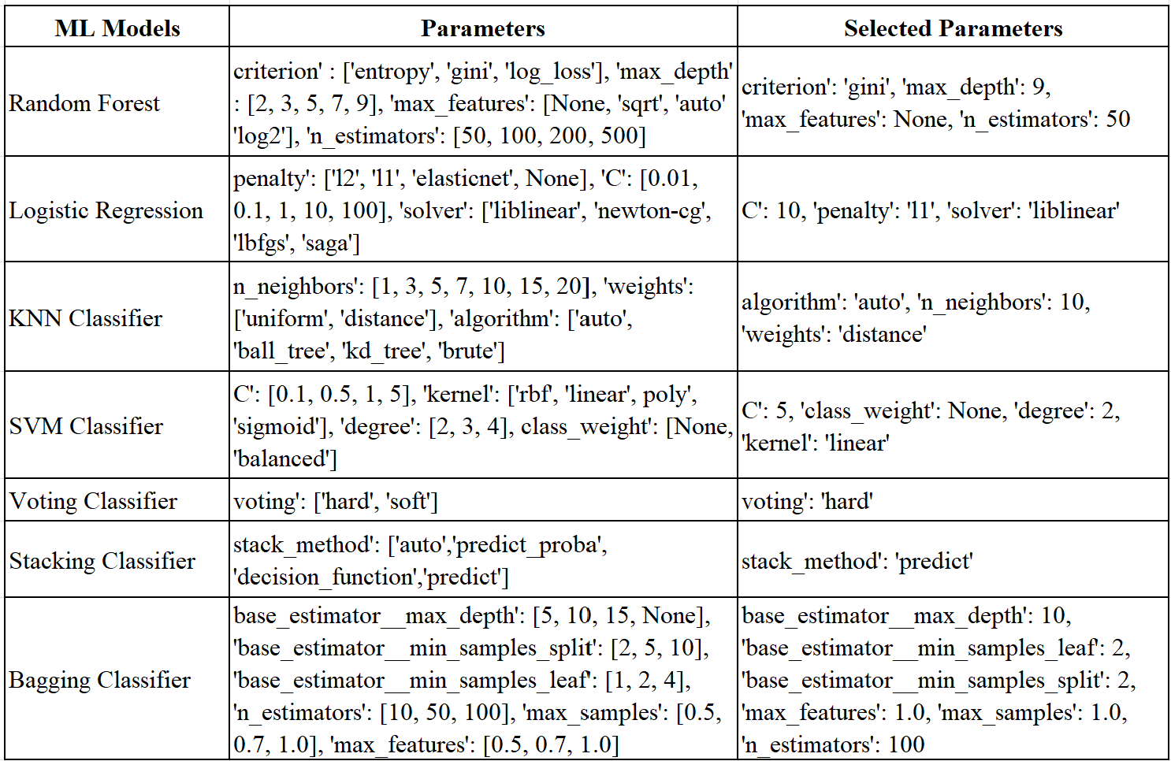

4.6 Chapter Summary
This chapter presented the research design and its application in developing a predictive maintenance system using ML. This chapter included data collection, data cleaning, and data exploration, handling of categorical data, splitting data into training and testing, applying various ML models including RF, LR, KNN, SVM, ensemble models including Voting Classifier, Stacking Classifier, Bagging Classifier with hyperparameter tuning using GridSearchCV. The chapter also attempted at graphing the data to see how the variables are related. Last, the chapter described how individual and ensemble models are implemented in detail.

CHAPTER 5: RESULTS & DISCUSSIONS
In the previous chapter, the data was preprocessed, visualized and best fit parameters have been selected. From the selected parameters, the individual ML models such as RF, LR, KNN Classifier, SVM Classifier as well as the ensemble models such as Voting, Stacking and Bagging Classifiers are trained using the training data and the same has been tested using test data. The evaluated outcomes are discussed in detail.

5.1 Overall Comparison of Individual and Ensemble Models
Table 2: Overall performance comparison of individual and ensemble models
 | Models | Accuracy | Precision | Recall | F1- score
Individual models | RF | 0.99 | 0.99 | 0.99 | 0.99
Individual models | Logistic Regression | 0.98 | 0.97 | 0.98 | 0.97
Individual models | KNN | 0.97 | 0.97 | 0.97 | 0.96
Individual models | SVM | 0.97 | 0.97 | 0.97 | 0.97
Ensemble models | Voting Classifier | 0.97 | 0.97 | 0.97 | 0.97
Ensemble models | Stacking Classifier | 0.99 | 0.99 | 0.99 | 0.99
Ensemble models | Bagging Classifier | 0.99 | 0.99 | 0.99 | 0.99

Table 2 states that the RF gained the highest accuracy, precision, recall and F1-score of 0.99 among the individual models. This indicates its capability to deal with complicated relationships and does not over fit. Logistic Regression also provided good results with an accuracy of 0.98, precision of 0.97, recall of 0.98, and F1-score of 0.97, due to its capability when the features and the target variable are linearly correlated. The traditional models such as KNN and SVM could not be able to perform better as the model could be able to predict the majority classes well but failed to detect the minority class effectively. However, these models have achieved better accuracy, precision, recall and f1 score of 97% respectively.

In the case of ensemble models, the Voting Classifier, which is an ensemble method that combines different models through a voting system, had an accuracy, precision, recall and F1-score of 0.97, proving that it is beneficial to combine different models. But it may lack some effectiveness when the base models have significant disagreements. The stacking classifier with accuracy, precision, recall and F1-score of 0.99 is the best of the ensemble models for predictive maintenance. In this case, the meta-model is capable of learning from the predictions of the base models and thus improves the results. The Bagging Classifier also performed equally well with accuracy, precision, recall and F1-score of 0.99, showed how combining multiple decision trees decreases variance and increases the model’s ability to generalize.

Figure 19: Results of individual ML models

Figure 20: Results of ensemble models

5.2 Comparison of Classification report of all models
Table 3: Classification report of all models
Random Forest ML  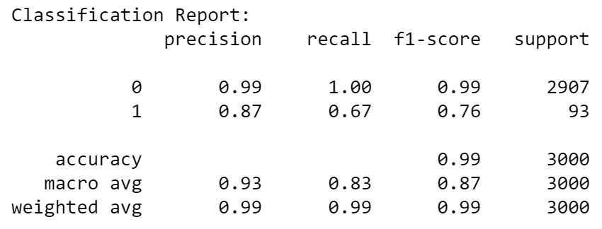 | Logistic Regression ML  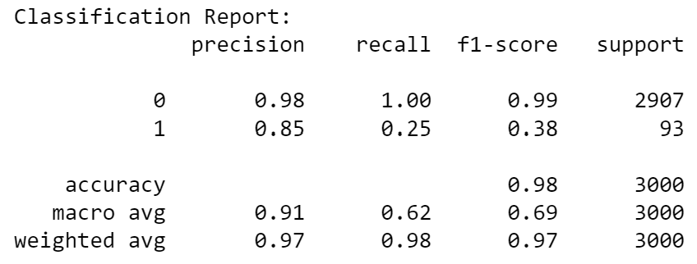
KNN Classifier  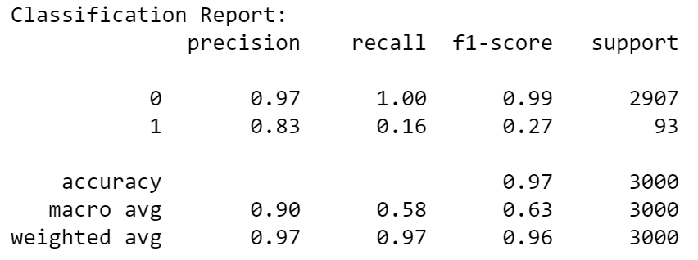 | SVM Classifier  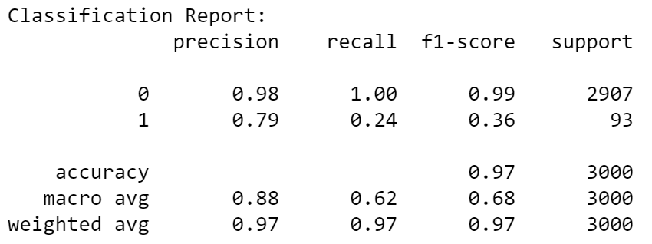
Voting Classifier  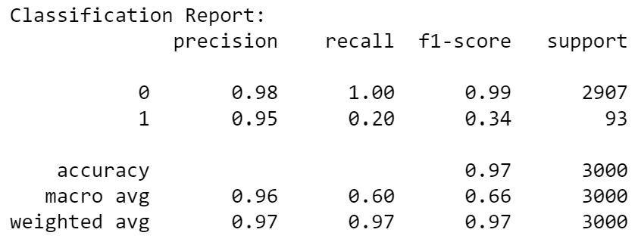 | Stacking Classifier  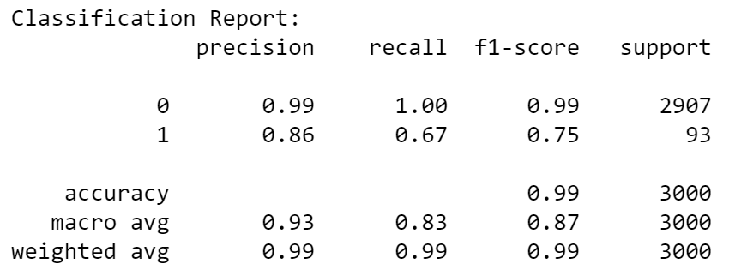
Bagging Classifier
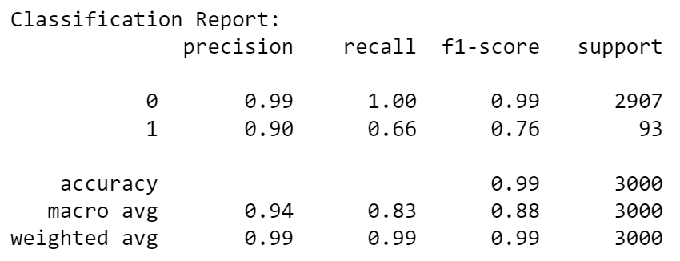
Bagging Classifier, Stacking Classifier and Random Forest outperform the other classifiers based on evaluation metrics for both class 0 and 1. Logistic Regression, KNN, and SVM struggle with the minority class (Class 1), showing low recall and poor F1 scores for it. Voting Classifiers combine different models to improve accuracy, but they do not significantly outperform Random Forest in terms of balancing performance across classes.

5.3 Confusion Matrix of all models
Through the breakdown of predictions and the comparison of predicted and actual labels, this research offers a thorough understanding of a classifier's performance. Based on the above classification report, the confusion matrix has been evaluated and illustrated figure 21.

Random Forest  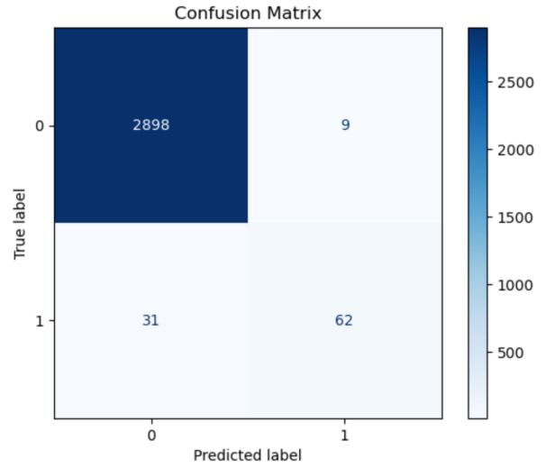 | Logistic Regression  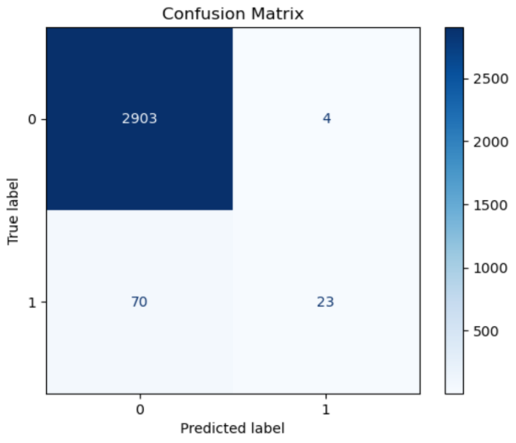
KNN Classifier  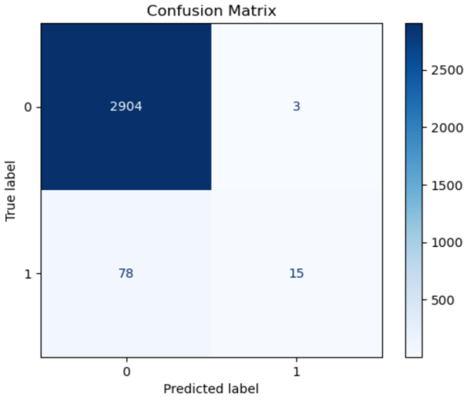 | SVM Classifier  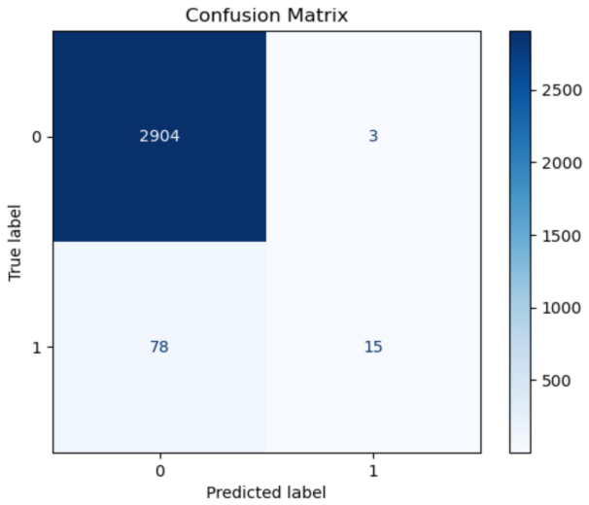
Voting Classifier  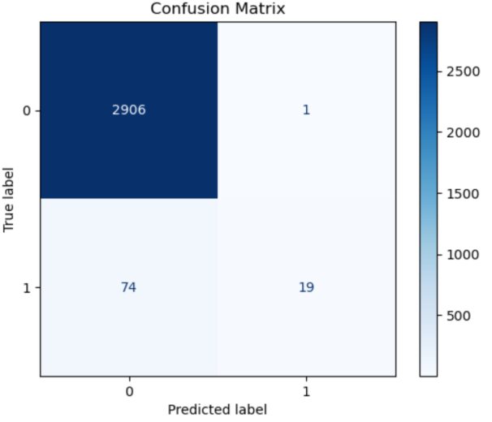 | Stacking Classifier  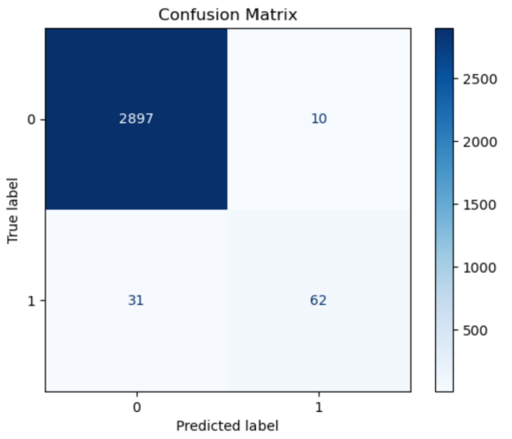
Bagging Classifier
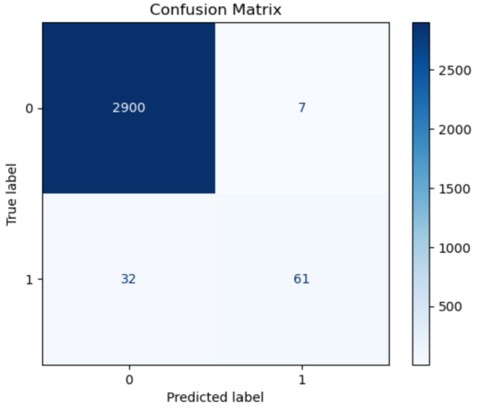

Figure 21: Confusion Matrix of all models

Hence, ensemble techniques, primarily Stacking and Bagging achieved better results than individual models, thus proving the significance of integrating several models for predictive maintenance in industrial machinery and equipment.

Table 4: Critical Comparison of this research with existing literatures

Model | Accuracy | Precision | Recall | F1-Score
RF [55]  RF | 0.966  0.99 | 0.977  0.99 | 0.960  0.99 | 0.966  0.99
LR | 0.98 | 0.97 | 0.97 | 0.98
KNN | 0.97 | 0.97 | 0.96 | 0.97
SVM | 0.97 | 0.97 | 0.97 | 0.97
Bagging [56]  Bagging | 0.9974  0.99 | 0.8764  0.99 | 0.7722  0.99 | 0.8210  0.99
Voting | 0.97 | 0.97 | 0.97 | 0.97
Stacking | 0.99 | 0.99 | 0.99 | 0.99

Table 4 states that the research utilized several ensemble approaches on a Kaggle predictive maintenance dataset with high accuracy performance metrics. The Random Forest, Stacking Classifier, and Bagging Classifier ensemble methods used in this project produced outstanding performance in the metrics with accuracy, precision, recall, and F1-score of 0.99.

When compared with previous work, [56] used bagging on Scania Trucks APS failures dataset and obtained higher accuracy of 0.9974 but lower precision of 0.8764 and recall of 0.7722 and [55], implementing RF on textile manufacturing E-Form data, showed slightly lower but still impressive results as follows: accuracy: 0.966, precision: 0.977, recall: 0.960, and F1-score: 0.966.

The datasets used were from Kaggle, a predictive maintenance dataset, the E-Form data from computerized sewing machines by [55] and the APS failures data from Scania Trucks by [56]. The analysis of the results shows that ensemble methods are highly efficient in industrial maintenance applications. The performance metrics obtained in the present work are also in line with the observations made from the existing literature, substantiating the use of the ensemble methods for predictive maintenance in various manufacturing systems.

5.4 Chapter Summary
This chapter highlighted the results and discussions of the individual and ensemble models developed in this research. The experiment revealed that the ensemble models, particularly Stacking and Bagging, had higher accuracy, precision, recall and F1-score than the individual models which included RF, LR, KNN, and SVM. This chapter also explained the weakness when using single model and how an ensemble can overcome these weaknesses. Furthermore, related the findings of this research to the literature and established that ensemble methods are beneficial in PdM. In conclusion, this research shows that ensemble methods can actually enhance the accuracy and efficiency of PdM systems.

CHAPTER 6: CONCLUSION & RECOMMENDATIONS
This chapter summarises the main conclusions of the study, offering suggestions for additional research, and emphasizing the useful applications.

6.1 Conclusion
In the prediction of the probability of a device failure in the manufacturing industry, this research has focused on implementing individual ML models such as RF, LR, KNN Classifier, SVM Classifier and ensemble models such as Voting Classifier, Stacking Classifier and Bagging Classifier. These models are evaluated using evaluation metrics such as Accuracy, Precision, Recall and F1 score.

To achieve the first objective of this research, this research reviewed the recent literature on predictive maintenance and discussed trends in ensemble methods as opposed to traditional and single methods. The results show that ensemble techniques, such as Stacking and Bagging which has an accuracy of 0.99 are much better compared to individual models such as LR with 0.98, KNN with 0.97 and SVM with 0.97. These ensemble methods helped in combining the best of all multiple models in terms of accuracy, precision, recall, and F1-score. Among individual models, RF is identified to be a robust individual model with an accuracy of 0.99 proving its capacity to model complex relationships and address overfitting.

To achieve the second and third objectives, the research used benchmark datasets and the comparison of ensemble methods of Bagging, Voting, and Stacking with individual ML models using the key evaluation metrics. The ML models, KNN and SVM provided satisfactory results, but they failed to solve complex decision boundaries, and the data inequality issues when it comes to handling multiple decision boundaries. Unfortunately, the Voting Classifier though very efficient is slightly less so as compared to Stacking and Bagging. Stacking can benefit from the base model’s predictions and thereby outperformed the other methods. Similarly, bagging that involves using many decision trees added to the overall accuracy and reduced the possibility of over-fitting. Thus, this work has shown that ensemble techniques are very useful in predictive maintenance. These techniques can be used to improve the performance of PdM systems by integrating the knowledge from multiple models, thus improving the accuracy, robustness, and reliability of the system and reducing downtime.

6.2 Limitations and Future Enhancement
In this research, Feature selection and engineering might be improved by applying different automated methods such as Recursive Feature Elimination or by applying techniques based on domain knowledge in order to select features estimating higher performance of a model. Moreover, when using interaction terms as independent variables or polynomial of the independent variables, the current model constructs might not capture non-linearity that exists in the corresponding relationships.
In this research, Grid search method has been used for finding the best fit parameter of all ML model. Further research can be extended by analyzing more advanced methods such as Random Search, Bayesian Optimization or Genetic Algorithms which could further optimize hyperparameters.
In this research, the traditional individual ML models such as RF, LR, KNN, SVM models and ensemble models such as Voting Classifier, Stacking Classifier and Bagging classifier have been used. Further exploration can be made by exploring deep learning (DL) techniques such as Recurrent Neural Networks (RNNs) or Convolutional Neural Networks (CNNs) for sequential or structured data which could lead to improved results.

6.3 Reflection
In this research work on predicting the probability of a device failure in the manufacturing industry, this research has analyzed and obtained the data from Kaggle and further it has been preprocessed and visualized. Further the data has been trained and tested with the individual ML models such as RF, LR, KNN & SVM and ensemble models such as Voting, Stacking, and Bagging Classifiers.
Using Grid Search to fine-tune the hyperparameters led to better model results, highlighting the importance of this step in ML workflows. Base models like RF, SVM, KNN and LR performed well, but the ensemble models (Voting, Stacking, and Bagging) proved to enhance performance.
To evaluate the model's capacity to identify the minority class, the evaluation method concentrated on criteria that go beyond accuracy, such as precision, recall, and F1 score. An improved understanding of the model's performance was made possible by the confusion matrix.
Additionally, I divided the project into smaller jobs and gave each one a certain date established by the supervisor, using a scientific approach to job management. This allowed me to closely monitor the situation and ensure that the job I completed was completed on time at every stage. Regular assessments and schedule adjustments ensured that I met all deadlines while preserving the quality of the work. Project management software combined with AI assistance is largely responsible for maintaining this equilibrium. During this process, I improved my programming and technical writing skills and learned how to employ AI technology to boost productivity. This experience has taught me a lot about software engineering, time management, the importance of iterative improvement, and how to successfully integrate AI technology into difficult projects to achieve the best outcomes.
I've learned a lot from this experience about time management, the value of iterative improvement, software programming and how to effectively incorporate AI technologies into challenging projects to get the best results.

6.4 Chapter Summary
This chapter provided the final outlook of the research by detailing the conclusions. The findings show that ensemble methods (Stacking and Bagging) outperform single models Logistic Regression, KNN, and SVM) in predictive maintenance. The chapter also presents the weaknesses of the research, and the utilization of Grid Search for hyperparameter optimization, and the recommendations for future work, including the utilization of sampling procedures and improved optimization strategies. Also, provides a brief reflection on the learning experience gained throughout the project.

REFERENCES

[1] Y. Ran, X. Zhou, P. Lin, Y. Wen and R. Deng, “A Survey of Predictive Maintenance: Systems, Purposes and Approaches,” 2019, arXiv. doi: 10.48550/ARXIV.1912.07383.
[2] T. Zonta, C. A. Da Costa, R. Da Rosa Righi, M. J. De Lima, E. S. Da Trindade, and G. P. Li, “Predictive maintenance in the Industry 4.0: A systematic literature review,” Computers & Industrial Engineering, vol. 150, p. 106889, Dec. 2020, doi: 10.1016/j.cie.2020.106889.
[3] M. Achouch et al., “On Predictive Maintenance in Industry 4.0: Overview, Models, and Challenges,” Applied Sciences, vol. 12, no. 16, p. 8081, Aug. 2022, doi: 10.3390/app12168081.
[4] R. Keith Mobley, An Introduction to Predictive Maintenance. Elsevier, 2002. doi: 10.1016/B978-0-7506-7531-4.X5000-3.
[5] L. L. Ferreira et al., “A pilot for proactive maintenance in industry 4.0,” in 2017 IEEE 13th International Workshop on Factory Communication Systems (WFCS), Trondheim, Norway: IEEE, May 2017, pp. 1–9. doi: 10.1109/WFCS.2017.7991952.
[6] H. H. Hansen, “Predictive Maintenance for Power Plants,” 2024.
[7] B. De Jonge, R. Teunter, and T. Tinga, “The influence of practical factors on the benefits of condition-based maintenance over time-based maintenance,” Reliability Engineering & System Safety, vol. 158, pp. 21–30, Feb. 2017, doi: 10.1016/j.ress.2016.10.002.
[8] R. M. Ayo-Imoru and A. C. Cilliers, “A survey of the state of condition-based maintenance (CBM) in the nuclear power industry,” Annals of Nuclear Energy, vol. 112, pp. 177–188, Feb. 2018, doi: 10.1016/j.anucene.2017.10.010.
[9] S. Jose, R. Zemouri, K. T. P. Nguyen, K. Medjaher, A. Tahan, and M. Lévesque, “From Fragments to Futures: Construction of Synthetic Run-to-Failure Trajectories for Fault State Prognostics,” in 2024 Prognostics and System Health Management Conference (PHM), Stockholm, Sweden: IEEE, May 2024, pp. 306–311. doi: 10.1109/PHM61473.2024.00062.
[10] S.A. Patil, N.P. Sable, P.N. Mahalle, and G.R. Shinde, “Intelligent Mechanisms for PdM in Automotive Machinery: A Comprehensive Analysis using ML/DL,” jes, vol. 19, no. 2, pp. 116–130, Jan. 2024, doi: 10.52783/jes.697.
[11] M. Nacchia, F. Fruggiero, A. Lambiase, and K. Bruton, “A Systematic Mapping of the Advancing Use of Machine Learning Techniques for Predictive Maintenance in the Manufacturing Sector,” Applied Sciences, vol. 11, no. 6, p. 2546, Mar. 2021, doi: 10.3390/app11062546.
[12] M. A. Ganaie, M. Hu, A. K. Malik, M. Tanveer, and P. N. Suganthan, “Ensemble deep learning: A review,” Engineering Applications of Artificial Intelligence, vol. 115, p. 105151, Oct. 2022, doi: 10.1016/j.engappai.2022.105151.
[13] P. S. Rao and P. V. Y. Jayasree, “Predictive Maintenance (PDM) for Complex systems using multidistinguised features,” Journal of Algebraic Statistics, vol. 13, no. 3, pp. 2434–2447, 2022.
[14] Rising O Odegua, “An Empirical Study of Ensemble Techniques (Bagging, Boosting and Stacking),” 2019, doi: 10.13140/RG.2.2.35180.10882.
[15] G. Ngo, R. Beard, and R. Chandra, “Evolutionary bagging for ensemble learning,” Neurocomputing, vol. 510, pp. 1–14, Oct. 2022, doi: 10.1016/j.neucom.2022.08.055.
[16] R. Genuer, J.-M. Poggi, C. Tuleau-Malot, and N. Villa-Vialaneix, “Random Forests for Big Data,” Big Data Research, vol. 9, pp. 28–46, Sep. 2017, doi: 10.1016/j.bdr.2017.07.003.
[17] R. Sikora and O. H. Al-laymoun, “A Modified Stacking Ensemble Machine Learning Algorithm Using Genetic Algorithms,” Journal of International Technology and Information Management, vol. 23, no. 1, Jan. 2014, doi: 10.58729/1941-6679.1061.
[18] R. Dey and R. Mathur, “Ensemble Learning Method Using Stacking with Base Learner, A Comparison,” in Proceedings of International Conference on Data Analytics and Insights, ICDAI 2023, vol. 727, N. Chaki, N. D. Roy, P. Debnath, and K. Saeed, Eds., in Lecture Notes in Networks and Systems, vol. 727. , Singapore: Springer Nature Singapore, 2023, pp. 159–169. doi: 10.1007/978-981-99-3878-0_14.
[19] L. G. Kabari and U. C. Onwuka, “Comparison of Bagging and Voting Ensemble Machine Learning Algorithm as a Classifier,” International Journal of Advanced Research in Computer Science and Software Engineering.
[20] B. Krawczyk, L. L. Minku, J. Gama, J. Stefanowski, and M. Woźniak, “Ensemble learning for data stream analysis: A survey,” Information Fusion, vol. 37, pp. 132–156, Sep. 2017, doi: 10.1016/j.inffus.2017.02.004.
[21] O. Dayo-Olupona, B. Genc, T. Celik, and S. Bada, “Adoptable approaches to predictive maintenance in mining industry: An overview,” Resources Policy, vol. 86, p. 104291, Oct. 2023, doi: 10.1016/j.resourpol.2023.104291.
[22] G. Zou, K. Banisoleiman, A. González, and M. H. Faber, “Probabilistic investigations into the value of information: A comparison of condition-based and time-based maintenance strategies,” Ocean Engineering, vol. 188, p. 106181, Sep. 2019, doi: 10.1016/j.oceaneng.2019.106181.
[23] A. A. Abro, “Vote-Based: Ensemble Approach,” Sakarya University Journal of Science, vol. 25, no. 3, pp. 858–866, Jun. 2021, doi: 10.16984/saufenbilder.901960.
[24] L. Breiman, “Random Forests,” Machine Learning, vol. 45, no. 1, pp. 5–32, 2001, doi: 10.1023/A:1010933404324.
[25] S. Goyal, “Predicting the Defects using Stacked Ensemble Learner with Filtered Dataset,” Autom Softw Eng, vol. 28, no. 2, p. 14, Nov. 2021, doi: 10.1007/s10515-021-00285-y.
[26] Z. Wu, W. Lin, and Y. Ji, “An Integrated Ensemble Learning Model for Imbalanced Fault Diagnostics and Prognostics,” IEEE Access, vol. 6, pp. 8394–8402, 2018, doi: 10.1109/ACCESS.2018.2807121.
[27] C. ZhiYuan, Olugbenro. O. Selere, and N. L. C. Seng, “Equipment Failure Analysis for Oil and Gas Industry with an Ensemble Predictive Model,” 2020, doi: 10.48550/ARXIV.2012.15030.
[28] D. Giordano et al., “Data-driven strategies for predictive maintenance: Lesson learned from an automotive use case,” Computers in Industry, vol. 134, p. 103554, Jan. 2022, doi: 10.1016/j.compind.2021.103554.
[29] S. Bakkhtiari Ramezani, A. Amirlatifi, T. Kirby, S. Rahimi, and M. Seale, “Machinery Faults Prediction Using Ensemble Tree Classifiers: Bagging or Boosting?,” PHM_CONF, vol. 13, no. 1, Nov. 2021, doi: 10.36001/phmconf.2021.v13i1.3063.
[30] A. Buabeng, A. Simons, N. K. Frempong, and Y. Y. Ziggah, “Predictive Maintenance Model Based on Multisensor Data Fusion of Hybrid Fuzzy Rough Set Theory Feature Selection and Stacked Ensemble for Fault Classification,” Mathematical Problems in Engineering, vol. 2022, pp. 1–24, Jun. 2022, doi: 10.1155/2022/4372567.
[31] P. Nunes, J. Santos, and E. Rocha, “Challenges in predictive maintenance – A review,” CIRP Journal of Manufacturing Science and Technology, vol. 40, pp. 53–67, Feb. 2023, doi: 10.1016/j.cirpj.2022.11.004.
[32] L. Silvestri, A. Forcina, V. Introna, A. Santolamazza, and V. Cesarotti, “Maintenance transformation through Industry 4.0 technologies: A systematic literature review,” Computers in Industry, vol. 123, p. 103335, Dec. 2020, doi: 10.1016/j.compind.2020.103335.
[33] J. West, M. Siddhpura, A. Evangelista, and A. Haddad, “Improving Equipment Maintenance—Switching from Corrective to Preventative Maintenance Strategies,” Buildings, vol. 14, no. 11, p. 3581, Nov. 2024, doi: 10.3390/buildings14113581.
[34] H. N. Teixeira, I. Lopes, and A. C. Braga, “Condition-based maintenance implementation: a literature review,” Procedia Manufacturing, vol. 51, pp. 228–235, 2020, doi: 10.1016/j.promfg.2020.10.033.
[35] W. Tiddens, J. Braaksma, and T. Tinga, “Exploring predictive maintenance applications in industry,” JQME, vol. 28, no. 1, pp. 68–85, Feb. 2022, doi: 10.1108/JQME-05-2020-0029.
[36] K. Matyas, T. Nemeth, K. Kovacs, and R. Glawar, “A procedural approach for realizing prescriptive maintenance planning in manufacturing industries,” CIRP Annals, vol. 66, no. 1, pp. 461–464, 2017, doi: 10.1016/j.cirp.2017.04.007.
[37] S. Choubey, R. G. Benton, and T. Johnsten, “A Holistic End-to-End Prescriptive Maintenance Framework,” Data-Enabled Discov. Appl., vol. 4, no. 1, p. 11, Dec. 2020, doi: 10.1007/s41688-020-00045-z.
[38] S. Alaswad and Y. Xiang, “A review on condition-based maintenance optimization models for stochastically deteriorating system,” Reliability Engineering & System Safety, vol. 157, pp. 54–63, Jan. 2017, doi: 10.1016/j.ress.2016.08.009.
[39] A. K. S. Jardine, D. Lin, and D. Banjevic, “A review on machinery diagnostics and prognostics implementing condition-based maintenance,” Mechanical Systems and Signal Processing, vol. 20, no. 7, pp. 1483–1510, Oct. 2006, doi: 10.1016/j.ymssp.2005.09.012.
[40] Y. He, C. Gu, Z. Chen, and X. Han, “Integrated predictive maintenance strategy for manufacturing systems by combining quality control and mission reliability analysis,” International Journal of Production Research, vol. 55, no. 19, pp. 5841–5862, Oct. 2017, doi: 10.1080/00207543.2017.1346843.
[41] R. Rai, M. K. Tiwari, D. Ivanov, and A. Dolgui, “Machine learning in manufacturing and industry 4.0 applications,” International Journal of Production Research, vol. 59, no. 16, pp. 4773–4778, Aug. 2021, doi: 10.1080/00207543.2021.1956675.
[42] A. Dogan and D. Birant, “Machine learning and data mining in manufacturing,” Expert Systems with Applications, vol. 166, p. 114060, Mar. 2021, doi: 10.1016/j.eswa.2020.114060.
[43] S. Butte, A. R. Prashanth, and S. Patil, “Machine Learning Based Predictive Maintenance Strategy: A Super Learning Approach with Deep Neural Networks,” in 2018 IEEE Workshop on Microelectronics and Electron Devices (WMED), Boise, ID: IEEE, Apr. 2018, pp. 1–5. doi: 10.1109/WMED.2018.8360836.
[44] D. D. Susilo, A. Widodo, T. Prahasto, and M. Nizam, “Fault diagnosis of roller bearing using parameter evaluation technique and multi-class support vector machine,” presented at the INTERNATIONAL CONFERENCE ON ENGINEERING, SCIENCE AND NANOTECHNOLOGY 2016 (ICESNANO 2016), Solo, Indonesia, 2017, p. 030081. doi: 10.1063/1.4968334.
[45] Z. M. Çınar, A. Abdussalam Nuhu, Q. Zeeshan, O. Korhan, M. Asmael, and B. Safaei, “Machine Learning in Predictive Maintenance towards Sustainable Smart Manufacturing in Industry 4.0,” Sustainability, vol. 12, no. 19, p. 8211, Oct. 2020, doi: 10.3390/su12198211.
[46] H. A. Gohel, H. Upadhyay, L. Lagos, K. Cooper, and A. Sanzetenea, “Predictive maintenance architecture development for nuclear infrastructure using machine learning,” Nuclear Engineering and Technology, vol. 52, no. 7, pp. 1436–1442, Jul. 2020, doi: 10.1016/j.net.2019.12.029.
[47] A. F. Khalil and S. Rostam, “Machine Learning-based Predictive Maintenance for Fault Detection in Rotating Machinery: A Case Study,” Eng. Technol. Appl. Sci. Res., vol. 14, no. 2, pp. 13181–13189, Apr. 2024, doi: 10.48084/etasr.6813.
[48] U. Farooq, M. Ademola, and A. Shaalan, “Comparative Analysis of Machine Learning Models for Predictive Maintenance of Ball Bearing Systems,” Electronics, vol. 13, no. 2, p. 438, Jan. 2024, doi: 10.3390/electronics13020438.
[49] S. Elkateb, A. Métwalli, A. Shendy, and A. E. B. Abu-Elanien, “Machine learning and IoT – Based predictive maintenance approach for industrial applications,” Alexandria Engineering Journal, vol. 88, pp. 298–309, Feb. 2024, doi: 10.1016/j.aej.2023.12.065.
[50] S. Gawde, S. Patil, S. Kumar, P. Kamat, and K. Kotecha, “An explainable predictive maintenance strategy for multi-fault diagnosis of rotating machines using multi-sensor data fusion,” Decision Analytics Journal, vol. 10, p. 100425, Mar. 2024, doi: 10.1016/j.dajour.2024.100425.
[51] A. Campagner, D. Ciucci, and F. Cabitza, “Aggregation models in ensemble learning: A large-scale comparison,” Information Fusion, vol. 90, pp. 241–252, Feb. 2023, doi: 10.1016/j.inffus.2022.09.015.
[52] G. Wang, J. Huang, and F. Zhang, “Ensemble clustering-based fault diagnosis method incorporating traditional and deep representation features,” Meas. Sci. Technol., vol. 32, no. 9, p. 095110, Sep. 2021, doi: 10.1088/1361-6501/abfb1f.
[53] M. Beretta, A. Julian, J. Sepulveda, J. Cusidó, and O. Porro, “An Ensemble Learning Solution for Predictive Maintenance of Wind Turbines Main Bearing,” Sensors, vol. 21, no. 4, p. 1512, Feb. 2021, doi: 10.3390/s21041512.
[54] Y.-H. Hung, “Improved Ensemble-Learning Algorithm for Predictive Maintenance in the Manufacturing Process,” Applied Sciences, vol. 11, no. 15, p. 6832, Jul. 2021, doi: 10.3390/app11156832.
[55] Y.-H. Hung, “Developing an Improved Ensemble Learning Approach for Predictive Maintenance in the Textile Manufacturing Process,” Sensors, vol. 22, no. 23, p. 9065, Nov. 2022, doi: 10.3390/s22239065.
[56] F. Akanni, “APPLICATION OF MACHINE LEARNING METHODS ON PREDICTIVE MAINTENANCE”.
[57] P. Sharma and A.L. Sangal, “Examining the Predictive Capability of Advanced Software Fault Prediction Models – An Experimental Investigation Using Combination Metrics,” EISEJ, vol. 16, no. 1, p. 220104, 2022, doi: 10.37190/e-Inf220104.
[58] M. Amini and M. Rabiei, “Ensemble Learning for Fraud Detection in E-commerce Transactions: A Comparative Study,” JAISIS, vol. 3, no. 2, Dec. 2022, doi: 10.22034/jaisis.2022.377265.1057.
[59] Aleksandras Melnikovas, “Towards an Explicit Research Methodology: Adapting Research Onion Model for Futures Studies,” Journal of Futures Studies, vol. 23, no. 2, Dec. 2018, doi: 10.6531/JFS.201812_23(2).0003.
[60] S. Mardiana, "Modifying research onion for information systems research," Solid State Technology, vol. 63, no. 4, pp. 5304–5313, 2020.
[61] F. Iovino and N. Tsitsianis, Changes in European Energy Markets: What the Evidence Tells Us. Emerald Publishing Limited, 2020. doi: 10.1108/9781839091070.
[62] R. Alturki, “Research Onion for Smart IoT-Enabled Mobile Applications,” Scientific Programming, vol. 2021, pp. 1–9, Sep. 2021, doi: 10.1155/2021/4270998.
[63] O. Mphale, K. N. Gorejena, and O. Nojila, “Understanding IoT Adoption in Botswana’s SMEs: A Research Onion Approach,” vol. 6, no. 4, 2024.
[64] M. Deshpande and B. Magerko, “Holistic Approach to Design of Generative AI Evaluations: Insights from the Research Onion Model”.
[65] P. Bhattacharjee, V. Dey, and U. K. Mandal, “Risk assessment by failure mode and effects analysis (FMEA) using an interval number based logistic regression model,” Safety Science, vol. 132, p. 104967, Dec. 2020, doi: 10.1016/j.ssci.2020.104967.
[66] Achyutasai Nikhil and B Techstudent, “A Predictive Analytic studyonstock market trend by supervised machine learning algorithms,” 2020, doi: 10.13140/RG.2.2.10903.60322.
[67] D. Valkenborg, A.-J. Rousseau, M. Geubbelmans, and T. Burzykowski, “Support vector machines,” American Journal of Orthodontics and Dentofacial Orthopedics, vol. 164, no. 5, pp. 754–757, Nov. 2023, doi: 10.1016/j.ajodo.2023.08.003.
[68] E. H. Tusher, M. A. Ismail, M. A. Rahman, A. H. Alenezi, and M. Uddin, “Email Spam: A Comprehensive Review of Optimize Detection Methods, Challenges, and Open Research Problems,” IEEE Access, vol. 12, pp. 143627–143657, 2024, doi: 10.1109/ACCESS.2024.3467996.
[69] K. Taunk, S. De, S. Verma, and A. Swetapadma, “A Brief Review of Nearest Neighbor Algorithm for Learning and Classification,” in 2019 International Conference on Intelligent Computing and Control Systems (ICCS), Madurai, India: IEEE, May 2019, pp. 1255–1260. doi: 10.1109/ICCS45141.2019.9065747.
[70] O. E. Farombi, A. B. Adetunji, and F. A. Ajala, “DEVELOPMENT OF RFC, SVC AND GAUSSIAN NB CLASSIFIER MODELS FOR DISEASE PREDICTION IN MACHINE LEARNING”.
[71] M. Alsumaidaie, K. Alheeti, and A. Alaloosy, “An Assessment of Ensemble Voting Approaches, Random Forest, and Decision Tree Techniques in Detecting Distribuvbbbbbbncmted Denial of Service (DDoS) Attacks,” IJEEE, vol. 20, no. 1, pp. 16–24, Jun. 2024, doi: 10.37917/ijeee.20.1.2.
[72] N. Rane, S. P. Choudhary, and J. Rane, “Ensemble deep learning and machine learning: applications, opportunities, challenges, and future directions,” SMHS, vol. 1, no. 2, pp. 18–41, Jul. 2024, doi: 10.48185/smhs.v1i2.1225.
[73] F. Matteucci, V. Arzamasov, and K. Boehm, “A benchmark of categorical encoders for binary classification,” 2023, arXiv. doi: 10.48550/ARXIV.2307.09191.
[74] P. Ranganathan, C. Pramesh, and R. Aggarwal, “Common pitfalls in statistical analysis: Logistic regression,” Perspect Clin Res, vol. 8, no. 3, p. 148, 2017, doi: 10.4103/picr.PICR_87_17.
[75] G. James, D. Witten, T. Hastie, and R. Tibshirani, “Support Vector Machines,” in An Introduction to Statistical Learning, in Springer Texts in Statistics. , New York, NY: Springer US, 2021, pp. 367–402. doi: 10.1007/978-1-0716-1418-1_9.
[76] R. K. Halder, M. N. Uddin, Md. A. Uddin, S. Aryal, and A. Khraisat, “Enhancing K-nearest neighbor algorithm: a comprehensive review and performance analysis of modifications,” J Big Data, vol. 11, no. 1, p. 113, Aug. 2024, doi: 10.1186/s40537-024-00973-y.
[77] A. Paul, D. P. Mukherjee, P. Das, A. Gangopadhyay, A. R. Chintha, and S. Kundu, “Improved Random Forest for Classification,” IEEE Trans. on Image Process., vol. 27, no. 8, pp. 4012–4024, Aug. 2018, doi: 10.1109/TIP.2018.2834830.
[78]S. Mittal, "Machine Predictive Maintenance Classification Dataset," Kaggle, 2018. [Online]. Available: https://www.kaggle.com/datasets/shivamb/machine-predictive-maintenance-classification. [Accessed: Jan. 5, 2025].

PROJECT MANAGEMENT
For this research project to be completed successfully, effective project management is essential. I used a thorough plan, which is represented in figure 22 to make sure the project kept on schedule.

Figure 22: Gantt Chart

ETHICS FORM














