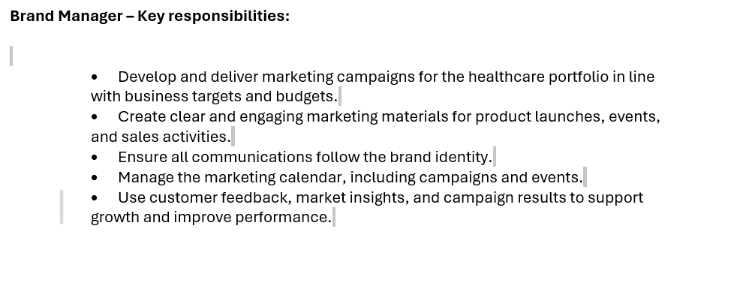
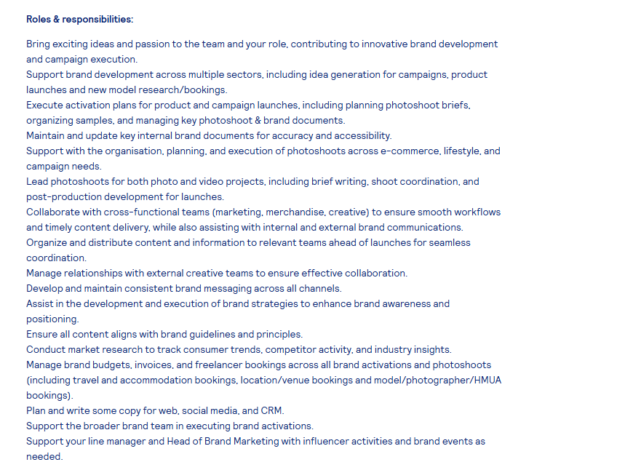

The first job advertisement requires you to
- develop & deliver marketing campaigns aligned to business targets & budgets.
- Use customer feedback, market insights & performance data to drive brand growth.
- Manage full marketing calendar for campaigns, events & product launches.
The second advertisement requires you to
- Contribute innovation & ideas to brand development & campaign delivery
- Generate campaign concepts, product launch ideas & market research proposals
- Support brand strategy rollout across multiple industry sectors
Both roles require the position of a brand manager to take full ownership of a brand's identity, values, reputation, and long-term growth trajectory. They translate high- level business goals into clear, consistent brand strategies that guide all marketing and communication work.

- Brand planning - Both roles require you to have the ability to translate business goals into a clear brand strategy, using customer feedback, market research and performance data to make campaigns.
- Brand consistency – Both roles insist on rigorous rules for maintaining a unified brand identity: ensuring all materials, activities and communications follow brand guidelines.

Having branding consistency helps to deliver coordinated identity, bringing a excelling customer experience, from your website and social media to health care development. Customers need to observe consistent cues to remember and trust your brand. 60% of consumers prefer buying from brands they recognise over unknown alternatives (Nielsen 2025). Consistency ensures that your core values are met. It helps with sustainability, safety, and transparency. When having consistency, it drives efficiency and value. It reduces wasted time and resources. Over time, consistency produces brand equity: the extra value your brand carries simplicity because it is well-known and trusted. According to Index box (2026) found that brands with high consistency see 23% higher revenue on average than inconsistent peers, as customers are usually willing to pay a premium for reliability and clarity.

Task 2
Self-Assessment: Conduct a self-assessment to identify your personal strengths and areas for further development. You may use the SWOT analysis (Strengths, Weaknesses, Opportunities, Threats).

Self-assessment is vital for understanding my capabilities and areas of growth. I will be using a SWOT analysis to reflect on my strengths, weaknesses, opportunities, and threats regarding my employability and career development. The personal SWOT analysis uses the framework established by Humphry (2005) and follows best practice outlined by Johnson et al. (2023), evaluating internal capabilities and external factors relevant to the brand manager role.

One of my key strengths lies in excellent communication skills. The ability to multitask and problem-solve. Leading teams and directing people. Having the assurance to be confident and complete tasks consistently. I know how to conduct a meeting and provide next steps. I pride myself on having the ability to meet deadlines. According to British Business Bank (2026), Support for Small Businesses: Marketing and Branding. London: British Business Bank. “Access to targeted training and resources can strengthen brand management capabilities without high costs.

Table 1: Personal strengths identified in SWOT Analysis
strength | Evidence | Impact on Employability
Impact on brand management performance | I have firsthand knowledge of exactly what makes the service different, which reduces the risk of diluting the brand. | Employers and investors actively seek managers who can build trusted ethical brands; this is a rare and high-demand skill.
Teamwork and cooperation | Experience working in a group with positive contributions as a team player. When the team leader wasn’t present, I kept the team motivated. I was there to remind other team members of the roles they had and to encourage them to get tasks done. | To have excellent communication skills to help build effective relationships.
Academic commitment | Being consistent with completing assignments and attending classes. | Having the ability to achieve the goals I have set.
Proactive learning & self-development | Demonstrated resilience, growth and the ability to adapt. | Being proactive

The things that some employers look for are reliability, teamwork and accountability. When participating in group projects, I consistently completed tasks on time and to a high standard, highlighting my organisational skills and commitment to the team. This showed my dedication. When I have completed courses in the past, I have completed the course, showing I am committed to finishing tasks.

Weaknesses
As part of my self-assessment, I have identified areas where I can develop further, and I recognise these weaknesses are opportunities to improve my skills and work performance. I am fully committed to addressing each point through clear action plans.

One of my main weaknesses is that I tend to overcommit to tasks, as I want to deliver high standards and support others whenever possible. This means I sometimes take on more work than I can comfortably manage, which can lead to tight deadlines to say “no” when people ask for help, as I am to be reliable and helpful, though I know this can affect my own workload.

Balancing business, study and family responsibilities | Managing three key areas at once means I sometimes need to adjust plans last minute or may take longer to complete tasks than expected. This requires careful planning to keep everything on track. | Use time-blocking and weekly schedules to allocate dedicated time for each area. Review progress every week and adjust priorities if things change.
Finding it hard to say “no” to requests | I often agree to extra jobs or favours even when my schedule is already full, because I want to be supportive and reliable. This spreads my focus too thin and risks lowering the quality of my work or delaying existing commitments. | Practise polite but clear communication: explain my current workload, offer alternative dates, or suggest other ways to help. Instead of agreeing immediately, set clear boundaries for what I can reasonably manage.
Tendency to overcommit to tasks | I take on more work or projects that I can comfortably deliver within set timescales, because I want to help and meet high standards. This can create unnecessary pressure, cause tight deadlines, or mean I spend less time on detailed, high-priority work. | Use the Eisenhower Matrix to rank tasks by important and urgency. Always check my current capacity before agreeing to new work, and set realistic timelines from the start.

Opportunities
Opportunities are external factors or possibilities I can take advantage of to grow my skills, advance my career, and develop my business. By recognising these areas, I can effectively make the most of them and move closer to my goals.
There are several key opportunities available to me right now, including growing demand for sustainable services, access to learning resources, and expanding into new markets. I can also use my existing skills and background to build strong professional connections and open up new pathways for development.

Opportunity | Evidence | Impact on Employability
University careers support | One-to-one guidance sessions, CV and cover letter checks, mock interviews and skills workshops. | Helps me present myself professionally, understand what employers look for, and fix gaps in my application style, making me much more prepared for recruitment processes.
Online learning & professional development | Access to certified courses on LinkedIn. | Let's me learn new skills and gain recognised qualifications in my own time, adding extra value to my CV and showing I am motivated to keep learning
Flexible working options | More employers are now offering hybrid, part-time or remote working arrangements | Gives me access to a wider choice of jobs, and makes it easier to balance work, studies and family responsibilities reliably.

Threats
Threats are external factors, challenges or changes outside of my control that could potentially affect my studies, skill development or future employment prospects. By identifying these risks early, I can plan how to manage or reduce them, so they do not stop me from achieving my academic and career goals.

Treat | Evidence/ Explanation | Impact on Academic Progress & Employability
High competition for jobs & training places | Large numbers of students and graduates enter the workforce each year; many roles have many applicants | Makes it harder to secure interviews or positions; means I need stronger evidence of skills and experience to stand out
Cost of living financial pressures | Rising living costs in the UK: expenses for study materials, travel, or training courses | May limit how much time or money I can spend on extra learning, work experience or development activities

Conclusion
Overall, completing this SWOT self-assessment has helped me gain a clear understanding of my current position, my strengths and the areas I need to develop further. I have valuable strengths, including strong organisational skills. I recognise my weaknesses, such as taking on too much work and developing new industry knowledge, but I now have clear action plans to improve these areas.

Personal development plan

Action | Timeline | Resources | Measurement
Complete CIM/uni brand strategy tutorials | 3 weeks | Brand Management (Kotler & Keller) | Produce 1 analysis aligned with module criteria
Apply theory to Brand Manager role | 4 weeks | British Business Bank guides, lecture notes | Tutor confirms strong theory-practice links
Practice referencing | 2 weeks | Uni Harvard guide, Cite Them Right | 0 errors in 2 consecutive assignments

Reference list
- Nielsen (2025). Annual Global Marketing Report 2025. Nielsen Holdings plc, New York.
- Index Box (2026). Small Business Branding & Marketing Benchmarks 2026. Index Box Research, London.
- Humphry, A. (2005). Brand Meaning and Culture Practice. Routledge, London.
- Johnson, D., Hughes, J. and Lee, S. (2023). ‘Entrepreneurial branding for UK SMEs: practical strategies for growth’, Journal of Small Business and Enterprise Development, 30(2), pp. 345-362. DOI: 10.1108/JSBED-08-2022-0321.
- British Business Bank. (2026). Support for Small Business Marketing and Branding. British Business Bank, London.
- London British Business Park. (2026). Business Support Services. London British Business Park, London.

