

Student name: | Yaatri Ramesh bapodra | Student ID number: | 2536592
Programme: | Master of Business Administration
Module: | Marketing Management
Module code: | LCMB7024 | Contribution to Overall Module Assessment (%): | 50%
Lecturer: | Laila Maazouz (London)  Taonga Kaonga Sobere-Snithers (Birmingham) | Internal Verifier: | Vasilios Tavlaridis  Hoang Nguyen

Table of Contents
List of Figures 2
List of Tables 2
List of Abbreviations 3
Introduction 4
Element 1: Sustainable Brand Extension Poster 5
1.1 Sustainable Brand Extension Poster Summary 5
Element 2: Segmentation, Targeting, Differentiation and Positioning (STDP) Analysis 6
2.1 Segmentation 6
2.1.1 Geographic Segmentation 7
2.1.2 Demographic Segmentation 7
2.1.3 Psychographic Segmentation 7
2.1.4 Behavioural Segmentation 8
2.2 Targeting 8
2.3 Differentiation 9
2.4 Positioning 9
Element 3: Marketing Mix (4Ps) 10
3.1 Product 11
3.2 Price 12
3.3 Place 12
3.4 Promotion 13
Element 4: Reflection 14
4.1 Description 14
4.2 Feelings 15
4.3 Evaluation 15
4.4 Analysis 15
4.5 Conclusion 15
4.6 Action Plan 16
References 17

List of Figures
Figure 1: Key Sustainability Trends Supporting Dove Solid Care
Figure 2: Sustainable Brand Extension Poster
Figure 3: Segmentation Strategy for Dove Solid Care
Figure 4: Target Market for Dove Solid Care
Figure 5: Marketing Mix (4Ps) Strategy for Dove Solid Care
Figure 6: Application of Gibbs' Reflective Cycle to the Development of Dove Solid Care

List of Tables

Table 1: Evaluation of Dove Solid Care Marketing Strategy

List of Abbreviations

Abbreviation | Full Term
CAGR | Compound Annual Growth Rate
IMC | Integrated Marketing Communication
STDP | Segmentation, Targeting, Differentiation and Positioning

Introduction
Dove is one of the world's most popular personal care brands, renowned for its high-quality products and its increasing commitment to sustainability initiatives (Unilever, 2025). As consumer preferences continue to evolve to demand ever greener products, sustainable brand development has become a crucial strategy for business growth in the long term. According to Rahman et al. (2024), a successful brand development is done by responding to the changing market needs by offering meaningful innovation.

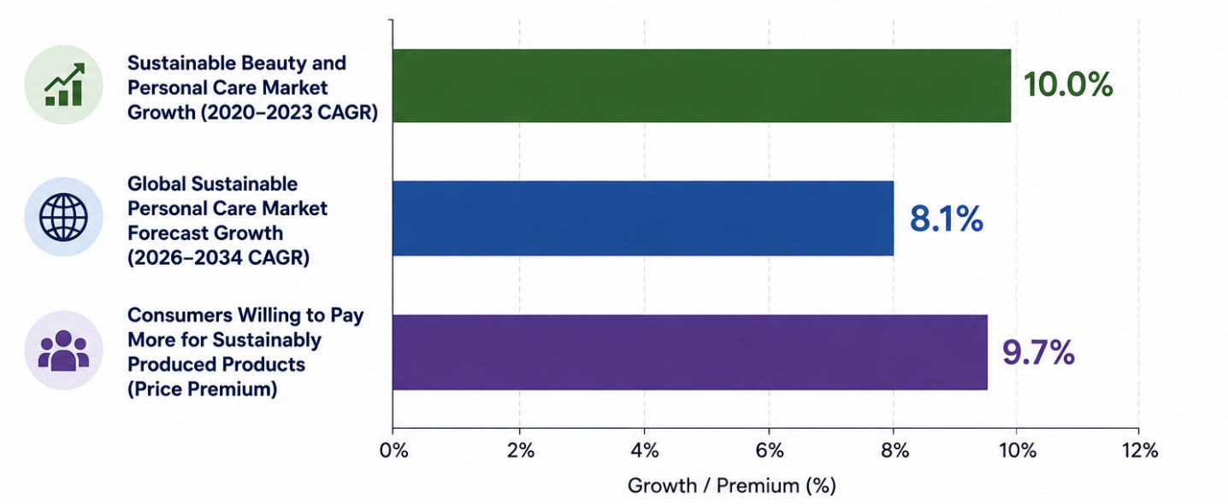
Figure 1: Key Sustainability Trends Supporting Dove Solid Care
Source: Adapted from Euromonitor International (2024), PwC (2024), and Fortune Business Insights (2025).

The beauty industry is not spared of this trend either, as consumers have become more interested in sustainable and eco-friendly personal care products and services. Unilever's increasing focus on sustainability and how it is incorporated into its long-term marketing strategy is also emphasised by Reza (2020). Therefore, this portfolio suggests the product: Dove Solid Care, which is a sustainable brand extension with waterless products in personal care with plastic-free packaging to reduce environmental impact. The portfolio will critically discuss the proposed extension in a poster presentation, a STDP analysis, the Marketing Mix.

Element 1: Sustainable Brand Extension Poster
The proposed sustainable brand extension is communicated through a professional marketing poster which first shows the strategic value of the brand extension and then its commercial potential. The poster is a concise overview of the concept's solution to the current sustainability issues and also acts as the basis for Dove's long term development plan.
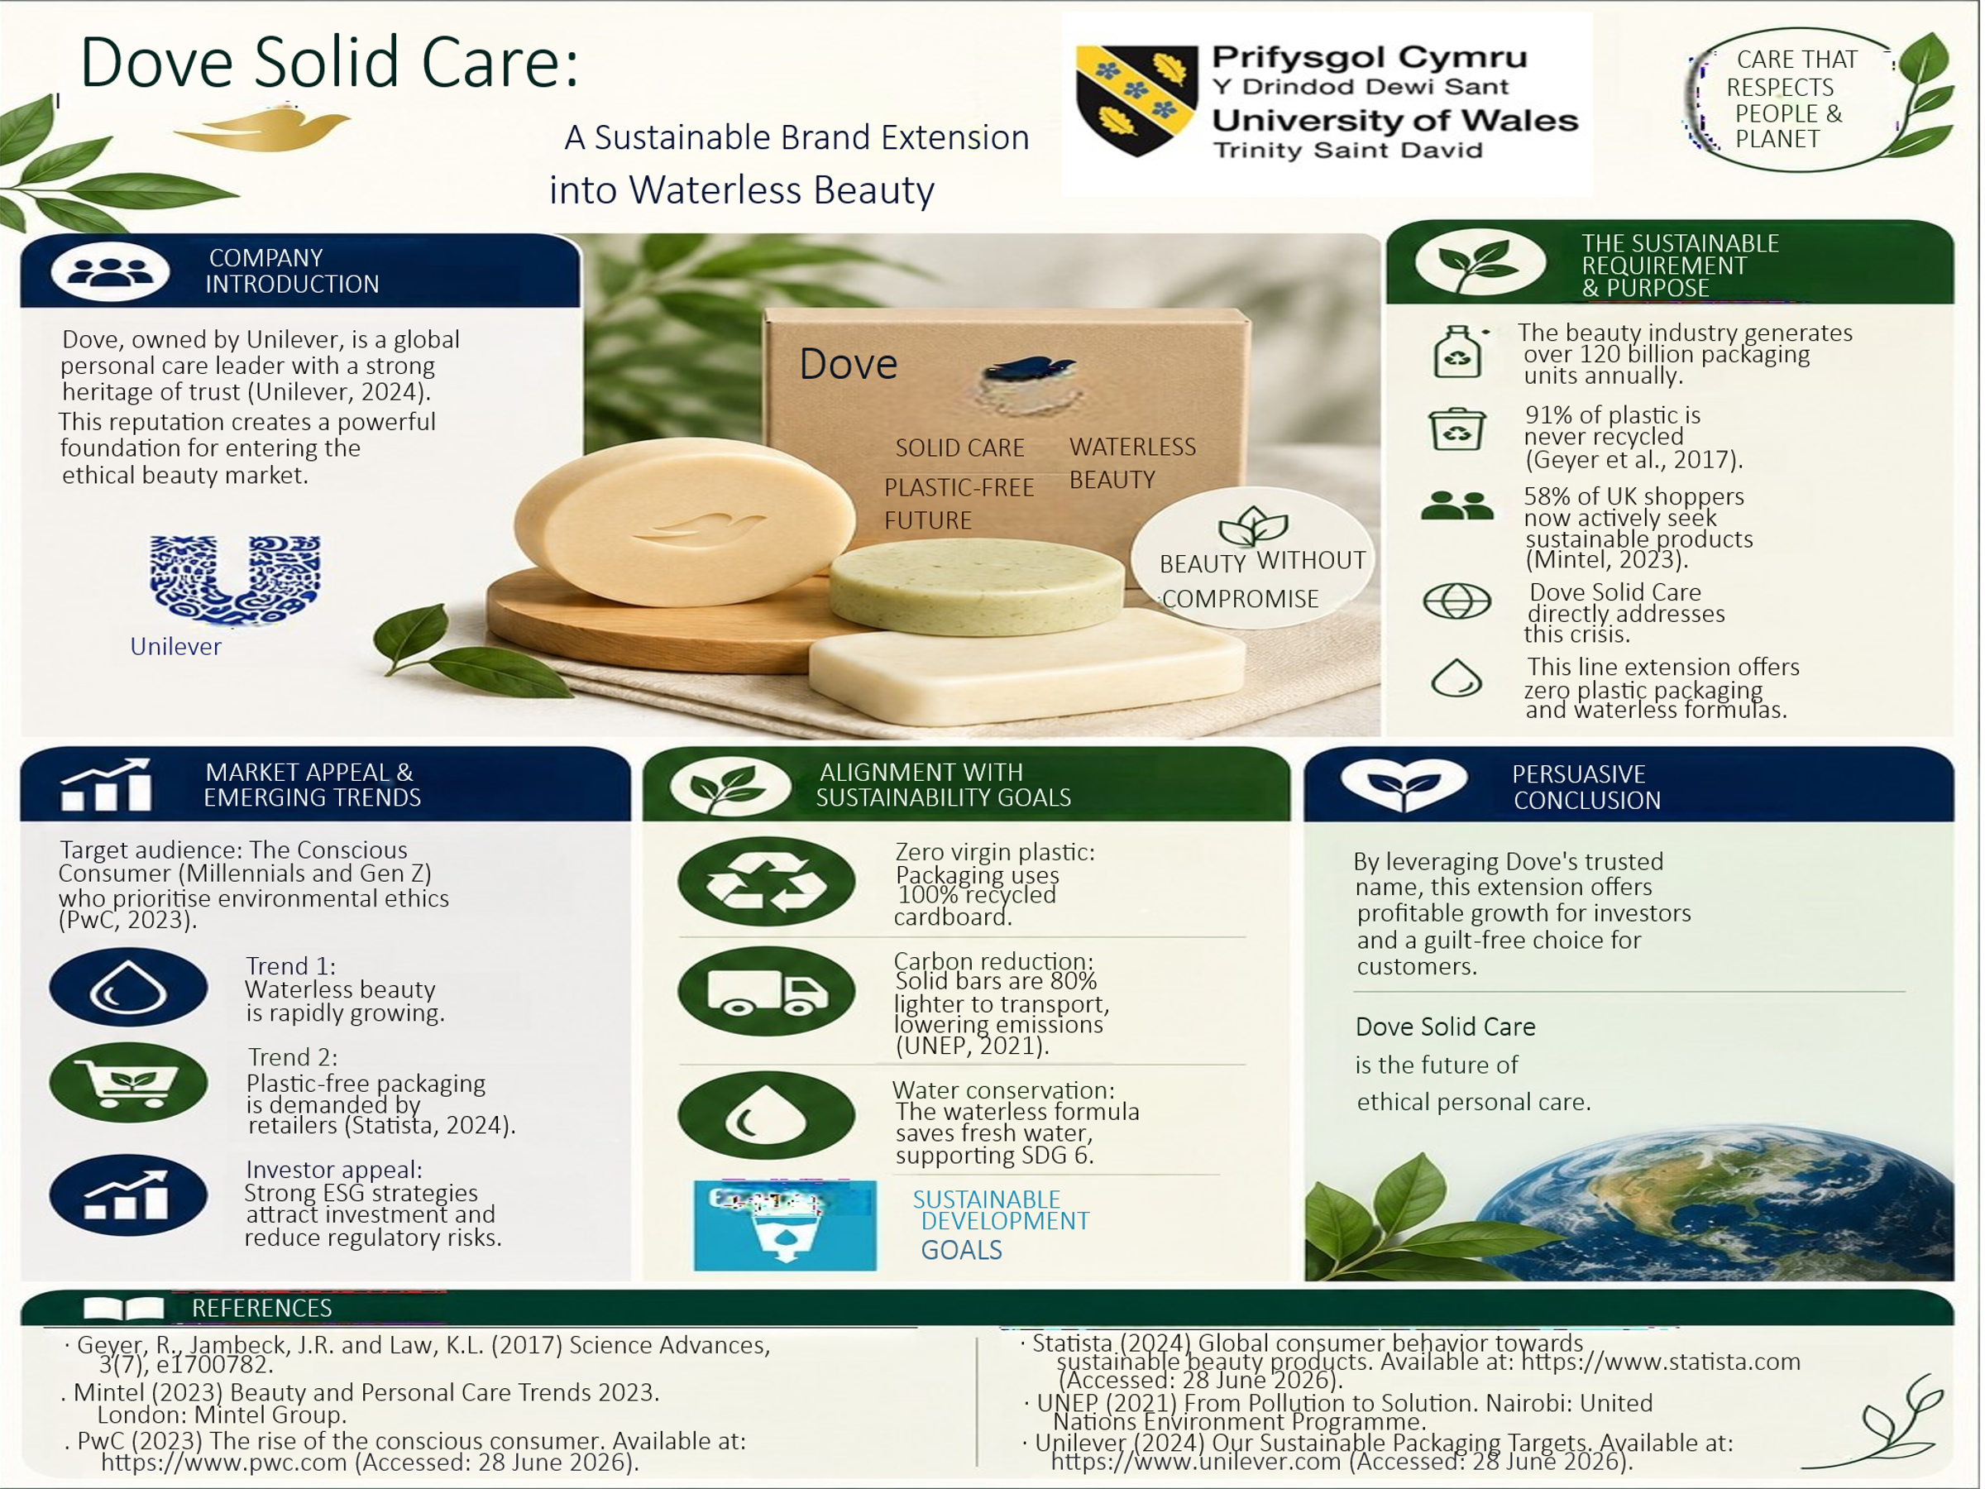

1.1 Sustainable Brand Extension Poster Summary
The poster introduces Dove Solid Care, the first sustainable brand extension to offer waterless personal care items, which help to solve the problem of plastic packaging waste and water waste. Shows how Dove has excellent brand recognition and how the extension is a smart move for the growing demand for sustainable beauty products. The beauty industry produces more than 120 billion packaging units each year, and about 91% of plastic waste is never recycled (Frantzeskos, 2022). What's more, 58% of UK consumers actively buy sustainable products, indicating market potential is growing (Sinervö, 2025). The waterless formulations and plastic-free packaging will minimize packaging waste, transportation emissions, and water consumption at the same time in Dove Solid Care. The poster is also aligned with the United Nations Sustainable Development Goals, specifically responsible consumption and environmental sustainability. Overall, the proposed brand extension is a good business extension that will enhance Dove's competitive edge and will provide value to consumers, investors, and the environment.

Element 2: Segmentation, Targeting, Differentiation and Positioning (STDP) Analysis

2.1 Segmentation
Market segmentation is a process that breaks down a heterogeneous market into smaller units of markets with similar needs and purchasing behaviour. According to Kotler and Keller (2024) a good segmentation allows organisations to create value propositions that better meet customer expectations for improved marketing performance. For Dove Solid Care, segmentation is a way to distinguish customers who prioritize and appreciate a sustainable lifestyle and want to use innovative personal care products that provide the best skin care benefits and contribute to the environment less. The proposed sustainable brand extension is enhanced by this targeted approach.
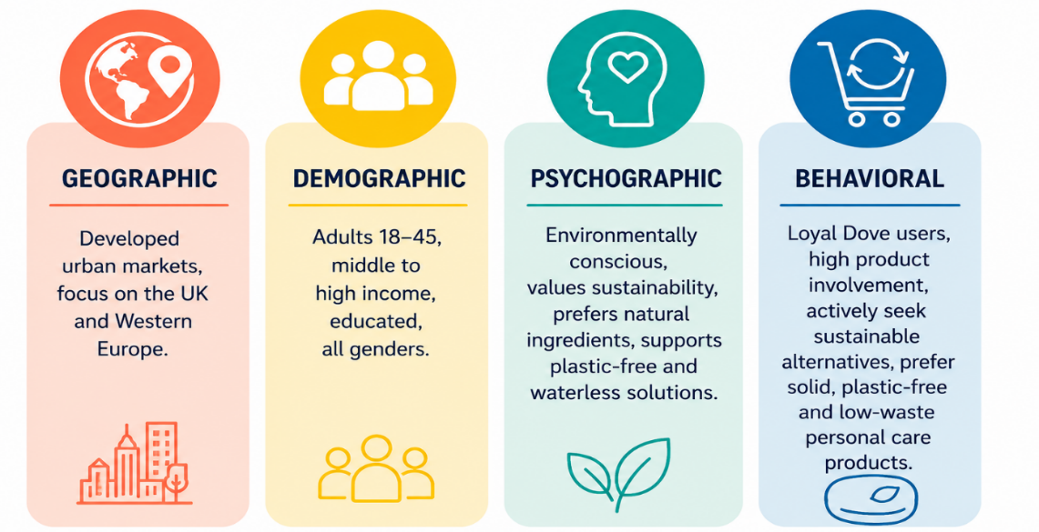
Figure 2: Segmentation Strategy for Dove Solid Care
Source: Author's Own illustration

2.1.1 Geographic Segmentation
Dove Solid Care focuses its efforts on developed urban markets; primarily on the United Kingdom and Western Europe, where environmental awareness and sustainability regulations and demand for sustainable consumer products remains growing. The European Commission (2025) emphasizes that the EU is currently implementing a number of policy measures aimed at waste reduction and more sustainable consumption patterns. In addition, Akter and Kabir (2025) state that consumers in developed markets are increasingly becoming inclined towards sustainable packaging and environmentally friendly products. This means that Dove Solid Care can thrive in these markets due to the waterless products and plastic-free packaging that is in line with regulatory demands and consumer preferences.

2.1.2 Demographic Segmentation
The target market for this brand extension is men and women in the age range of 18-45 and with middle to high income levels and relatively high educational level. These consumers tend to be more willing to try new products that offer them both personal and environmental benefit. While Dove has traditionally been a brand for women, gender-inclusive purchasing is taking place in the personal care sector. According to Paulauskaite (2019), demographics are still important when looking at purchasing decisions, but should be analysed in conjunction with lifestyle and value factors. Hence, Dove Solid Care targets consumers who have the capability and awareness to back up sustainable product innovations.

2.1.3 Psychographic Segmentation
Psychographic segmentation is based on consumers' lifestyles and personal values that are more in tune with sustainable consumption. The Dove Solid Care market focuses mainly on people that are aware of their surroundings and concerned with ethical buying, waste reduction and responsible use of resources. While sustainability has become a bigger driver of consumer purchasing among Millennials and Generation Z, consumers are still focused on quality, convenience and value, as well as sustainability (PwC, 2024). This understanding of the changing landscape of beauty products means that Dove Solid Care sets itself apart by offering both waterless solid products and Dove's proven skincare knowledge, without sacrificing product efficacy for sustainability.

2.1.4 Behavioural Segmentation
Behavioural segmentation targets personal care consumers who have already chosen Dove as their product of choice, are regular users of the brand and actively look for sustainable options like waterless products and plastic-free packaging. These consumers show higher level of brand loyalty, product usage, and are more likely to adapt environmentally friendly purchasing behaviours. Gupta, Tyagi and Upadhyay (2025) state that when new innovations are introduced that are sustainable, consumers' perceived risk is reduced when the innovation is from a trusted brand. This makes Dove more trusted by consumers, making them more likely to keep purchasing Dove Solid Care and become more sustainable consumers.

2.2 Targeting
Dove Solid Care targets consumers who are actively looking for personal care products made from environmentally responsible ingredients and who are loyal to the brand. The extension is not for everyone in the personal care market it aimed at consumers who prefer waterless products, reduction in plastic packaging and sustainable use without sacrificing product performance.
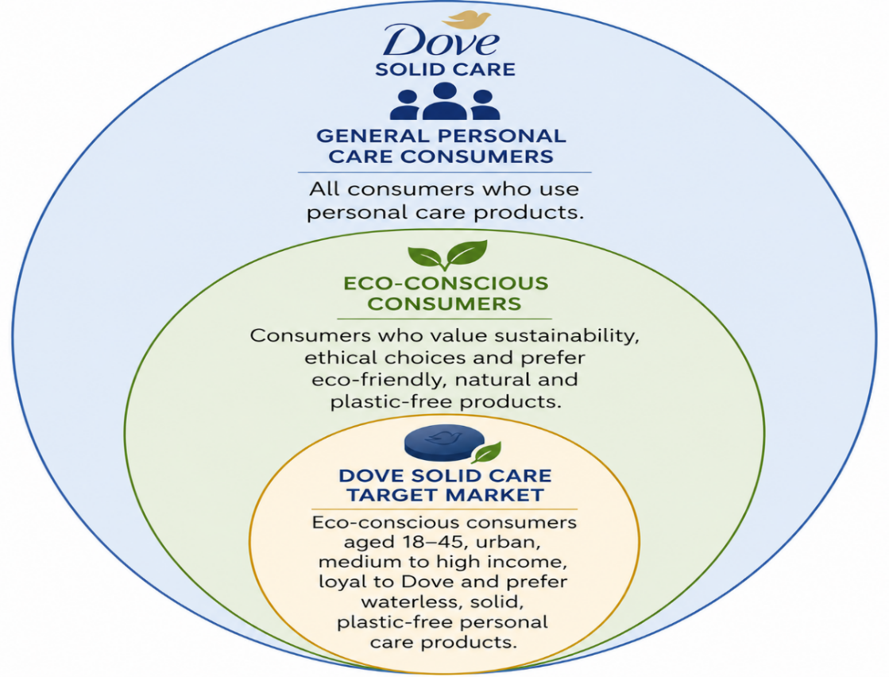
Figure 3: Target Market for Dove Solid Care
Source: Author's Own illustration
According to Jensen (2024), focused targeting allows an organisation to tailor a more relevant value proposition, which enhances marketing effectiveness and helps build customer relations. This strategic direction is in line with Dove's goal of fostering long-term customer loyalty and adoption of their sustainable personal care products. Moreover, brand which sustainably manage to link their work with consumers' demands, will have better competitive performance and brand equity (Paulauskaite, 2019). Therefore, focusing on this expanding market segment is more effective in the marketing campaign, fosters repeat sales and contributes to sustainable business development.

2.3 Differentiation
The differentiating factor of Dove Solid Care is the use of multiple solid formulations, wrapped in plastic-free packaging, using Dove's trusted skincare expertise which has a minimal impact on the environment. The extension adds value to the product by combining sustainability with the quality of care that is taken every day with skin. Porter (1985) says that while differentiation gives competitiveness, it must provide something that is different and valuable to others that is hard to duplicate. Brands like The Body Shop and L'Oréal Paris have set up their sustainability strategies, Dove Solid Care has got something that differentiates it with the rest; Dove's waterless personal care products and Dove's reputation for gentle skin care and brand trust (Abubakari and Thuranira, 2021). The integrated value proposition enhances the competitor value while contributing to the long-term brand value.

2.4 Positioning
Dove Solid Care is a quality, affordable and eco-friendly personal care line that helps consumers to minimize plastic waste and water usage, while maintaining skin care efficacy. According to Duarte, Till and Hafeez (2024), the effective positioning creates a unique place in consumers' minds by delivering a clear and meaningful value proposition. Thus, Dove Solid Care is an extension of Dove's commitment to trusted skin care and sustainable innovation, by using waterless skin care products and plastic-free packaging. This positioning will reinforce brand loyalty, differentiate this extension from the usual personal care products and boost Dove's presence in the growing competitive sustainable beauty sector.

Element 3: Marketing Mix (4Ps)
The Marketing Mix is a strategic tool through which the chosen brand extension can be put into practice, by coordinating marketing operations to match the needs of customers and the mission of the organisation. Product, price, place and promotion integration can increase the value to customer, reinforce competitive advantage (Kpoku, 2021). The discussion below critically reviews the contribution of each of the 4Ps, to the successful implementation of Dove Solid Care and to its sustainability goals.
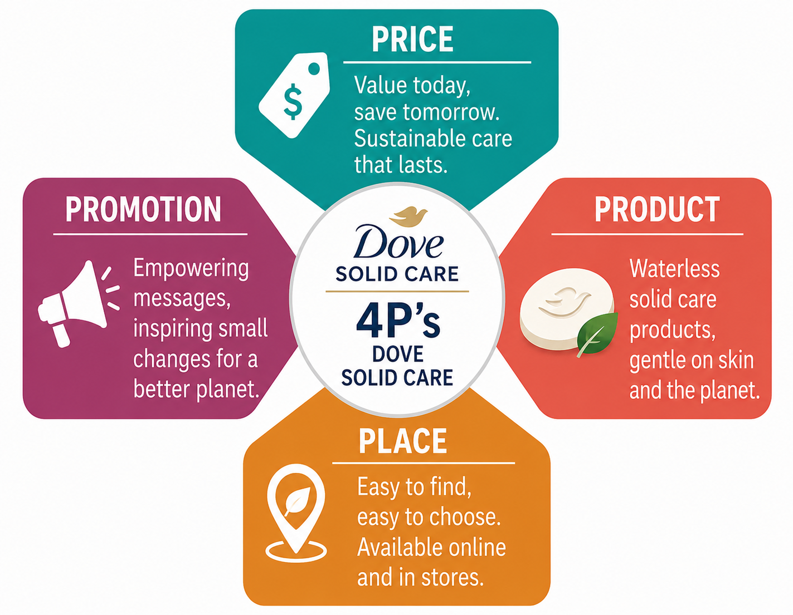
Figure 4: Marketing Mix (4Ps) Strategy for Dove Solid Care
Source: Author’s Own illustration

Table 1: Evaluation of Dove Solid Care Marketing Strategy
Marketing Mix | Strategic Decision | Strategic Justification | Potential Challenge
Product | Waterless solid products with plastic-free packaging | Promotes sustainability without compromising on Dove's trusted skin care quality | Consumer acceptance of solid product formats
Price | Value-based pricing | Shows environmental value and product value at an affordable price | Higher perceived price than conventional products
Place | Omnichannel distribution | Expand distribution by retail stores and through online channels | Maintaining consistent product availability
Promotion | Integrated sustainability communication | Establishes trust through real environmental improvements | Avoiding consumer perceptions of greenwashing
Source: Author's Own illustration

3.1 Product
Product strategy is not just about the functional characteristics of the product, but also about providing value to meet evolving consumer needs, alongside organizational goals. According to Jurewicz and Dehghan (2025), the key to developing a successful product is to combine physical characteristics with intangible qualities that will help to enhance customer satisfaction and brand equity. To this end, Dove Solid Care launches a line of 100% water-free personal care products such as shampoo bars, conditioner bars, body wash bars and cleansing bars in plastic-free, recyclable packaging.
The extension meets the growing demand from consumers for eco-friendly products and is based on Dove's long history of gentle, dermatologically-tested skin care. Sustainable packaging does not necessarily provide a competitive edge, though, without ensuring quality and convenience. Nitsis (2022) believes that sustainable innovation results in higher value when taken together with consumer expectations and added to the environmental benefits. This results in the synergy of effective skincare technology, water saving and plastic free packaging; Dove Solid Care has made an impact on brand equity and sustainable consumption.

3.2 Price
Dove Solid Care has a value-based pricing model, which accounts for the environmental and functional value being created by the waterless formulations and plastic-free packaging. The goal is not to be the lowest cost competitor but to be the one most valuable to the consumer and be of the highest product quality. According to Fadheel (2024), value-based pricing enhances customer satisfaction by making the price more meaningful to the customer.
While solid personal care products may be priced slightly higher than traditional products, they will often last longer, and will decrease packaging waste, which will be more beneficial in the long run. Moreover, consumers are more willing to pay for sustainable products if they like the product and the brand is well known (Chou, 2025). As a result, Dove Solid Care is not just cost-effective but also eco-friendly, reinforcing its high-end positioning and ensuring sustainable business growth.

3.3 Place
Dove Solid Care has an omnichannel distribution, in order to increase accessibility and foster sustainable consumption. It is sold in supermarkets, pharmacies, online stores, on the Dove website and in selected sustainable beauty stores. Syaharani (2021) states that good distribution will help to make the customer's life easy, as well as covering the entire market, which is important to achieve successful product adoption.
By combining both physical and online distribution, Dove can serve those consumers with its products who are environmentally conscious at the places they like to shop. This strategy provides greater convenience for customers, helps to encourage repeat purchases and ties in with Dove's long term sustainability goals (Unilever, 2024). Therefore, the chosen distribution strategy ensures market penetration and helps to achieve the successful commercialisation of Dove Solid Care.

3.4 Promotion
Dove Solid Care uses an integrated marketing communication (IMC) approach, leveraging digital marketing, social media, influencer partnerships and sustainability campaigns to convey its value proposition regarding environmental sustainability. Alamsah and Purwanto (2025) state that the integrated promotion can improve the brands awareness and trust by enabling a consistent communication across multiple channels.
Dove Solid Care is not a sustainability message itself; it is a sustainability product that brings together Dove's trusted skin care expertise. This is not only a more credible way of communicating a message, but it also helps lower consumer scepticism about sustainability messages. Moreover, genuine storytelling backed up by clear environmental actions contributes to the enhancement of the brand's reputation and, consequently, to the positive impact on purchasing behaviour (Kittler, 2025). As a result, the promotional approach helps to increase engagement, boost the usage of waterless personal care products, and further solidify Dove's competitive position in the long term.

Element 4: Reflection
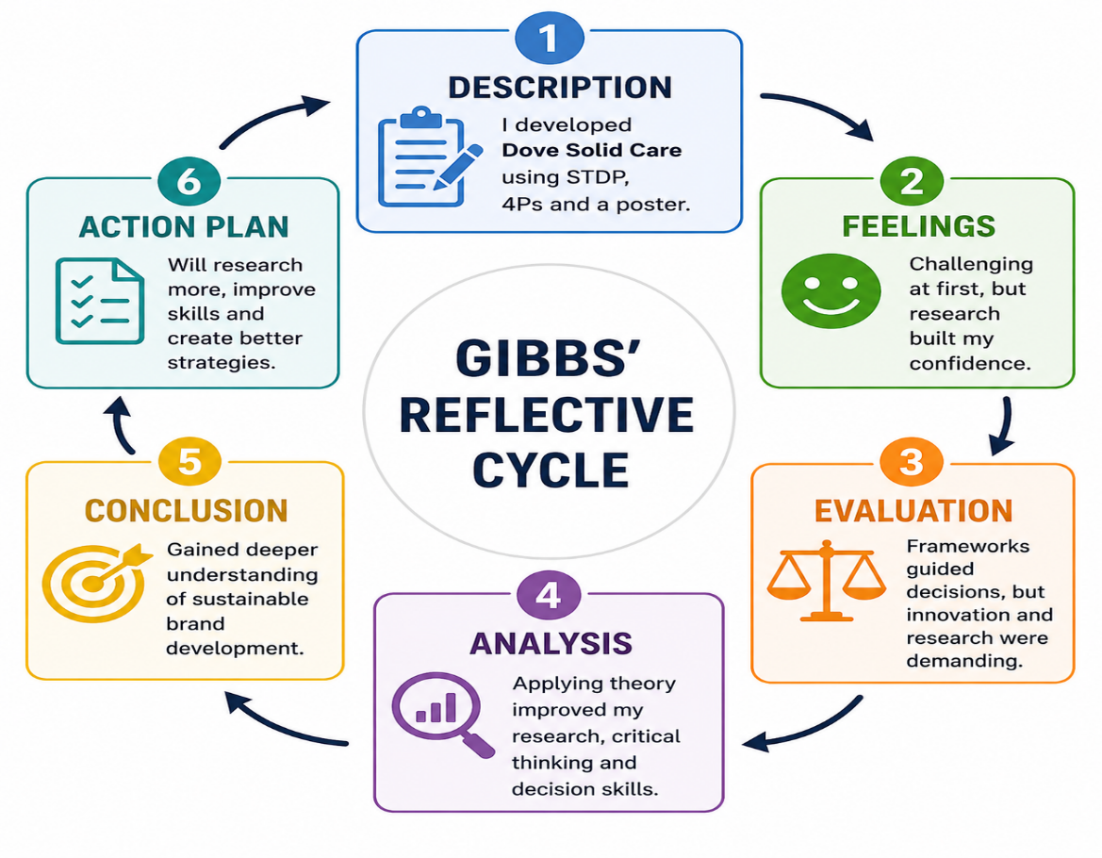
Figure 5: Application of Gibbs' Reflective Cycle to the Development of Dove Solid Care
Source: Author's Own illustration

4.1 Description
According to Gibbs (1988), description stage is one which gives an objective account of an experience prior to the critical evaluation stage. In this portfolio, I use the marketing concepts of Segmentation, Targeting, Differentiation and Positioning (STDP), and the Marketing Mix to develop Dove Solid Care as an extension of the brand that will be sustainable. The project also includes the design of a professional poster for communication of the strategic value of the proposed extension. All along the way I refer to current academic research and industry evidence to support marketing decisions and to make sure that a proposed strategy can solve current sustainability issues in the personal care industry (Chou, 2025).

4.2 Feelings
I struggle with this project at the beginning because there is a need to combine theory aspects of marketing with business aspects. I start to build myself up, though, as I read more academic research and industry evidence, my confidence slowly builds up. The way Gibbs (1988) describes it, personal responses are the recognition that fosters the development of self-awareness and reflective learning. The experience in assessing marketing strategies and creating evidence-based recommendations for sustainable business growth (Kotler et al., 2024) has boosted my confidence and competence.

4.3 Evaluation
The project offers a great chance to use well-known marketing tools in a real sustainability problem. The use of the STDP framework and the Marketing Mix helps to ensure that decisions made are academic and not assumption based. The ability to choose an innovative brand extension and critically analyse literature from the past few years, however, does take a lot of analytical thinking and judgment. Although all these are obstacles, it has improved my capacity to create marketing strategies that will align customer value with organisational goals (Fadheel, 2024).

4.4 Analysis
The experience shows that theoretical knowledge and understanding are not sufficient for successful sustainable marketing, but also involves critical examination of market conditions and consumer requirements. The analysis process is useful in gaining a better understanding by looking at the how and why of the outcomes. Implementing marketing theories in a real organisational context is helpful to build up my research skills, critical thinking and logic skills to support a strategic decision with credible evidence. These skills are vital to successful strategic marketing (Kotler et al., 2024).

4.5 Conclusion
Overall, this project has helped me to gain a better understanding of sustainable brand development and the value of evidence-based marketing decisions. Reflective practice allows me to identify my strengths and where I need to develop further, which helps my professional development (Kpoku, 2021).

4.6 Action Plan
In the future, I plan to improve my strategic marketing skills by doing more research from current academic research and industry reports. I will also continue to build my critical analysis, presentation and communication skills to create more innovative and sustainable marketing strategies that will effectively meet the varying demands of the market and organisational goals (Jensen, 2024).

References
Abubakari, M. and Thuranira, B. (2021) ‘The consumer goods sector and the sustainability agenda in Ghana: A review of sustainability commitments’, Discover Sustainability, 2(1), Article 27. Available at: https://doi.org/10.1007/s43621-021-00037-8 (Accessed: 7 July 2026).
Akter, M.S.B. and Kabir, T. (2025) Exploring the impact of sustainable packaging on brand value and consumer loyalty in the FMCG sector: Insights from Unilever. Bachelor’s thesis. South-Eastern Finland University of Applied Sciences. Available at: https://www.theseus.fi/bitstream/handle/10024/886161/Akter_Kabir.pdf?sequence=2&isAllowed=y (Accessed: 7 July 2026).
Alamsah, H.A. and Purwanto, S. (2025) ‘The influence of product quality, brand image, and packaging on customer loyalty of Dove products in Surabaya City, Indonesia’, Golden Ratio of Mapping Idea and Literature Format, 6(1), pp. 252–265. Available at: https://www.goldenratio.id/index.php/grmilf/article/view/1691/1089 (Accessed: 7 July 2026).
Chou, Y.C. (2025) SDG branding’s price premium effect in the cosmetic industry: Empirical study of how Sustainable Development Goals affect consumer willingness to pay. Doctoral dissertation. Waseda University.
Duarte, A., Till, B. and Hafeez, K. (2024) ‘Brand positioning strategies: Creating and communicating unique value propositions’, in Strategies for Brand Communications and Management: Bridging Academia and Practice, pp. 86–115. Available at: https://www.gbppublications.com/_files/ugd/5e526c_c3bf3b6cf4554b91a722de8e7c512c9a.pdf#page=99 (Accessed: 7 July 2026).
European Commission (2025) Annual activity report 2024: Secretariat-General. Brussels: European Commission. Available at: https://commission.europa.eu/document/download/978fd0f7-588f-4a3f-a969-e6e5742f5111_en?filename=SG_AAR_2024_final.pdf (Accessed: 7 July 2026).
Fadheel, M. (2024) Navigating the transition: Implementing value-based pricing for refurbished products offered as services. Master’s thesis. Karlstad University. Available at: https://www.diva-portal.org/smash/get/diva2:1901765/FULLTEXT01.pdf (Accessed: 7 July 2026).
Frantzeskos, O. (2022) Beauty and the Beast: Plastic Pollution in the Personal Care and Cosmetics Industry. Bachelor’s thesis. Fordham University. Available at: https://research.library.fordham.edu/cgi/viewcontent.cgi?article=1134&context=environ_2015 (Accessed: 7 July 2026).
Gibbs, G. (1988) Learning by doing: A guide to teaching and learning methods. Oxford: Oxford Polytechnic.
Gupta, G.K., Tyagi, P. and Upadhyay, A. (2025) ‘Dr. Gaurav Kumar Gupta, Pankaj Tyagi and Dr. Akhilesh Upadhyay’, Journal of East-West Thought, 15(4), pp. 110–121. Available at: https://jetjournal.us/index.php/journals/article/view/1011/639 (Accessed: 7 July 2026).
Jensen, S.M. (2024) A study on the advertisements of soap brands. Project report. Available at: http://115.242.226.198:8080/jspui/bitstream/123456789/1117/1/Saincy%20Maria%20Jensen.pdf (Accessed: 7 July 2026).
Jurewicz, E. and Dehghan, P.M. (2025) Optimizing CSR strategies for brand equity: A managerial approach in multinational corporations. Bachelor’s thesis. Mälardalen University. Available at: https://www.diva-portal.org/smash/get/diva2:1990656/FULLTEXT01.pdf (Accessed: 7 July 2026).
Kittler, Z.E. (2025) Authentic storytelling in sustainable branding: How narratives shape consumer trust and behavior. Bachelor’s thesis. South-Eastern Finland University of Applied Sciences. Available at: https://www.theseus.fi/bitstream/handle/10024/909260/Kittler_Zoe.pdf?sequence=2&isAllowed=y (Accessed: 7 July 2026).
Kotler, P., Keller, K.L. and Chernev, A. (2024) Marketing management. 17th Global edn. Harlow: Pearson.
Kpoku, O.K. (2021) Positive and negative influence of globalization on international business actors’ activity (on materials of Unilever Group). Master’s thesis. Poltava University of Economics and Trade. Available at: http://dspace.puet.edu.ua/bitstream/123456789/11137/1/Obed-Thesis-2020.pdf (Accessed: 7 July 2026).
Nitsis, C. (2022) Reduce, reuse, refill: Understanding the refill-based sector in Ontario. Master’s thesis. University of Toronto. Available at: https://www.proquest.com/openview/00fc82d2f234f99e42b1480ef324e1cc/1?pq-origsite=gscholar&cbl=18750&diss=y (Accessed: 7 July 2026).
Paulauskaite, K. (2019) The Millennial Generation’s Impact on Brand Equity and Brand Personality: Reinforcement of Consumer Loyalty. Bachelor’s thesis. Metropolia University of Applied Sciences. Available at: https://www.theseus.fi/bitstream/handle/10024/186587/Paulauskaite_Karolina.pdf?sequence=2&isAllowed=y (Accessed: 7 July 2026).
Porter, M.E. (1985) Competitive advantage: Creating and sustaining superior performance. New York: Free Press.
PwC (2024) Global annual review 2024: A year of solving together. London: PricewaterhouseCoopers International Limited. Available at: https://www.pwc.com/gx/en/global-annual-review/2024/pwc-global-annual-review-2024.pdf (Accessed: 7 July 2026).
Rahman, M.M., Miah, M.A., Siddiqa, K.B. and Orthi, S.M. (2024) ‘Successful digital transformation strategies in global business: A case study on Unilever’, International Journal of Advance Research, Ideas and Innovations in Technology, 10(1), pp. 773–787. Available at: https://ijariie.com/manuscript/22473 (Accessed: 7 July 2026).
Reza, M.M.H. (2020) Marketing strategy and sustainable plan of Unilever.
Sinervö, S. (2025) Understanding the line between greenwashing and green marketing. Bachelor’s thesis. South-Eastern Finland University of Applied Sciences. Available at: https://www.theseus.fi/bitstream/handle/10024/895775/Sinervo_Sanna.pdf?sequence=2&isAllowed=y (Accessed: 7 July 2026).
Syaharani, D.I. (2021) ‘The effectiveness of Dove Campaign for Real Beauty in affecting customers’ purchase decision toward Dove products’, Advanced International Journal of Business, Entrepreneurship and SMEs, 3(9), pp. 244–264. Available at: https://web.archive.org/web/20210927015119id_/http://www.aijbes.com/PDF/AIJBES-2021-09-09-20.pdf (Accessed: 7 July 2026).
Unilever (2024) Annual report and accounts 2024. London: Unilever PLC. Available at: https://www.annualreports.com/HostedData/AnnualReports/PDF/LSE_ULVR_2024.pdf (Accessed: 7 July 2026).
Unilever (2025) Annual report and accounts 2025. London: Unilever PLC. Available at: https://www.unilever.com/files/unilever-annual-report-and-accounts-2025.pdf (Accessed: 7 July 2026).

