ASSIGNMENT O1 – ESSAY
Harriot Hotel

Student name: Ventsislava Koleva
Student number: 1914054
Module: Management Accounting
Module code: LCBB5002

Brief Introduction of cost and its Behavior:
Executive Summary:
Here we will discussed about Harriot Hotel cost benefit analyses program. Due to pandemic All business suffered losses including hoteling industry. Harriot hotel is one of them which is facing huge losses.
So by cost benefit analyses program and by cost cutting we have reduced all cost up to some extent by doing so revenue increased up to some extent.
Here in Harriot hotel analyses we analyze cost and its behavior whether it is fixed cost variable or semi variable. We also provide suggestion for reduction in cost that will also be included in conclusion. We have also presented cost behavior by diagrammatically this will help for clear understanding of the case.

Cost
Definition:
Within the context of accounting and business, cost refers to the monetary value that has been spent by a company in order to produce something. In a business, cost expresses the amount of money that is spent on the production, development or creation of goods or services.
Cost behavior
Cost behavior shows four basic patterns, that is;
- Fixed
- Variable
- Mixed (semi-variable)
- Step
These costs would graphically appear as follows:
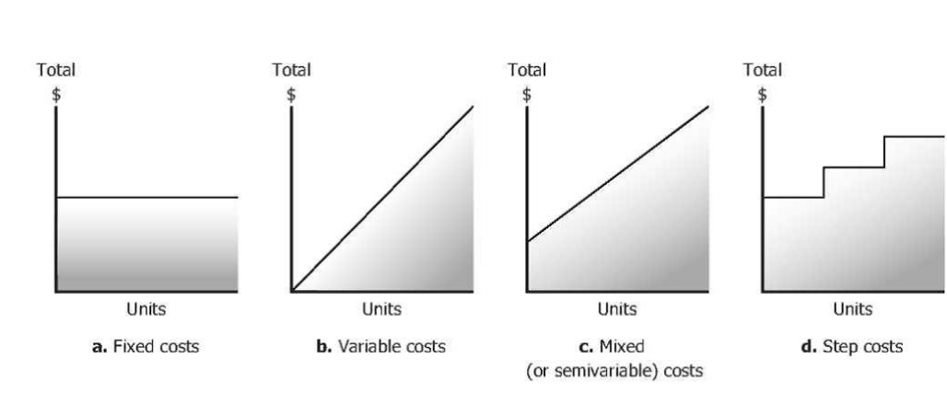
Fixed cost:
Fixed cost in total remains constant and does not change with level of output or production within some range of activity or output. Employees’ salaries, depreciation expense, insurance expense and taxes on property are examples of fixed cost. In short term, fixed cost remains constant but not necessarily in long term.
For example, during Covid-19, hotel management company did not want to lay off employees because they did not want to hire and train new employees. Management is treating direct labor cost as fixed cost. However, number of customers decreased, direct labor cost remained fixed. (Nakamura, 2020)
Variable cost:
Variable cost changes with the level of activity, output or production. If the level of activity or output increases, variable cost also increases and if the level of activity or output decreases, variable cost also decreases. Packaging, raw materials, direct labor and sales commission are examples of variable costs.
Direct labor is a variable cost in majority situations. If the total direct labor cost increases as the level of activity increases and decreases as the level of activity decreases, direct labor shall be treated as variable cost. Moreover, direct labor is commonly a variable cost for staff paid on hourly basis, as the level of activity or output increases, more staff are employed. However, sometimes work nature or company policy does not permitdirect labor to change as level of activity or output changes and direct labor may be a fixed cost.(Yoon, S., Chung, Y. and Son, H., 2021)
Semi-Variable Cost or Mixed Cost:
Semi variable cost or mixed cost has characteristics of both fixed and variable cost. Semi variable cost includes a variable portion of cost that increases directly with the level of production or output, and fixed portion of cost that incurred even when the production is stop or idle. Example of semi variable cost is electricity. Company must incur certain basis cost for electrical service. As level of production or output increases, more machines are running and also running for longer time. Company also increases its hours of production and so does the cost of electricity.
Usually, management divides semi variable cost in to fixed and variable portion for decision making. They incorporate the fixed component of semi variable cost in to other fixed cost and assume variable component changes with volume. (Ran, 2020)
Step Cost:
A step cost remains constant at fixed amount over certain level of production or activity or output. After certain threshold, step cost jumps to higher amount. Step cost looks like a stair step as depicted in the figure above.
Example of cost is supervisor salaries, when management employs new supervisors as production increases.
By mathematically we can bifurcate semi variable cost by method the main method which used for bifurcation of cost is High low method and linear regression method. (Rowthorn, R. and Maciejowski, J., 2020)
Analyses of Harriot Hotel:
Before Changes Made.
First of all, we will have discussed and critically evaluate why the profit of Harriot Hotel is declined and what step should be taken by Harriot Hotel Management to increase Hotel profit.
As the reason behind the devaluation and losses of every business is pandemic Covid,19 which has damaged the economy of all industries specially the business which is specially hit by pandemic is Hoteling and tourism business Here in our case the Harriot hotel is also hit by pandemic and management is so concerned about the decline in profit.
The expenses is directly related to revenue. So for the main expenses which should be reduced is wages and adverting cost. These expenses are covering the major part of revenue by reducing them specially the there will be significant change in profit. Before Changes the Revenue and cost table as under:
Particulars | Value | Percentage of Revenue
Revenue | 6,0000
Wages | 10,800 | 25%
Advertising cost | 7000 | 12%
Interest on loan | 10000 | 17%
Household and cleaning supplies | 5000 | 8.3%
Customer discount | 8000 | 13.3%
Stationaries for Front desk | 3000 | 5%

Cost Benefit Analyses After changes:
Secondly we will analyze and critical evaluate the Harriot Hotel. As Management of Harriot Hotel facing difficulty Due to pandemic Covid,19. There cost is increasing and their Revenue is decline day by day. We will suggest them by analyzing which cost should be reduced or outsourced for maximization of revenue.
Cost Benefit Analyses.
Particulars | Value | As Percentage of Revenue
Revenue | 60,000
Employee wages(Note-1) | 10,800 | 18%
Advertising (Note-2) | 3,000 | 5%
Interest on loan (Note-3) | 7200 | 12%
House Hold and Cleaning supplies (Note-4) | 3600 | 6%
Customer Discount (Note-5) | 6000 | 10%
Stationary (Note-6) | 1800 | 3%

After changes made in the above table we have reduced all expenses up to some extent now we will discuss one by note number following concept.
- Up to what extend expense is reduced.
- What is behavior of cost?
- What should be done to maintain maximum profit.

Note-1.
Before employee wages are constituting 25% of revenue which is almost (i.e. 1/4th) so it is reduced to 18% to maintain maximum profit Harriot Hotel management should layoff some employee because due to Covid-19 there is no more requirement of staff.
As by behavior the cost of wages is semi variable cost as it is fixed up to some extend when it is paid for fixed working hours it come in to variable when it is paid for overtime. So by reduction in wages by 7% the profit will be increase.
Note-2.
The other cost which is reduced to 5% is Advertising cost. The advertising cost is fixed in nature and it can be controlled by outsourcing to advertising agencies quotation must be taken from more than one advertising agencies and contract should be awarded to agencies on the basis of cost benefit analyses which mean low bid will be accepted from advertising agencies by doing so the revenue will be increased as compared to first scenario.
Note-3.
The next cost which we are going to discuss is interest on loan. This cost is reduced to 12%. The nature of this cost is fixed again this cost can be reduced if the quotation from different banks especially small bank is obtained. The loan will be obtained from bank which have low interest by doing so again by cutting the cost revenue will be increased.

Note-4.
The next cost which reduced to 6% is Household and cleaning supplies. As the nature of this cost variable so we can reduced this cost also by outsourcing at a lowest bid quoted by contractor.
So by cutting the cost of Household and cleaning supplies there will sufficient upward shift in revenue.
Note-5.
The next cost which reduced to 10% is Customer discount. The nature of this cost is variable because it depends upon no of units which is customer. The discount rate is directly relate to percentage of revenue so discount rate should be reduced not eliminated by reduction in discount rate is reduction in expense by doing so the revenue will be increased.

Note-6.
The next cost which is reduced to 3% is stationary cost the nature of this cost is Fixed.
No extra stationary will be purchased the stationary will be purchased from the vendors which are selected under lower bid quotation process.
By purchasing demanded stationary from selected vendor will save the cost of stationary. By reducing the expense of stationary it will directly increase the profit. (Rowthorn, R. and Maciejowski, J., 2020)

Conclusion:
As due to Covid’19 Harriot Hotel business is decline day by day after significant changes and by introduction of cost cut program we have reduced expenses i.e. Wages, Interest on loan, Advertising, customer discount, Housekeeping Cleaning supplies and Stationaries for front desk up to some extent.
By doing so the revenue will increased.
Keeping in view of the changes made these changes will increased the revenue by 30% which is so better as compared to before changes made.
So if Harriot Hotel will make these changes according to suggestion there will be 30% increment in profit.

REFRENCES:
- Yoon, S., Chung, Y. and Son, H., 2021. The relationship between cost behaviour and R&D efficiency: empirical evidence from Korean stock markets. Technology Analysis & Strategic Management, pp.1-14.
- Rowthorn, R. and Maciejowski, J., 2020. A cost–benefit analysis of the COVID-19 disease. Oxford Review of Economic Policy, 36(Supplement_1), pp.S38-S55.
- Nakamura, K., Denzumi, S. and Nishino, M., 2020. Variable shift SDD: a more succinct sentential decision diagram. arXiv preprint arXiv:2004.02502.
- Ran, Z., Lun, R., Jinlin, L. and Tao, D., 2020. A Step-by-step Fixed Cost Allocation Method Based on Leader-follower DEA Model. Management Review, 32(3), p.279.
- Lai, K. and Baker, M., 2020. Managing relationships and cost-cutting are key Covid-19 strategies. International Financial Law Review.

