In this comprehensive discussion, the evolution and engineering behind the centrifugal clutch will be deliberated. Visual aids, in the form of detailed diagrams and drawings will be included to develop our understanding of this mechanism. Additionally, the range of materials being used in the construction of centrifugal clutch systems, and explore the typical circumstances in which they are applied, as well as the operating conditions that dictate their performance will be discovered.
As the essay progresses, it will highlight a multitude of advantages that centrifugal clutches offer, illuminating ideal set-ups where they surpass other systems. Moreover, the focus will shift to the field of automation within manufacturing processes. Within this context, practical applications of electromagnetic clutches, demonstrating their pivotal role in heightening the efficiency, and precision of automated manufacturing operations will be revealed.
A centrifugal clutch is a mechanically designed device that enable the engagement and disengagement of power between a driving source and the driven components. This specific type of clutch operates by using centrifugal force to achieve these conditions. The engagement process happens when the driving components achieve a specific velocity, this will in turn, force the shoes of the clutch to contact the clutch plate. Friction from these two parts will cause the driven components to rotate. When the driving components drops below that velocity the clutch will disengage. In Figure 1 (Centrifugal Clutch Diagram) a detailed diagram is shown to where these parts are located and how they will interact with each other. (Atkins, A G and Escudier, M, 2019)
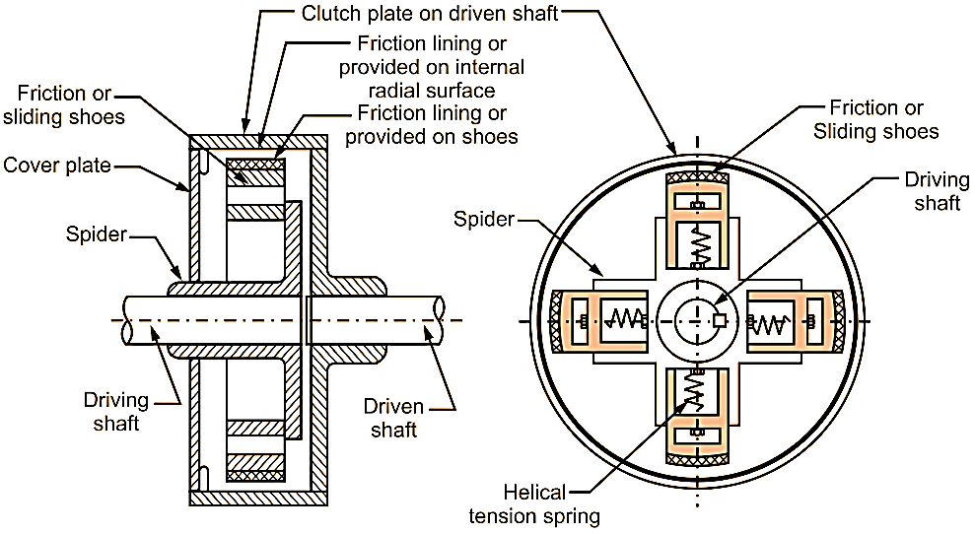
Figure 1 (Centrifugal Clutch Diagram)
The Early stages of the centrifugal clutch can be seen in processes used in the 18th century. The design of these concepts was simple, as they usually consisted of a Drum that connected to the driving source, then shoes and a linkage system. Below in Figure 2 (Concept Centrifugal Clutch) the simple design was patented in 1898. During the time, this was when produced materials were limited, which meant more common materials were used to create this mechanism. Cast iron was commonly used to create the clutch drum, while steel was used to manufacture the linkages, and fabric lining or leather was used for the shoes. (Herapath 1958)
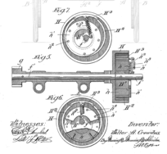
Figure 2 (Concept Centrifugal Clutch)
Standard function of the early-stage clutches saw uses in all types of industrial settings, some of these include, a variety of industrial machinery, including but not limited to textile machinery and early iterations of steam engines. This means they saw large use in rail industry and commonly used in agricultural equipment. But due to limited material development, these clutches needed to be further advanced for industry to progress.
During the 19th and 20th century, advancements in materials and manufacturing processes were made, and the main improvements involved, metallurgy advancements, steel and alloy uses and precision manufacturing. Metallurgy advancements allowed for development of alloys that had an increased strength, durability, and heat resistance. These three properties were crucial as they enabled development of centrifugal clutches as it permitted the components of this mechanism to withstand higher rotational velocities and to overcome an increased friction without wearing hastily (Bureau of Mines, 2009).
The development of steel played an immense role in progression of the centrifugal clutch as higher quality steel was produced, it became standard material for many components in the clutch; such as, drums, friction shoes and the linkages. From these parts being made of higher quality material, it allowed for increased longevity and performance of these centrifugal clutches, and these changes made the clutch more suitable for high-speed applications (Smil, V. 2016)
Manufacturing techniques greatly improved during this time, this allowed for tolerances of parts to become tighter. In turn, this created more precise parts, thus permitting for an improvement in the smoothness, consistency, and efficiency of the clutch mechanism. The improvements in the manufacturing techniques, also allowed for the centrifugal clutch to be designed and produced with specific engagement and disengagement limits that were tailored to various applications. As shown in Figure 3 (20th Century Machine Shop) a machine shop that may typically been used to produce precision parts for centrifugal clutches and other mechanisms.

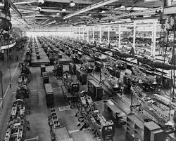
Figure 3 (20th Century Machine Shop)
The replacement of leather and fabric clutch linings contributed largely to further development of this mechanism. Due to the new heat-resistant lining, the life of the clutch was extended and the reliability increased. The newly developed linings were commonly manufactured from asbestos. From these many improvements the centrifugal clutch saw further use in automotive industry, this further pushed for the development of these mechanisms, as growth of automobiles became more popular. The primary use in automobiles was to eliminate the use for manual gear changes and increase smoothness for gear changes (Li, T.C., Lin, J.F. and Huang, Y.W. 2015).
As these clutches developed over the years, they found applications in a wide platform of industries, these include anything from small engines to industrial machinery. The amount of customisation on the centrifugal clutch have made them irreplaceable in several different industries. The main points of development for this mechanism have been efficiency, safety, user-friendly operation, and reliability. The efficiency was improved due to new materials being introduced to aid in the increased friction between the show and drum. Also, precision components allowed for any unnecessary play or movement in the mechanism to be virtually eliminated.
Dependant on function of the modern centrifugal clutch the materials will change, Steel alloys are commonly used for critical components such as the drum and pressure plates due to durability and strength. Heat-resistant friction materials such as carbon composites and ceramics are used for their resistant to high temperatures and wear resistance. For lighter weight clutches, aluminium alloys are incorporated to help reduce weight, this may be seen in applications such as racing vehicles. Many other materials such as stainless steels, polymers, titanium alloys, composite materials and brass are commonly used dependant on application of the clutches which can be seen below in Figure 4 (Modern Centrifugal Clutch).
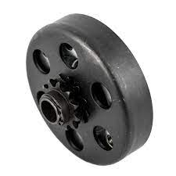
Figure 4 (Modern Centrifugal Clutch)
Due to large development of these clutches, there are many advantages that can be highlighted. Firstly, automated engagement eliminates the requirement for any manual operations, as this solely simplifies operations and controls of the machinery. Another strength of centrifugal clutches is the smoothness of operations; this means that they provide a steady and smooth engagement, that in turn reduces wear and tear on the machinery and shock loads. Additionally, energy efficiency can optimize transmissions of power as it ensures the power is delivered only when it is needed. This can then result in improvement in energy efficiency and energy savings when using the clutch. Enhanced safety is another positive of using centrifugal clutches, especially in industrial machinery and go karts as they reduce the risk of sudden starts and stops (Mecholic 2017).
Similarly, reduced need for maintenance is another specific strong point for the centrifugal clutches, as when they are designed and maintained in the correct manner, this can lead to a longer service life-span compared to other types of clutches. Another strength is that they have a compact design so they can be used in smaller engines where weight would be an important factor. They are also designed with adjustable engagement points, which means they are usually set the RPM where the clutch engages which enables customisation. Lastly, the type of materials that this type of clutch is made has increased in durability which makes them durable even in the most demanding applications. (V.O. Protsenko 2017).
Electromagnetic clutches hold a crucial part in modern automation, it provides an efficient and reliable technique to engage and disengage power. It uses electromagnetic forces to engage or disengage two rotating components. These clutches can be seen in multiple applications. One being conveyors. Electromagnetic clutches are extensively used in material handling as they can supply an accurate control over the movement of the materials, allowing for efficient transport of materials. They are commonly used to start, stop, and control the speeds of conveyors. Electromagnetic clutches are also used in CNC machine tooling, it’s used here to transmit power between the driving component and then machine tooling, they are also used in rapid tool changes which will reduce downtime on these machines and eliminating need for manual tool changes, this will further atomize the process.
The introduction of robotics systems can further automate these processes as it allows for the material to be unloaded or loaded into the machine from conveyors or other means of transport. Electromagnetic clutches are also used in robotics to manage movement of the robotics arms, enabling accurate and rapid movements of the arms. To further automation again, these clutches can be found in automated assembly lines to aid in the control of movements of components and modules to enable precise assembly.
Overall, electromagnetic clutches are critical mechanisms in modern day automation, they are a key component as they can provide a way to engage and disengage power with, speed, precision, and reliability. The versatility they have enable them to be instigated with a large variety of manufacturing processes, this will allow for improved efficiency, reduced downtime, and enhanced product quality that is offered by automating manufacturing processes (‘electromagnetic clutch’ 2019).
Table of figures
Figure 1 (Centrifugal Clutch Diagram) 1
Figure 2 (Concept Centrifugal Clutch) 2
Figure 3 (20th Century Machine Shop) 3
Figure 4 (Modern Centrifugal Clutch) 4

Reference list
Atkins, A G and Escudier, M (2019) A Dictionary of Mechanical Engineering. 2nd edn. Oxford University Press.
Herapath (1958) Herapath's Railway Journal, London
Bureau of Mines (2009) Minerals Yearbook Vol 1. Bureau of Mines.
Smil, V. (2016) Still the iron age: Iron and steel in the modern world. Amsterdam: Butterworth-Heinemann.
Li, T.C., Lin, J.F. and Huang, Y.W. (2015) ‘Studies on Centrifugal Clutch of Frictional Lining Materials’, Key engineering materials, 642, pp. 39–44. Available at: https://doi.org/10.4028/www.scientific.net/KEM.642.39
V.O. Protsenko (2017) ‘Some Structurally-Force Parameters of the Profile Centrifugal Clutch with Rope Elements’, Naukovij vìsnik NLTU Ukraïni (Online), 27(1), pp. 164–167. Available at: https://doi.org/10.15421/40270139.
Mecholic (2017) Centrifugal clutch working, applications, advantages and disadvantages, Mecholic. Available at: https://www.mecholic.com/2016/01/centrifugal-clutch-working-applications-advantages.html#google_vignette (Accessed: 02 November 2023).
‘electromagnetic clutch’ (2019) A Dictionary of Mechanical Engineering. 2nd edn. Oxford University Press.

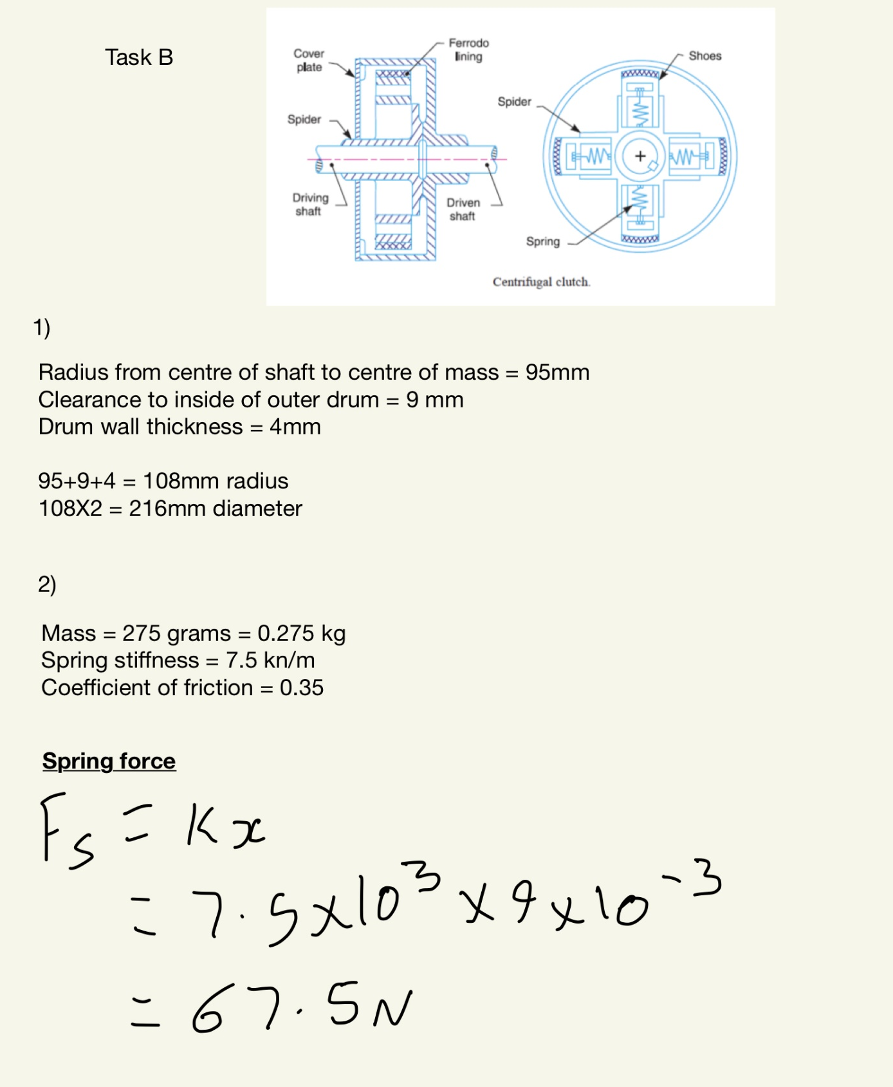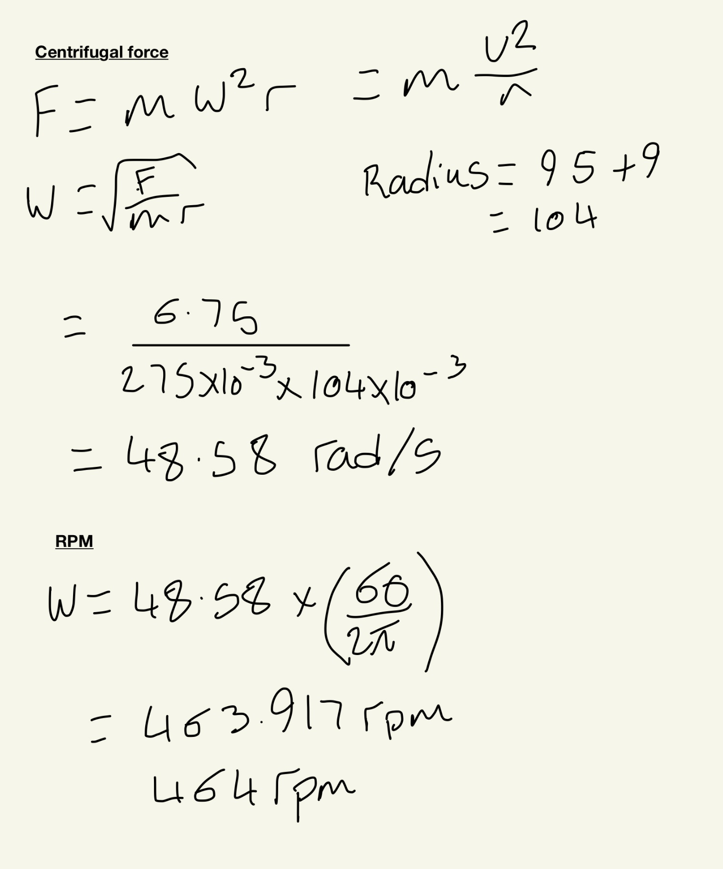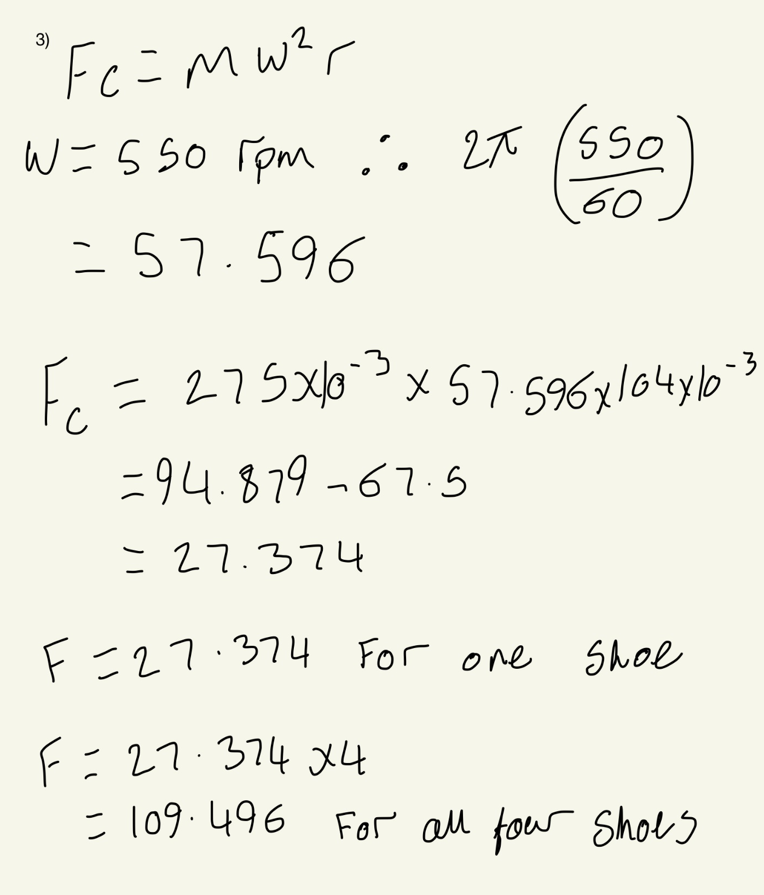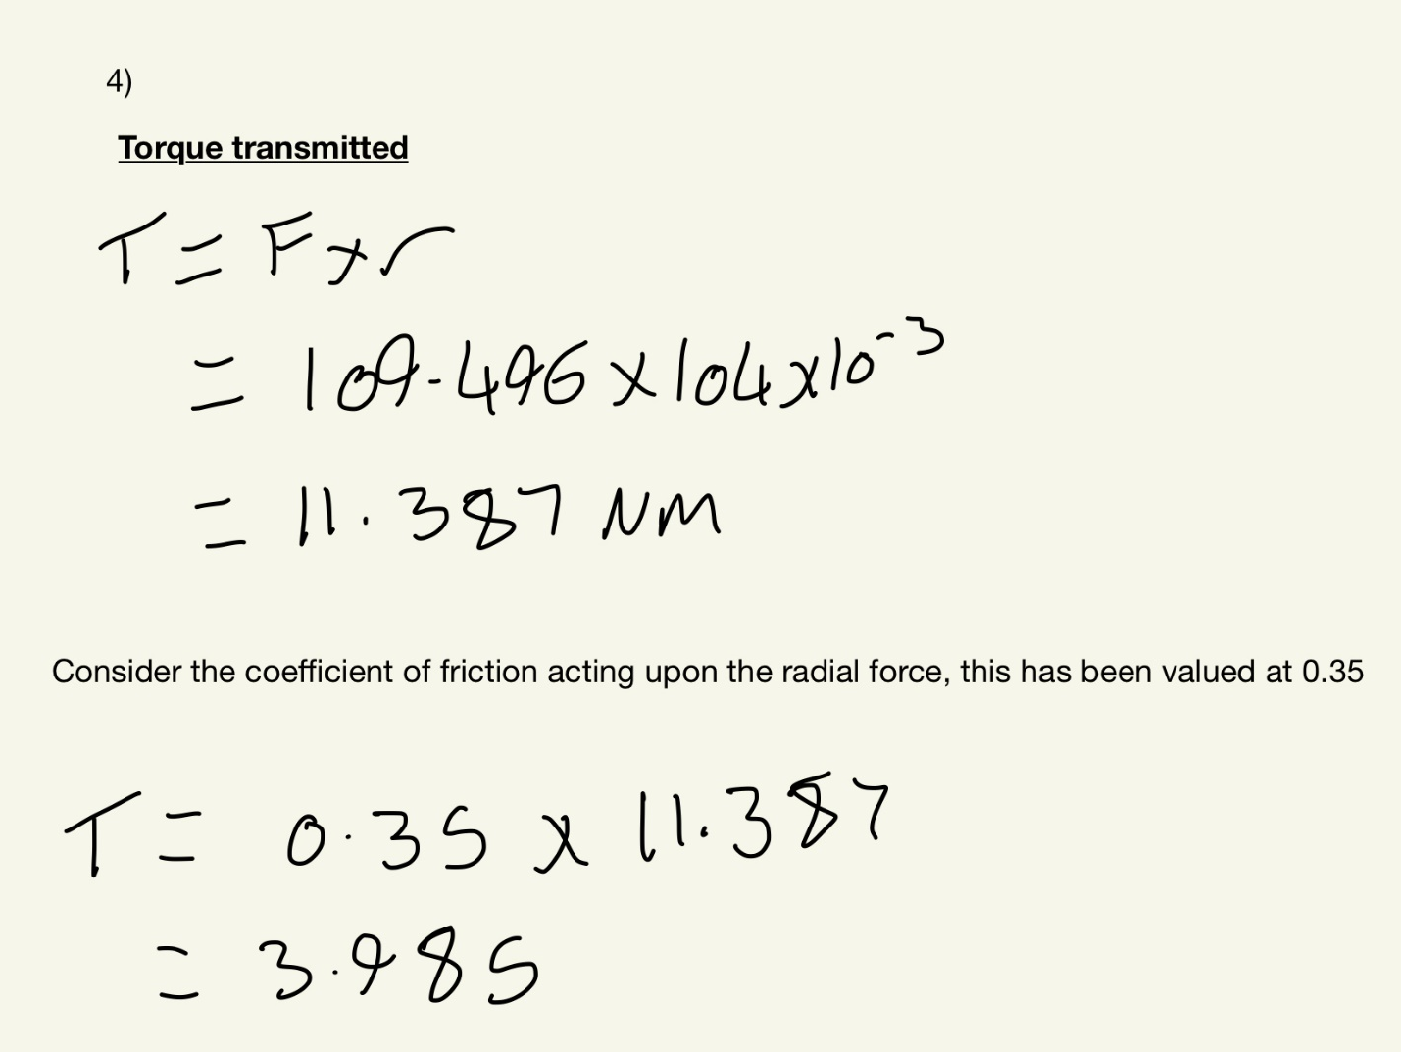

Task 5
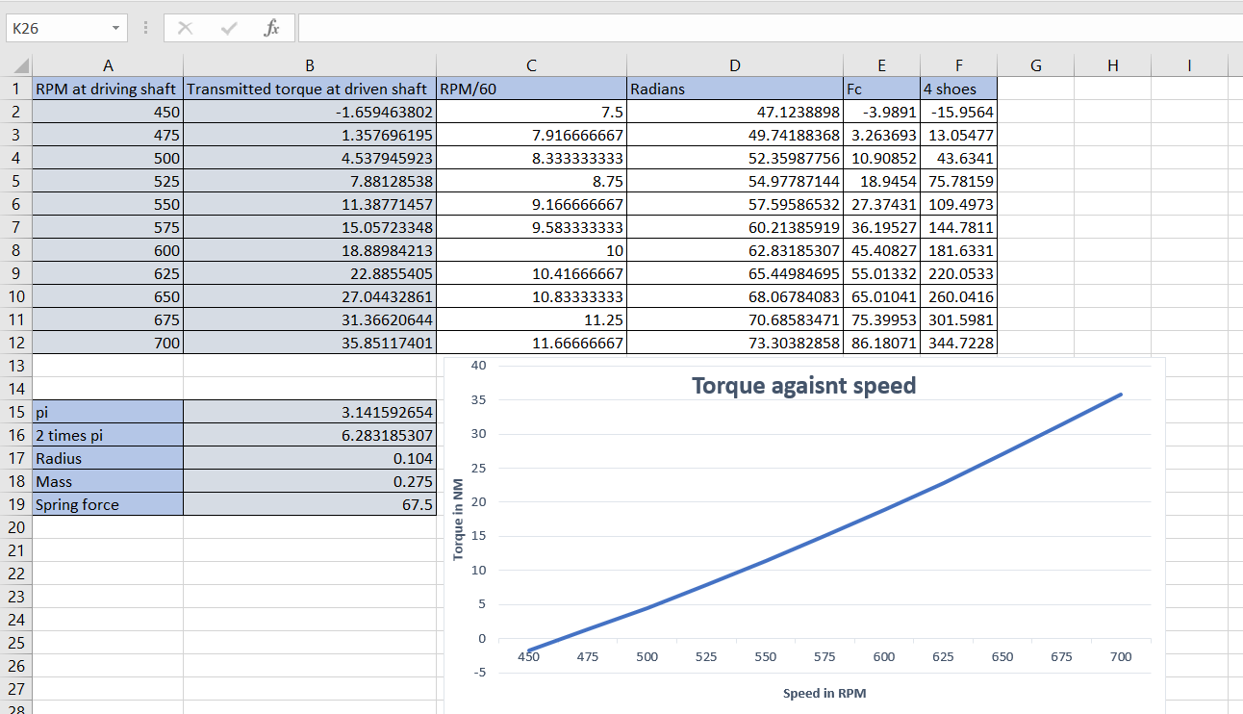
Task 6


