

LEVEL 4 ASSESSMENT SPECIFICATION

Student name: | Sam Lewis | Student ID number: | 151028
Programme: | HNC Process Operations Engineering
Module: | Plant Maintenance and Asset Care
Module code: | PCPO4005 | Contribution to Overall Module Assessment (%): | 100%
Lecturer: | P R Taylor | Internal Verifier: | Lance Rutherford
Assignment Title: | Asset Management | Word count (or equivalent): | 2000
Submission deadline: | 08 April 2020 | Return date of provisional marks & written feedback: | 06 May 2020
Submission method: | All written assessments, where practical and possible, must be submitted via Turnitin unless otherwise instructed by the Lecturer. (Please DO NOT put this assessment specification into Turnitin or it will match many similarities with other students’ submissions.)  Alternative submission method (if applicable):  Late submission of the assessment will result in a late penalty mark. Penalties for late submission: Up to one week late, maximum mark of 40%. Over one week late, 0%. Only the Extenuating Circumstances Panel may approve a change to submission dates.
Academic honesty / referencing: | Academic honesty is required. In the main body of your submission you must give credit to authors on whose research and ideas your work is based. Append to your submission a reference list that indicates the books, articles, etc. that you have used, cited or quoted in order to complete this assessment.

Module Learning Outcomes
(from module syllabus)
- Explain maintenance strategies and asset care methodologies.

- Select an appropriate maintenance strategy based on an assessment of the operational, business and legal requirements for the asset.

- Develop and implement asset care improvement techniques

TASK DESCRIPTION

Task 1. System Life Cycle (SLC)

Many companies adopt a System Life Cycle approach to the management of their assets. Explain this strategy and how it applies to the purchase, commissioning, operation, maintenance and decommissioning of equipment.

Task 2. Improvement techniques - Kaizen

Kaizen is an approach to creating continuous improvement in lean manufacturing that is adopted by a number of business. Explain this methodology and how it can be applied in an industrial setting.

Task 3. Total Productive Maintenance (TPM)

Total Productive Maintenance (TPM) is a maintenance methodology that is used to optimise asset utilisation. Explain this methodology and the key principles.

Task 4

A company has completed the installation of two electrically driven centrifugal pumps (see figure 1). The pumps will be operated in a duty/standby configuration and supply cooling water to a chemical processing vessel carrying out an endothermic reaction. The maintenance department are now assessing the new equipment to determine the most appropriate intervention strategy.

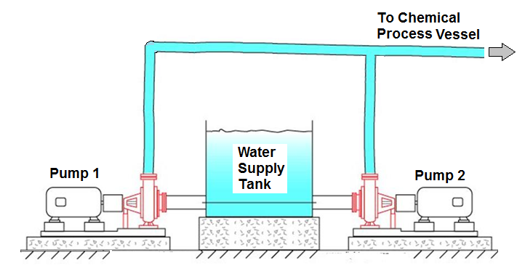

In order that a maintenance strategy can be put in place, operating information must be gathered from the new plant. Discuss a range of monitoring equipment which can be used to obtain this information. With respect to the above scenario and equipment, discuss the advantages and disadvantages of adopting either a run to failure or a planned preventative maintenance strategy. Select which strategy you would adopt, providing your justifications based on operational, business and legal requirements.

Task 5

Assets deteriorate over time which risks affecting production requirements.

For an asset that you are familiar with at your place of work, conduct an asset care assessment. Based on your assessment, develop an asset care improvement plan and describe how this might be implemented.

Report writing

To complete this assignment you are required to generate a report of 2000 words. Your report should critically present the research work undertaken. Present and discuss the results obtained with reference to any background material and draw appropriate conclusions to the results obtained.

Note: Any hand written submission will not be accepted.

Student FEEDBACK FORM

This section details the extent to which the assessment criteria are demonstrated by you, which in turn determines your mark. The marks available for each category of skill are shown. Lecturers will use the space provided to comment on the achievement of the task(s), including those areas in which you have performed well and areas that would benefit from development/improvement.

Generic Assessment Criteria | Marks available | Marks  awarded
1. Engagement with Literature Skills
.
 | 10
2. Knowledge and Understanding Skills

 | 40
3. Cognitive and Intellectual Skills

 | 20
4. Practical Application Skills

 | 20
5. Transferable Skills for Life and Professional Practice

 | 10

Assessment Mark (Assessment marks are subject to ratification at the Exam Board. These comments and marks are to give feedback on module work and are for guidance only until they are confirmed. ) | Late Submission Penalties (tick if appropriate) |  | %
 | Up to 1 week late (40% Max) |  | %
 | Over 1 week late (0%) |  | %

HNC Process Operations Engineering Yr.1
Plant Maintenance & Asset Care Assignment 1

Samuel Lewis
University of wales, trinity st. david

Contents
Task 1 2
Task 2 4
Task 3 6
Task 4 8
Task 5 10
Table Of Figures 12
Bibliography 13

Task 1

System life cycle refers to phases that an asset would experience through time, the phases refer to the stages of the equipment’s life cycle and how it is run.
Firstly, is the design/research phase. The company purchasing the asset would research the market for the ideal piece of equipment. If aiming to pump crude oil, a pump that can offer this service effectively should be designed considering the equipment required, space available, finances and process requirement such as output or liquid consistency. This design and research process should ensure that the asset is correctly constructed and safe to operate while producing the desired product.
Purchasing and commissioning follows, after the asset is identified and purchased the equipment would be set up. Including, placing and securing the pump and connecting pipework. Once all equipment is in place, it should then be tested during pre-commissioning to ensure operability. “Pump pre-commissioning, commissioning and start-up is crucial in today’s industry,” Almasi, (2013). Before the pump can be fully commissioned it must be correctly set up to avoid damaging itself or other equipment when running. Almasi goes on to mention pump alignment which is a key factor and how it should be carried out effectively to ensure a long operating life. “Improper pump alignment can cause excessive vibration, premature wear and early failure,” Almasi, (2013).
Useful life is the next phase, the largest phase of the cycle. This represents the day to day running of the equipment and over time maintenance will be required as they degrade. This equipment should then have maintenance strategies assigned to them. Different criticalities of equipment require different strategies to be followed as explained by Hanifan, (2011). “PM includes time-based inspections for assets whose consequence of failure presents enough of a risk to warrant an intrusive inspection.” Identifying planned maintenance as the ideal strategy for critical equipment to avoid risk of unplanned downtime, by planning to take it offline for a period of time to carry out any maintenance. While Hanifan (2011), also mentions condition-based maintenance and reactive maintenance programmes. “A condition monitoring program helps identify the required maintenance work and ideally allows reliability and maintenance professionals to program all required maintenance on a given piece of equipment to occur simultaneously, saving costly downtime. It allows planners and schedulers to schedule maintenance when it is most cost-effective and precedes functional failure.” Stating that condition monitoring allows the asset to stay online to avoid downtime while also identifying when would be best to take the asset offline for maintenance, rather than doing it via a set of periodic intervals. “Reactive Maintenance is maintenance performed after a failure or after an obvious, unforeseen threat of immediate failure. Running machines in run-to-failure (RTF) mode is a strategy for assets where the consequence of failure, is so low that it makes sense to allow the asset to fail in lieu of spending value maintenance time doing PM tasks.” In regard to the pump, reactive maintenance strategies would be unwise as you are waiting for a failure to occur before carrying out maintenance, which could then be catastrophic to the pump and other equipment. While a mixture of preventative and condition monitoring would be best to follow.
After useful life, the cycle may revert back to the beginning via the design phase. This could be due to an upgrade taking place, due to lack of efficiency. The research phase would begin again as engineers look to solve the problem by searching the market for a replacement pump which is more efficient to the task in hand. This would then be implemented and commissioned for the equipment to then enter the useful life and maintenance sector of the cycle.
The cycle can come to an end for equipment if equipment is outdated or no longer used, it will enter the final stage of the cycle, de-commissioning. For this the equipment in question should then be isolated, from process and power source and then taken apart or removed from the premises.
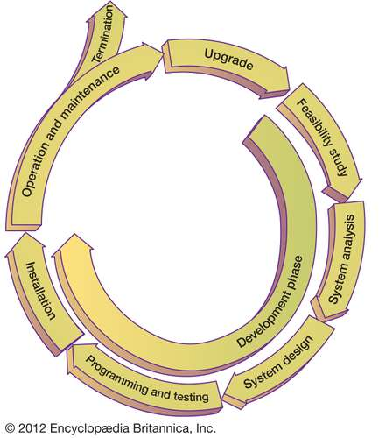
Figure 1 - Equipment Life Cycle Diagram

Task 2

Kaizen is applied to industry to create continuous improvement in lean manufacturing, resulting in lower running costs, higher efficiency and profit. Kaizen, Japanese for improvement, was started by Japanese companies after WWII. The methodology behind it is to make small and regular changes to better the cause. Kaizen revolves around a strong sense of teamwork with high worker morale and discipline to create a quality output. When bringing kaizen into a place of work, the entire process is analysed from top to bottom and the most efficient way to complete a job is then enforced.
An example of an industrial setting that could follow kaizen is a machine workshop. The first steps of implementing kaizen are changes to attitudes. Teamwork is encouraged, this would ensure that all workers help each other to achieve an acceptable level of work, this will then lead to an increase in worker morale, which is required in as, happy workers are productive workers. The next step is introducing a level of discipline. Relaying what levels are expected and discouraging “that’ll do” attitudes that lead to accidents and a drop-in quality product as well as ensuring machinery are kept in good working order. Such as, checking condition and providing basic maintenance before use and cleaning after use, ensuring the asset is suitably cared for. Accepting suggestions for improvements from workers is also encouraged, as they are the people with experienced and could improve the process and provide insights as how to best maintain the condition of the equipment.
Physical changes can also be made, to support kaizen. These can easily be remembered by referring to them as “The 5 S’s”:
1) Sorting – This is aimed to better organise the workshop. The tools stores are much easier to navigate and find the correct tool if the stores are neat, tidy and stored logically.
2) Simplifying – This could be in multiple forms, if there is an overly complicated procedure for a specific task, it should look to be simplified but still achieve the desired outcome.
3) Sweeping – This is simply pride of ownership, workers should treat their work areas as their personal work areas and be encouraged to keep them and all tools used clean and operable.
4) Standardising – The levels of performance reached through kaizen should then become the normal expected standard.
5) Sustaining – Ensure that the new better standards are followed, and performances do not dip.

Task 3

TPM aims to achieve the maximum performance of systems via maintaining and improving the integrity of the system. Achieved by measuring the overall equipment effectiveness of the machinery within the system by grading the equipment in 3 important categories, performance, availability and quality on a scale from 0% to 100%, 100% being perfect. An average throughout the 3 categories is calculated with lower scoring identified and plans to improve the score should then be synthesised as the ideal of TPM is to achieve a system that is perfect.
Autonomous maintenance
The operator to carry out routine checks of the machine and low-level maintenance tasks to ensure the machine runs as it should, including checking oil is clean and levels are correct. This ensures problems are identified and resolved early before they can become larger.
Kaizen
“(Kaizen) has been identified as a crucial factor for strengthening firms’ competitiveness… Kaizen has often been conceived of as an accumulation of similarly small, mutually independent, incremental process innovations that are conducted by workers, work-teams, and their leaders.” Iwao, (2017), shows that continuous improvement is achieved by small simple everyday actions including, cleanliness, organisation, good morale and simple and effective working methods with high standards enforced throughout the work teams and their leaders.
Planned maintenance
Aims to reduce the number of equipment breakdowns, meaning that the equipment has more running time and a longer useful life. Maintenance will enforce strategies such as planned maintenance and condition maintenance to ensure the assets are running as should be to avoid complete breakdowns and downtime.
Quality maintenance
Zero defects in maintenance carried out is the goal, meaning the asset will not require re-work and can continue to operate for a length of time. Training encourages all personnel to be adequately trained in the task they are carrying out. It would include identifying the knowledge and skills required and then arranging training time and facilities to learn and improve on the current skillset, in time then ensuring maintenance work is completed to high standards. This also effects operators who are trained to best run the equipment, leading to less errors and failures which lead to downtime.
Office TPM
This aims to increase efficiency of office spaces, including using the 5 S’s in the office, being cost efficient in sales and marketing and managing goods and products effectively to minimise over storage and waste.
Safety, health & environment (SHE)
Emphasises zero accidents by increasing awareness and encouraging correct behaviour to carry out tasks, which reduces injuries in turn. While also taking actions that reduce waste and lessen environmental impacts.

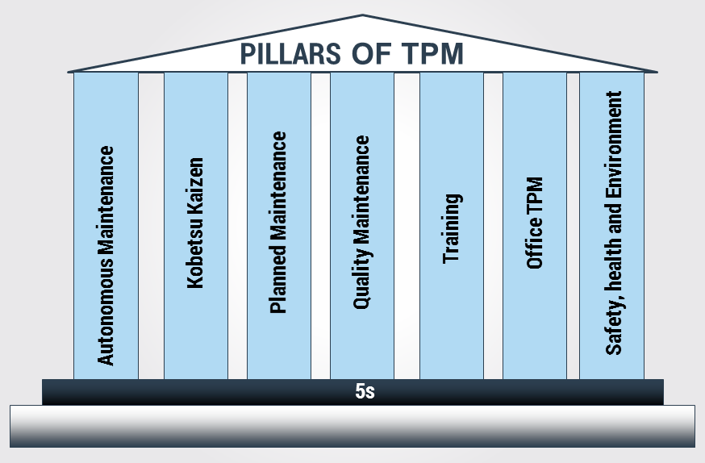
Figure 2 - Pillars Of TPM

Task 4

To create a viable maintenance strategy, methods of monitoring equipment must be investigated and carried out. Monitoring the physical aspects of the equipment to see the true condition of the pump involves temperature and vibrational readings. Temperature can be monitored with use of a heat gun pointed at the bearing housing of the pump and the reading taken and compared to operating temperature ranges. If the reading is outside of this, it can indicate lubrication and bearing problems. Vibrational analysis can then be taken by use of a vibe scanner placed on the bearing housing in line with the bearings and readings be compared to an operating range. High readings will then show defects with the bearings which could be due to poor lubrication or wear and tear from cavitation of the pump. Monitoring discharge pressures can be used to ensure that the pump is working effectively to the correct output. Lower discharge pressures would indicate the pump isn’t working to the required level and may be experiencing problems. Using all these pieces of monitoring equipment will enable successful monitoring of the asset and allow to pinpoint certain failures and when they occur.
Run to failure requires less planning, because the maintenance will only be carried out when the breakdown occurs, meaning nothing needs to be planned and as there is less maintenance and less downtime of the equipment. This also means that there is less work scheduled day to day, meaning less maintenance staff is required therefore cost is lowered. However, the maintenance cost can then skyrocket if the problem is detrimental, a complete breakdown can become costly as maintenance cost and increased downtime, if the repair is time consuming, are generated. It is also extremely difficult to predict when the asset will fail, creating a potential risk to employees and other assets if the equipment was to fail at the wrong time.
Planned maintenance benefits the equipment as it encourages a planned schedule for maintenance to be carried out periodically. This ensures that any problems that occur to the equipment can be identified early and rectified before they become catastrophic, meaning breakdown costs are lower and safety is ensured as failure is avoided. However, maintenance and its planning can become more complex and the cost to implement this system is usually high at the start.
In conclusion, it would benefit to follow a planned preventative strategy. If a run to failure strategy was implemented, when a failure occurs it could cause catastrophic effects on the reaction vessel if it were to overheat. It could then be made worse as the standby pump would have been idle for a length of time, meaning it may have ceased or not operate properly. Under a planned maintenance strategy, maintenance would anticipate a failure rather than waiting for it. Doing this will ensure the pumps both work by running up periodically with conditions checked to identify problems which are then rectified, ensuring that both operate and are ready to supply cooling water to the reaction vessel.

Task 5

Creating an asset care improvement plan must be carried out upon critical equipment, crude feed desalters serve a key role of removing minerals and water from the crude feed, so would require an asset care assessment and improvement plan.
Failure modes for this equipment include high levels and electrical grid failures. High levels cause failure as water rises to the level of which crude is drawn off and be pulled further into the crude feed. While electrical grid failures will prevent entrained water being removed from the crude. Both scenarios lead to water carryover from the desalters.
If water carryover is allowed from the desalters it will have adverse effects on equipment further down the train. Firstly, within the fired heaters where the water would be flashed off within the tubes due to an increase in temperature. Creating steam hammer which in turn could then rupture the tubes and allow crude to be released into the firebox of the heater causing a safety risk. Secondly, if water carryover entered the distillation column, it would put products off spec, as they would cool column temperatures and reduce efficiency in separating certain products from one another resulting in off spec products, as well as increasing pressure within the vessel as the water is flashed into steam, which has an expansion ratio of 1:1700, which could then force the PSV’s for the column to lift.
Failure effects of the desalters then signify that they are extremely critical to the process. Without them the product produced is of lower standard, safety of workers and equipment is impacted when heater tubes rupture and if PSV’s lift there will also be a release of product to atmosphere which is negative for the environment.

Table 1 - Crude Desalter Criticality Analysis Table
Factor | Score 0-5 (0=low / 5=high)
Safety | 4
Environmental | 4
Effect on quality | 5
Effect on other equipment | 5

Total Score = 400
Due to the criticality analysis being high, an improvement plan should be enforced to prevent the failure of the equipment. This would include daily checks of the equipment to prevent the water carryover. Such as level checks to ensure water levels are not too high as well as precipitator panel checks which will signify if the electrical grids are working optimally to remove the entrained water. Periodic checks can then also be enforced such as internal cleaning, vessel strengthening and internal inspection to monitor and improve the condition of the asset to secure peak performance over its running lifetime.

Word Count: 2,194

Table Of Figures

Figure No. | Source
Figure 1 | Britannica (2012) System Life Cycle. Available from:  https://www.britannica.com/topic/system-life-cycle  [Accessed 27/12/2019]
Figure 2 | Mulder, P. (2016) ToolsHero, TPM. Available from:  https://www.toolshero.com/quality-management/tpm-total-productive-maintenance/  [Accessed 04/03/2020]

Bibliography

- Britannica (2012) System Life Cycle. Available from:
https://www.britannica.com/topic/system-life-cycle
[Accessed 27/12/2019]

- Azizul Haque (2016) Kaizen In Educational Dimension. Available from:
https://www.slideshare.net/azizulhaque/kaizen-in-educational-dimension
[Accessed 27/12/2019]

- Mulder, P. (2016) ToolsHero, TPM. Available from:
https://www.toolshero.com/quality-management/tpm-total-productive-maintenance/
[Accessed 04/01/2020]

- TPM 8 Pillars, (2018) YouTube. Available from:
https://www.youtube.com/watch?v=Le9JWH6bPR0
[Accessed 20/02/2019]

- Pros & Cons Of Maintenance Strategies (2016) Hansford Sensors. Available from:
https://www.hansfordsensors.com/blog/2016/05/25/the-pros-and-cons-of-different-maintenance-strategies/
[Accessed 18/03/2020]

- How To Implement Asset Care (2019) Rolls Royce. Available from:
https://www.rolls-royce.com/~/media/Files/R/Rolls-Royce/documents/sustainability/value-chain-competitiveness/19-vcc-how-to-implement-asset-care.pdf
[Accessed 18/03/2020]

- M. T. Tham (2019) Distillation, Factors Affecting Distillation. Available from:
https://www.rccostello.com/distil/distilop.htm
[Accessed 27/03/2020]

- Saugata Palit (2012) EPTQ, Effects Of water Carryover. Available From:
http://www.eptq.com/qandaquestion.aspx?q=949b4553-2206-409e-8583-8d23b8fc418a
[Accessed 27/03/2020]

- Amin Almasi, (2013) Pumps&Systems, Pump Commissioning. Available from:
https://www.pumpsandsystems.com/pump-commissioning-alignment-field-balancing-and-startup
[Accessed 09/04/2020]

- Michael Hanifan, (2011) Pumps&Systems, Optimising Your Maintenance Strategy. Available from:
https://www.pumpsandsystems.com/optimizing-your-maintenance-strategy
[Accessed 09/04/2020]

- Shumpei Iwao, (2017) Revisiting The Existing Notion Of Continuous Improvement. Available from:
https://link.springer.com/article/10.1007/s40844-017-0067-4
[Accessed 09/04/2020]

