

Report on InterContinental Hotel Group (IHG)

Module Name
Management & Organisational Behaviour (BMIH5004)

Lecturer’s Name
Ernest Wavei

Prepared by
Showkoth Choudhoury
Student ID: 2208181

Word Count
2068 words

Executive Summary
One of the largest and most successful hotel chains is the InterContinental Hotel Group (IHG), with over 6,300 hotels in over 100 countries. IHG's goals, structure, and culture are examined along with recent change management and strategic directions. IHG wants to provide the best service, expand its market share, and impress guests to lead the hospitality industry. The report uses Mintzberg's organizational framework and the Competing Values Framework to demonstrate IHG's strong structure and unified culture foster innovation and success. Kotter's 8-step model can be used to examine recent changes in loyalty programs, branding, partnerships, and environmental efforts. Since these changes, customer satisfaction and market share have increased. IHG uses a variety of brands and technology-based services to differentiate and focus. IHG needs a cost leadership plan to compete in the economy. The report suggests encouraging more people to use technology, encouraging new ideas, and supporting practices that are good for the environment. Through coordinating these strategies with operational goals, IHG can stay ahead of the competition and enjoy long-term success.
Contents
Executive Summary 2
Introduction 4
Organisational Goals, Structure, and Culture of IHG 4
Change Management of IHG 8
IHG’s Strategic Directions 9
Competitor Analysis 10
Conclusion 10
Recommendations 10
Reference list 12

Introduction
Hotel management is a challenging and complex task. The dynamic changing environment makes it difficult to make the right decisions such as applying the right strategies and change initiatives to address the emerging issues and utilise the opportunities (Boddy, 2017). For the report, the InterContinental Hotel Group has been chosen. InterContinental Hotel Group (IHG) is a multinational hospitality organisation. The organisation is headquartered in the UK. It serves international hospitality markets and its hotel operations have created a strong position in more than 100 countries around the world. The hotel group has more than 6300 hotels which offer hospitality services to diversified groups of people (IHG, 2023). The organisational goals, structure, and culture of IHG will be evaluated in this report. Recent change management aspects of IHG will also be analysed. Finally, the strategic direction will be analysed to determine whether the hotel group is achieving the organisational goals and objectives.

Organisational Goals, Structure, and Culture of IHG
Goals are the key drivers of the organisational activities. Hotel organisations have certain goals to achieve, so they perform their activities to achieve those goals (Armstrong, 2012). IHG has specific organisational goals. The company aims to utilise its key resources to provide exceptional guest experiences and services. It aims to be a profitable and high-performing hospitality organisation in the industry. The company aims to enter profitable market segments and increase its business size. IHG aims to be the market leader in the hospitality industry. Goals are crucial in shaping the organisational strategies, structure, and culture. Organisational structure needs to be aligned with the goals and objectives (Mullins and Dossor, 2013). The goals that IHG has are highly relevant for a hospitality business. These goals are attainable if the resources are managed properly and effective strategies are implemented.
The organisational structure is crucial to outline the strategic direction of a company. The organisational structure clearly explains how the activities of the company should be directed and performed (Mullins, 2016). Mintzberg's organisational configuration framework can be applied to analyse IHG's structure comprehensively. The seven configurations of the framework on IHG's organisational structure are analysed below:

Figure 1: IHG's structure
Source: (Author)
Strategic Apex: IHG has a board of directors and executives who are responsible for creating global strategies for all units. They ensure that the organisation is directed in the right way. These people are the strategic apex of the organisation because they stay at the top of the configuration. Strategic Apex emphasises consistency in strategic direction for all hotel units across the world (Dimitrios et al., 2020).
Middle Line: IHG has regional managers and hotel managers. They have the responsibility to translate the strategic objectives into operational plans. In other words, the management is to ensure that the strategic objectives are achieved by the successful execution of the plan. The management stays in the middle line of the structure.
Technostructure: IHG aims to standardise its hotel services across all units and so it employs analysts and specialists who make up the technostructure. They are the ones who design the systems and procedures.
Support Staff: The support staff plays the leading role in maintaining the brand standards and supporting the hotel operations. The core hospitality activities such as marketing, human resources management, and financing activities are handled by the support staff (J. Harrington et al., 2014).
Operating Core: The primary hospitality services are provided within IHG hotels by the operating core. The operating core consists of housekeeping staff, front office employees, and food and beverage staff. They ensure that guests can get the desired services and that they are satisfied with the hotel brand.
Ideology: IHG's ideology is centred around its commitment to providing genuine hospitality services to the guests and contributing to the world with positivity.
Politics: This particular configuration focuses on the power dynamics within the organisation. To maintain a good relationship with the stakeholders and successful negotiations among the owners, franchisees, and corporate offices, IHG must oversee the political configuration (Elbanna, 2016; Mullins, 2019).
Organisational culture has a significant impact on the performance and profitability of the hospitality businesses. Businesses operating in the hospitality industry have different cultures that help them offer unique value propositions (Nazarian, Atkinson and Foroudi, 2017). IHG's organisational culture can be analysed by applying the Competing Values Framework (CVF). The framework is widely recognised because it can address the key aspects of the organisational culture to have a better understanding of it. The framework considers two dimensions: flexibility and stability (Baradarani and Kilic, 2018).

Figure 2: CVF
Source: (Author)
Based on these two dimensions, four types of organisational cultures can be identified. The cultures are analysed below:
Clan Culture: IHG emphasises "True Hospitality for Good" commitment showing that the organisation ensures a family-like culture where employees get the environment and support for growing in their careers. Its internal focus improves the service quality and develops a clan culture.
Adhocracy Culture: IHG focuses on continuous innovation and technological adoption. By emphasising external forces to improve service quality and bring flexibility within the organisation, the company develops an adhocracy culture (María del Rosario, Patricia S. and René, 2017).
Market Culture: The highly competitive hospitality industry influenced IHG to be result-oriented. The company evaluates the employee performance and KPIs of the hotel operations. It creates a market culture within the organisation.
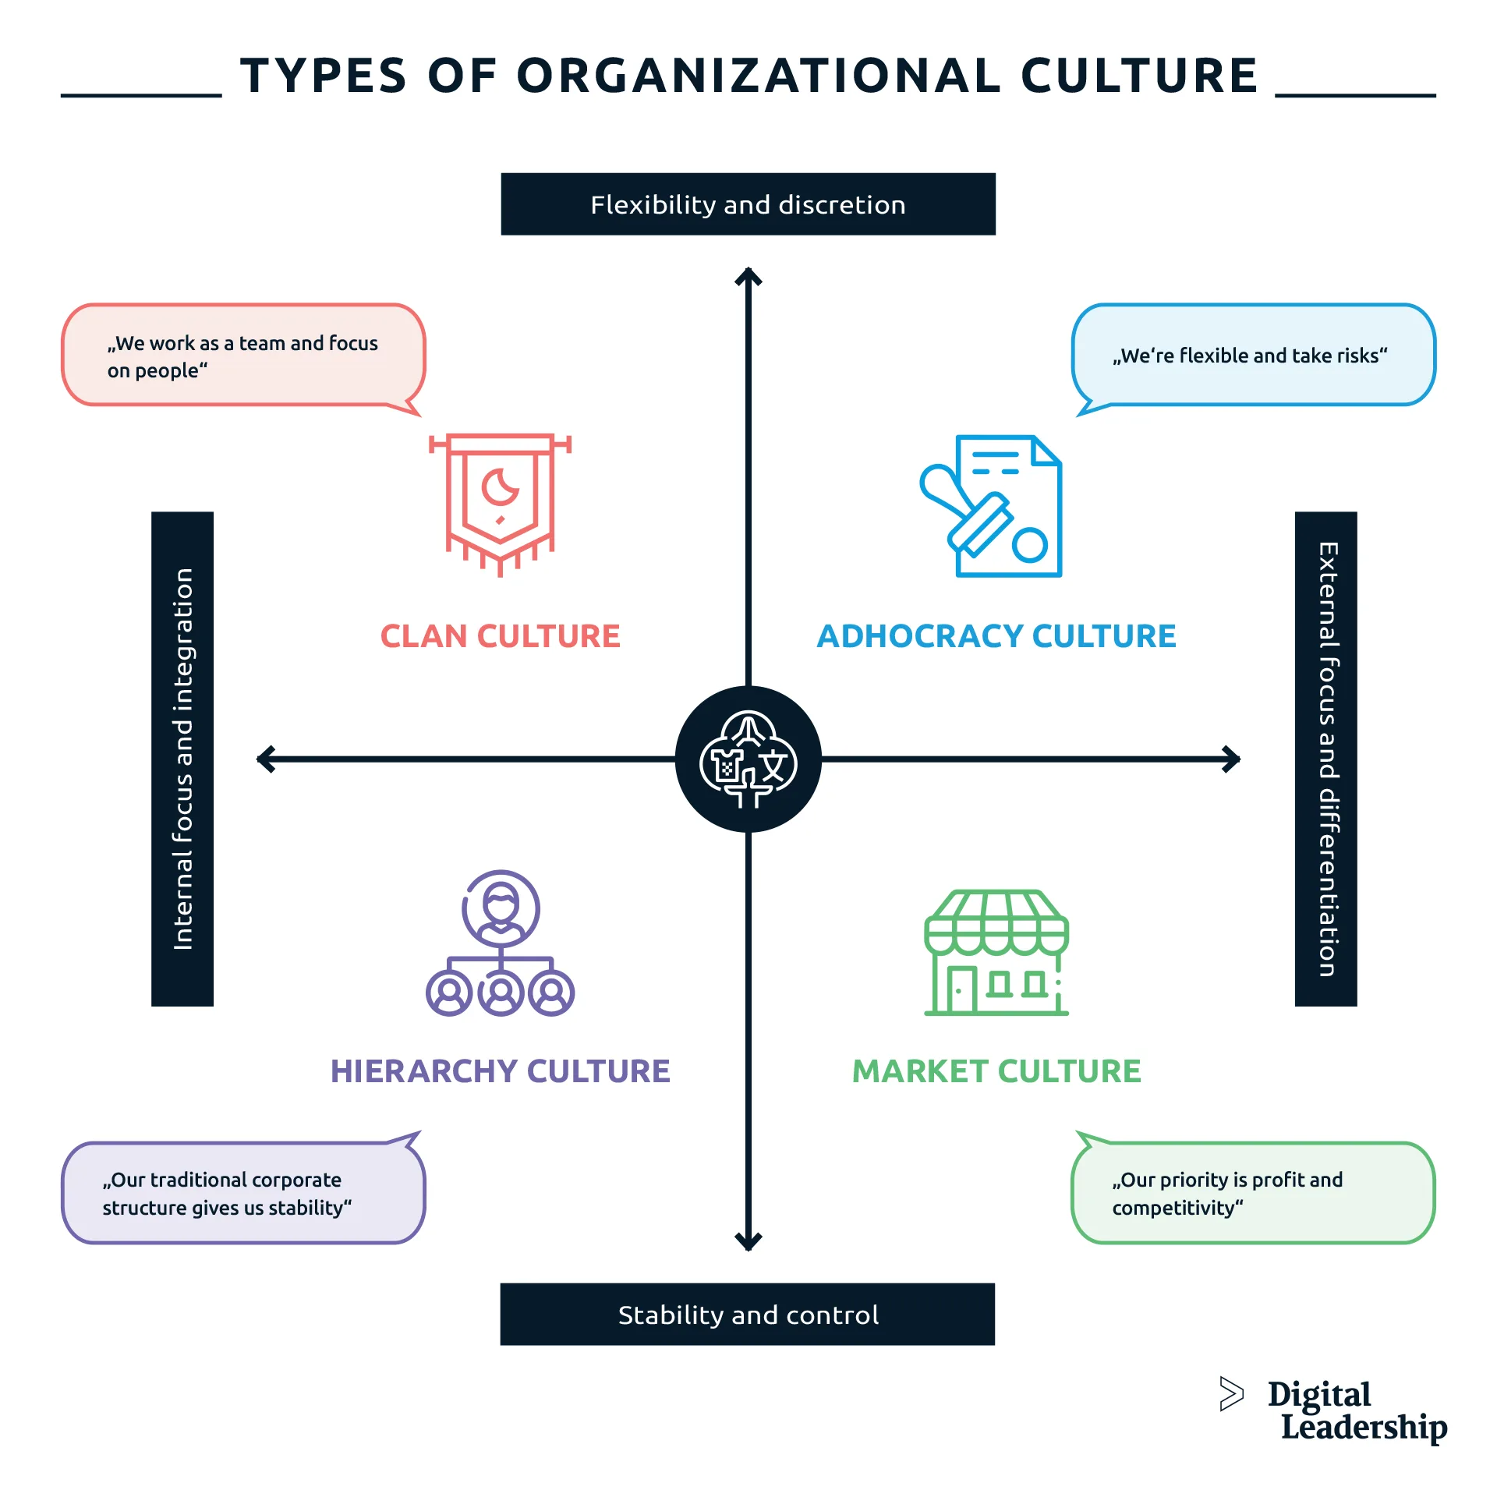
Figure 3: Types of organisational cultures
Source: (Zeb et al., 2021)
Hierarchy Culture: To bring stability to the organisation, IHG focuses on internal factors such as the roles and responsibilities of the employees, clear directions and guidelines, and processes. The formal practices create a hierarchy culture in IHG (Zeb et al., 2021).
The application of CVF suggests that IHG has integrated four types of organisational culture to drive its performance.

Change Management of IHG
InterContinental Hotels Group (IHG) has undertaken several change initiatives to overcome emerging hospitality issues and strengthen its market position. Some of its change initiatives are the transformation of the loyalty programme, branding of its hotels, partnership with leading market players, and commitments to sustainability (IHG PLC, 2019). Its "Journey to Tomorrow” aims to bring positive changes in the society. How well the company has managed the changes can be analysed by applying Kotter’s 8-step change model. The 8 stages are analysed below:
Create Urgency: IHG understands that change is imminent. If it does not implement organisational changes, it may lose its market competitiveness (Tang, 2019). Hence, its strategic directions to implement changes show that the company created a sense of urgency for change.
Form a Powerful Coalition: The leadership of IHG collaborated with the global teams to facilitate the change process.
Create a Vision for Change: The company has a vision to be the market leader in the hospitality industry that drives its change initiatives.
Communicate the Vision: Through announcements, annual reports, and press releases, IHG has informed its stakeholders about the vision and possible changes to the organisation.
Remove Obstacles: Asset-light strategy, franchising, and managing properties are some strategies that IHG applied to remove obstacles to the change.
Create Short-term Wins: The successful transformation of one reward loyalty programme can be characterised as a short-term win for the company. It also implies the company’s commitment to future changes.
Build on the Change: The company has made significant investments in technologies and innovation to drive the change process.
Anchor the Changes in Corporate Culture: Finally, IHG has ensured that the new rules and procedures have become the norms and culture of the organisation.
The change initiatives and successful implementations have a significant impact on the organisation. The changes have increased the guest experiences by meeting their needs and expectations (Nieto-Rodriguez, 2023). The improved loyalty programme has helped the company to retain more customers and increase its market share. IHG could strengthen its market presence in the luxury segment by successfully implementing its changes (InterContinental Hotels Group PLC, 2024). Its responsible business practices and sustainability initiatives influence the company to improve its performance and market presence in the existing segments (McNeive, 2024). The change management initiatives are crucial to overcoming industry-wide challenges such as the COVID-19 pandemic, labour shortage, and regulatory changes. IHG’s digital transformation was a critical decision to remain competitive in the UK hospitality industry.

IHG’s Strategic Directions
The strategic direction refers to a course of actions that organisations make to achieve some predetermined goals and objectives. The actions performed by the organisation may be directed by the higher-level management or the mid-level management. Primarily, senior leaders or managers make such strategies for all hotel units so that they can collectively achieve organisational common goals (Lynch, 2021). Porter’s generic strategies can be applied to analyse IHG’s strategic directions. The three generic strategies are cost leadership, differentiation, and focus.
Cost Leadership: IHG does not compete on prices rather it competes on the quality of the hospitality services. However, the hotel group has benefited from its cost-efficient strategies. The company’s asset-light strategy has enabled it to be less reliant on property ownership. IHG emphasises franchising options to bring efficiency to hotel operations. The strategy saved significant capital expenditure to expand businesses in other key regions (IHG, 2024).
Differentiation: IHG applies a differentiation strategy. The company has made a diverse portfolio of its 19 brands. These well-diversified brands cater to various customer segments meeting their unique needs and preferences. Its luxurious and personalised hospitality services that integrate the latest technologies and innovative solutions differentiate its service quality and provide a competitive edge in the industry (IHG PLC, 2019).
Focus: The focus strategy involves targeting a profitable market niche where the business can maximise its profits. IHG applies a focus strategy to target its high-end market segment. The company utilises its scalability and expertise to target various markets with different focus strategies.
IHG’s strategies are a blend of differentiation and focus strategies that helped the company gain a competitive advantage in the UK hospitality industry. The company will guide its future directions by effectively implementing these two generic strategies.

Competitor Analysis
IHG has many competitors who serve a similar market. These competitors have presented various challenges to the company's strategic directions. IHG's direct competitors who compete in the luxury market segment are Hyatt Hotels, Marriott International, and Hilton Hotel Group. IHG has a worldwide market presence like its competitors (SimilarWeb, 2024). However, the company has a poorer market presence in the economy market segment than its competitors. The competitive pressure has affected its market performance and competitiveness. The company has adopted digitisation like its competitors but it would be challenging to be at the forefront of innovation and technology adoption to become the market leader in the industry.

Conclusion
IHG’s organisational structure and culture are aligned with its organisational goals. The company has implemented various changes recently to remain competitive and overcome business challenges. Its effective change management can drive success in its hotel operations. However, its competitors have a better position in the economy market segment. By adopting a cost leadership strategy, IHG can increase its market presence in the economic segment.

Recommendations
For addressing organisational issues and improving IHG’s market position, some recommendations are given below:
- Because IHG has a poor presence in the economy market segment, the company has to increase its market presence in the particular market segment. It is aligned with its strategic goal which is to be the market leader in the hospitality industry. The company has to adopt a cost leadership strategy. The cost leadership strategy will help the company to offer the hospitality services of the economy segment at a competitive price (Lynch, 2021). IHG needs to diversify its revenue streams and enhance its profitability. IHG may manage the change successfully by communicating with the key stakeholders and specifying the strategic directions for all hotel units.
- IHG needs to ensure that it continuously adopts digital technologies. The company must establish a culture of continuous innovation. It will be a high-performing culture for the company. The latest technologies such as AI technology, big data analytics, and IoT-enabled hotel room amenities should be implemented and integrated into the organisational structure (Bounatirou and Lim, 2020). Hence, the hotel group will be able to provide personalised services and meet the expectations of the guests.
- The organisational structure should be favourable to promote innovation and sustainability practices. The employees should get the scope and opportunities to apply their innovative ideas and collaborate. The collective initiatives to tackle the sustainability issues will ensure that IHG gets long-term success (Mullins, 2016).

Reference list
Armstrong, M. (2012) Armstrong’s Handbook of Management and Leadership : a Guide to Managing for Results. 3rd ed. London ; Philadelphia: Kogan Page.
Baradarani, S. and Kilic, H. (2018) Service innovation in the hotel industry: culture, behavior, performance. The Service Industries Journal, 38(13-14), pp.897-924. doi:https://doi.org/10.1080/02642069.2017.1420172
Boddy, D. (2017) Management : an Introduction. 8th ed. Harlow: Pearson.
Bounatirou, M. and Lim, A. (2020) A Case Study on the Impact of Artificial Intelligence on a Hospitality Company. Advanced Series in Management, pp.179–187. doi:https://doi.org/10.1108/s1877-636120200000024013.
Dimitrios, B., Christos, P., Ioannis, R. and Vasiliadis, L. (2020) Strategic management in the hotel industry: proposed strategic practices to recover from COVID-19 global crisis. Academic Journal of Interdisciplinary Studies, 9(6), pp.130-130. doi:https://doi.org/10.36941/ajis-2020-0117
Elbanna, S. (2016) Managers’ autonomy, Strategic control, Organizational Politics and Strategic Planning effectiveness: an Empirical Investigation into Missing Links in the Hotel Sector. Tourism Management, [online] 52, pp.210–220. doi:https://doi.org/10.1016/j.tourman.2015.06.025.
IHG (2023) About Us. [online] InterContinental Hotels Group PLC. Available at: https://www.ihgplc.com/en/about-us [Accessed 14 May 2024].
IHG (2024) How Our Business Works. [online] InterContinental Hotels Group PLC. Available at: https://www.ihgplc.com/en/about-us/how-our-business-works#:~:text=Our%20asset%20light%20model%20is [Accessed 14 May 2024].
IHG PLC (2019) Our Strategy. [online] InterContinental Hotels Group PLC. Available at: https://www.ihgplc.com/en/about-us/our-strategy [Accessed 14 May 2024].
InterContinental Hotels Group PLC (2024) IHG Hotels & Resorts Strengthens Leading Position in the Luxury & Lifestyle Segment. Available at: https://www.ihgplc.com/en/news-and-media/news-releases/2024/ihg-hotels-and-resorts-strengthens-leading-position-in-the-luxury-and-lifestyle-segment (Accessed: 15 May 2024).
J. Harrington, R., K. Chathoth, P., Ottenbacher, M. and Altinay, L. (2014) Strategic Management Research in Hospitality and tourism: past, Present and Future. International Journal of Contemporary Hospitality Management, 26(5), pp.778–808. doi:https://doi.org/10.1108/ijchm-12-2013-0576.
Lynch, R. (2021) Strategic Management. 9th ed. Harlow, United Kingdom ; New York: Pearson Education Limited.
María del Rosario, R.-S., Patricia S., S.-M. and René, D.-P. (2017) Eco-innovation and Organizational Culture in the Hotel Industry. International Journal of Hospitality Management, 65, pp.71–80. doi:https://doi.org/10.1016/j.ijhm.2017.06.001.
McNeive, A. (2024) Change Management for Sustainability. Available at: https://www.prosci.com/blog/change-management-for-sustainability (Accessed: 15 May 2024).
Mullins, L.J. (2016) Management & Organisational Behaviour. 11th ed. Harlow: Pearson.
Mullins, L.J. (2019) Organisational Behaviour in the Workplace. 12th ed. Harlow: Pearson.
Mullins, L.J. and Dossor, P. (2013) Hospitality Management and Organisational Behaviour. 5th ed. Harlow: Pearson.
Nazarian, A., Atkinson, P. and Foroudi, P. (2017) Influence of national culture and balanced organizational culture on the hotel industry’s performance. International Journal of Hospitality Management, 63, pp.22-32. doi:https://doi.org/10.1016/j.ijhm.2017.01.003
Nieto-Rodriguez, A. (2023) Organize Your Change Initiative Around Purpose and Benefits. Available at: https://hbr.org/2023/05/organize-your-change-initiative-around-purpose-and-benefits (Accessed: 15 May 2024).
SimilarWeb (2024) ihg.com Competitors & Alternative Sites Like ihg.com | Similarweb. [online] Similarweb. Available at: https://www.similarweb.com/website/ihg.com/competitors/ [Accessed 14 May 2024].
Tang, K.N. (2019) Change Management. Leadership and Change Management, [online] 1(1), pp.47–55. Available at: https://link.springer.com/chapter/10.1007/978-981-13-8902-3_5.
Zeb, A., Akbar, F., Hussain, K., Safi, A., Rabnawaz, M. and Zeb, F. (2021) The Competing Value Framework Model of Organizational Culture, Innovation and Performance. Business Process Management Journal, 27(2), pp.658–683. doi:https://doi.org/10.1108/bpmj-11-2019-0464.

