
Programme: Master of Business Administration
Module: Marketing Management
Module Code: LCMB7024
Name: Devarshsinh Manharsinh Solanki
Student ID- 2428526 Word Count: 2,752

Table of Contents
Introduction 3
Advantages of being a pioneer and follower company 3
Product life cycle that provides increased growth and maintains a strong competitive advantage for pioneer and follower companies 8
References 16
Appendix 22

Introduction
In strategic marketing, companies must make an important decision – whether to become pioneers by innovating new products and technologies or to follow preset market paths. Each of these stances has its own unique benefits and challenges, which influence success over time. This report examines the strategies of pioneers and followers, with Uber as the pioneer and Lyft as a follower, as well as Whole Foods (pioneer) and Thrive Market (follower) in the organic foods industry and Boeing (pioneer) and Airbus (follower) in aviation. Through the lens of these strategies, this report analyses how companies manage the product life cycle in order to stimulate growth and remain competitive. The analysis sheds light on the best strategies for entering the market and how these strategies affect the business's sustainability and profitability.

Advantages of being a pioneer and follower company.
Advantages of being a pioneer
Uber (pioneer)
As a pioneer, a company can be first in the market and, hence, become a market leader, get a first-mover advantage and so set industry standards. When Uber came in as the first major ride-hailing platform, it revolutionised the way people use their vehicles in metropolitan cities with app-based ride-hailing, cashless transactions, and dynamic pricing. The one great plus of being a pioneer is being able to dictate the market. Uber was able to grow very rapidly, becoming a dominant force in major cities before any competitors (Olson et al., 2021). It had quickly expanded early on, and developed a large set of drivers and a customer network, which is big enough to sustain its competitive advantage using network effects.

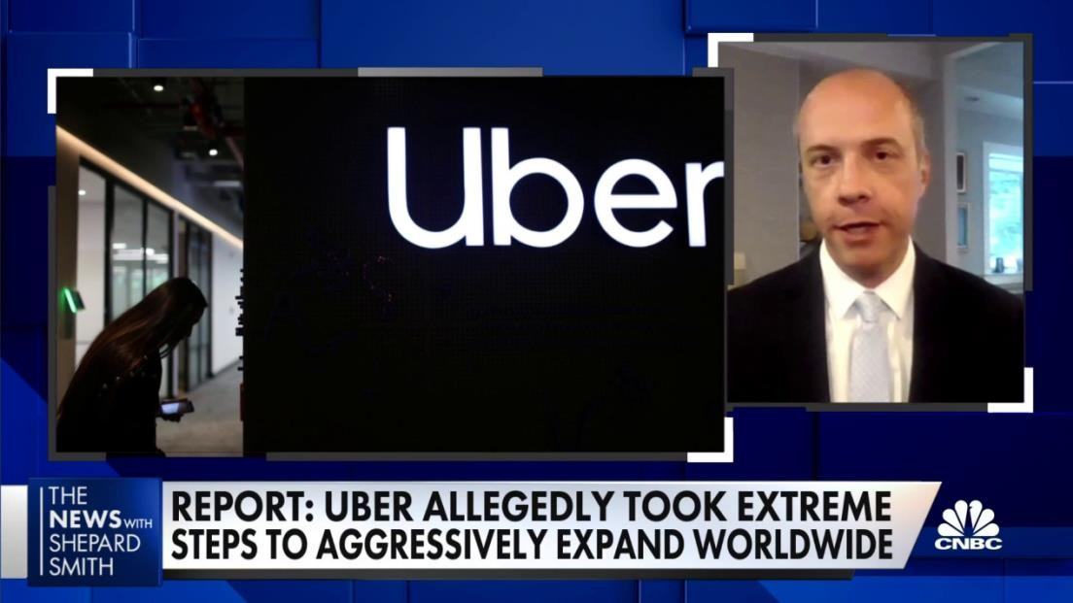
Figure: Uber’s business methods to expand worldwide.
(Source: CNBC, 2022)
One big plus is investor appeal. Uber raised billions in venture capital to innovate and grow explosively. Pioneers also set technological benchmarks. However, the algorithms that Uber used for ride matching and surge pricing became industry best practices. Large governments regulated taxi unions and managed to resist Uber with enough force for it to require licensing and legal affairs energy as well as a bunch of lobbying efforts (Valdez, 2022).
Being a pioneer also has the advantage of brand recognition. Since Uber was the first major ride-hailing platform, it became associated with the service itself. The strong presence of the brand helped Uber to keep the customers' trust and loyalty as other firms like Lyft and Bolt appeared in the market (Samuel, 2024).

Whole Foods
In the same way, Whole Foods was the first to operate within the organic and natural food retail sector while maintaining high standards in quality and sustainability. Whole Foods established itself as the frontrunner in premium grocery retail by offering an extensive selection of organic products (Bulah et al., 2023). Whole Foods redefined consumer expectations, and loyal customers branded the store their go-to grocery shop. Even after the emergence of online marketplaces like Thrive Market, Whole Foods' dominance over the organic food sector was unmatched due to its brand identity and first-mover advantage in the sector. Whole Foods Market grew from 275 locations in 2008 to almost 500 in 2017. This was also the year they were purchased by Amazon for $13.7 billion (Statista, 2024).
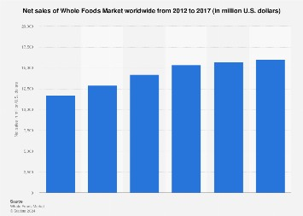

Figure:

Net sales of Whole Foods Market worldwide

(
Source:
Statista, 2024)

Boeing (Pioneer)
Boeing is a prime example of a pioneer in the aviation sector. Through its advanced aircraft designs and engineering innovations, the company transformed commercial air travel. As the first major player in the industry, Boeing set the safety and efficiency benchmarks that make modern aviation what it is today (Lopes Rose, 2024). The company's initial success laid the foundation for strong relationships with airlines and long-term contracts before facing significant competition from Airbus. Boeing's longlasting role as a pioneer in the industry continues to drive competition in new technologies and aviation advancements, branding the company the first mover.
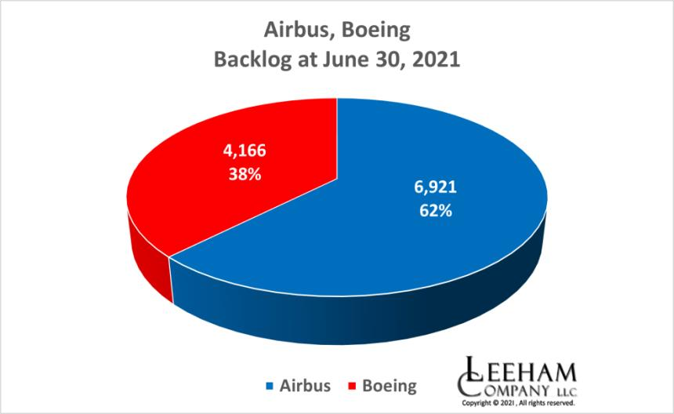

Figure: Boeing Market Share

(Source: Hamilton, 2021)

Advantages of being a follower
Entering an already existing market means reducing risks and costs for a Follower company. As a result of this, Lyft positioned itself as a more community and ethicaloriented company that built customer loyalty on a driver-friendly approach, lower commission fees, and the possibility of tipping. Among the advantages, followers can learn from the pioneer's mistakes, like Uber's controversy regarding corporate culture, driver treatment, and regulatory conflicts, which Lyft avoided (Gómez et al., 2022).

Figure: Lyft cabs.
(Source: Napolitano, 2024)
Costs are also lowered for the followers, as they can adopt proven technologies and business models without spending major efforts on research and development. Riding towns in short periods was more valuable than expanding widely. Followers can never catch up to pioneers’ market share (Yang et al., 2025). Yet, the strategic advantages of being a follower are shown by Lyft’s leveraging of the groundwork laid by Uber, and their ability to improve customer satisfaction and remain profitable.
Followers can also narrow the experience for customers by filling in gaps left by leaders. The dedication and responsiveness that Lyft had for driver-friendly terms of service and fairer wages and a desire for more flexible working conditions than the likes of Uber – helped them stand out (Dubal, 2023).
In the organic grocery market, Thrive Market was a Whole Foods follower but set itself apart with a digital-first, membership-based model. Whole Foods created the organic market, and Thrive Market improved the model with competitively priced, consumer-direct convenience (Dianat and Hou, 2024). Thrive Market cut costs by eliminating physical stores, instead using an online marketplace, allowing them to cater to price-sensitive customers who value organics.
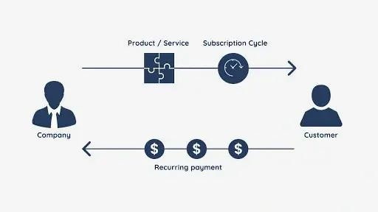

Figure: Membership
-
Based Model

(Source: created by Author)
In the aviation industry, Airbus was a later follower of Boeing but quickly became a strong contender through optimal efficiency and innovation focus. Boeing established industry standards, but there was market demand for more fuel-efficient aircraft which Airbus capitalised on. The A320neo series was in direct competition with Boeing's 737 models, providing better fuel economy and operational efficiency to airlines (Lo Verde, 2024).

Product life cycle that provides increased growth and maintains a strong competitive advantage for pioneer and follower companies.
Product life cycle (PLC) is a very significant concept in marketing; the stages a product goes from the product’s introduction stage to its decline stage are the introduction, growth, maturation, and decline stages. The life cycle dynamics of a product are a focus of this discussion, which takes up how successful product pioneers, such as Uber, Whole Foods, and Boeing, have navigated the PLC to sustain competitive advantage.

Strategies of Pioneer Companies: Uber Market Creation and Brand Awareness
Following the introduction of Uber, the company’s first goal in the introduction stage was to educate the market and induce demand for the company’s newly introduced ridehailing service. Aggressive marketing strategies were used by the company that involved offering free rides, referral incentives, and driver bonuses to build a strong customer base for the company (Abbas et al., 2021). The ride matching feature was also made GPSbased, and other features such as cashless transactions and surge pricing were added to make the use convenient.

Expansion and Network Effects
Once market acceptance was confirmed, then Uber focused on its capacity to become geographically wide to gain a competitive advantage (Howcroft & Leaver, 2024). The company launched into new cities aggressively and would enter a market before its regulatory approvals were in place to generate demand from consumers that would apply pressure on authorities to legalise ride-hailing. Uber also increased the service it offered, with UberX for value-oriented clients, UberPOOL for shared rides, and UberEats for food delivery.

Differentiation and Sustainability
Facing saturation in the market and intensifying competition, Uber, like many other firms, started focusing on differentiation and operational efficiency. In the choice of investment, the company opted for AI-driven route optimisation, customer personalisation, and safety features like real-time tracking and background checks (Ushakov et al., 2022).

Market Segmentation and Personalization
Introducing personalisation in the market and understanding the behaviour of the consumers are done by Uber to enhance user engagement and maximise profitability as a pioneer. Other features, including fare estimates, ride suggestions, and loyalty programs, are added to improve user experience further with contextual features. Dynamic pricing is another tactic used by Uber wherein AI is used to dynamically price products to different consumer segments such that the firm can achieve maximum efficiency in serving them (Yan et al., 2019).

Strategic Partnership and Ecosystem Expansion
Uber has established itself as a dominator in transportation and other sectors through both partnerships and acquisitions, expanding its ecosystem strategically. Automated electric vehicles have been developed through collaborations with Toyota, Volvo, and other companies in the automotive industry; however, collaboration with payment providers simplifies transactions. One of the ways that (Uber Eats) diversifies its revenue

streams is by using the existing ride-hailing infrastructure (Anwar, Odeo, and Otieno, 2022).

Whole Foods: Pioneering Organic Retail

Ignition of Market Demand and Consumer Education
Whole Foods initiated a transformation in the organic grocery sector by introducing natural, organic, and sustainable food products into mainstream retail. Unlike supermarket chains, Whole Foods created demand by educating shoppers on the benefits of organic eating (Gundala and Singh, 2021). The company further classed itself as a premium retailer, thereby guaranteeing high-quality products, unlike commodities offered by conventional grocery chains, to differentiate itself.
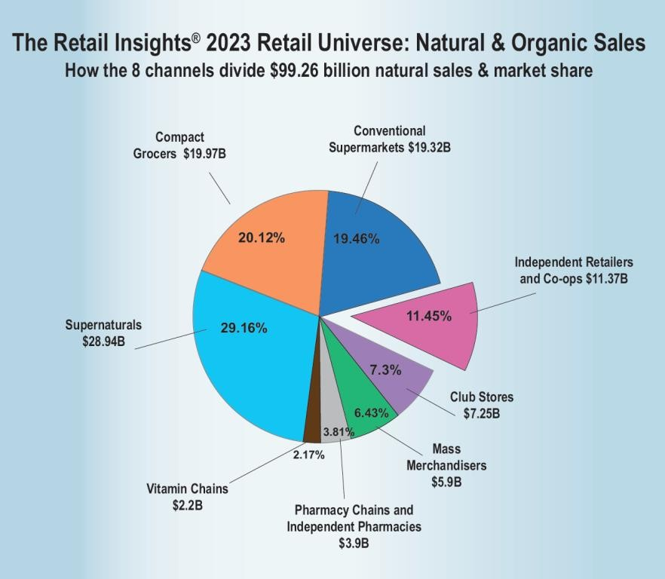

Figure: Whole Foods Market Consumer Education Data (WholeFoods Magazine)
(Source: Director, 2023)

Expansion and Market Leadership
During its period of growth, Whole Foods capitalised on the shifting trend to healthy eating. The company aggressively expanded into urban centres with affluent, environmentally conscious patrons (Lerner Patrón, 2024). It also broadened its scope of offerings by adding ready-to-eat organic meals, health supplements, and ethically sourced beauty products and bolstered its brand image further.

Differentiation and Competitive Sustainability
As competition increased from other supermarkets and online retailers, Whole Foods focused on ethical sourcing, sustainability, and exclusive product deals as a means to sustain market leadership (Vadakkepattet al.2021). It also used its strong brand identity to partner with Amazon, adopting digital shopping and home delivery services. Undoubtedly, these tactics enabled Whole Foods to remain dominant in the marketplace amid increasing competition.
Boeing: Pioneering Commercial Aviation

Innovation and Market Entry
Boeing, one of the aviation pioneers, changed air travel forever with the first successful commercial jet airliner. In the introduction stage, the focus of the company strategy was
“technological leadership,” meaning Boeing aircraft had to be and were the best in the industry in terms of performance, safety, and fuel efficiency (Vadakkepatt et al.2021).

Expansion and Market Domination
During the growth stage, Boeing enhanced its fleet with long-haul, domestic, and even cargo airline models to accommodate many different airline types (Grimme, Maertens and Bingemer, 2021). The company further built brand loyalty by continuously increasing fuel efficiency, aerodynamics, and comfort for passengers, thus strengthening bonds with airlines.

Differentiation and Technological Advancement
With the growing competitiveness from Airbus, Boeing invested significant capital towards R&D in lightweight materials, such as Lyft, Thrive Market, and Airbus have successfully navigated the Product Life Cycle (PLC) by adopting refined market entry strategies (Iveson, Hultman and Davvetas, 2022). AI for flight path optimisation and next-gen fuelefficient engines, and began developing Boeing Global Services, a subsidiary providing MRO and training services, fostering loyalty, sustainable revenue, and ensuring competitiveness.
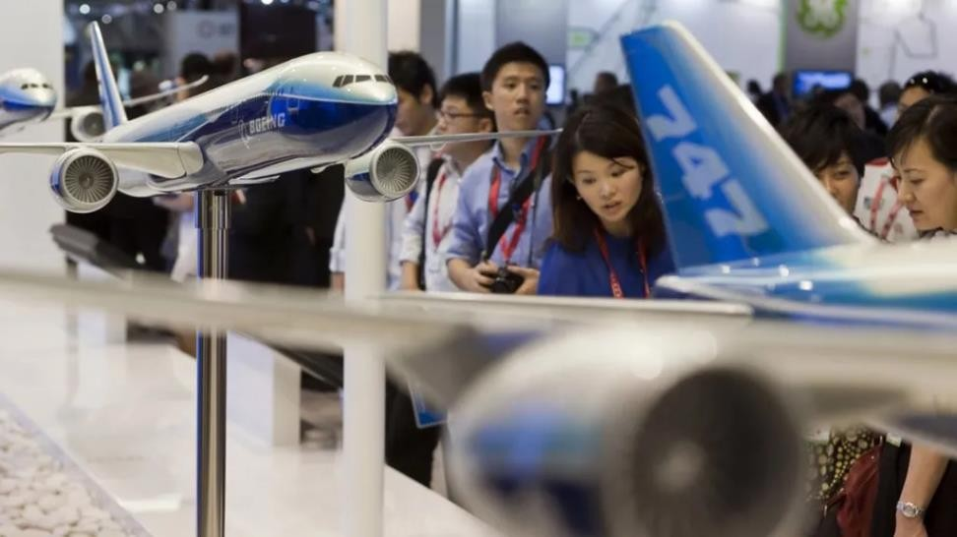

Figure: Visitors Observing Boeing Airliner Models at an Airshow
(Source: Miller, 2024)
Strategies of Follower Companies: Lyft

Market Penetration and Differentiation
Compared to Uber, Lyft did not have to educate the consumers about ride-hailing since the market was already set. Rather, it took the path of differentiation by positioning itself as a friendly and community-oriented alternative. To keep drivers unhappy with Uber’s pricing and undercut policy, Lyft was known to offer driver-friendly policies like lower commission fees and tipping options. This also used word-of-mouth marketing and social campaigns to create a strong emotional bond with its users (Ade et al., 2024).

Competitive Pricing and Regional Focus
At The growth stage, Lyft was focused more on regional growth rather than globalising. While Uber continued to blast off around the world, Lyft carried out its activities on U.S. soil and refined the services to make it a better experience. Competition in the price segment was utilised by the company, with price matching Uber and also offering discounts to frequent riders. Lyft also made strategic partnerships with major companies, such as Delta Airlines and Chase Bank, and incorporated ride-hailing benefits of corporate loyalty programs (Valderrama & Cameron, 2023).

Service Innovation and Sustainability
As the ride-hailing industry grew, Lyft took so many initiatives to differentiate itself again and again. The eco-friendly initiatives, such as partnerships with electric vehicle manufacturers, carbon offset programs, etc., made the company more attractive to environment-friendly consumers (Liu et al., 2024).

Community Engagement and Corporate Social Responsibility
As a follower, Lyft has been successful by strong community engagement and corporate social responsibility (CSR). Whereas Uber was aggressive about how it grew the company, Lyft approached things differently, proclaiming to be a socially responsible brand with ethical business practices. Lyft tries offering fairer wages, lower commission fees, and tipping options for drivers as well, thus fostering a more driver-friendly environment (Lyft, 2024). On the environmental front, the company's carbon-neutral rides and electric vehicle programs are in line with environmental concerns.

Technology Adoption and Agile Adaptation
Through adoption and agile adaptation to technology, Lyft has succeeded in the ridehailing industry to be competitive. The main lesson here is that by learning from Uber’s technology innovation, they quickly adopted Uber-proven features like real-time ride tracking, dynamic pricing, and scheduled rides.

Thrive Market: Ethical and Affordable Online Retail

Market Penetration and Niche Targeting
With its affordability model, Thrive Market stepped into the organic grocery space as a competitor to Whole Foods. Whole Foods was already servicing a market for organic, sustainable food, but the steep pricing cut accessibility to many. Thrive Market tackled this problem by offering organic products at wholesale prices through a membershipbased model (Sreekumar, Raju and Siddique, 2022). Thrive Market was able to reduce operational costs by utilising e-commerce and direct-to-consumer sales, which, in turn, allowed the company to offer lower prices than Whole Foods.

Subscription-Based Competitive Pricing
Thrive Market leveraged the shift towards online grocery shopping, whereas Whole Foods centred its brand on physical retail locations. By putting a membership pricing strategy in place, the company guarantees an annual payment for access to discounted organic products. This strategic offer solidifies customer retention while simultaneously ensuring Thrive Market receives stable income (Okeyo, 2024).

Sustainability and Ethically Sourced Items
Thrive Market implemented carbon-neutral shipping, zero-waste packaging, and sustainably sourced products. This approach not only helped align consumer loyalty but also proved beneficial for promoting sustainability, leading to Thrive Market gaining popularity and a devoted shopper base (Alhawamdeh et al.2024).

Airbus: Competing Against Boeing in Aerospace

Strategic Market Entry and Competitive Differentiation
Airbus, a laggard in the aerospace sector, positioned itself against Boing—the Boeing commercial aircraft pioneer. Instead of competing head-to-head with Boeing's earlier dominance, Airbus concentrated on building aircraft with greater fuel efficiency, wider cabins and quieter engines (Lo Verde, 2024).

Technology Optimisation and Cost Efficiency
While investing in new aviation technology is the motto of Boeing, Airbus has adopted and improved on existing innovations. Instead of creating new classes of aeroplanes, Airbus focused on redesigning planes to be more efficient and consume less fuel. With the A320neo series, which has better fuel economy than the 737 models from Boeing, Airbus gained significant market share without the R&D spending of Boeing (Lo Verde, 2024).

Flexibility and Market Responsiveness
Boeing miscalculated in a few areas, and that became an opportunity for Airbus. During the Boeing 737 MAX fiasco, when Boeing had safety as well as regulatory concerns, Airbus jumped at the opportunity to massively increase production and sign new airline contracts (Christianto and Smarandache, 2025).

Comparison of the Strategies of Pioneers and Followers
While both pioneers and followers operate in the same sector, their approaches differ in the Product Life Cycle (PLC) Strategies template.
- Pioneers like Uber, Whole Foods, and Boeing devote significant resources to market creation, brand loyalty, and new innovations.
- Examples of followers include Lyft, Thrive Market, and Airbus. These optimise business models, work on existing technologies, and find efficiencies in costs and offerings.
An example of this is alongside Uber's aggressive geographic expansion, Lyft focused on deepening regional community ties. In the parallel case, instead of riding the demand, Thrive Market sought to increase the affordability and availability of organic food after Whole Foods started the trend. In commercial aviation, Boeing was the industry's leader until Airbus discovered the opportunity to outmanoeuvre Boeing's inflexible cost structures and rigid systems.

References
Abbas, U., Islam, K.M.A., Hussain, S., Baqir, M. and Muhammad, N. (2021). IMPACT OF
BRAND IMAGE ON CUSTOMER LOYALTY WITH THE MEDIATING ROLE OF CUSTOMER SATISFACTION AND BRAND AWARENESS. International Journal of Marketing Research Innovation, [online] 5(1), pp.1–15. Available at:
https://doi.org/10.46281/ijmri.v5i1.987. [Accessed on: 21 March 2025]
Ade, M., Soemitra, A. and Tri (2024). Market Penetration Strategy by Increasing Firm Competitiveness. Golden Ratio of Marketing and Applied Psychology of Business, 5(1), pp.44–52. Available at: https://doi.org/10.52970/grmapb.v5i1.712. [Accessed on: 21 March 2025]
Alhawamdeh, A.K., Mohammad, A.M., Alshaketheep, K., Padlee, S.F. and Al-Shamaileh,
I., 2024. Fostering Customer Satisfaction and Loyalty in Jordanian Banks: A Digital Approach Through Philanthropic and Environmental Responsibility. International Journal
of Sustainable Development & Planning, 19(1). Available at: https://www.researchgate.net/profile/Khaled-
Alshaketheep/publication/377844144_Fostering_Customer_Satisfaction_and_Loyalty_i n_Jordanian_Banks_A_Digital_Approach_Through_Philanthropic_and_Environmental_
Responsibility/links/66e1a4e5fa5e11512cb1fc33/Fostering-Customer-Satisfaction-andLoyalty-in-Jordanian-Banks-A-Digital-Approach-Through-Philanthropic-andEnvironmental-Responsibility.pdf [Accessed: 28 March 2025].
Anwar, M.A., Odeo, J.O. and Otieno, E. (2022). ‘There is No Future in it’: Pandemic and Ride Hailing Hustle in Africa. International Labour Review. Available at: https://doi.org/10.1111/ilr.12364. [Accessed on: 24 March 2024]
Bulah, B.M., Tziva, M., Bidmon, C. and Hekkert, M.P., 2023. Incumbent entry modes and entry timing in sustainable niches: The plant-based protein transition in the United States,
Netherlands, and United Kingdom. Environmental Innovation and Societal Transitions,
48, p.100735. Available at: https://www.sciencedirect.com/science/article/pii/S221042242300045X [Accessed: 28 March 2025].
Christianto, V. and Smarandache, F., 2025. High Standards, Persistent Risks: Lessons from Boeing, Busan Airport and Beyond. SciNexuses, 2, pp.64-71. Available at: https://sciencesforce.com/index.php/scin/article/download/494/661 [Accessed: 28 March 2025].
CNBC (2022). Uber allegedly took extreme steps to aggressively expand worldwide, a new report shows. [online] CNBC. Available at:
https://www.cnbc.com/video/2022/07/11/uber-allegedly-took-extreme-steps-toaggressively-expand-worldwide-new-report-shows.html [Accessed 21 Mar. 2025].
Dianat, D. and Hou, Y., 2024. Navigating the Grocery Supply Chain in Sweden-Insights from Consumer Behavior and Service Provision amidst the COVID-19 Pandemic.
Available at: https://gupea.ub.gu.se/bitstream/handle/2077/82137/LTM%202024-
4.pdf?sequence=1 [Accessed: 28 March 2025].
Director, M. J. C. (2023, March 16). 2023 45th Annual Retailer Survey. WholeFoods
Magazine. Available at: https://www.wholefoodsmagazine.com/articles/15985-202345th-annual-retailer-survey [Accessed: 28 March 2025].
Dubal, V. (2023). On Algorithmic Wage Discrimination. Columbia Law Review, [online] 123(7), pp.1929–1992. Available at: https://www.jstor.org/stable/27264954. [Accessed on: 24 March 2024]
Gómez, J., Pérez-Aradros, B. and Salazar, I. (2022). How to beat early movers: The role of competitive strategy and industry dynamism on followers’ performance in the telecommunications industry. Long Range Planning, 55(5), p.102244. Available at: https://doi.org/10.1016/j.lrp.2022.102244. [Accessed on: 21 March 2025]
Grimme, W., Maertens, S. and Bingemer, S., 2021. The role of very large passenger aircraft in global air transport–a review and outlook to the year 2050. Transportation
Research Procedia, 59, pp.76-84. Available at:
https://www.sciencedirect.com/science/article/pii/S2352146521008607/pdf?md5=07d45 8709c004a94f5c2a466db7504f9&pid=1-s2.0-S2352146521008607-main.pdf [Accessed:
28 March 2025].
Gundala, R.R. and Singh, A., 2021. What motivates consumers to buy organic foods? Results of an empirical study in the United States. Plos one, 16(9), p.e0257288. Available at:
https://journals.plos.org/plosone/article/file?id=10.1371/journal.pone.0257288&type=prin table [Accessed: 28 March 2025].
Hamilton, S. (2021, July 18). HOTR: Boeing’s backlog market share vs Airbus falls below 40% - Leeham News and Analysis. Leeham News and Analysis. Available at: https://leehamnews.com/2021/07/14/hotr-boeings-backlog-market-share-vs-airbus-fallsbelow-40/ [Accessed: 28 March 2025].
Howcroft, D. and Leaver, A. (2024). Unstable platforms: Uber’s business model and the challenge of organisational legitimacy. Accounting Forum, 1(1), pp.1–26. Available at: https://doi.org/10.1080/01559982.2024.2309018. [Accessed on: 21 March 2025]
Iveson, A., Hultman, M. and Davvetas, V., 2022. The product life cycle revisited: an integrative review and research agenda. European Journal of Marketing, 56(2), pp.467499. Available at: https://eprints.whiterose.ac.uk/181137/1/EJM-08-20200594.R3_Proof_hi.pdf [Accessed: 28 March 2025].
Lerner Patrón, A., 2024. The ruins of a steel mill: planetary urbanisation in the Brazilian
Amazon. Journal of Urban History, 50(3), pp.541-562. Available at: https://journals.sagepub.com/doi/pdf/10.1177/00961442231209298 [Accessed: 28 March 2025].
Liu, H., Hao, P., Liao, Y., Shams Tanvir, KanokBoriboonsomsin and Barth, M.J. (2024).
Eco-Friendly Crowdsourced Meal Delivery: A Dynamic On-Demand Meal Delivery System with a Mixed Fleet of Electric and Gasoline Vehicles. IEEE Transactions on Intelligent Transportation Systems, [online] 25(9), pp.11397–11410. Available at: https://doi.org/10.1109/tits.2024.3367621. [Accessed on: 21 March 2025]
Lo Verde, A., 2024. Competition Dynamics and Market Power: Analysis of the Duopoly Between Airbus and Boeing in the Civil Aircraft Manufacturing Industry (Doctoral
dissertation, Politecnico di Torino). Available at: https://webthesis.biblio.polito.it/secure/32687/1/tesi.pdf[Accessed: 28 March 2025].
Lo Verde, A., 2024. Competition Dynamics and Market Power: Analysis of the Duopoly Between Airbus and Boeing in the Civil Aircraft Manufacturing Industry (Doctoral dissertation, Politecnico di Torino). Available at: https://webthesis.biblio.polito.it/secure/32687/1/tesi.pdf [Accessed: 28 March 2025]. Lopes Rose, R., 2024. Limitations of Commercial Aviation Safety Assessment Standards
Uncovered in the Wake of the Boeing 737 MAX Accidents (Doctoral dissertation,
Massachusetts Institute of Technology). Available at:
https://dspace.mit.edu/bitstream/handle/1721.1/155396/Lopes-rlrose-SM-AeroAstro2024-thesis.pdf?sequence=1&isAllowed=y [Accessed: 28 March 2025].
Lyft (2024). A Deep Dive into Driver Earnings & Expenses. [online] www.lyft.com. Available at: https://www.lyft.com/blog/posts/driver-net-earnings. [Accessed on: 24 March 2024]
Miller, M. (2024, February 23). Boeing: Aviation giant displays crisis management at
Asia’s top airshow. https://www.bbc.com/news/business-68292714 [Accessed: 28 March 2025].
Napolitano, E. (2024). Lyft says drivers will receive at least 70% of rider payments. [online] Cbsnews.com. Available at: https://www.cbsnews.com/news/lyft-drivers-pay-70-percentrider-payments/. [Accessed on: 21 March 2025]
Okeyo, M., 2024. Customer-centric data strategies to drive revenue growth. Available at: https://ecommons.aku.edu/cgi/viewcontent.cgi?article=3233&context=theses_dissertatio ns [Accessed: 28 March 2025].
Olson, E.M., Olson, K.M., Czaplewski, A.J. and Key, T.M. (2021). Business Strategy and the Management of Digital Marketing. Business Horizons, 64(2), pp.285–293. Available at: https://doi.org/10.1016/j.bushor.2020.12.004. [Accessed on: 21 March 2025]
Samuel, B. (2024). Promotion Strategies and Performance of Taxi-Hailing Services in Calabar Metropolis. Deleted Journal, [online] 17(1), pp.153–177. Available at:
https://doi.org/10.62154/ajmbr.2024.017.010498. [Accessed on: 24 March 2024] Sreekumar, A., Raju, R.K. and Siddique, K.H., 2022. Sustaining Smallholder Farming through Collective Action and Entrepreneurship. In Innovation in Small-Farm Agriculture
(pp. 11-22). CRC Press. Available at: https://www.kikp-
pertanian.id/pustaka/uploaded_files/temporary/DigitalCollection/YjEyODM2YzJmZDZkZ TczMGEzNDVkN2Y2Zjc1MDEwMmYzOGNiZjViNg==.pdf [Accessed: 28 March 2025]. Statista, Whole Foods Market net sales 2017 | Statista. (2024, November 6). Available at: https://www.statista.com/statistics/258673/net-sales-of-whole-foods-marketworldwide/ [Accessed: 28 March 2025].
Ushakov, D., Dudukalov, E., Shmatko, L. and Shatila, K. (2022). Artificial Intelligence as a factor of public transportations system development. Transportation Research Procedia, 63, pp.2401–2408. Available at: https://doi.org/10.1016/j.trpro.2022.06.276. [Accessed on: 21 March 2025]
Vadakkepatt, G.G., Winterich, K.P., Mittal, V., Zinn, W., Beitelspacher, L., Aloysius, J.,
Ginger, J. and Reilman, J., 2021. Sustainable retailing. Journal of Retailing, 97(1), pp.6280. Available at: https://papers.ssrn.com/sol3/Delivery.cfm?abstractid=3714958 [Accessed: 28 March 2025].
Valderrama, D.X. and Cameron, B.G. (2023). Customer loyalty in two-sided markets: Rider multihoming in the United States rideshare market. Research in Transportation
Business & Management, [online] 47, p.100950. Available at:
https://doi.org/10.1016/j.rtbm.2023.100950. [Accessed on: 21 March 2025]
Valdez, J. (2022). The Politics of Uber: Infrastructural Power in the United States and
Europe. Regulation & Governance, 17(1). Available at:
https://doi.org/10.1111/rego.12456. [Accessed on: 21 March 2025]
Yan, C., Zhu, H., Korolko, N. and Woodard, D. (2019). Dynamic pricing and matching in ride‐hailing platforms. Naval Research Logistics (NRL), 67(8). Available at: https://doi.org/10.1002/nav.21872. [Accessed on: 24 March 2024]
Yang, Y., Chuang, Y.-T., Wu, C.-H. and Chen, Y.-J. (2025). Is Switching Cost Always a
First-Mover Advantage for the Technology Leader? Available at:
https://doi.org/10.2139/ssrn.5143033. [Accessed on: 21 March 2025]

Appendix
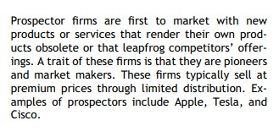
(Olson et al., 2021)
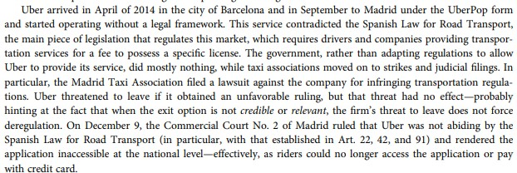
(Valdez, 2022)
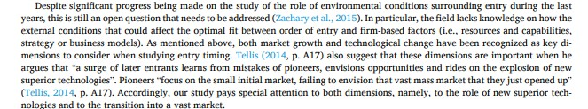
(Gómez et al., 2022)
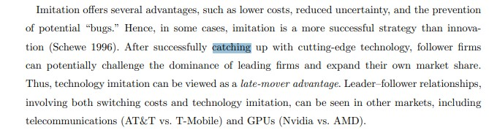
(Yang et al., 2025)
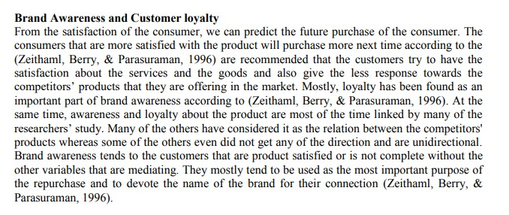
(Abbas et al., 2021)
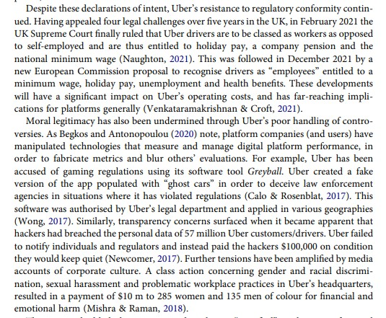
(Howcroft& Leaver, 2024)
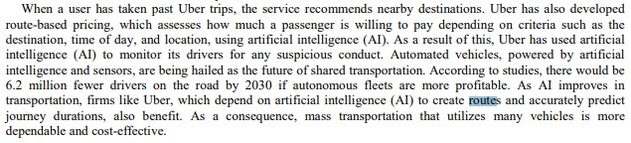
(Ushakov et al., 2022)
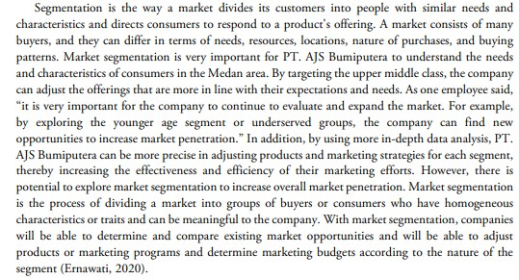
(Ade et al., 2024)
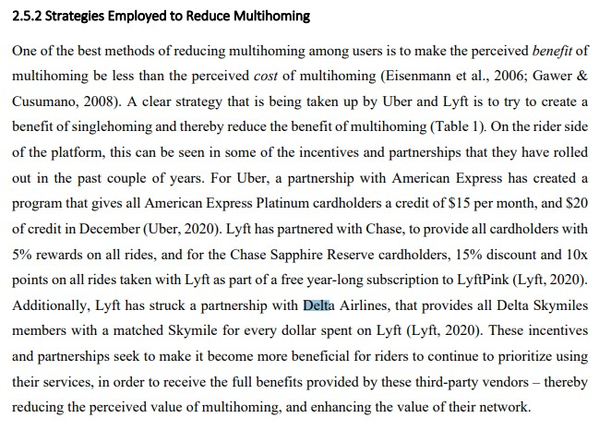
(Valderrama& Cameron, 2023)
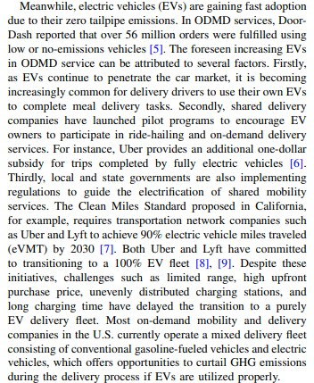
(Liu et al., 2024)
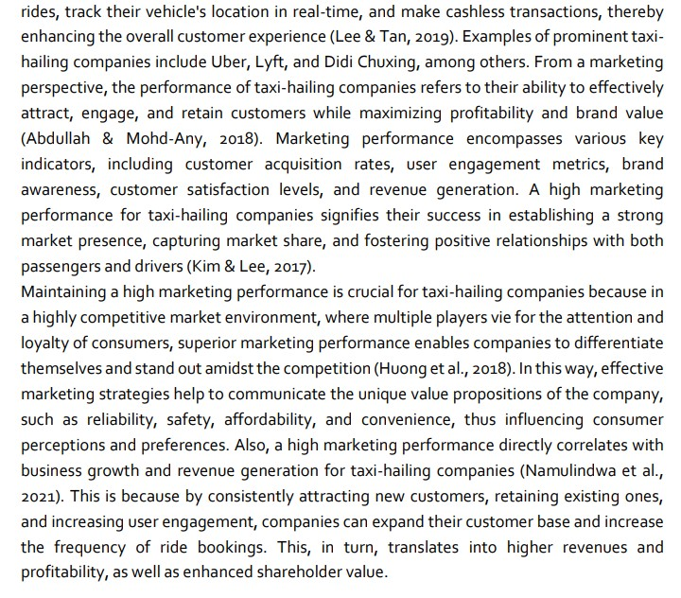
(Samuel, 2024)
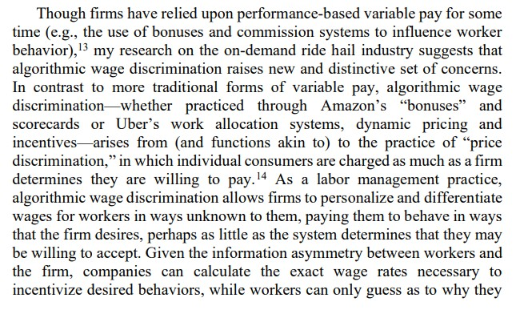
(Dubal, 2023)
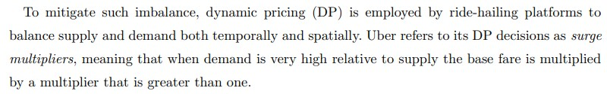
(Yan et al., 2019)
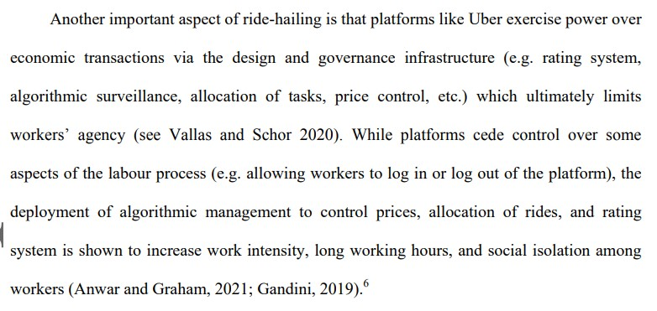
(Anwar, Odeo and Otieno, 2022)
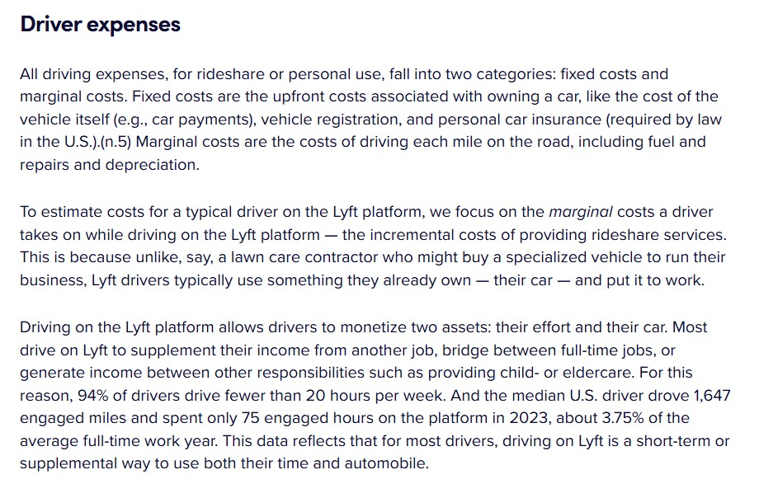
(Lyft, 2024)

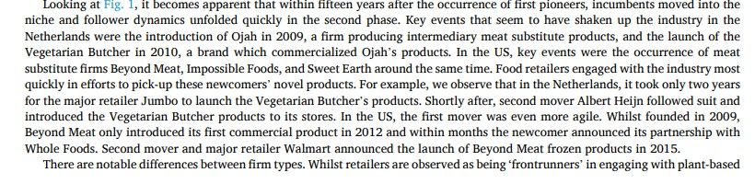
(Bulah et al.2023)
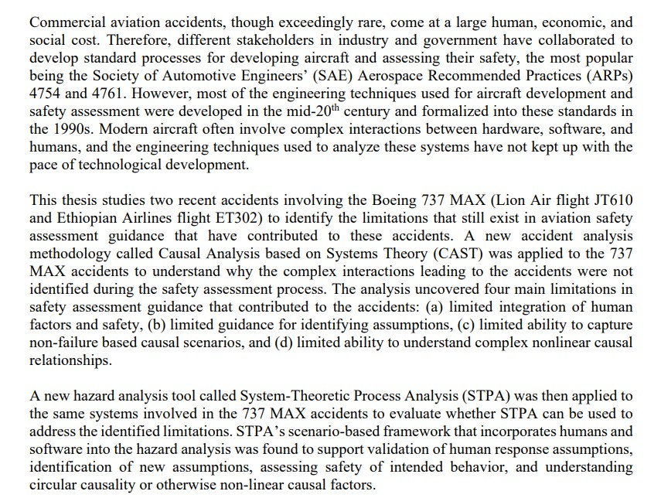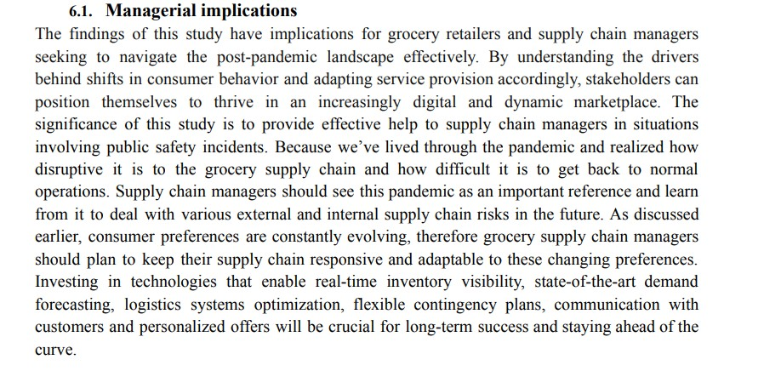

(
Lopes Rose, 2024
)

(Dianat and Hou, 2024)

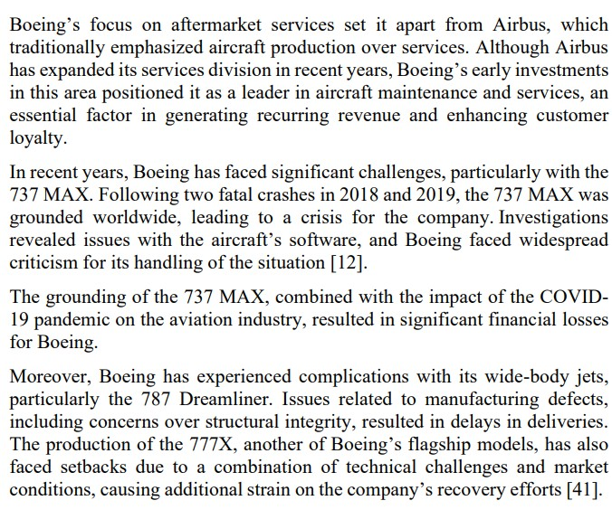

(
Lo Verde, 2024)

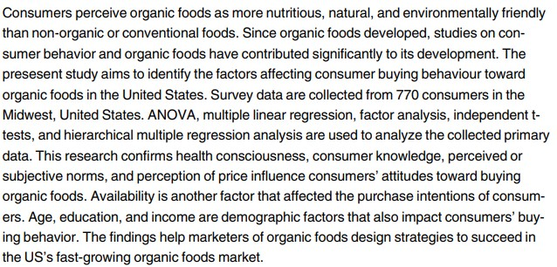

(
Gundala and Singh, 2021
)

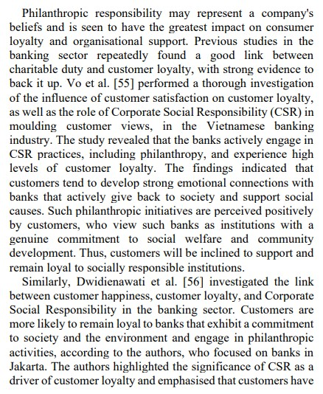

(
Alhawamdeh
et al.
2024)
.

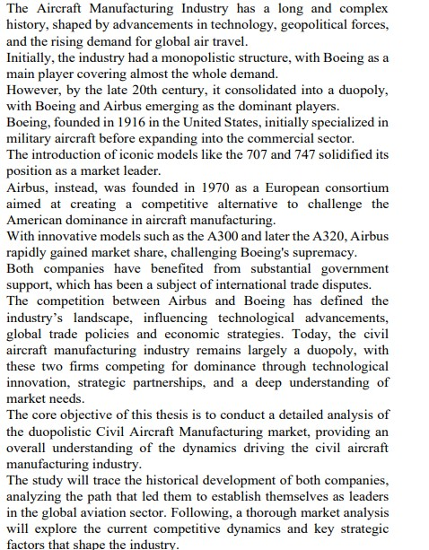

(
Lo Verde, 2024
)

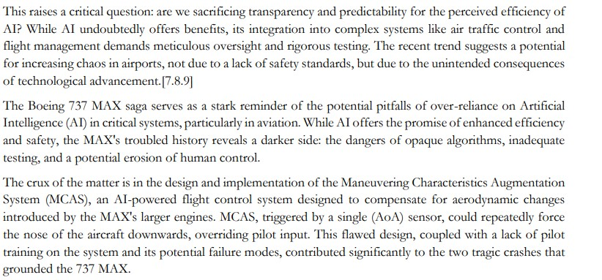

(
Christianto and Smarandache, 2025
)

