

Programme: Master of Business Administration

Module: Marketing Management
Module code: LCMB7024
Lecturer: Laila Maazouz Taonga Kaonga Sobere-Snithers
Assignment Title: Marketing Environment Analysis

Student Name: Ritika Rastogi
Student ID Number: 2536680
Word Count: 2531

Table of Contents
Task 1: Marketing Environment Analysis 3
BHP’s Transition Towards Lower-Carbon Products 3
1.1 Introduction 3
1.2 Natural Environment: The Primary External Marketing Actor 4
1.2.1 Climate Change and Greenhouse Gas Emissions 4
1.2.2 Renewable Energy Transition 5
1.2.3 Decarbonisation Challenges 6
1.2.4 Critical Evaluation of Natural Environmental Influence 7
1.3 Political and Regulatory Environment: The Secondary External Marketing Actor 8
1.3.1 Government Climate Policies and Regulations 8
1.3.2 International Carbon Pricing 9
1.3.3 Government Support and Green Innovation 9
1.3.4 Critical Evaluation of Political Influence 10
Task 2: Strategic Growth and Competitive Positioning using the Ansoff Matrix 11
2.1 Market Penetration 11
2.2 Product Development 13
2.3 Market Development 15
2.4 Diversification 17
Task 3: Critical Reflection on AI Usage 19
3.1 Disclosure of tool 19
3.2 Critical analysis of AI Output 19
3.3 Contribution Analysis 19
3.4 Ethical & Professional Reflection 20
References 21

Task 1: Marketing Environment Analysis

BHP’s Transition Towards Lower-Carbon Products

1.1 Introduction
11% of global scope and scope of greenhouse emissions was accounted for mining and metal sector with a large maturity originated from Asia highlighting the role of the sectors, both major a meter and an essential of transition to clean energy (Bracken, 2026). The memo indicated the company’s plans on decarbonisation which includes Pilbara mines, power plants, trains and diesel truck for western Australian iron ore division a major contribution on global emission.
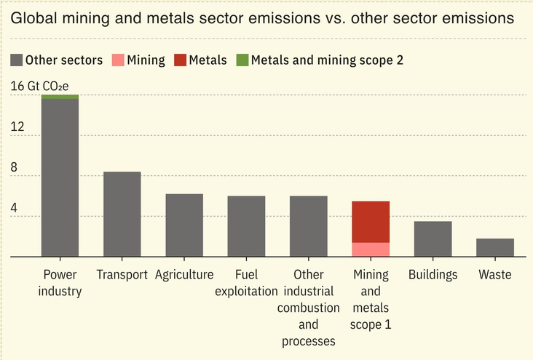
Figure 1: Global Mining and Metal Sector Emissions vs Other Sector Emissions
(Source: Bracken, 2026)
BHP is on track to meet the mid-term goal, which was supported by a 40% greenhouse gas emission intensity reduction from the shipping of BHP products by 2030 (BHP, 2026a). However, a leaked memo revealed that BHP has slowed down the decarbonisation program due to current technologies, particularly battery-electric mining equipment and large-scale renewable infrastructure, which are not sufficient to fully commercialise the deployment (Knaus and Morton, 2026). This created significant challenges, such as balancing operational efficiency and meeting the expectations of stakeholders for reducing greenhouse gas emissions.
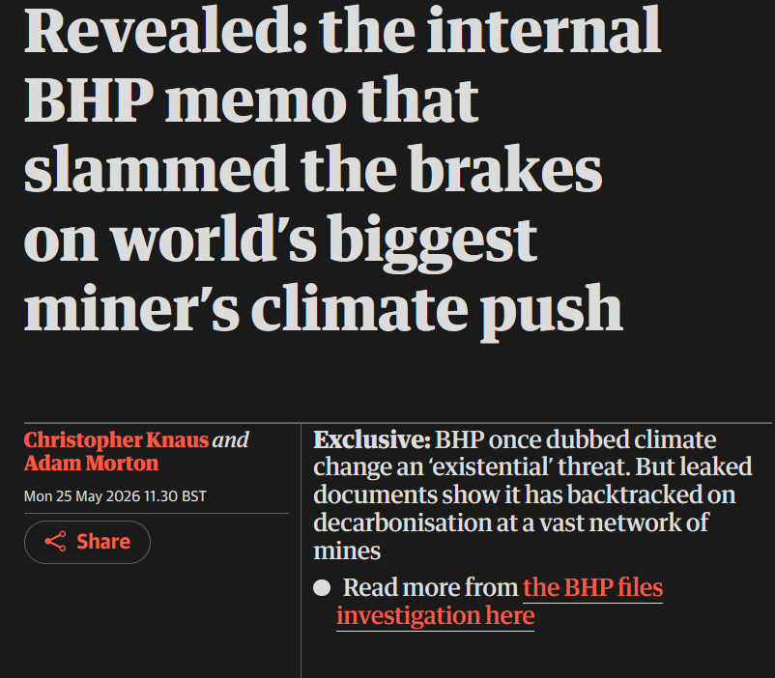
Figure 2: Revealed: the internal BHP memo that slammed the brakes on the world’s biggest miner’s climate push
(Source: Knaus and Morton, 2026)

1.2 Natural Environment: The Primary External Marketing Actor

1.2.1 Climate Change and Greenhouse Gas Emissions
The emissions are more than double those from Australian mined was reported by the International Energy Agency. The government report indicated that the emission of 0.82Mt of methane from coal mines was equivalent to 25Mt of carbon dioxide, which was a major factor in climate change (Readfearn, 2026). In the previous report, IEA have investigated and stated that there could be 60% more methane emissions from the Australian coal and gas sector.
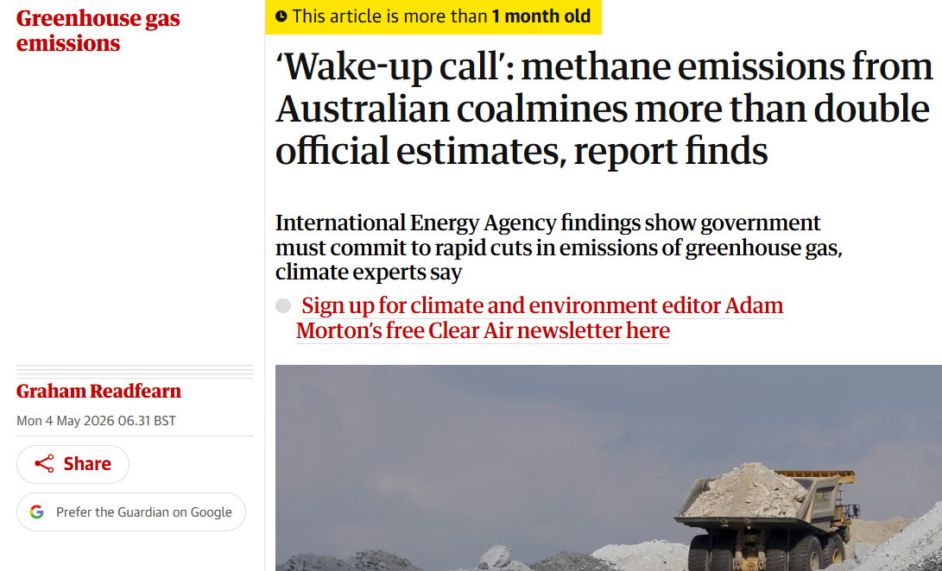
Figure 3: ‘Wake-up call’: methane emissions from Australian coalmines more than double official estimates
(Source: Readfearn, 2026)
This doubt can create indirectly pressure also on BHP on greenhouse gas emission where the company has slowed its decarbonization due to a lack of modern technology and infrastructure. This impacted the company’s long term sustainability on toward a green transition.

1.2.2 Renewable Energy Transition
For example, in the construction industry across Australia, projected large-scale renewable energy projects which are. There are currently 133 renewable energy projects under construction across Australia (Clean Energy Council, 2026). Another example, the electricity sector is the primary driver of reduction, and emissions from electricity generation dropped by 3.3% in the month of June 2025, reflecting rapid expansion in renewable energy across the grid (Gregory, 2026).
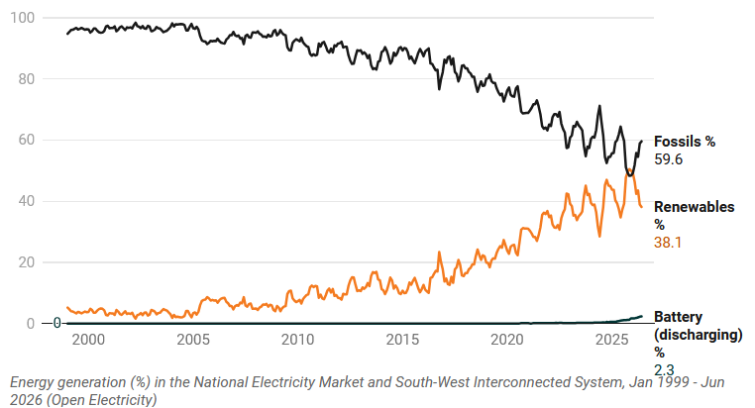
Figure 4: Accelerating the clean energy transition
(Source: Clean Energy Council, 2026)
Different sector examples indicated that Australian companies are moving toward a green energy transition to support the green economy in the country, which will boost investments in BHP to create large-scale technology and renewable energy infrastructure to boost decarbonisation programs.

1.2.3 Decarbonisation Challenges
Australia's mining and metals sector faced major decarbonisation challenges. The industry was still mainly relying on diesel-powered machinery, and the cost of the fuel tax credit scheme was predicted to be A$47 billion over four years, with over A$1 billion spent annually by coal mine operators (Morton and Jervis-Bardy, 2026). Proposed coal developments would get an extra AUD6.2 billion in diesel rebates for 11.6 billion litres of diesel fuel.
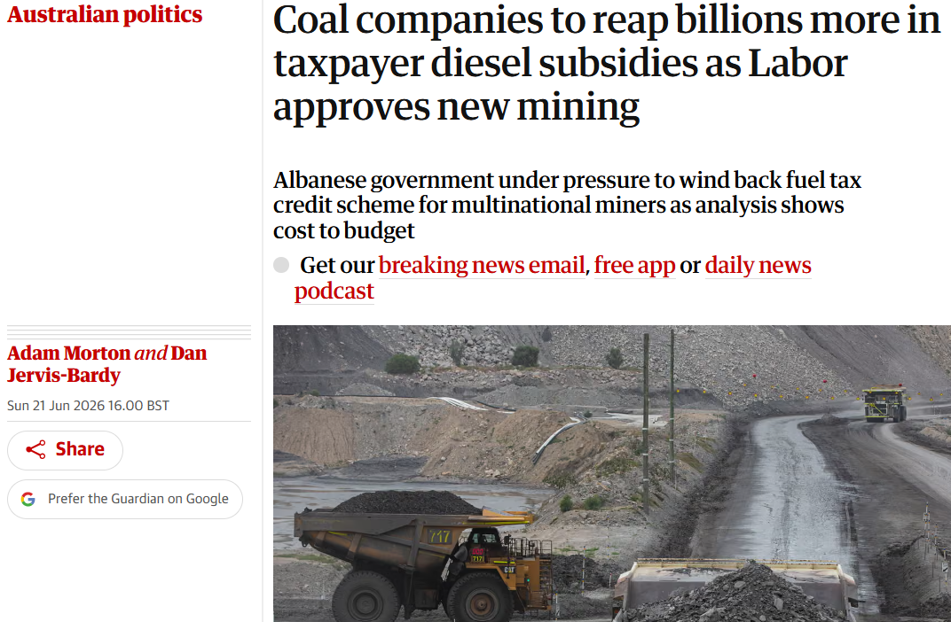
Figure 6: Coal companies to reap billions more in taxpayer diesel subsidies as Labour approves new mining
(Source: Morton and Jervis-Bardy, 2026)

1.2.4 Critical Evaluation of Natural Environmental Influence
Opportunities
- In 2025, the Australian government announced $5 billion to support the Net Zero target of heavy industry for decarbonisation (Minister.Industry.GOV.AU, 2025).
- In 2025, BHP had a market capitalisation of over 216 billion Australian dollars (Sasu, 2025).
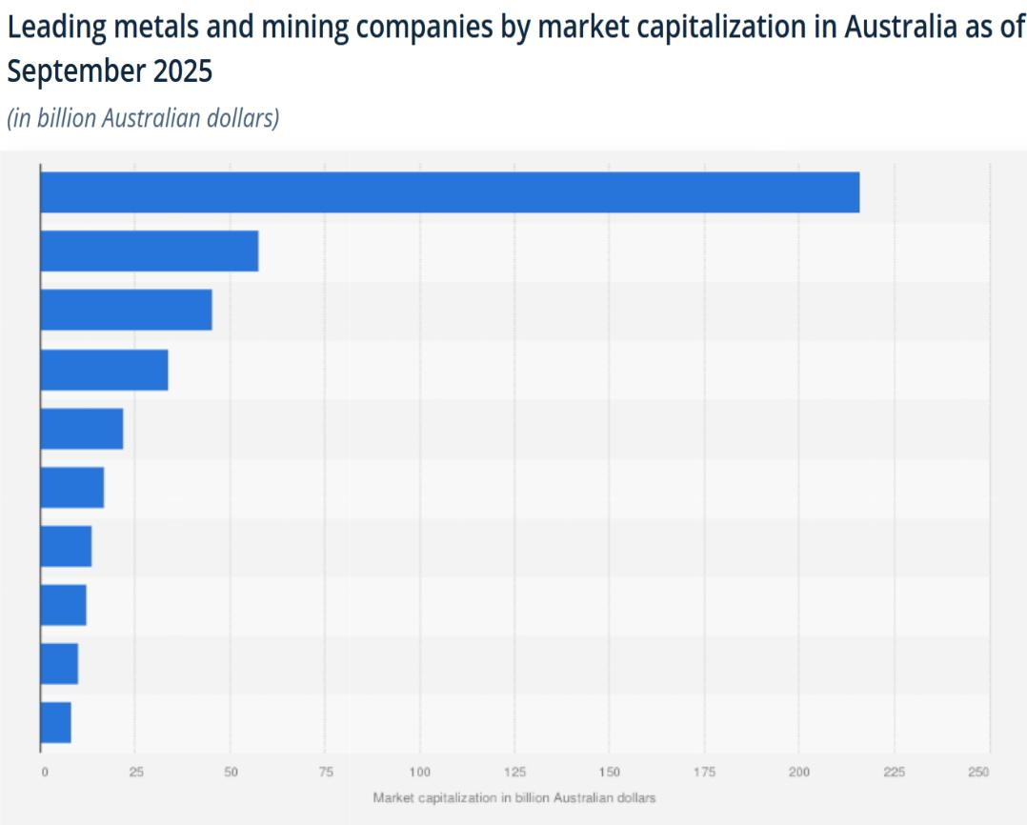
Figure 7: Leading metals and mining companies in Australia, 2025, by market capitalisation
(Source: Sasu, 2025)
Challenges
- Need for modern, high technological and renewable energy production infrastructure.
- The transition period is slow due to the limited availability of electric battery trucks.
- Diesel use conflicts with the net-zero emission target of BHP.

1.3 Political and Regulatory Environment: The Secondary External Marketing Actor

1.3.1 Government Climate Policies and Regulations
Australian government aimed to reduce greenhouse gas emissions to keep the economy secure. Australian government legislated to reduce emissions below 43% by 2030 and achieve net zero emission by 2050 (DCCEEW, 2026). BHP has collaborated with DNV to use the cloud technology named Veracity monitor and report the greenhouse gas emission and management (DNV, 2026). Australian government committed $1.1 billion to the Cleaner Fuels Program to encourage the domestic production of low-carbon liquid fuels to support the green economy (Infrastructure, 2025).

1.3.2 International Carbon Pricing
In 2025, 85 carbon pricing instruments were in place to cover 28% of global emissions, and this growing usage of instruments is significantly helping in global emission reduction. The EU Emissions Trading System played an important role in carbon pricing to reduce greenhouse gas emissions, with a 50% reduction in sectors (Europa, 2026).

1.3.3 Government Support and Green Innovation
Singapore Australia Green Economy Agreement set aside $20 million to support relevant and eligible projects under GGCIP over the period 2023 to 2026 (DFAT.GOV.AU, 2026). A blast furnace can be extended in service through relining, which is much more cost-effective than replacing the furnace, and can be relined for more than 50 years of operation for blast furnaces (BHP, 2026b). In steel industry gas-based steel production emits low emission then coal blast furnace but gas-based production is still emissions-intensive which product 1.4 tonnes of carbon dioxide (CO2) per tonne of crude steel production (IEEFA, 2025).
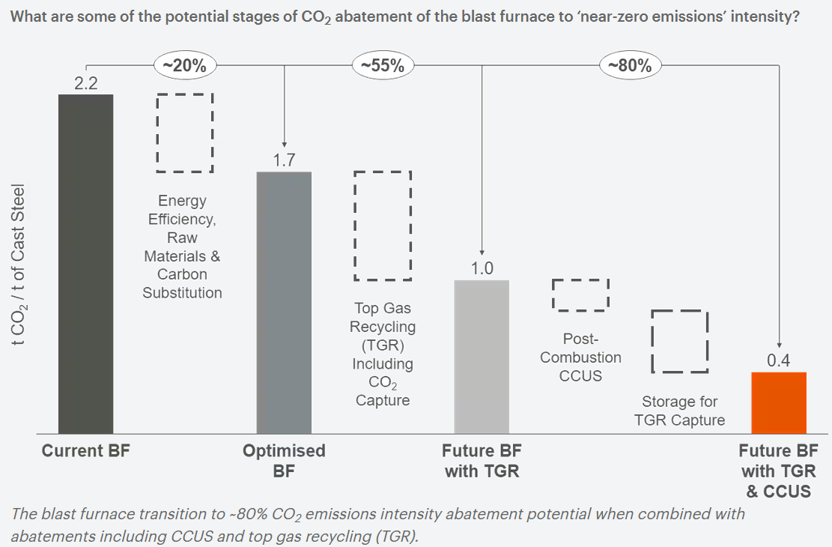
Figure 8: The Blast Furnace Transition
(Source: BHP, 2026b)

1.3.4 Critical Evaluation of Political Influence
Opportunities
- Carbon pricing encouraged cleaner technology and emission risk reductions in the future.
- Green innovation funding was used for funding infrastructure projects for renewable energy and decarbonisation of industry.
Challenges
- Compliance costs for mining companies became quite high with the strict emission regulations.
- The cost of carbon has increased operational costs and impacted international competitiveness all over the world.

Task 2: Strategic Growth and Competitive Positioning using the Ansoff Matrix

2.1 Market Penetration

NEW
Product
NEW
Existing
Market
Figure 9: Ansoff Matrix
(Source: Self-made)
Ansoff Matrix helps businesses to evaluate the growth opportunities by managing the market risks. By using Ansoff Matrix the market growth position can be evaluate by analyse BHP product and market development strategy. BHP is accelerating market penetration of its existing product offerings in these markets with a reduced carbon footprint and sustainable business practices. But Australian mining exports continued to be strong as there was a continuing rise in global demand for critical minerals in key markets recently. The metal mining market in Australia had a value of USD 24,274.8 million in 2025 and will likely increase to USD 33,349.6 million by 2033 (Grand View Research, 2026).
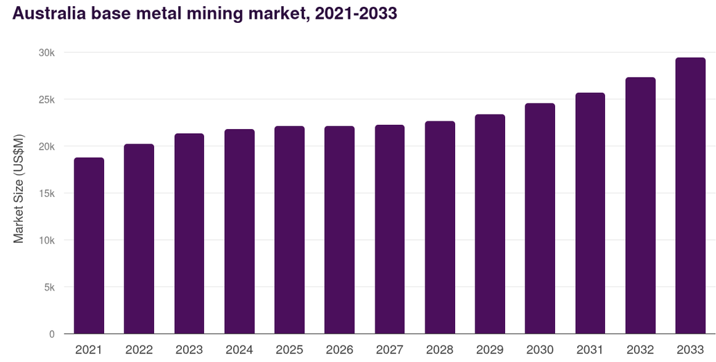
Figure 10: Australian Base Metal Mining Market 2021-2033
(Source: Grand View Research, 2026)
A 100% renewable energy transition was allowed to BHP by the agreements of renewable electricity self-supply and storage in Chile at the Escondida and Spence copper mining operations (IM-Mining, 2026). Expanding export demand provides opportunities for the mining and metals industry to expand its market share through sustainable mining operations (Hirlekar et al. 2025). BHP needs to build trust among customers by adopting responsible mining and reporting on its environmental issues in all its operations.
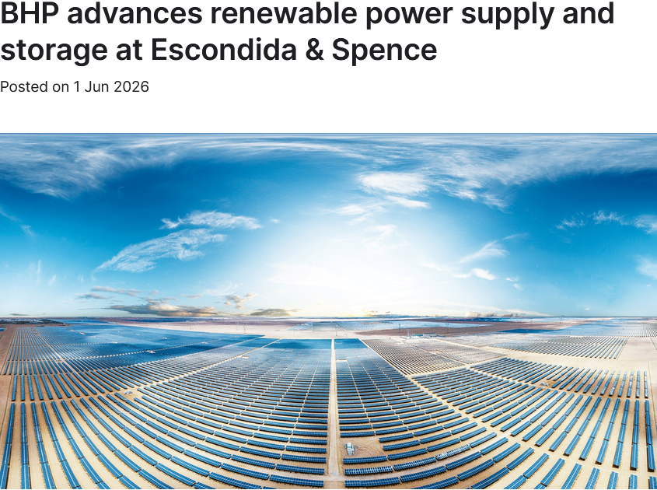
Figure 711: BHP advances renewable power supply and storage at Escondida & Spence
(Source: IM-Mining, 2026)
The company can build a competitive edge by providing responsibly produced iron ore, copper and potash products on a consistent basis worldwide. Digital monitoring, automation and energy management technologies can be applied to existing mining sites to enhance the efficiency of their operations. Operational enhancements improve the profitability of current markets while maintaining or improving the environment and customer satisfaction. This approach is an effective way of driving lower carbon growth of the company, as well as customer satisfaction, market share, profitability and long-term competitive advantage.

2.2 Product Development
BHP can effectively implement annual changes to products to lower their carbon footprint and satisfy evolving customer requirements and worldwide environmental expectations through product development. The demand for copper is increasing due to its extensive use in renewable energy solutions, for electricity transmission, and in electric vehicles (Podobińska-Staniec et al. 2025). In the context of clean energy scenarios, the demand for copper can almost double by 2040, according to the International Energy Agency's estimate (IEA, 2026a). This increasing demand opens the market for BHP's premium copper products to meet global decarbonisation targets successfully.
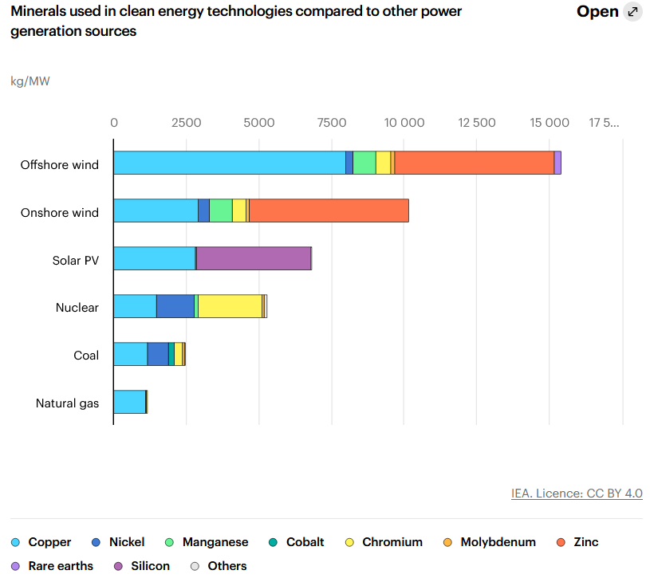
Figure 12: Minerals used in clean energy technologies compared to other power generation sources
(Source: IEA, 2026a)
BHP is also still working on the Jansen Potash Project, which is intended to provide sustainable fertiliser products for the agricultural sector around the world. The Jansen mine in Saskatchewan, which represents BHP's largest investment ever at $15.3 billion, will be one of many when it starts production about a year from now. Global potash prices are expected to be under pressure from 12.6 million tons of output from new potash mines in countries such as Canada, Russia and newcomer Laos expected to start by 2030 (TOMESCO, 2026). New products also generate new business values as customers are expecting more products to be eco-friendly now in all aspects of the industries across the globe. This is a policy that can provide a competitive advantage by innovation, sustainability, product differentiation, and ensure long-term sustainable profitable business growth in the global market.
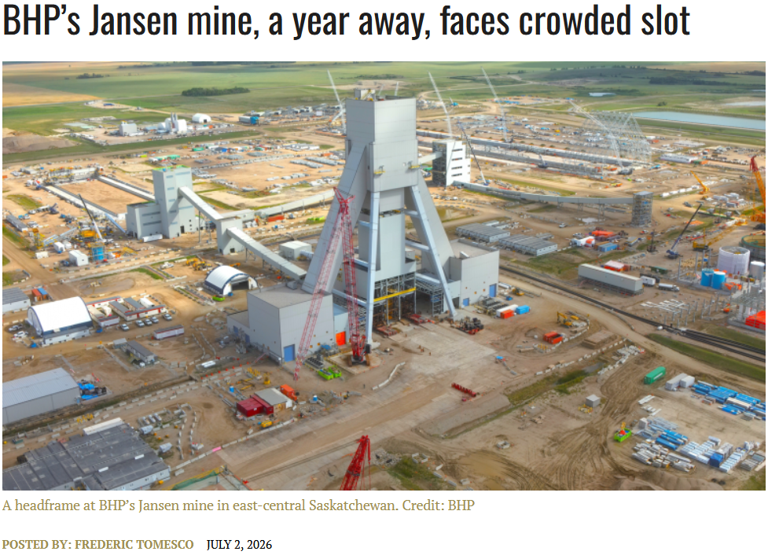
Figure 13: BHP’s Jansen mine, a year away, faces a crowded slot
(Source: TOMESCO, 2026)

2.3 Market Development
BHP should increase its sales to the emerging economies, also investing heavily in the development of modern industrial infrastructure and renewable energies. The Australia-Canada-India Technology and Innovation (ACITI) Partnership is a new trilateral technology and innovation partnership between Australia, Canada and India that aims to strengthen the partnership between the three countries with a focus on the enhancement of technology and innovation (PM, 2026). Initiatives were leveraging the natural strengths of the three countries and were focused on green energy innovation, building resilient supply chains, including ones for critical minerals.
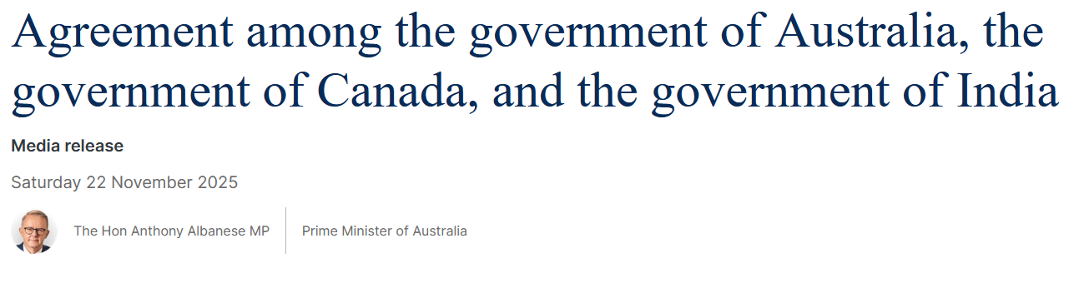
Figure 14: Agreement among the government of Australia, the government of Canada, and the government of India
(Source: PM, 2026)
These agreements could provide BHP with good chances to expand its iron ore and copper export projects without difficulties in the international market. BHP needs to further forge long-term collaborations between separate international manufacturers of battery products, renewable energy systems, and electric transport equipment. The increasing demand for critical minerals fuels expansion efforts in new markets, and responsible and sustainable mineral suppliers are essential (Zhang, 2026). Copper production improvements of approximately 30% over the last four years since the 2023 acquisition of Oz Minerals and its operational improvements at Escondida and future development upside at Vicuna have resulted in BHP's copper production growth (Sun, 2026).
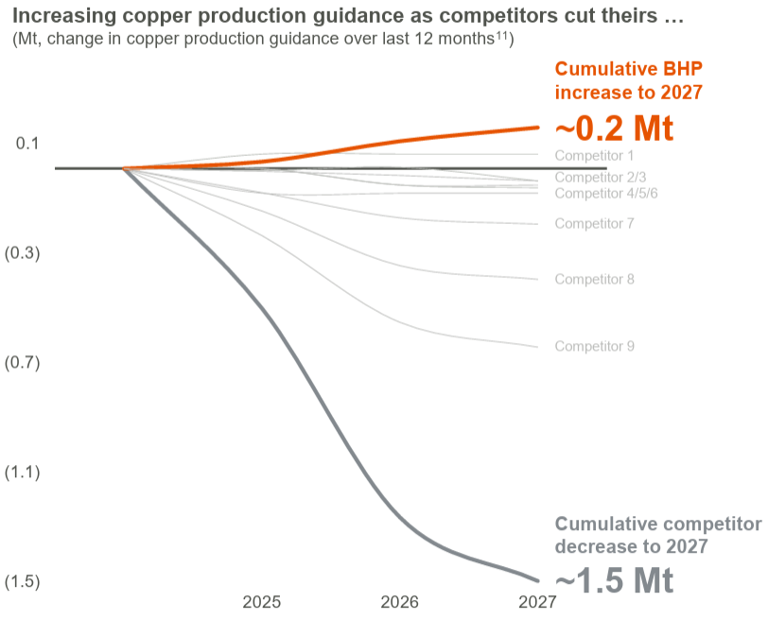
Figure 15: Increasing Copper Production
(Source: Sun, 2026)
Effective global partnerships build customer confidence and effectively support responsible sourcing and sustainable business development in industries worldwide. This approach will enhance competitiveness via greater market opportunities, increased exports, improved relationships and global sustainable earnings growth.

2.4 Diversification
Diversification enables BHP to expand into new industry sectors and develop a lower carbon economy in them in the long term, successfully. BHP should put more money into clean energy and advanced mineral processing technologies than just mining for growth. Due to the need for reliable energy storage in international markets today, global battery storage demand remains high. In total lithium-ion battery deployment, over 70% of EV deployments represent a share of the population (IEA, 2026b).
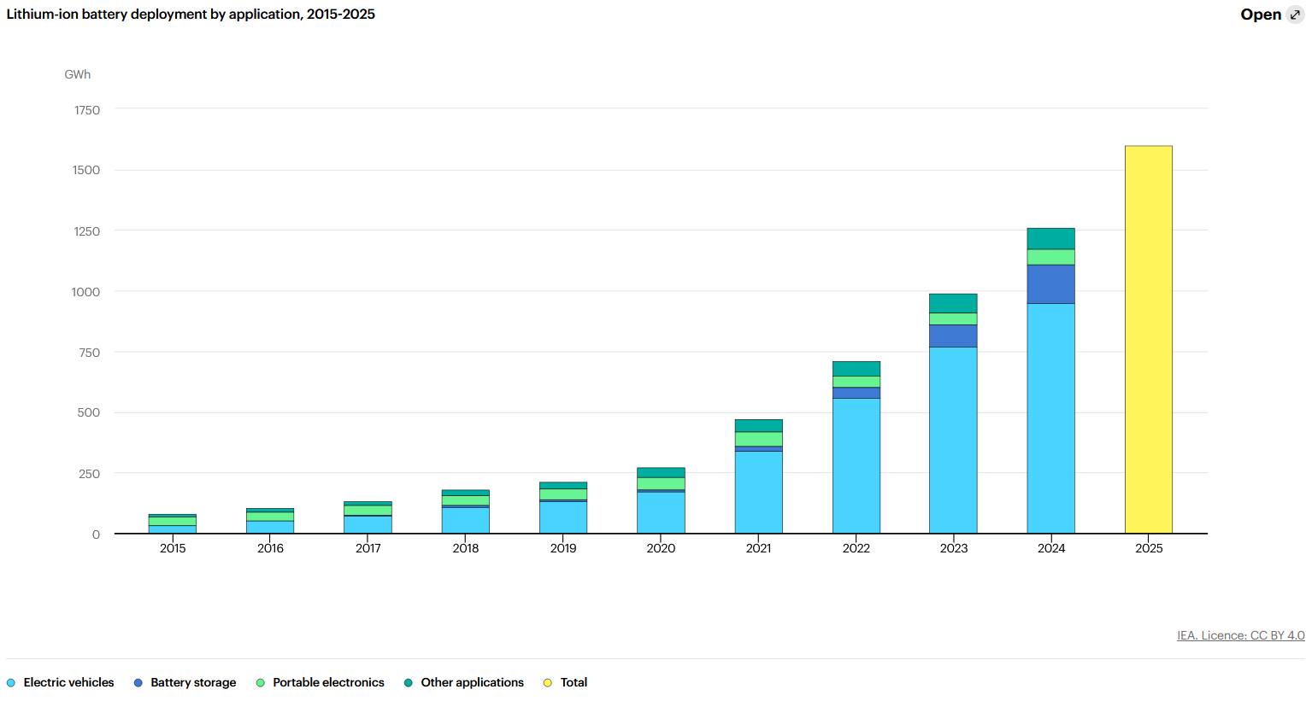
Figure 16: Lithium-ion battery deployment by application, 2015-2025
(Source: IEA, 2026b)
This is followed by battery energy storage at over 15%, reflecting the growing role of batteries in providing flexibility in power systems. Industry diversification to recycling enhances resource efficiency but does not rely on newly mined mineral resources. BHP may partner with these technology firms to advance sustainable mining and manufacturing practices and to clean up the mining industry. This approach will foster innovation, diversified revenue streams, increased resilience, and growth opportunities for the company in the long term through the application of its business globally.

Task 3: Critical Reflection on AI Usage

3.1 Disclosure of tool
This marketing analysis and strategic growth report for BHP has used generative AI technologies - particularly the application academi.cx Pro in conjunction with high-capacity cloud-based generative AI systems - to assist with the preparation of the report. The primary usage of these tools occurred during the initial brainstorming session through which we outlined the most important external marketing players (in reference to both the Natural and Political environments) and generated the initial concepts for the Ansoff Matrix strategies. Additionally, the generative AI tools were employed for proofreading, sentence structure re-development, and enhancement of the overall academic quality in the final draft of the document.

3.2 Critical analysis of AI Output
In its synthesis of general mining industry trends using AI, the information produced was very well structured and cohesive but did not have enough critical depth or contextual specificity required for a level III Marketing module. Process technology investments may help pioneers to sustain their competitive advantages (Covin et al. 2000). For example, while the AI correctly identified greenhouse gas emissions as a key environmental consideration, it did not automatically incorporate very specific, up-to-date local data that is A$47 billion for the Australian fuel tax credit scheme over 4-years, or the specific nature of BHP's decelerated climate push which can be seen from previously leaked insider information. As a result of this, the AI's output had to be significantly edited, cross-checked and then added to from many credible journalistic/newspaper and government sources to produce a much better quality and more reliable analysis.

3.3 Contribution Analysis
This report has been produced jointly through the combined efforts of both human intellect and artificial intelligence (AI). Approximately 30% of the effort on this report was contributed by AI about formatting, generating initial concepts regarding product development and how to penetrate different markets, and basic grammar refinement. All remaining efforts (70%) have solely been performed by humans, including evaluating the natural and political environments, applying the Ansoff Matrix in a strategic manner to BHP's copper and potash projects (i.e. Jansen Potash Project), and incorporating evidence from peer-reviewed literature and reliable datasets to support our arguments.

3.4 Ethical & Professional Reflection
Using AI to accomplish this task illustrates the significance of integrity and transparency in research. Using solely AI could create the risk of presenting "lost" or uncurrent data and would not be acceptable in either a professional or academic context. In addition to these ethical implications, this project has shown that although AI can be an extremely powerful tool for marketing managers in terms of quickly processing large quantities of macro-environmental data, AI will never replace a marketing manager's ability to make good strategic decisions. Especially when making strategic decisions regarding sensitive subjects such as carbon pricing, regulatory compliance, and sustainable diversification, the marketing manager must use a human perspective to develop a comprehensive understanding of any stakeholder's needs and the company's responsibility toward them something that AI cannot currently replicate.

References
BHP (2026a). Operational GHG emissions (Scopes 1 and 2 emissions from our operated assets). [online] Available at: https://www.bhp.com/sustainability/climate-change/operational-ghg-emissions [Accessed 6th Jul. 2026].
BHP (2026b). Modifying the blast furnace route for lower carbon intensity steelmaking. [online] Available at: https://www.bhp.com/news/bhp-insights/2026/06/modifying-the-blast-furnace-route-for-lower-carbon-intensity-steelmaking [Accessed 6th Jul. 2026].
Bracken, N. (2026). Exclusive / Mining, metals sector accounts for 11% of global emissions, report finds. [online] Available at: https://www.semafor.com/article/03/10/2026/mining-metals-sector-account-for-11-of-global-emissions-report-finds [Accessed 6th Jul. 2026].
CLEAN ENERGY COUNCIL (2026). Accelerating the clean energy transition. [online] Available at: https://cleanenergycouncil.org.au/advocacy/industry-snapshot [Accessed 6th Jul. 2026].
Covin, J.G., Slevin, D.P. and Heeley, M.B. (2000). Pioneers and followers: Competitive tactics, environment, and firm growth. Journal of business venturing, 15(2), pp.175-210. https://www.academia.edu/download/67341664/s0883-9026_2898_2900015-920210516-3730-rx3scc.pdf
DCCEEW (2026). Reducing emissions. [online] Available at: https://www.dcceew.gov.au/climate-change/emissions-reduction [Accessed 6th Jul. 2026].
DFAT.GOV.AU (2026). Go-Green Co-Innovation Program grant recipients. [online] Available at: https://www.dfat.gov.au/geo/singapore/singapore-australia-green-economy-agreement/go-green-co-innovation-program-grant-recipients [Accessed 6th Jul. 2026].
DNV (2026). BHP reduces Scope 3 greenhouse gas emissions through the cloud platform Veracity. [online] Available at: https://www.dnv.com/sustainable-practices/bhp-scope3-greenhouse-gas-reduction/ [Accessed 6th Jul. 2026].
Europa (2026). International carbon pricing and markets diplomacy. [online] Available at: https://climate.ec.europa.eu/eu-action/carbon-markets/international-carbon-pricing-and-markets-diplomacy_en [Accessed 6th Jul. 2026].
Grand View Research (2026). Australia Base Metal Mining Market Size & Outlook, 2026-2033. [online] Available at: https://www.grandviewresearch.com/horizon/outlook/base-metal-mining-market/australia?__cf_chl_f_tk=lzqtNapk7d9gRsG7tElcEWSCeDyU8yEM_rXCPxftdxU-1783166386-1.0.1.1-W2kQhSIzegTqwno7BLpFlG0jlW8peVIBbWNLmH5o1Sw [Accessed 6th Jul. 2026].
Gregory, J. (2026). Australia: 2026 Emissions Forecast. [online] Available at: https://www.climatescorecard.org/2026/03/australia-2026-emissions-forecast/ [Accessed 6th Jul. 2026].
Hirlekar, O., Kolte, A. and Vasa, L. (2025). Transition in the mining industry with green energy: Economic dynamics in mining demand. Resources Policy, 100, p.105409. https://www.sciencedirect.com/science/article/pii/S0301420724007761
IEA (2026a). Executive Summary – the Role of Critical Minerals in Clean Energy Transitions – Analysis. [online] Available at: https://www.iea.org/reports/the-role-of-critical-minerals-in-clean-energy-transitions/executive-summary [Accessed 6th Jul. 2026].
IEA (2026b). Global battery markets are growing strongly – and so are the supply risks. [online] Available at: https://www.iea.org/commentaries/global-battery-markets-are-growing-strongly-and-so-are-the-supply-risks [Accessed 6th Jul. 2026].
IEEFA (2025). Australia’s steel sector too focused on replacing one fossil fuel with another. [online] Available at: https://ieefa.org/resources/australias-steel-sector-too-focused-replacing-one-fossil-fuel-another [Accessed 6th Jul. 2026].
IM-Mining (2026). BHP advances renewable power supply and storage at Escondida & Spence. [online] Available at: https://im-mining.com/2026/06/01/bhp-advances-renewable-power-supply-and-storage-at-escondida-spence/ [Accessed 6th Jul. 2026].
Infrastructure (2025). Towards net zero for transport and infrastructure. [online] Available at: https://www.infrastructure.gov.au/infrastructure-transport-vehicles/towards-net-zero-transport-and-infrastructure [Accessed 6th Jul. 2026].
Knaus, C. and Morton, A. (2026). Revealed: the internal BHP memo that slammed the brakes on the world’s biggest miner’s climate push. [online] Available at: https://www.theguardian.com/world/ng-interactive/2026/may/25/bhp-files-internal-memo-revealed [Accessed 6th Jul. 2026].
Minister.Industry.GOV.AU (2025). New $5 billion Net Zero Fund will accelerate Australia’s industrial decarbonisation. [online] Available at: https://www.minister.industry.gov.au/ministers/timayres/media-releases/new-5-billion-net-zero-fund-will-accelerate-australias-industrial-decarbonisation [Accessed 6th Jul. 2026].
Morton, A. and Jervis-Bardy, D. (2026). Coal companies to reap billions more in taxpayer diesel subsidies as Labour approves new mining. [online] Available at: https://www.theguardian.com/australia-news/2026/jun/22/mining-tax-credit-scheme-coal-companies-subsidies-taxpayer-refunds-diesel [Accessed 4 Jul. 2026].
PM (2025). Agreement among the government of Australia, the government of Canada, and the government of India. [online] Available at: https://www.pm.gov.au/media/agreement-among-government-australia-government-canada-and-government-india [Accessed 4 Jul. 2026].
Podobińska-Staniec, M., Wiktor-Sułkowska, A., Kustra, A. and Lorenc-Szot, S. (2025). Copper as a critical resource in the energy transition. Energies, 18(4), p.969. https://www.mdpi.com/1996-1073/18/4/969
Readfearn, G. (2026). ‘Wake-up call’: methane emissions from Australian coalmines more than double official estimates, report finds. [online] Available at: https://www.theguardian.com/environment/2026/may/04/methane-emissions-australian-coalmines-more-than-double-official-estimates-report-finds [Accessed 4 Jul. 2026].
Sasu, D.D. (2025). Leading metals and mining companies Australia 2025, by market capitalization . [online] Available at: https://www.statista.com/statistics/1241687/australia-largest-metal-mining-companies-by-market-capitalization/ [Accessed 4 Jul. 2026].
Sun, K. (2026). BHP just hit all-time highs. Here are three reasons it has more to give. [online] Available at: https://www.marketindex.com.au/news/bhp-just-hit-all-time-highs-here-are-three-reasons-it-has-more-to-give [Accessed 4 Jul. 2026].
TOMESCO, F. (2026). BHP’s Jansen mine, a year away, faces crowded slot. [online] Available at: https://www.northernminer.com/news/bhps-jansen-mine-a-year-away-faces-crowded-slot/1003892644/ [Accessed 4 Jul. 2026].
Zhang, H. (2026). Resilience of critical transition minerals supply chain in the context of strategic rivalry: implications for the national policy and regulatory frameworks. Journal of Energy & Natural Resources Law, 44(1), pp.67-93. https://www.tandfonline.com/doi/pdf/10.1080/02646811.2025.2495920

