COVER PAGE
Title:
Mindfulness and Emotional Intelligence in the Workplace
Report Prepared for:
Senior Management Team (SMT)
Module:
Emotional Intelligence and Organisational Behaviour
Module code:
LCLM5006
Assignment Title:
Evaluation of Emotional Intelligence and Generational Characteristics in the Workplace
Student Name:
Mahagoub Abdelbanat
Student ID:
2325355
Institution:
University of Wales Trinity Saint David (Birmingham)
Lecturer:
Nishi Ramsurrun
Abdallah Naser
Submission Date:
23/03/2026

COVER PAGE 1
Mindfulness and Emotional Intelligence in the Workplace 4
Introduction 4
1. Critic 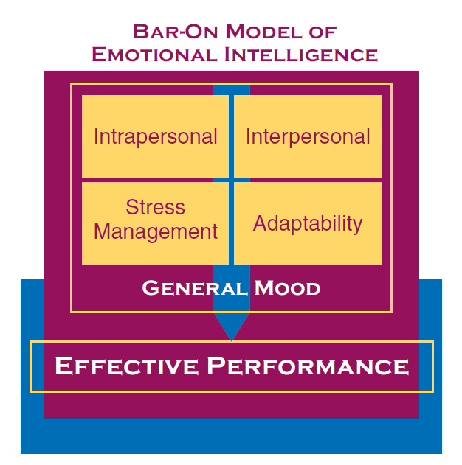al Evaluation of Emotional Intelligence Components in the Workplace 6
Goleman’s Emotional Intelligence Model 6
7
What Is Stress? 7
Types of Stress 7
4. The Science of Stress in the Brain 🧠 8
5. The Science of Stress in the Brain 9
The Amygdala: The Brain’s Alarm System 10
The Hypothalamus: Command Centre 11
The Prefrontal Cortex: Rational Thinking 11
Short-Term vs Long-Term Brain Effects 11
Self-Awareness 12
Self-Regulation 12
Motivations 12
Empathy 13
Social Skills 13
Mayer and Salovey Ability Model 13
Bar-On Emotional-Social Intelligence Model 14
Mindfulness and Emotional Intelligence 14
Critical Evaluation 15
2. Generational Characteristics in Recruitment and Workplace Management 15
Generation X 15
Managing a Multi-Generational Workforce 16
Conclusion and Recommendations 17
Conclusion 17
Recommendations 17

Mindfulness and Emotional Intelligence in the Workplace
Report for Senior Management Team (SMT)

Introduction
In modern organisational environments, employee performance is influenced not only by technical competence but also by interpersonal and emotional capabilities. Emotional intelligence (EI) has emerged as a crucial factor that enables individuals to recognise, understand and manage their emotions while also responding effectively to the emotions of others (Goleman, 1998). Emotional intelligence is particularly important in workplaces where teamwork, communication and leadership play a significant role in achieving organisational objectives. As organisations become increasingly diverse and complex, the ability to manage emotional interactions and build positive relationships has become essential for both employees and managers.
Emotional intelligence is closely linked to the concept of mindfulness, which refers to maintaining awareness of one’s thoughts, emotions and behaviours in the present moment. Mindfulness encourages individuals to observe their internal experiences without immediate judgement or reaction (Kabat-Zinn, 2003). By practicing mindfulness, employees can improve emotional regulation, reduce stress and enhance decision-making processes. Mindfulness therefore acts as a supporting mechanism that strengthens emotional intelligence and promotes workplace wellbeing.
Research has shown that emotional intelligence contributes significantly to leadership effectiveness and organisational success. According to Goleman (1998), emotional competencies such as empathy, self-awareness and social skills often differentiate high-performing leaders from average performers. Similarly, Mayer, Salovey and Caruso (2004) argue that emotional intelligence influences how individuals perceive emotional information and use it to guide thinking and behaviour. These competencies allow employees to respond constructively to workplace challenges, build productive relationships and maintain positive organisational cultures.
Furthermore, the modern workforce consists of multiple generations with different experiences, values and expectations. Generational diversity can influence communication styles, work preferences and leadership expectations within organisations (Twenge, 2017). Generational groups such as Generation X, Generation Y (Millennials) and Generation Z have grown up in different social and technological environments, shaping how they approach work and career development. Managers who understand these generational differences can create more inclusive workplaces and develop recruitment strategies that attract diverse talent.
The ability to manage generational diversity has become particularly important as organisations compete for skilled employees in increasingly competitive labour markets. Each generation brings unique strengths, knowledge and perspectives that contribute to organisational performance. However, misunderstandings between generations may lead to communication challenges or workplace conflict if not managed effectively.
This report aims to critically evaluate how emotional intelligence components are used by employees in workplace environments, drawing upon recognised EI models. The report will examine the relevance of emotional intelligence and mindfulness in organisational behaviour and leadership. Additionally, the report will explore generational characteristics relevant to recruitment and workplace management, particularly focusing on Generation X, Millennials and Generation Z. Finally, the report will provide recommendations for organisations seeking to improve emotional intelligence development and manage generational diversity effectively.

1. Critic al Evaluation of Emotional Intelligence Components in the Workplace
Emotional intelligence plays a crucial role in shaping employee behaviour, leadership effectiveness and workplace relationships. Employees with high emotional intelligence demonstrate greater adaptability, improved communication skills and stronger interpersonal relationships. Several theoretical models explain emotional intelligence and provide frameworks for understanding how individuals process and manage emotional information. Among the most widely recognised models are Goleman’s Mixed Model, Mayer and Salovey’s Ability Model and Bar-On’s Emotional-Social Intelligence Model.

Goleman’s Emotional Intelligence Model
Daniel Goleman (1998) proposed a widely used model of emotional intelligence consisting of five core competencies: self-awareness, self-regulation, motivation, empathy and social skills. These components collectively influence how individuals manage themselves and interact with others in workplace environments.
Overall, emotional intelligence provides significant benefits for organisational performance, leadership effectiveness and employee wellbeing. Emotional competencies allow individuals to manage interpersonal relationships and workplace challenges more effectively. Nevertheless, emotional intelligence should be considered a complementary skill rather than a substitute for technical expertise. Organisations that integrate emotional intelligence training into leadership development programmes often experience improvements in communication, teamwork and organisational culture (Boyatzis, 2018).

What Is Stress?
Stress is the body’s natural reaction to pressure, challenges, or demands. When you face a difficult situation, your brain signals your body to release hormones like adrenaline and cortisol. This prepares you to respond quickly—often called the “fight-or-flight” response.

Types of Stress
- Acute Stress
  - Short-term stress.
  - Comes from immediate challenges (exams, deadlines, arguments).
  - Usually goes away once the situation ends.
- Chronic Stress
  - Long-term stress that continues for weeks or months.
  - Often caused by ongoing problems like financial pressure or work overload.
  - Can affect health if not managed.
- Eustress (Positive Stress)
  - Motivating stress that helps you perform better.
  - Example: excitement before a competition or presentation.
- The Science of Stress in the Brain
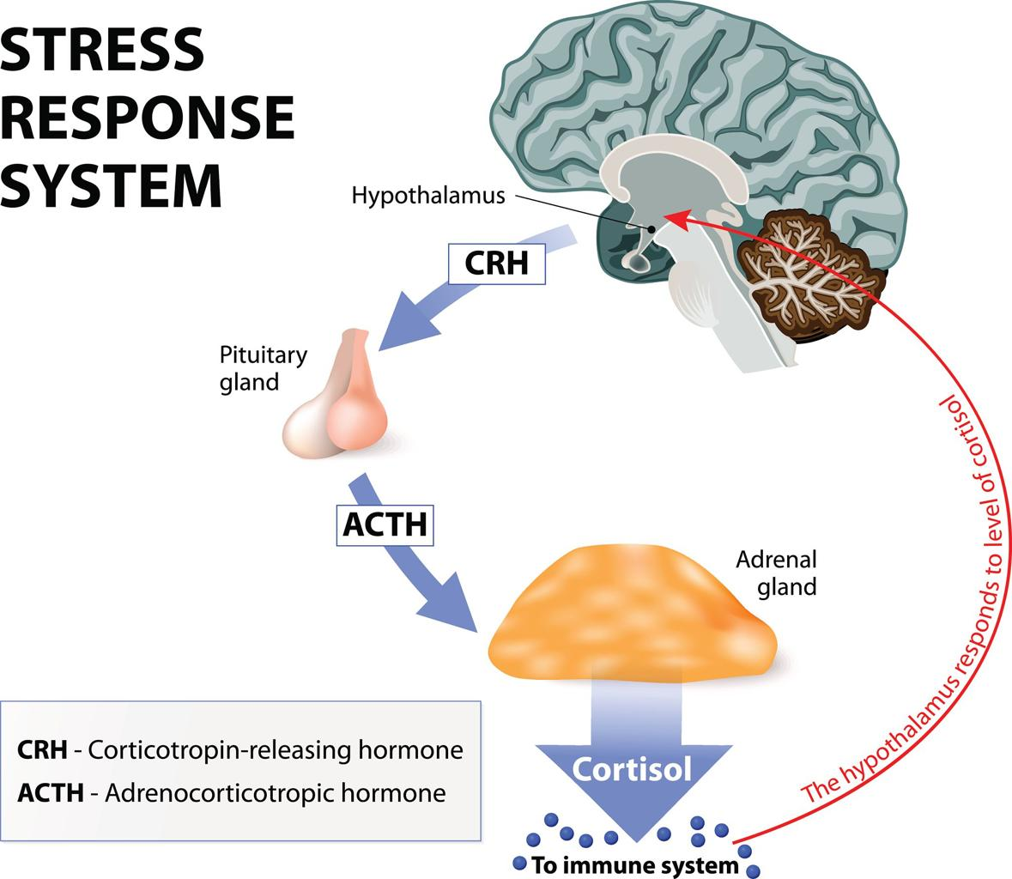
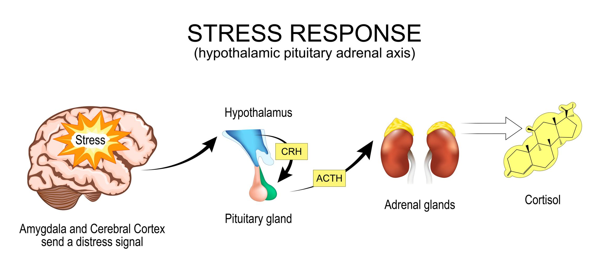

Stress is not just a feeling—it is a biological process controlled by the brain and hormones. When you experience a threat or challenge, several brain regions work together to prepare the body to react.
- The Science of Stress in the Brain
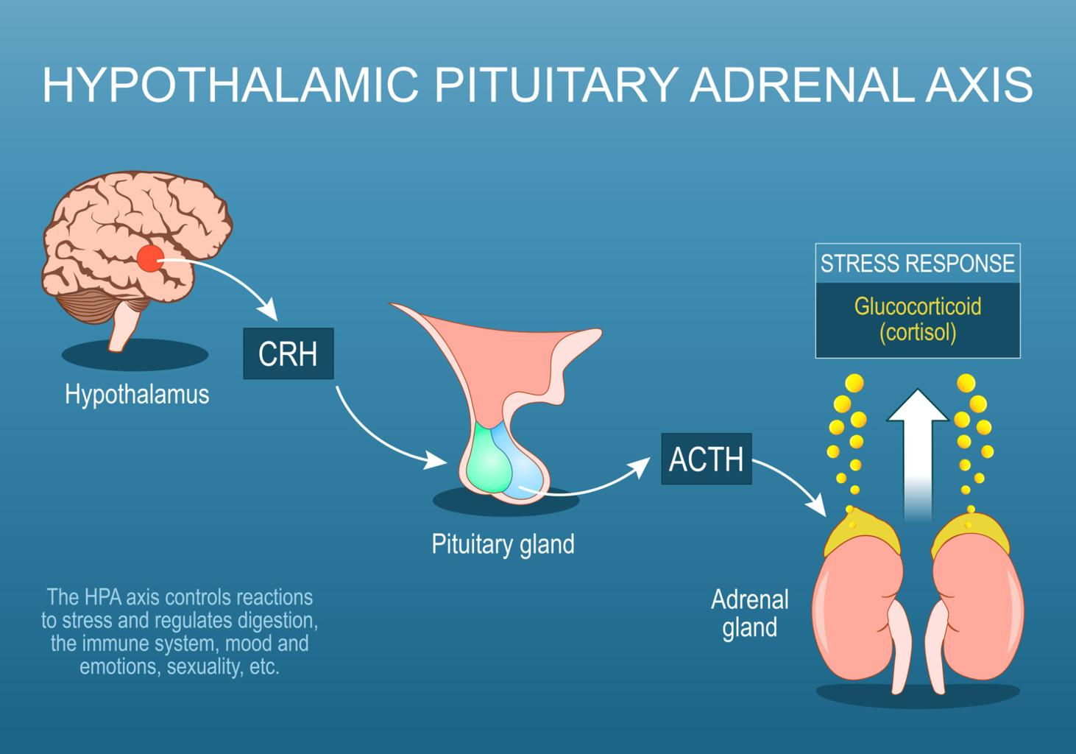

Stress is not just a feeling—it is a biological process controlled by the brain and hormones. When you experience a threat or challenge, several brain regions work together to prepare the body to react.

The Amygdala: The Brain’s Alarm System
The Amygdala detects danger and emotional threats.
- It constantly scans your environment.
- If it senses danger, it sends a signal to the Hypothalamus.
- This triggers the body’s fight-or-flight response.

The Hypothalamus: Command Centre
The Hypothalamus connects the brain with the endocrine system.
It activates the Hypothalamic–Pituitary–Adrenal axis (HPA axis).
This system signals the adrenal glands to release stress hormones

The Prefrontal Cortex: Rational Thinking
The Prefrontal Cortex controls:
- Decision-making
- Self-control
- Logical thinking
During high stress:
- Activity here decreases
- Emotional reactions from the amygdala become stronger
This is why people may panic or make poor decisions when stressed.

Short-Term vs Long-Term Brain Effects
Short-term stress
- Improves focus and reaction speed
- Helps survival
Chronic stress
- Weakens memory
- Reduces concentration
- Increases risk of anxiety and depression
- Can change brain structure over time
Simple summary
Stress pathway in the brain:
- Amygdala detects danger
- Hypothalamus activates HPA axis
- Adrenal glands release adrenaline & cortisol
- Body enters fight-or-flight mode

Self-Awareness
Self-awareness refers to the ability to recognise and understand one’s emotions and how these emotions influence behaviour and decision-making. Employees with high levels of self-awareness are able to identify emotional triggers and evaluate how their feelings affect workplace interactions (Goleman, Boyatzis and McKee, 2013).
For example, a manager who recognises that they feel frustrated during stressful meetings may take time to reflect before responding to colleagues. This awareness prevents emotional reactions that could negatively affect team relationships. Self-awareness also encourages individuals to seek feedback and engage in continuous personal development.
However, developing self-awareness requires reflection and openness to criticism, which some individuals may find uncomfortable. Organisations must therefore promote supportive environments that encourage learning and self-reflection (Boyatzis, 2018).

Self-Regulation
Self-regulation refers to the ability to control emotional impulses and respond to situations in a calm and constructive manner. Employees who demonstrate effective emotional regulation can manage stress and remain professional during challenging circumstances (Cherniss, 2010).
In leadership roles, self-regulation is particularly important because leaders’ emotional responses can influence team morale and organisational culture. Leaders who respond calmly to crises or workplace conflicts can reduce tension and encourage problem-solving.
Nevertheless, critics argue that excessive emotional control may lead to emotional suppression, which could negatively affect employee wellbeing if individuals feel unable to express genuine emotions (Landy, 2005).

Motivations
Motivation within emotional intelligence refers to the internal drive that encourages individuals to pursue goals and maintain commitment to their work. Emotionally intelligent employees tend to demonstrate high levels of intrinsic motivation, meaning they are driven by personal satisfaction and achievement rather than solely external rewards.
Research suggests that intrinsically motivated employees are more resilient and innovative, contributing positively to organisational performance (Ryan and Deci, 2000). Motivated individuals often demonstrate perseverance when facing challenges, which is particularly valuable in competitive or rapidly changing business environments.
However, organisational culture also plays an important role in maintaining motivation. If employees perceive that their contributions are undervalued, their motivation may decline regardless of their emotional intelligence levels.

Empathy
Empathy refers to the ability to understand and respond appropriately to the emotions of others. In workplace environments, empathy enables employees and leaders to build trust, resolve conflicts and support colleagues effectively.
Empathetic leaders are more likely to recognise employee concerns and provide support that improves morale and engagement (Goleman et al., 2013). For example, managers who demonstrate empathy may recognise when employees experience stress and offer flexible working arrangements or additional support.
However, empathy must be balanced with professional boundaries. Employees who constantly absorb the emotional burdens of others may experience emotional fatigue or burnout (Ashkenazy and Daus, 2005).

Social Skills
Social skills refer to the ability to communicate effectively, build relationships and influence others positively. Employees with strong social skills are often successful collaborators because they can manage interpersonal dynamics and resolve conflicts constructively.
These skills are particularly important in modern organisations where teamwork and cross-functional collaboration are common. Effective communication allows employees to share ideas, coordinate tasks and maintain productive relationships.
However, social skills must be supported by authenticity and ethical behaviour. Manipulative or insincere communication may damage trust and undermine workplace relationships.

Mayer and Salovey Ability Model
Mayer and Salovey (1997) conceptualised emotional intelligence as a set of cognitive abilities related to emotional information processing. Their model identifies four key abilities: perceiving emotions, using emotions to facilitate thinking, understanding emotions and managing emotions.
This model highlights the cognitive dimension of emotional intelligence and emphasises the importance of emotional perception in decision-making processes. Employees who can accurately perceive emotional cues are better equipped to understand workplace dynamics and respond effectively.
For instance, recognising subtle emotional signals during team meetings may allow managers to identify emerging conflicts and address them before they escalate. This ability contributes to effective leadership and conflict resolution.
Despite its theoretical strengths, the ability model faces challenges related to measurement. Emotional abilities are difficult to quantify objectively, which can complicate organisational assessments of emotional intelligence (Mayer et al., 2004).

Bar-On Emotional-Social Intelligence Model
Bar-On (1997) developed another influential model that emphasises emotional and social competencies associated with psychological wellbeing. This model includes several components, such as intrapersonal skills, interpersonal skills, adaptability, stress management and general mood.
The Bar-On model highlights the importance of resilience and adaptability in workplace environments. Employees who possess strong stress management abilities are more capable of maintaining productivity under pressure.
However, critics argue that the Bar-On model overlaps with personality traits and broader psychological characteristics. As a result, it may be difficult to distinguish emotional intelligence from general personality attributes (Landy, 2005).

Mindfulness and Emotional Intelligence
Mindfulness has become increasingly recognised as an effective approach for strengthening emotional intelligence. Mindfulness involves maintaining awareness of thoughts and emotions in the present moment while avoiding automatic reactions (Kabat-Zinn, 2003).
Employees who practice mindfulness often demonstrate improved emotional regulation, concentration and resilience. Mindfulness techniques such as meditation and breathing exercises help individuals recognise emotional responses and respond more thoughtfully to workplace challenges.
Research suggests that mindfulness training programmes can improve employee wellbeing and leadership performance (Good et al., 2016). However, mindfulness practices may not be equally effective for all individuals, and organisations must ensure that such initiatives align with workplace culture and employee preferences.

Critical Evaluation
Overall, emotional intelligence provides significant benefits for organisational performance, leadership effectiveness and employee wellbeing. Emotional competencies allow individuals to manage interpersonal relationships and workplace challenges more effectively. Nevertheless, emotional intelligence should be considered a complementary skill rather than a substitute for technical expertise.
Organisations that integrate emotional intelligence training into leadership development programmes often experience improvements in communication, teamwork and organisational culture (Boyatzis, 2018).

2. Generational Characteristics in Recruitment and Workplace Management
The modern workforce includes employees from multiple generations with distinct experiences, values and expectations. Understanding these generational differences is important for managers responsible for recruitment, leadership and organisational development.

Generation X
Generation X individuals were born approximately between 1965 and 1980. This generation experienced significant social and economic transitions, including the emergence of personal computers and globalisation.
Generation X employees tend to value independence, stability and work-life balance (Smola and Sutton, 2002). They often prefer autonomy in the workplace and may resist micromanagement. Many Generation X employees also possess strong problem-solving abilities due to their extensive professional experience.

Managers should recognise that Generation X employees often appreciate flexible working arrangements and opportunities to demonstrate leadership. Providing autonomy and recognising their experience can improve engagement and retention.
Generation Y (Millennials)
Millennials were born between 1981 and 1996 and represent a significant portion of the current workforce. This generation grew up during the expansion of digital technology and social media, which has influenced their communication styles and workplace expectations (Twenge, 2017).
Millennials typically value meaningful work and organisational cultures that align with their personal values. They often seek continuous feedback and opportunities for professional development. Collaborative working environments and mentorship programmes are particularly attractive to Millennial employees.
However, Millennials have sometimes been criticised for expecting rapid career advancement. Organisations must therefore balance employee expectations with realistic career development pathways.

Generation Z
Generation Z represents the newest generation entering the workforce. Born after approximately 1997, this generation has grown up in an environment dominated by digital technology and instant communication.
Generation Z employees are highly technologically skilled and comfortable using digital collaboration tools (Schroth, 2019). They often value diversity, inclusivity and social responsibility in organisations.
Managers should recognise that Generation Z employees prefer flexible working environments and opportunities to develop new skills. Providing training programmes and clear career pathways can help organisations attract and retain Generation Z talent.

Managing a Multi-Generational Workforce
Managing generational diversity requires flexible leadership strategies. Organisations should encourage open communication and collaboration among employees from different age groups.
Cross-generational mentoring programmes can facilitate knowledge sharing between experienced employees and younger workers. For example, Generation X employees may provide industry knowledge while younger employees contribute technological expertise.
Organisations that recognise generational differences can create inclusive environments that maximise employee potential and organisational performance (Parry and Urwin, 2011).

Conclusion and Recommendations

Conclusion
This report has examined the importance of emotional intelligence and mindfulness within modern workplace environments. Emotional intelligence plays a critical role in leadership effectiveness, interpersonal communication and organisational performance. The analysis of major emotional intelligence models demonstrates that competencies such as self-awareness, emotional regulation, empathy and social skills are essential for managing workplace relationships and decision-making processes.
Mindfulness further strengthens emotional intelligence by enhancing individuals’ ability to remain present and manage emotional responses effectively. Organisations that incorporate mindfulness practices into employee development programmes often experience improvements in employee wellbeing and productivity.
Additionally, the report explored the significance of generational diversity in modern workplaces. Generation X, Millennials and Generation Z each possess unique characteristics that influence workplace expectations and behaviours. Managers who understand these generational differences are better equipped to create inclusive environments and develop effective recruitment strategies.

Recommendations
Organisations should introduce emotional intelligence training programmes that help employees develop self-awareness, empathy and interpersonal communication skills.
Companies should also implement mindfulness initiatives such as stress management workshops or wellbeing programmes to enhance emotional regulation and reduce workplace stress.
Managers should adopt flexible leadership styles that recognise generational differences and promote inclusive workplace cultures.
Finally, organisations should encourage cross-generational mentoring and collaboration to facilitate knowledge sharing and innovation.

References:
Ashkenazy, N. and Daus, C. (2005) Rumours of the death of emotional intelligence in organisational behaviour are vastly exaggerated. Journal of Organisational Behaviour, 26(4), pp.441–452.
Bar-On, R. (1997) The Emotional Quotient Inventory (EQ-i): Technical Manual. Toronto: Multi-Health Systems.
Boyatzis, R. (2018) The Competent Manager. New York: Wiley.
Cherniss, C. (2010) Emotional intelligence: Toward clarification of a concept. Industrial and Organisational Psychology, 3(2), pp.110–126.
Goleman, D. (1998) Working with Emotional Intelligence. New York: Bantam Books.
Goleman, D., Boyatzis, R. and McKee, A. (2013) Primal Leadership. Boston: Harvard Business Review Press.
Good, D. et al. (2016) Contemplating mindfulness at work. Journal of Management, 42(1), pp.114–142.
Kabat-Zinn, J. (2003) Mindfulness-based interventions in context: Past, present and future. Clinical Psychology: Science and Practice, 10(2), pp.144–156.
Landy, F. (2005) Some historical and scientific issues related to research on emotional intelligence. Journal of Organisational Behaviour, 26(4), pp.411–424.
Mayer, J., Salovey, P. and Caruso, D. (2004) Emotional intelligence: Theory, findings and implications. Psychological Inquiry, 15(3), pp.197–215.
Mayer, J. and Salovey, P. (1997) What is emotional intelligence? In: Salovey, P. and Sluyter, D. (eds.) Emotional Development and Emotional Intelligence. New York: Basic Books.
Parry, E. and Urwin, P. (2011) Generational differences in work values. International Journal of Management Reviews, 13(1), pp.79–96.
Ryan, R. and Deci, E. (2000) Intrinsic and extrinsic motivations. Contemporary Educational Psychology, 25(1), pp.54–67.
Schroth, H. (2019) Are you ready for Generation Z? California Management Review, 61(3), pp.5–18.
Twenge, J. (2017) eigen: Why Today’s Super-Connected Kids Are Growing Up Less Rebellious. New York: Atria Books.

