Reflective Report on
Kolb’s Reflective Cycle
and Johari Window

PROFESSIONAL CAREER DEVELOPMENT 10/11/2023
Name: Sandra Gorolova

Executive Summary
This study compares Kolb's experiential learning model and Johari's window in professional growth. These concepts are meant to improve self-awareness, communication, and relationship management. Kolb's paradigm explains direct experience, reflection, theory development, and practical application as learning processes. A popular psychological tool for self-awareness and understanding others is the Johari Window. This is done by examining openness, blindness, delay, and unconsciousness. Integrating these concepts is crucial for personal growth, collaborative work, and professional connection management. The study found that these methods boost personal and professional growth. Online platforms encourage genuine interactions, collaboration, and helpful ideas to solve professional problems.

Table of Contents
Executive Summary 2
Introduction 4
Background/Theory 4
Observation (Kolb's Model) 4
Personal Experience with Johari Window 6
Conclusion 7
References 7
Component 2 9
References 10

Introduction
Johari's window model, introduced by Luft and Ingham in 1955, and Kolb's experiential learning model from 2014 are compared in the workplace. Kolb (2014) proposed a four-dimensional experiential learning framework in his key work. Tactile experience, internal viewpoint observation, unconscious attention, and action function are these dimensions. Luft and Ingham proposed the Johari window in 1955, encompassing shared and private attributes. This course offers a structured framework for cultivating self-awareness and enhancing interpersonal understanding via the examination of concealed facts. This study emphasizes the use of these principles in professional environments. The focal point lies in the development of individual growth, interpersonal competencies, and the establishment of productive connections. This course facilitates job advancement by instructing individuals on the proper management of professional communication, thereby bridging the divide between theoretical knowledge and practical application.

Background/Theory
One well-known paradigm in educational psychology that emphasizes the value of experience learning is the Kolb (2014) experiential learning model. The paradigm's four aspects are Concrete Experience (CE), Reflective Observation (RO), Abstract Conceptualization (AC), and Active Experimentation (AE) (Kolb, 2014). The RO phase is "purposeful reflection on those experiences," whereas the CE phase is "acquiring new experiences or reevaluating existing ones," according to Kolb (1984). According to Kolb (2014), moving to the AC phase allows pupils to improve theoretical skills while also encouraging generalization and planning. The AE phase, according to Kolb and Kolb (2005), allows students to apply their ideas in new settings.
Luft and Ingham developed the Johari window paradigm in 1955 with the goal of increasing self-awareness and interpersonal understanding. According to West et al. (2010), it divides individual awareness into four levels: open, blind, concealed, and unknown. Ford (2022) divides information into four categories: present, blind, remote, and unknown. The open quadrant represents collective knowledge, whereas the blind quadrant represents information visible to others but not to the individual. The hidden quadrant denotes personal knowledge that is hidden from others, whereas the unconscious quadrant denotes information that is unknown to both oneself and others. The importance of self-awareness, effective communication, trust, and the formation of true relationships is emphasised in this approach.

Observation (Kolb's Model)
Kolb (2014) emphasises the importance of self-reflection and active participation in the experiential learning paradigm. Luft and Ingham (1955) encourage interpersonal communication and self-awareness in their Johari window paradigm. The four quadrants of the approach encourage introspection and an acceptance of uncertainty. It emphasises the advantages of enhancing communication and self-awareness within the team.
Kolb (2014) characterises the construction of an experiencing body, which involves psychological observation, as the active phase of the learning process. This phase highlights the value of reflection and research. Abstract conceptualization is a crucial step in the conceptual and abstract growth that Kolb's experiential learning theory fosters (Kolb, 2014). This approach necessitates guaranteeing practical applicability and integrating empirical data into a cogent theoretical framework.
Luft and Ingham invented the Johari window in 1955 as a tool to help with self-expression and self-identification analysis. By examining the effects of research findings on the growth of interpersonal relationships and self-awareness, this stage contributes to theoretical knowledge (Tsur et al., 2016). Crews et al. (2019) claim that this process can change one's self-concept and communication preferences, leading to better interpersonal relationships and personal development.
According to Kolb (2014), Active Experimentation (AE) is the phase of his experiential learning cycle wherein novel ideas are put to the test in authentic situations. This is consistent with the idea of the Johari Window (Luft & Ingham, 1955), which enhances interpersonal relationships and self-awareness. By actively seeking feedback, people in professional contexts can use Actionable Evaluation (AE) to increase the "open area" of the Johari Window. By revealing previously hidden facets of a person's psyche, the interaction between Artistic Expression (AE) and the Johari Window fosters personal growth.
AE's integration into the Johari Window architecture presents difficulties, especially when handling unfavourable comments. Understanding feedback as a valuable learning tool instead than just criticism is essential for effectively addressing and overcoming obstacles.
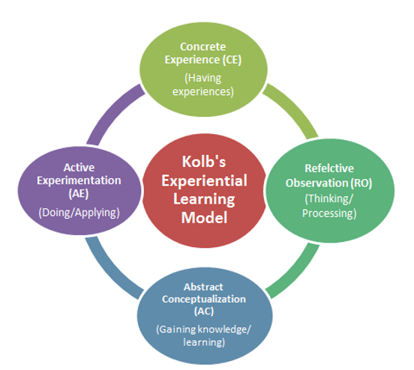
Figure 1: Kolb's Experiential Learning Model

Personal Experience with Johari Window
My self-awareness and interpersonal connections at work have benefited from the Johari Window, which Luft and Ingham devised in 1955 (Prasad and Rao, 1969). Self-reflection has helped me discover aspects of my professional identity that I was previously unaware of and has also helped me understand my interpersonal and personal dynamics better. Through emphasising the importance of candid communication and sharing personal traits, this tactic has changed my perspective on fostering relationships and working together.
The Johari Window approach has exposed new strengths and weaknesses, fostering trust and enhancing team relationships. In a project brainstorming session, an example of the impact of open communication impacted by the Johari Window was noticed. I created a positive environment that enabled team members to openly discuss their thoughts and show off their hidden talents. According to Kier and McMullen (2020), this resulted in the production of fresh ideas, improved team harmony, and a greater recognition and value of the team's diverse strengths and opinions.
The Johari Window concept has enhanced self-awareness and interpersonal communication significantly. This emphasises the need of understanding other points of view and the critical function of open communication in individual development and successful teamwork.
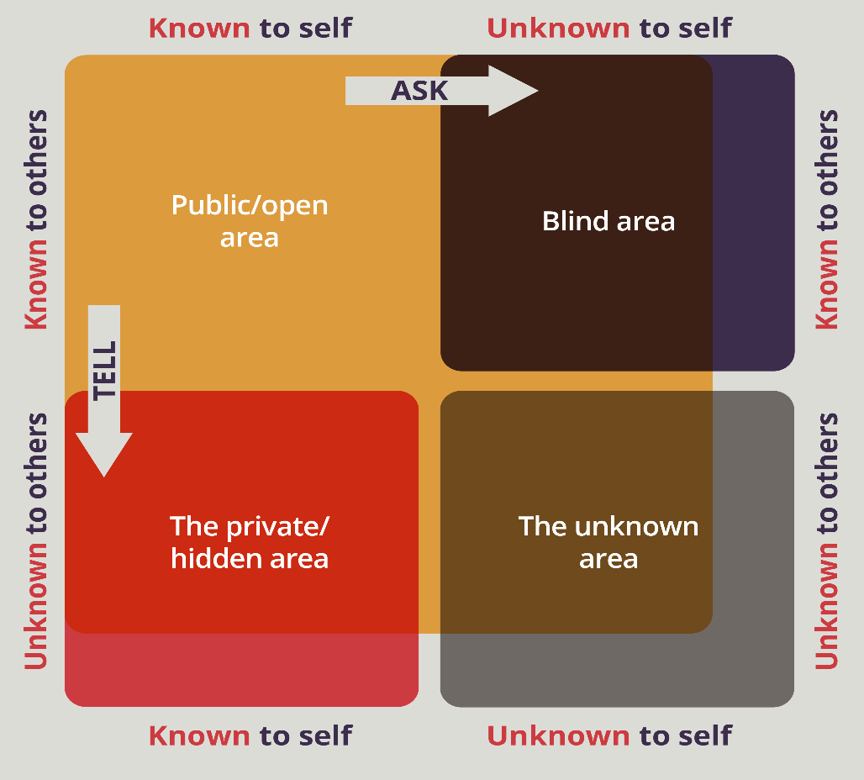
Figure 2: Johari Window Model

Conclusion
In my business research, I used Kolb's experiential learning model and Johari's window, and the results were astounding. I have developed a more profound understanding of my behaviours and the way I learn by actively participating in the iterative process of concrete experience, reflective observation, abstract conceptualization, and active experimentation. The Johari Window has increased my self-awareness and interpersonal abilities tremendously. It has improved my comprehension and appreciation of my peers' perspectives and efforts.
These models have served as a solid foundation for my personal and professional growth, facilitating my continued improvement. These realisations will be useful for building relationships, encouraging collaboration, and efficiently negotiating workplace challenges. Furthermore, incorporating these models will continually drive me to critically analyse my beliefs, recognise the importance of other perspectives, and commit to a lifelong process of personal growth and continuous learning.

References
Crews, E.R., Brouwers, M. and Visagie, J.C., 2019. Transformational and transactional leadership effects on communication styles. Journal of Psychology in Africa, 29(5), pp.421-428.
Ford, K., 2022. Determining Rural Church Growth and Sustainability Based on Population Trends and Outreach.
Kier, A.S. and McMullen, J.S., 2020. Entrepreneurial imaginativeness and new venture ideation in newly forming teams. Journal of Business Venturing, 35(6), p.106048.
Kolb, A.Y. and Kolb, D.A., 2005. Learning styles and learning spaces: Enhancing experiential learning in higher education. Academy of management learning & education, 4(2), pp.193-212.
Kolb, D.A., 2014. Experiential learning: Experience as the source of learning and development. FT press.
Luft, J. and Ingham, H., 1955. The Johari window, a graphic model of interpersonal awareness. Proceedings of the western training laboratory in group development, 246.
Miller, C., 2020. Self-Disclosure and Interpersonal Communication. Exploring Communication in the Real World.
Prasad, K.D.V. and Rao, M., 2021. Application of Johari Window to expand Open Arena with Team Building for enhancing psychological Well-being: A case study concerning E-Commerce Industry. Turkish Online Journal of Qualitative Inquiry, 12(4).
Tsur, N., Berkovitz, N. and Ginzburg, K., 2016. Body awareness, emotional clarity, and authentic behavior: The moderating role of mindfulness. Journal of Happiness Studies, 17, pp.1451-1472.
West, R.L., Turner, L.H. and Zhao, G., 2010. Introducing communication theory: Analysis and application (Vol. 2). New York, NY: McGraw-Hill.

