Ethan Harris (1912242)

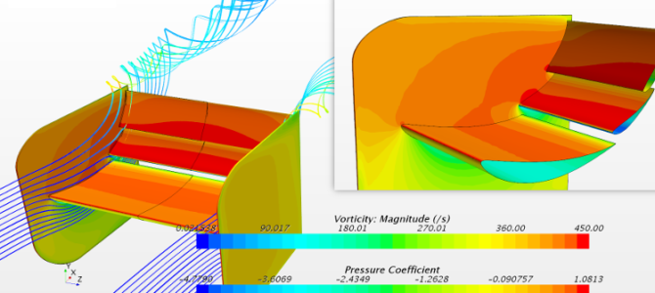
Designing a race car wing.

Contents
Introduction 2
What is Reynolds number 3
Why is Reynolds number important? 3
How does Reynolds number influence flow around a race wing? 3
Reynolds number estimation 4
Discussing boundary flow around the wing. 4
Carbon fibre reinforced plastics 6
Implications with performance 6
Historical, current, and future developments 6
Modelling techniques that simulate fluid flow 7
Advantages 7
Disadvantages 8
Types of prototype testing 8
Conclusion 9
References 10

Introduction
The advancement in race car technology has progressed ever so much since the early days of the sport being recognised. From the early 60’s where aerodynamics was not even to be considered into racing to current day, where race wings can give you the edge in performance. The critical relationship between the cars wing shape and the flow around the wing is what allows the car to have its effectiveness when out on the track.
The crucial role for a cars race wing is to produce additional downforce to combat the power that the cars put out (Prestige Imports, 2020). By doing this the car is gained extra traction when driving on the track at higher speeds. When acceleration the wing reacts with the flow of air initiating the element of downforce (ChatGPT, 2023).
Engineers have been able to really become familiar with this dynamic element by the aid of software that allows them to visually see the effects own a wings performance. Using software like CFD (Computational Fluid Dynamics) it can grant the benefits and disadvantages in areas of the race wing. Using the software permits engineers to carry out the process of ‘’mathematically predicting physical fluid flow by solving the governing equations using computational power’’ (Simscale , 2023). Since created, CFD has become a very well-established tool to aid engineers in prototyping theirs designs to see how they would perform in a real-world environment.
This report will be going into depths on how the race wings are created, the reasoning behind why the shape of the race wing is used and the implications that may become apparent when collecting data on the race wing itself.

What is Reynolds number

Reynolds number (Re) is a dimensionless number. It allows for engineers to visualise fluid flow patterns around an object (Simscale , 2023). The number is used to work out and determine whether the flow around an object is laminar or turbulent (Simscale , 2023). Reynolds Number is one of if not the most principal factor when it comes to numerically modelling viscous flows (Simscale , 2023). Pictured below can be found the formula to get achieve the Reynolds Number:
Figure 1- Reynolds Number

Why is Reynolds number important?
Reynolds number has the importance of identifying dimensionless quantities fluids (Science Direct, 2017). The number that the Reynolds equation produces describes and indicates how the transport of fluid or air flows around or through an object. When calculated it will tell the engineer if the flow is steady or turbulent (vedantu, 2023). In the scenario of designing a race wing, it would be ideal that the shape of the wing will produce Laminar flow which means the flow will travel smoothly across a surface which is opposed to turbulent flow which means the streamlines of the fluid will have increased separation across the surface (vedantu, 2023). All this can be identified by also understanding the boundary layers behaviour. This is a very thin layer of fluid that is neighbouring to a solid surface (ChatGPT, 2023).

How does Reynolds number influence flow around a race wing?
The aim of using Reynolds Number is to understand how the flow of a liquid or air travels across a surface. When racing, the car is designed to have the least amount of drag as possible to ensure a clean cutting motion to combat the resistance of driving fast. When calculating Reynolds number factors like velocity, density and viscosity will affect your outcome (CFD, 2023). If a low Reynolds number is calculated, then it will indicate to the engineer that there is a presence of high viscous forces affecting the inertial forces-This allows for laminar pathways (CFD, 2023). This is ideally what engineers are looking for when designing a wing. There are other factors to take into consideration such as complex shapes of the wing, different environmental changes such as difference in air pressure E.T.C. By using the Reynolds Number, you can also gain data in understanding the drag and lift coefficients of a cars race wing. If the race wing produces too much lift, then it could cause the vehicle to lose traction at high speeds triggering the car to crash (Nath , Pujari, Jain, & Rastogi, 2021).

Reynolds number estimation
To achieve an estimation of a Reynolds number on a race car wing, you need to use the Reynolds equation which is:
$$RE=\frac{(ρ ×V ×L)}{μ}$$
To get a Reynolds number some estimations must be used such as the length of the race wing and some other dimensions that are crucial to calculating the figures for the wing. It was found that the average length of the foil on a F1 race wing is around 0.35m (Chronicle, 2021). It is also required to find the density of the air as air holds a vast amount of force against the wing whilst in use. As the density of air is 1.225Kg/m³ (Helmenstine, 2020) and the average temperature of air being 20ºC (Sharp, 2022). Furthermore, after carrying out some data collection on f1 wings it was found that on average they travel at speeds of 186MPH (Toet, 2023) Lastly, studying the dynamic viscosity of air is 1.8 x 10⁻5 (GPT, 2023)- Having this data allows for the calculation to be carried out.
$$RE=\frac{1.225 × 83.15 ×0.35}{1.8 x {10}^{-5}}$$

After conducting the above calculation, it was found that the Reynolds number was 1,980,586.81. Comparing this to a table found (What is Reynolds number, 2023) it was found that the number that was calculated was turbulent flow.

Discussing boundary flow around the wing.
When discussing the boundary flow around a race wing- this will refer to the actions carried out near a race wings surface (ChatGPT, 2023). When designing the race wing the development of boundary development is crucial to ensure that the fluid flows correctly over the wing. The boundary layers consist of flow in an immediate area of a solid surface. When a fluid flows over the wing a boundary layer will start to develop. The motion produced in this zone effects the frictional resistance that is exerted by the boundary (Southard, n.d.). When introducing the race wing, it is necessary for all the flow to travel smoothly within these zones. Boundary layers will develop on an object which has many complex shapes and sizes which also has engaged fluid flowing them those shapes and at the same time being relevant to the object (Southard, n.d.).
There are also laminar boundary layers and turbulent boundary layers to be taken into consideration. As previously mentioned, these two types of flows determine on how the object will react when it encounters any resistance. Pictured below demonstrates how the flow would appear:
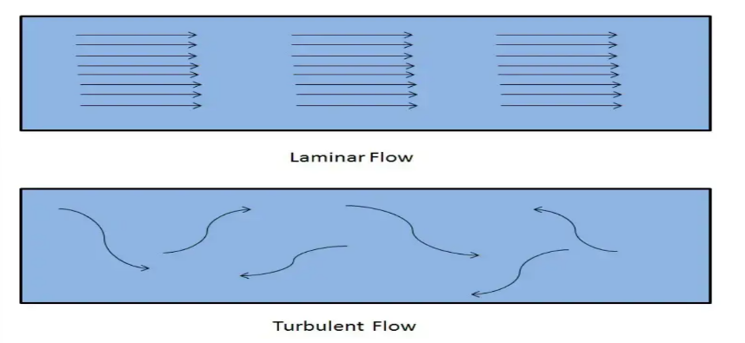
Figure 2- Laminar and Turbulent flow

As you can see pictured above laminar flow produces a smooth self-directed flow whilst turbulent flow produces a swirled action. These two flows will change due to distinctive characteristics such as the smoothness of the surface that the flow is travelling across. If the surface has a rough layer, then turbulent flow is more likely to become evident. Again, pictured below shows how different surfaces effects the two flow types:
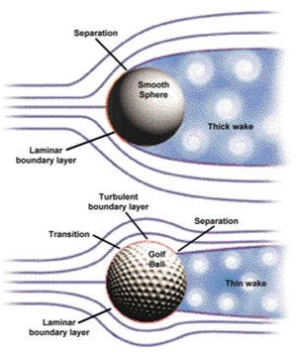

Figure 3- Surface finish effects

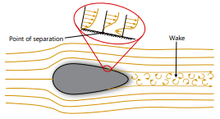
When taking flow into consideration, separation must also be thought about. Separation occurs when ‘’the velocity of the boundary layer struggles against an adverse pressure gradient’’ (Ansys, 2023). Another issue with separation is that it will eventually become what was laminar flow into turbulent flow where laminar produces calmer straight lines of flow whereas turbulent causes an almost swirling effect of flow (Vapourtec , 2023). This can be a common issue when designing race wings due to the excessive amounts of pressure like downforce and other shared factors when going at high speeds. When this problem takes place, it will cause an abnormal volume of drag to arise. Due to the fact race wing wants to be as aerodynamic as separation is not ideal. Below is a diagram showing the effect of separation.
Figure 4- Separation of layers

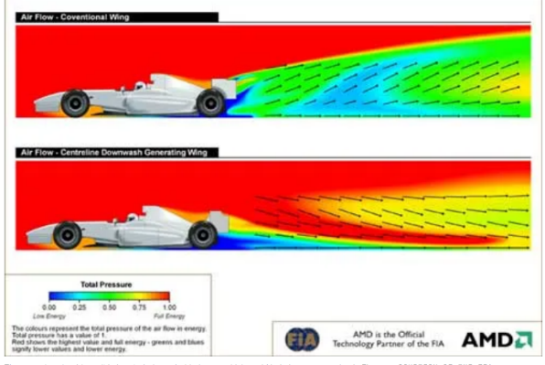
Lastly, the last topic to discuss is turbulent flow. Turbulent flow has a crucial part in overall performance of a f1 rear wing. ‘’ Turbulence is a phenomenon in Formula 1 racing that refers to the chaotic, unpredictable flow of air around a race car’’ (Rehman, Turbulence in Formula 1: What Does It Mean?, 2024). Due to turbulent flow being very unpredictable (Rehman, Turbulence in Formula 1: What Does It Mean?, 2023)It is particularly important that the engineers of the team designing the wing can control the vicious forces turbulent flow can have by ensuring the wings dimensions can aid the driver instead of causing performance issues. Pictured below is shown has the newer race wings in formula 1 produce less turbulent flow when it exits the rear wing as to of previous wings (MCCLUSKY, 2005).

To conclude boundary flow around and in a formula 1 wing, their primary reason for looking the way the way they are is to benefit and aid the drivers when their cars are going at high speeds. The wings primary use is to moderate any drag the cars generates to increase performance (Partridge, 2021).

Carbon fibre reinforced plastics
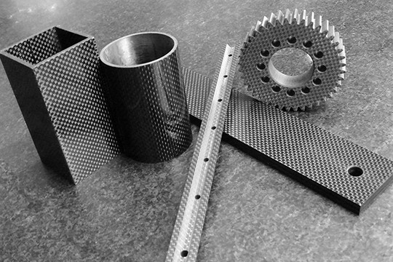
Carbone fibre is one of the most used advanced materials in the engineering industry. It has become widely used in the automotive industry and even satellite technology. Carbon Fibre-reinforced plastics or CFRP offer a vast number of advantages when working with carbon fibre (SGL carbon, 2023). The material consists of a base substance known as a matrix and is then secondly reinforced with a component (SGL carbon, 2023). CFRP is used to replace materials that do not have high load bearing capability (SGL carbon, 2023). Having this property allows for lightweight yet high-performance wings to be created. CRFP is now frequently used in the formula 1 industry and in 2023 it is known that CFRP ‘’makes up 85% of a standard F1 car’’ (Shortland, 2023).
Figure 5- CFRP

Implications with performance
An obvious issue with carbon fibre is cost. On average the cost of carbon fibre is around £100/Kg in the United Kingdom (NetComposites, 2009). With the weight of a carbon fibre rear wing also being around 11Kg (formula1-dictionary, 2023) it costs around £1,100 for a single rear wing.
Secondly, CFRP is very difficult to carry out repairs on. If a small amount of damage accumulated on the rear wing for example it could potentially mean a new wing is needed. There are ways around repairing CFRP by means of patch repairing but this can only be achieved if the damage hasn’t penetrated the resin layer (Hall, 2022). Due to how CFRP is manufactured it can be reasonably challenging to locate small cracks (Hall, 2022). By having this issue-having cracks could cause a serious lack of performance to the wing.

Historical, current, and future developments
CFRP seen its first mechanical use in the late 60’s to early 70’s (Plastics Technology , 2005). It was to be used in the aerospace industry to create landing components for the Boeing 727 jet (Plastics Technology , 2005). Although due to high cast and very little knowledge of the material it was mainly focused on being used in the world of aerospace and luxury cars (RW Carbon , 2014). Fast forward to the late 80’s when it was then to be implemented into the F1 world when McLaren explored the materials beneficial properties (Mitchell, 2023). As Widley known, carbon fibre is now one of if not the most used materials in the high-performance motorsport industry (Mitchell, 2023).
Fast Forward to the 21st century and CFRP is a commonly used material in the aerospace, performance racing and wind energy (SGL carbon, 2023). Other than F1 racing, CFRP after market parts are being produced for the public to purchase- ‘’The distinct carbon fibre weave has become a symbol of hi-tech and hi-performance’’ (Johnson, 2018). The material has also been found to make its way into the wind industry as the blades are started to be produced using CFRP (Johnson, 2018).

As CFRP develops, there will be further investigation on how to improve the material, ways to manufacture it more efficiently and how to reduce its overall costs. The materials industry will investigate targeting new applications, lower the cost of the technology required to make CFRP and reduce the cost of the material as a whole (ZOLTEK, 2023). Finally, materials developers want to rid of the ‘’low volume, high cost’’ view on carbon fibre (Sloan, 2022). If manufactures can get gone of this idea on the material, it will become a regularly used material.

Modelling techniques that simulate fluid flow
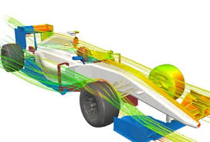
A commonly used modelling technique that is vastly used in both educational and real-world scenarios is CFD (Computational Fluid Dynamics). The use of CFD is to ‘’analyse the flow of fluids using numerical solution methods’’ (Femto, 2017). CFD can be utilised to measure and record properties such as lift and drag (Femto, 2017) for applications such as F1 cars. When carrying out CFD the process can give you a quick and effective result once performed (SIEMENS, 2022). Computational fluid dynamics can also be used in other areas such as the chemical, nuclear and marine industries (SIEMENS, 2022).

Figure 6- CFD of F1 Car

Advantages
By performing CFD techniques-as an engineer you will be saving time, cost and can have reliable accurate results (Quadco Engineering, 2023). Firstly, having the ability to save money is a big advantage when designing and experimenting with such complex componentry (Quadco Engineering, 2023) as it enables for the engineer to experiment with different figures and dimensions to see what will yield the beneficial outcome.
Moreover, by using CFD you can simulate different scenarios and different conditions (Pretechnologies, 2023). By having this capability, you can essentially trial your wing to see how it will perform in a worst case and base case situation. Relating back to the previous point this again will aid you in saving time and money (Quadco Engineering, 2023).
Finally, when using software’s such as CFD you are testing components to their limits (Peritus, 2019) and fundamentally ensuring the components will work under a sizable load whilst maintaining a great factor of safety (Peritus, 2019). CFD is also enabling for risk management strategies to be deployed. By doing this it allows for the design engineer to understand any uncertainties that they may have (Peritus, 2019).

Disadvantages
Although computational fluid dynamic software’s have many benefits, the software can also present themselves with many difficulties when using them. The first and nearly obvious negative about the software program is that its very difficult to operate (Ablison, 2023). The operator of the program will no doubt need some educating and guidance to initially use the program (Ablison, 2023).
Secondly, the program requires long run times in order to compute the required data and information required to complete the job in hand (IFES, 2023). For example, if you are required to present data from CFD in a short timescale, it may not be the best option, although this depends on the size on the model in hand (IFES, 2023).
Lastly, if the simulations corrupt or fail, it will amount to a big loss of money to due what could have been an avoidable mistake (IFES, 2023). The reason the software costs so much is because it is required to be operated by a human who is required to input the data (Terry, 2023). The operator is required to design and create a CAD (computer Aided Design) model. It is then required to be built into a computational mesh, furthermore it is then needed for the user to set up the simulation and process the results (Terry, 2023).

Types of prototype testing
To create a prototype of a new or redesigned component is crucial when you are required to collect data or experiment. ‘’Prototyping is an experimental process where design teams implement ideas into tangible forms from paper to digital’’ (Interaction Design Corperation , 2023). By creating a prototype of a component, you are setting yourself a good start point of where you would like to have your final design (Interaction Design Corperation , 2023). An example of a prototype is a 3D printed part. Formula 1 team such as Renault have used 3D printers to create prototypes of component which are then used to trial (Verdict , 2022). By doing this to users are creating cheap yet strong and lightweight parts that are easy to make and use.
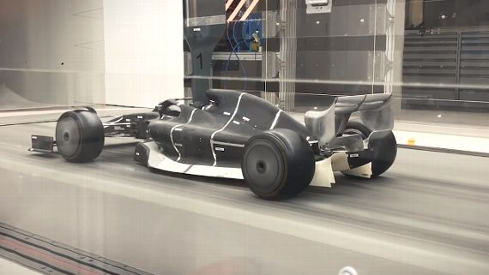
The mock designs of components can then be used in environments such as wind tunnels. Wind tunnels are used to ‘’Test the aerodynamics of car models, or parts of car models, in a simulated racing environment’’ (Chronicle , 2021). Wind Tunnels are a very beneficial tools to component developers as it allows them to visualise and collect data on how their designed wing could perform in an ideal situation (Auto123, 2023). By doing this the engineers can see how the boundary layers react, what the flow of air is like around the component and what forces may negatively affect the performance of the wing (Auto123, 2023). By visual aid the engineers can then alter and change the dimensions of the rear wing for example to refine and perfect the operation of the component (CarThrottle, 2016).
Figure 7- F1 car during wind tunnel testing.
Although wind tunnels provide their advantages, the tests come with their negatives that the design engineers need to take into consideration when the tests are completed. One implication with wind tunnels is that they are very expensive to operate and run (NASA, 2023). Due to the tests required by f1 teams they are required to run multiple tests in different environments to gain better knowledge about their prototype (Noble, 2020). Lastly, wind tunnels tests are carried out in ideal conditions meaning that the air flow over the wing is clean as opposed to ‘’dirty’’ (worldofspeed, 2023) which is more likely to happen in real world race.

Conclusion
To conclude the overall report, it was found that the design process of a F1 rear race wing is a long and complex process that must be completed to a professional standard and with the correct tools and equipment. Aerodynamic laws must be abided by to ensure that correct results and accurate and true. As important as aerodynamic laws, the overall structural integrity of the wing must be as equally strong as the car itself as the wing is required to understand high amounts of pressure and force from the environment that it will be preset in (Nath , Pujari, Jain, & Rastogi, 2021).
Due to the strong funding that formula 1 teams have access to the could ensure that they have the utmost professional kit to allow them to gain cutting edge performance when their car is on the track (CFD, 2023). A technology advances there is no doubt that the automotive industry will follow through by having their adaptations to achieve marginal gains all the way to race wining advantages.

References
Ablison. (2023, July 1). Pros And Cons Of Computational Fluid Dynamics. Retrieved from Ablison: https://www.ablison.com/pros-and-cons-of-computational-fluid-dynamics/?expand_article=1
Anderson, G. (2022, January 27). GARY ANDERSON: HOW F1 FRONT WINGS ARE CHANGING FOR 2022. Retrieved from The Race : https://the-race.com/formula-1/gary-anderson-how-f1-front-wings-are-changing-for-2022/#:~:text=The%20front%20wing%20assembly%2C%20including,each%20side%20of%20the%20centreline.
Ansys. (2023, June 23). Flow Separation and. Retrieved from Ansys: https://courses.ansys.com/wp-content/uploads/2020/09/Flow-Separation-and-Reattachment-Lesson-4-Handout.pdf
Auto123. (2023, July 1). F1 TECHNIQUE: EXPLAINING THE FORMULA 1 WIND TUNNELS. Retrieved from Auto123: https://www.auto123.com/en/news/f1-technique-explaining-the-formula-1-wind-tunnels/35966/
CarThrottle. (2016, July 1). 4 Reasons why wind tunnel testing is so important to race car aerodynamic development. Retrieved from CarThrottle: https://www.carthrottle.com/post/n43v9xq/
CFD, C. (2023). How Does Reynolds Number Affect Flow? Retrieved from Cadence : https://resources.system-analysis.cadence.com/blog/msa2022-how-does-reynolds-number-affect-flow
ChatGPT. (2023, June 19). ChatGPT. Retrieved from ChatGPT: https://chat.openai.com/
Chronicle . (2021, June 24). How Does An F1 Wind Tunnel Work? Retrieved from Chronicle : https://f1chronicle.com/how-does-an-f1-wind-tunnel-work-f1-technology/
Chronicle. (2021, April 8). How Do Formula 1 Rear Wings Work? Retrieved from Chronicle: https://f1chronicle.com/how-do-formula-1-rear-wings-work-f1-technology/#How-is-the-Formula-1-rear-wing-constructed
Femto. (2017, April 10). What is CFD. Retrieved from Femto: https://www.femto.eu/stories/what-is-cfd/#:~:text=Computational%20Fluid%20Dynamics%20(CFD)%20is,solid%20or%20fluid%2Dgas%20interaction.
formula1-dictionary. (2023, July 1). Weight Balance. Retrieved from formula1-dictionary: https://www.formula1-dictionary.net/weight_balance.html#:~:text=These%20days%2C%20the%20450kg%20may,average%20driver%20contributing%20about%2070kg.
GPT, C. (2023, June 23). Retrieved from Chat GPT: https://chat.openai.com/
Hall, Z. (2022, July). The effectiveness of patch repairs to restore the impact properties of carbon-fibre reinforced-plastic composites. Retrieved from Science Direct : https://www.sciencedirect.com/science/article/pii/S0013794422003058
Helmenstine, A. M. (2020, February 3). What Is the Density of Air at STP? Retrieved from ThoughtCo.: https://www.thoughtco.com/density-of-air-at-stp-607546
IFES. (2023, July 1). COMPUTATIONAL FLUID DYNAMICS (CFD). Retrieved from IFES: https://www.ifes-koeln.de/en/services-20-years-project-experience/simulation-analysis/computational-fluid-dynamics-cfd.html
Interaction Design Corperation . (2023, July 1). Prototyping. Retrieved from Interaction Design Corperation : https://www.interaction-design.org/literature/topics/prototyping#:~:text=Prototyping%20is%20an%20experimental%20process,concepts%20and%20test%20on%20users.
Johnson, T. (2018, June 22). Uses For Carbon Fiber. Retrieved from thoughtco: https://www.thoughtco.com/uses-of-carbon-fiber-820394
MCCLUSKY, M. (2005, November 2). Formula 1 Eases Into Passing Lane. Retrieved from Wired: https://www.wired.com/2005/11/formula-1-eases-into-passing-lane/
Mitchell, R. (2023, February 4). How is carbon fibre made for F1 cars? Retrieved from RN365: https://racingnews365.com/watch-how-is-carbon-fibre-made-for-f1-cars#:~:text=Carbon%20fibre%20was%20first%20introduced,light%20enough%20to%20give%20performance.
NASA. (2023, July 1). Closed Return Wind Tunnel. Retrieved from NASA: https://www.grc.nasa.gov/www/k-12/airplane/tuncret.html#:~:text=There%20is%20usually%20an%20additional,increased%20size%20and%20operating%20costs.
Nath , D., Pujari, P. C., Jain, A., & Rastogi, V. (2021). Drag reduction by application of aerodynamic devices in a race car. Retrieved from SpringerOpen: https://aia.springeropen.com/articles/10.1186/s42774-020-00054-7#Sec1
NetComposites. (2009, May). The UK Carbon Fibre Composites Industry. Retrieved from NetComposites : https://avaloncsl.files.wordpress.com/2013/01/composites-carbon-fibre-study.pdf
Noble, J. (2020, July 17). FIA assessing F1 rear wing flexibility test changes. Retrieved from Autosport: https://www.autosport.com/f1/news/fia-assessing-f1-rear-wing-flexibility-test-changes-4981060/4981060/#:~:text=Currently%20the%20FIA%20conducts%20two,500N%20load%20is%20applied%20horizontally.
Partridge, J. (2021, April 6). How Do Formula 1 Front Wings Work? Retrieved from Chronicle: https://f1chronicle.com/how-do-formula-1-front-wings-work-f1-technology/#:~:text=Any%20drag%20is%20detrimental%20to,around%20the%20car%20comes%20in.
Peritus. (2019, March 13). The Benefits and Limitations of Computational Fluid Dynamics in the Offshore Oil and Gas Industry. Retrieved from Peritus: https://www.peritusint.com/benefits-and-limitations-of-computational-fluid-dynamics/
Plastics Technology . (2005, January 10). Carbon Fiber. Retrieved from Plastics Technology: https://www.ptonline.com/articles/no-18---carbon-fiber
Prestige Imports. (2020, July 29). Want a wing? How about a spoiler? Alert, they’re different! Retrieved from Prestige Imports: https://www.prestigeimports.com/blog/whats-the-difference-between-a-wing-and-a-spoiler/#:~:text=The%20reason%20that%20wings%20are,the%20car%20is%20pushed%20down.
Pretechnologies. (2023, July 1). Advantages of computational fluid dynamics . Retrieved from Pretechnologies: http://www.pretechnologies.com/services/computational-fluid-dynamics/advantage
Quadco Engineering. (2023, July 1). Advantages and disadvantages of Computational Fluid Dynamics. Retrieved from Quadco Engineering: https://www.quadco.engineering/en/know-how/cfd-advantages-and-disadvantages.htm
Rehman, M. u. (2023, February 24). Turbulence in Formula 1: What Does It Mean? Retrieved from Formulapedia: https://formulapedia.com/turbulence-in-f1/
Rehman, M. u. (2024, Rebruary 24). Turbulence in Formula 1: What Does It Mean? Retrieved from formulapedia: https://formulapedia.com/turbulence-in-f1/
RW Carbon . (2014, August 12). Carbon Fiber & its History in Formula One Racing. Retrieved from RW Carbon : https://blog.rwcarbon.com/2014/08/12/carbon-fiber-its-history-in-formula-1-racing/
Science Direct. (2017). Reynolds' Number. Retrieved from Science Direct : https://www.sciencedirect.com/topics/engineering/reynolds-number
SGL carbon. (2023, June 28). Carbon Fibers and Carbon Fiber-Reinforced Plastic (CFRP). Retrieved from SGL carbon: https://www.sglcarbon.com/en/carbon-fibers-and-cfrp/
Sharp, T. (2022, February 25). What is the average temperature on Earth? Retrieved from Space.Com: https://www.space.com/17816-earth-temperature.html
Shortland, R. (2023, June 28). Speed, Strength, and Safety: The Importance of Plastics in Formula One. Retrieved from bpf: https://www.bpf.co.uk/article/plastics-in-formula-one-3292.aspx#:~:text=Carbon%20fibre%20has%20now%20become,car%20(4%2C%205).
SIEMENS. (2022, July 1). What is CFD Simulation? Retrieved from SIEMENS: https://www.plm.automation.siemens.com/global/en/our-story/glossary/cfd-simulation/67873
Simscale . (2023, June 12). What is CFD | Computational Fluid Dynamics? Retrieved from Simscale: https://www.simscale.com/docs/simwiki/cfd-computational-fluid-dynamics/what-is-cfd-computational-fluid-dynamics/
Simscale . (2023, May 12). What is Reynolds Number. Retrieved from Simscale : https://www.simscale.com/docs/simwiki/numerics-background/what-is-the-reynolds-number/
Sloan, J. (2022, October 31). The future of carbon fiber manufacture. Retrieved from Composites World: https://www.compositesworld.com/articles/the-future-of-carbon-fiber-manufacture
Southard, J. (n.d.). Boundary Layers. Retrieved from LibreTexts Geosciences : https://geo.libretexts.org/Bookshelves/Sedimentology/Book%3A_Introduction_to_Fluid_Motions_and_Sediment_Transport_(Southard)/03%3A_Flow_Past_a_Sphere_II_-_Stokes'_Law%2C_The_Bernoulli_Equation%2C_Turbulence%2C_Boundary_Layers%2C_Flow_Separation/3.06%3A_Bo
Terry, E. (2023, July 1). CFD: the truth and the tales. Retrieved from Actiflow: https://actiflow.com/cfd-the-truth-and-the-tales-2/#:~:text=CFD%20is%20expensive,cost%20and%20'man%20hours'.&text=In%20order%20to%20reach%20a,not%20that%20expensive%20any%20more.
Toet, W. (2023, June 23). Aerodynamics of F1. Retrieved from Formula 1 Dictionary : https://www.formula1-dictionary.net/aerodynamics_of_f1.html
Vapourtec . (2023, June 23). Laminar and turbulent flow. Retrieved from VapourTec : https://www.vapourtec.com/flow-chemistry/laminar-turbulent/?ppc_keyword=&gclid=EAIaIQobChMIg_m0mKHZ_wIVWe7tCh3C5QdNEAAYASAAEgLe5fD_BwE
vedantu. (2023, June 13). What is Reynolds Number? Retrieved from vedantu: https://www.vedantu.com/formula/reynolds-number-formula
Verdict . (2022, November 9). Formula 1 adoption of 3D printing technologies. Retrieved from Verdict : https://www.verdict.co.uk/formula-1-3d-printing-f1/
What is Reynolds number. (2023, May 12). Retrieved from https://www.simscale.com/docs/simwiki/numerics-background/what-is-the-reynolds-number/
worldofspeed. (2023, July 1). What Is Clean Air In F1? Retrieved from worldofspeed: https://worldofspeed.org/blog/what-is-clean-air-in-f1/#:~:text=What%20is%20Dirty%20air%20in,called%20racing%20in%20dirty%20air.
ZOLTEK. (2023, July 1). The Future of Carbon Fiber. Retrieved from ZOLTEK: https://zoltek.com/carbon-fiber/the-future-of-carbon-fiber/

Figure 1- Reynolds Number 3
Figure 2- Laminar and Turbulent flow 4
Figure 3- Surface finish effects 5
Figure 4- Separation of layers 5
Figure 5- CFRP 6
Figure 6- CFD of F1 Car 7
Figure 7- F1 car during wind tunnel testing. 8

