Construction Management - Programme Control
Jenny Stroud
2008886

Table of Contents
1.0 – Project 3
1.1 – Resources Review 3
1.2 – Productivity 4
1.3 - Incentivizes to Increase Productivity 5
1.3.1 - Financial incentives 5
1.3.2 - Non-financial Incentives 5
2.0 – Issue that has occurred 5
2.1 – Ways to overcome the issue 6
2.2 – Cost for Chosen Area 7
3.0 – References 8
3.1 - Images 8

1.0 - Project
The Innovation Matrix project schedule has a very smooth running. With the construction phase starting on the 6th of March as requested by the client, and the completion date being 4th April 2024. Throughout the project the level of productivity will be monitored to ensure deadlines are being met, as well as encouraging different incentives to have a high productivity output and reduce the chances of issue or delays in the project.
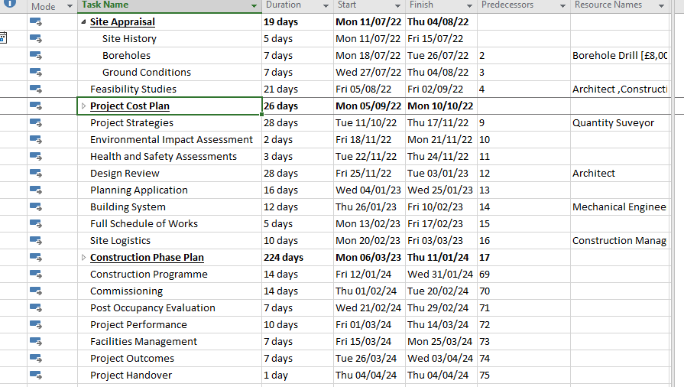
Image 1 – From Microsoft Project (By Author, January 2023)
1.1 - Resources Review
Plant
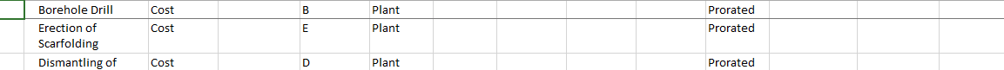
Image 2 – From Microsoft Project (By Author, January 2023)
Material
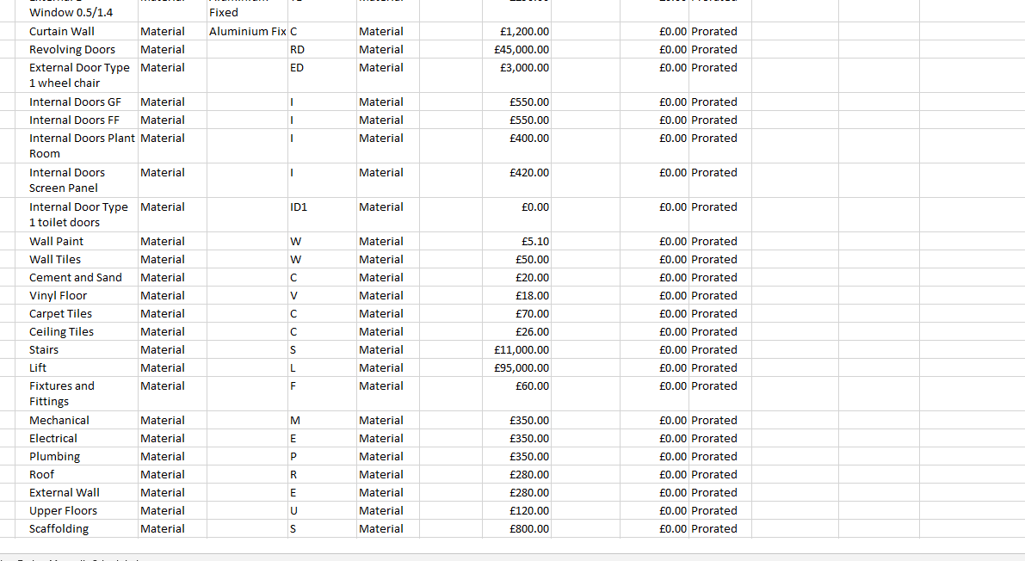
Image 3 – From Microsoft Project (By Author, January 2023)
Labour
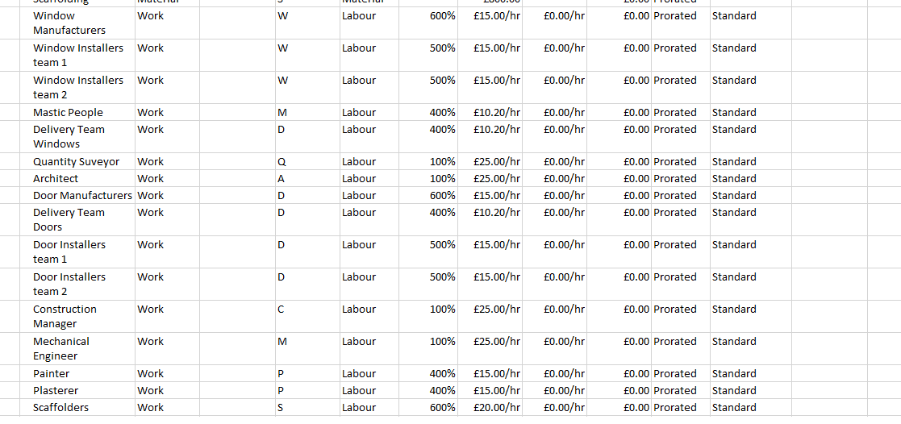
Image 4 – From Microsoft Project (By Author, January 2023)
Throughout the project many different labour, materials and plant will be needed. The resource sheets will show the cost of use or per hour rate, this allows the task to be linked with what is required for the smooth running and provide more information of the job being completed. For example on image 4 the labour chart, shows that there are multiple window installer teams. This is due to the amount of windows on this project that will need to be installed, this then results in multiple mastic people which will seal around each window. With each window being put in will require more than one person per window, as one person cannot hold and place the window while doing the job safely this then causes the hourly rate to increase as the rate is per person.
1.2 - Productivity
The productivity normally is measured on the gross value added to the sites project and the labor work over a period (CIOB, January 2016). Over the UK the average productivity levels in construction are extremely low. Before 2008’s financial crisis productivity was growing at a steady pace. Since 2008 it’s hardly increased, this is believe to have been caused by the average labor pay being low compared to the rise of the economy (Office of National Statistics, October 2021). There are many different contributions for productive being low, another can be poor planning. Inefficient planning cause issue, such as incorrect material amounts or delays causing the labor not being able to complete the job on time meaning low productivity. Many contractors will work endlessly to meet deadlines agreed with the client to ensure their reputation isn’t jeopardized, this causes working overtime to meet the target. Working the extra leads to staff being fatigued, not working at their best, being slower and not achieving the high quality standard (RIBCCS, September 2011).
1.3 - Incentivizes to Increase Productivity
There are many different methods to increase productivity, most companies turn to incentives. The incentives being offered should be personally aimed at the workers, to what would encourage the labor staff to work more efficient to meet deadlines. If the goal is achieve receiving an incentive is giving recognition for the work which boosts the staff’s self-esteem, while also giving the sense of respect from your company (Alan Draper, October 2022). Some examples of incentives for the construction sector can be:
1.3.1 - Financial incentives
- As many people are driven by money. Additional payment on top of the agreed pay allows workers to work better and more efficiently, it pushes people to work at their best (Alan Draper, October 2022) this method may not be the best option if the project is limited by cost or is exceeding the original agreed price.
1.3.2 - Non-financial Incentives
- Special bonuses are another method to encourage work. In the construction sector a bonus could be the agreement of another job, by this you are ensuring that the contractor has additional work and money flowing through the business. This method can also start a relationship with the contractors, building trust will resulting in the gaining of more work (Alan Draper, October 2022).
- Keep refreshing incentives. Changing/creating new incentives gives a sense of personalised rewards and that the company knows their staff, while also allowing excitement to aim for new rewards that not everyone will be able to achieve (Fond, July 2019).
- Personal development courses is another good method of incentives, as this lets people develop their skills while putting it back into the company. The development will allow workers to be eligible for promotions and receive larger pays, some may believe that this isn’t a popular incentive for people but it benefits workers in the longer term (Fond, July 2019).
2.0 – Issue that has occurred
Issue can occur at any point of the project. Some are unprecedented issues theses cannot be controlled by people, as if the weather is poor as if concrete need to be pour and set but its rain this task will have to be delayed until the weather is suitable for the task. Another is Covid, this wasn’t any ones fault and couldn’t be predicted at the time to plan ahead of the issue (Emerald Insights, May 2019). Other issues can culpable or non-culpable:
- Culpable is fault from the contractor side, the contractor can be delayed from poor planning causing delays in material delivery, low productivity meaning the labor workers taken longer with the allocated time given or on every project there is always the risk of injuries even after the completion of a health and safety report (Construction Management Guide, June 2012).
- Non-culpable is the delay of the contractors works but not at any fault of their own. The client can be at fault for different reasons such as, delays in design information for the contractor, changing of designs or a new variation (Construction Management Guide, June 2012).
During the project there was a delay of 5 weeks on the manufacturing of the bespoke windows this will cause the delivery date to be 14th of September instead of the 21st of August. As the manufacturing was set to be finished before the delivery date it will not cause the full 5 weeks delay. Even with having the delay, it is going to cause push backs of many different tasks that cannot be completed until the windows have been installed and sealed, this push back sets the new handover date to be 30th of April 2024. There will be additional issues that can possibly occur from the culpable delay. Some of these issues could be:
- The work forces that are needed to complete the tasks after the windows may no longer be available, as the tasks will be pushed back. The contractors that have been hired for the tasks, have agreed to arrive and complete the works over certain dates. With the dates being compromised the contractors may no longer be available due to other commitments or new jobs.
- Deliveries have been scheduled to arrive on site just before that work is going to take place, for example the furnishing deliveries. There would be two options to address this issue. Contact with the companies to delay the delivery to match the new dates, but this could cause additional costs for changing the dates. Or there will need to be additional storage required to hold the materials on site, which will also cause extra cost for storage and potentially not have the site space to store the materials.
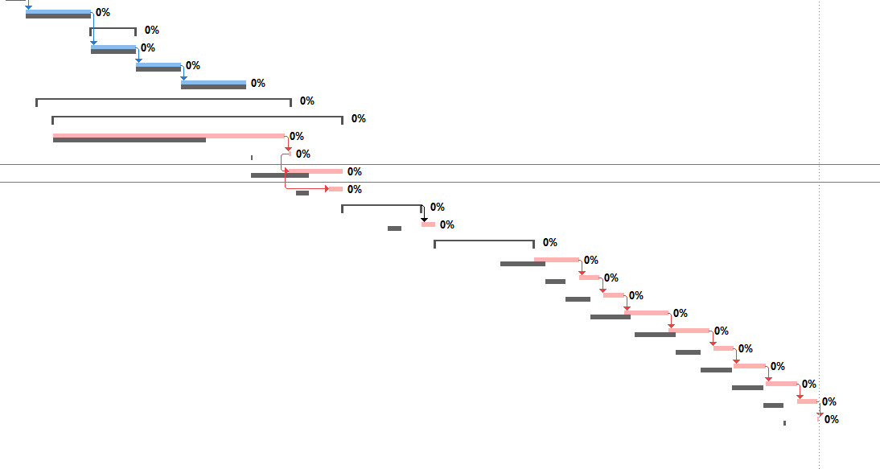
Image 5 – From Microsoft Project (By Author, January 2023)
2.1 – Overcoming the issue
Due to the issue this will require new deadlines to be set. A new arrival date will need to be discussed with the original window manufacturing company, or search to find a new company that can make the product to arrive on the original delivery date or as close to. As the product is stated as bespoke, there will need to be reassurance that another company will be able to make the product to the same quality or even have the skills to make the windows (Kissflow, November 2021). Due to the manufacturing company being at fault, as the client there can be discussions to adjust the contract to accommodate the changes and can also negotiate a new overall product cost. This one issue is going to cause a knock-on effect which will increase the projects over cost, if the discount is agreed upon it can help balance the additional charges cause by the window company (Kissflow, November 2021).
The project productivity will take a decline, as the lack of materials will prevent the work being completed and having to plan a new schedule that is suitable for all involved. This will require for the stakeholders to meet and plan ahead for the issue. As the issue is culpable which is the fault of the contractor, allows changes to be adapted and gives the client the power to discuss adjustments to the schedule to try and reduce the delay of the final handover date, while also trying to minimize the additional costs as much as possible. (Buildertrend, December 2022). When planning ahead this will include discussions with the contractors. For the tasks to be completed after the window installation, incentives can be offered to the company’s involved. Due to the project’s cost already being increased the best option for the client to offer can be future work. With this agreement the contractor will work to achieve the goals set, while also improving their relationship with the client and guarantee for future works. This method will also allow the project’s cost to not increase anymore (Alan Draper, October 2022).
2.2 – Cost for Chosen Area
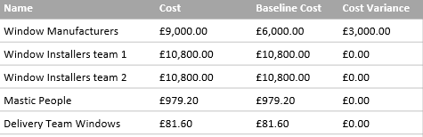
Image 6 – The Labour cost of Windows, From Microsoft Project (By Author, January 2023)
The above image shows the additional cost of a 5-week delay in the labour for the window manufacturers, causing the cost variance.
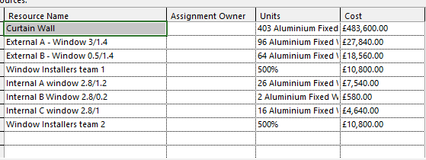
Image 7 – The Material cost of Windows, From Microsoft Project (By Author, January 2023)
Image 7 shows the cost of the windows and how many of each size is needed for the project.

3.0 - References
CIOB, (January 2016), CIOB Productivity Report 2016 PDF, Available at - https://www.ciob.org/industry/research/Productivity-Construction-Creating-framework-industry-thrive (Accessed on 13th January 2023)
Office of National Statistics, (October 2021), Productivity in the Construction Industry, UK: 2021, Available at - https://www.ons.gov.uk/economy/economicoutputandproductivity/productivitymeasures/articles/productivityintheconstructionindustryuk2021/2021-10-19 (Accessed on 13th January 2023)
RIBCCS, (September 2011), What Impacts Construction Productivity and What to do about it, Available at - https://ribccs.com/what-impacts-construction-productivity/ (Accessed on 13th January 2023)
Alan Draper, (October 2022), 16 Creative Incentives that Increase Workplace Productivity, Available at - https://www.business2community.com/strategy/16-creative-incentives-that-increase-workplace-productivity-02121612 (Accessed on 17th January 2023)
Kissflow, (November 2021), How to Avoid and Overcome Project Delays, Available at - https://kissflow.com/project/how-to-avoid-project-delays/ (Accessed on 17th January 2023)
Buildertrend, (December 2022), Mining the Data Field: Materials Causing the Greatest Construction Delays, Available at - https://buildertrend.com/blog/materials-causing-construction-delays/ (Accessed on 17th January 2023)
Fond, (July 2019), 10 Ways to Increase Employee Productivity with Rewards and Recognition, Available at - https://www.fond.co/blog/increase-employee-productivity/ (Accessed on 19th January 2023)
Emerald Insights, (May 2019), Causes of Delays on Construction Projects: A Comprehensive List, Available at - https://www.emerald.com/insight/content/doi/10.1108/IJMPB-09-2018-0178/full/html#:~:text=Weather%2Fclimate%20conditions%2C%20poor%20communication,stakeholders%2C%20labour%20shortages%20and%20poor (Accessed on 20th January 20, 2023)
Construction Management Guide, (June 2012), Delay and Extension of Time in Construction Contracts, Available at - http://www.cmguide.org/archives/2769 (Accessed on 20th January 20, 2023)
3.1 - Images
Image 1 – From Microsoft Project (By Author, January 2023)
Image 2 – From Microsoft Project (By Author, January 2023)
Image 3 – From Microsoft Project (By Author, January 2023)
Image 4 – From Microsoft Project (By Author, January 2023)
Image 5 – From Microsoft Project (By Author, January 2023)
Image 6 – The Labour cost of Windows, From Microsoft Project (By Author, January 2023)
Image 7 – The Material cost of Windows, From Microsoft Project (By Author, January 2023)

