Effective Team Working and Communication

Alina -Daniela Halunga
STUDENT NUMBER: 1907863

Table of contents

- Effective Communication
- Channels of communication
- Communication in the workplace
- Effective communication components
- Listening Skills
- Influences and complications of communication
- Written communication/Types of written communication
- Active voice and passive voice
- Using strong verbs
- Models of communication
- Stakeholders/ What Are the Benefits of Stakeholder Communication?
- Stakeholders communication strategy
- In class exercises scanned copies
- Conclusion

The scope of this paper is to create a briefcase about what I learned in class about effective communication including evidence of exercises which I did and I will write some things about my experience from my job which relates to communication in context of health and social care. This portfolio will prove what I understand by communication skills, what are de models of communication and all the aspects of it to deliver an effective communication.

It is evident that workers in the health and social care industry need to cope with a wide range of people who have different needs and issues of their own. However, if contact with staff and service users is not good, it could influence the interaction between different groups and, from the point of view of users, the regularity of care could be stuck. Employees are then expected to aim on improving their direction skills in order to improve their quality of service. Possibly, there are different theories that can help you understand the importance of communication skills in health and social care (Dissertationhomework.com, 2014).

Effective communication means an act of delivering information’s with the scope to create an understanding and is divided in three channels:
- Verbal communication- things we say through our voice
- Nonverbal communication-things we can not say but we express them through our body language
- Media-newspapers, magazine, promotional materials.

Effective communication is a skill that all health professionals use, and is not only critical, but is necessary to meet patient’s needs. I work as a community healthcare assistant with pediatric patients were effective communication has a very important role because everyone knows that children in health environments face a range of emotions, from fear to anxiety, which may be expressed by unfamiliar environment, people and equipment (Ahern, 2017).
However, through the use of age-appropriate language and complex diversion techniques, health care providers can support paediatric children effectively with such treatments, resulting in the best results.
My job relates to looking after children with complex care needs. With most of them I communicate nonverbal. Here, my body language which is a very important aspect help me to communicate effectively with them. I always use my posture, gestures, movements, eye contact, facial expression, the way how I dress, to make sure they understand my message.

Communication in the workplace is very important and means encoding and decoding messages by:
Verbal communication
Nonverbal communication
Posturing

Poor communication and cooperation between health professionals is directly linked to ongoing medical errors and the loss of personnel. In fact, the absence of adequate support structures, expertise and professional responsibility results in contact discrepancies that could affect patients (U.S. Newswire,2006.).

Effective communication in healthcare sector is important as well because:
- All patients feel comfortable with a good communication.
- Patients may feel in control through good communication.
- Good communication improves the performance of patients (rcn,2015).

Effective communication has few components:
Active listening
Assertiveness
Centralized/de-centralized communication
Virtual communication
Knowledge sharing
Problems
Challenges

Related to my job, I always make sure I have an effective communication with my patients by listening them/understanding them/responding to them. The same time I always ensure I have my listening skills as well, improved over the years which I spent doing this job.
Effective pauses
Minimal encourages
Mirroring
Labeling
Paraphrase
Summarizing

I also learned from my experience as a healthcare assistant that communication has influences and implications. Healthcare professionals can speak to people of different educational, cultural and social backgrounds and they must do it in an effective, caring and professional way. Communication is directly linked to the ideals and culture of individuals or organizations.
People should value the thinking and working style of each other. The implication and community must include appreciation, and, above all, the support environment must be supported. When respect is very minor, then effective communication methods within the company can never be developed.
When I had my first interview to get this job, the source was one of my worry. But was successful because that interview depended on how credible I am, my attractiveness, my expertise and my similarity.
Because of my culture and language, first few years was a bit difficult for me to perform in this role. Language was one of the worst problems when I started working and from here, I faced encoding errors.
Written communication has a very important role in employability and in Academic study as well. At my job I have a duty as well to write every shift, report of what I did during my shift and to write formal letters as well.

An effective communication can be checked by following:
Clear
Concise
Concrete
Correct
Coherent
Complete
Courteous

As I mentioned above, my first beginning in this job was an issue because my language barrier. Using complicated medical words, or ‘jargon’ was difficult for me to deliver my messages but was part of the job and I always tried to put things, so they are easy to understand. I tried to use language that is simple, clear, concrete, coherent, while staying honest and true. I based my language on the questions put to me and the cognitive ability of the patient I was speaking with.

Also, written communication is used in healthcare sector and remains the larger and most used form of communication between healthcare professionals. The most frequently used forms of written communication are referral and discharge letters (Vermeir et al., 2015).

Types of written communication:
Letters- Formal (promotional materials, product information’s, handbooks, logs, plans), need to be direct to the point, polite, action orientated, encourage a response.
- Informal: include basic rules and show supportiveness. -internal (family, friends, close people).
-external (outside people, not that close to you).

Memos
Reports- Introduction (subject matter)
-Main body (Procedure, Assessment, Analysis)
-Conclusion (summary of what you done)
-Appendices (detailed information)

Factors in successful written communication are very important in Academic studies to perform well, e.g. words/sentences/paragraphs/tone.
I learned in class as well how to improve Academic writing, by not using contraction, avoid using abbreviations…

Another lesson in Academic studies was about Active voice and Passive Voice
Active voice is used for most non-scientific writing. Using active voice for most of the phrases will explain their importance to readers and will avoid the phrases less confusing or wordy. Only science writing will distort the context of related statements by overusing passive voices.

Using strong verbs:
Example; - Weak verb- He gave assistance to my friend.
-Strong verb- He assisted my friend.

Channel- Source where the message is situated.
Decoder- done by the receiver
Encoder-here the message is transformed into signals.
Feedback
Receiver-the one who receive the message.
Sender- the person who deliver the message
Shannon-Weaver model of communication includes few concepts:

I also learned in Academic studies that communication is divided in 3 models:
Shannon-Weaver model: The sender encodes and sends the message via a digital channel such as telephone and telegraph to the receiver.



Berlo’s model of communication:
The model focuses on encoding and decoding which happens before sender sends the message and before receiver receives the message respectively.
Berlo Model has four components of communication:
- Sender is the source of the message or the person who originates the message.
- Message; is the substance that is being sent by the sender to the receiver.
- Channel is the medium used to send the message. Channel refers to five sense organs: hearing/seeing/touching/smelling/tasting.
- Receiver is the person who gets the message sent in the process.
Each of the component is affected by many factors.


Schram model of communication

Schram model of communication is containing all basic principle of communication. It is used to identify how communication between two peoples work.

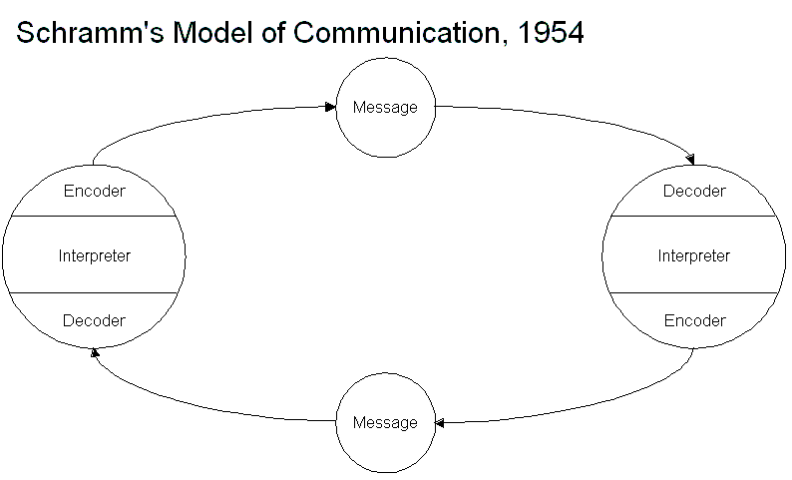

Over few years working as a healthcare assistant, I gained lot of experience and my communication skills improved a lot.
During my daily tasks, I connected with and improved my skills with patients and also had the opportunity to learn from the practise of more colleagues by working in a team. Teamwork had a very important role as well in my development plan through the effective communication.

Another in class lesson was about Stakeholders.
Stakeholder Communication strategy - verbal communication(telephone)
- letter communication (informal)
-media (tv, news, magazine, conference)

What Are the Benefits of Stakeholder Communication?
Stakeholders involve individuals and organizations that influence an impact or company's success. Employees, suppliers, clients, corporate partners, creditors and owners, local authorities and regulators all contribute to stakeholders. The values, behaviors and preferences of various stakeholders vary. Effective communication means that they are presented with relevant information and develop good attitudes about their organization or task (Chron.com, 2019).
Regular interaction and constructive understanding with stakeholders will help to build successful long-term relationships with key groups. There are several advantages of a strong relationship. Consumer interaction can be good as customers make purchasing decisions.
Effective communication in stakeholders result in reaching their target groups, goals, objectives.

In class exercises:

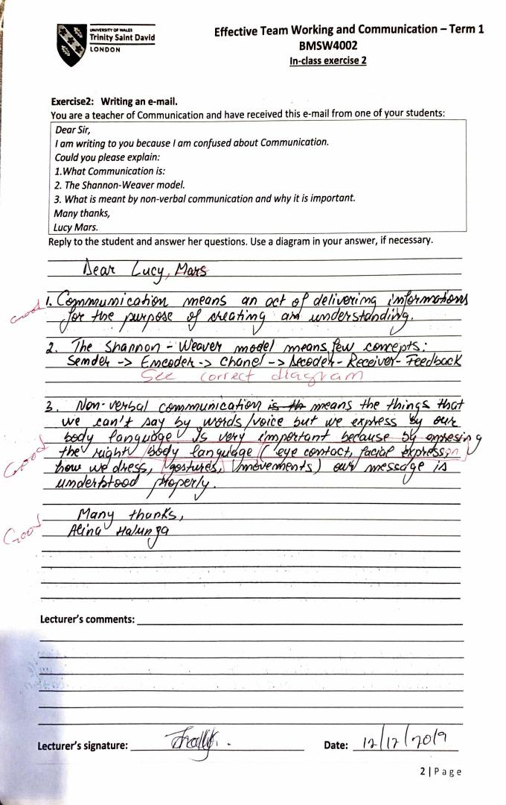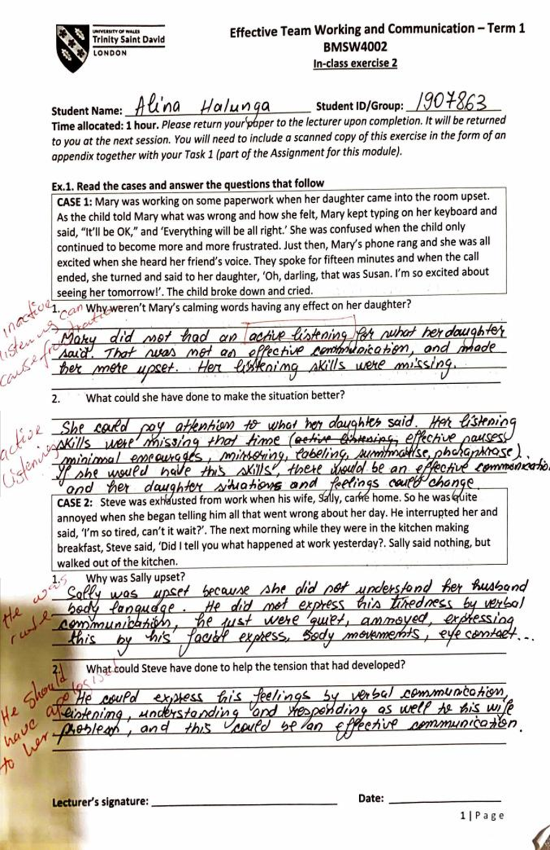

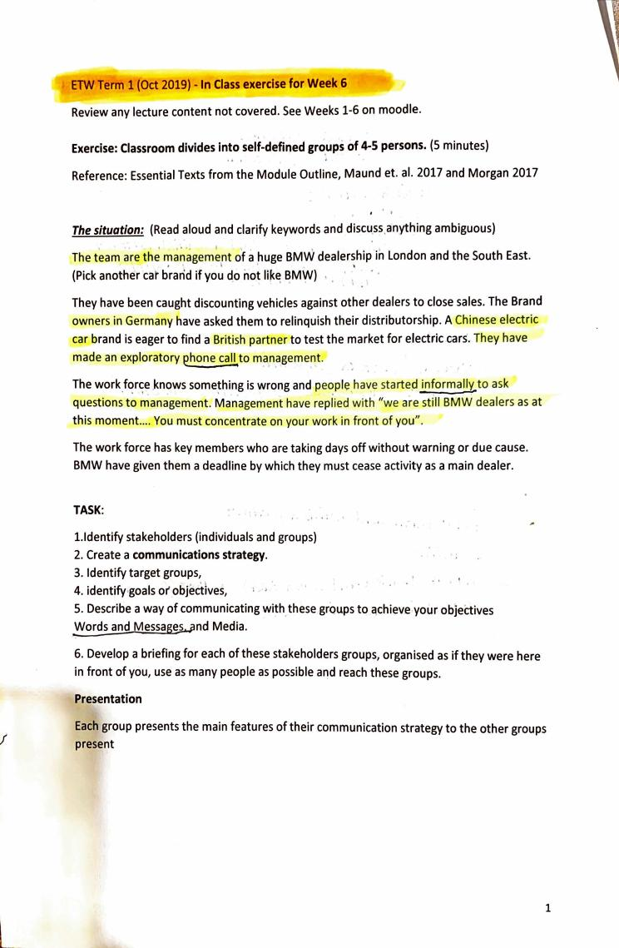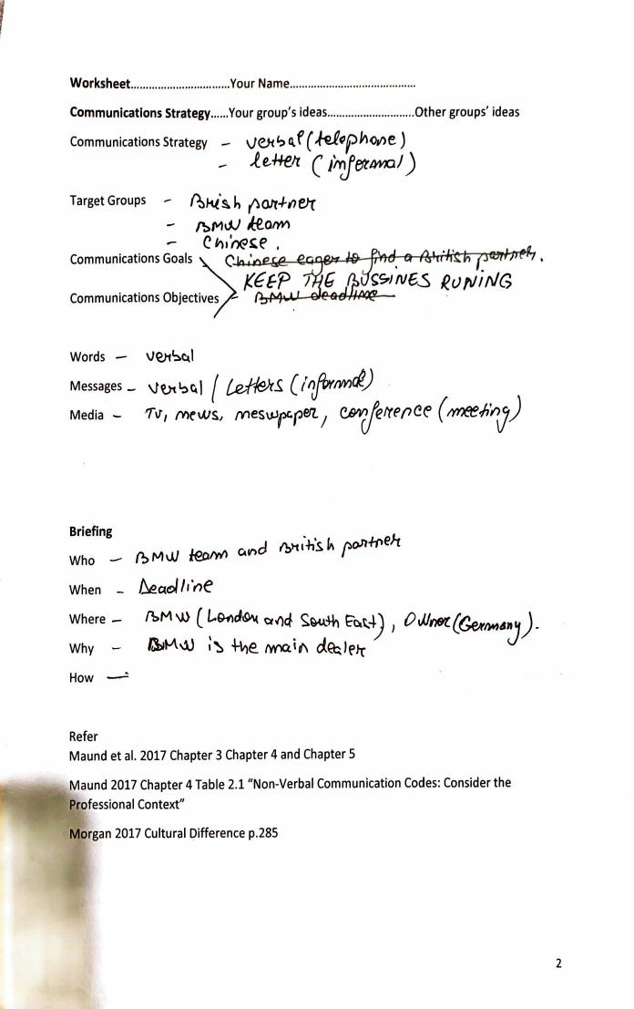

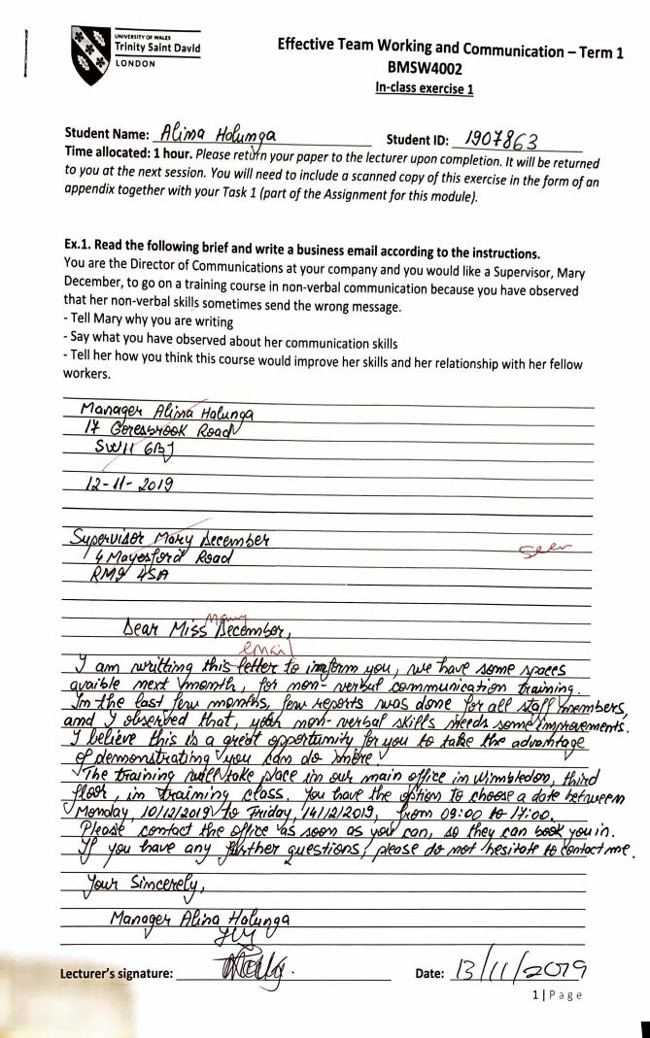

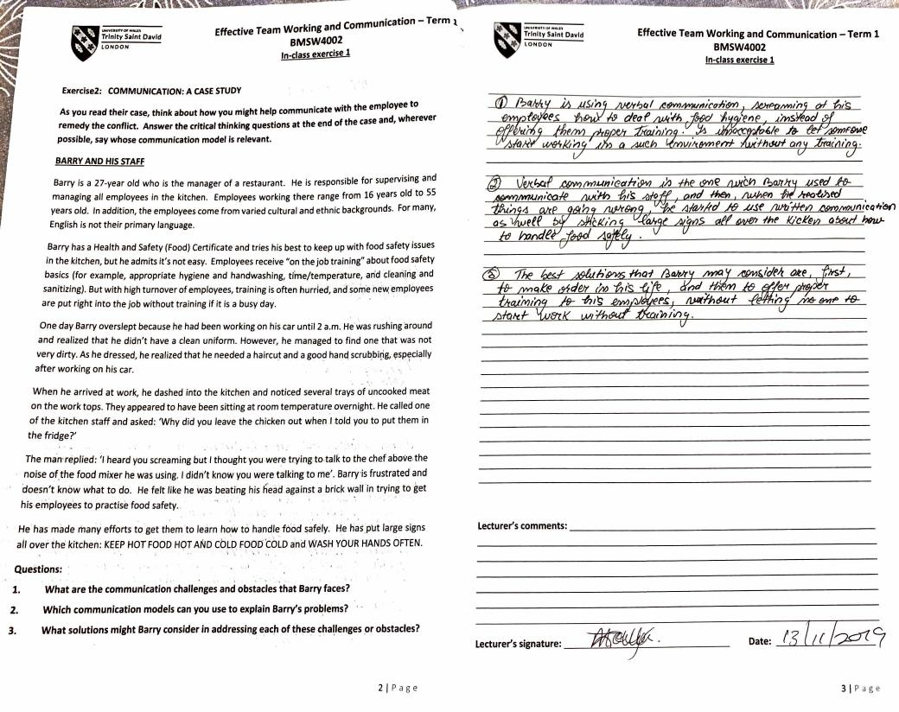
This paper shows that the effect of communication has become evident on different aspects of health and social care. Communication skills and communication processes could be separated into two groups via this report. The gap between these factors and their applicability has become obvious. A significant knowledge of current studies also offers the role of principles, cultures and legal practice. The latest study also tells several other ways to improve contact. Communication cannot be ignored because it is important for service users and social and healthcare services. The relevance of communication skills has been outlined in this study. In addition, the different factors which could affect the quality of communication have also been totally explained in terms of health and social services. These are, therefore, some important aspects of the contact included in the study.

Conclusion

In conclusion, it’s all about us to connect. This is how in everyday life we communicate with each other. The reason we obtain feedback has a lot to do with our senses and even if a sense is damaged there are still ways to get that message through.
Contact is not only vocabulary but a mixture of body and sound. You can use your voice and body language efficiently to communicate the message. It is often advised that eye-to-eye coordination be formed when appropriate instead of other types of indirect communication. Not only will you send the wrong message for some time, but only a phrase will cause lot of problems. The job of health and social care can be generated by gratitude and recognition, in which workers are encouraged to improve communication.
Communication is an important business aspect. While communicating is a common part of human interaction it is important to think about how you interact respectfully and efficiently that suits your roles and your credibility as an employee and in Academic studies.

REFFERENCES

Ahern, G. (2017). Ausmed Education Pty Ltd. [online] Ausmed. Available at: https://www.ausmed.co.uk/guides/communication-skills Accessed 18 December 2019

Chron.com. (2019). What Are the Benefits of Stakeholder Communication? [online] Available at: https://smallbusiness.chron.com/benefits-stakeholder-communication-38875.html. Accessed 16 December 2019

Cram.com. (2013). Essay on Effective Communication in Health Care - 805 Words | Cram. [online] Available at: https://www.cram.com/essay/Effective-Communication-In-Health-Care/F3JTL4W35C [Accessed 18 Dec. 2019].

Dissertationhomework.com. (2014). Communication in Health and Social care- Essay Example. [online] Available at: http://www.dissertationhomework.com/essays/health-and-social-care/communication-health-and-social-care [Accessed 26 Oct. 2019]

rcn (2015). Why communication is important. [online] First Steps. Available at: http://rcnhca.org.uk/top-page-001/19-2/. Accessed 17 December 2019

Vermeir, P., Vandijck, D., Degroote, S., Peleman, R., Verhaeghe, R., Mortier, E., Hallaert, G., Van Daele, S., Buylaert, W. and Vogelaers, D. (2015). Communication in healthcare: a narrative review of the literature and practical recommendations. International Journal of Clinical Practice, [online] 69(11), pp.1257–1267. Available at: https://www.ncbi.nlm.nih.gov/pmc/articles/PMC4758389/. Accessed 17 December 2019

