5/16/2025
Assessment 1
Research, Build and Deploy a Virtualised Enterprise Network

Module NaMe: Network operating system and services
Module Code: ACCA 5023
Student NAME: oneil h clarke
Student ID: 2409936
Lecturer: Sadeque Imam Shaikh
Trinity saint david University of Wales (London Campus)

Koushik Modak
Student ID:
Table of Contents
Introduction 1
Main Body 2
Task 1 2
Research Hypervisor 2
Research on IP addresses 2
Research on Routing 4
Research on Network Services 5
Task 2 6
Choosing hypervisor 6
Download and Setup 6
Configure IP 12
Test and troubleshoot 16
Task 3 18
Reflection 18
Conclusion 18
Reference 19
Appendices 20

Introduction
The main function of this assignment is to assume I have been hired as an IT Tech by Multinational Corporation called NOSS2026. They operate in two locations, in Swansea and London. I am asked to do research and implement the network as given the topology.

Main Body

Task 1

Research Hypervisor
Bare metal hypervisor type 1 (also known as Type 1) operate natively at the hardware layer to provide direct control over hardware resources, and manage one or more virtual machine(s). The Type 1 architecture provides superior performance, scale, and security compared to all other architectures and is ideal for large-scale enterprise data center deployments.
Hosted Hypervisors (also referred to as Type 2) are installed on top of a traditional Operating System (OS), and they have no direct control over hardware resources, relying on the underlying Host OS to gain access to hardware resources. This approach provides greater simplicity and flexibility in deployment and administration for end-users, developers, etc., but with the added overhead of depending on the Host OS for hardware resource management [1].
In summary, Type 1 focuses on efficient, secure operation, whereas Type 2 focuses on easier to deploy, simpler administration [2].
A Type 1 hypervisor (such as Hyper-V, VMware ESXi or KVM) is preferred to host both Windows Server 2022 and Debian Server, because of its direct run on hardware capabilities, which contribute to better performance, and greater scalability and security than Type 2. Also, the Type 1 hypervisor offers wide support for both Windows and Linux, therefore it's the best choice for server virtualization in an enterprise environment [3].
Type 1 Hypervisors are most suitable to meet SWANSEA.ACCA’s secure, scalable Virtualization needs for both Windows Server 2022 and Debian clients. These Hypervisors are running directly on the hardware, they have a very low overhead of software layers between them and the hardware. They also support enterprise level functions such as Clustering. Most importantly, since they run on the bare metal of each server, this is the best way to isolate each Guest Operating System from one another. As such, Type 1 Hypervisors meet the strict security needs and hardware efficiencies required by multi-OS Domain Environments, making it the better choice.

Research on IP addresses
An IP address is used to identify (and allow) computers and devices to communicate with one another and to find their way around on a network. An IP address provides a digital "home" for data packets to travel through, and to arrive at the right computer or device, by giving them the correct digital address of the intended recipient. Additionally, an IP address is used in configuring a network, securing a network, and troubleshooting issues on a network, and allows us to distinguish between systems that are based on IPv4, from those that are based on IPv6. The Internet would cease to function as we know it without the use of IP addresses, making it impossible to have reliable, real-time communication and seamless connectivity over the Internet [4].
IPv4 uses a 32 bit dotted decimal notation (i.e., 192.168.1.1) whereas IPv6 is a 128 bit hexadecimal group format (i.e., 2001:db8::1). Subnetting allows for splitting of networks into smaller subnets which increases both the security and efficiency of network operations and will ultimately lead to better utilization of addresses. Due to the abundance of available address space in IPv6, address allocations are greatly simplified when compared to the limited availability of addresses with IPv4, allowing for more scalable and reliable network connectivity [5].
The use of IP addresses facilitates identification of a device as well as communication between devices. IPv4 utilizes 32-bit dotted decimals to identify each address (i.e., 192.168.1.1); where as, IPv6 is identified by 128-bit hexadecimal notation (i.e., 2001:db8::1). The subdivision of networks through subnetting improves both efficiency and security in network operation. For example, home LANs are created using subnetting, and also subnetting can be used to segment an enterprise; and, as a result of this, scalable internet routing can be accomplished with subnetting [6].
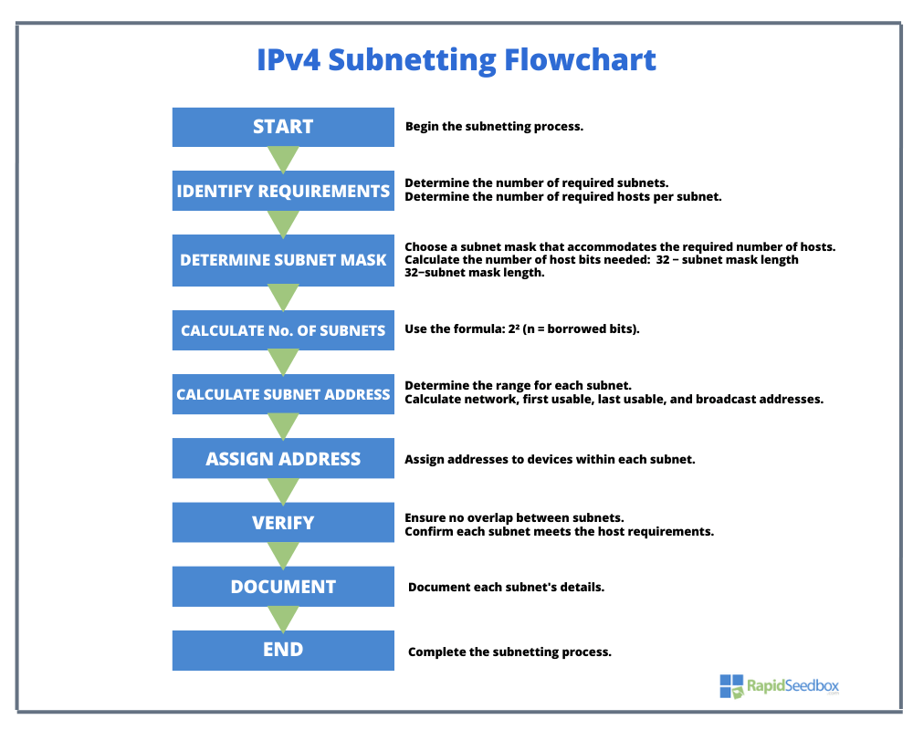
[7]

Research on Routing
Routing refers to the method of directing information packets through a series of connected networks from their origin to their end point. Routing can be performed statically, which involves simply directing data packets from one device to another manually, or dynamically (using an algorithm) to route packets based on changing network traffic patterns. While static routing is easy to implement, more secure and does not require changes to be made by the system administrator, static routing only works well with smaller, more stable networks; whereas, dynamic routing using algorithms such as OSPF, BGP, or RIP allow for automatic adjustments to routing tables in real-time as network conditions change, making it possible to support larger, more complex networks that are constantly changing [6].
Because of the way that a Debian DHCP Relay will send DHCP requests between multiple subnets, using dynamic routing (such as OSPF), makes more sense than static routing. Static routing would be more suited for an environment where there are few servers or when the network configuration is unlikely to ever change, because it would have to be updated manually every time something changed within the network. Using dynamic routing would enhance the ability to scale your network, add redundancy (fault tolerance), and allow for a seamless DHCP request to be made from the DHCP relay to the Windows clients. So when considering the need for a highly reliable, flexible network setup, using dynamic routing over static routing is obviously the better choice [8].

Research on Network Services
VPNs, DHCP, Active Directory Domain Services (AD DS), and Certificate Authorities represent a collection of mission-critical network services that facilitate secure communication, scalability, and efficiency.
A VPN creates an encrypted tunnel from a remote client to the corporate environment, thereby providing secure and private access to the organization’s resources over public networks; this protects both the confidentiality and integrity of data transmitted. It is recommended that organizations utilize strong encryption standards and implement multi-factor authentication to enhance their security posture when utilizing VPNs [9].
DHCP automatically assigns IP addresses to hosts on a network, which can assist in the reduction of administrative overhead associated with manual IP address assignments and assists in the efficient use of IP addresses. The implementation of DHCP relay agents will allow seamless communication between hosts and/or routers located in different subnets, as well as provide a means of communication between the subnets within an enterprise environment [9].
AD DS provides centralized authentication and authorization services by providing administrators with a single point of management for users, devices, and policies. Best practices include creating organizational units to organize users, devices, etc., and utilizing Group Policy Objects (GPOs) to enforce consistent settings/policies on all managed systems. Creating redundant AD DS structures can also increase the availability/resilience of your directory services infrastructure [10].
CAs create, distribute, and manage digital certificates, and form the basis of Public Key Infrastructure (PKI). Digital certificates can be utilized for identity verification/authentication, secure communication (i.e. SSL/TLS encryption), and digital signatures. Best practices include creating an offline Root CA to protect the Root Certificate Authority's private key, conducting regular audits of digital certificate usage to identify potential issues/compliance problems, and storing/protecting the private keys associated with CAs/HSMs (Hardware Security Module) to prevent unauthorized access/use of those keys [10].

Task 2

Choosing hypervisor
A Type 1 (bare-metal) hypervisor is preferred. Microsoft Hyper-V or VMware ESXi due to its superior performance, reliability, and compatibility with both Windows Server 2008/2009 and Debian Linux.
Type 1 Hypervisors (Bare-Metal). Run directly on the hardware; therefore, do not require a host operating system. Can offer better performance, scalability, and resource management than Type 2 (Hosted) hypervisors. Example hypervisors include: Microsoft Hyper-V, VMware ESXi, Xen, and KVM. Compatibility of Windows Server 2008/2009 Hyper-V is integrated in many Windows Server editions; therefore, it can be a good choice for hosting Windows workloads. VMware ESXi also offers support for earlier Windows Server versions and provides an enterprise-level virtualization solution.
Compatibility with Debian Server. Debian is completely compatible with Hyper-V and VMware ESXi and there are integration services that can be used to ensure seamless operation. KVM (Kernel-Based Virtual Machine) is a viable alternative for environments focused on Linux.

Download and Setup
Located in my download folder, highlighted yellow as proof of download. VirtualBox which is located on the website, free installation.
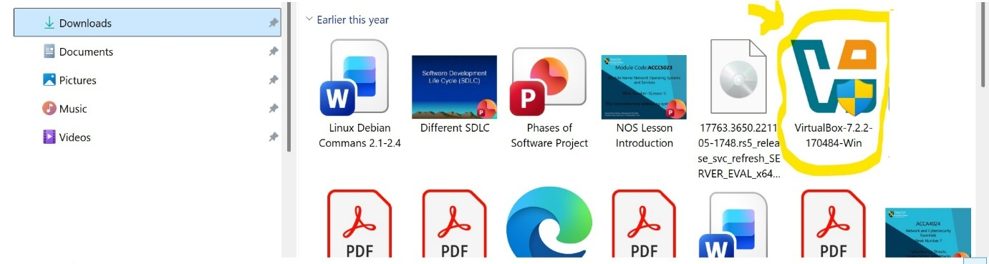

Evidence of Debian download which is accessible for VirtualBox integration.


Windows 2019 download also available to access.
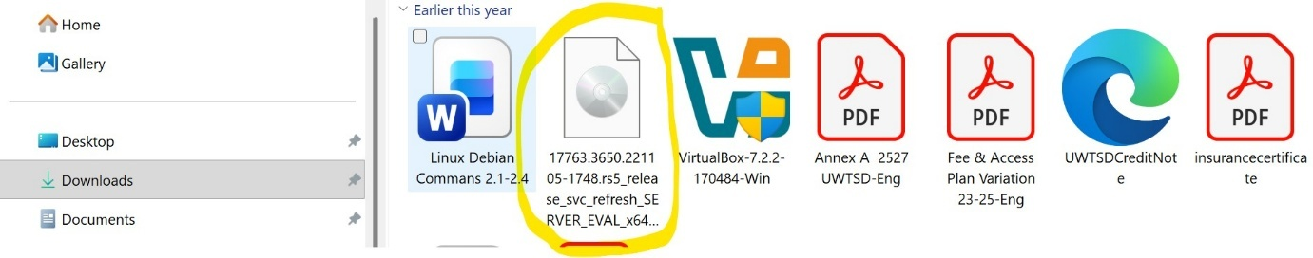

After installing the files the proper procedure is needed in order to select the files. By clicking on “NEW” naming the file either server or client, choosing the version windows 2019, go to storage, select the “virtual optical disk” in order to choose the downloaded windows file.

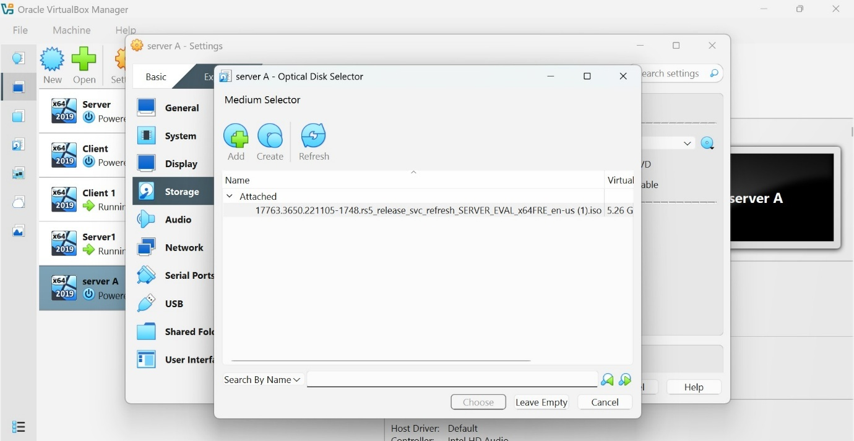

Both Debian machines are successfully downloaded and running.
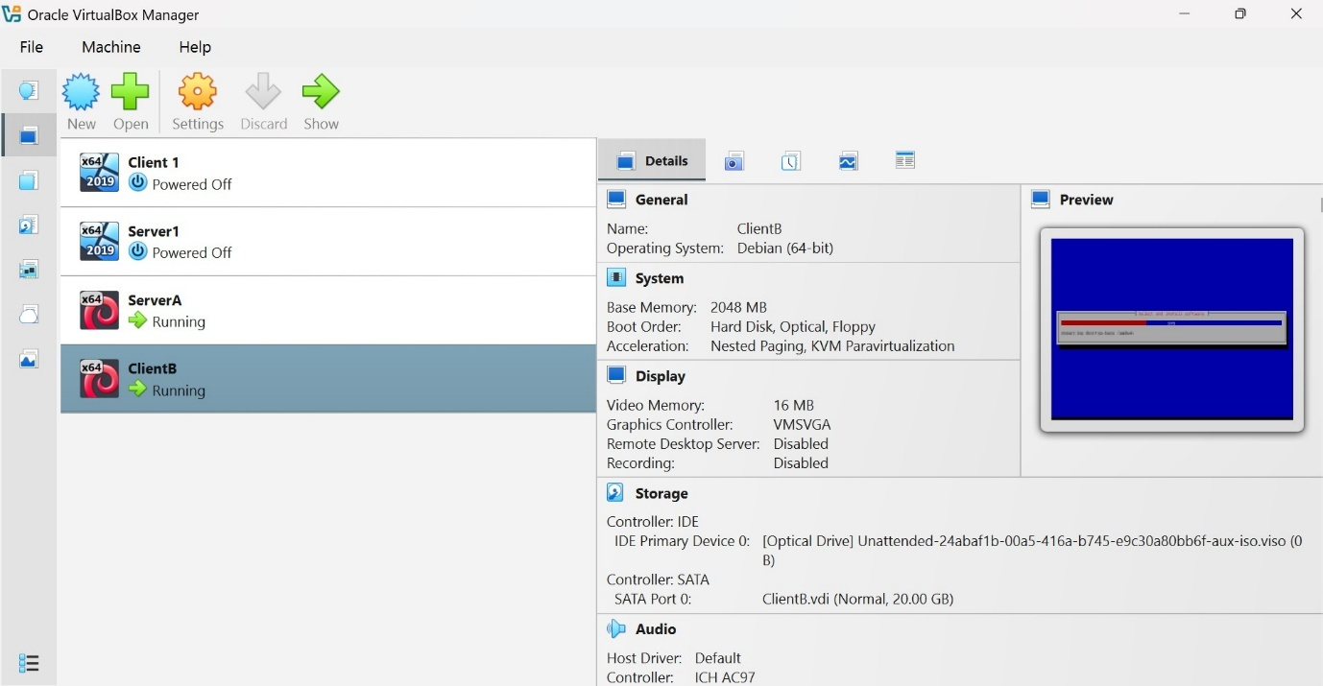

After creating both a client and server I then press the start arrow for both client and server to start running them both.
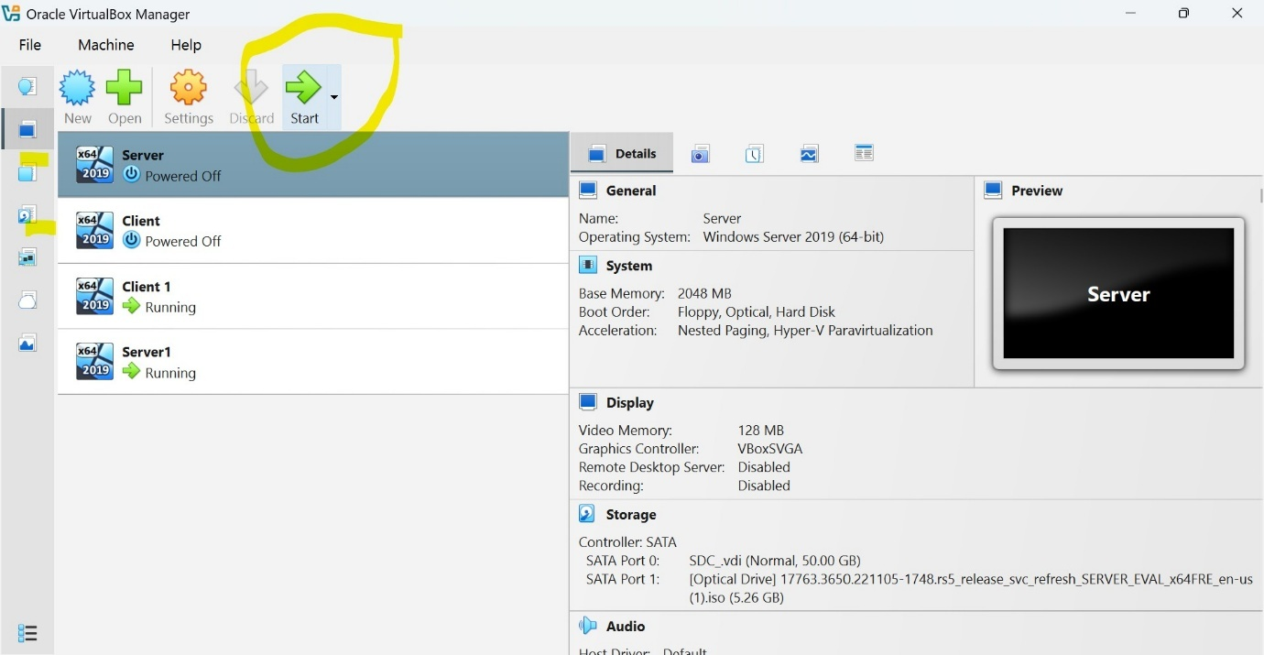

All machines, windows and Debian is now running.
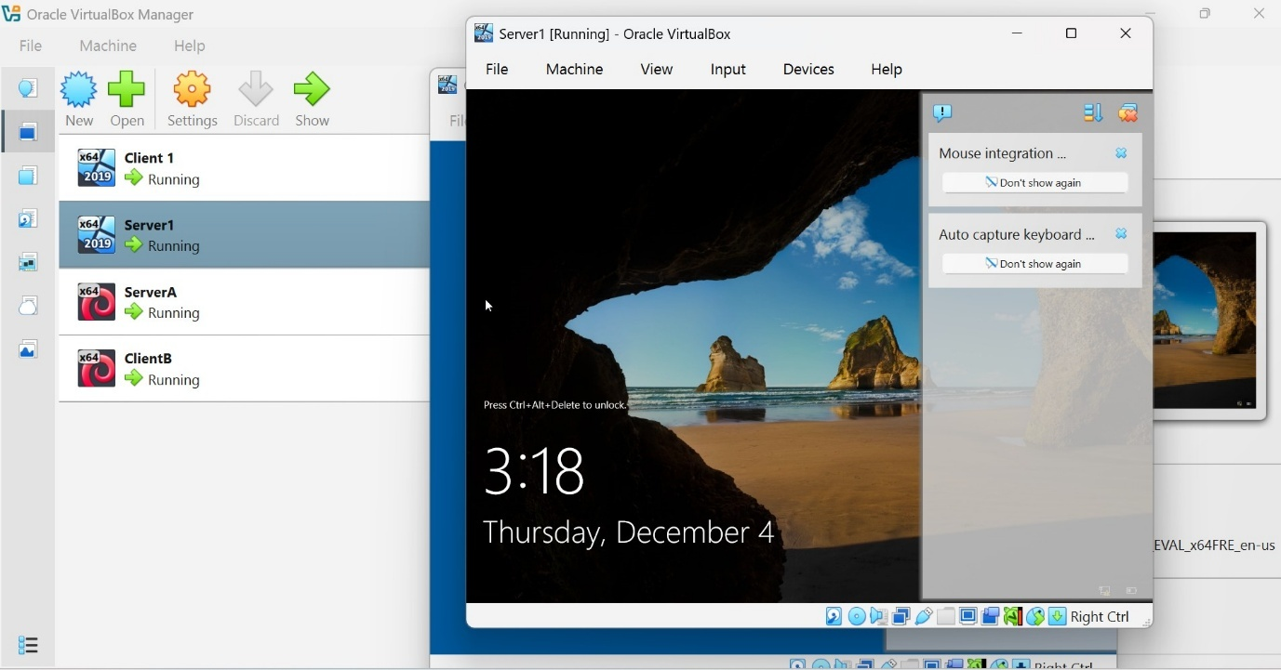

Nat Network is the main setting which allows the networks to talk to each other.
Nat Network has now been set up for Debian machines.
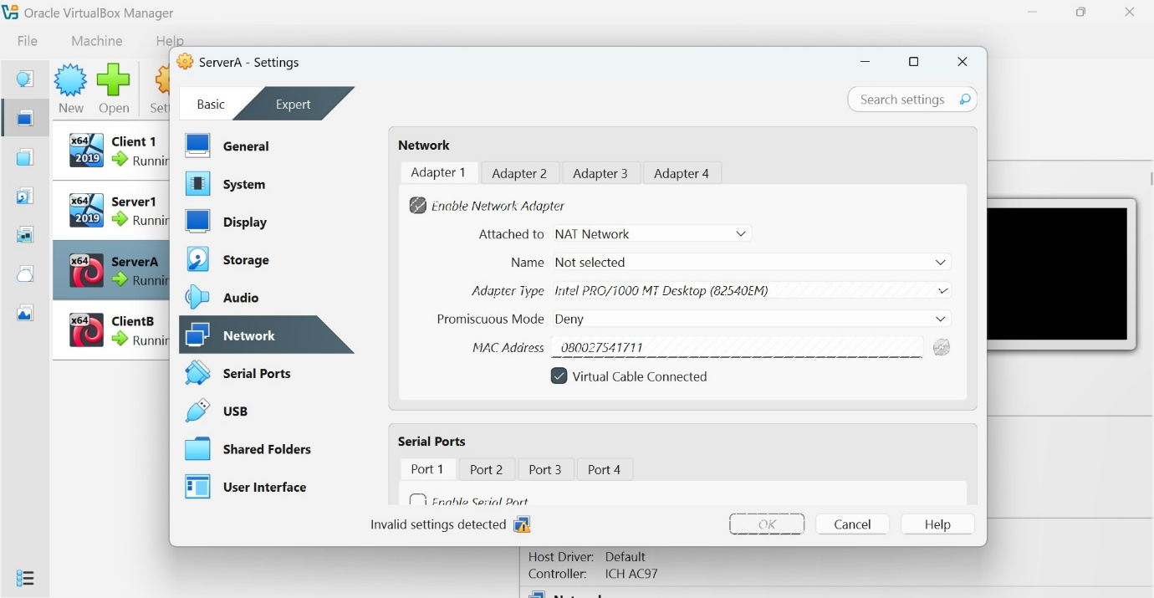

And Nat Network setup for Windows machines.
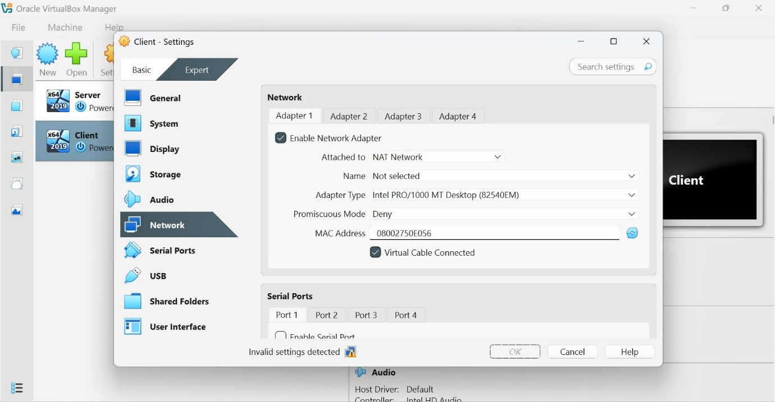

It will then come to this installation screen. After choosing the right setting the program will then start to install.

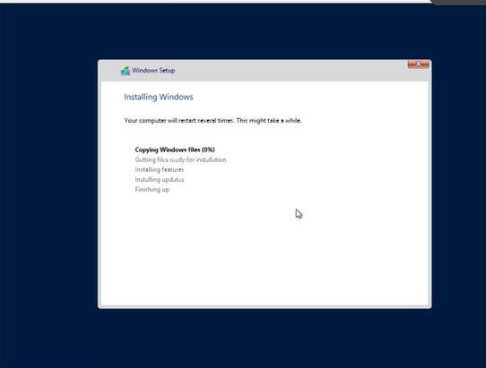

Once the window has been successfully installed and running and password has been created. The server is now assessable.
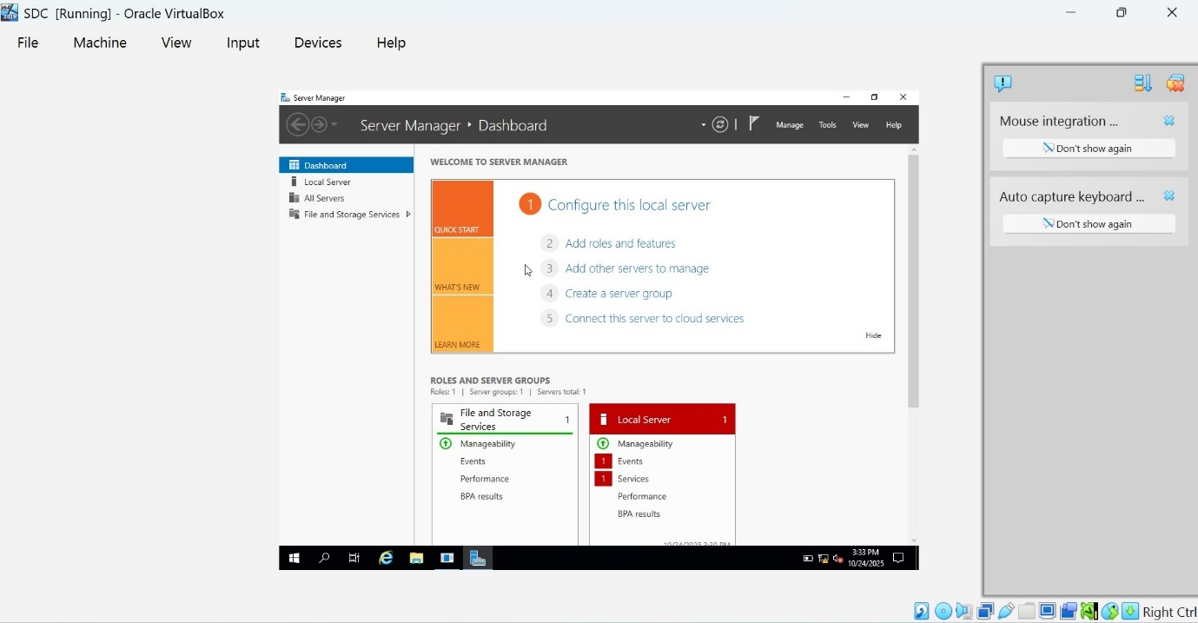

By clicking on tools I was able to successfully add a new user.
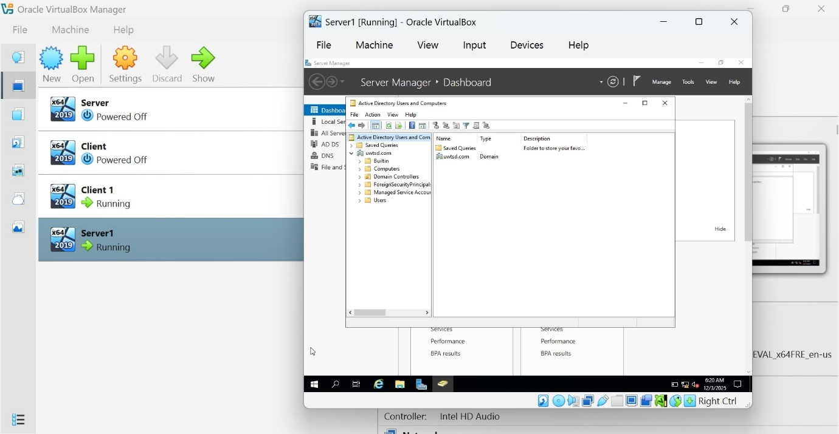

I then went to client server in order to further interlink server and client. While on the client machine I was able to now change workgroup by clicking and changing the domain.
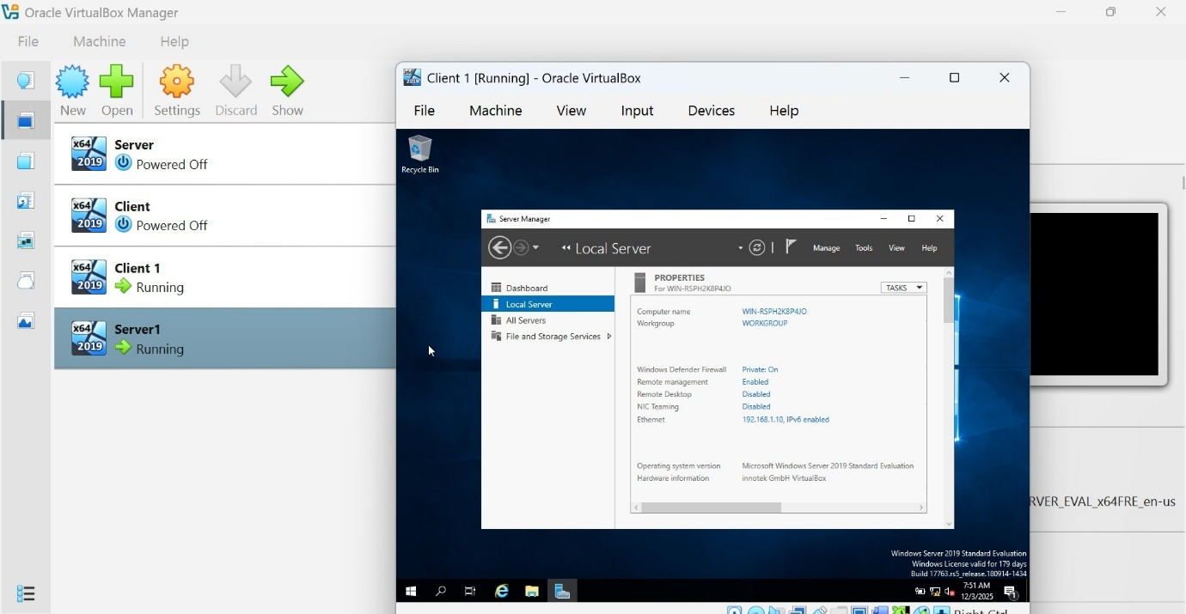

I am now no longer in the work group
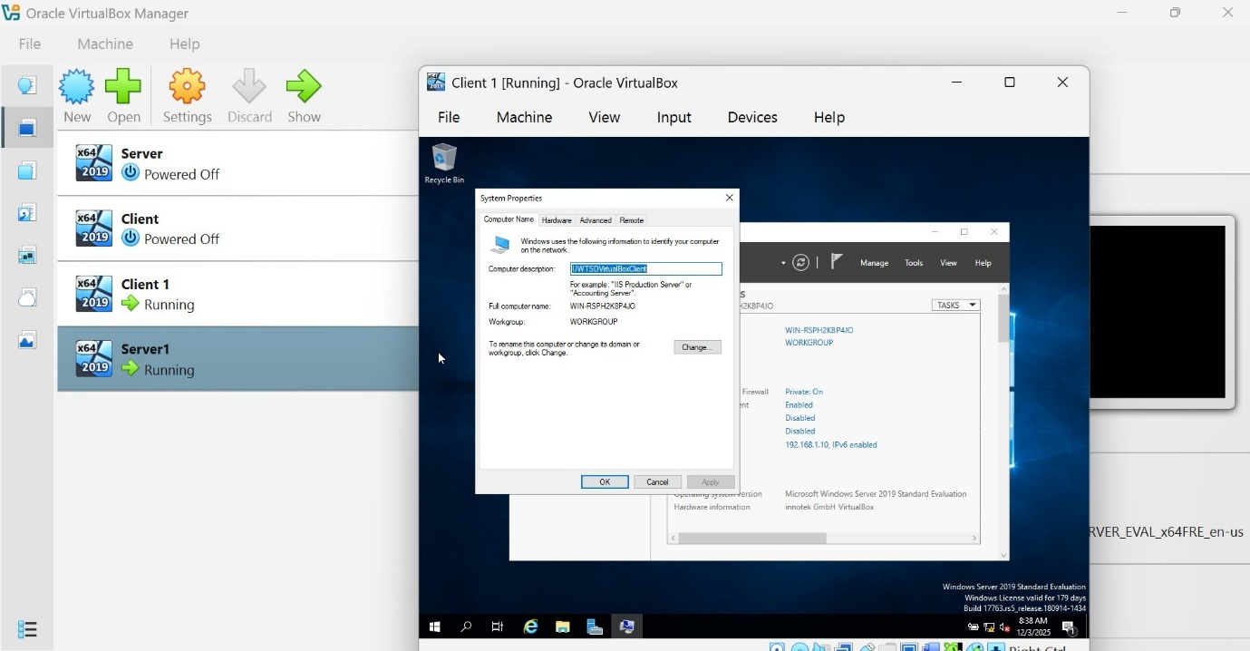

After having password issues with the domine change I then managed to solve it by entering the correct password.
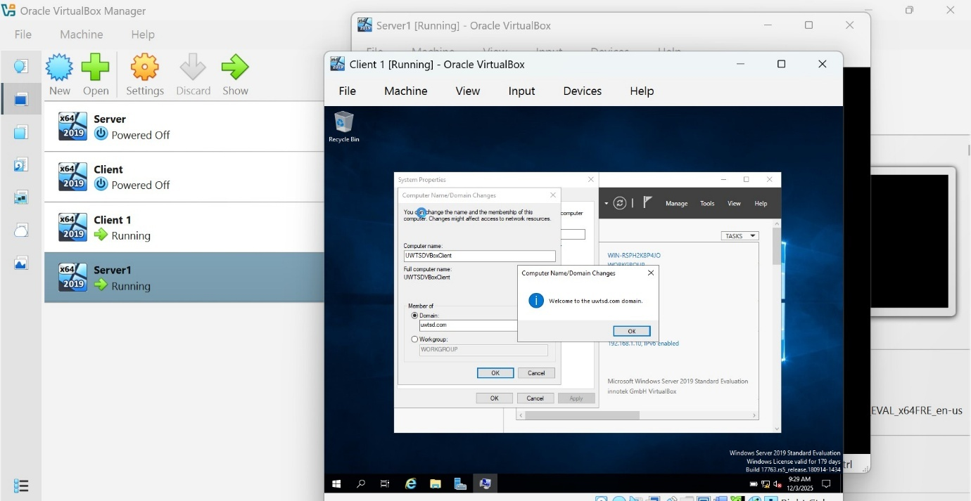

Configure IP

After installation and login in I then go to “Network and sharing centre” to configure the IP.
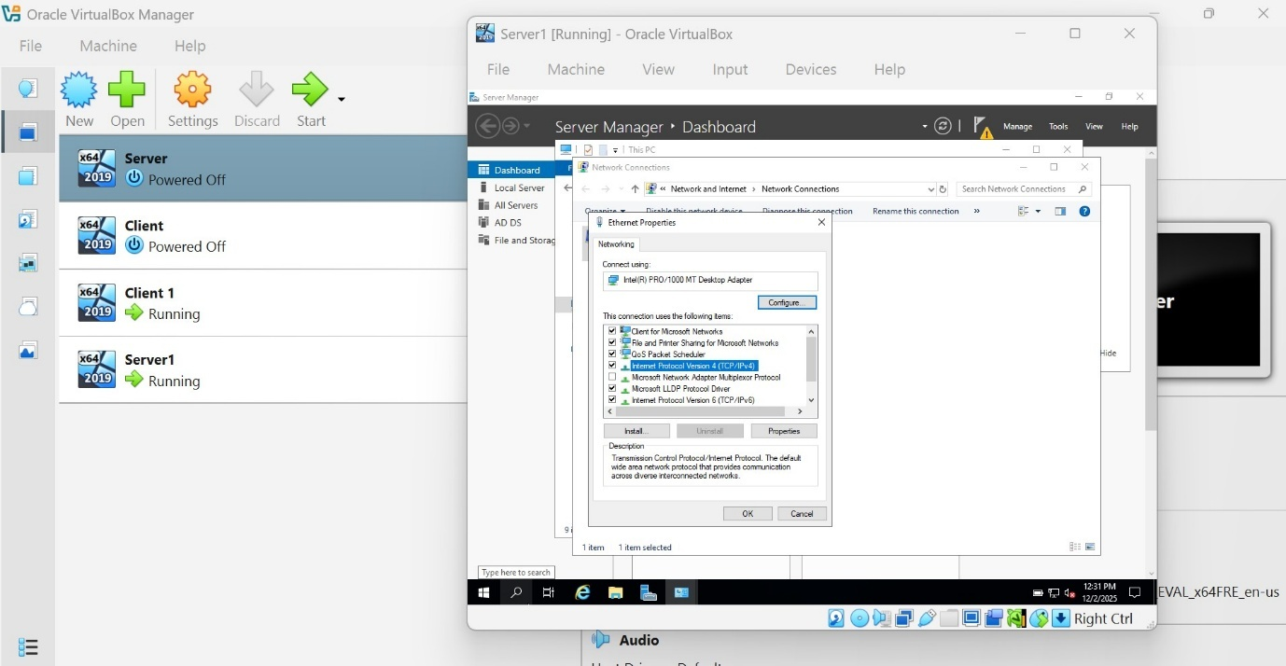

Starting with the Server IP change placing the given IP address, subnet and preferred DNS, then pressing ok.
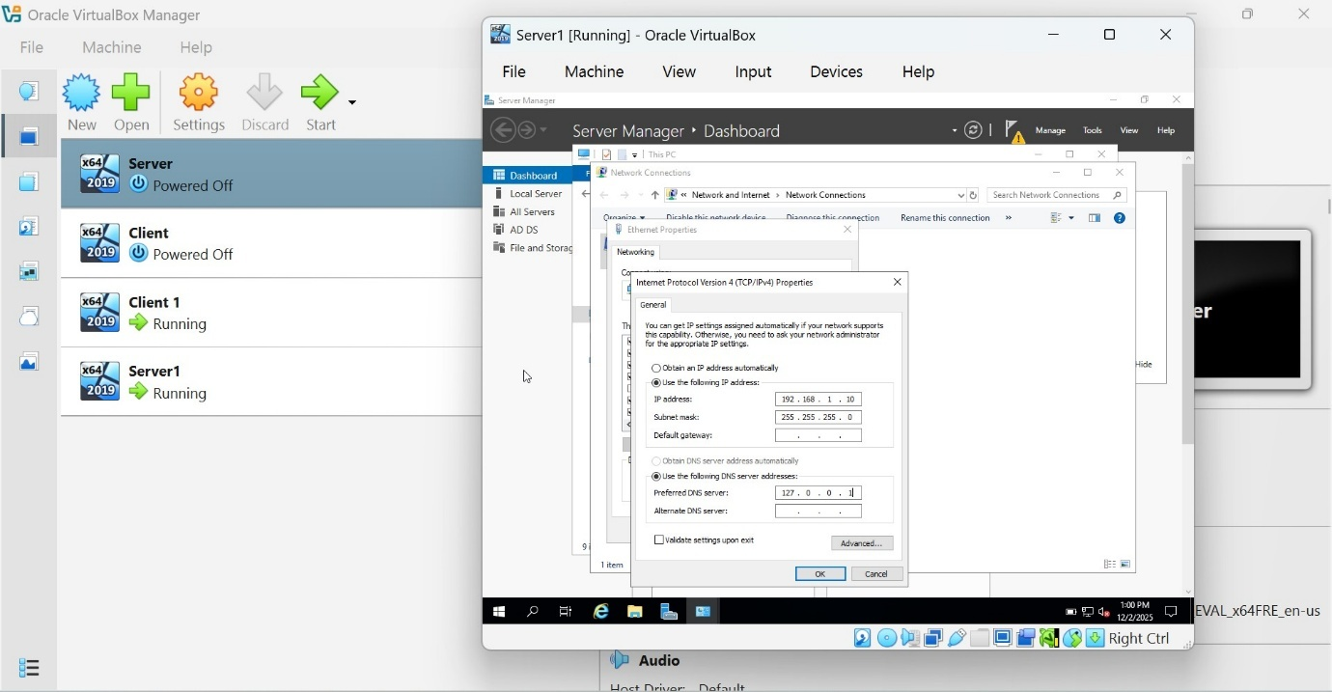

After changing the Server IP address I then did the same to the Client IP address.
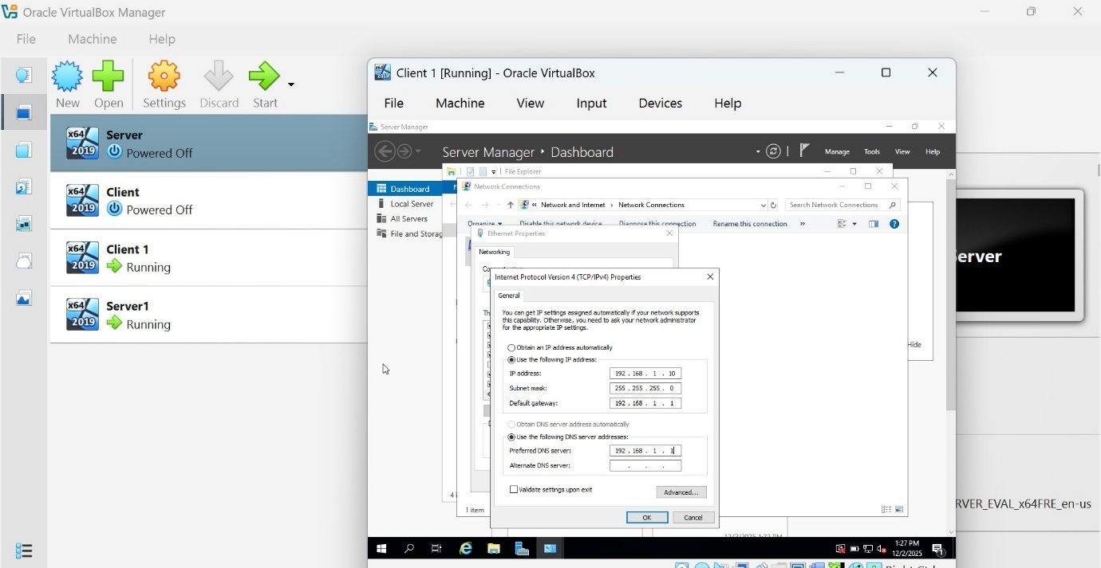

This is the client IP address.
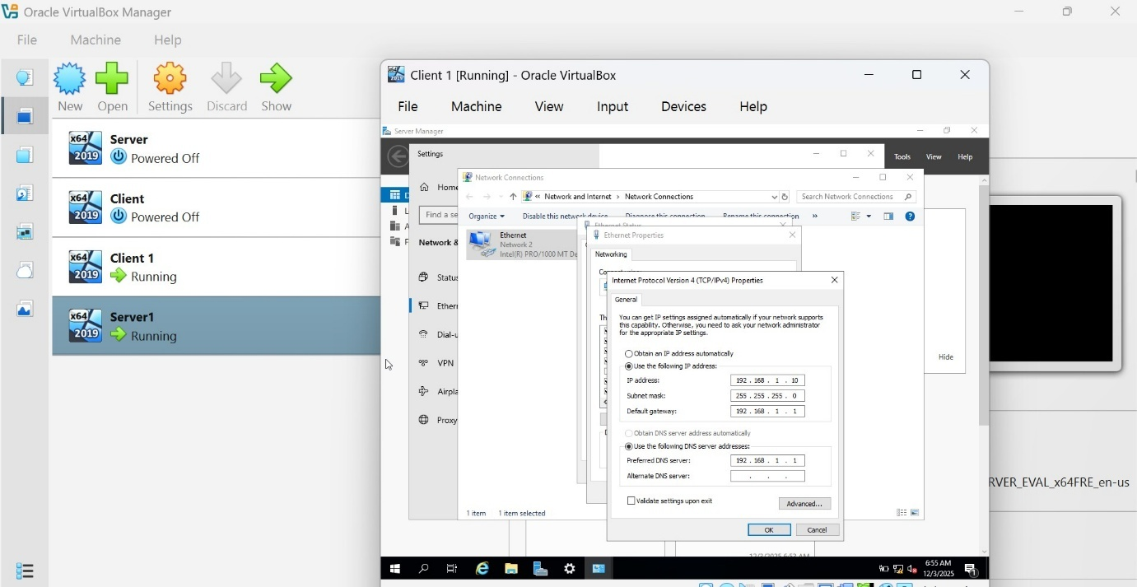

These are the result for Debian server IP.
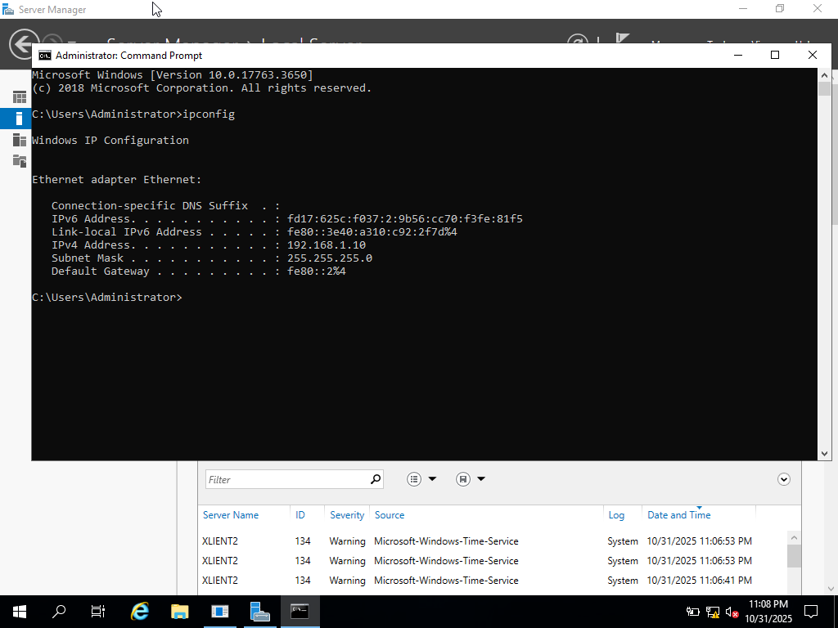For Linux IP configuration.
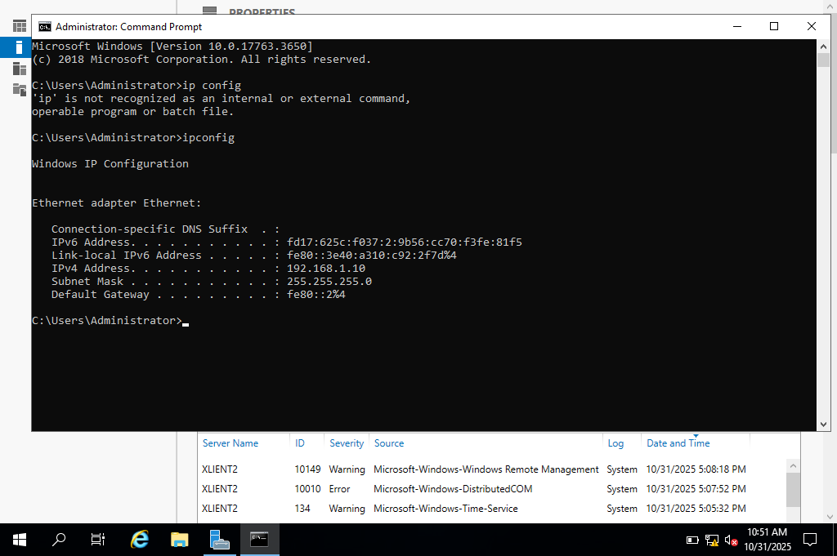

Test and troubleshoot
Client is now added in Server active directories displayed as “UWTSDVirtualBoxClient.”
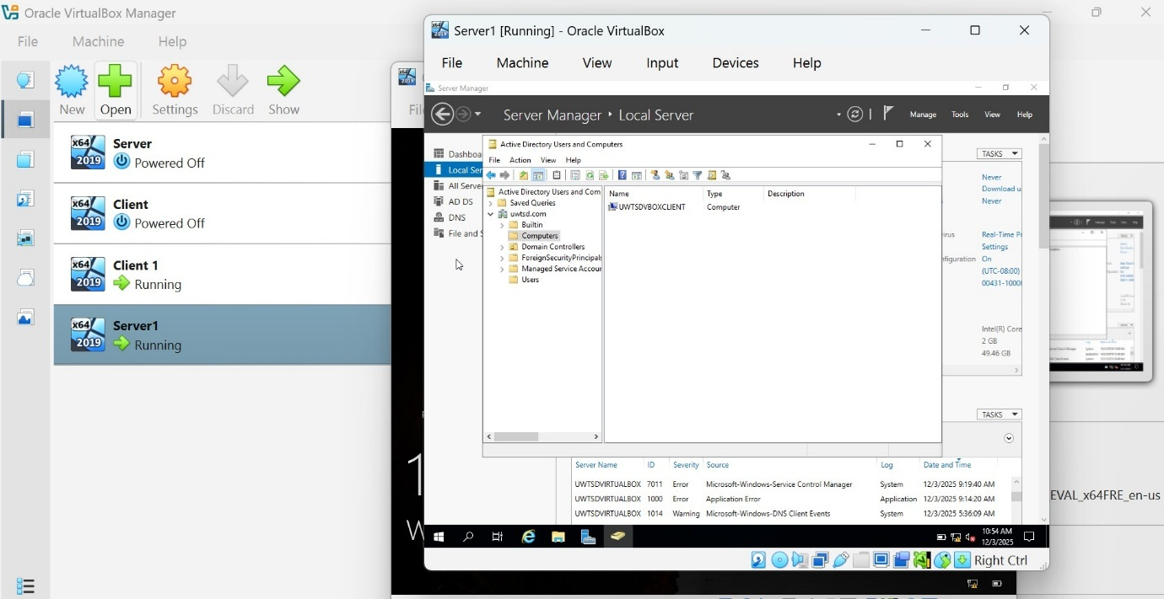
There are the screenshots for testing and pinging for Debian Linux system.
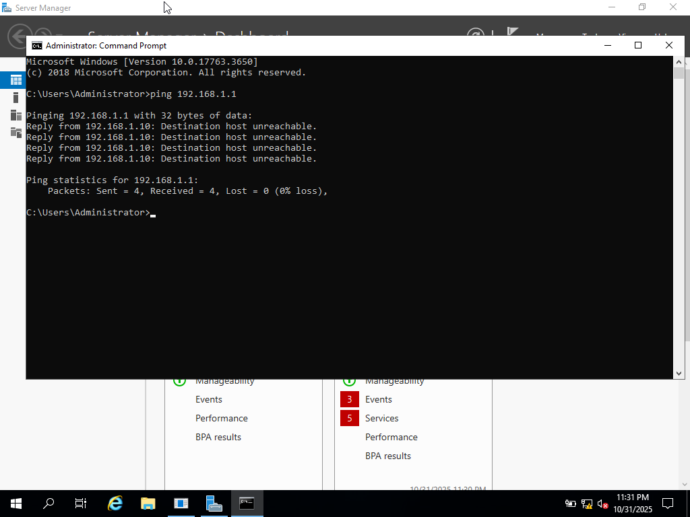
An user administration ping test was carried out.
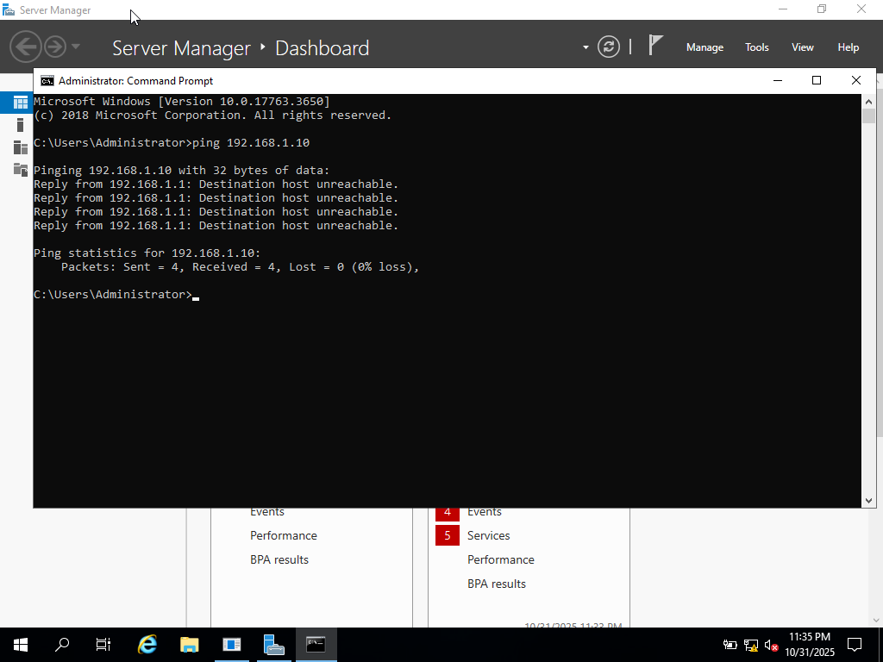

Task 3

Reflection
Throughout task 2 I had plenty of issues along the way, some difficult and other simple to solve. First issue I would say I had while starting was the right windows to download but once I was guided to the correct link it was seen as just a minor issue. After downloading the correct windows 2019 the next problem arise was how to select it while starting my server but that was quickly learnt and was able to move through it with ease. Upon creating both server and client by selecting the correct methods and running them both. It was a challenge for me to find the right menus and links in order to set up the server but once I found the correct buttons and links I was able to input the correct information starting with the domain names. The IP address I found a little tricky at first only because I was not sure on which IP to enter along with which setting to actually go to but once I learn the correct methos and where to enter both IP addresses for client and server I then executed it with ease and went onto my next task.

Conclusion
When deploying and testing, I encountered difficulties in the form of conflicting IP addresses, failure to resolve a DNS query, and overly restrictive firewall policies. We utilized ipconfig, ping tests, etc. to identify and diagnose IP address conflicts so that we could make sure I were assigning unique IP addresses to each device through our use of DHCP. I also used the nslookup command to identify and trace DNS resolution problems which helped me verify whether the DNS name-to-IP mapping was correct. The cause of the restrictions imposed by our firewalls were determined through the analysis of blocked port logs and then corrected by modifying the inbound/outbound rules on the firewall. To systematically troubleshoot the problem I isolated each of the layers (i.e., Network Layer, Host Layer, Service Layer), documented the process and results at each step. The systematic nature of this troubleshooting process allowed for an efficient solution, improved reliability, and confirmed the integrity of the network as it relates to its operational integrity.

Reference

[1] | R. Kumar, “tecadmin,” 2013. [Online]. Available: https://tecadmin.net/type-1-vs-type-2-virtualization/.
[2] | “Code Lucky,” 2025. [Online]. Available: https://codelucky.com/hypervisor-types/.
[3] | S. Cooper, “comparitech,” 2024. [Online]. Available: https://www.comparitech.com/net-admin/best-hypervisors/.
[4] | S. Lee, “numberanalytics,” 2025. [Online]. Available: https://www.numberanalytics.com/blog/role-of-ip-addresses-in-modern-networking.
[5] | A. Timokhin, “interlir,” 2021. [Online]. Available: https://interlir.com/2024/12/26/a-beginners-guide-to-subnetting-ipv4-and-ipv6-addresses/.
[6] | W. T. P. D. S. P. -. A. S. C Okoh, “Enhancing Data Security Through VLSM Subnetting and TCP/IP Model in an ENT,” 2024.
[7] | https://www.rapidseedbox.com/blog/subnetting-cheatsheet.
[8] | “geeksforgeeks,” 2025. [Online]. Available: https://www.geeksforgeeks.org/computer-networks/difference-between-static-and-dynamic-routing/.
[9] | R. Howard, Cybersecurity first principles: a reboot of strategy and tactics, 2023.
[10] | L. H. -. Apress, Pro Active Directory Certificate Services, 2022.

Appendices

