Chemical Kidscommunity engagement scheme proposal

Index:
Program summary: Pages 2-3
Program schedule: Pages 3-4
Staffing: Pages 4-5
Funding: Pages 5-6
Community benefits: Pages 6-8
Advertisement: Page 8
Potential flaws and improvements: Page 8-9

What is the Chemical Kids community engagement scheme all about?
Chemical Kids is a relatively simple concept involving the blending of a child’s innate desire to learn and curiosity with a hands-on approach to science, in order to provide a healthy and happy attitude towards learning. The program was inspired by similar global programs such as Mad Science. However, Chemical Kids seeks to address the niche which others have failed to do. Chemical Kids will be designed to be accessible to all, whilst this is somewhat altruistic common flaws of other programs were their high costs thus alienating large numbers of children from lower affluency backgrounds. The program will utilise various members of the community from a variety of backgrounds and skill sets to provide a different perspective on education for both children and parents alike.
The scheme will be run once a week for 2 hours from 5:30 to 7:30pm (in order to allow both children and parents to attend should they wish to) for children aged 5-11. Exact days would vary from location to location based upon staffing and location availability.
Chemical Kids is a scheme in which both parents and their children are invited to take part in awe inspiring activities designed to bring forth the child’s imagination and explorative nature. Moreover, the presence of parents is encouraged though not exclusive as to build trust for the program but also to allow the parent to develop a keen interest in the education of their children and to show them that education can take place outside of school. The program seeks to highlight the importance of a more light-hearted approach to education and how play can be utilised as an educational tool. The ethos of such a program is built upon child centric learning and the importance of play as seen in modern day early years education and philosophers such as Freidrich Froebel.
‘Froebel sought to encourage the creation of educational environments that involved practical work and the direct use of materials. Through engaging with the world, understanding unfolds. Hence the significance of play – it is both a creative activity and through it children become aware of their place in the world.’ (Smith, 1997)
As highlighted in the statistics report, Swansea has an above national average rate of children in poverty at 22.8%; 0.5% higher than the Welsh average. This is one of the key factors in ensuring that Chemical Kids takes note of in order to provide an inclusive program. The program will need to be a cost-effective supplement to a child’s education making sure any and all cost to the children/ parents are mitigated as much as possible. Further highlighted in the report was the number of adults and consequently parents who had no academic qualifications thus providing a further consideration for the program. The key reasoning for allowing parents to be present throughout was indeed to provide security, trust and all the above mentioned however it was primarily to instil confidence not only in their children but also themselves and to empower the parent to believe that they can play an active role in their child’s education regardless of their background in education. It is imperative for the success of the program that both the parents and the children grow in confidence if the long term aims and benefits of Chemical Kids are to be met.
What might a typical session look like?
A typical session for Chemical Kids would be run by a single trained adult who would both guide and assist the children and parents. At the start of each session the lead scientist (member of staff) would introduce themselves using a science themed name for example Radioactive Ryan. If it is a child’s first session they would be invited to create their own science name/ persona as to help develop a sense of belonging, fun and to aid in achieving an identity within the program; yes, even the parents! The theme would be introduced by the member of staff for that day e.g. plastics and polymers and an open discussion between the children and parents would take place to talk about what they already know. The member of staff would help lead the discussion by posing simple questions such as where can we find plastic? Can you see any in this room? Etc. This would culminate in a moment of feedback so that the children can share their ideas with the room again to develop confidence and help develop a sense of community within the group. Following this a brief talk will be given by the member of staff about the topic utilising their own knowledge and the answers of the children then leading into an experiment and in the case of plastics and polymers, making slime. The experiments are designed to be as simple, safe and hands on as possible and where possible repeatable at home. You might ask why go elsewhere for what you can do at home? Whilst this is a valid question the purpose of the scheme is to broaden individual’s horizons and open their minds to the possibilities of what they can do and how they can explore the world around them both as a community and independently. Many will not have seen or heard of the experiments available, so it is critical to introduce the possibilities to children and parents alike.
The idea that each experiment is as hands on as possible is imperative to the ethos of the program in that it wishes to be an alternative approach to the type of learning in school primarily focusing on a kinaesthetic approach. The reason for this is because this style of learning is somewhat overlooked in schools as a result of the modern health and safety culture as well as being somewhat time consuming in an already time stricken curriculum. This is one of the niche’s Chemical Kids wishes to address as according to Vark (2017) ‘In the 2017 June to December database (n=170653), of the total options chosen, 22.0% were for Visual, 25.8% were for Aural, 23.7% were for Read/write and 28.0% were for Kinaesthetic’. This highlights the clear need for some facet of education to offer some outlet of kinaesthetic learning which is not being met in schools outside of the foundation phase.
The remainder of the session would be used as a time for discussing the experiment or furthering it as in the case of slime the children would be encouraged to explore its properties e.g. is it stretchy or not? Is it soft or hard? Can it bounce? Allowing the children time to reflect on what they’ve made and to develop critical thinking skills. This time would mostly be used for the lighter side of the session and simply allowing the children to play and interact with both their parents and others.
Who would staff the programs?
As previously mentioned Chemical Kids seeks to mitigate any and all costs in order to help reach out to some of the less affluent areas of Swansea as stated in the statistics report. However, herein lies an opportunity to assist in the building of the relationship of two communities within Swansea. For those who live in Swansea it is extremely apparent to all that there is an incredibly large student populous particularly in areas such as Townhill and central Swansea. It is well documented (see appendix) and felt that there is some hostility towards students in the area for one reason or another and as such universities often seek to repair and build a bridge between the student and local communities. Chemical kids will hope to do the same by offering experience based voluntary work to the students in areas such as Townhill. This could prove particularly fruitful in this area given Townhill’s university campus is comprised of students seeking jobs and experience in teaching/ education and childcare. Moreover, utilising this need for experience provides the students with the unique opportunity to engage with the local community on a level they are familiar with but also to show that people who live locally can achieve and do great things academically. This would undoubtedly help build relations between both communities in a safe and controlled environment and create a sort of symbiotic relationship or co dependency on one another and again help build trust between all parties.
As far as training the staff goes this would be subject to a DBS check being completed and from there every member of staff would be expected to shadow at least two sessions before being allowed to run sessions of their own. Staff would be provided with example plans and experiments however would be encouraged to plan their own ideas and experiments subject to clearance. This would help the students develop skills such as planning, time management, communication and leadership moreover it also allows the student to build a sense of ownership of the program in that it is as much their scheme as anyone else’s. Moreover, in terms of the experiments very little training would be required as they’re designed to be simplistic in nature, most of the training will be focused on things such as public speaking and crowd control.
This opportunity differs from other potential experience as it allows the student to run a class/ session of their own unlike many school settings prior to PGCE. Students would of course be provided not only with a unique opportunity in terms of pedagogy, but also the chance for networking amongst members of the community such as parent governors, school workers and of course the children themselves. Furthermore, it is needless to say that any volunteer could use the experience as a point of reference for future endeavours. For further reading on the importance of community engagement in projects such as this please see appendix.
How will such a project be funded?
Whilst in an ideal world it would be fantastic to have the latest and greatest pieces of science and technology this is simply not a reality for a project such as this especially one in its infancy. However, this is not necessarily a bad thing as to have unparalleled wealth would critically undermine the ethos of Chemical Kids. As stated above this is supposed to be an all-inclusive program for anyone and everyone with the clear majority of what we do repeatable at home under supervision. This cannot be achieved particularly in low affluency areas if the scheme’s experiments are not cost effective.
Costs in this instance are of course estimated and a reflection of the ideologies of the program. For a simple outlay of cost per session please see the table below. Please note 3rd party funding/ donations refers directly to programs such as Swansea Youth Bank. For more information on Swansea Youth Bank please see appendix. Each child will be charged £2 per session and figures are based upon an average class of 15. Hall hire is based upon my own experience working with scouts and similar programs and various quotes. All costs and gains are estimations and are subject to change.

Having worked directly with Neath Youth Bank and seeing the types of projects that get funding I feel confident that funding could be attained through their application process as the project meets all their stated criteria.
Staffing cost not to be included as this would be a voluntary position as mentioned above. The above estimations would allow the program to run for one year at one location for 50 weeks of the year. After one year the program expenditure and funding would again be reviewed to reflect its position at the time. Swansea Youth Bank are one of several funding opportunities including Change Fund Small Grants and The Austin Bailey Foundation that could be utilised to assist in funding the program.
Experiment costs are low overall with reasons given above but have been formed based upon my own experience running these activities in similar scenarios.
The reason for charging £2 per session for each child is designed more as a token amount. By no means does this cover the incurred expenditure on its on however it resembles a cheap and fair compromise for the scheme to maintain a good quality of output alongside ensuring it is accessible for everyone. This is in line with the ethos of the project and represents extremely good value for money. It is hoped, perhaps optimistically, that over time this could be abolished as the program grows in size and stature and can branch out into further opportunities which may provide the required funding.
How will this project benefit the community long term?
Whilst this project will have many short-term benefits such as bridging communal differences, alternative education prospects and parental engagement the long-term goal is very specific to Swansea and the social mobility within it. As shown in the statistics report, many parents face low income jobs or part time employment which contributes to things such as child poverty, crime and low attainment. This in turn inhibits the social mobility of Swansea despite their being the tools present to turn Swansea into an incredibly socially mobile area. One of the purposes of Chemical Kids is to promote a positive attitude towards learning but also to show that anyone regardless of background can do amazing things through science. In fairness, a program such as this could potentially be run with any school subject however science was very deliberately picked with Swansea in mind. As shown in the statistics report in low affluency areas 52% of adults have no qualifications and therefore it stands to reason likely have little to no faith in the education system or their place in it often passing on this attitude to their children and thus creating a poverty cycle. It is hoped that with the assistance of programs such as this that ideology can be broken for child and parent alike. Right on their doorstep they have subsidised access to a myriad of universities offering all sorts of courses but particularly focusing on the new build university along SA1 being coined as one of the best universities for scientific study globally. By promoting a positive attitude towards learning and science in particular it is hoped that the program may instil enough confidence for people for all backgrounds regardless of affluence can dream big when it comes to education. Even in the poorest of areas/ backgrounds a welsh student would not have to move or leave home should he or she not be able to afford it, they would have greatly subsidised fees due to welsh government grants, student loans based upon parental income would weigh in their favour to aid their education and lastly there are a wide variety of bursaries available for those who strive to attain great things and especially where science is concerned.
Whilst this is perhaps very optimistic it is easy to see a path for progression and the means by which an individual might attain it with the aid of schemes such as this. Moreover, by creating locally sourced skilled individuals it is likely much of what they earn through university and beyond will be brought back into the local area thus increasing affluency and in the very long-term creating a skilled workforce capable of helping build even the poorest of communities into something more. This would be most apparent in areas such as Townhill and could serve as a multi-purpose tool for eradicating many of the issues stated in the statistics analysis. It is widely noted than investment in education is hugely beneficial in the long run and often returns far greater than what is initially invested often with unintentional benefits.
‘Each additional year of schooling raises average annual gross domestic product (GDP) growth by 0.37%.’ (Global Partnership for Education, 2018)
How will the program be advertised?
This is an incredibly challenging aspect at least initially for the scheme. Whilst word of mouth can be an incredibly powerful tool, advertisement will largely have to be done through more modern memes by creating a social media presence. This can be as simple as getting a Facebook page or twitter and sharing the page amongst various community pages to ensure there is some basic awareness within the community. Moreover, the scheme will aim to run free sessions to schools and local scout groups to help garner initial interest and again build reputation. Working with the scouts could prove extremely useful as it allows for greater mobility and networking than perhaps schools might allow for. Nevertheless, free sessions at institutions such as scouts would lay the groundwork for building a communal presence and would go some way as to build trust within the local community. The cost of these free sessions would be realistically minimal as venue nor staffing would be necessary and in theory should offer a good return if uptake increases as a result of these sessions. Eventually, once the program gains traction other avenues of advertisement could be explored depending on cost.
What are the potential flaws of the program?
As with any community engagement scheme it is incredibly easy to fall into one of several common pitfalls most notably gaining the trust of the local community. This perhaps will be the greatest challenge facing the scheme as any local community is understandably cautious of any outside entity interfering especially where their children are concerned. It is hoped a the very least the will be mitigated by openly inviting the parents to attend should they wish to as to build communication links and a sense of security.
The second and equally dangerous flaw will be securing funding and building a good reputation. Whilst it is likely funding could be achieved by one means or another the biggest gamble will be ensuring there is a suitable level of uptake on a consistent basis. This will largely be based somewhat on chance however the free sessions offered to various organisations should ensure there is a sufficient level of interest generated.
Conclusion
To summarise the above proposals, Chemical Kids is undoubtedly a large-scale program which in parts is somewhat optimistic. Despite this, the program operates on statistically identified niches and aims to solves local problems from within through means which are accessible to all. The project will likely require several amendments and changes over time to match any potential growth. Regardless, the scheme allows for several of Swansea’s issues to be addressed simultaneously and would likely represent a fantastic investment in the long run for both the community and the individuals within it. As shown in the statistical analysis many of Swansea’s problems stem from a cycle of poverty and low educational attainment. Only by addressing these issues at their root can we begin to solve the issues highlighted. By securing the futures of the youth of today we ensure a better tomorrow.
Word Count: 3177
Please find statistics report attached below.
Reference list:
Global Partnership for Education, 2018 The Benefits of Education https://www.globalpartnership.org/education/the-benefits-of-education (Accessed 22/01/2018)
M.K. Smith, 1997 Friedrich Froebel http://infed.org/mobi/fredrich-froebel-frobel/ (Accessed 20/1/2018)
Vark, 2017 Research and Statistics http://vark-learn.com/introduction-to-vark/research-statistics/ (Accessed 20/1/2018)

An analysis of the socio-economic needs and issues in Swansea
This report is a compilation of various social and economic problems facing Swansea today. This will include statistical analysis surrounding each issue mentioned as well as the inclusion of some anecdotal evidence where applicable. This report will seek to highlight the major issues within Swansea and its various communities and will seek to highlight any issues which may be linked to one another.
The first issue to be examined will be the economic status of Swansea and the people and families within it. This will include a detailed look at levels of poverty and employment within the area to ascertain the severity of the issue.
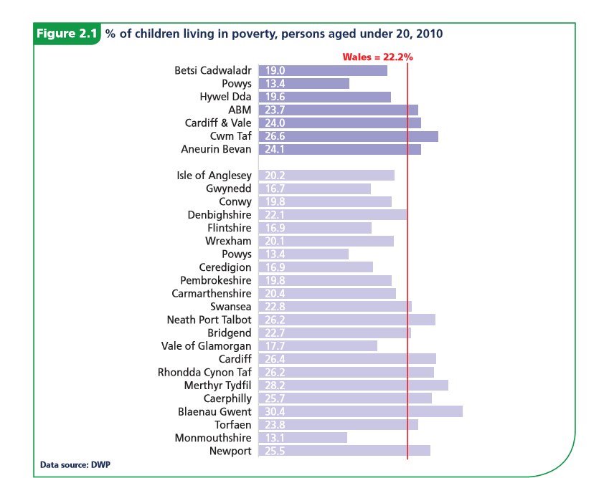(Public Health Wales Observatory, 2012)
‘Relative poverty is deﬁned with reference to the society being studied and can differ over time. It is deﬁned as when an individual’s resources are so seriously below those commanded by the average individual or family that they are, in effect, excluded from ordinary living patterns, customs and activities. (Public Health Wales Observatory, 2012)’
At 22.8% the graph clearly depicts Swansea as ranking higher in levels of poverty for children as seen in the rest of Wales. Whilst Swansea is not significantly higher than the national average in this case it should be noted that this is in one of the most modern, industrialised and affluent area of Wales with better job prospects for the local people when compared with other areas of Wales. Despite the small difference, it is perhaps most alarming that even with a relatively strong local economy comparatively speaking we still see these elevated levels of childhood poverty. This could be down to a number of factors; however, this is also reflected in the relative levels of deprivation as seen below.
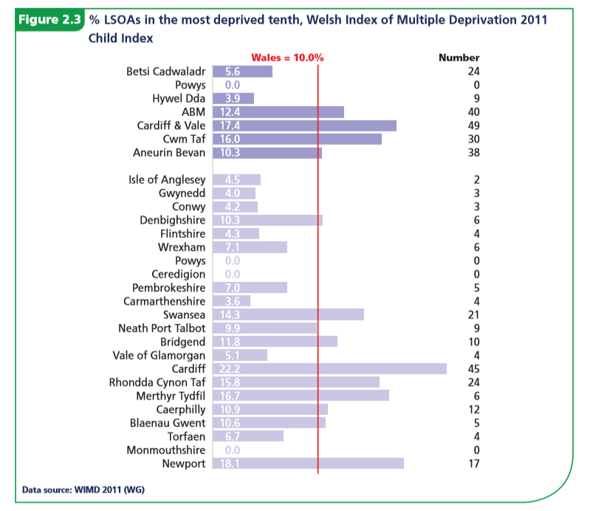 (Public Health Wales Observatory, 2012)
The data above shows relative levels of deprivation in Wales providing a broader picture than income related poverty alone. This is split into things such as income, health, education, access to services, safety and housing. It is here we see a significant elevation in levels of deprivation in the major cities including Swansea. Once again this is perhaps most alarming given that geographical location should grant the highest levels of access to services in the country yet deprivation stands at just under 50% above the national average. This would indicate that issues within Swansea are far greater than being purely economic. The above data would imply, at the very least, the income alone is not responsible for levels of poverty and deprivation.
Employment and academic achievement are intrinsically linked to an areas affluency and could give a broader perspective as to Swansea’s problems particularly in low income areas such as Townhill.
(Swansea Council, 2014)
The above graph shows that even without student population Swansea faces above average levels of unemployment amongst the working class. Moreover, this issue is further exacerbated by the type of employment seen in Swansea as recognised by Swansea Council (2014) as they state:
‘Part-Employment
In Swansea, nearly a quarter (24.7%) of children currently live in households with “mixed” employment, where some people aged 16-64 are working and others are not. Part employment is a problem: The Joseph Rowntree Foundation points out that part-timers earn less per hour (£7.60 average) than full-timers (£11.55 average), and that increases in both hours and pay rates are needed to tackle poverty.’
With higher levels of unemployment and those within employment either not being paid a living wage or getting enough working hours, it becomes clearer to see why Swansea faces high levels of poverty and deprivation.
Despite all the above, what is the factor causing so many to be jobless and or part time employed? In a major city where jobs should be easier to come by in less developed areas of Wales why do we see such levels of deprivation. The key could be within the education sector and the relative skill of a workforce. This is recognised by Swansea council particularly in areas of low affluency for example according to Swansea Council 2014,
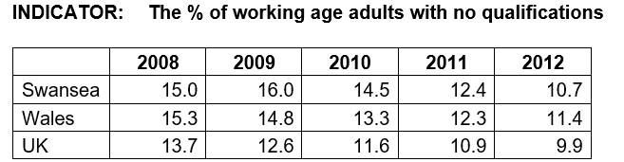
‘Qualifications are visible evidence of the cycle of poverty, with children from low-income families, where parents are less likely to have qualifications, being in turn less likely to get any themselves, and thus more likely to remain in unskilled employment. Employers have been found to be more likely to invest in increasing the qualifications of employees who already have some to begin with, thus they can be an important springboard to better financial well-being.’
Whilst Swansea does fall just below the national average for Wales, it is still above the UK average. Moreover, this does not in the case paint the whole picture as according to the very same report by Swansea Council 2014 ‘42.6%of all residents aged 16 and over in Penderry Ward have no qualifications’ and ‘52.41% of adults aged 25 – 59/65 in Townhill have no qualifications’. This quite frankly incredible jump in a lack of qualifications in some of Swansea’s poorest areas suggest that there is high level of inequity within Swansea most notably regarding education and access to services. The key to resolving many of Swansea’s social and particularly economic issues perhaps lies with education and improving education opportunity in areas such as Townhill, Penderry Ward and others in order to ensure equity amongst the populus. It is likely that areas such as these where extreme levels of poverty, unemployment, poor education etc are driving figures up as opposed to a more generalised problem for everyone in Swansea. By investing in education services and taking a more proactive approach many of these problems will at the very least be mitigated. In my own experience of working in schools in deprived areas it is apparent the children within these schools are given fewer opportunities to further their education and often face poorer standards of education. Furthermore, often in these areas of low affluency and by extension low qualification rate parents are often disengaged with their children’s education as they feel they couldn’t offer much help. Removal of this stigma and encouraging parental involvement would be tremendously helpful in the schools I’ve worked in as well as the potential attainment of children from these areas.
Issues such as deprivation and poverty are often the leading causes for other social issues, this is apparent also in Swansea as the types of crimes are reflective of the socio-economic issues stated above.
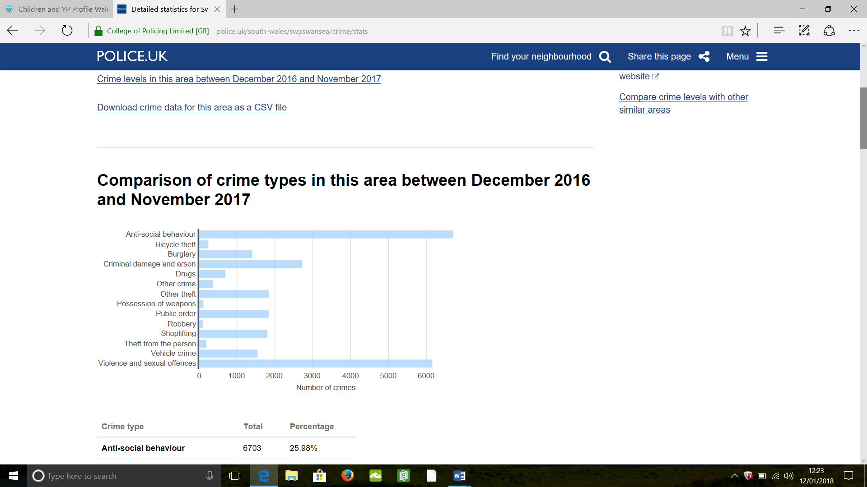
(UK police force, 2017)
We see high levels of anti-social behaviour and violent offences as well as high levels of various thefts. Whilst much of the violent offences and anti-social offences can be in part attributed to Swansea’s infamous nightlife much of the theft and anti-social behaviours can be strongly attributed to the aforementioned issues. This ideology is recognised by world health and crime organisations. For example, according to CAN 2017 ‘Anti-social behaviour can stem from a variety of factors such as: poor education, worklessness, ill health, poverty, child development and family problems.’ According to the above statistics anti-behaviour accounts for approximately 25% of all crime in Swansea. In turn this implies that 25% of all crime in Swansea, perhaps more, can be directly attributable to the previously mentioned issues of poverty, deprivation and most importantly a lack of qualifications/ quality education. It becomes apparently that the type of crimes being committed are intrinsically linked to other issues in these communities.
The data provided above regarding all issues not only provides heavy correlation and links to each other but strongly matches both my own experience but also that of my peers and colleagues.
To conclude, Swansea’s largest issues lay strongly in its divided communities where inequity of income and finances provide the driving force for many of Swansea’s social and economic problems particularly seen in low affluence areas. This is further compounded by the disparity in quality of education and academic attainment across Swansea. It is without question a proactive approach towards education and improving quality of life would prove immeasurably beneficial to all of Swansea. Everything from, qualification rate, unemployment, wages and even crime can be traced back to education within Swansea and by extension the deprivation this has built over time. The evidence both factual and anecdotal show heavy correlation between education and the socio-economic issues in Swansea’s communities especially in areas of low affluence.

References:
CAN 2017 https://can-online.org.uk/about-can/news-and-blog/what-causes-anti-social-behaviour-and-what-can-we-do-to-help (Accessed 12/01/18)
Public Health Wales Observatory 2012 http://www2.nphs.wales.nhs.uk:8080/PubHObservatoryProjDocs.nsf/3653c00e7bb6259d80256f27004900db/7b6c4b38fb85ff1880257c2700585ca6/$FILE/Children%20and%20YP%20Profile%20Wales%20Socioeconomic%20and%20Environmental%20(Eng).pdf (Accessed 11/01/18)
Swansea Council, 2014 Poverty profile pdf http://swansea.gov.uk/povertystrategy (Accessed 11/01/18)
UK Police Force, 2017 https://www.police.uk/south-wales/swpswansea/crime/stats/ (Accessed 12/01/18)

Appendices:
Austin Bailey Foundation https://www.scvs.org.uk/austin-bailey-foundation
Change Funds Small Grants https://www.scvs.org.uk/change-fund-small-grants
Friedrich Froebel http://infed.org/mobi/fredrich-froebel-frobel/
Global Partnership for Education on the benefits of education https://www.globalpartnership.org/education/the-benefits-of-education
Penn State College on the importance of community engagement http://aese.psu.edu/research/centers/cecd/engagement-toolbox/engagement/why-community-engagement-matters
Social Mobility Commission https://www.gov.uk/government/organisations/social-mobility-commission
Swansea Youth Bank https://www.scvs.org.uk/swansea-youth-bank
Wales online report on student issues in the community http://www.walesonline.co.uk/news/wales-news/new-council-powers-clamp-down-10825062
VARK learning http://vark-learn.com/

