

Reflective Report

Module BMSW4001 Academic and Employability Skills

Elayne Gaspar Pires Dos Santos Da Cruz

Student number: 2016547

Efua Adams

Introduction

This is my reflection on the knowledge I gained and the experiences I had while taking the BMSW4001 Academic and Employability Skills module. In my report, I'll go into detail about how I completed my 2000-word first assignment and how I collaborated with others for a class presentation. I'll talk about my experiences, my encounters, how I handled them, and the skills I developed and absorbed through this curriculum. To create my reflective report and include my personal growth plan, I will use the Gibbs reflective cycle

Reflective Writing

Is the analytical practice in which the writer describes a real or imaginary scene, event, interaction, passing thought, or memory and adds a personal reflection on its meaning. Do many reflective writers keep in mind questions such as What did I notice? How has this changed me? or What might I have done differently? when reflecting. Thus, in reflective writing, the focus is on writing that is not merely descriptive. The writer revisits the scene to note details and emotions, reflect on meaning, examine what went well or revealed a need for additional learning, and relate what transpired to the rest of life. According to Kara Taczak, “Reflection is a mode of inquiry: a deliberate way of systematically recalling writing experiences to reframe the current writing situation”. The more someone reflectively writes, the more likely they are to regularly reflect in their everyday life, think outside the box, and challenge accepted practices.

Reflective writing is regularly used in academic settings, as it helps students think about how they think. In other words, it is a form of metacognition It is frequently assigned to postsecondary students and is particularly useful to students and practitioners in composition, education, and health-related fields as it helps them reflect on their practice. Typical academic reflective writings include portfolios, summaries, and journals. Reflective writing is not limited to academic writing because it often takes many different forms. Sometimes it is used in stand-alone assessment tasks, and other times it is incorporated into other tasks such as essays.
Evidence shows that reflective writing is a good way to increase empathy in medical students. Another study showed that students who were assigned reflective writing during a camp developed greater self-awareness, had a better understanding of their goals, and were better able to recognize their personal development.

Every day we are learning something new and add them to our experiences. Perhaps it doesn’t cross our minds until and unless it’s a major issue, but the process of learning does not stop for one single day. Well, that is how life goes. As a student, you may learn tons of interesting stuff every day, but how many of them really leave a mark on your mind? The concept of quality learning can be described as the process where students actively and purposefully engage themselves with issues and activities they presume as important.

In simpler words, reflective writing can be described as:

- A process of thinking to explore one’s learning
- A chance to obtain self-knowledge
- An opportunity to have a better understanding of what one has learnt
- An opportunity to improve writing skills
- A way of understanding the underlying meaning of what is being taught.

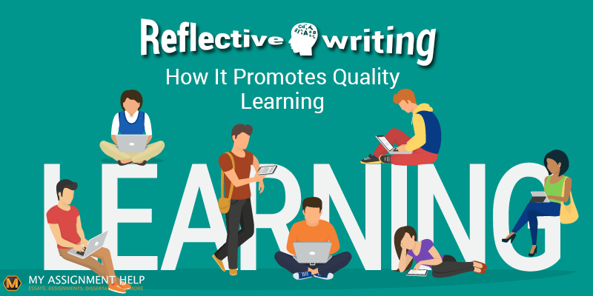
Source: https://www.google.com/search?q=Reflective+Writing&client=safari&rls=en&sxsrf=ALiCzsZNyAbpC75LB0CplYyZZC_7j-yKMg:1670101623722&source=lnms&tbm=isch&sa=X&ved=2ahUKEwjm8JSwrd77AhXIUqQEHe9gAc8Q_AUoAXoECAIQAw&biw=1440&bih=820&dpr=2#imgrc=xKfKXlqLhRzQbM

Model of Reflection
As with other models, Gibb's begins with an outline of the experience being reflected on. It then encourages us to focus on our feelings about the experience, both during it and after. The next step involves evaluating the experience - what was good or bad about it from our point of view? We can then use this evaluation to analyse the situation and try to make sense of it. This analysis will conclude what other actions (if any) we could have taken to reach a different outcome. The final stage involves building an action plan of steps which we can take the next time we find ourselves in a similar situation.
Gibb's cycle contains six stages:

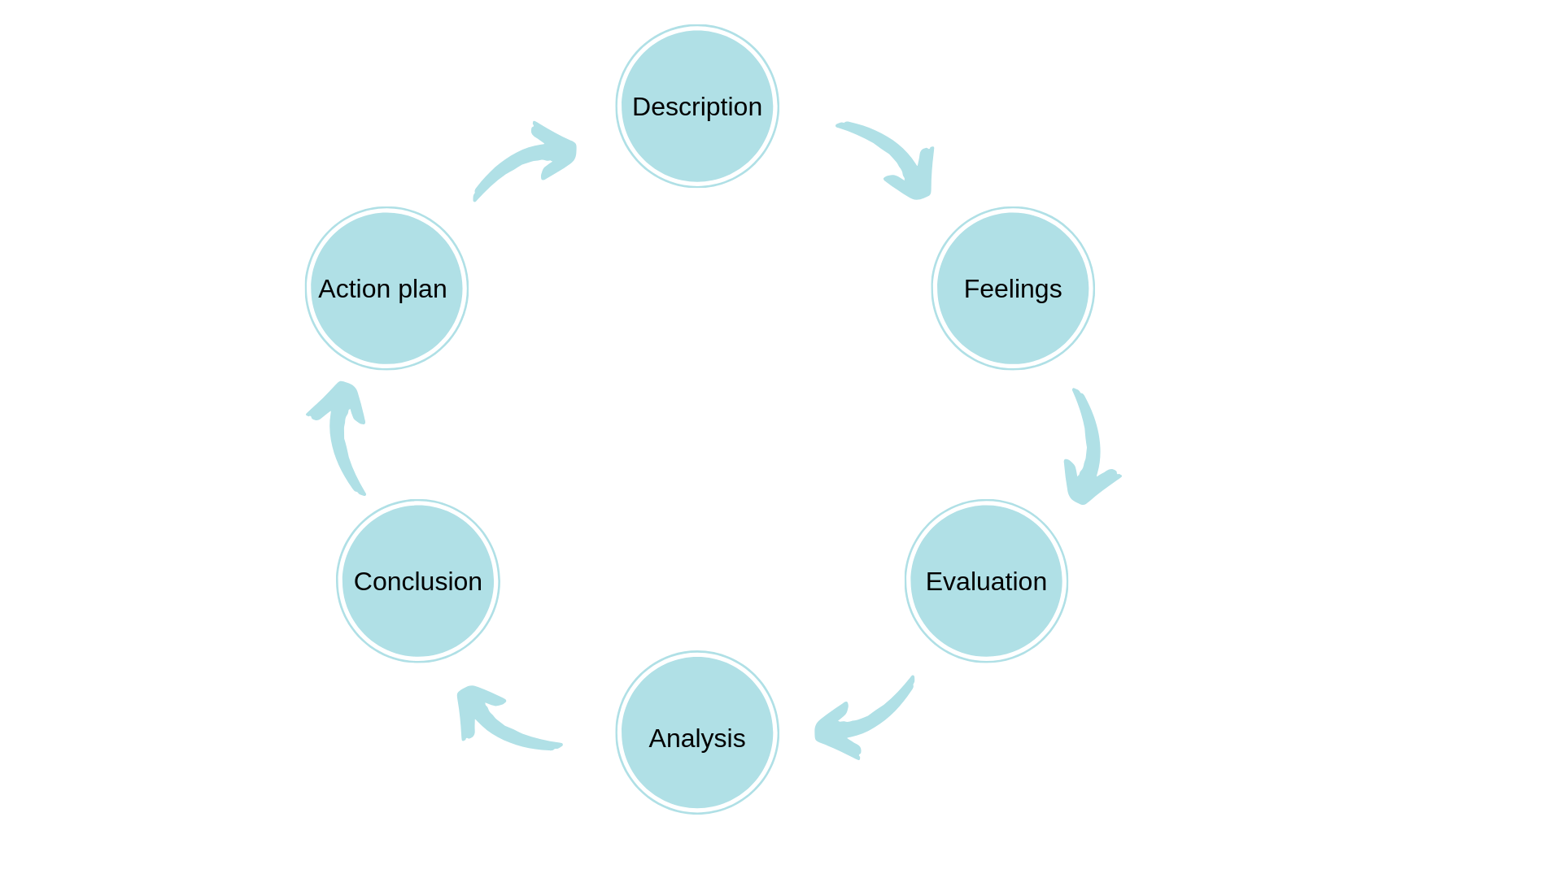
Source: https://libguides.cam.ac.uk/reflectivepracticetoolkit/models

As with other models, Gibb's begins with an outline of the experience being reflected on. It then encourages us to focus on our feelings about the experience, both during it and after. The next step involves evaluating the experience - what was good or bad about it from our point of view? We can then use this evaluation to analyse the situation and try to make sense of it. This analysis will conclude what other actions (if any) we could have taken to reach a different outcome. The final stage involves building an action plan of steps which we can take the next time we find ourselves in a similar situation.

Driscoll (2007) employs the "what" method, one of many reflective models that are employed and organized in different ways. It is divided into the following three sections: "what," "so what," and "now what." What happened, why it happened, and what you're going to do about it make up the process. The cycle is simpler and more straightforward, making it ideal for reports.
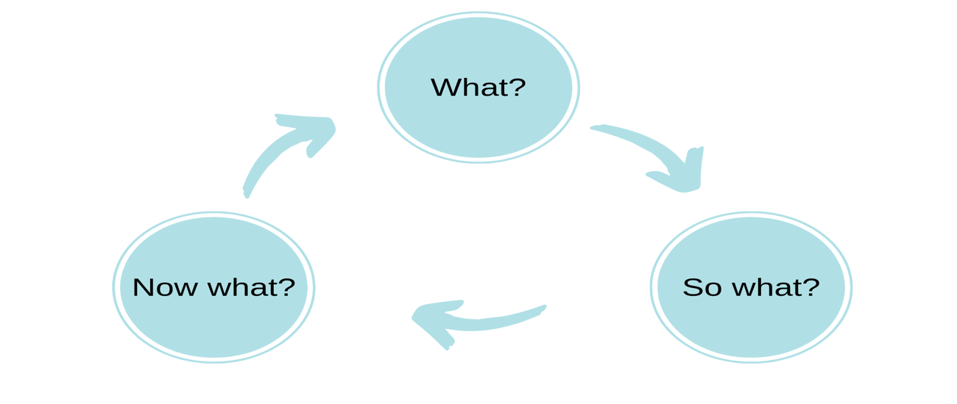
Source: https://libguides.cam.ac.uk/reflectivepracticetoolkit/models

I'll use the Gibbs reflective cycle to evaluate my group projects and academic reports. I choose this cycle so that I could break down my experience and provide as much detail as possible. Six subjects make up the learning cycle known as the Gibbs cycle. Description, emotions, assessment, analysis, judgement, and plan of action.
This cycle is beneficial since it gives you the finest understanding of your knowledge and expertise. This can then be used for upcoming exercises. The relevance of people's moods and emotions during learning is acknowledged by Gibbs (1988). According to an article by Markkanen et al (2020), teachers who deal daily with students that exhibit problematic behaviours have been trained to use The Gibbs (1988) Reflective technique. They have found this cycle to be quite helpful since it has given them the opportunity to consider students with challenging behaviour as learning opportunities rather than just challenges.

Reflection on Assignment 1 (Academic Report)
In module BMSW4001 Academic and Employability Skills, my first work was given to 2000 words. This was the theme of my previous work "What is the most effective way to motivate the staff". It was a very interesting topic. With this, I can understand a little more about the business world, and it was very helpful to have done this job.
The best way to motivate staff is a good team, working conditions, payment, good vision, mission and values of the company and team, good effective feedback, praise-minute, manage the team on day-to-day.
Many business owners often think of turning towards financial means when it comes to motivating their staff. Essentially, it comes down to the fact that if you work hard and do well, you will be potentially given a pr Employee recognition is a fundamental human resource activity that leads to psychologically healthy work environments. Employee appreciation programmes are widely recognized as a good business practice that boosts productivity and engagement when an employee receives praise and acknowledgement, it pushes them to work even more, increasing the company's production.

Reflection on Group Work

Group work has its advantages and disadvantages. The good part of group work will always adhere more knowledge and you will share several ideas that enrich the work. At the same time, you will make friends and have fun with your colleagues in the group, you will be able to know a little more besides the life of the school. Teamwork is a necessary skill for all members to achieve the common goal. Advantages of teamwork: better job results, empathy, leadership, resolution skills and communication skills. Disadvantages don't always have a compatible, work delays, several, that's a bad part of working as a team. Lack of productivity of some members. That is, although teamwork is highly valued, it is important to analyze all the smallest, if it is the best to achieve the objectives.

Personal Development Plan (PDP)
Is my personal development plan, having a PDP will help to perform better and be able to achieve individual set goals.
Personal Target | How will I achieve this? | How will this improve my academic or employability prospects? | How will I know that I have achieved this? | When will I achieve this by?
Be confident in myself and trust in my potencies | Trust me | Hard work | When you´re on the right track | He didn’t know
Know how to speak English better ant stop being afraid to speak in public | Practice several times | Never give up | Follow your instincts | At the right time
Accept a criticism | Stop being defensive | Achieve my goals | At the right time | When you´re around
Giving opportunities for other things | Go to the search for what I think is good | Be competent and firm | Being patient and understanding | At the right time

Conclusion:

I learned a lot during the Academic and Employability module, overcame most of the difficult obstacles and was able to understand what was asked for in my academic report and work within a group. I was also able to reflect on my group work and my academic report and write more words. I learned a lot during this module, skills that were new to me and skills that I didn't know I already had. I gained research and reading skills, note-taking skills, and writing skills. These models provide a useful guide or place to start but reflection is a very personal process, and everyone will work towards it in a different way. Take some time to try different approaches until you find the one that works for you. You may find that as time goes on and you develop as a reflective practitioner that you try different methods which suit your current circumstances. The important part is that it works - if it doesn't then you may need to move on and try something else. I was able to brush up on my digital abilities and learn more thanks to this training. Academically, I now have more information and comprehension, such as how to reference using the Harvard style, create academic papers, and write reflective reports. recognizing the value of reflection and employing tools like the Gibbs cycle. I believe this module has been helpful to me and will help and direct me throughout the rest of the academic year and my subsequent modules. The abilities I have acquired over my academic year will be transferred to my future employment. I have benefited greatly from this experience in terms of my personal growth

References:

Taczak, Kara (2015). "Reflection is Critical for Writers' Development". In Adler-Kassner, Linda; Wardle, Elizabeth (eds.). Naming What We Know: Threshold Concepts of Writing Studies. Utah: Utah State University Press. p. 78. ISBN 978-0-87421-989-0.
Dwivedi, Amitabh Vikram (2016). "Critical Skills: Reflective writing". Salem Press Encyclopedia.Hampton, Martin. "Reflective writing: a basic introduction" (PDF). University of Portsmouth, Department for Curriculum and Quality Enhancement. Retrieved 26 February 2020.
Gibbs, G. (1998) Learning by Doing: A Guide to Teaching and Learning Methods. Oxford: Further Education Unit, Oxford Polytechic.
Driscoll, J (2007) Practising Clinical Supervision: A reflective approach for healthcare professionals, Edinburgh: Balliere Tindall, Elsevier
Borton, T. (1970) Reach, Touch and Teach. London: Hutchinson.
Driscoll, J. (ed.) (2007) Practicing Clinical Supervision: A Reflective Approach for Healthcare Professionals. Edinburgh: Elsevier.
Bassot, B. (2020) The Reflective Journal, London: Red Globe Press

