LCLM4005: Employability and Career Development
Component 2

Task 1: Comparing Job Adverts

1.1 Selecting Job Adverts
In this assessment, I compare two job adverts posted on Glassdoor for chef positions to identify key skills and areas of knowledge relevant for the role. The following two figures present these adverts. While the first one refers to a chef role at Boulebar in London, the second one is about a junior sous chef role at Flat Iron, Birmingham.
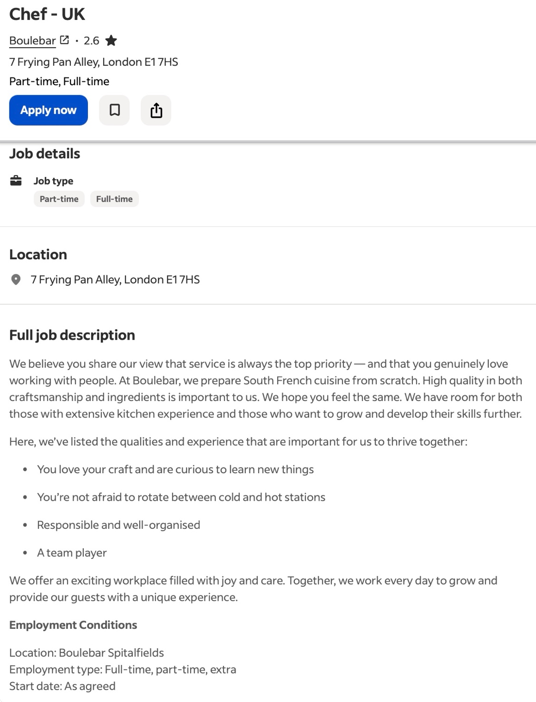
Figure 1: Advert 1, Chef Role at Boulebar
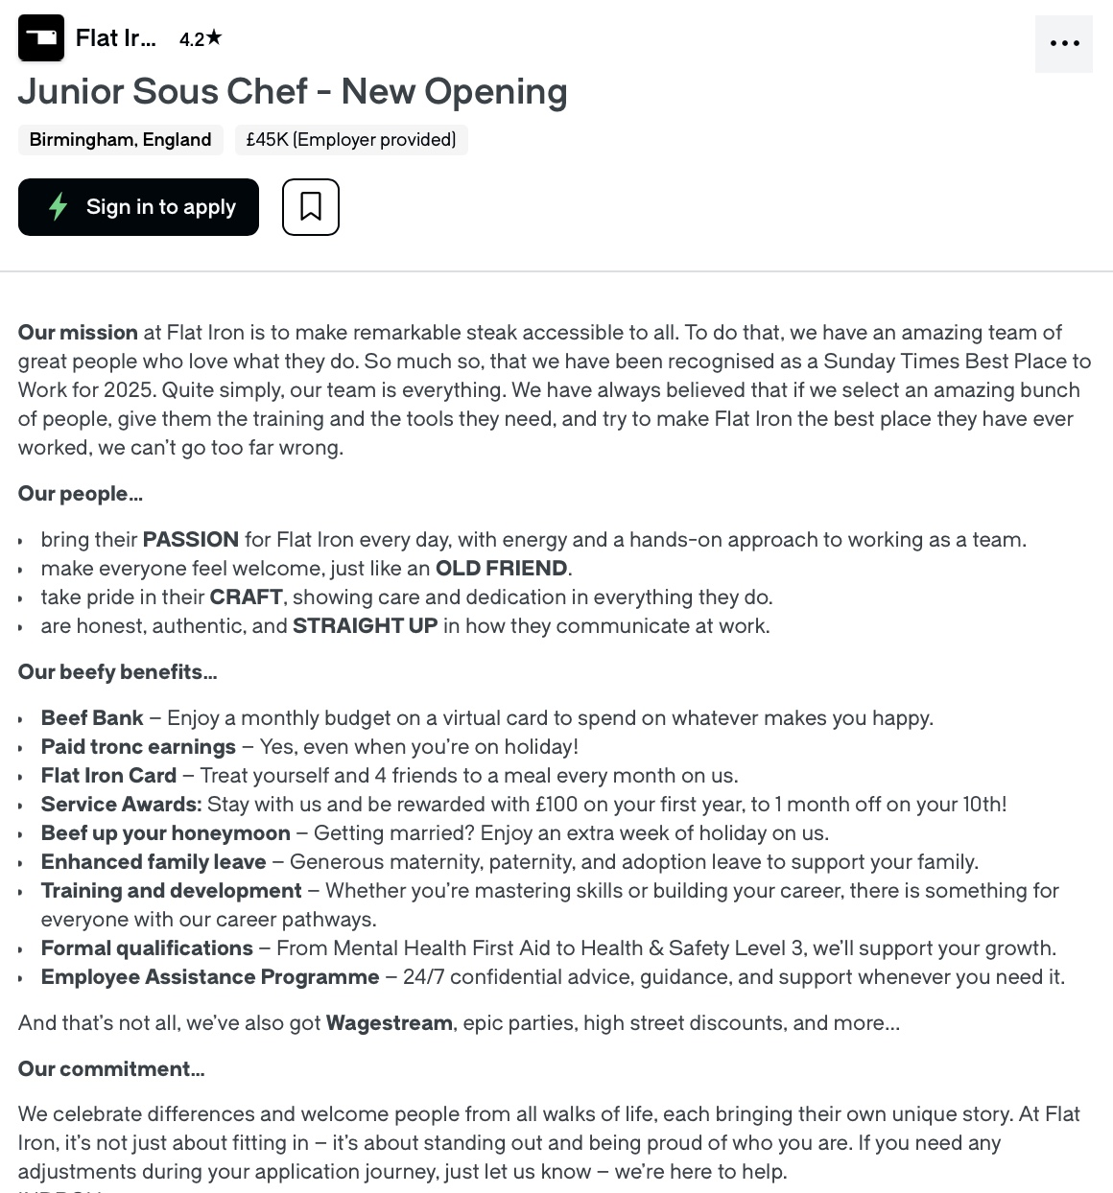
Figure 2: Advert 2, Junior Sous Chef Role at Flat Iron

1.2 Identifying Key Skills & Areas of Knowledge
From a comparative perspective, a close reading of these two adverts indicate a number of required skills and areas of knowledge relevant to become a chef in the UK, specifically combining technical kitchen understanding and strong personal qualities. These are identified separately for each role in Table 1.

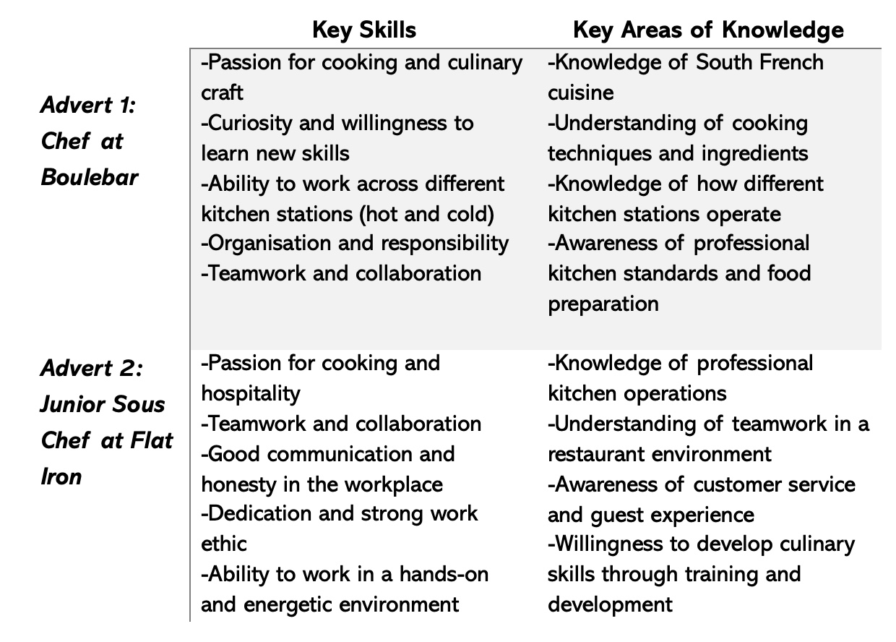
Figure 3: Summary of Key Skills and Areas of Knowledge Mentioned in Each Advert
Accordingly, I have identified some common skills and areas of knowledge emerging from both adverts, including passion for cooking and pride in culinary work, teamwork and collaboration in the kitchen environment, professionalism, organisation, and reliability, knowledge of professional kitchen operations, techniques, and ingredients, as well as willingness to learn and develop culinary skills. In the following section I delve into collaboration and teamwork in the kitchen environment, highlighting its relevance in the select profession.

1.3 Key Skill Appraisal: Collaboration and Teamwork in Kitchen Environment
Collaboration and teamwork collectively represent a relevant skill to become a chef, given working in a busy kitchen requires communicating and cooperating with other staff member to ensure that food is being prepared efficiently and being delivered to customers on time. Indeed, empirical literature also suggests that multiple professional chefs traditionally consider collaboration and teamwork as central to the profession (Wellton, Jonsson and Svingstedt, 2019; Marinakou and Giousmpasoglou, 2022; Håland, 2026). In this context, the qualitative research by Håland (2026) based on interviewing culinary professionals including chefs shows that collaboration and teamwork is not simply about efficiently working together but also about acknowledging the expertise and skills of each staff member, in terms of learning about and incorporating their different strengths to approach the broader goal of effectively navigating the kitchen environment. Thus, developing collaboration and teamwork skills is relevant for me as an aspiring chef, considering it can help me with effectively working across different kitchen stations, learning from more experienced chefs and team members, as well as contributing meaningfully to tackle the fast-paced kitchen environment.

Task 2: Self-assessment and Evidence of Readiness

2.1 Self-assessment
Reflective self-assessments enable individuals to self-monitor their own actions, demonstrating willingness to leverage the observations for improving thinking and behaviour for the future (Andrade, 2019). In this regard, I have approached self-assessment based on implementing the SWOT framework to identify my key strengths, weaknesses, opportunities and threats. This approach not only helps me to identify the key areas of my strength but also the areas of future development.
Table 2: SWOT Analysis
Strengths  -A strong understanding of the relevance of teamwork and collaboration (specifically in high-stress kitchen environments)  -Attaching high value to professionalism, in terms of efficiency and quality  -Time management skills  -Communication and interpersonal skills  -Problem-solving skills | Weaknesses  -Lack of adequate confidence working in fast-paced environments  -Developing technical and role-specific skills  -Limited experience in managing workload and responsibilities independently.  -Lack of adequate organisation skills, critical for the chosen profession of a chef (Bressan et al., 2022)
Opportunities  -Developing technical skills through training and practical experience, specifically in terms of learning from experienced professionals in a team environment  -Improving confidence and growing adaptability through real-world experiences  -Engaging with continuing professional development through a continuous learning attitude to learn from relational interactions by practising reflection (Neugebauer and Evans-Brain, 2016) | Threats  -The competitive nature of the UK job market  -High-pressure work environments demanding resilience and consistency  -Employer expectations to balance both technical, leadership, and soft skills (Marinakou and Giousmpasoglou, 2022)

Through the SWOT Analysis, I have tried to identify my key strengths, weaknesses, opportunities and threats. From a critical perspective, the identification of areas of personal strengths and of future development demonstrated my awareness regarding the relevance of different skill sets in my chosen employment context like teamwork, problem-solving, and time-management, although there is a noticeable gap between this understanding and the maintaining consistent performance in real-life contexts. Notably, I have arrived at this idea specifically with an intention of becoming more self-aware, drawing on the relevance of inner speech for self-referential activity (Morin, 2011). However, self-awareness alone cannot usher behavioural change when practice-oriented approach to skill development is absent.
The evaluation further shows that opportunities for professional development exist through real-life experience, training and so on, although present issues associated with low confidence and organisational skills as well as developing technical skills can pose a broader challenge to obtaining meaningful employment opportunities. Besides, external factors like the competitive UK job market further problematises the issue. This idea also underscores the relevance of real-world experience, specially keeping in my chosen profession role of a chef. In this context, I should also foreground the relevance of continuing professional development through reflexive practice. Notably, continuing professional development or lifelong learning has been defined by Collin, Van der Heijden and Lewis (2012) as the means through which professionals maintain the knowledge and skills associated with their professional lives. In my case, engaging with this practice since the beginning of my career as a professional chef can help with learning from more experienced professionals, specifically in high-pressure team environments. Addressing areas of future development through tracking practice based on reflective journaling can also be relevant for me, given my learning style is that of a reflector (Honey and Mumford, 1992). Reflectors not only learn from observing others but they also think thoroughly regarding their experiences from more than one perspective. Hence, situating the relevance of reflection in the process of continuing professional development can help with building on my existing strength and self-awareness to address areas of future development.

2.2 Evidence of Readiness
Work Experience: I have accumulated some professional experiences as a chef, albeit limited and mostly in operational roles rather than in leadership roles. In this section, it is relevant to offer some evidence of my readiness to enter the chosen profession. Both before and after coming to the UK, I interned for multiple restraints and majorly operated as an apprentice. More specifically, my experience includes being employed at least two restaurants so far including Chandni Chowk Restaurant & Sweets in New Delhi, The Broadway in Southall, London. With reference to the latter, I have earned the opportunity of learning from two notable chefs including The Broadway’s head chef, Navjeet Singh Rawat and its Tandoori chef, Madhab Prasad Bhandari. I have attached some images below that capture my mentors, colleagues, and I in the professional settings I indicated above.
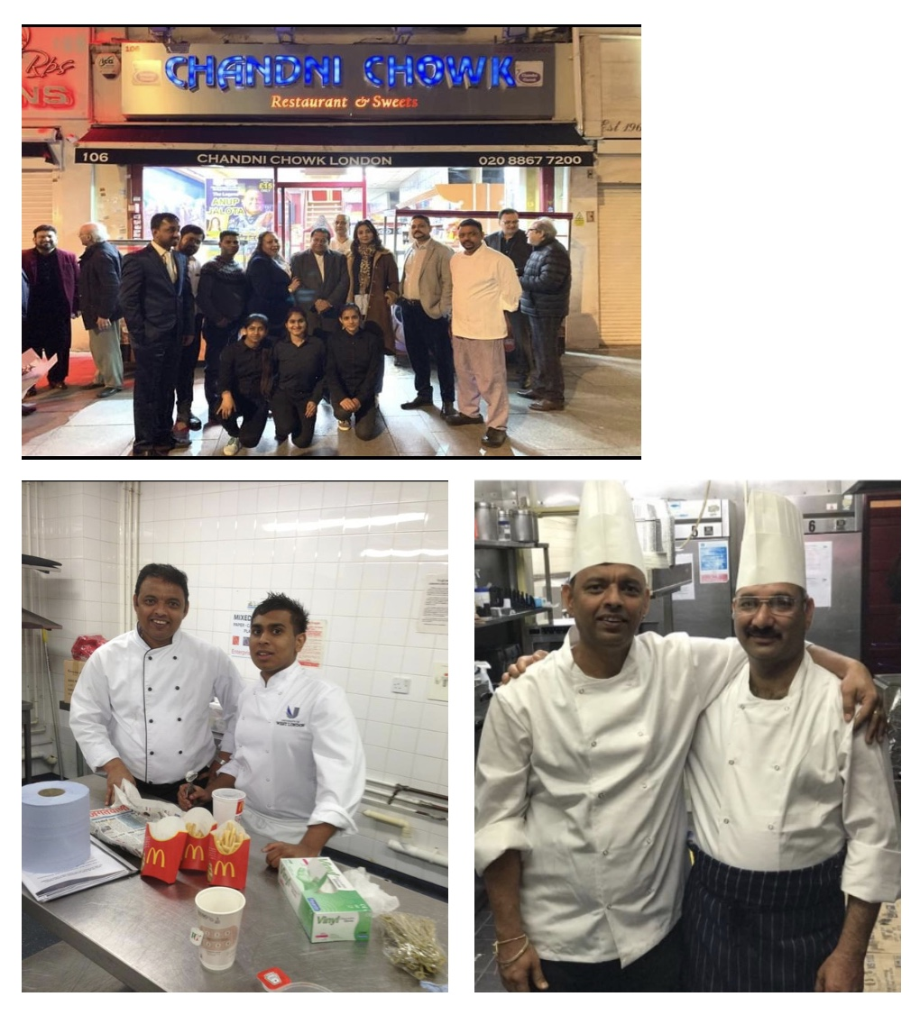
Figure 4: Images taken in Professional Setups in My Former and Current Workplaces
Academic achievement: After my enrolment to the University of Wales Trinity Saint David, my focus on addressing academic activities on time and maintaining good grades has resulted in grades higher than I originally expected. My engagement with courses on Enterprise and Entrepreneurship as well as Problem Solving and Decision-making and so on have added to my readiness based on both improving my critical thinking capabilities and teaching me how to make practical considerations for launching and managing a business venture. Collectively, the academic experience can be helpful in equipping me with theoretical knowledge and critical thinking skills, supporting my long-term career development.

Task 3: Self Employment Goals and Personal Development Plan

3.1 Self Employment Goals
Based on the weaknesses analysed through my SWOT Analysis, I have developed two long-term and two short-term goals to address my professional development, with the goals being directly linked to my chosen profession of a chef. These are as follows.
Short-term Goal 1: To enhance my existing technical skills and consistency in performance, specifically through managing tasks independently in high-pressure kitchen environments
Short-term Goal 2: To improve my organisational skills based on developing expertise in mise en place ("everything in its place") through meticulous preparation, workflow planning, and keeping a clean work station
Long-term Goal 1: Developing operational and management required for becoming a head chef
Long-term Goal 2: Launching my own venture, applying both my work experience and critical thinking

3.2 Personal Development Plan
The specific action plan to address the weaknesses are as follows.
Weaknesses | Actions | Resources | Timeline | Measures
Lack of adequate confidence working in fast-paced environments | -Gradually assuming greater responsibility during service; noting the feedback gained from superiors | -Mentor feedback | 0-12 months | -Ability to work under pressure with limited errors
Developing technical and role-specific skills | -Practising culinary techniques regularly, learning from experienced chefs | -YouTube tutorials; on-the-job training | 0-18 months | -Improved quality, speed and consistency in cooking
Limited experience in managing workload independently | -Requesting to manage own station during shifts, practising task prioritisation through workflow planning | -Checklists and manual planning templates | 0-6 months | -Ability to complete tasks independently and efficiently
Lack of organisational skills | -Preparing mise en place in advance, following a structured workflow | -Kitchen tools | 0-10 months | -Reduced delays; improved workflow and cleanliness

Reference List
Håland, E. (2026) ‘Collaborative craftmanship; how restaurant workers articulate good professional practice in a changing society’, Tourism and Hospitality Research [Preprint]. Available at: https://doi.org/10.1177/14673584261416890.
Marinakou, E. and Giousmpasoglou, C. (2022) ‘Chefs’ competencies: a stakeholder’s perspective’, Journal of Hospitality and Tourism Insights, 5(1), pp. 205–229. Available at: https://doi.org/10.1108/jhti-06-2020-0101.
Wellton, L., Jonsson, I.M. and Svingstedt, A. (2019) ‘“Just trained to be a chef, not a leader”: A study of head chef practices’, International Journal of Hospitality & Tourism Administration, 20(4), pp. 400–422. Available at: https://doi.org/10.1080/15256480.2017.1397584.
Andrade, H.L. (2019) ‘A critical review of research on student self-assessment’, Frontiers in Education, 4(87), pp. 1–13. Available at: https://doi.org/10.3389/feduc.2019.00087.
Bressan, A., Duarte Alonso, A., Kim Vu, O.T., Tran, L.N. and Tran, T.D. (2022) ‘The importance of knowledge management in gastronomy: a chef’s future career, the next generations of chefs and trends’, International Journal of Contemporary Hospitality Management, 35(3), pp. 1087–1108. Available at: https://doi.org/10.1108/ijchm-03-2022-0391.
Collin, K., Van der Heijden, B. and Lewis, P. (2012) ‘Continuing Professional Development’, International Journal of Training and Development, 16(3), pp. 155–163. Available at: https://doi.org/10.1111/j.1468-2419.2012.00410.x.
Honey, P. and Mumford, A. (1992) The manual of learning styles. Peter Honey Publications.
Morin, A. (2011) ‘Self-Awareness Part 1: Definition, Measures, Effects, Functions, and Antecedents’, Social and Personality Psychology Compass, 5(10), pp. 807–823. Available at: https://doi.org/10.1111/j.1751-9004.2011.00387.x.
Neugebauer, J. and Evans-Brain, J. (2016) Employability: Making the Most of Your Career Development. Sage Publications Ltd.

