21 July 2023
Kallum Doyle (2237962)
2237962@student.uwtsd.ac.uk
Applied Computing
learning in the digital era
Assignment 2: Personal Development Plan

TABLE OF CONTENTS
Contents
TABLE OF CONTENTS 1
TASK 1: SELF-EVALUATION 2
TASK 2: PDP 5
TASK 3: UNIT 4 TOPIC SUMMARY 7
TASK 4: VIDEO PRESENTATION 9

TASK 1: SELF-EVALUATION
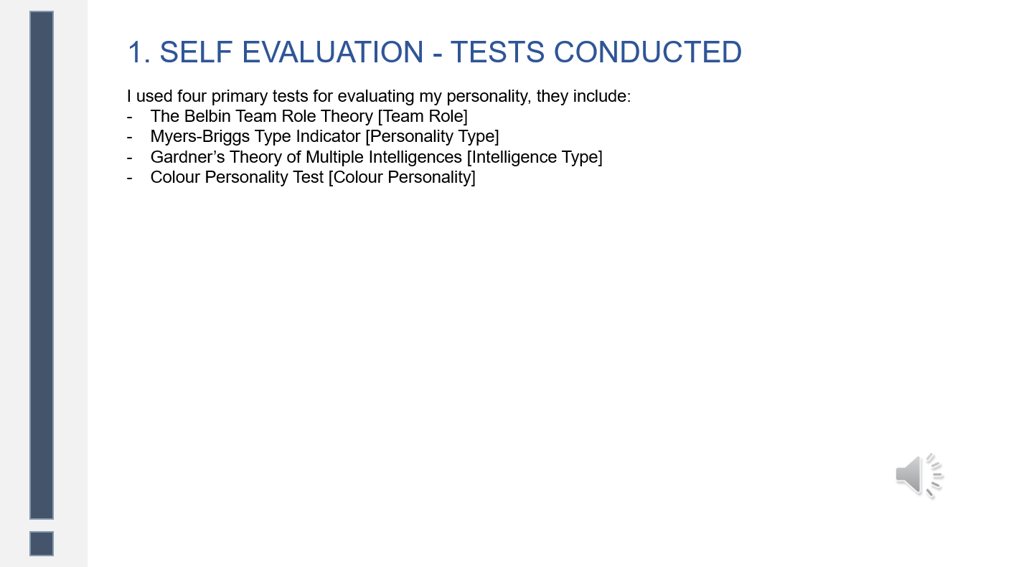
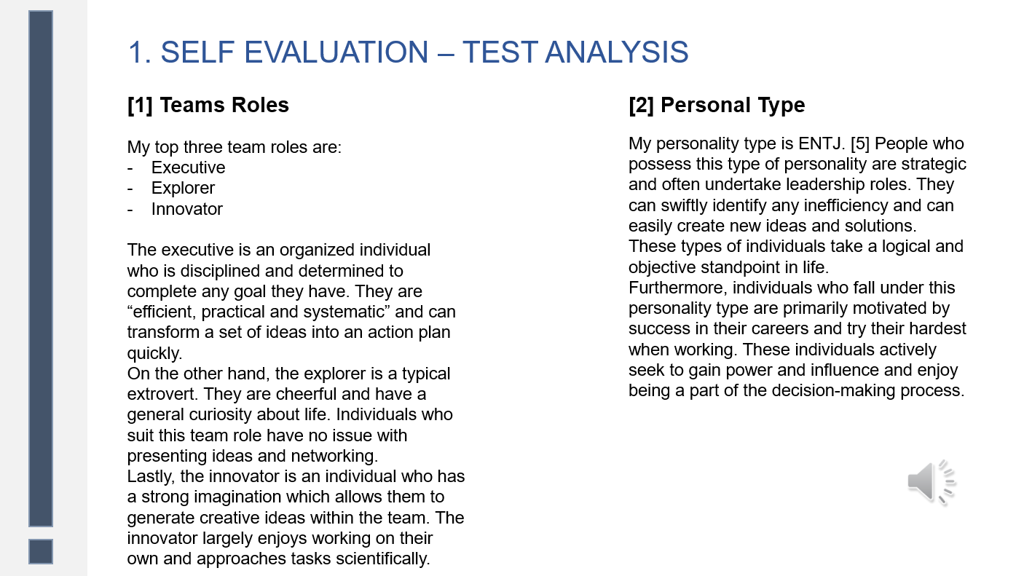
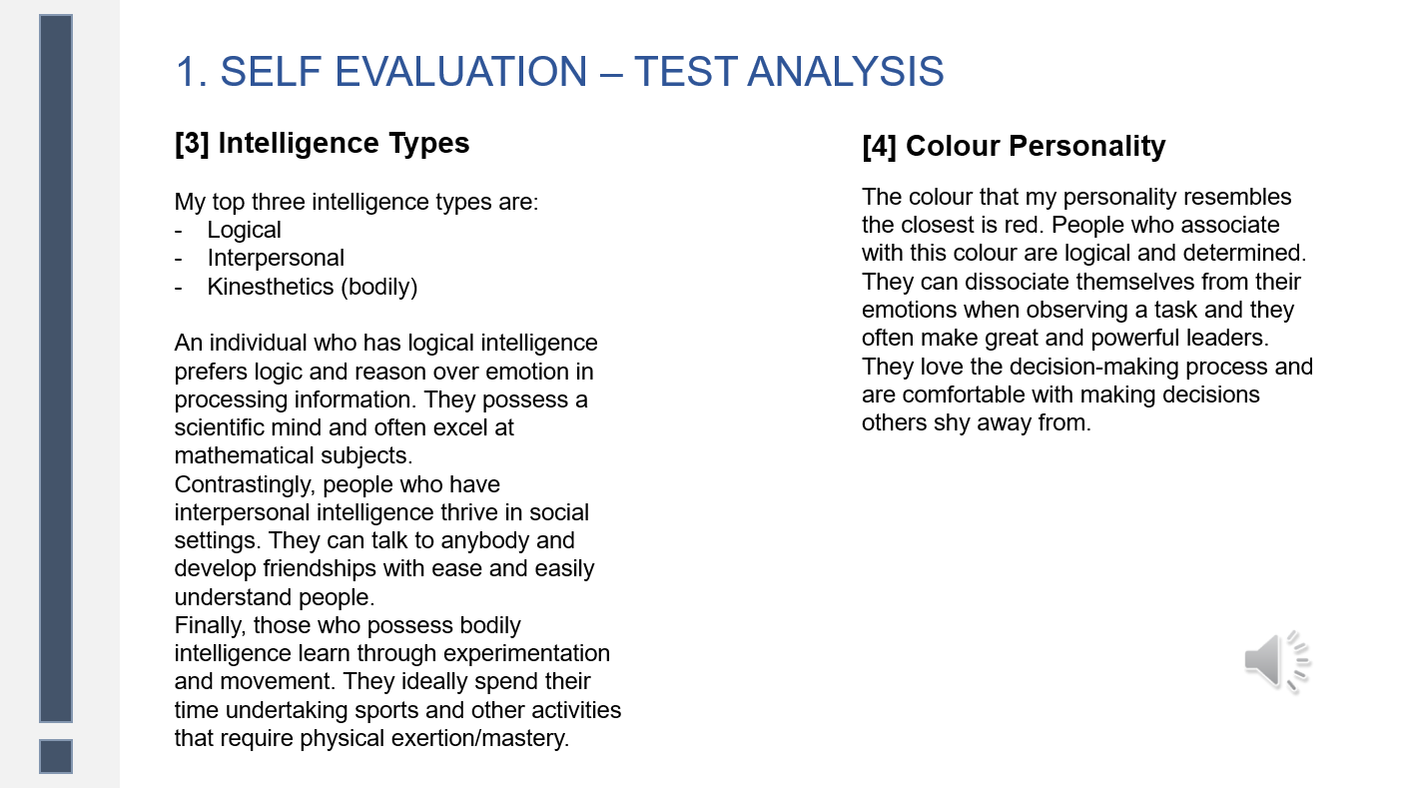
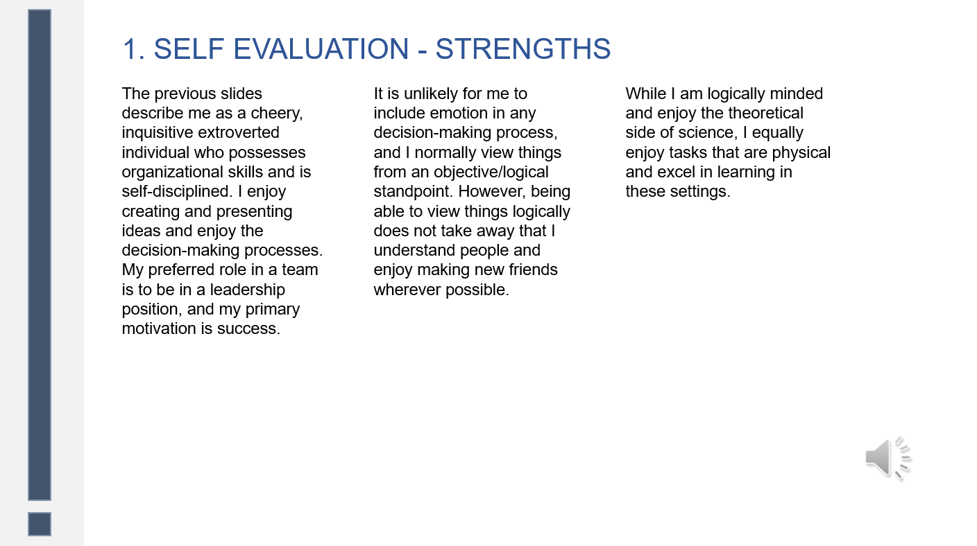
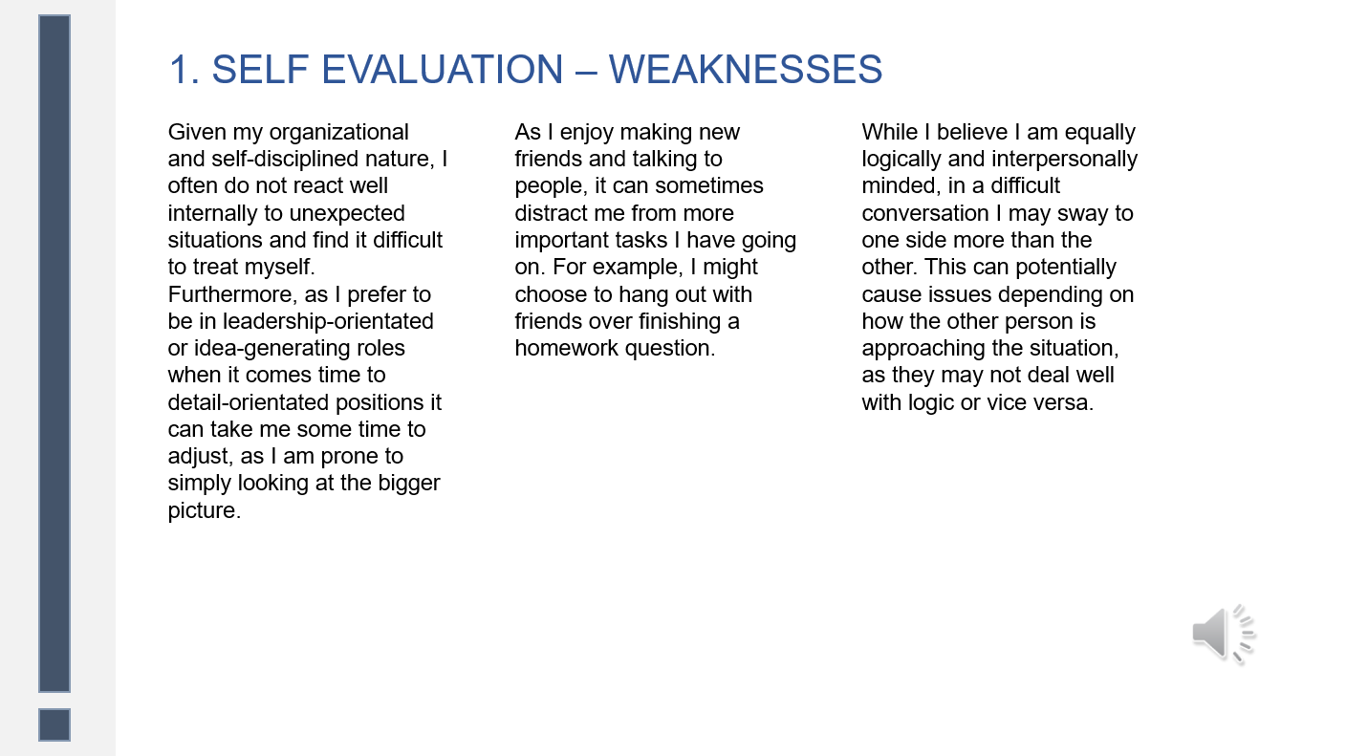

TASK 2: PDP

Note: The PDP was completely designed in presentation, therefore the link to this answer is the same as the presentation’s cloud link.
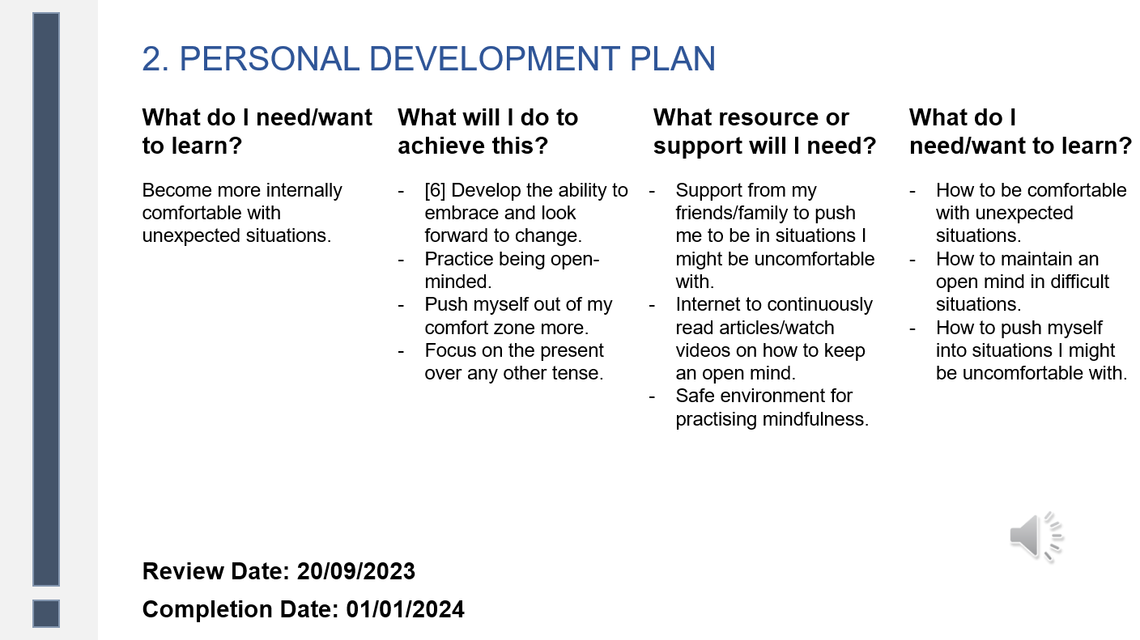
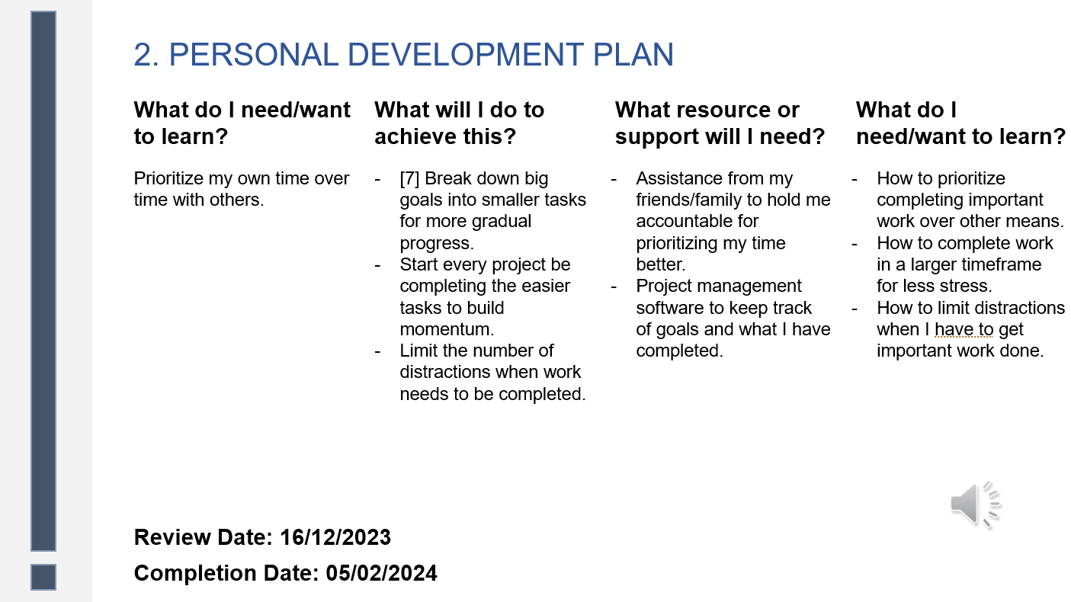
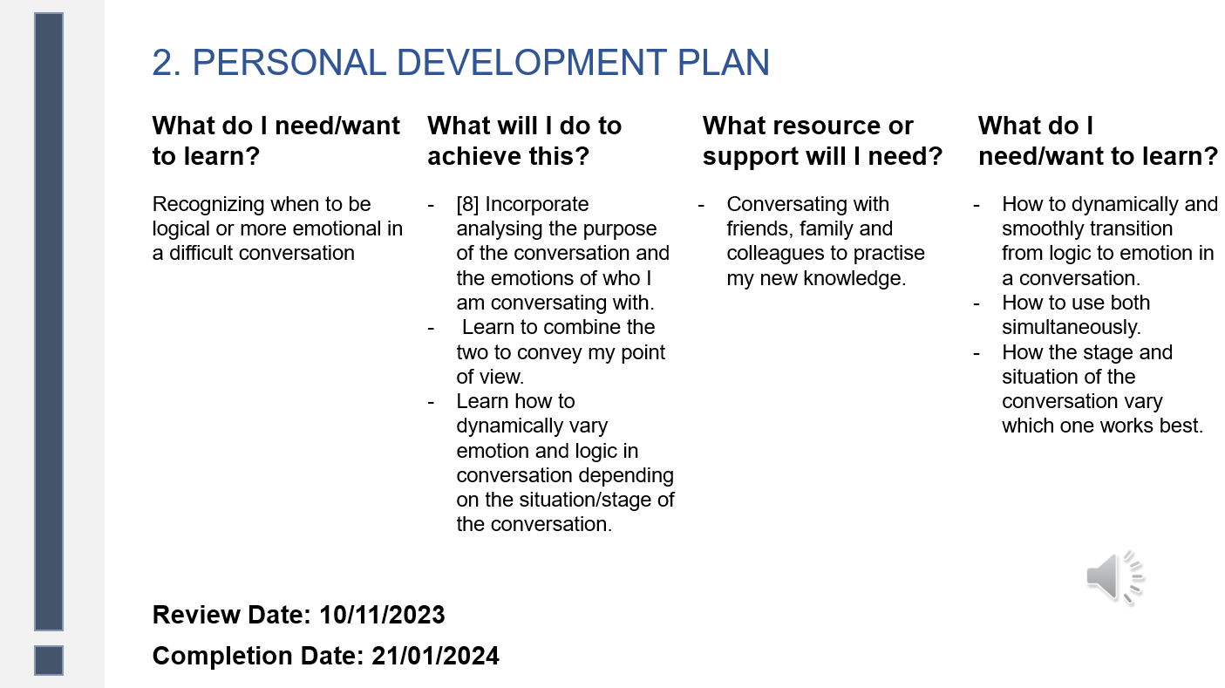

TASK 3: UNIT 4 TOPIC SUMMARY

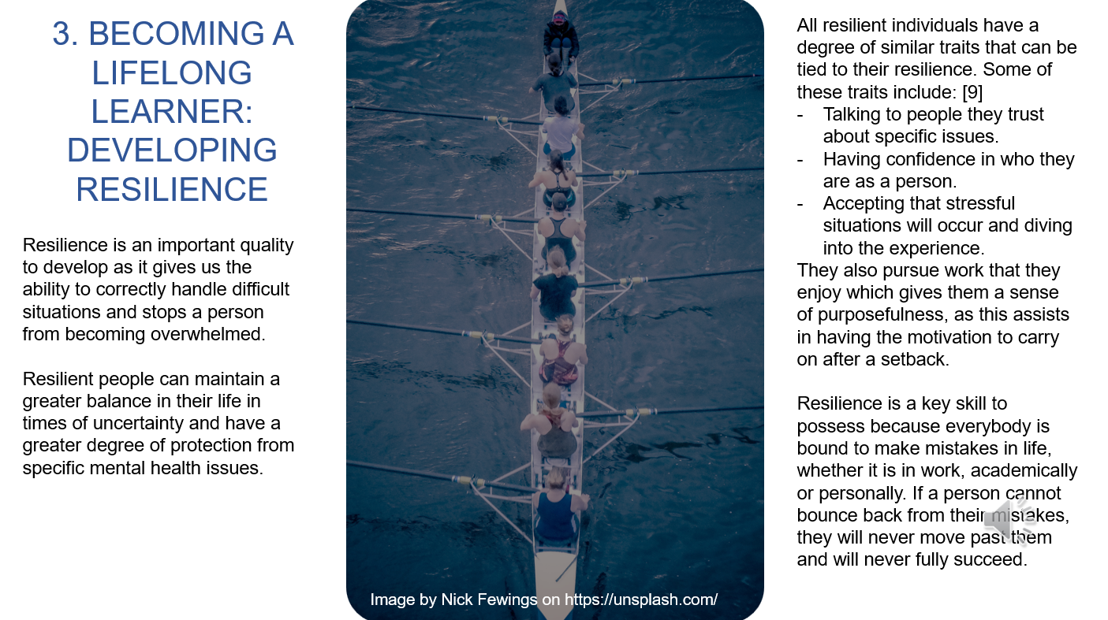
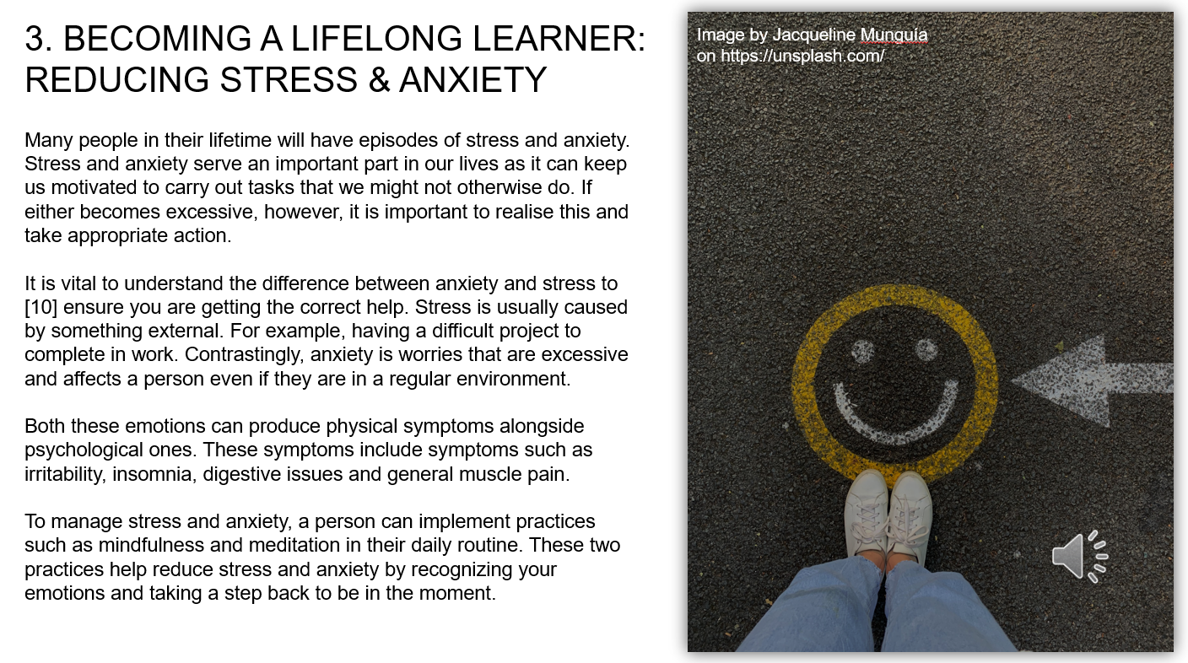
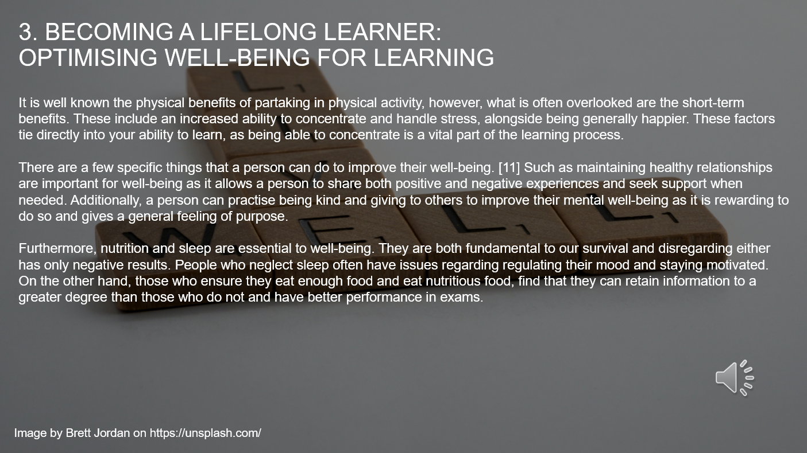

TASK 4: VIDEO PRESENTATION

Video link: https://youtu.be/54Tb9KIZd3k
Link for viewing presentation in OneDrive: https://uowtsd-my.sharepoint.com/:p:/g/personal/2237962_student_uwtsd_ac_uk/ESk9eP0m78ZHsajER5OviEIBJFTUzjV6VHCGpkglm4ds6w?e=Ja4ZZy
Video screenshot: 

