4. Chapter Four: Analysis of results
4.1 Introduction
This chapter will provide an analysis of results, and a discussion of the findings obtained from the 21 participants who contributed to this study. The purpose of this study is to explore the impact of rape investigation on the mental health of police officers investigating these offences within South Wales Police. In order to achieve this, the following three objectives were composed:

- To explore the impact of the rape investigation role has on mental health.
- To explore the support services currently in place for officers within investigative departments.
- To investigate if South Wales Police officers within a rape investigation team find that they are sufficiently supported.

4.2 Demographic of participants

Question 1) I understand the reasoning for this study and provide my consent for my answers to be used for this research
Question 1 outlines the participants informed consent to participating in the questionnaire. Informed consent is essential when ensuring any study complies with research ethics and should always be obtained prior to the participant offering any contribution (University of Oxford, 2021b). The National Research Council (US) Panel on Collecting et al (2010) state the importance of informed consent being provided to participants as it ensures that they can make an informed choice on whether they contribute, based on the risks and benefits of doing so.

Question 2) Are you an officer employed within South Wales Police? Question 3) Is your current role within a Rape Investigation Team (RIT)?

Due to this study being specific to analysing the mental health of rape investigators employed within South Wales Police, it was therefore essential that participants declared their employment and their role in order for the study objectives, in particular object three to be achieved. 100% of participants stated that they were employed within South Wales police and positioned in a rape investigatory role.

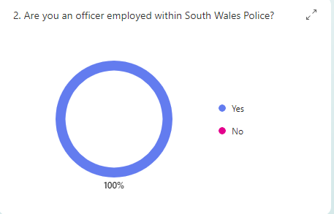

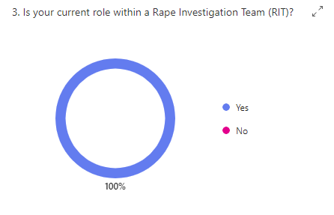

4.3 Participant responses

Question 4) Since joining RIT, I feel like I have attended traumatic incidents.

Question 4 sought participants to declare if they felt that they had attended traumatic incidents whilst positioned as an investigative officer within South Wales Police’s Rape Investigation Team. The results show that the majority of participants state they have, with 52% of those agreeing and 14% strongly agree. This coincides with the research conducted by Carleton et al (2020) who states that the likelihood of being exposed to traumatic incidents is significantly higher whilst employed as a police officer and further supports the argument raised within the research of Morabito, Pattavina and Williams (2020b) who state that those investigating crimes of a sexual nature are indeed at risk of experiencing an increase of psychological distress.

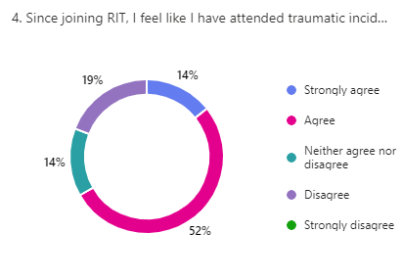

Question 5) Since joining RIT I feel I have been subjected to reviewing traumatic material

Similarly to the previous question involving attending traumatic incidents, this question focuses in reviewing traumatic material, thus, suggesting a comparison between primary trauma outlined in question 4 and the potential of secondary trauma from reviewing traumatic material.

The result of this question suggests that the majority of participants state that they have been subjected to reviewing traumatic material, with a total of 55% stating they agree and stating that they strongly agree.

Interestingly, this supports the research by the College of Policing (2018e) whose research shows that officers within a rape investigation team are at a higher percentage of suffering secondary trauma due to their often-continuous exposure to reviewing distressing material.

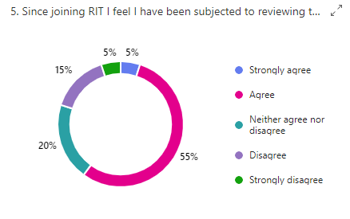

Question 6) I feel that dealing with rape investigation has a negative impact on my mental health.

The area of mental health within police officers has been explored however the effects of rape investigation specifically on officers has not, therefore participants within this department were asked if they feel dealing with this type of crime has had a negative effect on them. The results confirm that 58% of respondents stating that they agree, only 21% disagreeing with this statement and 21% providing a neutral response.

This research corroborates the results of Cronje and Vilakazi (2020) research which suggest that employment as a detective investigating crimes of a sexual nature, therefore contributes to the likelihood of suffering from secondary trauma. Additionally, much like Cronje and Vilakazi’s (2020) results, over half of their detective participants (51%) stated they suffer with high to severe levels of secondary trauma due to their role.

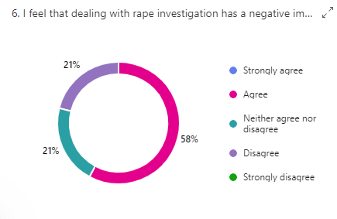

Queston 7) Since joining the police but prior to my role on RIT, I have experienced the following mental health symptoms – Question 8) I have experienced the following mental health symptoms as a direct result of my position on a rape investigation team:
- Stress
- Anxiety
- Post-traumatic stress disorder (PTSD)
- Insomnia
- Trauma
- Other
- None of the above

The above questions aim to provide an indication to the mental health of participants prior to gaining a position on the rape investigation team in Question 7 versus after in Question 8, with the aim to determine if investigating rape offences negatively impacts officers’ mental health. Interestingly, responses show an increase in officers suffering from stress, anxiety, trauma and PTSD having been later positioned on the RIT team. A reason for this may be due to the extensive workload investigators are faced with whilst in an investigatory role, thus impacting officers stress levels and anxiety of strict case deadlines as suggested by the research of Queirós et al (2020c).

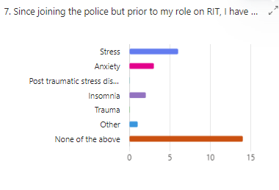

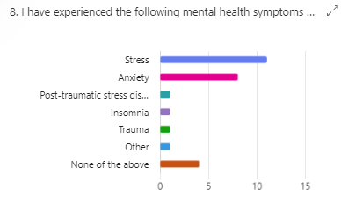

Question 9) I have been medically diagnosed since positioned in my role with having the above mental health related symptoms.

Participants (47%) indicate in the above question that although they have not been medically diagnosed with any mental health related symptoms, they had however experienced symptoms. The answer to this question can be as a result of officers not being willing to receive a diagnosis due to feeling shame or the stigma felt by having a mental health condition as explored by Edwards and Kotera (2020c)

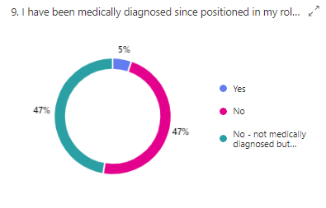

Question 10) I am aware of services within the police that are available to offer support with my mental health Question 11) As a result of my role, I have needed to access support for my mental health.

Concerningly Question 10 states that 58% of participants were unaware of the support services available to them within the police however, 12 participants stated that they did not need to seek mental health support. Due to these figures, it could be argued that participants have not needed to access support due to them not knowing that is available, which in turn highlights the importance of the responses in the following questions (Question 13).

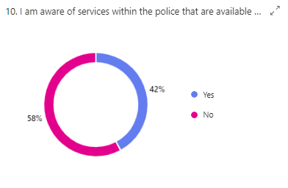

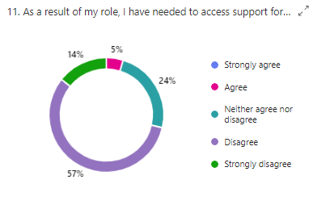

Question 12) I have been offered regular check-ins regarding my mental health by my employer. Question 13) I believe that I would benefit from regular check-ins regarding my mental health in relation to my role

Question 12 indicated that the majority of respondents have not been offered regular check-ins and as outlined in Question 13 a huge 81% of participants agree that these checking would be beneficial. It can be suggested that a service like this could improve the mental health of police officers as it could encourage those who are struggling to come forward.

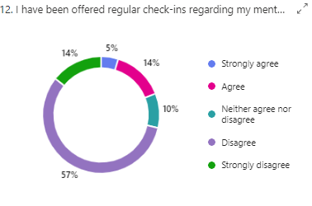

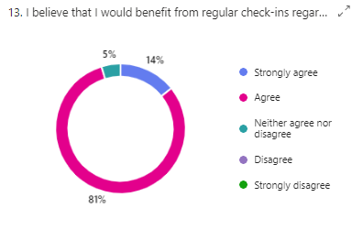

Queston 14) I believe that there are sufficient services available within the police to support me with my mental health. Question 15) I feel that I can easily access support via police services if I were to suffer with my mental health

Question 15 outlines concerning data that 63% of participants believe that they cannot access support via police services if required. It could be argued that this is due to lack of advertisement or encouragement around the topic by the organisation itself or again it could be argued this can be drawn back to Edwards and Kotera’s (2020d) research surrounding the stigma around mental health and policing.

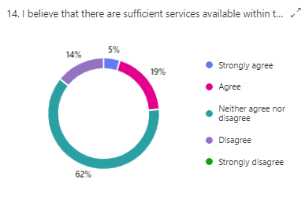

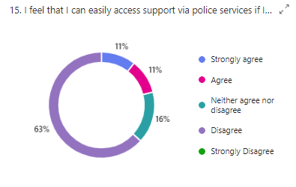

Question 16) I believe that improvements could be made to the services that are available to police officers who require support for their mental health

Arguably, the most important response of this research is outlined in Question 16, which indicates 55% of participants agree, and 25% strongly agree that support services dedicated to helping officers with their mental health within RIT and investigatory roles needs improvement. These results support the study by Demou, Hale and Hunt (2020) who put forth that Improvements are still required in relation to mental health support services within the police. When the results from participants are compared to 2022 research statistics by College of Policing (2018f) and Porter and Lee (2023d), it can be argued that improvements to support the mental health in police officers are still required two years on.
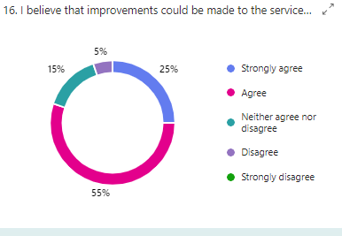

Reference list
Alves, L., Abreo, L., Petkari, E. and da Costa, M.P. (2023). Psychosocial risk and protective factors associated with burnout in police officers: A systematic review. Journal of Affective Disorders, [online] 332. doi:https://doi.org/10.1016/j.jad.2023.03.081.
Avon and Somerset Police Federation (2021). Capture Data On Traumatic Incidents. [online] www.polfed.org. Available at: https://www.polfed.org/avonsom/news/news-articles/capture-data-on-traumatic-incidents/ [Accessed 24 Aug. 2024].
Bazzano, L.A., Durant, J. and Brantley, P.R. (2021). A Modern History of Informed Consent and the Role of Key Information. The Ochsner Journal, [online] 21(1), pp.81–85. doi:https://doi.org/10.31486/toj.19.0105.
Bell, S. and Eski, Y. (2015). ‘Break a Leg—It’s all in the mind’: Police Officers’ Attitudes towards Colleagues with Mental Health Issues. Policing, [online] 10(2), pp.95–101. doi:https://doi.org/10.1093/police/pav041.
Bertilsson, J., Niehorster, D., Fredriksson, P., Dahl, M., Granér, S., Fredriksson, O., Mårtensson, J., Magnusson, M., Fransson, P. and Nyström, M. (2019). Towards systematic and objective evaluation of police officer performance in stressful situations. Police Practice and Research, [online] 21(6), pp.1–15. doi:https://doi.org/10.1080/15614263.2019.1666006.
Buchman-Wildbaum, T., Váradi, E., Schmelowszky, Á., Griffiths, M.D., Demetrovics, Z. and Urbán, R. (2020). The paradoxical role of insight in mental illness: The experience of stigma and shame in schizophrenia, mood disorders, and anxiety disorders. Archives of Psychiatric Nursing, [online] 34(6), pp.449–457. doi:https://doi.org/10.1016/j.apnu.2020.07.009.
Busetto, L., Wick, W. and Gumbinger, C. (2020). How to use and assess qualitative research methods. Neurological Research and Practice, [online] 2(1), pp.1–10. doi:https://doi.org/10.1186/s42466-020-00059-z.
Carleton, R.N., Afifi, T.O., Taillieu, T., Turner, S., Mason, J.E., Ricciardelli, R., McCreary, D.R., Vaughan, A.D., Anderson, G.S., Krakauer, R.L., Donnelly, E.A., Camp, R.D., Groll, D., Cramm, H.A., MacPhee, R.S. and Griffiths, C.T. (2020). Assessing the Relative Impact of Diverse Stressors among Public Safety Personnel. International Journal of Environmental Research and Public Health, [online] 17(4), p.1234. doi:https://doi.org/10.3390/ijerph17041234.
Chetty, P. (2016). Limitations and weakness of quantitative research methods. [online] Project Guru. Available at: https://www.projectguru.in/limitations-quantitative-research/ [Accessed 8 Jul. 2024].
Cheung, A.K.-L. (2021). Structured Questionnaires. Encyclopedia of Quality of Life and Well-Being Research, [online] pp.1–3. doi:https://doi.org/10.1007/978-3-319-69909-7_2888-2.
College of Policing (2018a). Responding to trauma in policing A practical guide BetterProfessionals forBetterPolicing TM. [online] College of Policing. Available at: https://assets.production.copweb.aws.college.police.uk/s3fs-public/2021-02/responding-to-trauma-in-policing.pdf [Accessed 25 Mar. 2024].
College of Policing (2018b). Responding to trauma in policing A practical guide BetterProfessionals forBetterPolicing TM. [online] Available at: https://assets.college.police.uk/s3fs-public/2021-02/responding-to-trauma-in-policing.pdf [Accessed 29 Jun. 2024].
College of Policing (2018c). Responding to trauma in policing A practical guide BetterProfessionals forBetterPolicing TM. [online] Available at: https://assets.college.police.uk/s3fs-public/2021-02/responding-to-trauma-in-policing.pdf [Accessed 29 Jun. 2024].
College of Policing (2018d). Responding to trauma in policing A practical guide BetterProfessionals forBetterPolicing TM. [online] Available at: https://assets.college.police.uk/s3fs-public/2021-02/responding-to-trauma-in-policing.pdf [Accessed 29 Jun. 2024].
College of Policing (2021). Wellbeing. [online] College of Policing. Available at: https://www.college.police.uk/support-forces/health-safety-welfare/wellbeing [Accessed 15 May 2024].
College of Policing (2023). Hostage and Crisis Negotiator. [online] College of Policing. Available at: https://profdev.college.police.uk/professional-profile/hostage-and-crisis-negotiator/ [Accessed 19 Mar. 2024].
College of Policing (2024). Response policing career pathway | College of Policing. [online] www.college.police.uk. Available at: https://www.college.police.uk/career-learning/career-development/career-pathways/response-policing#:~:text=In%20this%20initial%20hour%20of [Accessed 19 Mar. 2024].
Cronje, J.H. and Vilakazi, M.J. (2020). Secondary traumatic stress in police detective officers dealing with complainants of sexual crimes. South African Journal of Psychology, p.008124632092381. doi:https://doi.org/10.1177/0081246320923819.
Cummins, I. (2022). Policing and stress. Policy Press eBooks, [online] pp.78–89. doi:https://doi.org/10.51952/9781447360865.ch005.
Demou, E., Hale, H. and Hunt, K. (2020). Understanding the mental health and wellbeing needs of police officers and staff in Scotland. Police Practice and Research, [online] 21(6), pp.1–15. doi:https://doi.org/10.1080/15614263.2020.1772782.
Deschênes, A.-A., Desjardins, C. and Dussault, M. (2018). Psychosocial factors linked to the occupational psychological health of police officers: Preliminary study. Cogent Psychology, 5(1). doi:https://doi.org/10.1080/23311908.2018.1426271.
Donnelly, R., Dallat, J. and Fitzmaurice, M. (2013). Supervising and Writing a Good Undergraduate Dissertation. [online] Google Books. Bentham Science Publishers. Available at: https://books.google.co.uk/books?hl=en&lr=&id=x7IeDgAAQBAJ&oi=fnd&pg=PA78&dq=importance+of+ethics+in+dissertations&ots=7DsFyyH0zT&sig=OQ9DaDbIsOMcXfo_xhnt_z4lRgI#v=onepage&q=importance%20of%20ethics%20in%20dissertations&f=false [Accessed 8 Jul. 2024].
Edwards, A.-M. and Kotera, Y. (2020a). Mental Health in the UK Police Force: a Qualitative Investigation into the Stigma with Mental Illness. International Journal of Mental Health and Addiction, [online] 19(4). Available at: https://link.springer.com/article/10.1007/s11469-019-00214-x [Accessed 19 Mar. 2024].
Edwards, A.-M. and Kotera, Y. (2020b). Mental Health in the UK Police Force: a Qualitative Investigation into the Stigma with Mental Illness. International Journal of Mental Health and Addiction, [online] 19(4). Available at: https://link.springer.com/article/10.1007/s11469-019-00214-x [Accessed 24 Aug. 2024].
Eyisi, D. (2016a). The Usefulness of Qualitative and Quantitative Approaches and Methods in Researching Problem-Solving Ability in Science Education Curriculum. [online] Journal of Education and Practice, pp.91–100. Available at: https://files.eric.ed.gov/fulltext/EJ1103224.pdf [Accessed 8 Jul. 2024].
Eyisi, D. (2016b). The Usefulness of Qualitative and Quantitative Approaches and Methods in Researching Problem-Solving Ability in Science Education Curriculum. [online] Journal of Education and Practice, pp.91–100. Available at: https://files.eric.ed.gov/fulltext/EJ1103224.pdf [Accessed 8 Jul. 2024].
F.A. Abbas, M.O. Babikir, Mirghani, M. and Nassereldeen Ahmed Kabbashi (2012). Why ethics in research are crucial? [online] ResearchGate. Available at: https://www.researchgate.net/publication/289623850_Why_ethics_in_research_are_crucial [Accessed 8 Jul. 2024].
Foley, J., Jones, F.W., Hassett, A. and Williams, E. (2023). ‘Holding onto trauma?’ The prevalence and predictors of PTSD, anxiety and depression in police officers working with child abuse, rape and sexual exploitation victims. Holding onto trauma?, [online] 97(2). doi:https://doi.org/10.1177/0032258x231183638.
Friedman, M.J., Keane, T.M. and Resick, P.A. (2007). Handbook of PTSD, First Edition: Science and Practice. [online] Google Books. Guilford Press. Available at: https://books.google.co.uk/books?hl=en&lr=&id=zCEs1Rn6Dh8C&oi=fnd&pg=PA37&dq=Sigmund+Freud+ptsd&ots=mhC-wJbqov&sig=xVUw25fGvR5eqBikyuOjC02OeRA&redir_esc=y#v=onepage&q=Sigmund%20Freud%20ptsd&f=false [Accessed 19 Mar. 2024].
Fusar-Poli, P., Salazar de Pablo, G., De Micheli, A., Nieman, D.H., Correll, C.U., Kessing, L.V., Pfennig, A., Bechdolf, A., Borgwardt, S., Arango, C. and Van Amelsvoort, T. (2020). What is good mental health? A scoping review. European Neuropsychopharmacology, [online] 31, pp.33–46. doi:https://doi.org/10.1016/j.euroneuro.2019.12.105.
Galanis, P., Fragkou, D. and Katsoulas, T.A. (2021). Risk factors for stress among police officers: A systematic literature review. Work, 68(4), pp.1255–1272. doi:https://doi.org/10.3233/wor-213455.
Gray, C. and Rydon-Grange, M. (2019). Individual characteristics, secondary trauma and burnout in police sexual and violent offending teams. The Police Journal: Theory, Practice and Principles, [online] 93(2), p.0032258X1984749. doi:https://doi.org/10.1177/0032258x19847499.
Grupe, D.W. (2023). Mental health stigma and help-seeking intentions in police employees. Journal of Community Safety and Well-Being, [online] 8(Suppl_1), pp.S32–S39. doi:https://doi.org/10.35502/jcswb.290.
Herrman, H. (2001). The Need for Mental Health Promotion. Australian & New Zealand Journal of Psychiatry, [online] 35(6), pp.709–715. doi:https://doi.org/10.1046/j.1440-1614.2001.00947.x.
HMICFRS (2018). Policing and Mental Health Picking Up the Pieces. [online] Available at: https://assets-hmicfrs.justiceinspectorates.gov.uk/uploads/policing-and-mental-health-picking-up-the-pieces.pdf [Accessed 16 May 2024].
Josephson, A. and Smale, M. (2020). What Do you Mean by ‘Informed Consent’? Ethics in Economic Development Research †. Applied Economic Perspectives and Policy, [online] 43(4), pp.1305–1329. doi:https://doi.org/10.1002/aepp.13112.
Karaffa, K.M. and Koch, J.M. (2015). Stigma, Pluralistic Ignorance, and Attitudes Toward Seeking Mental Health Services Among Police Officers. Criminal Justice and Behavior, [online] 43(6), pp.759–777. doi:https://doi.org/10.1177/0093854815613103.
Leicestershire Police Federation (2024). Pay and Morale Survey reveals how police officers are struggling. [online] www.polfed.org. Available at: https://www.polfed.org/leics/news/2024/pay-and-morale-survey-reveals-how-police-officers-are-struggling/ [Accessed 22 Jun. 2024].
McLeod, S. (2023). Qualitative Vs Quantitative Research Methods & Data Analysis. [online] Simply Psychology. Available at: https://www.simplypsychology.org/qualitative-quantitative.html [Accessed 8 Jul. 2024].
Mind (2011). What is mental health and mental wellbeing? | Mind, the mental health charity - help for mental health problems. [online] Mind.org.uk. Available at: https://www.mind.org.uk/information-support/your-stories/what-is-mental-health-and-mental-wellbeing/ [Accessed 15 May 2024].
Morabito, M.S., Pattavina, A. and Williams, L.M. (2020a). Vicarious trauma, secondary traumatic stress or burnout?: an exploratory study of the effects of investigating sexual assault cases on detectives. Policing: An International Journal, [online] 44(1), pp.77–92. doi:https://doi.org/10.1108/pijpsm-07-2020-0123.
Morabito, M.S., Pattavina, A. and Williams, L.M. (2020b). Vicarious trauma, secondary traumatic stress or burnout?: an exploratory study of the effects of investigating sexual assault cases on detectives. Policing: An International Journal, [online] 44(1), pp.77–92. doi:https://doi.org/10.1108/pijpsm-07-2020-0123.
National Careers Service (2019). Police officer | Explore careers. [online] Service.gov.uk. Available at: https://nationalcareers.service.gov.uk/job-profiles/police-officer [Accessed 16 Jun. 2024].
National Research Council (US) Panel on Collecting, S., Hauser, R.M., Weinstein, M., Pool, R. and Cohen, B. (2010). Informed Consent. [online] www.ncbi.nlm.nih.gov. National Academies Press (US). Available at: https://www.ncbi.nlm.nih.gov/books/NBK50730/#:~:text=Thus%20the%20process%20of%20informed [Accessed 24 Aug. 2024].
Police Care UK (2023). The Job The Life. [online] Police Care UK. Available at: https://www.policecare.org.uk/research-article/the-job-the-life/ [Accessed 15 May 2024].
Police Federation (2016). Mental health. [online] www.polfed.org. Available at: https://www.polfed.org/our-work/wellbeing/mental-health/ [Accessed 15 May 2024].
Police Federation (2022). Praise floods in for Welfare Support Programme. [online] www.polfed.org. Available at: https://www.polfed.org/news/latest-news/2022/praise-floods-in-for-welfare-support-programme/ [Accessed 29 Jun. 2024].
PoliceCareUK (2024). Post Traumatic Stress Disorder (PTSD/CPTSD) - Police Care UK. [online] Police Care UK. Available at: https://www.policecare.org.uk/help/ptsd/#:~:text=Primary%20trauma%20is%20the%20direct [Accessed 24 Aug. 2024].
Porter, C.N. and Lee, R. (2023a). The policing culture: an exploration into the mental health of former British police officers. Current Psychology, [online] 43. doi:https://doi.org/10.1007/s12144-023-04365-y.
Porter, C.N. and Lee, R. (2023b). The policing culture: an exploration into the mental health of former British police officers. Current Psychology, [online] 43. doi:https://doi.org/10.1007/s12144-023-04365-y.
Porter, C.N. and Lee, R. (2023c). The policing culture: an exploration into the mental health of former British police officers. Current Psychology, [online] 43. doi:https://doi.org/10.1007/s12144-023-04365-y.
Porter, C.N. and Lee, R. (2023d). The policing culture: an exploration into the mental health of former British police officers. Current Psychology, [online] 43. doi:https://doi.org/10.1007/s12144-023-04365-y.
Queirós, C., Passos, F., Bártolo, A., Faria, S., Fonseca, S.M., Marques, A.J., Silva, C.F. and Pereira, A. (2020a). Job Stress, Burnout and Coping in Police Officers: Relationships and Psychometric Properties of the Organizational Police Stress Questionnaire. International Journal of Environmental Research and Public Health, [online] 17(18), p.6718. doi:https://doi.org/10.3390/ijerph17186718.
Queirós, C., Passos, F., Bártolo, A., Faria, S., Fonseca, S.M., Marques, A.J., Silva, C.F. and Pereira, A. (2020b). Job Stress, Burnout and Coping in Police Officers: Relationships and Psychometric Properties of the Organizational Police Stress Questionnaire. International Journal of Environmental Research and Public Health, 17(18), p.6718. doi:https://doi.org/10.3390/ijerph17186718.
Queirós, C., Passos, F., Bártolo, A., Faria, S., Fonseca, S.M., Marques, A.J., Silva, C.F. and Pereira, A. (2020c). Job Stress, Burnout and Coping in Police Officers: Relationships and Psychometric Properties of the Organizational Police Stress Questionnaire. International Journal of Environmental Research and Public Health, [online] 17(18), p.6718. doi:https://doi.org/10.3390/ijerph17186718.
Regehr, C., Carey, M.G., Wagner, S., Alden, L.E., Buys, N., Corneil, W., Fyfe, T., Matthews, L., Randall, C., White, M., Fraess-Phillips, A., Krutop, E., White, N. and Fleischmann, M. (2019). A systematic review of mental health symptoms in police officers following extreme traumatic exposures. Police Practice and Research, 22(1), pp.1–15. doi:https://doi.org/10.1080/15614263.2019.1689129.
Resnik, D. (2020). What is ethics in research & why is it important? [online] National Institute of Environmental Health Sciences. Available at: https://www.niehs.nih.gov/research/resources/bioethics/whatis [Accessed 8 Jul. 2024].
Santre, S. (2024a). Mental Disorders and Mental Health Promotion in Police Officers. Health Psychology Research, [online] 12. doi:https://doi.org/10.52965/001c.93904.
Saunders, M., Lewis, P. and Thornhill, A. (2007). Research Methods for Business Students. [online] Google Books. Financial Times/Prentice Hall. Available at: https://books.google.co.uk/books?id=43wDBmAKzA4C&printsec=frontcover#v=onepage&q&f=false [Accessed 8 Jul. 2024].
Schrader, C. and Ross, A. (2021). A Review of PTSD and Current Treatment Strategies. Missouri Medicine, [online] 118(6), pp.546–551. Available at: https://www.ncbi.nlm.nih.gov/pmc/articles/PMC8672952/ [Accessed 19 Mar. 2024].
Siriporn Santre (2024b). Mental Disorders and Mental Health Promotion in Police Officers. Health Psychology Research, [online] 12. doi:https://doi.org/10.52965/001c.93904.
Siriporn Santre (2024c). Mental Disorders and Mental Health Promotion in Police Officers. Health Psychology Research, [online] 12. doi:https://doi.org/10.52965/001c.93904.
South Wales Police (2024). Eligibility. [online] South Wales Police. Available at: https://www.south-wales.police.uk/police-forces/south-wales-police/areas/careers/careers/uniformed/police-officer-role/eligibility2/ [Accessed 8 Jul. 2024].
Sparks, S.W. (2018). Posttraumatic Stress Syndrome. Journal of Trauma Nursing, 25(1), pp.60–65. doi:https://doi.org/10.1097/jtn.0000000000000343.
Steel, C., Tehrani, N., Lewis, G. and Billings, J. (2021a). Risk factors for complex posttraumatic stress disorder in UK police. Occupational Medicine, [online] 71(8). doi:https://doi.org/10.1093/occmed/kqab114.
Steel, C., Tehrani, N., Lewis, G. and Billings, J. (2021b). Risk factors for complex posttraumatic stress disorder in UK police. Occupational Medicine, 71(8). doi:https://doi.org/10.1093/occmed/kqab114.
Sutrop, M. and Lõuk, K. (2020). Informed Consent and Ethical Research. Springer eBooks, [online] pp.213–232. doi:https://doi.org/10.1007/978-3-030-16759-2_8.
Tracey, S. (2015). Types of Rating Scales in Quantitative Research. [online] Analythical by Stephen Tracy - An Analytics & Research Blog. Available at: https://analythical.com/blog/types-of-rating-scales [Accessed 8 Jul. 2024].
University of Cambridge (2019). Police workforce: almost one in five suffer with a form of PTSD. [online] University of Cambridge. Available at: https://www.cam.ac.uk/stories/police-ptsd [Accessed 25 Mar. 2024].
University of Oxford (2021a). Informed Consent | Research Support. [online] University of Oxford. Available at: https://researchsupport.admin.ox.ac.uk/governance/ethics/resources/consent [Accessed 8 Jul. 2024].
University of Oxford (2021b). Informed Consent | Research Support. [online] University of Oxford. Available at: https://researchsupport.admin.ox.ac.uk/governance/ethics/resources/consent [Accessed 24 Aug. 2024].
University of Wales Trinity Saint David (2024). Research Integrity and Ethics. [online] The University of Wales Trinity Saint David. Available at: https://www.uwtsd.ac.uk/research/research-integrity-and-ethics [Accessed 8 Jul. 2024].
Van Selm, M. and Jankowski, N.W. (2006). Conducting Online Surveys. Quality and Quantity, [online] 40(3), pp.435–456. Available at: https://link.springer.com/article/10.1007/s11135-005-8081-8 [Accessed 8 Jul. 2024].
West Mercia Police Federation (2024). Mental Health Awareness Week: ‘Mental health as important as physical health’. [online] www.polfed.org. Available at: https://www.polfed.org/westmercia/news/2024/mental-health-awareness-week-mental-health-as-important-as-physical-health/ [Accessed 16 May 2024].
Westmarland, N., Aznarez, M., Brown, J. and Kirkham, M. (2012). The Benefits of Police Specialist Rape Teams. [online] Available at: http://nicolewestmarland.pbworks.com/w/file/fetch/63338851/Westmarland%2520et%2520al%2520specialist%2520rape%2520teams%2520report%2520for%2520ACPO%2520distribution.pdf [Accessed 16 Jun. 2024].
Wittmann, L., Jörns-Presentati, A. and Groen, G. (2020). How Do Police Officers Experience Interactions with People with Mental Illness? Journal of Police and Criminal Psychology, [online] 36(1). doi:https://doi.org/10.1007/s11896-020-09398-8.
World Health Organization (2022). World mental health report: Transforming mental health for all. [online] www.who.int. Available at: https://www.who.int/publications/i/item/9789240049338 [Accessed 14 Jun. 2024].
World Health Organization (2023). Mental Health. [online] World Health Organization. Available at: https://www.who.int/health-topics/mental-health#tab=tab_1 [Accessed 15 May 2024].

