Claire Thomas 2210937
The Worlds Ocean

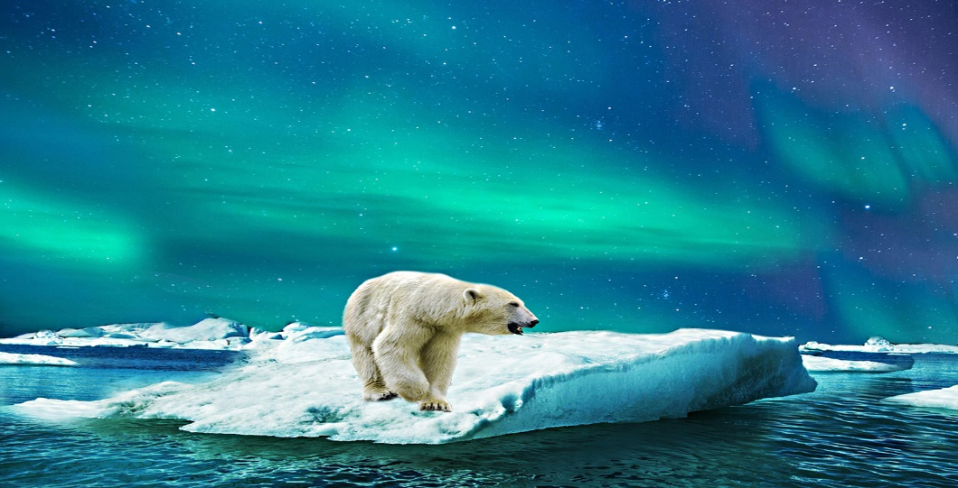
This Photo by Unknown Author is licensed under CC BY-NC

Over the last decade our sea levels have risen significantly. This is due to climate change which is melting the Ice on glaciers and the Pole regions. According to United Nations (2023) the sea consumes extreme heat and energy which is discharged from rising greenhouse gas emissions caught within the Earth’s atmosphere. Nowadays, the sea has kept 90 percent of heat which is produced by rising emissions. However, according to Lindsey and Dahlman (2020) more than 90 per cent of the warming that has happened on Earth within the last 50 years, compared to 10 years with the rise of sea level. As you can see from that data published by NOAA within Lindsey and Dahlman (2020) report that there has been a significant increase within the rising temperature in our Ocean. For instance, in 2015 the temperature of the ocean was 130 joules as. now in 2020 the ocean is 170 joules that’s more than 40 percent increase.
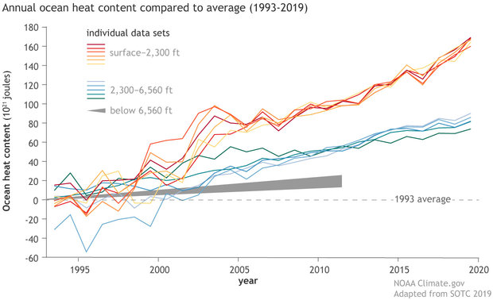
Annual ocean heat content compared to the 1993 average from 1993-2019, based on multiple data sets: surface to depths of 700 meters (2,300 feet) in shades of red, orange, and yellow; from 700-2,000 meters (6,650 feet) in shades of green and blue; and below 6,650 feet (2,000 meters) as a gray wedge. Graph by NOAA Climate.gov, adapted from Figure 3.6 in State of the Climate in 2019. See original figure for details about data sources and uncertainty.

This means that globally we will be seeing an increase on the rising levels of the sea. And acknowledge that this is the biggest threat to the future of humankind. This is why I have chosen this.
According to United Nations (2023), the ocean is central to decreasing worldwide greenhouse gas outflows and stabilizing the Earth’s climate. Nevertheless, expanding greenhouse gas outflows have influenced the wellbeing of the sea – warming and acidifying seawater – causing inconvenient changes to life beneath water and lessening the ocean’s ability to assimilate carbon dioxide and protect life on the planet. The sea produces 50 percent of the oxygen we require, retains 25 percent of all carbon dioxide emanations, and captures 90 percent of abundance warm created by these outflows’ emissions. Unfortunately, the ‘the lungs of the planet’ being affected, but moreover its biggest ‘carbon sink’ – a crucial buffer against the impacts of climate change.
However, Lindsey and Dahlman (2020) agrees with the United Nations (2023) that the warming ocean water is raising worldwide. Combined with water from thawing glaciers on land, the rising ocean undermines characteristic environments and human structures close to coastlines around the world. Warming sea waters are moreover involved within the diminishing of ice shelves and ocean ice, both of which have advance results for Earth’s climate. Furthermore, Lindsey and Dahlman (2020) states that warming sea waters undermine marine environments and human livelihoods. For example, warm waters jeopardize the wellbeing of corals, and in turn, the communities of marine life that depend upon them for protect and nourishment. Therefore, individuals who depend upon marine fisheries for nourishment and occupations may be affected by negative impacts from the warming sea.
Also the United Nations (2023) stated that these changes eventually can cause an enduring effect on marine biodiversity, and the lives and livelihoods of coastal communities and past - counting around 680 million individuals living in low-lying coastal regions, nearly 2 billion who live in half of the world’s megacities that are coastal, about half of the world’s population (3.3 billion) that depends on angle for protein, and nearly 60 million individuals who work in fisheries and the aquaculture segment around the world.

Colliver (2017) she focusses on climate change education and encouraging positive actions that make a direct contribution to reducing our carbon footprint and how we can mitigate greenhouse gas emissions and adapt to a changing climate. Collier (2017) related to the Australian Curriculum and how they integrate climate change with their education system, such as linking it into Humanities, Geography and Science. Collier (2017), argues that teachers can take a more integrator and inter-disciplinary approach to climate change education in Australian schools, given there are numerous illustrations of leading practice in schools that are as of now actualizing climate change education.
Within the primary Australian Curriculum, Collier (2017) states that the area of `Science as a Human Endeavour strand offers boundless opportunities from year 3 onwards to involve in the climate change learning journey.
The new curriculum for Wales reform was published in 2020, where schools can create their own Curriculum ( Welsh Government , with ensure that their pupils develop towards the four purposes. For, instance if the schools choose to do topic, such as climate change there are a range of activities that can be implemented. Such as Biodiversity where each pupil can learn about how man-kind actions is affecting the ocean, wildlife, plants, rising level of the ocean, coastal communities, flooding. They will have a understand on how they can start making changes to climate change through this, the skills that they will need are active listening skills, team building skills and creative thinking skill. In 1994 the Eco-School Programme was launched within Wales, stated that environmental issues such as climate change, biodiversity-loss or plastic contamination are tremendous worldwide issues. The thought of handling them can be threatening, leaving numerous feeling overpowered and pondering ‘Where do I begin?’. According to Eco-Schools (1994) they provide a simple, seven-step framework that answers this question whilst empowering young people to have influence in their school, local community and beyond. (“eco school — Blog — Oakridge Parochial School”) Since 1994, millions of young people around the world have worked through the Eco-Schools Seven Steps before being recognised for their efforts with a prestigious Eco-Schools Green Flag. (“What are Eco-Schools? - Eco Schools”) (“What are Eco-Schools? - Eco Schools”)
However, within the Australian Curriculum they already integrate climate change within their education system with subject such as Maths, Science, Humanities and Social Science. As well as Italy, Climate change is mentioned in the Geography and Biology curricula and is also included in the curriculum guidelines’ underlying principles. UNESCO (2021)
The UNESCO (2021) stated that 47 % of national educational programs systems of 100 nations checked on had no reference to climate change. Teachers are at the forefront of providing learners of all ages have the information, abilities, values and drive to act to address the climate crisis. Also, UNESCO (2021) stated that the country’s most likely to incorporate climate change content are those in coastal areas that are defenceless to the impacts of climate change, as restricted to those widely dependable for the emissions causing climate change.
According to Lee (2013); Selby and Kagawa (2010) cited in Cutter-Mackenzie (2019), Children and young individuals are developing up in unpredictable and unstable times, as the social, cultural, and natural impacts of worldwide climate change starts to infuse their ordinary lives and communities. (McNeill and Engelke 2014) cited in Cutter-Mackenzie (2019) says that numerous children and young individuals are challenged on a day-by-day basis with unsustainable arrangement of human utilization, population development, waste production, environment devastation, pollution, and contamination that outstrip the carrying capacities of the Earth’s ecological framework.

According to the UK government (2022) the Education Secretary Nadhim Zahawi states that he will set out his vision for all children to be educated around the significance of preserving and securing our planet. Teachers will be backed to convey world-leading climate change education through a showing science curriculum, which will be in place by 2023, to educate children about nature and their effect on the world around them.
In 2022 the UK government implement a Sustainability and Climate Change Strategy within that they have policies called for by the Let’s Go Zero. Which ensure that all schools have climate change action plans and sustainability guides and include sustainability and climate change in teacher training. The Let's Go Zero policy includes urgent upgrades to school grounds to make buildings more energy efficient to reduce emissions and fuel costs and inspire children to study in them.

Within educational setting it is important to establish children`s feelings and values regarding climate change and the effects that its having on the world. We can distinguish by enhancing children`s learning and how it is important to understand the changes happening around the World. There are many methods that can be used such as questions and surveys, by completing these we can identify each child`s individual feelings and values regarding climate change. Educational settings can join Eco- schools (2023), the program aims to empower and inspire young people to make positive environmental change in schools and the wider community, build skills including numeracy and literacy, and embrace education for sustainable development and global citizenship.
For children it's often a good idea to work as group or pairs to help develop an optimal solution. This helps avoid personal bias or group think that can limit idea generation, before they come together as a class. Whilst the children are in their groups or pairs, they can create their idea of making it out of cardboard, cubes, ice cream sticks, plastic, or other resources that are available within the classroom. After they have designed it, they can present what they have created to the school and see if the school agrees with the solution or whether it needs further improvement or they move forward with it. (Technokids (2023)

References

Australian Curriculum (2023) Cross-curriculum priorities. Sustainability. Available at: https://www.australiancurriculum.edu.au/f-10-curriculum/cross-curriculum-priorities/sustainability/ (Accessed 26 March 2022)
Colliver, A. (2017) Education for climate change and a real-world curriculum. Curric Perspect 37, 73–78. Available at: https://doi.org/10.1007/s41297-017-0012-z (Accessed 22 March 2022)
Rousell, D & Cutter-Mackenzie-Knowles, A. (2020) A systematic review of Climate Change Education: Giving children and young people a ‘voice’ and a ‘hand’ in redressing Climate Change, Children's Geographies, PP 18:2, 191-208, DOI: 10.1080/14733285.2019.1614532 (Accessed 28 March 2023)
Eco-Schools (2023) Keep Wales Tidy. Available at@ https://keepwalestidy.cymru/eco-schools/#:~:text=Eco%2DSchools%20is%20a%20global,Wales%20by%20Keep%20Wales%20Tidy (Accessed 28 March 2023)
Government UK (2022) Sustainability and climate change strategy. Available at https://letsgozero.org/uk-schools-climate-policy-2022/ (Accessed 28 March 2023)
Government UK (2022): UK to lead the way in climate and sustainability education. Available at: https://www.gov.uk/government/news/uk-to-lead-the-way-in-climate-and-sustainability-education (Accessed 11 March 2023)
NOAA (2020) Climate Change: Ocean Heat Content. Available at: https://www.climate.gov/news-features/understanding-climate/climate-change-ocean-heat-content (Accessed 22 March 2022)
Technokids (2023) Design Thinking. Available at: https://www.technokids.com/blog/teaching-strategies/design-thinking-education/ (Accessed 28 March 2023)
United Nation (2023) Climate Action: How is climate change impacting the world’s ocean. Available at https://www.un.org/en/climatechange/science/climate-issues/ocean-impacts (Accessed 14 March 2023)
United Nation (2023) Climate Action: The ocean – the world’s greatest ally against climate change Available at: https://www.un.org/en/climatechange/science/climate-issues/ocean (Accessed 15 March 202)
UNESCO (2021) Getting every school climate-ready: How countries are integrating climate change issues in education. Available at: https://unesdoc.unesco.org/ark:/48223/pf0000379591 (Accessed 25
Welsh Government (2023) Curriculum for Wales Available at: https://hwb.gov.wales/curriculum-for-wales (Accessed 25 March 2023)

