A discussion of how has the natural world has influenced artists and designers from the 16th century to the 21st century; highlighting the importance of curiosity, experimentation and the development of technology.

Naomi Seaward: 1706436
Supervisor: Ainsley
Word Count: 6490

Submitted in partial fulfilment of the requirements for the degree of BA (Hons) Surface Pattern Design (Maker)
University of Wales Trinity Saint David,
Swansea,
11th of December 2019

Contents

List of Figures………………………………………………3
Introduction…………………………………………………6
Chapter 1: Drawing From Nature………………………...7
Chapter 2: Cultivating The Connection………………...14
Conclusion………………………………………………...23

List of Figures

Figure 1: Stone, S. (1790) The Splendid Parrot Prints, [etching, printed with black ink, from one copper plate; hand-coloured in watercolour]. Available at https://artsearch.nga.gov.au/detail.cfm?irn=243510

Figure 2: Hoefnagel, J. (1542-1600) Ringlet, False Jerusalem Cherry, and Milkwort [Watercolors, gold and silver paint, and ink on parchment]. Available at http://www.getty.edu/art/collection/objects/2345/joris-hoefnagel-and-georg-bocskay-ringlet-false-jerusalem-cherry-and-milkwort-flemish-and-hungarian-1561-1562-illumination-added-1591-1596/

Figure 3: Hoefnagel, J. (1542-1600) Trompe l'Oeil Stem of Milkwort [Watercolors, gold and silver paint, and ink on parchment]. Available at http://www.getty.edu/art/collection/objects/2346/joris-hoefnagel-trompe-l'oeil-stem-of-milkwort-flemish-and-hungarian-1561-1562-illumination-added-1591-1596/?dz=0.5000,0.5000,0.73

Figure 4: Da Vinci, L. (1506-12) Sprigs of oak and dyer’s greenweed [Red chalk, touches of white chalk, on orange-red prepared paper]. Available at https://www.rct.uk/collection/912422/sprigs-of-oak-and-dyers-greenweed

Figure 5: Merian, M. (1702-1703) Branch of Guava tree with Army Ants, Pink-Toe Tarantulas, Huntsman Spiders, and Ruby-Topaz Hummingbird [Watercolour and bodycolour with gum arabic over lightly etched outlines on vellum]. Available at https://www.rct.uk/collection/921172/branch-of-guava-tree-with-army-ants-pink-toe-tarantulas-huntsman-spiders-and-ruby

Figure 6: Haeckel, E. (1880) Desmonema Annasethe [Lithograph print]. Available at https://commons.wikimedia.org/wiki/File:Haeckel_Discomedusae_8.jpg

Figure 7: Unknown, (1800) The Chinese Drawing Room at Temple Newsam House [Unknown]. Available at https://advisor.museumsandheritage.com/news/leeds-museums-unveil-chinese-room-at-temple-newsam-house-following-painstaking-conservation/

Figure 8: Morris, W. (1883) Strawberry Thief, [Indigo-discharged and block-printed cotton]. Available at https://collections.vam.ac.uk/item/O78889/strawberry-thief-furnishing-fabric-morris-william/

Figure 9: Morris, W. (1875) Acanthus, [block-printed in distemper colours, on paper]. Available at http://collections.vam.ac.uk/item/O1036456/acanthus-wallpaper-morris-william/

Figure 10: Crane, W. (1889) Peacock Garden, [Colour woodblock print, on paper]. Available at http://collections.vam.ac.uk/item/O224446/peacock-garden-wallpaper-crane-walter-rws/

Figure 11:Pearson, C. (2005-2007) Willow Boughs 1887
from the series Look At Your Walls [DVD video projection, edition 1 of 3]. Available at https://www.mfah.org/art/detail/90914?returnUrl=%2Fart%2Fsearch%3Fartist%3DChristopher%2BPearson

Figure 12: Moooi Wallcovering, (Unknown) Menagerie of Extinct Animals [Digitally Printed Wallpaper]. Available at https://www.arte-international.com/en/collections/moooi-wallcovering-extinct-animals/menagerie-of-extinct-animals/MO2073

The natural world is impossible to ignore. We live within it, we interact with nature every moment of our lives, experience the seasons change and form relationships with the living organisms within it. Many people have a passionate desire to gain a deeper understanding of it, pushed by their curioisity of the unknown. My first chapter will explore when our movement of travel was limited and we could not easily access information by sharing knowledge, detailing how naturalists, philosophers and artists took it upon themselves to try to unlock the secrets of our environment; the species we only dreamed of existing, the variety of plant life that inhabits the environments, and the science of our human biology. By undertaking careful and dedicated observational drawings, and utilising their available techniques to bring colour and life into their pieces; they are able to depict their representation of nature. Alongside this, It is necessary to consider the state of science and technology during the period these artists worked. What tools did they have access to in order to create their representation of nature? With the gradual development of global trade and the ease of communication, sharing knowledge and satiating curiosity become a lot easier. This text will suggest how art and science formed a relationship through these creators, and allowed for nature to be brought into the foreground of our culture.
The second chapter will delve deeper into the theory of our relationship with nature, touching on Kellert’s theory of Biophilia, and the human need to be surrounded and involved with nature to feel content. I have chosen to explore wallpaper as the answer to the modern representation of nature, as In my own practice I am highly influenced at all times by natural history and how illustrative representation has changed and developed up until the 21st century. Exploring the new style of illustrative representation by key designers such as William Morris, this chapter will explore the topics of aesthetic and ornament in wallpaper design throughout the 18th to 21st century, and how artists valued the natural world as a resource for inspiration and knowledge, but instead applying it to the world of wallpaper design. Again, considering the height of science and technology during these periods, and how in particular contemporary wallpaper designers have used 21st century technology to innovate their representation of nature, bringing the outside into our homes in the form of decoration.

Drawing From Nature

To discuss the influence of nature on our art and culture, it is important to understand why we are so curious about it, and what drives us to be curious. Whilst being considered essential to all human beings, Loewenstein, 1994 believes curiosity is self-motivated, and derives from a lack of knowledge or our understanding. When we are exposed to a small amount of information, it acts as a initial dose, which increases our curiosity in the subject, as well as fuelling us to seek more. The life cycle plays out where we will eventually become satiated and further information will decrease our curiosity in the subject (Kidd and Hayden, 2015).What then happens next? Do we move onto new stimuli to reignite our curiosity? These questions are some of those that we will eventually all ask ourselves, as designers, researchers and problem solvers. The area of curiosity that is going to be explored further here is the exploration of our natural world and history, through the documentation, categorization and expression of our connection with nature.

Our curiosity and wonder at the environment we share has been a driving motivator for scientists and artists alike throughout the centuries, the two disciplines sharing an intimate connection. The key to both practices’ strategies begins with ‘careful observation’. “Before artists or scientists can usually represent the world, they must observe it. Just as scientists conduct experiments and measurements prior to the construction of a theory, successful artists make a study of the objects they intend to represent” (Young, 1996). The use of the word successful is interesting here, suggesting that for artists to succeed through their medium they must complete observational sketches and explorations. The both will then go through the process of researching, going through testing initial concepts, designing new methods and innovating, and eventually sharing their result. They may also intermingle contents, developing a relationship that is mutually beneficial to the creator and consumer. We realise that art can be used as a tool to further scientific theory, and to assist in the development of knowledge. “A common pursuit of artists and scientists has always been, and always will be, to probe a reality beyond appearances” (Miller, 1995). Miller contemplates how we portray ideas, and exactly how both science and art question representation of that thought, utilising diverging methods. Whilst these methods may change, the underlying similarities of the two practices remain. What I will explore further in this chapter is how exactly the natural world was explored alongside this developing language of science and art, highlighting key artists and important technological advancements from the 16th to the 19th century that supported this.

The development of society’s desire to learn more about the natural world can be seen in the collecting of natural oddities and curiosities by wealthy and prominent figures of society. Addressing a prince for entertainment of Queen Elizabeth, Francis Bacon performed his proposal for a collection of Nature, containing a space that could facilitate “all rare beasts, and to cage in all rare Birds; with two Lakes adjoining, the one of fresh Water, and the other of salt, 10 for like variety of Fishes… And so you may have, in a small Compass, a Model of Universal Nature made private” (Bacon, Davison and Canning, 1688). Bacon’s goal for developing these ‘Curiosity Cabinets’ was to supply the curiosity of the public, as well as to educate and further the scientific discovery involving natural history.
These Cabinets of Curiosities are widely accepted as the precursor to our modern day museum, a collection of objects and curiosities that are foreign to our knowledge, collated in a certain way so that we can study and learn about them. Often eclectic, these cabinets were used more prominently as a display of wealth and intelligence, only held by the elite and powerful. However as our ability to travel further and collect more specimens of the natural world grew, it become more accessible for the study of science and natural history. One notable collection In Britain was Sir Ashton Lever’s museum, wherein held creatures of all shapes and sizes. When it opened, it contained 1300 glass cases filled with specimens from New South Wales to South America, and was opened to naturalists and artists alike to observe the collection.
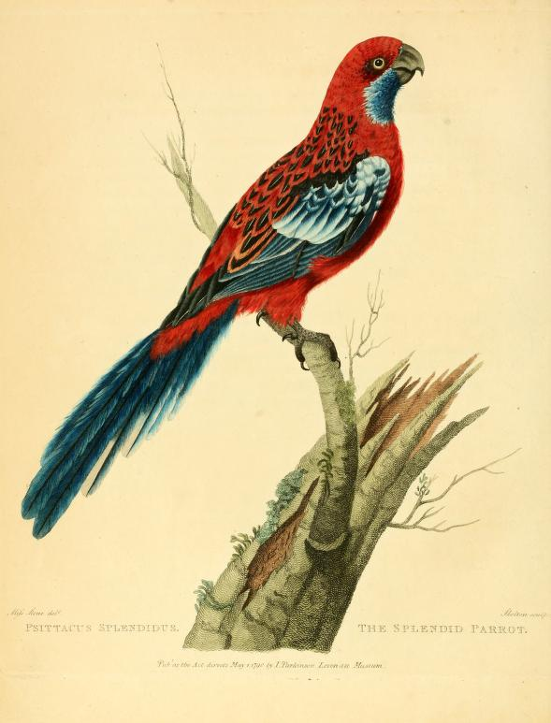
Lever commissioned Sarah Stone, a proficient watercolour artist, to draw and paint the specimens, who took to the bird specimens quickly, producing hundreds of beautifully illustrated paintings. One such image shown in Fig. 1 is of her artistic brilliance, The Splendid Parrot. Stone’s dedicated to realism led her to undertake years of observational drawing and painting at the museum, using watercolours and very fine brushes to painstakingly produce each feather and lichen on the perch.

Fig. 1 : The Splendid Parrot

Where curiosity was developing about the natural world, how was it being explored, particularly in visual arts? An interesting early exploration of the natural world came in the form of employing techniques such as trompe l’oeil, the mastery of painting in such a way that allowed the chosen subject to spring forth from the pages. “It’s express purpose is to mystify, to transcend and replace the illusion of reality by its certainty” (Milman, 1983). Utilising shadow, perspective and a keen eye for minute detail, these paintings can utilise their canvas to create the illusion of reality. When done right, these works of art are able to confuse our sight, a perfect representation of nature (Kaufmam, 1993, p.15).

We can see how Hoefnagel uses subtle shadows to make the cherries appear to sit on the surface of the paper, in addition to the finely detailed brush strokes and use of vivid colour. This particular trompe l’oeil is how the stalk of the plant is painted in such a way to give the illusion of being slipped through a cut hole in the page, emerging out of figure 3.

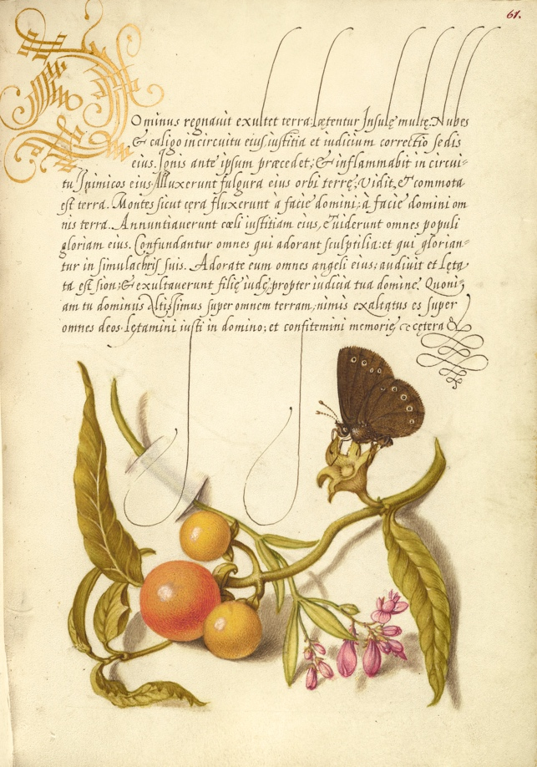
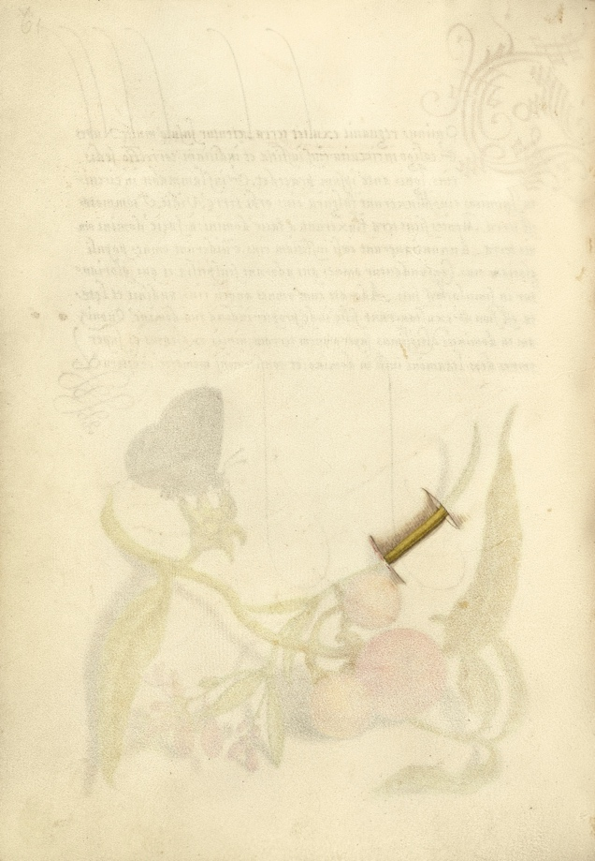

Fig. 2 Ringlet, False Jerusalem Cherry,
and Milkwort Fig. 3 Trompe l'Oeil Stem of Milkwort

On the search for an approach on reality in art and science, paired with the natural world spanned centuries of development; elevated by these advancements and mastery of technique by artists, Panofsky had this to say,

A theory of art which was no longer a code of generally accepted rules, but a rational discipline equipping the artist for his individual encounter with reality… book printing and the techniques of woodcut and engraving by means of which one man could disseminate his ideas or inventions all over the world.
(Kleinbauer, 1989)

The advancement in technology of book printing was an essential part of the development of relationship between art and science; ideas and theories could be documented, collated, and shared with a global audience.
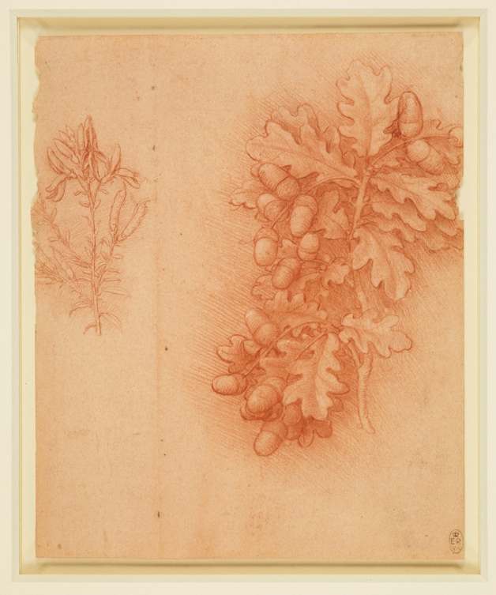
One such artist who excelled in his practical technique, as well as personifying the important relationship between art and science is Leonardo da Vinci. His treatise was to create “a complete description of every aspect of natural phenomena” (Attenborough et al., 2016). This ambitious goal drove Da Vinci to complete immense studies into a wide range of topics, not limited to flight, optics, botany, human and animal biology. He was very invested in achieving true realism in painting, leading him to write entire books on the effect of shadows and light on various objects, evidenced by drawings and illustrations of his own experiments. Loewenstein’s theory of a gap in knowledge reflects in Da Vinci’s practice; Where he had no information or knowledge to take note from, he devised theories and completed extensive testing and experimenting through his observational drawing to justify his hypothesis.
The detail Leonardo delves into when discussing nature is impressive, focusing only on trees he writes 47 separate studies of leaves that he conducts; how their position affects transparency, the movement of wind and its effect on leaves regarding their colour (Da Vinci and Richter, 2016). The detail he creates when illustrating botanicals is even more so impressive, utilising a range of mediums such as his red chalk study of Acorns and Dyer’s green weed shown in Figure 4. Chalk being a medium that “is more colouristic than precise… Leonardo has given the greatest possible fullness of definition” (Clark, 2005).

Fig. 4 Sprigs of Oak and dyers greenweed

Achieving such precise lines whilst dealing with a volatile medium like chalk demonstrates Leonardo’s patience and perseverance to achieve his replication of nature in observational drawing.

It can be assumed that Leonardo began to study botany for the pleasure of understanding it, due to the excessive detail he entered into his studies in addition to the volumes of notes he made on the subject. Leonardo felt strongly about Nature’s divine wisdom and purpose in contrast to human creation in entry 838; “It will never devise any inventions more beautiful, nor more simple, nor more to the purpose than Nature does; because in her inventions nothing is wanting, nothing is superfluous” (Da Vinci and Richter, 2016) Leonardo was of the opinion that whilst man can create with innovation and intelligence through the use of technology, and certainly he did, mankind can’t create on the same level as Nature. It is perfection, the exact necessity of what is needed and nothing more. We can assume that this is a large factor in Leonardo’s choice to study the natural world.
In Leonardo's context, his passion for illustrative representation of nature and his immense curiosity could fuel his want to make miracles; push the boundaries of what is thought possible and complete his treatise of a complete study of natural phenomenon.

Unsatisfied with simply seeing deceased or partial specimens in Holland brought back from the East for natural history collections, Maria Sibylla Merian was an artist and keen scientist who undertook a voyage to Surinam in 1699, to study metamorphosis in detail. Merian’s approach to illustration depicts the changing attitudes of art and representation in its move to the individual choice, her images containing a ‘naturalistic approach’, with thought out composition and arrangement of both plant and animal, whereas years before these would have been kept very separate, clinical and organised (Nelson, Elliot and Waring, 2015).
During her time in Surinam, Merian was able to study and make observational paintings of near 200 species of plant and animal. This immense task was completed by Merian at the age of 52, undertaking two years of meticulous research and observations. On her return, she was encouraged to share her findings with the world. Merian explains,

In making this work I have not been profit-seeking, and would be content if I just recover the expenses I have made. I have spared no expense in the production of this work, but have had the plates cut by the most famous masters and used the best paper for that purpose, so that it would give pleasure and satisfaction to the art connoisseurs as well as to the amateurs of insects and plants, just as I will be pleased when I hear that I have reached my objective and at the same time will have provided pleasure.
(Merian, 1705)

This excerpt from Metamorphosis insectorum Surinamensium, In Merian’s own words, portrays her dedication to her art and her own curiosity, through her willingness to not only fund the trip herself but to also source only the best materials and craftsmen to create her ‘magnum opus’. She feels the reward of satisfaction and pride at having satiated our curiosity and driven others, and much like Leonardo da Vinci, she places little importance in financial gain as a motivator for her work. Kay Etheridge considers Merian’s significance in the world of science and while her education was certainly not university-based, despite her inaccuracies that are picked apart by naturalists, and her methods were ‘unusual’ to her peers; “Linneaus and his followers used Merian’s images and descriptions to name dozens of plant and animal species” (Etheridge, 2011).

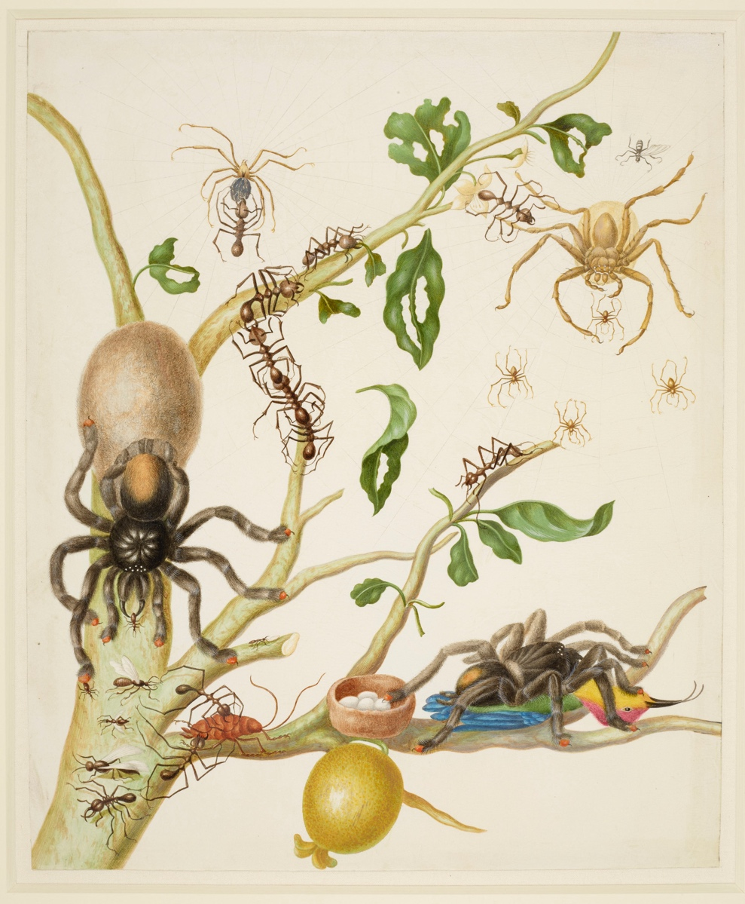

Fig.5 Branch of Guava tree with Army Ants, Pink-Toe Tarantulas, Huntsman Spiders, and Ruby-Topaz Hummingbird

This image explores a composition of ants, Huntsman spiders, Pink toed Tarantulas and a Hummingbird. The accuracy of her scale and truth to reality is questioned in this particular composition, “Merian seems little concerned about relative sizes. The hummingbirds nest is scarcely bigger in diameter than the ants close by.” (Attenborough et al., 2016). Merian was not without her critics, passing judgement not only on her scientific representation but also her artistic license. The proportion of the ants is skewed in a strange way, the relative size of nest to ant being a jarring image. We can see that Merian’s observational paintings are controversial, referring back to the idea of thought out composition and mixing of species in her plates. The clash between art and science in Merian’s plates are clear to see, through the struggle between accurate representation and aesthetic quality. Merian could be said to sacrifice scientific accuracy for a comprehensive, readable and beautiful piece of art.

Discussing the theory of aesthetics and ornament, It must be mentioned how Ernst Haeckel depicted his passion for nature in his research of sea creatures. Dedicated to Darwin’s theory of evolution, Haeckel produced illustrations that stemmed from “the basic laws of the simplest of organisms” (Sachs and Zürich, 2007). Haeckel was able to depict the peculiarities of these creatures, in their shape and form, and was able to educate as well as inform others of their beauty.

Haeckel’s illustrative style acquired a quality that, as far as he was concerned, went far beyond the appearance of beauty. Depicting nature in this way proved that the variety of forms in nature was based in aesthetics. They mutated into ornamentation in the actual process of nature.
(Briedbach, 2006)

The prints aimed to give the public an understanding of the evolution of organic life, exploring the topic of ornamentation through the explanation of symmetry and order in aquatic life.
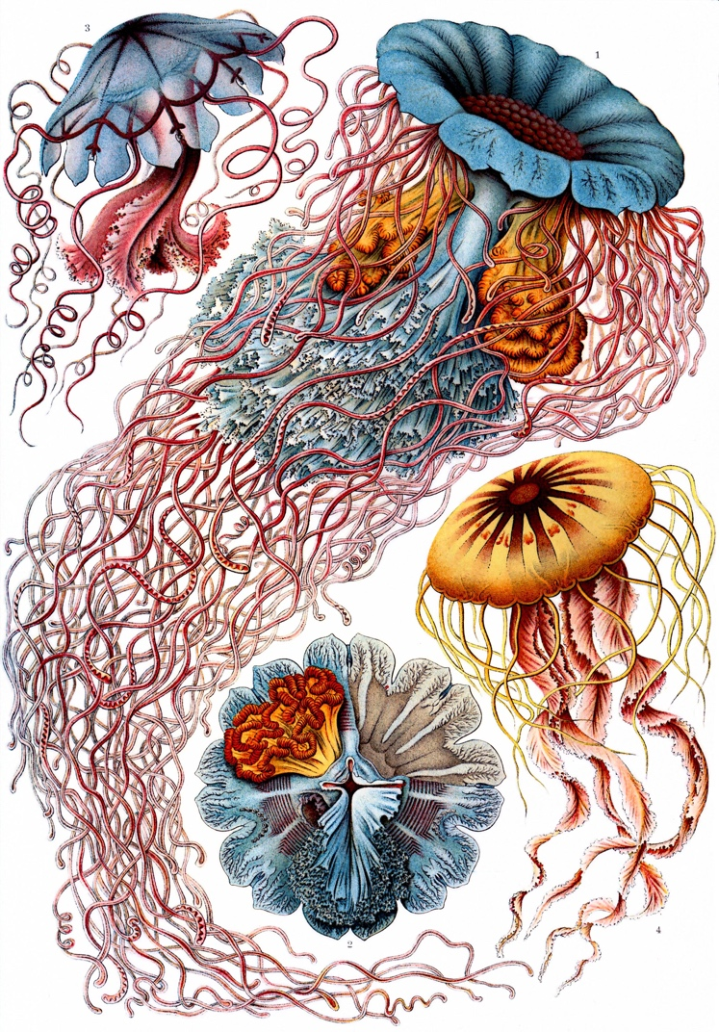
In figure 6 we can see his use of rich colours and keen attention to detail in the illustration. Even now in the 21st century, people continue to appreciate Haeckel’s plates for their contribution to ornamentation. This particular plate is of importance to Haeckel as an artist and naturalist, as well as the meaning of his collections.
“Rarely does he permit himself as much artistic license as in his representation of Desmonema An nasethe, the jellyfish he had named after his beloved wife … irruption of diaphanous divinity into the mundanity of textbook science” (Irmscher, 2018).
Irmscher refers to Haeckel’s use of artistic license in this particular piece, praising Haeckel in his ability to highlight the beauty of these natural forms in a scientific textbook.

Fig. 6 Desmonema Annasethe

The way in which the tentacles seem to swirl and dance as if moving with the sway of water give a playful and lifelike appearance. His talent and passion for the natural world allowed him to bring these illustrations to life.
Haeckel’s collection of illustrated wonders pushed us to realise that we create, subconsciously or consciously, from nature’s influence. Much alike Leonardo’s opinion that Nature’s inventions were the pinnacle and human creation could not hope to match, Haeckel encouraged us to use nature and our natural world as the only true inspiration for ornament.

Cultivating the Connection

In a similar framework to Leonardo da Vinci, Wolfgang von Goethe explored his curiosity on the metamorphosis of plants, through notes on the science of botany. Aiming for a thorough understanding of the natural world, he believed that we could gain satisfaction in finding out how nature creates and why; emphasising once more how deeply merged science, art and the study of the natural world are. “My belief that Goethe’s way of science offers hope for lessening the modern alienation from nature that not only diminishes the beauty and joy of human life but also fuels environmental irresponsibility and apathy” (Wolfgang Von Goethe, 2009). In Miller’s opinion, nature enhances the human experience of living, and to live without it leads to the disregard of environmental issues and a lack of care and understanding of the world.
Nature began to become increasingly more prominent in our culture and in our art, illustrated by many of the key painters who utilised nature as a resource, such as Matisse. “An artist must possess Nature. He must identify himself with her rhythm, by efforts that will prepare the mastery which will later enable him to express himself in his own language” (Chipp, Selz and Taylor, 1968, p140). In his letter dated 1948, Matisse explains how to develop the artist’s language, you must first understand and connect with nature, as a source of inspiration and self-improvement. Pairing with Goethe’s theories on the human experience, we can assume that by incorporating nature not only into our art but into our life will immensely improve it.

The Biophilia hypothesis sets out to discuss the human interaction with nature. The term ‘biophilia’, discussed by Kellert is the genetic and hereditary need of humans to be close and associated with the natural world. We are part of an immense system of living organisms, but have knowledge of only a fraction; “The living world is the natural domain of the most restless and paradoxical part of the human spirit. Our sense of wonder grows exponentially: the greater the knowledge, the deeper the mystery” (Wilson, 1929). Wilson considers how the sheer size of our world and the seemingly unending stream of knowledge ignites the curiosity within us, leading us to seek out nature and satiate our need for answers. Stemming from our primate roots, our evolution as a species has worked hand in hand with nature to preserve our innate feelings towards it, whether we realise that consciously or we explore it subconsciously. It “powerfully asserts that much of the human search for a coherent and fulfilling existence is intimately dependent upon our relationship with nature” (Kellert and Wilson, 1993). In a similar methodology to Matisse and Goethe, Kellert suggests we place high value in nature as a necessity for a happy, realised existence. If we consider this to be true, then to live our best lives we must incorporate the natural world into our everyday existence. One highly debated and controversial art form that does this, which adapted to the changing styles and fashions of society in addition to setting trends, is wallpaper.

Early wallpapers In Britain were printed using woodblock printing, a relief printing technique that when multiple were cut, allowed multiple layers of colour to be overlaid. This practice was an industry standard in the 18th century, alongside the developing taste for floral and natural designs. This was a time of continual improvement in the industry; production became more effective where designers improved registration, attempted more experimental colourways and began to push the boundaries of the medium. There was a wealth of demand for floral print wallpaper, stylized and hatched, embracing the naturalistic stance (Hoskins, 2005, p34). The global market and demand was also developing, as discussed in chapter 1, as a result of book printing becoming commonplace and distribution channels being opened worldwide, designs were able to be shared globally.
Other countries were embracing the influence of nature in their designs, in particular demand were the Chinese wallpapers, that displayed an entirely new approach to pattern for our walls.
Intense realism, and with an attention to aesthetic ornamentation, these wallpapers personified the passion and love for the natural world. Discussed by Clifford in her chapter, the Chinese style papers were everything Britain had not yet accomplished, smooth, flexible and attractively painted, in contrast to the chalky, rough distemper printing and repetitive patterns Britain produced (Finn and Smith, 2018). Outlines were block printed, and then skilled workers worked back into the panels or lengths, filling in exquisite detail by careful hand-painting, much like scientific botanical illustration.
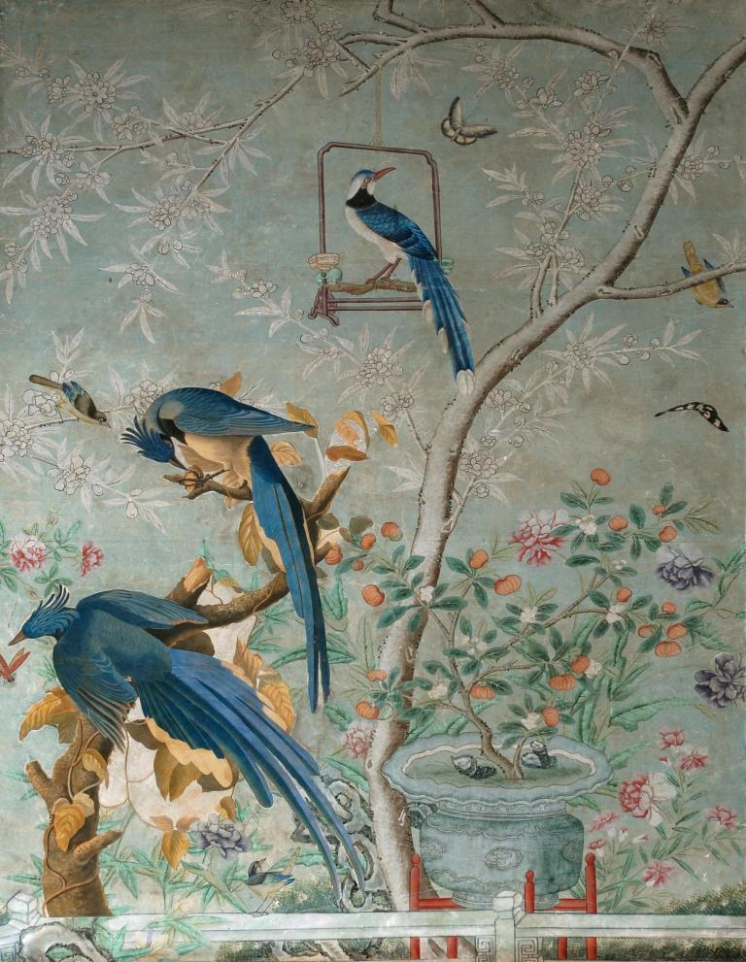
This particular panel in figure 7 hung in Yorkshire, at Temple Newsam. It dates 1800, and exudes the brilliance of the original artist. Their attention to detail in their observational drawing and painting is clear. “Chinese artists were perfecting a style which was characterized by a close and exact observation of nature… the artists successfully combined scientific accuracy with decorative purpose” (Hoskins, 2005, p52). We can determine then that the Chinese design theory closely mirrored the passions of many botanical illustrators of the same century, in particular Maria Sibylla Merian and Ernst Haeckel.

Fig.7 The Chinese Drawing Room at Temple Newsam House

This type of wallpaper can be then considered an important and extravagant portrayal of the passion for nature and the aesthetic of natural ornament of the early 19th century, and the demand of British society for these ornate and beautiful artworks suggests there must be some truth in Kellert’s theory of ‘Biophilia’, and the need to be close to nature.

To look for the demand for seamless integration of nature in our everyday lives, we should look no further than William Morris; one of the most prolific naturalists of the 19th century, who worked tirelessly in his endeavours of design, politics and literature. Passionate about reform and change, Morris was strongly opposed to the society and culture created by the Industrial Revolution, in addition to the penalisation of the poor and benefit of the rich. He believed that by returning to traditional practices of hand crafting, combined with the reform and reorganisation of the political environment, we could change the perception of applied arts and allow high quality craft and knowledge to enrich our lives (Gillow, 1995).

William Morris felt very strongly about the aesthetics and beauty of our everyday lives, in all aspects that we come into contact with. He believed that there lacked a current ‘sense of beauty’ In society that would drive designers and artists into producing ‘genuine organic art’ as a solution. Morris’ motivating factor then was to produce beauty, unlike the craftsmen before him whose pretensions were for notoriety and reputation, and his inspiration was nature. The Industrial Revolution led to mass market ‘trade finish’ quality art, and the Arts & Crafts Exhibition Society dedicated its efforts to utilities and furnishings, In William Morris’s opinion, ‘that really most important side of art’; that were created and decorated with traditional, artistic finish (Arts and Crafts Exhibition Society and Morris, 1893).

Establishing a collective of highly skilled and renowned partners, Morris & Co was formed in 1861 in an attempt to ignite the flame of interest and desire for the applied arts. Morris later became the sole owner, allowing him to focus on his passion for nature inspired design and the study of the natural world.

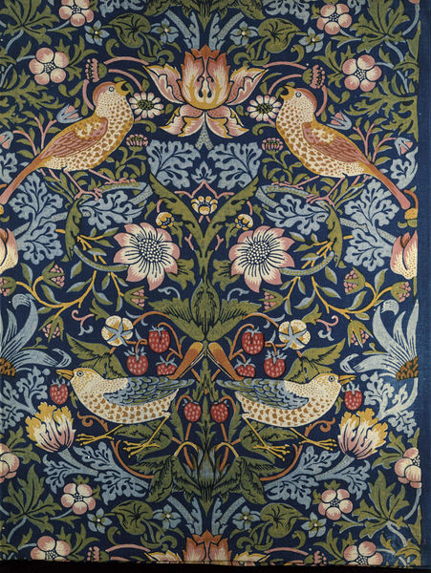
His curiosity and perfectionism led him to conduct extensive experimentation, not only in wallpaper process but also in textiles used for wall hangings, with natural dyes. Abhorring the chemical processes popularised in the 19th century for textile dyeing, Morris took to vegetable dyeing with force, utilising red madder, indigo and yellow weld; dyes utilised in medieval times. In his letter to Aglaia Coronio we see his enthusiasm for the process of dyeing 20 lbs of silk in a vat, “It was very exciting, as the thing is quite unused now, and we ran a good chance of spoiling the silk” (Naylor, 1996). Morris expresses his anticipation, but not worry, at the possibility of ruining the large amounts of silk, that were surely not cheap. It demonstrates Morris’s dedication to his process of experimentation, fuelling his curiosity of what will happen if I do this, or this. He is not afraid to fail, and he did fail many times with vegetable dyeing, but as seen in this image of vegetable dyed cotton in Figure 8 he definitely could succeed.

Fig. 8 Strawberry Thief

His beautiful outcomes are worth the dedication to nature and it’s applications.
His innovation and experimental attitude did not end with his textiles. When it came to wallpaper, the industry standard was wood-block, an effective and repeatable method of production.
The techniques Morris & Co. began their exploration into wallpaper with in 1862 were oil based inks printed with zinc plates etched with designs. However, as they found through testing this process was tedious and resulted in poor quality, so woodblocks were cut. Dealing with Jeffrey & Co, the wallpapers were printed with distemper, giving an immense range of shades and hues at the compromise at using chemical based processes (Parry and Victoria and Albert Museum, 1996). While being innovative and curious benefitted Morris in his textile designs, wallpaper production was a lot more constrained in its processes, and we can see that sacrifices were made for the sake of aesthetically pleasing design and colouring.
He developed an intimate understanding of wallpaper, developing his illustrations to suit the linear and flattened aspect of the wall, flattening forms such as flowers to aid this. Pattern design was Morris’s expertise, and he wished to share his knowledge. In ‘The Lesser Arts’ lecture given in 1877, Morris speaks on ornament and art. On how decoration should have a purpose, and that purpose is driven by the utilisation of nature;

Those wonders of intricate patterns interwoven, those strange forms invented, which men have so long delighted in: forms and intricacies that do not necessarily imitate nature, but in which the hand of the craftsman is guided to work in the way that she does.
(Naylor, 1996)

Morris talks of the wonders of nature’s forms, and of the invention of strange motifs that have captivated the attention of man. Much like Ernst Haeckel’s unusual, conversational representations of aquatic life, Morris suggests these are what have and should continue to inspire craftsmen to create, guided by nature’s influence. These laws of design set out by Morris are clearly shown in his own practice, taking on this naturalist stance. His wallpaper ‘Acanthus’ in Figure 9 was designed in 1875, the scrolling acanthus leaves were originally painted in watercolour, and then translated into distemper for the printing process. The leaves fold and overlap into each other, weaving around and curling gently. Illuminated by a ditsy pattern of simplistic floral shapes between the gaps in foliage, it required 30 separate woodblocks to print with a range of subtle hues of distemper colours.
Morris’s wallpapers enjoyed the exploration of naturalist design, with an individual style incorporated by himself that is difficult to pin to any specific movement. While Morris clearly loved and drew from nature, he did so in a more individual way, flattening forms and filling in detail with colour and subtle shading and hatching.

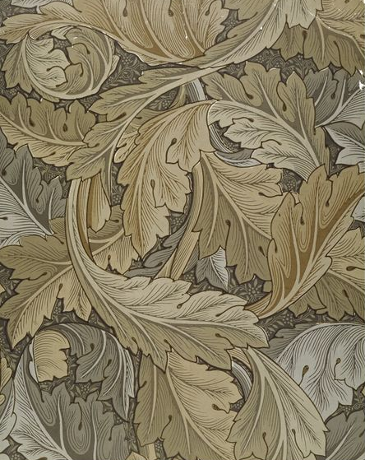

Fig.9 Acanthus

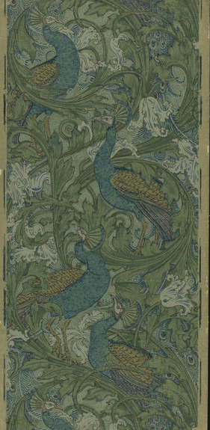
In his absence, the impact Morris left on the world of applied arts was notable. Many designers and craftsmen worked under William Morris, admiring his ethics and passion for the arts and crafts movement, much like Walter Crane. His essay on wallpaper in the Arts and Crafts Essays book explores his respect of Morris’s design theory. Crane suggests that Morris has shown us how pattern can be beautiful and contain character, aided by the right choices in colour and geometric design, and has thus given the designers of the 19th century ‘a new impulse’, sparking their passion for innovation and strive for perfection much like Morris had. Patterns were now “constructed with more direct reference to their beauty, and interest as such, while strictly adapted to the methods of manufacture” (Arts and Crafts Exhibition Society and Morris, 1893). In this image we see one of Crane’s wallpaper designs, Peacock Garden 1889, also printed by the Jeffrey & Co. The influence taken from Morris is abundantly clear, from the wide scrolling leaves and subtle patterns laid in the background.

Fig. 10 Peacock Garden

While constricted by the limitations of his manufacture and the limits of wallpaper design, we can understand that Morris’s practice has inspired other designers to create in accordance to and alongside nature, employing the traditional techniques explored earlier alongside the new technology and processes of the 19th century; bringing the natural world’s beauty into our homes.

In the 20th and 21st centuries, the influence of nature on us as designers, artists, but also as human beings has shifted. The late 20th century was a difficult year for wallpaper as a medium, cast aside in favour of more ‘modern’ approaches to interior decoration. In the architectural review, 1932, FRS Yorke boldly expresses his distaste for it, favouring instead surface treatments that allowed texture but not pattern such as glass or foiled walls. However by 1939 the same journal expressed the more relaxed opinions on wallpaper, “appropriate wallpapers were both permissible and desirable in modern interiors” (Joia and Bradley, 1990, p.18). We can understand from this that wallpaper was a volatile medium even in the 20th century, and was still in the early days of gaining respect and generating interest. Alongside this, the modern movement was similarly harsh on natural representation in wallpaper, the theory that nature was the source of ornamentation and the only true influence on it was disregarded, and ornamentation itself was looked at with contempt.
In contrast, the 21st century reignited the passion for nature on a big scale, quite literally. Our love as a culture for the illustrated representation of nature has sustained through the centuries, and we are now able to on past designers and naturalists, learn from their experimentation and theories and create new and inspiring pieces with our available resources. Scenic wallpapers soared in demand, and with advancements in digital printing, could now be readily available to the public. These murals are a beautiful way to immerse yourself in nature, “the wallpaper brings nature inside” (Brunner, 2019). The large scale motifs are able to transform the space into a celebration of the natural world. We can only wonder what designers such as William Morris could have done with the technologies of today.
The development of science and technology up to the 21st century has left us in a position where we have the world at our fingertips.

Real-time technologies are key to our everyday lives, without them we would not have email, the internet, and many of the systems that run our machinery and production. “The history of modern art can be read, at least in part, as a history of various artistic responses to the increasing speed and accelerating evolution of technology”(Gere, 2006). What Gere suggests is that art is the answer to one method of interpreting our new technologies, and that they continue to work together to develop the language of art and science. In our digital age, we can utilise the resources we have to produce innovative and individual pieces of art, such as Christopher Pearson’s ‘Look at your Walls’ in Figure 11. This installation piece utilises William Morris’s Willow Bough pattern, displayed across mounted screens along walls and through projection. The leaves morph and sway with a simulated wind, part to reveal birds fluttering past and seem to grow and shrink as if displaying the life cycle of the tree (Saunders et al., 2010, p.91). Undulating swirls and swaying branches thrust Morris’s vision for his designs into reality; this reproduction effectively brings the flat design to life, as it grows across the wall and incorporates other living organisms. Technology has allowed us in the 21st century to experience limitless possibilities for the illustrated representation of nature, and a new experience of aesthetic ornament.

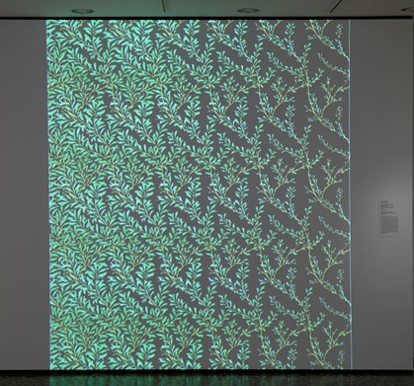

Fig. 11 Willow Boughs 1887 from the series Look At Your Walls

But along with our advancements in science and technology come more pressing issues of environmental destruction. Is it enough now to just enjoy a beautifully illustrated representation of nature? Many designers now want to make a statement, and to start a conversation about these issues. Washington comments,

Our populations are expanding, and the increases in energy use from fossil fuels, and our release of wastes, are weakening the very life- supporting functions on which we all depend for survival. Many entire ecosystems are degraded and verging on collapse.
(Washington, 2013)

High profile wallpaper designers have begun to focus on the natural world and its preservation and protection. We are destroying the ecosystems in our natural world that we rely on, and are risking the lives of all other living organisms by doing so. The harrowing truth is that we have already pushed too far for many, countless endangered species becoming extinct to never be seen again. Moooi seeks to explore this in their ‘Menagerie of Extinct Animals’ wallcovering, shown in this image. “Moooi celebrates nature’s diversity, stimulating to stretch the limits of imagination” (Moooi, no date).With intricate and detailed observational drawing, the designers at Moooi are able to recreate these creatures we will never see in the flesh again, creating a sombre but aesthetically beautiful composition. Mixing large and smaller scale motifs of foliage and animal life, this wallpaper spins a narrative of life for these species in the tropical rainforests before they became extinct. In an illustrative style much like Merian, and technical skill in painting evident in the true to life colours and realism of the animals, Moooi have used the curiosity of society about the natural world and created a tableau of still life.

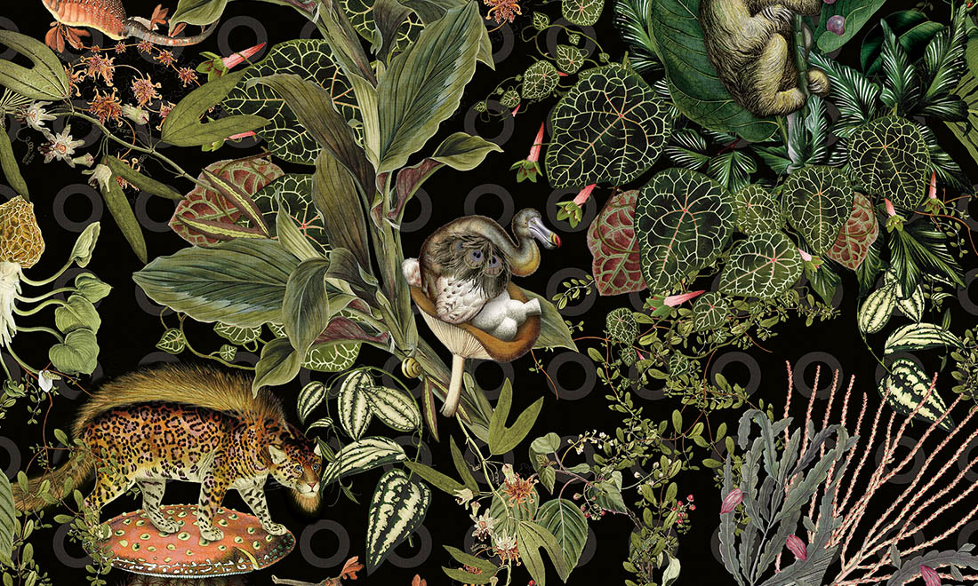

Fig. 12 Menagerie of Extinct Animals

Conclusion

Bringing this discussion to a close, I have explored the artists, scientists and designers of the 17th to the 21st century, who have laid the foundations of our knowledge about nature, and then satiated our curiosity for the natural world through their work. By incorporating my practice of Wallpaper into this essay, I have developed an understanding of how the natural world can be visualised and represented; By first exploring some of the most driven and passionate artists of the early 16th to 19th century, finding out their methodologies, what inspires and excites them, and what they wanted to achieve through their work. Curiosity played its role in driving these artists to investigate and experiment, the desire to understand and gain new knowledge drives us throughout our life spans; searching and questioning. Debating and deriving answers is thought to be an intrinsic quality of being human (Kidd and Hayden, 2015). Merian’s thirst for knowledge led her on an ambitious voyage far from home, whilst Sarah Stone, without the means to travel, spent much of her life illustrating from Curiosity Cabinets that shared their knowledge with her. Da Vinci’s notebooks and extensive list of interests not limited to botany and nature exhibit his intense curiosity, and the more modern Mooi Designs explore extinct species they have never seen in the flesh, utilising these treasures of history to produce their design. Each of these early artists work heavily incorporated the relationship between science and art, using art as a means to further scientific discovery, but also using science as a means to produce wonderous illustrations of nature, that are still relevant and respected today. The advancements in the technology of book printing can also be considered an essential part of each early artists exploration of nature, as it allowed them to share their ideas. Global trade and travel also were a key part of this process, providing trade links and access to natural specimens.

Incorporating Wallpaper into this exploration of natural representation in art began with the key values artists such as Ernst Haeckel and William Morris shared, that nature is the true influence of ornament in design. Moving from Haeckel’s strange, captivating motifs to Morris’s linear, decorative style of design is very natural in itself, and allowed the further exploration of naturalistic design for the home. The Biophilia theory supports Morris’s advocation of floral and plant based designs for the home, and gives theoretical support to the demand for Chinese style wallpapers in the 19th century.
Looking forward, designers such as Christopher Pearson demonstrate the ability to incorporate new technologies such as projectors and screens, as well as the systems used in his creation process. Breathing new life and meaning into a previously flat and motionless depiction of nature, contemporary wallpaper in the 21st century takes inspiration from the past and focuses on the innovations of today. Moooi’s exploration of the extinct natural world is also a relevant and important source as It highlights how attitudes are changing towards the natural world, and we cannot ignore the pressing issues facing our environment for fear of losing more than we already have.
There is a lot more to be said about the illustrative representation of the natural world, a deeper exploration into the more recent environmental crisis could raise new questions and new curiosities to be satiated. This essay has definitely sparked a curiosity in me to press further into the realm of natural illustration and ornament, to expand on the knowledge gained through experiencing this piece of writing.

Bibliography

Arts and Crafts Exhibition Society and Morris, W. (1893) Arts and Crafts Essays by Members of the Arts and Crafts Exhibition Society. London: Rivington, Percival, & Co. Available at: https://archive.org/details/artscraftsessays00artsrich/page/52 (Accessed: 30 October 2019).

Attenborough, D. et al. (2016) Amazing Rare Things. 5th edn. London: Royal Collection Trust.

Bacon, F., Davison, F. and Canning, W. (1688) ‘Gesta Grayorum: or, The history of the high and mighty prince, Henry Prince of Purpoole, Arch-Duke of Stapulia and Bernardia, Duke of High and Nether Holborn, Marquis of St. Giles and Tottenham, Count Palatine of Bloomsbury and Clerkenwell, Great Lord of’. London: Printed for W. Canning, at his shop in the Temple-Cloysters, p. 34.

Briedbach, O. (2006) Visions of Nature: The Art and Science of Ernst Haeckel. Munich, Berlin, London, New York: Prestel.

Brunner, M. (2019) ‘Wallpaper murals no longer a splurge : Digital-printing technology is making them accessible to the masses’, Chicago Tribune, 4. Available at: https://search-proquest-com.ezproxy.uwtsd.ac.uk/docview/2218085945?accountid=130472&rfr_id=info%3Axri%2Fsid%3Aprimo (Accessed: 11 December 2019).

Chipp, H. B., Selz, P. and Taylor, J. C. (1968) Theories of Modern Art: A Sourcebook by Artists and Critics. Berkeley, Los Angeles and London: University of California Press. Available at: https://books.google.co.uk/books?id=UZ4Gu7a7V9UC&pg=PA140&lpg=PA140&dq=An+artist+must+possess+Nature.+He+must+identify+himself+with+her+rhythm,+by+efforts+that+will+prepare+the+mastery+which+will+later+enable+him+to+express+himself+in+his+own+language&sou.

Clark, K. (2005) Leonardo Da Vinci. London: The Folio Society.
Etheridge, K. (2011) ‘Maria Sibylla Merian and the metamorphosis of natural history’, Endeavour, pp. 16–22. doi: 10.1016/j.endeavour.2010.10.002.

Finn, M. and Smith, K. (2018) East India Company at Home, 1757-1857. London: UCL Press. doi: 10.2307/j.ctt21c4tfn.1.

Gere, C. (2006) Art, Time, and Technology. Oxford: Berg Publishers. Available at: https://web-b-ebscohost-com.ezproxy.uwtsd.ac.uk/ehost/ebookviewer/ebook/bmxlYmtfXzIwNDEyN19fQU41?sid=b3d08b12-c3e3-472a-8ca2-f08e3fdf2c4b@sessionmgr101&vid=4&format=EB&rid=1 (Accessed: 11 December 2019).

Gillow, N. (1995) William Morris : designs and motifs. London: Studio Editions.
Hoskins, L. (2005) The Papered Wall: The History, Patterns and Techniques of Wallpaper. London: Thames and Hudson Ltd.

Irmscher, C. (2018) ‘“The Art and Science of Ernst Haeckel” Review: The Zoologist as Artist; A scientist-draftsman for whom the organic world was a pageant of loveliness’, Wall Street Journal (Online). Available at: https://search-proquest-com.ezproxy.uwtsd.ac.uk/docview/2024600960?accountid=130472&rfr_id=info%3Axri%2Fsid%3Aprimo (Accessed: 7 December 2019).

Jackson, C. E. (1998) Sarah Stone: Natural Curiosities from the New Worlds. London: Merrel Holberton, The Natural History Museum London.

James, W. (1983) Talks to Teachers on Psychology and to Students on Some of Life’s Ideals. Cambridge, Massachusetts, London: Harvard University Press. Available at: https://books.google.co.uk/books?hl=en&lr=&id=fQ_afRTtS4kC&oi=fnd&pg=PR5&ots=ueXEFqOHxX&sig=xqOOtqyai3TRbfy9MP-GhteMz88&redir_esc=y#v=onepage&q&f=false (Accessed: 19 November 2019).

Joia, R. de and Bradley, E. (1990) A Popular Art: British Wallpapers 1930 - 1960. London: Middlesex Polytechnic.

Kaufmam, T. D. (1993) The Mastery of Nature Aspects of art, science and humanism in the renaissance. New Jersey: Princeton University Press.

Kellert, R. S. and Wilson, E. (1993) The Biophilia Hypothesis. Washington: Island Press.

Kidd, C. and Hayden, B. Y. (2015) ‘The Psychology and Neuroscience of Curiosity’, Neuron. Cell Press, pp. 449–460. doi: 10.1016/j.neuron.2015.09.010.

Kleinbauer, W. E. (1989) Modern Perspectives in Western Art History: An Anthology of Twentieth-century Writings on the Visual Arts. Canada: University of Toronto Press. Available at: https://lauradufresne.files.wordpress.com/2013/12/panofsky_renaissance-and-renascences.pdf.

Loewenstein, G. (1994) ‘The psychology of curiosity: A review and reinterpretation.’, Psychological Bulletin, 116(1), pp. 75–98. doi: 10.1037/0033-2909.116.1.75.

Merian, S. M. (1705) Metamorphosis insectorum Surinamensium Verandering der Surinaamsche insecten: Transformation of the Surinamese insects. Edited by van M. Delft and H. Mulder. Lannoo Publishers and Koninklijke Bibliotheek.

Miller, A. I. (1995) ‘Aesthetics, Representation and Creativity in Art and Science’, Leonardo, 28(3), p. 185. doi: 10.2307/1576073.

Milman, M. (1983) Trompe-L’oeil painting: The Illusions of Reality. London: Geneva.
Moooi (no date) Menagerie of Extinct Animals. Available at: https://www.arte-international.com/en/collections/moooi-wallcovering-extinct-animals/menagerie-of-extinct-animals (Accessed: 11 December 2019).

Naylor, G. (1996) William Morris By Himself: Designs and Writings. Edited by S. Chapman and E. Eyres. Great Britain: Little, Brown and Company.

Nelson, C. E., Elliot, D. J. and Waring, J. O. (2015) The Curious Mister Catesby: A ‘truly Ingenious’ Naturalist Explores New Worlds. Athens: University of Georgia Press.

Parry, L. and Victoria and Albert Museum (1996) William Morris. London: Philip Wilson Publishers.

Sachs, A. and Zürich, M. für G. (2007) Nature Design: From inspiration to innovation. Edited by C. Reble. Baden : Lars Müller.

Saunders, G. et al. (2010) Walls Are Talking: Wallpaper, Art and Culture. Manchester: The Whitworth Art Gallery.

Da Vinci, L. and Richter, J. P. (2016) The Notebooks of Leonardo Da Vinci: Volume 2. United States: Dover Publications.

Washington, H. (2013) Human Dependence on Nature: How to help solve the environmental crisis. New York and Oxon: Routledge.

Wilson, E. O. (1929) Biophilia: The human bond with other species. Cambridge: Harvard University Press.

Wolfgang Von Goethe, J. (2009) The Metamorphosis of Plants. Massachussetts: The MIT Press. Available at:
https://rekveld.home.xs4all.nl/growth/Goethe_MetamorphosisPlants2009.pdf (Accessed: 29 April 2019).

