2110786
Action Research Project
Student Engagement: What are the methods for syncing the delivery of in-person and online teaching sessions.

Introduction:
Following the COVID-19 pandemic, there has been a significant change in how educational organisations deliver lessons, with some students attending in-person lessons whereas others attend online (Williams, Haynes and Kim, 2021). There is academic consensus that student engagement is an integral part of teaching due to the links to academic attainment that engagement has on the learner (Giallo and Little, 2003; Khan et al, 2021; Park, 2003; Parsonson, 2012; Reece and Walker, 2007). According to Khan et al (2021, p. 107) ‘’student engagement is key to successful teaching and learning, irrespective of the content and format of the content delivery mechanism.’’ This highlights how engagement from students during lessons is important from those participating in sessions, both online and in-person.
The overall research question for this research project is:
‘’Student Engagement: What are the methods of syncing the delivery of in-person and online teaching sessions’’.
This topic area has been chosen due to observing and experiencing difficulty in simultaneously engaging students online and in-person when delivering sessions during placement and a noticed a lack of engagement from students participating online.
In light of the context provided and the overall research problem, the following objectives have been developed to explore the current methods used to synchronise the delivery of in-person and online teaching:
- To what extent is student engagement within sessions important and necessary?
- To what extent, is student engagement from students participating in sessions in-person and online important?
- What strategies can be used to ensure the engagement of students in-person and online?
The following section will provide an overview of the methodology utilised for this project considering the epistemological and ontological considerations, the data that will be analysed and the methodological and ethical limitations that have been accounted for. Moreover, there will be an extensive review of literature and discussion on the importance and necessity of student engagement as a whole and when students are participating in sessions in-person and online and the strategies employed by lecturers to ensure the engagement of both participating parties. Additionally, recommendations will be suggested on how students could be engaged simultaneously online and in-person during teaching sessions.

Methodology:
Action Research, Epistemology and Ontology:
An action research approach has been chosen for this project, a popular methodological approach within education (Baumfield, Hall and Wall, 2012; Cohen, Manion and Morrison, 2018; Hine, 2013). Despite this, there is a lack of academic consensus on the definition of what constitutes as action research, however, Costello (2003, p.5) examined various definitions of action research and implied that action research is ‘’a term, process, approach, flexible spiral process’’ that ‘’has practical’’ and ‘’problem solving’’ elements that ‘’involves research, systematic, critical reflection and action’’ to ‘’improve educational practice.’’
It is important to understand the epistemological and ontological positions taken within this research. The purpose of this research is to investigate strategies used to keep students engaged simultaneously during in-person and online sessions. Epistemology ‘’examines the concept of ‘knowledge’’’ (Crow and Semmens, 2006, p. 23). The epistemological position taken in this research is interpretivism. According to Edirisingha (2012, no page number), ‘’the goal of interpretivism research is to understand and interpret the meanings in human behaviour’’. Therefore, this study aims to look into the importance of student engagement and the strategies utilised by teachers to ensure that both students participating online and in-person are engaged with the content of the lesson. This links in with the ontology which is defined as ‘’the nature of social entities’’ and if these entities are socially constructed by ‘’perceptions and actions’’ (Bryman, 2016, p. 29). The ontological position taken within this research is subjectivism as this research enquires into how people communicate and the different experiences that people have (Bahari, 2010).
Methodological Process:
The methodological approach utilised for this research is a secondary analysis which is defined as ‘’a form of inquiry and analysis based entirely on pre-existing sources’’ (Jupp et al, 2002, cited in Davies, Francis and Jupp, 2011, p. 22). Considering this research enquires into the importance of student engagement and the strategies employed to ensure that students are simultaneously engaged when participating online and in-person, the research will draw on sources within education and utilise reports, research articles and student-teacher experience reports. However, it is important to look at internet sources such as blogs and journal articles to be able to examine the importance of student engagement and the strategies used to achieve this in a Hyflex teaching environment.
Methodological Limitations and Ethical Considerations:
It is beneficial to recognise the methodological limitations of utilising secondary data as a method as understanding the limitations can aid in minimising any issues within this research project. Some limitations of secondary data are - lack of familiarity with data, complicated data and a lack of control over the quality of the data (Bryman, 2016). However, these limitations can be mitigated by ensuring that the data is extensively analysed before being utilised within this research and critically analysing the data within the discussion to draw attention to any issues with the quality of the data.
Moreover, it is important to understand the ethical principles that guided the methodological choice of conducting secondary data analysis for this research. For example, The Social Research Association (SRA) (2003, p. 27) highlights how informed consent is one of the issues that usually occurs within research due, to the fact participation within research projects should be as ‘’informed as possible’’ and they should be aware of their right to ‘’refuse’’ participation and ‘’withdraw from the study’’ if they choose to. This indicates how research involving human subjects should be given information regarding their involvement within the study which may influence the results of the project. Despite this, the subject of inquiry in this research involves secondary data that is available on open-source platforms, therefore, its ‘’permission for further use is implied’’ (Tripathy, 2013, p. 1478). Furthermore, the SRA (2003) states that measures should be taken to ensure that the participant’s identity is not disclosed within the research. This highlights the importance of confidentiality and anonymity. However, the use of secondary analysis reduces issues with anonymity within this research project.

Discussion:
To what extent is student engagement within sessions important and necessary?
Student engagement is a vital part of the teaching and learning process, as students who engage more with the lesson content have higher levels of academic attainment and success (Park, 2003). Advance HE (2020, no page number) define student engagement as ‘’the amount of time and effort students invest in their studies’’ and engagement with their learning is ‘’linked to their level of academic achievement’’. This accentuates the importance of student engagement due to the fact it has a significant impact on their overall success.
Student engagement is concerned with the interaction between the time, effort and other relevant resources invested by both students and their institutions intended to optimise the student experience and enhance the learning outcomes and development of students and the performance, and reputation of the institution. (Trowler, 2010, p. 3).
This highlights, however, that engagement within learning is a two-way process between students and teachers. Therefore, teachers must utilise tools to engage students within their learning both in an in-person and online environment. However, there have been issues with engaging students within lessons, for example, Kahn (2014, p. 1005) states how ‘’student engagement has become problematic following the rise of mass and universal forms of higher education.’’ This indicates how student engagement has become difficult due to the different forms of higher education available to students. This could be due to the fact in modern-day society there are a variety of ways that students can participate in education, for example, ‘’hybrid, flipped, blended or web-facilitated, instruction… combines online and face-to-face components’’ are ‘’more prevalent than ever in higher education’’ (Perrow, 2017, p. 1). This illustrates the different methods of delivery available to students, despite this, student engagement is still an extremely important factor for learners (Khan et al, 2021; Perrow, 2017; Trowler, 2010).
As stated in the introduction, the COVID-19 pandemic changed the face of education in the way that lessons were delivered, with many educational organisations adopting ‘’blended learning initiatives to ensure continuity’’ (Dahmash, 2020, p. 221). However, amid the adoption of blended learning approaches, there has been a decrease in the levels of student engagement and students have seemed to favour face to face learning due to the fact they viewed these methods of teaching as more engaging (Mali and Lim, 2021). Khan et al (2021, p. 1) stress how ‘’student engagement is not only a challenge in traditional face-to-face classrooms but also, and debatably more so, in online courses.’’ This accentuates how student engagement is a challenge as a whole but can be increasingly difficult with individuals participating online.
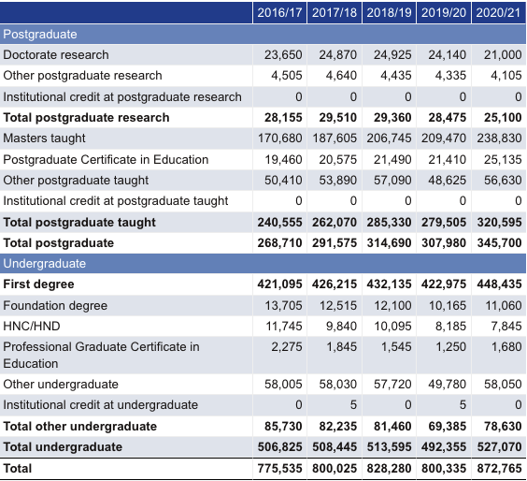
When measuring engagement during online learning there are three dimensions - ‘learner-instructor interaction’, ‘learner-learner’ interaction’ and ‘learner-content interaction’ (Kennedy, 2020). However, these dimensions may be difficult to measure when teaching simultaneously to students online and in person. Similarly, traditional student engagement has been measured in terms of - behavioural, emotional and cognitive engagement (Uden, Ritzen and Pieters, 2014). According to Uden, Ritzen and Pieters (2014) behavioural engagement refers to punctuality to lessons and deadlines, emotional engagement refers to their interest in the topic and cognitive engagement is connected to their understanding of the topic and assignment. These dimensions of measuring engagement are more manageable when applying it to a synchronised in-person and online sessions. For example, attendance can be measured in online and in-person sessions simultaneously which measures the students’ behavioural engagement and students’ cognitive engagement can be measured during formative and summative.
Despite the changing landscape in education since the COVID-19 pandemic there has been an overall increase in the number of individuals participating in higher education within the UK.
(HESA, 2022).
This table indicates a 9% increase in the number of individuals participating in higher education in the academic year of 2020/21 compared to the year of 2019/20. Despite the increase in the number of individuals engaging in higher education programmes, this does not mean that effective levels of student engagement are being met during higher education courses. For example, Rowan and Neves (2021) in the UK Engagement Survey (UKES) highlight how there is a continual low level of interaction with staff, staff-student partnerships, as well as relatively low levels of learning with peers which illustrate how student engagement is not being effectively met. Payne (2019, p. 641) brings to attention how ‘’student engagement is an issue which concerns many academics across further and higher education’’ which accentuates the importance that student engagement has within education.
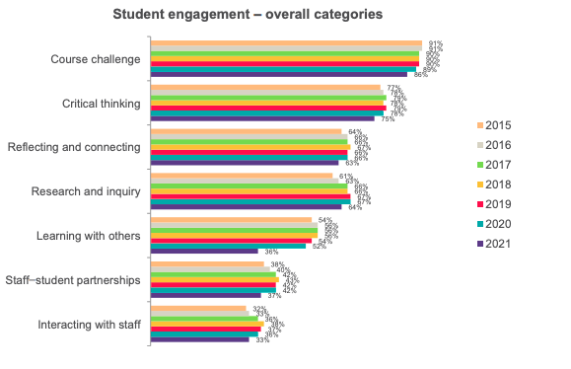
The UKES is a national questionnaire developed for undergraduate students that focuses on engagement. The categories that they use to enquire into student engagement are - ‘course challenging’, ‘critical thinking’, ‘reflecting and connecting’, ‘research and inquiry’, ‘learning with others’, ‘student-staff partnerships’ and ‘interacting with staff’ (Rowan and Neves, 2021).
ECPT6009

Sian Wall (2110786)

(Rowan and Neves, 2021, p. 10).
This table has been taken from the 2021 UKES and illustrates the overall categories used to measure student engagement in 2021 compared to previous years. One of the most significant decreases in engagement during the year 2021 was learner-learner engagement as that only scored 36% compared to 52% during the previous year. Arguably this could be a result of the COVID-19 pandemic where learning moved from in-person to online means (Dahmash, 2021; Kohnke and Moorehouse, 2021; Williams Haynes and Kim, 2020). According to Bolliger and Martin (2018, p. 569) ‘’Learner-learner interaction is important in the engagement of students’’ as this interaction allows students to interact with their peers for further support and brainstorming ideas between each other.
It has been noted how it is important and necessary for students to be engaged within sessions due to the links that engagements has with academic success and attainment (Park, 2003; Trowler). According to Martin and Bolliger (2018, p. 205) ‘’student engagement increases student satisfaction, enhances student motivation to learn, reduces the sense of isolation, and improves student performance’’, this accentuates the importance and necessity of student engagement within sessions. Additionally, there is evidence that suggests that engagement or lack thereof is a mitigating factor in the reasons that students drop out of university (Behr et al, 2021) which heightens the importance and necessity of engaging students within higher education.

To what extent, is student engagement from students participating in sessions in-person and online important?
Many higher education institutions today teach in multiple modes, including on-campus, at a distance, online or a blend of a number of modes. The challenge is to provide all students with equitable access to learning independent of the blends of delivery modes.
(Taylor and Newton, 2013, p. 54).
This quote highlights how many educational institutions are delivering their teaching via various methods which includes a synchronous approach online and in-person and highlight the need for all students to have equal opportunities within their learning regardless of whether they’re choosing to attend sessions online or in-person. Nevertheless, simultaneously engaging students who are participating online and in-person has been met with challenges and negative feedback from students. For example, Kohnke and Moorehouses’ (2021) research highlight how students who have experienced simultaneous teaching environments found there to be communication problems, desire for normalcy in teaching environments, increased workloads, motivational issues and software problems. This emphasises how concurrently delivering lessons to students online and in-person can cause problems for the students.
Additionally, traditional and online teaching environments are different due to the fact ‘’communication in traditional classrooms are mainly verbal, with visual cues and body language’’ being seen (Lin, 2008, p. 57), whereas body language and visual cues can be missed online. Despite Lin’s (2008) research being slightly outdated highlights the challenges of engaging students during an online environment as there can be issues with miscommunication during online lessons and no visual cues from body language. However, Hapke, Lee-Post and Dean (2021) illustrate in the results of their research that students felt more engaged and involved in their learning, had questions addressed more, understood the learning materials better, were more engaged in non-assessed work and were more interested in the course when a hybrid approach was applied rather than solely relying on face-to-face interaction. This suggests that utilising methods of teaching that are applied both online and in-person are beneficial to learner engagement. Despite this, Hapke, Lee-Post and Deans’ (2021) research does not address how to simultaneously engage students participating in sessions online and in-person.
As touched upon, student engagement is a challenge even in traditional means of delivering content to students (Kahn, 2014). Kemp and Grieve (2014, p. 2) indicate how engagement depletes even further when they are participating online as they ‘’felt more disconnected from their peers and lecturers, more obliged to be self-directed in their studies, and less aided by their lecturer…’’ This heightens how students can feel disengaged from their studies when participating online. However, the research by Kemp and Grieve (2014) does not enquire into how students feel in terms of engagement when students are being taught online and in-person simultaneously. Cavinato et al (2021) illustrate within their research some of the challenges that online learning brings, these include - limited interaction with peers and limited engagement with teaching staff. However, these can be mitigated through various pedagogical strategies already in place for traditional means of teaching. For example, when teaching sessions to individuals participating in-person and online group work may be challenging, however, if the teacher ensured that breakout rooms were utilised so that the students participating online could engage with this task as well as the students on-campus this would be significantly advantageous to both parties. Moreover, allowing students to engage with peers regardless of where the individual is joining from the teacher could utilise technology to allow students to collaborate virtually within the lesson (Kohnke and Moorhouse, 2021). The use of technology is beneficial in amplifying learner engagement due to the fact it ‘’excites learners, increasing their motivation to learn’’ and this ‘’allows learners to test their understanding’’ and encourage ‘’reluctant learners’’ to participate (Race and Pickford, 2007, p. 98). This suggests that technology is a valuable tool to assist with engaging learners online and in-person coincidently.
According to Heilporn and Lakhal (2021) the way in which higher education courses are being delivered in recent years has substantially changed with an increase with online, blended and Hyflex means of delivering lessons to students. This can often have a negative impact on the levels of engagement from students participating in these different modes of teaching.
On the one hand, students in face-to-face (or traditional blended courses) have multiple opportunities to interact with the instructor and other students… On the other, students in online asynchronous courses often suffer from a lack of interaction opportunities and have to bear all the responsibility for their learning.
(Heilporn and Lakhal, 2021, p. 2).
This quote indicates the importance of engaging students within their learning regardless of the mode or means that they are participating. Regardless of whether a student is choosing to participate in sessions in-person or online, they should still have the same level of engagement. It has been noted that students who participate in sessions online feel more disconnected from their lecturers and class and feel that they experience less guidance and support from their lecturer (Kemp and Grieve, 2014).
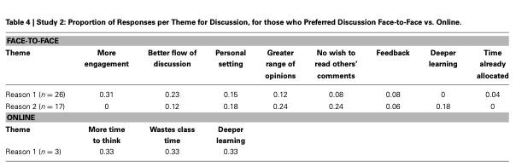 (Kemp and Grieve, 2014, p. 8).
This table has been taken from Kemp and Grieve’s (2014) research and illustrates students’ responses in relation to the utilisation of discussions in online and face-to-face learning. It is evident in this table that more engagement and the flow of discussion was better in a face-to-face setting than in an online setting. However, discussions online allowed the student more time to think. Despite this, Kemp and Grieve’s research does not investigate the importance of simultaneously engaging students participating in-person and online.

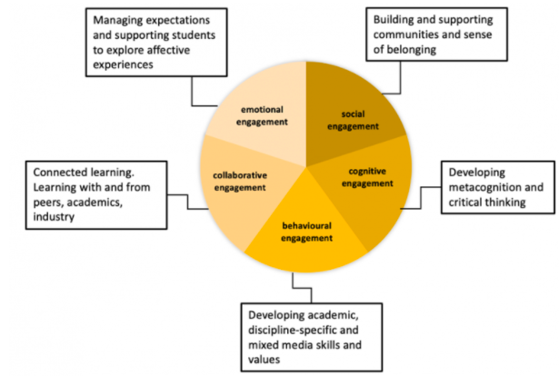
(University College London (UCL), 2021).
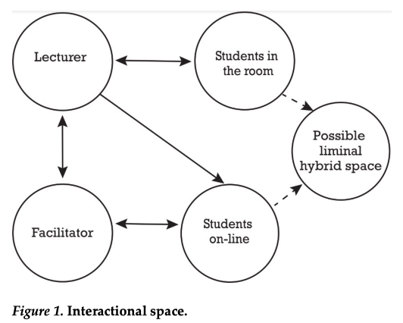
This diagram by UCL (2021) illustrates the modes of engagement that can be adopted by lecturers during in-person and online teaching. Although these modes of engagement are more centred on in-person learning environments, they can easily be adapted to environments where students are engaging online and in-person. For example, ‘social engagement’ and ‘cognitive engagement’ could be applied in an in-person-online teaching environment by making students in-person complete tasks on shared documents with those participating online.

(Leijon and Lundgren, 2019, p. 5).
This figure taken from Leijon and Lundgren’s (2019) research exemplifies the possible space whereby they can get the students in different spaces to interact. For example, taking the modes of engagement proposed by UCL (2021) the lecturer could get the students in-person to collaboratively engage with the students online during tasks. Also, the lecturer could provide emotional engagement to both parties of students by taking the time to speak to students regarding their comprehension and actively engaging students online during this process. This also links in with objective three, however, these strategies are important to discuss within this objective as they can alleviate students’ disconnect to sessions when it is being delivered via simultaneous modes.

What strategies can be used to ensure the engagement of students in-person and online?
There is a lack of academic research that enquires into the effective methods of teaching students simultaneously online and in-person. However, Ferlazzo (2021) suggests that when teachers are conducting hybrid sessions the students online still need to feel part of the lesson, interaction with students online and in-person is vital to ensuring engagement, there may need to have different expectations for the in-person and online learners and teachers should use a variety of strategies to demonstrate engagement from learners participating online as well as those in the classroom. Furthermore, Crook and Crook (2020) propose that when teaching online and in-person at the same time there need to be chat functions available for students who are participating online which can also be accessed by students in-person, breakout rooms to allow for peer-to-peer engagement that mirrors what would be occurring during in-person settings and interactive tools for both participating parties to access. Despite these methods of engaging students online and in-person simultaneously, Kemp and Grieve (2014, p. 5) suggest that students ‘’felt more engaged when the activities were completed in the social environment of a classroom setting, rather than online.’’ Although Kemp and Grieves’ research is somewhat outdated as there have been major technological advancements since their research was conducted, which can actively engage students via online delivery methods.

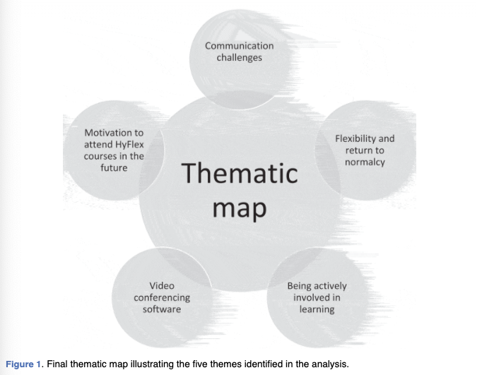
(Kohnke and Moorehouse, 2021, p. 236).
This figure from Kohnke and Moorehouse’s (2021) research illustrates the five key themes that became apparent following their research on students’ perspectives of a Hyflex approach within higher education. One predominant theme that emerged was communication issues between the lecturer and the student when it comes to tasks (Kemp and Moorehouse, 2021). However, there are methods that can be used to improve communication when teaching students online and in person.
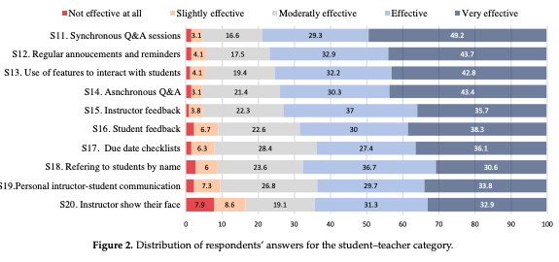
(Abou-Khalil et al, 2021, p. 8).
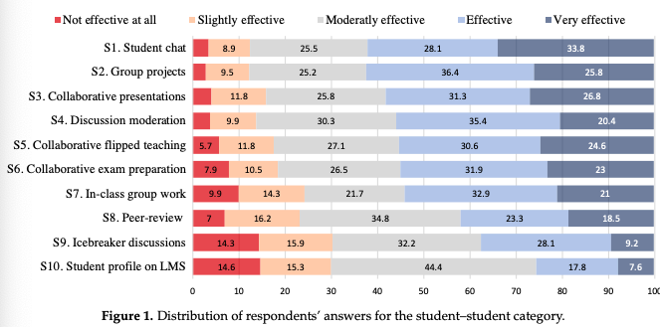
This figure is from Abou-Khalil et al (2021) research on effective online engagement strategies and clearly highlights how 78.5% of student respondents thought that synchronous Q&A sessions were effective engagement strategies, 75% of students thought the use of features to interact with students were effective and 63.5% of students believed the use of instructor communication was an effective engagement strategy utilised by lecturers.
(Abou-Khalil et al, 2021, p. 7).
This figure illustrates the findings from Abou-Khalil et al (2021) study on how the to engage students with other students in online sessions. This figure demonstrates how 61.9% of students felt that student chat functions were an effective engagement strategy, 55.8% of students felt that discussion moderation was an effective engagement strategy and 53.9% of students felt effectively engaged in in-class group work. Although Abou-Khalil et al’s (2021) research does not enquire into the methods of engagement utilised in simultaneous in-person and online sessions and focuses solely on online sessions, however, these methods can be utilised during in-person and online sessions simultaneously. For example, lecturers can use Q&A sessions via means of technology: students online and in-person can engage in this simultaneously and this can be enhanced by the use of chat functions Teams whereby students online can communicate with the students in-person.
Leijon and Lundgren’s (2019) research investigates how lecturers interacted with students during Hyflex learning environments with those participating online and in person. Their research investigated how three teachers connected with students online and in-person simultaneously and found that there was a difference between how the teachers interacted - some being online and room-orientated and others being room-orientated (Leijon and Lundgren, 2019). It can be deciphered that room-orientated teachers can have a detrimental effect to those who are participating online, whereas the online and room-orientated strategies employed can effectively engage students in both participating spheres. However, Leijon and Lundgren’s (2019) hold limitations due to the fact they only enquired into how three teachers engaged students online and in person.

Conclusion:
The overall aim of this action research project was to unveil the main research question - Student Engagement: What are the methods of syncing the delivery of in-person and online teaching sessions. This research aimed to inquire into the importance of student engagement and the strategies employed by lecturers to ensure engagement from students participating online and in person.
In light of the overall focus and aim of this action research questions, three objectives were proposed:
- To what extent is student engagement within sessions important and necessary?
- To what extent, is student engagement from students participating in sessions in-person and online important?
- What strategies can be used to ensure the engagement of students in-person and online?
After an extensive and critical discussion of literature, this action research project has found that student engagement is important and necessary due to the links that engagement has with academic attainment, connection with content, peers and staff and overall student satisfaction (Hapke, Lee-Post and Dean, 2021; Kemp and Grieve, 2014; Park, 2003). Additionally, this project has established how student engagement has become increasingly problematic with the increasing modes of delivery in modern-day society (Heliporn and Lakhal, 2021; Kemp and Grieve, 2014; Taylor and Newton, 2013). Moreover, it has been determined that there are various methods and strategies for engaging students participating in sessions online and in-person such as utilising breakout rooms, chat functions and technology that can aid in the engagement of both participating parties (Abou-Khalil et al, 2021; Ferlazzo, 2021; Crook and Crook, 2020). Most importantly, this project has discovered a lack of research and literature that examines the strategies used by practitioners in education settings to ensure the simultaneous engagement of students in-person and online.
Taking into consideration the findings of this action research project, the following recommendations have been suggested:
- Student engagement, whether that be from students online or in-person, should be at the forefront of concern for lecturers when developing lessons and activities for their lecturers. Therefore, lecturers need to ensure that they utilise engaging pedagogical strategies within their lessons that focuses on engaging students in-person and online.
- Ensuring that students have engagement with other peers and the lecturer is essential to student engagement, therefore lecturers should ensure that students have opportunities to interact with other students and staff.
- When lecturers are delivering sessions simultaneously to students in-person and online, it is important that they adopt a room-online orientated approach, so that neither mode feel disconnected from the lesson.
- To further understand the strategies utilised by lecturers to ensure that students online and in-person are simultaneously engaged it may be beneficial to carry out another action research project using primary methods, such as observations, questionnaires and interviews, to see first-hand the strategies used by practitioners in certain organisations to ensure the engagement of students in Hyflex learning environments.

References:
Abou-Khalil, V., Helou, S., Khalife, E., Chen, M.A., Majumdar, R., and Ogata, H. (2021) ‘Emergency Online Learning in Low-Resources Settings: Effective Student Engagement Strategies’, Education Sciences, 11(24), pp. 1-18. DOI: 10.3390/edusci11010024.
Advance HE (2020) UK Engagement Survey. Available at: https://www.advance-he.ac.uk/reports-publications-and-resources/student-surveys/uk-engagement-survey-ukes (Accessed: 23 February 2022).
Bahari S.F. (2010) ‘Qualitative versus Quantitative Research Strategies: Contrasting Epistemological and Ontological Assumptions. Jurnal Teknologi, 52, pp. 17-28.
Baumfield, V., Hall, E., and Wall, K. (2012) Action Research in Education: Learning Through Practitioner Enquiry. 2nd Edn. London: SAGE Publications Ltd.
Behr, A., Giese, M., Kamdjou, H.D.T., and Theune, K. (2021) ‘Motives for dropping out from higher education - An analysis of bachelor’s degree students in Germany’, European Journal of Education, 56(2), pp. 325-343. Available at: https://onlinelibrary.wiley.com/doi/full/10.1111/ejed.12433 (Accessed: 11 March 2022).
Bolliger, D., and Martin, F. ‘Instructor and student perceptions of online student engagement strategies’, Distance Education, 39(4), pp. 568-583. DOI: 10.1080/01487919.2018.1520041
Bryman, A. (2012) Social Research Methods. 4 Edn. New York: Oxford University Press Inc.
Cohen, L., Manion, L., and Morrison, K. (2018) Research Methods in Education. 8th Edn. New York: Routledge.
Costello, P.J.M. (2003). Action Research. London: Continuum.
Crook, A.E., and Crook, T.W. (2020) ‘6 Tips for Teaching Online and In Person Simultaneously’, Inside Higher Ed. Available at: https://www.insidehighered.com/advice/2020/08/26/strategies-teaching-online-and-person-simultaneously-opinion (Accessed: 22 February 2022).
Crow, I., and Semmens, N. (2008) Researching Criminology. Maidenhead: Open University Press.
Dahmash, N.B. (2020) ‘’I couldn’t Join the Session’: Benefits and Challenges of Blended Learning amid COVID-19 from EFL Students’, International Journal of English Linguistics, 10(5), pp. 221-230. Available at: https://pdfs.semanticscholar.org/2820/2c8fcac24df3e1d82caa4968564a1eece1ec.pdf (Accessed: 23 February 2022).
Davies, P., Francis, P., and Jupp, V. (2011) Doing Criminological Research. (eds.) London: SAGE Publications.
Edirisingha, P. (2012) ‘Interpretivism and Positivism (Ontological and Epistemological Perspectives’ Word Press [blog]. 14th March. Available at: https://prabash78.wordpress.com/2012/03/14/interpretivism-and-postivism-ontological-and-epistemological-perspectives/ (Accessed: 7 March 2022).
Ferlazzo, L. (2021) ‘Strategies for Teaching Students Online and Face to Face at the Same Time’, Education Week [blog]. Available at: https://www.edweek.org/teaching-learning/opinion-strategies-for-teaching-students-online-face-to-face-at-the-same-time/2021/02 (Accessed: 24 February 2022).
Giallo, R., and Little, E. (2003) ‘Classroom Behaviour Problems: The Relationship between Preparedness, Classroom Experiences, and Self-efficacy in Graduate and Student Teachers’, Australian Journal of Educational and Developmental Psychology, 3, pp. 21-34. Available at: https://www.newcastle.edu.au/__data/assets/pdf_file/0017/100484/v3-giallo-little.pdf (Accessed: 22 February 2022).
Hapke, H., Lee-Post, A., and Dean, T. (2021) ‘3-in-1 Hybrid Learning Environment’, Marketing Education, 31(2), pp. 154-161. DOI: 10.1080/10528008.2020.1855989
Heilporn, G., and Lakhal, S. (2021) ‘Converting a graduate level course into a Hyflex modality: What are effective engagement strategies?’, The International Journal of Management Education, 19, pp. 1-12.
HESA (2022) What are HE students’ progression rates and qualifications? Available at: https://www.hesa.ac.uk/data-and-analysis/students/outcomes (Accessed: 11 March 2022).
Hine, G.S.C. (2013) ‘The importance of action research in teacher education programs’, Issues in Educational Research, 23(2), pp. 151-163. Available at: https://www.iier.org.au/iier23/hine.pdf (Accessed: 7 March 2022).
Kahn, P.E. (2014) ‘Theorising student engagement in higher education’, British Educational Research Journal, 40(6), pp. 1005-1018. DOI: 10.1002/berj.3121
Kemp, N., and Grieve, R. (2014) ‘Face-to-face or face-to screen? Undergraduates’ opinions and test performance in classroom vs. online learning’, Educational Psychology, 5, pp. 1-11. Available at: https://www.frontiersin.org/articles/10.3389/fpsyg.2014.01278/full (Accessed: 24 January 2022).
Kennedy, G. (2020) What is student engagement in online learning… and how do I know when it is there? Available at: https://melbourne-cshe.unimelb.edu.au/__data/assets/pdf_file/0004/3362125/student-engagement-online-learning_final.pdf (Accessed: 23 February 2022).
Khan, A., Egbue, O., Palkie, B., and Madden, J. (2021) ‘Active Learning: Engaging Students to Maximise Learning in an Online Course’, The Electronic Journal of e-Learning, 15(2), pp. 107-115.
Kohnke, L., and Moorehouse, B.L. (2021) ‘Adopting Hyflex in higher education in response to COVID-19: students’ perspectives’, The Journal of Open, Distance and E-Learning, 46(3), pp. 231-244. DOI: 10.1080/02680513.2021.1906641
Lin, Q. (2008) ‘Student Views of Hybrid Learning: A One-Year Exploratory Study’, Journal of Computing in Teacher Education, 25(2), pp. 57-66. Available at: https://files.eric.ed.gov/fulltext/EJ834097.pdf (Accessed: 24 February 2022).
Leijon, M., and Lundgren, B. (2019) ‘Connecting Physical and Virtual Spaces in Hyflex Pedagogic Model with a Focus on Teacher Interaction’, Journal of Learning Spaces, 8(1), pp. 1-9.
Mali, D., and Lim, H. (2021) ‘How do students perceive face-to-face/blended learning as a result of the Covid-19 pandemic?’. The International Journal of Management Education, 19, pp. 1-17.
Martin, F., and Bolliger, D.U. (2018) ‘Engagement Matters: Student Perceptions on the Importance of Engagement Strategies in the Online Learning Environment’, Online Journal, 22(1), pp. 205-222.
Park, C. (2003) ‘Engaging Students in the Learning Process: the learning journal’, Journal of Geography in Higher Education, 27(2), pp. 183-199. DOI: 10.1080/03098260302000107496
Parsonson, B.S. (2012) ‘Evidence-based Classroom Behaviour Management Strategies’, Kairaranga, 13(1), pp. 16-23. Available at: https://eric.ed.gov/?Id=EJ976654 (Accessed: 22 February 2022).
Payne, L. (2019) ‘Student engagement: three models for its investigation’, Journal of Further and Higher Education,43(5), pp. 641-657. DOI: 10.1080/0309877X.2017.1391186
Perrow, M. (2017) ‘Strengthening the Conversation in Blended and Face-to-Face Courses: Connecting Online and In-Person Learning with Crossover Protocols’, College Teaching, pp.1-9. DOI:10.1080/87567555.2017.1300869
Race, P., and Pickford, R. (2007) Making Teaching Work: Teaching Smarter in Post Compulsory Education. London: Sage Publications.
Reece, I., and Walker, S. (2007) Teaching, training & learning: A practical Guide. 6th Edn. Great Britain: Business Education Publishers Limited.
Rowan, A., and Neves, J. (2021) UK Engagement Survey. Available at: https://www.advance-he.ac.uk/reports-publications-and-resources/student-surveys/uk-engagement-survey-ukes (Accessed: 11 March 2021).
Social Research Association (2003) Ethical Guidelines. Available at: https://the-sra.org.uk/common/Uploaded%20files/ethical%20guidelines%202003.pdf (Accessed: 11 March 2022).
Taylor, J.A., and Newton, D. (2013) ‘Beyond blended learning: A case study of institutional change at an Australian regional university’, Internet and Higher Education, 18, pp. 54-60.
Tripathy, J.P. (2013) ‘Secondary Data Analysis: Ethical Issues and Challenges’, Iranian Journal of Public Health, 42, pp. 1478-1479. Available at: https://www.ncbi.nlm.nih.gov/pmc/articles/PMC4441947/pdf/IJPH-42-1478.pdf (Accessed: 11 March 2022).
Trowler, V. (2010) ‘Student engagement literature review’, The Higher Education Academy, pp. 1-74. Available at: https://www.advance-he.ac.uk/knowledge-hub/student-engagement-literature-review (Accessed: 23 February 2022).
University College London (2021) Encouraging student engagement with blended and online learning. Available at: https://www.ucl.ac.uk/teaching-learning/publications/2021/oct/encouraging-student-engagement-blended-and-online-learning (Accessed: 11 March).
Uden, J.M., Ritzen, H., and Pieters, J.M. (2014) ‘Engaging students: The role of teachers beliefs and interpersonal teacher behaviour in fostering student engagement in vocational education’, Teaching and Teacher Education, 34, pp. 21-32.
Williams, H., Haynes, M., and Kim, J. (2021) ‘Dual Teaching: Simultaneous Remote and In-Person Learning During COVID’ (from the Proceedings of 22nd Annual Conference on Information Technology Education. SIGITE, New York, 6th-9th October). United States Military Academy, pp. 111-116.

