
Assignment Component 1
Website Redesign for Online Business Presence

Morgan Dora 2327894

Module: Business and Web Management
BSc Applied Computing


Module code: ACCA5019

Lecturer: Md Sadeque Imam

University of Wales, Trinity Saint David, London Campus
05. November 2025

Task 1 – UI/UX Web Design Phases

Phase 1: Mood board creation
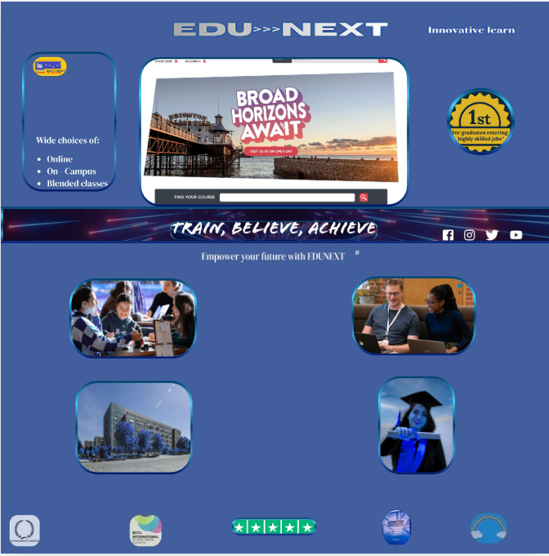
https://www.canva.com/design/DAG4rHTuEgg/_KhZDiZnru1D6fBw8IyNqQ/edit?utm_content=DAG4rHTuEgg&utm_campaign=designshare&utm_medium=link2&utm_source=sharebutton
Logo prototype WF: 

Phase 2: Wireframe design
Objective:
Defining the structure, layout, and functionality of the website’s key pages.
  - Home page
  - Course listing page and Course descriptions
  - User profile/dashboard
  - Enrolment/checkout page.
  - About us / contact pages
Key Considerations: Clear navigation and menu structure, Logical placement of CTAs (Call-to-Action buttons), User-friendly flow for browsing, searching, and enrolling in courses, Accessibility, and responsive layout.

Link: https://www.figma.com/make/FnTYRTe7Ucp5a02BOK6Uf2/Wireframe-Design?node-id=0-1&t=Dz4GURNhon8GaCGK-1

Screenshots of Wireframe design:
Home page
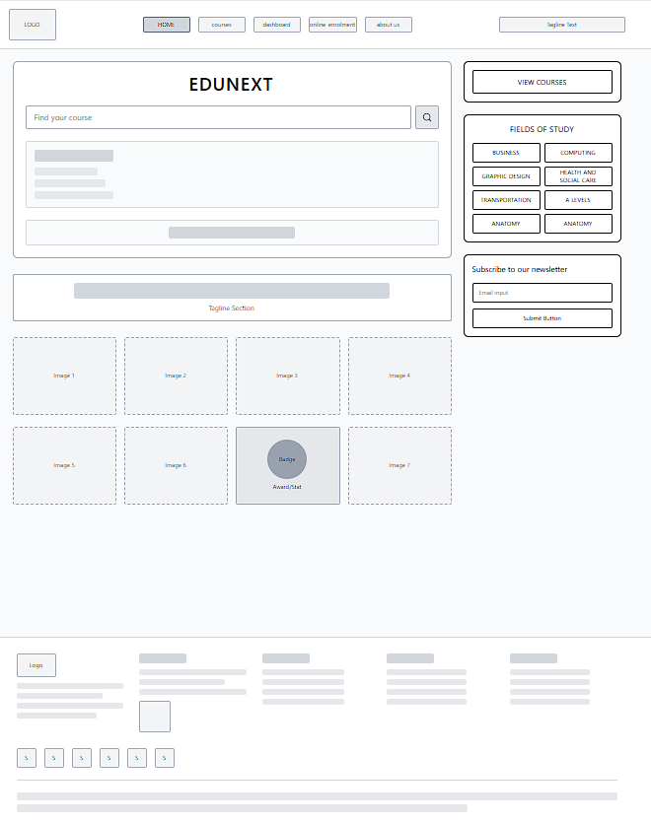

Courses page
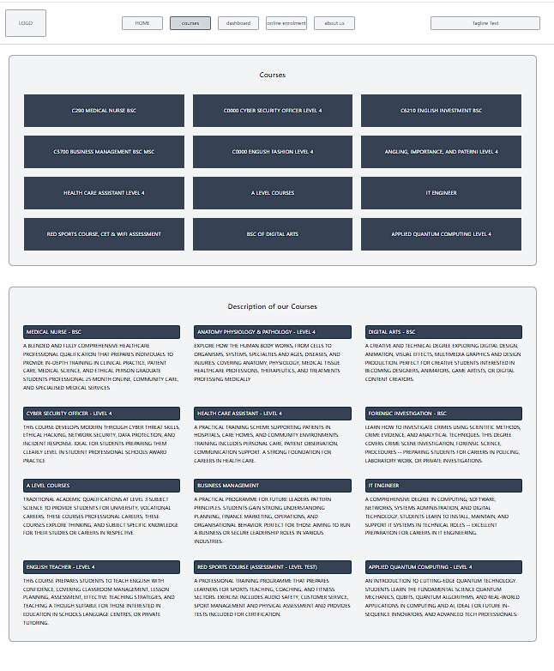

Dashboard page

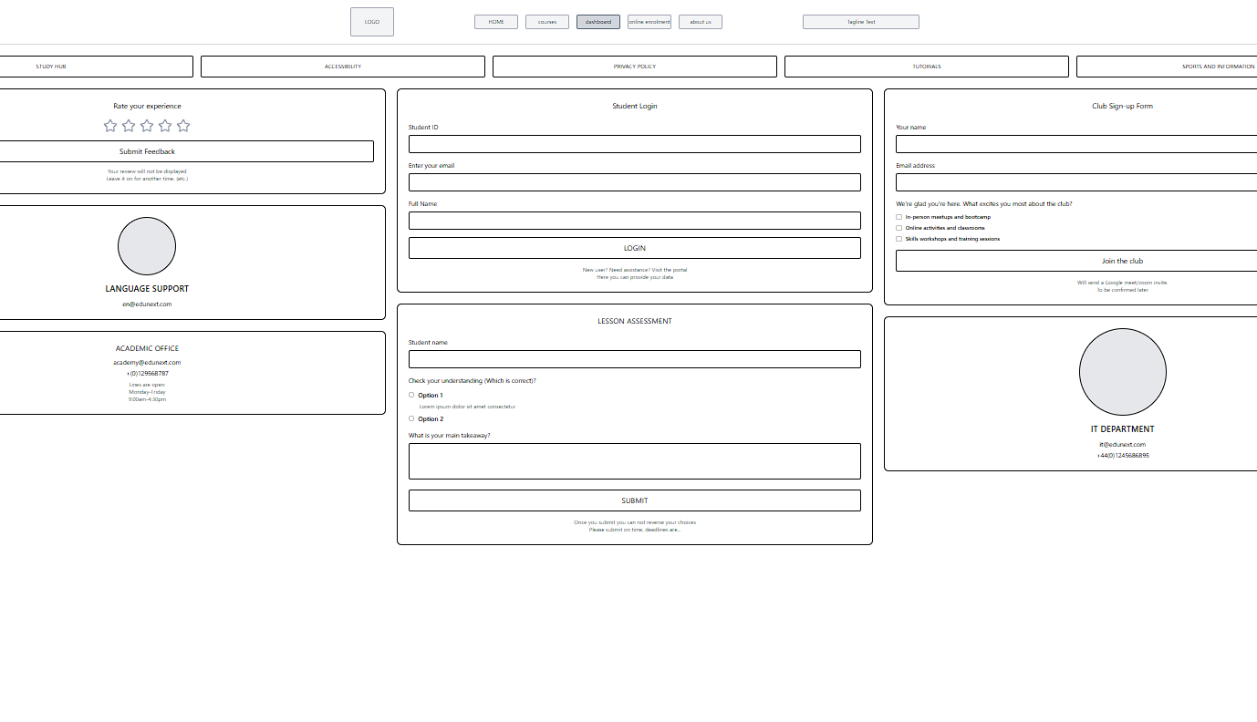

Online enrolment page
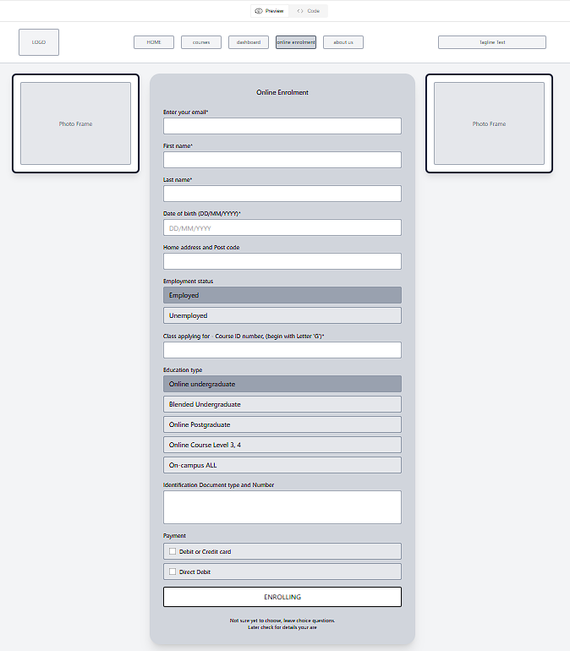

About us page
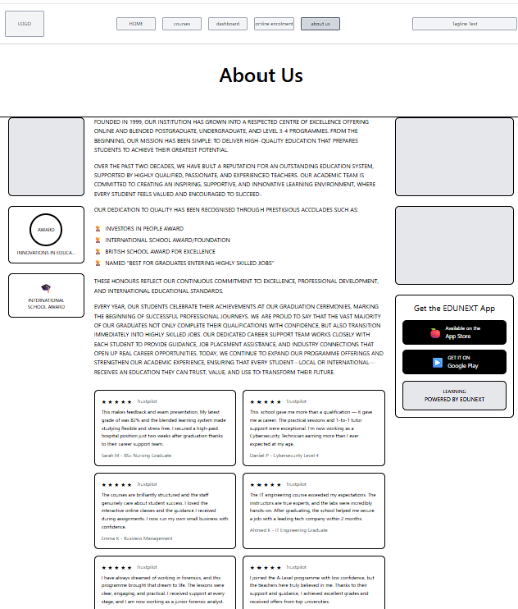

Phase 3. Interactive Prototype

https://www.canva.com/design/DAG3k7eynv4/3R6WJQncxCxqsLGdF1x85Q/edit?utm_content=DAG3k7eynv4&utm_campaign=designshare&utm_medium=link2&utm_source=sharebutton Page 1: Home / Landing
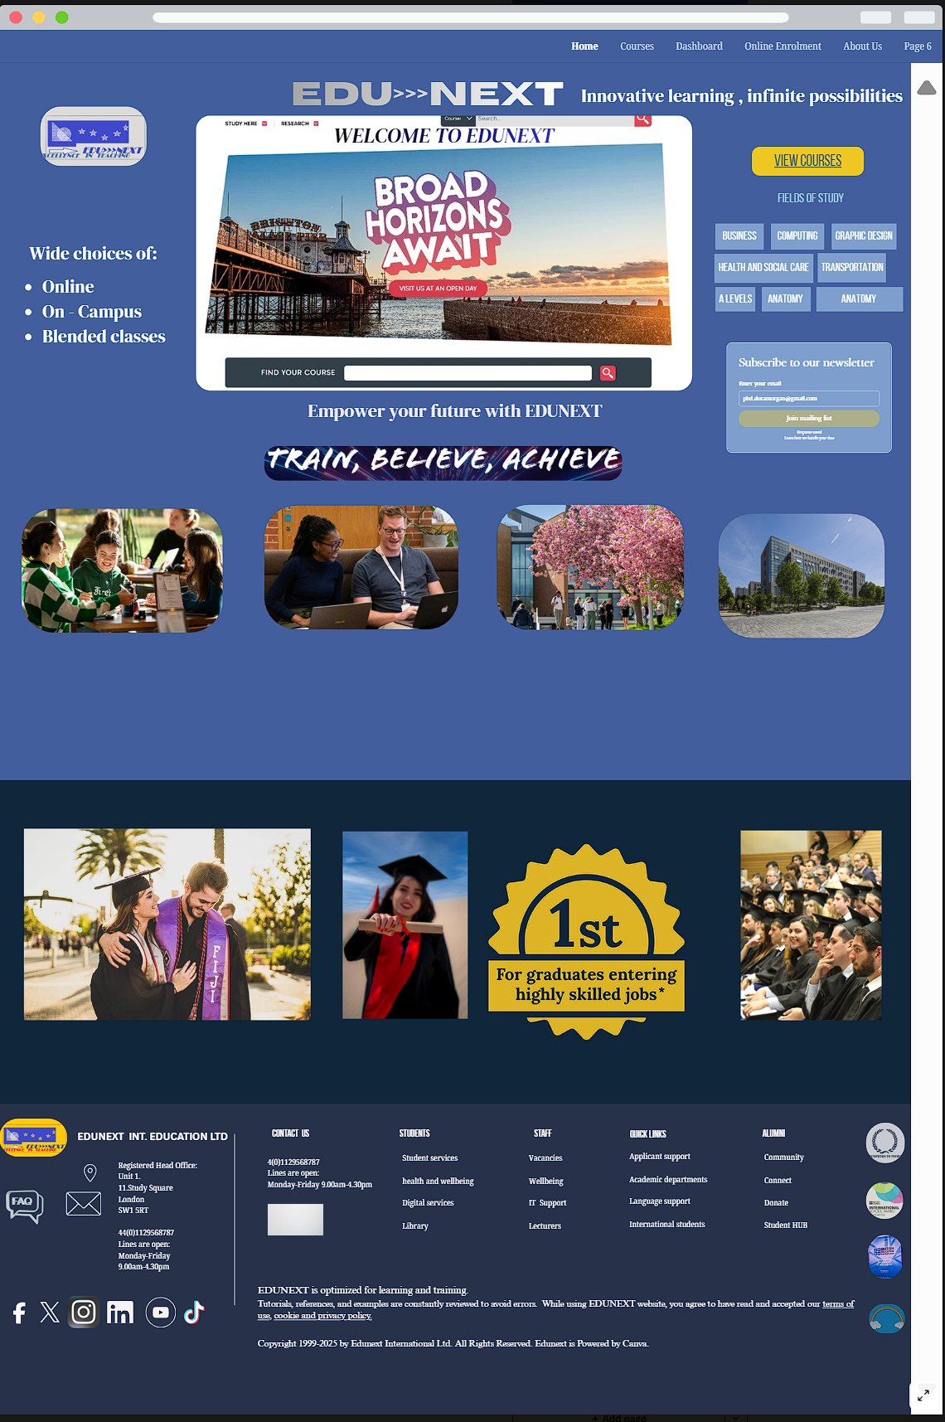

Page 2: Course listing with Course details page

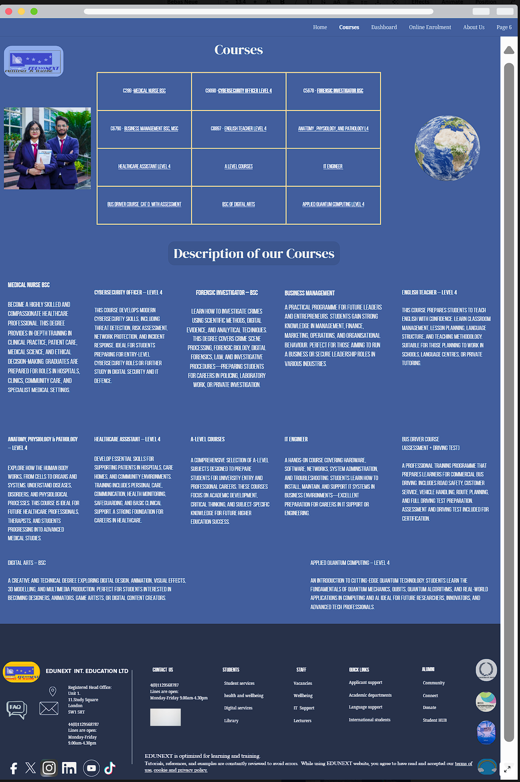

Page 3: Dashboard and Login Page

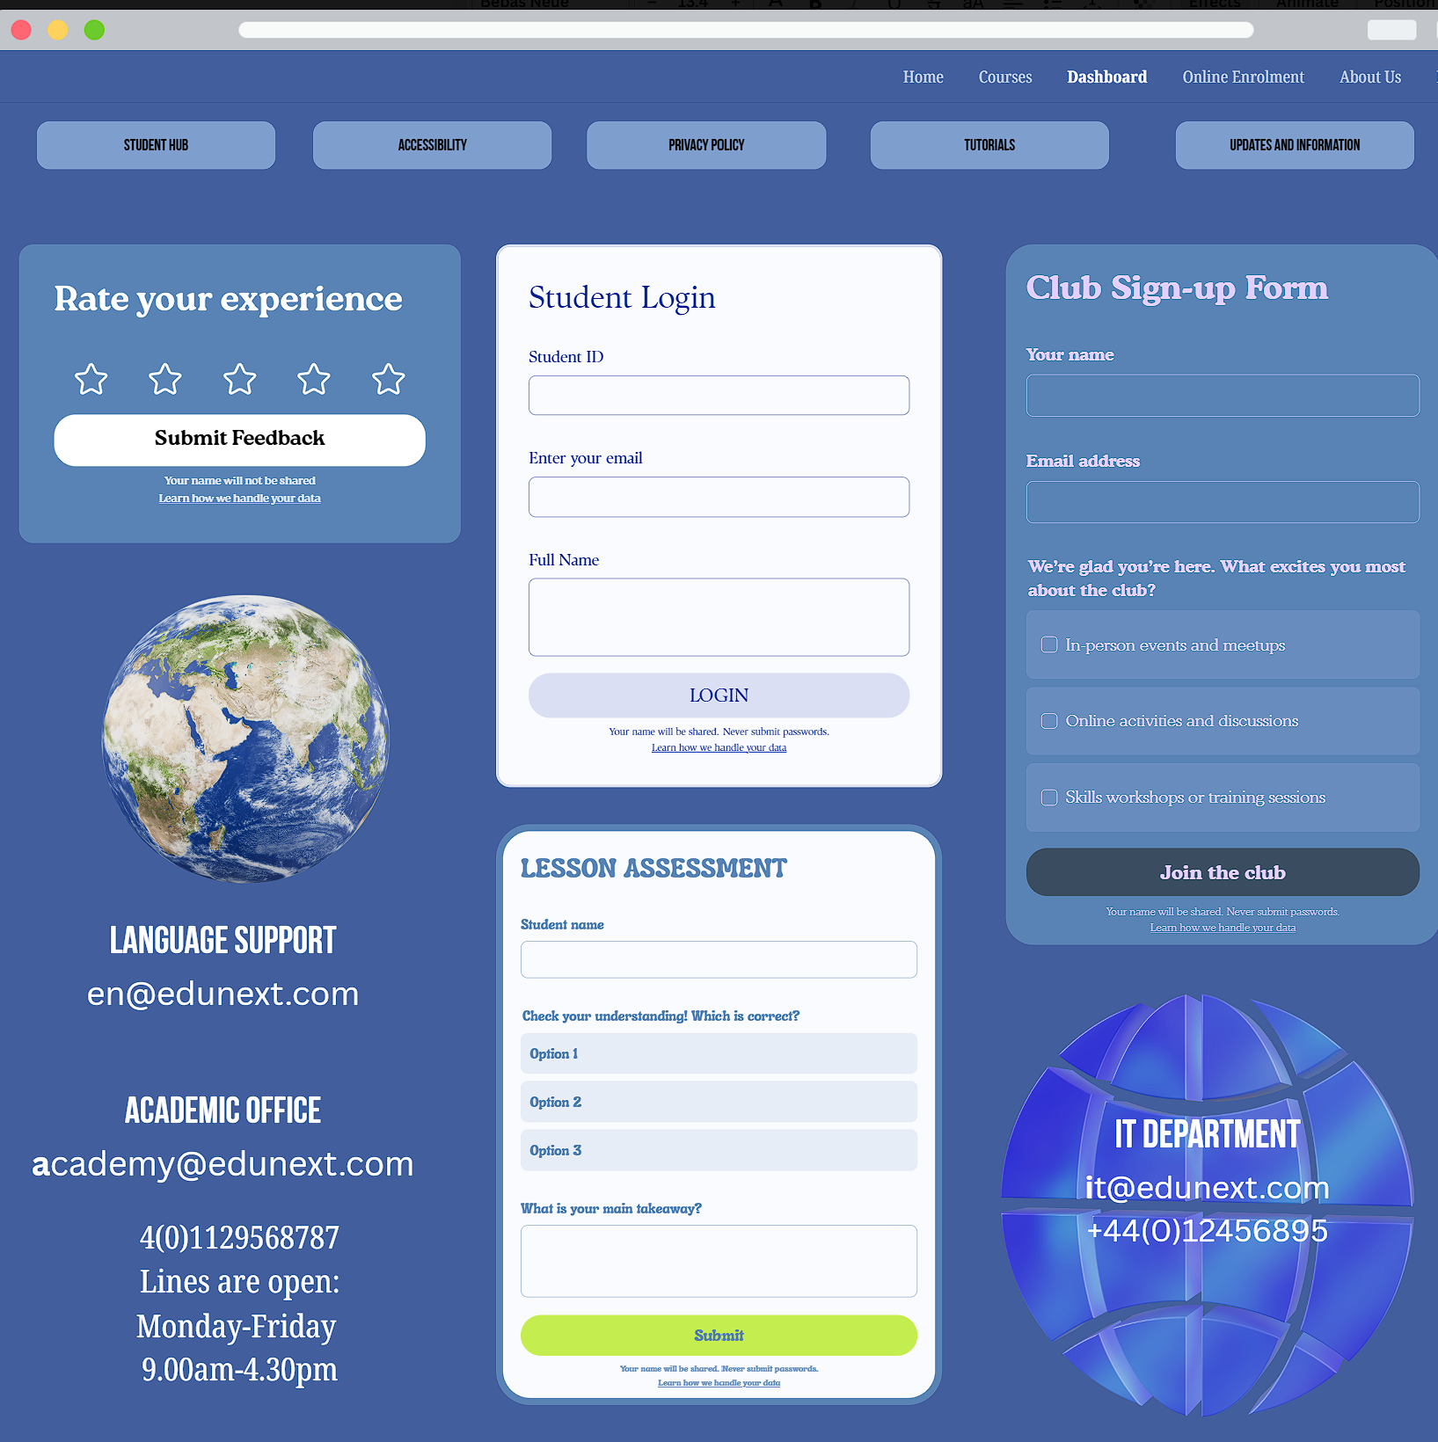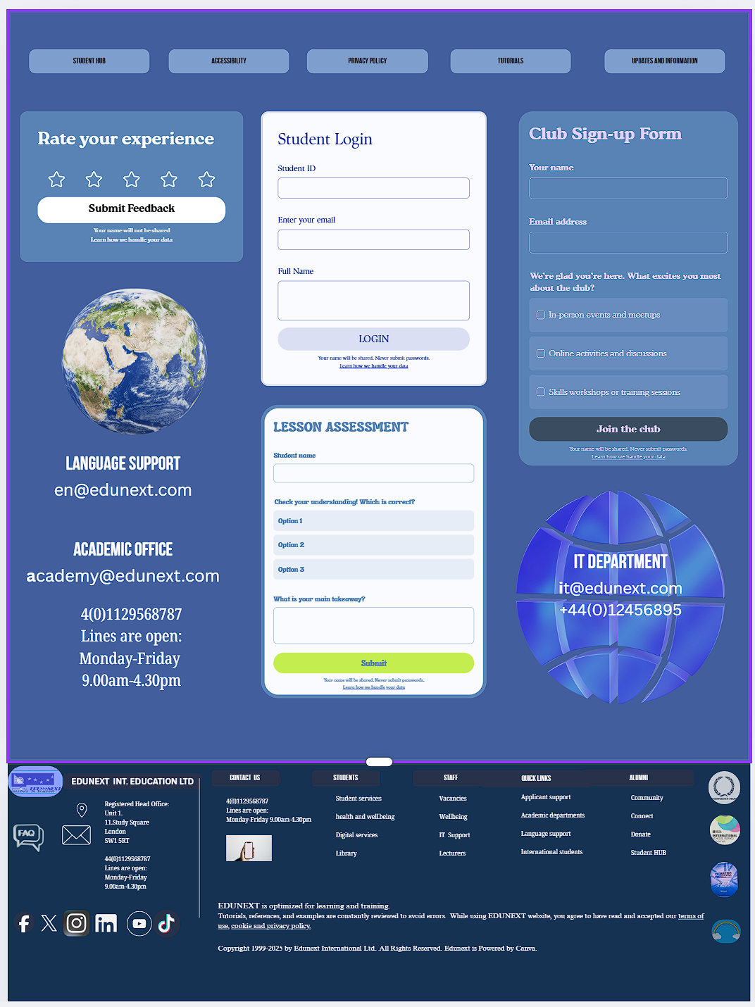

Page 4: Enrolment page

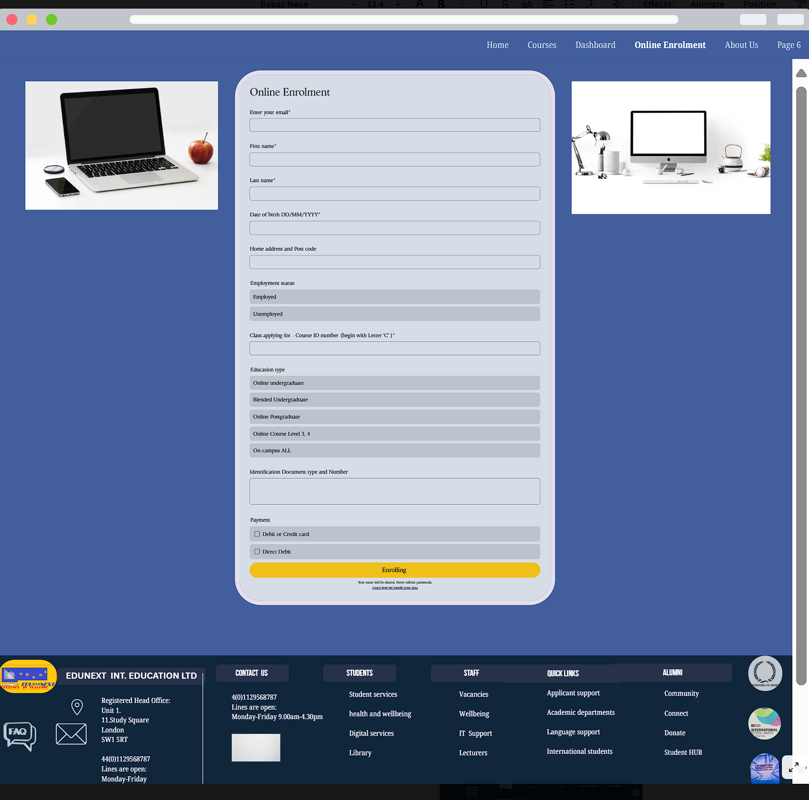

Page 5: About Us page


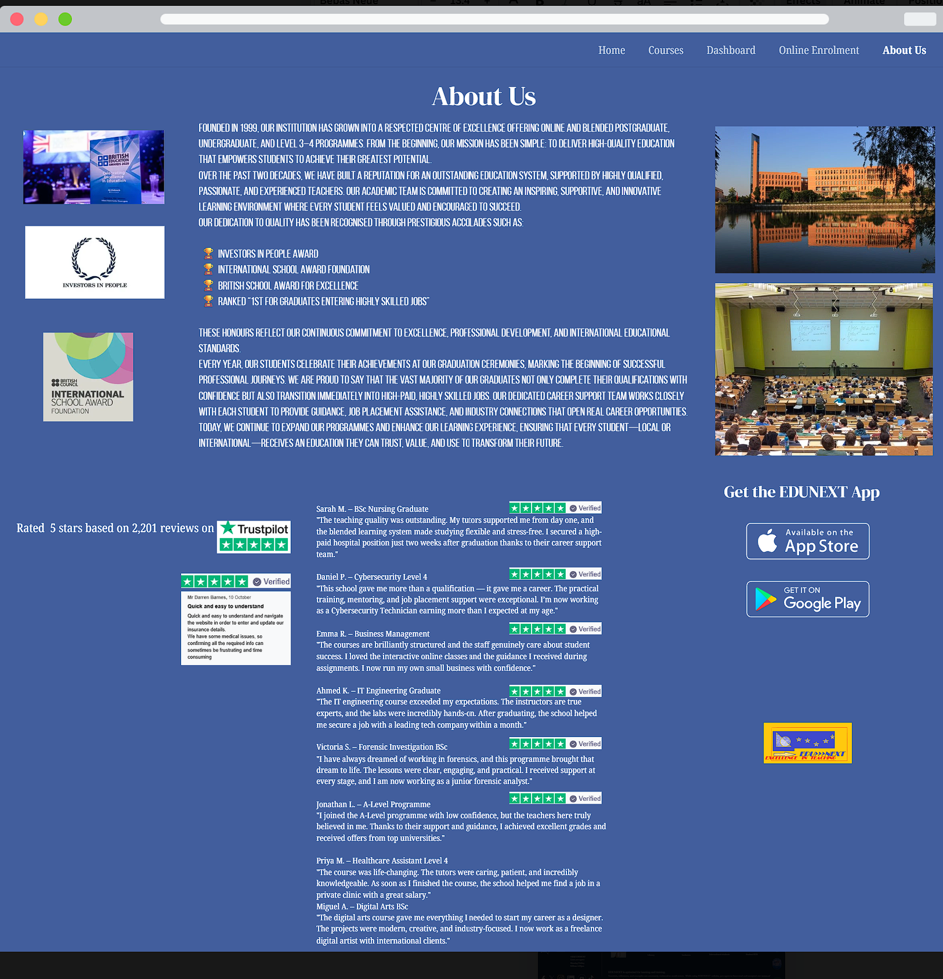
The website is published at: https://morgandoraedu.my.canva.site/

Task 2: Report Section Title Page
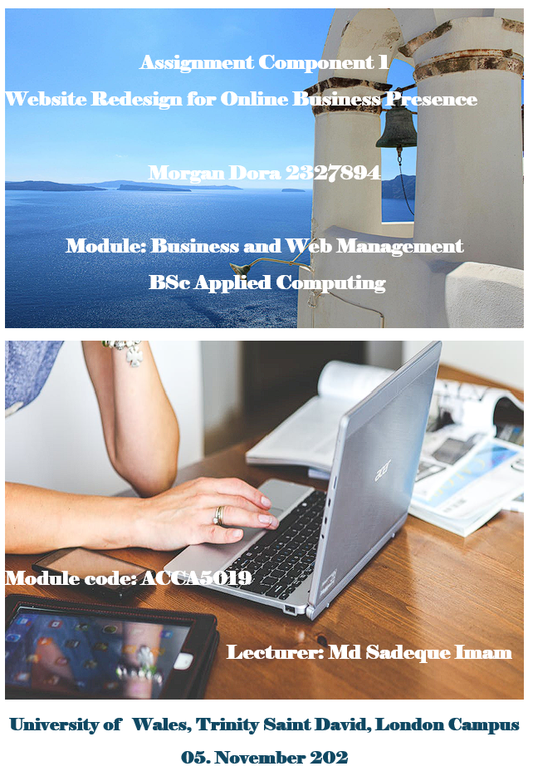
18. November 2025
Table of Contents

Task 1 – UI/UX Web Design Phases 2
Phase 1: Mood board creation 2
Phase 2: Wireframe design 3
Phase 3. Interactive Prototype 9
Task 2: Report Section Title Page 14
Introduction 16
EDUNEXT Website Redesign 16
Current problems to be resolved. 17
Solution plan 18
Responsive Design 22
Importance of Responsive Design Implementation 22
Implications for User Experience (UI/UX) 22
Implications for E-Commerce and Conversion 23
Results and Conclusions 24
Implementation section 25
Moodboard 25
Interactive prototype implementation: 26
Mood Board and Wireframe shaping the design 27
1. Mood Board Influence: 27
2. Wireframe influence: 28
Conclusion 30
References Page 31

Introduction
This report presents a redesigned proposal for EDUNEXT, an online and hybrid education platform offering high-quality courses taught by professional teachers.
The primary goal of this project is to enhance user engagement, accessibility, and course enrolment through a modern, user-friendly interface design.
The report includes an analysis of current website issues and planned improvements. This paper presents the mood board, wireframes, and an interactive prototype.
Furthermore, I show my research on the role and importance of responsive design in improving usability and accessibility.
The project concludes with a reflection on how the design process contributes to creating a professional, better-performing website for “EDUNEXT” design solutions.

EDUNEXT Website Redesign
The website is currently functional, but it faces several limitations and challenges that hinder its ability to attract new students. The problems are with navigation, accessibility, and overall user trust. The redesign focuses on resolving the weaknesses through modern UI/UX design principles, ensuring an engaging, inclusive, and efficient learning platform.

Analysis of redesign: Why do companies choose to redesign a website?
“With that out of the way, there are some very good reasons why your website may need a redesign. Here are three of the strongest:
Your site doesn’t provide value to visitors.
Your site doesn’t accommodate mobile users or isn’t responsive; or
Your site looks outdated and outmoded.
Another good reason is having a new strategy or new business objectives that include clearly defined goals for your website. “[1]

Current problems to be resolved.

Poor Navigation and Structure
Users find it difficult to find courses or essential information due to unclear menus and inconsistent page layouts.
Outdated Visual Design
The existing interface is visually unappealing and lacks modern aesthetics, which reduces user engagement and brand credibility.
Non-Responsive Layout
The current website does not adapt well to different screen sizes, making it inconvenient for mobile and tablet users.
Limited Course Descriptions and Low-Quality Media
Course pages lack detail, and images or videos are of inadequate quality, leading to lower interest and enrolment rates.
Complicated Enrolment Process
Multiple unnecessary steps discourage users from completing enrolment.
Ineffective Search and Filtering
The lack of efficient search and filtering options prevents users from quickly finding relevant courses.
Lack of Personalisation
Users do not receive course recommendations tailored to their preferences or learning history.
Usability
Difficult, confusing for user.
Accessibility Problems
The lack of colour contrast, font sizing, and assistive features makes the site difficult to use for individuals with disabilities.
Weak Calls to Action
Buttons and messages do not guide users toward key actions such as enrolment or exploration.

Solution plan
Designing a successful website is particularly important, with simplicity, usability, and a transparent, organised structure being given priority.

Improving Navigation Structure
A simplified, clear, intuitive top navigation bar with clear categories and a consistent layout across all pages, including navigation bar and footer.

Modern Visual Redesign
Implementing a clean, professional colour palette and typography that reflect EDUNEXT’s academic identity and modern learning environment. Consistent pages with fast loading. Appropriate graphics setting application.
- Fully Responsive Design and Layouts
A highly responsive, dynamic approach that ensures usability across all devices.
All buttons and links to pages and information must be responsive, clickable, and take the user quickly to the required page.
- Enhanced Course Pages
Include a detailed summary, level description, user reviews, and credits to improve credibility and interest—a trouble-free application route to the enrolment page.
- Easier Enrolment Process
Reducing the number of steps in the enrolment flow, integrating a straightforward, transparent process to enhance user confidence, and ensuring it meets all disability and accessibility needs.
- Advanced Search and Filtering System
Introducing search filters by category, fields of study and rating. I choose this solution to simplify the searches. For instance, when student try to find an exact course, so they do not need to overwhelm themself or getting lost in the large crowd of data.
“If you use graphics, make them small but decipherable. Try to re-use the same graphics from page to page. Once downloaded into the visitor's browser, they won't need to be downloaded for subsequent use.” [[2]

Usability
Users must access the content easily, and need a simpler structure.
Designing a successful website is particularly important, with simplicity, usability, and a transparent, organised structure being given priority.
“Usability plays a key role in web design. It is important that visitors to your website can access the information they need easily and quickly. [3]
SEO: search engine optimization
Required to have a Google account. Google can make the website appear in the top results and rank highly when someone searches for EDUNEXT.
The website's content is essential, along with a simplified structure and simple page names and descriptions, so Google can easily analyse it. This service is a paid subscription service but comes with good advantages regarding SEO.
“Google and other search engines review your site and rank pages for relevancy based on various criteria such as keywords, page titles,
and the content itself. “[4]
Legal: Must meet requirements by law.
Privacy Policy (Mandatory under GDPR & UK GDPR)
If the website collects any customer personal details,email address, phone number, cookies, it is required to have a public privacy policy .
The policy needs to explain:
- Users' rights for handling data, e.g. deletion or access their data
- Methodology and details of storing data ( length, method)

“1. Where personal data relating to a data subject are collected from the data subject, the controller shall, at the time when personal data are obtained, provide the data subject with all of the following information: The identity and the contact details of the controller and, where applicable, of the controller’s representative; the contact details of the data protection officer, where applicable; the purposes of the processing for which the personal data are intended as well as the legal basis for the processing; where the processing is based on point (f) of Article 6(1), the legitimate interests pursued by the controller or by a third party; the recipients or categories of recipients of the personal data, if any;
where applicable, the fact that the controller intends to transfer personal data to a third country or international organisation and the existence or absence of an adequacy decision by the Commission, or in the case of transfers referred to in Article 46 or 47, or the second subparagraph of Article 49(1), reference to the appropriate or suitable safeguards and the means by which to obtain a copy of them or where they have been made available.
2. In addition to the information referred to in paragraph 1, the controller shall, at the time when personal data are obtained, provide the data subject with the following further information necessary to ensure fair and transparent processing:
the period for which the personal data will be stored, or if that is not possible, the criteria used to determine that period;
the existence of the right to request from the controller access to and rectification or erasure of personal data or restriction of processing concerning the data subject or to object to processing as well as the right to data portability;
where the processing is based on point (a) of Article 6(1) or point (a) of Article 9(2), the existence of the right to withdraw consent at any time, without affecting the lawfulness of processing based on consent before its withdrawal;
the right to lodge a complaint with a supervisory authority;
whether the provision of personal data is a statutory or contractual requirement, or a requirement necessary to enter into a contract, as well as whether the data subject is obliged to provide the personal data and of the possible consequences of failure to provide such data;
the existence of automated decision-making, including profiling, referred to in Article 22(1) and (4) and, at least in those cases, meaningful information about the logic involved, as well as the significance and the envisaged consequences of such processing for the data subject. “ [5]
“There are also legal issues to consider when you design your website. You have to ensure that you comply with the Equality Act 2010. “[3]

Accessibility Enhancements
Follow WCAG (Web Content Accessibility Guidelines) by improving colour contrast, providing alt text, and ensuring keyboard navigation.
“The Web Content Accessibility Guidelines (WCAGs) standard was developed by the World Wide Web Consortium (W3C).
The WCAGs specify how to make websites and applications accessible to people with a wide variety of disabilities.” [6]
Stronger Calls to Action
Strategically placed buttons such as “Enrol Now” or “Subscribe” to encourage immediate interaction from the new students. This is because it is especially important that student engage efficiently and effectively for sign up. The language used must be clear, and focus oriented to the required action.

Results

The redesigned EDUNEXT website will offer a user-friendly, more straightforward interface that is highly responsive, dynamic, and accessible. Improved navigation, usability, and easy-to-use enrollment will enhance user satisfaction, reduce dropout rates, and strengthen the platform’s reputation for quality online education.

Responsive Design

Importance of Responsive Design Implementation

Responsive design is a key part of the web design process. When we implement responsive techniques, the site automatically adjusts the sizes of pictures, logos, content, layout hierarchy, and other features. Hence, they appear correctly and professionally on every device and browser. In the context of Edu Next, implementing a fully responsive design is essential, as a significant percentage of students access online courses on several types of smartphones and laptops.
Responsive design directly affects attracting new students to the EDUNEXT platform and helps achieve the business's planned goals.
“Responsive design allows users to benefit from the web page without having to worry about screen size and resolution. “[7]

Implications for User Experience (UI/UX)

A responsive website enhances the user’s experience by providing smooth, fast navigation and consistent interaction across devices.
For EDUNEXT, this means:
Improved Accessibility: Students can access content anytime, anywhere, without usability issues.
Consistent Visual Identity: The interface, typography, and imagery adapt smoothly across all screen sizes, maintaining a professional appearance.
Reduced Frustration: Buttons, forms, and course cards remain appropriately normal-sized and easy to interact with on devices.
Enhanced Engagement: Users are more likely to explore courses and complete enrolments when the experience is smooth and easy to use.

Implications for E-Commerce and Conversion

In e-commerce environments, including online education platforms, responsive design plays a key role in increasing conversions and sales. For Edu Next, a mobile-friendly design can help new customers get engaged more easily and make their purchase with satisfaction and leave a good review.

Therefore, it is necessary:

- Simplified Checkout Process: Enrolment and payment pages are easy to navigate on mobile, reducing drop-off rates.

- Optimized Call-to-Action Placement: Buttons like Optimised Call-to-Action Placement: Buttons like “Enrol Now” remain visible and connect to the enrolment process straightaway.

- Faster Loading Speeds: Optimized images and layouts improve performance, which positively impacts SEO and user trust.

- Increased Mobile Conversions: Students can easily browse and purchase courses without technical difficulties.

Results and Conclusions

By implementing a fully responsive design, EDUNEXT will strengthen its competitive advantage of accessibility, increase accessibility, and achieve higher satisfaction. This approach is best suited to modern UI design, creating a learning platform that is both user-centered and adaptable to diverse devices, ensuring a seamless experience for every learner.

Implementation section

Moodboard
Link:https://www.canva.com/design/DAG4rHTuEgg/_KhZDiZnru1D6fBw8IyNqQ/edit?utm_content=DAG4rHTuEgg&utm_campaign=designshare&utm_medium=link2&utm_source=sharebutton
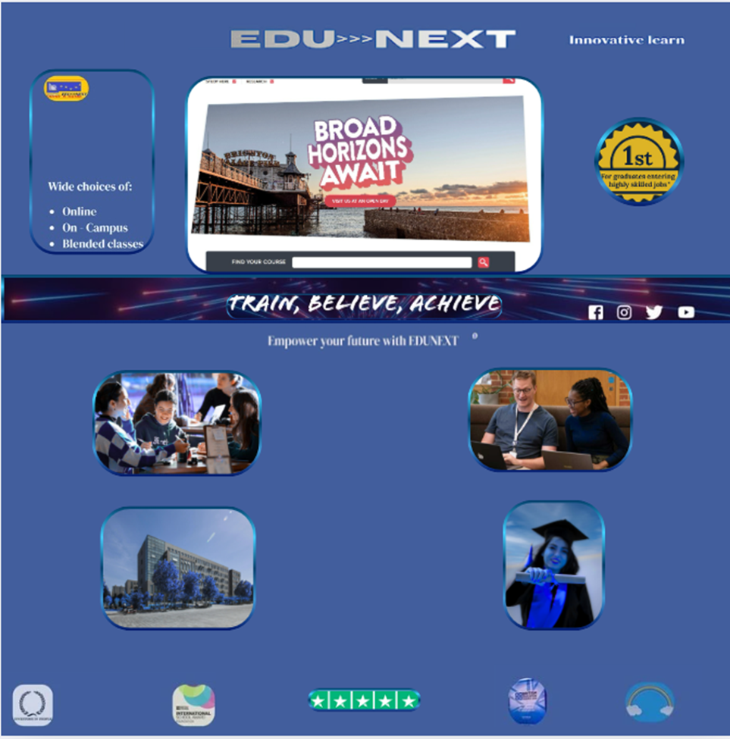

Interactive prototype implementation:

https://www.canva.com/design/DAG3k7eynv4/3R6WJQncxCxqsLGdF1x85Q/edit?utm_content=DAG3k7eynv4&utm_campaign=designshare&utm_medium=link2&utm_source=sharebutton

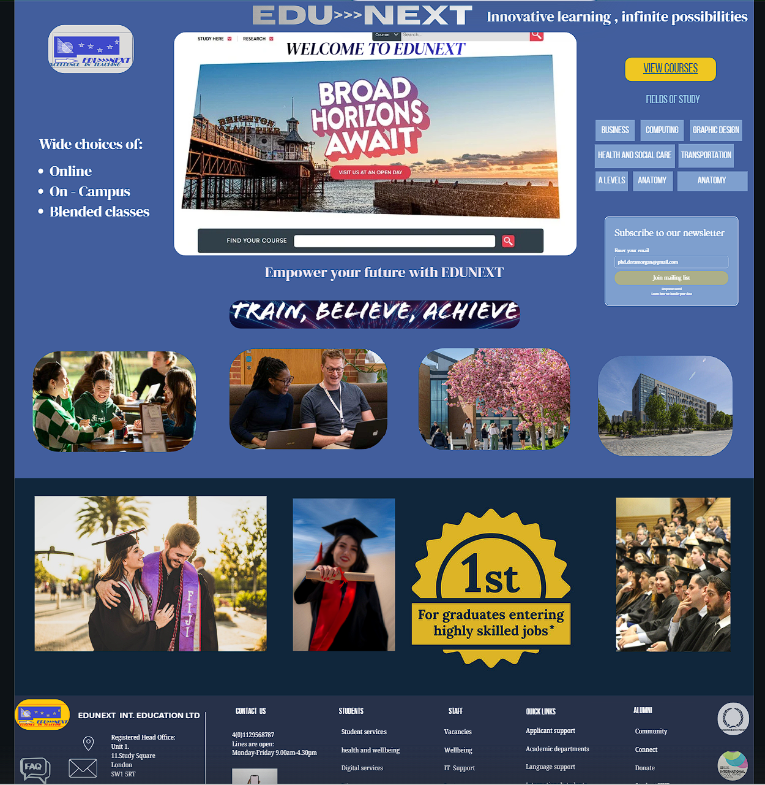

Mood Board and Wireframe shaping the design

Mood Board Influence:

A mood board sets the visual direction and emotional tone of a project.
It influences the design by:
Defining:
- Style
- Colour palette
- Typography
- Ensuring consistency across all pages.

Helping designers and clients visualise the brand’s personality before the actual design starts.
Reducing design confusion — every designer colleague can agree on the design experience at the early stage of the process, avoiding disagreements and confusion that can be difficult to manage later and time- and money-consuming if something needs to be replaced or modified.
Inspiring creativity and guiding visual decisions like image selection, icon styles, and layout atmosphere.
If the mood board uses calm blues and minimal fonts, the final design will reflect a clean, trustworthy, and professional tone. Too many bright tones can be disturbing and discouraging people from staying on the site.

“The use of image elicitation methods has been recognised in qualitative research for some time; however, the use of mood boards to prompt participant discussion is currently an under-researched area. This article explores the use of mood boards as a data collection method in qualitative research. Used in design disciplines, mood boards allow designers to interpret and communicate complex or abstract aspects of a design brief.” [8]

Wireframe influence:

“A wireframe serves as a crucial visual blueprint that conveys a UI's hierarchy, structure, and functionality, emphasizing usability and fostering alignment and communication among stakeholders. Despite their significance, wireframes are often underutilized or poorly executed, leading to design inefficiencies. “[[9]
Wireframes play a crucial role and are the first step in shaping the final design of the EDUNEXT website. They influence the design process in several important ways:

1. Provide a Clear Structural Blueprint
Wireframes are the skeleton of the digital product and map out where and how key elements (navigation, buttons, content blocks, forms, images) appear and function.
This ensures the design is built on a strong and logical foundation before adding colours, fonts, and visuals. It helps to plan everything properly.
“Wireframing doesn’t only help you visualize the aesthetics of your app. It also enables you to plan out the underlying system. This is called the app architecture,
and it describes all the components needed to run the app.
This includes data access methodologies, third-party tools, and other services running in the background. “[[10]

2. Improve User Experience (UX) Early
By focusing on layout and functionality, wireframes help us designers test usability early.
This allows us to name problems—such as confusing navigation or overcrowded screens—before the visual design phase.

“Good user experience (UX) design is critical for the success of websites and applications. However, translating user needs into functional UI designs poses challenges for many development teams, often resulting in misinterpretations, discrepancies in objectives, and increased costs. According to the Nielsen Norman Group, poor usability can result in the loss of up to 50% of potential users, highlighting the paramount importance of effective design practices. A wireframe serves as a crucial visual blueprint that conveys a UI's hierarchy, structure, and functionality, emphasizing usability and fostering alignment and communication among stakeholders.” [11]

3. Speed Up the Design Process
Because changes are cheaper and easier at the wireframe stage, the final design process becomes faster and more efficient.

4. Support Responsive Design Decisions
Wireframes often include desktop, tablet, and mobile variations, helping designers plan how layout elements adapt across devices.

5. Shape the final aesthetic
Although wireframes are not about visual styling, they strongly influence:
- Spacing
- Hierarchy
- Visual balance
- Content prioritisation
These decisions guide the look and feel of the final product.

“Several indications point to aesthetics, which has a multi-layered influence on people's perceptions. An example of this is the influence of the aesthetics of an app on users' subjective evaluation, which can take place within fractions of a second.” [12]

6. Reduce Development Costs
Clear wireframes minimise rework in later phases, helping avoid expensive changes during coding.

Conclusion

The redesign of the EDUNEXT education platform demonstrates the effectiveness of strong planning and visual direction. The mood board helped establish the overall tone, colour scheme, and branding identity, while the wireframe ensured a clear, functional, and user-friendly structure and strong planning foundations.
Together, they created a consistent and engaging interface that supports easy access, strong user engagement, and usability. By combining creativity with structured design, EDUNEXT achieves its goal of providing an accessible, modern, and motivating online education environment while also fulfilling the company’s business targets.
Furthermore, Search Engine Optimisation ensures that EDUNEXT's online presence ranks highly and that users find it among the top few results, giving the company an advantage over other educational platforms and enabling it to achieve its business targets.
Please scan the QR code below to view the test website

https://morgandoraedu.my.canva.site/

References Page
References
[1] c. a. t. Impact. "Free Website Redesign Guide:
The Ultimate Guide to Website Redesign for Businesses." https://www.impactplus.com/. https://www.impactplus.com/website-redesign-guide
[2] J. Ashenhurst, "Designing successful Web sites," Rough Notes, vol. 144, no. 5, pp.32–34, 2001. Available: https://www.proquest.com/trade-journals/designing-successful-web-sites/docview/200321986/se-2?accountid=130472 https://libkey.io/libraries/1422/openurl?ctx_ver=Z39.88-2004&ctx_enc=info:ofi/enc:UTF-8&rfr_id=info:sid/ProQuest&rft_val_fmt=journal&rft.genre=unknown&rft.jtitle=Rough+Notes&rft.atitle=Designing+successful+Web+sites&rft.au=Ashenhurst%252C+John.&rft.aulast=Ashenhurst&rft.aufirst=John&rft.date=2001-05-01&rft.volume=144&rft.issue=5&rft.spage=32&rft.isbn=&rft.btitle=&rft.title=Rough+Notes&rft.issn=00358525&rft_id=info:doi/
[3] Business Gateway, "Web design: best practice", www.bgateway.com, https://www.bgateway.com/resources/web-design-best-practice
[4] O. Modern Campus Canada, "College and University Website Redesign: The Ultimate Guide", moderncampus.com, https://moderncampus.com/blog/college-and-university-website-redesign-guide.html
[5] Intersoft Consulting, "Art. 13 GDPR," 2025. Available: https://gdpr-info.eu/art-13-gdpr/
[6] G. Bogdanova, et al., "Design and Development Model of aWeb Accessibility
Ecosystem," pp.2, 7 October 2024. doi: 10.3390/ info15100613. Available: https://www.mdpi.com/2078-2489/15/10/613
[7] A. Parlakkiliç, "Evaluating the effects of responsive design on the usability of academic websites in the pandemic," Educ Inf Technol, vol. 27, no. 1, pp.1307–1322, 12 July 2021. doi: 10.1007/s10639-021-10650-9. Available: https://link.springer.com/article/10.1007/s10639-021-10650-9
[8] S. Spawforth-Jones, "Utilising Mood Boards as an Image Elicitation Tool in Qualitative Research," Sociological research online PUBLISHED by BRITISH SOCIOLOGICAL ASSOCIATION, vol. 26, no. 4, pp.1, Dec 2021. doi: 10.1177/1360780421993486. Available: https://journals.sagepub.com/doi/full/10.1177/1360780421993486
[9] A. Almani and O. Alrwais, "The Role of Wireframes in Enhancing User Interface Design," International research journal of innovations in engineering and technology, vol. 8, no. 12, pp.134–140, 2024. doi: 10.47001/IRJIET/2024.812020.
[10] P. Simic, "6 benefits of app wireframing that will motivate you," vol. 1, pp.1–2, May 11 2022. Available: https://decode.agency/article/benefits-of-app-wireframing/
[11] A. Almani and O. Alrwais, "The Role of Wireframes in Enhancing User Interface Design," International research journal of innovations in engineering and technology, vol. 8, no. 12, pp.134–140, 2024. doi: 10.47001/IRJIET/2024.812020.
[12] Perrig A. C., Sebastian, Ueffing D., Opwis K., Bruhlmann F. et. al., "Smartphone app aesthetics influence users’ experience and performance," vol. 14, pp.1, 14 June 2023. doi: 10.3389/fpsyg.2023.1113842. Available: https://www.frontiersin.org/journals/psychology/articles/10.3389/fpsyg.2023.1113842/full

