Programme: MSc Public Health and Social Care in Practice
Module: Population Health and Digital Health Promotion
Module code: LCHS7009
Student Name: Krinalben Rajeshbhai Patel
Student ID: 2531474
Lecturer Name: Diola Bijilhout
Assignment Title: Component 1
2 Blogs

BLOG 1
Can Mobile Apps Help Smokers Quit for Good?
Published: July 2026 | 3-minute read
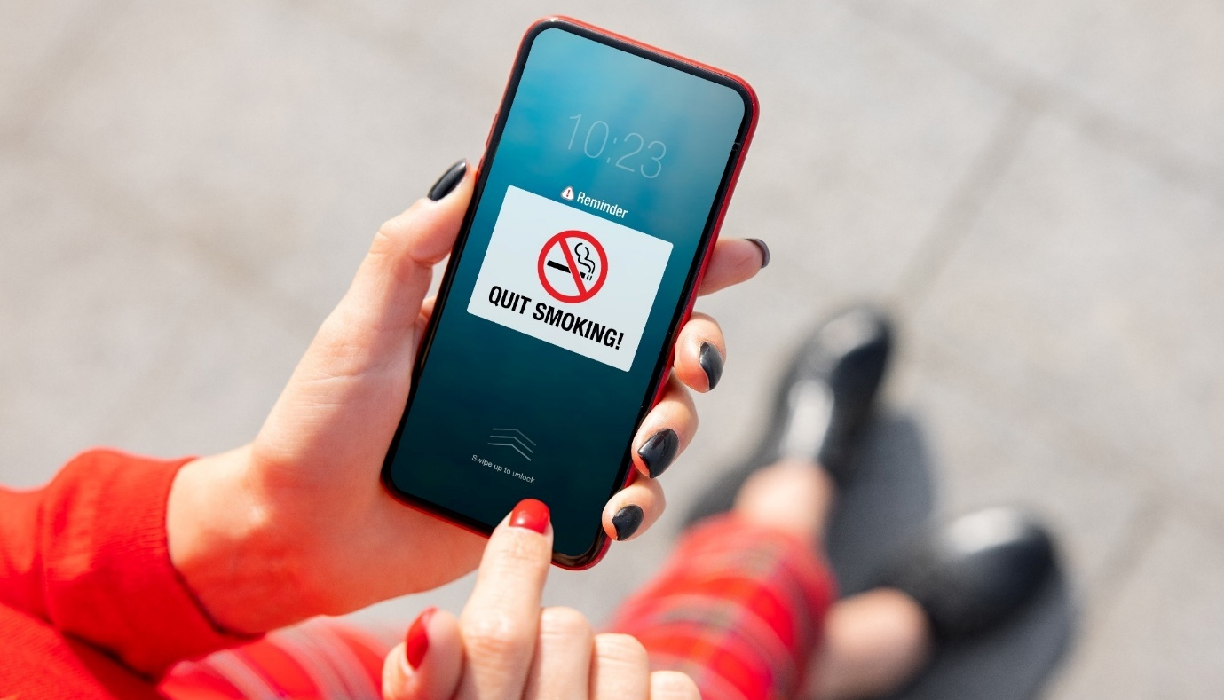
Mobile health (mHealth) applications provide smokers with accessible, personalised support to quit smoking.
Why Is Smoking Still a Public Health Concern?
Smoking is still one of the world's biggest avoidable health problems and causes early death. Smoking tobacco has been linked to lung cancer, cardiovascular disease, chronic respiratory disease and strokes and is responsible for millions of fatalities every year. NHS Stop Smoking Services are supporting thousands of smokers every year, highlighting the current need for effective smoking cessation interventions (NHS Digital, 2024).
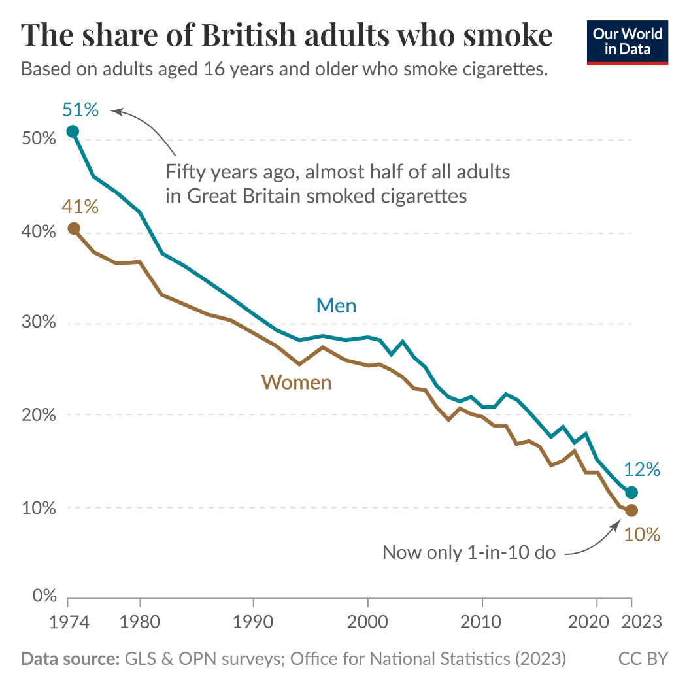
Figure 1. Adult smoking prevalence in Great Britain (1974-2023)
(Source: ourworldindata.org, 2024)
How Do Mobile Apps Promote Smoking Cessation?
These mobile apps: Smoke Free, QuitNow! and Quit Genius! employ behavioural change techniques to facilitate quitting. It contains customisable quit plans, craving diaries, motivating reminders, progress trackers and financial savings calculators. Other apps include cognitive behavioural therapy (CBT) exercises and peer support groups online to promote maintenance of lifestyle changes.
Demo website: www.quitsmok-demo.co.uk (illustrative link)
Are They Effective?
Mobile health interventions have been shown to have a significant effect on smoking cessation outcomes in recent research. Smoking remains a major public health problem and in Great Britain, 11.9% of adults smoke cigarettes in 2024 (ONS, 2024). Fang et al. (2023) and Guo et al. (2023) identified smartphone-based interventions that increased quit rates compared to USC, especially when combined with personalised feedback and behavioural support. However, Hersi et al (2024) found that continued user engagement is key for long-term success, which can wane during weeks.
Mobile apps offer easily accessible, low-cost and discreet support, but aren't a substitute for professional healthcare for those who are heavy tobacco users. Issues of digital exclusion are as well uncovered, along with the lack of clinical quality assurance and data privacy.
Potential areas for development: incorporating the use of AI and maintaining clinical oversight with direct access to NHS Stop Smoking Services to enhance engagement, personalisation and effectiveness of digital smoking quit interventions.

References
Fang, Y.E., Zhang, Z., Wang, R., Yang, B., Chen, C., Nisa, C., Tong, X. and Yan, L.L., 2023. Effectiveness of eHealth smoking cessation interventions: systematic review and meta-analysis. Journal of Medical Internet Research, 25, p.e45111.
Guo, Y.Q., Chen, Y., Dabbs, A.D. and Wu, Y., 2023. The effectiveness of smartphone app–based interventions for assisting smoking cessation: systematic review and meta-analysis. Journal of medical Internet research, 25, p.e43242.
Hersi, M., Beck, A., Hamel, C., Esmaeilisaraji, L., Pussegoda, K., Austin, B., Ahmadzai, N., Pratt, M., Thuku, M., Yazdi, F. and Bennett, A., 2024. Effectiveness of smoking cessation interventions among adults: an overview of systematic reviews. Systematic Reviews, 13(1), p.179.
NHS Digital, 2024. Statistics on NHS Stop Smoking Services in England, April 2023 to March 2024 (Q4, Annual). Available at: https://digital.nhs.uk/data-and-information/publications/statistical/statistics-on-nhs-stop-smoking-services-in-england [Accessed 19 July 2026].
Our World in Data, 2025. Once widespread, smoking is now uncommon in Great Britain. Available at: https://ourworldindata.org/data-insights/once-widespread-smoking-is-now-uncommon-in-great-britain [Accessed 19 July 2026].

BLOG 2
QuitSmok: An Intelligent Digital Coach for Smoking Cessation
Published: July 2026 | 3-minute read
Meet QuitSmok
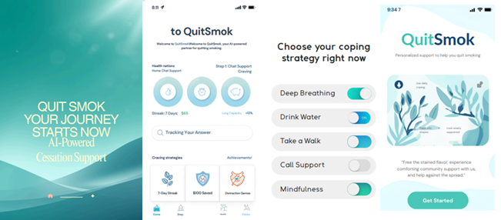
QuitSmok is a proposed AI-powered mobile application designed to deliver personalised smoking cessation support.
Why Design a New Smoking Cessation App?
While smoking prevalence has substantially decreased, tobacco use is still a significant public-health problem. 11.9% of people from Great Britain were smoking in 2024, equating to millions of people at higher risk of preventable diseases like lung cancer, chronic obstructive pulmonary disease (COPD) and heart diseases (ONS, 2024). The uptake and effectiveness of current smoking cessation apps is positive, but many users lose motivation to use them over time, as the content is too generic. This emphasises a need for a ‘tighter fitting’ digital health intervention.

Figure 2. Proposed QuitSmok user journey
(Source: Given by Author)
How Would QuitSmok Work?
QuitSmok is an AI-powered digital quit smoking coach – it generates an individual quit plan from factors like the speed, frequency, and triggers, as well as daily routines and behaviors of your smoking. Once a brief assessment is done, the app forecasts the dangerous scenarios with AI and delivers effective coping strategies in advance of the cravings (Albers et al. 2022). Users are greeted with motivating messages, breathing classes, financial savings information, wellness improvement marks and virtual “treats” for staying smoke-free. Instant links to NHS Stop Smoking Services are also offered when help is needed and a chatbot that gives unlimited support at any time.
Prototype website: www.QuitSmok-health.co.uk (illustrative link)
Potential Impact
Personalised actions for smoking cessation rather than generic reminders could benefit QuitSmok. AI could enhance user engagement and stimulate healthier behaviors and detect relapse sooner than traditional apps. Such attributes may help to increase the likelihood of smoking cessation and lower the downstream consequences of a smoker's burden of smoking-related disease (Onwuzo et al. 2024).
However, challenges remain. The extracted data from an AI system is used to feed into the recommendation system, which requires reliable user information, and persistently collecting this data might lead to privacy and cybersecurity issues. Some people may not be able to get access as a result of digital exclusion (Kelpin, 2024).
QuitSmok would aim to overcome these limitations by integrating features such as encrypted data storage, a straightforward consent process, clinician monitoring, and support in numerous languages. Incorporating carefully selected evidence-based behaviours with state-of-the-art personalized tooling could make QuitSmok an innovative online health promotion application for long-term smoking cessation.
References
Albers, N., Neerincx, M.A., Penfornis, K.M. and Brinkman, W.P., 2022. Users’ needs for a digital smoking cessation application and how to address them: a mixed-methods study. PeerJ, 10, p.e13824.
Office for National Statistics (ONS), 2025. Adult smoking habits in Great Britain: 2024. Available at: https://www.ons.gov.uk/peoplepopulationandcommunity/healthandsocialcare/healthandlifeexpectancies/bulletins/adultsmokinghabitsingreatbritain/2024 [Accessed 19 July 2026].
Kelpin, S., Brockman, T.A., Decker, P.A., Young, A., Boehmer, K., Nguyen, A., Kamath, C., St. Sauver, J., Sinicrope, P.S., Sharma, P. and McCoy, R., 2024. Increasing digital equity to promote online smoking cessation program engagement among rural adults: a randomized controlled pilot trial. Communications Medicine, 4(1), p.194.
Onwuzo, C.N., Olukorode, J., Sange, W., Orimoloye, D.A., Udojike, C., Omoragbon, L., Hassan, A.E., Falade, D.M., Omiko, R., Odunaike, O.S. and Adams-Momoh, P.A., 2024. A review of smoking cessation interventions: efficacy, strategies for implementation, and future directions. Cureus, 16(1).
Zhou, X., Wei, X., Cheng, A., Liu, Z., Su, Z., Li, J., Qin, R., Zhao, L., Xie, Y., Huang, Z. and Xia, X., 2023. Mobile phone–based interventions for smoking cessation among young people: systematic review and meta-analysis. JMIR mHealth and uHealth, 11(1), p.e48253.

