Volunteering Portfolio: Georgina Roylance-Smith
BMLC5005
Student Number; 2400897

Placement hours log
In this section, please record your placement hours, including dates and the number of hours completed on each day. Please note that this should also be signed by your placement provider to confirm that the recorded hours are correct.

Date | Hours completed
22/1/26 | + 5 hours (Swansea Prison)
28/1/26 | + 5 hours (Swansea Prison)
4/2/26 | + 5 hours (Swansea Prison)
5/2/26 | + 5 hours (Swansea Prison)
17/2/26 | + 5 hours (Swansea Prison)
19/2/26 | + 5 hours (Swansea Prison)
4/3/26 | + 5 hours (Swansea Prison)
5/3/26 | + 5 hours (Swansea Prison)
11/3/26 | + 5 hours (Swansea Prison)
12/3/26 | + 5 hours (Swansea Prison)
18/3/26 | + 5 hours (Swansea Prison)
19/3/26 | + 5 hours (Swansea Prison)
26/3/26 | + 5 hours (Swansea Prison)
1/4/26 | + 5 hours (Swansea Prison)
2/4/26 | + 5 hours (Swansea Prison)
9/4/26 | + 5 hours (Cardiff Prison)

Confirmation of hours completed
Placement provider signature; C. Neale (FFOPS)
Date signed; 27/04/26

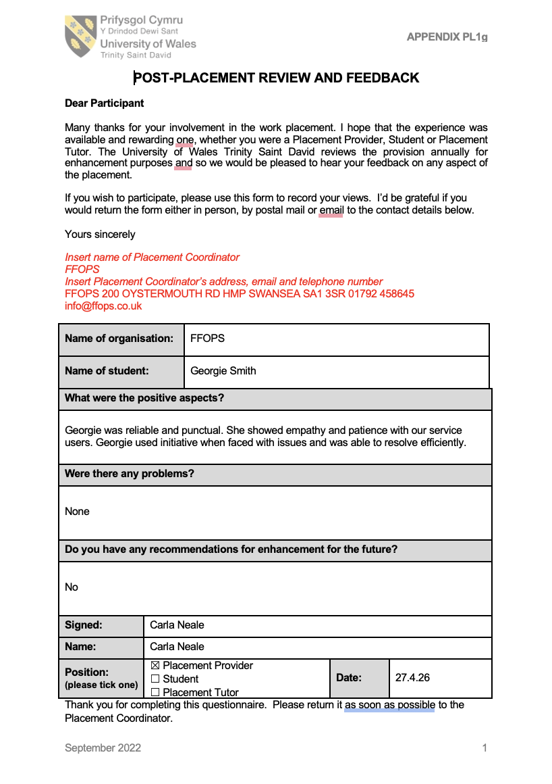

First 40 hours; A Reflection:
Ward (2023) describes Gibbs reflective cycle as a tool developed by Graham Gibbs during the 1980s and it is a structured framework that is to be used from a self-learning perspective. There are multiple stages in the whole cycle, and this will be my main structure throughout this self-reflection.
Description: Regarding my work volunteering for FFOPS (Friends and Family of Prisoners, Swansea), from the beginning I was very content with the idea of working at a prison environment without actually being involved directly with the inmates. Working with the family gave me a great sense of both accomplishment as well as at times, concern, worry and sadness.
Feelings: My role volunteering for FFOPS was acting as a helping hand to those visiting their loved ones in Swansea prison. I helped people of all backgrounds, ethnicities and lifestyles and I truly believe this helped me gain a less judgemental approach to those not only in prison but also the intensity and anxiety that comes with those visiting them. My role also included being an information point for any questions visitors had, regarding the dress code, visiting times and other similar situations. I also did activities with many children that came to visit, playing with them and colouring in, doing activities that ensure they are calm and in a good way to visit their loved one.
Evaluation: FFOPS (2025) describe their work as empathetic and helping those most vulnerable, which links to Comfort (2017) who claims that it is never just the perpetrator of the crime who is affected by the prison sentence, family and friends are very closely affected by the sentence as well as the trauma around having to go into the prisons. They state how the emotional and psychological trauma that goes on for young children has a lasting impact when someone is incarcerated. This links to Donald Braman's theory of ‘doing time on the outside’, where the theory explores how the financial and emotional strain on the family has similarly a life-changing impact (Braman, 2004)
Analysis: From this growing knowledge, as the weeks went on, I became more and more empathetic and sympathetic towards their situations. A situation that was a shifting point for me and my attitude was when a lady came into FFOPS cabin and was clearly destressed, she looked very well dressed and if I was to see her in public, it would be assumed she had no connections to Swansea Prison. Her son was on remand at Swansea prison and she was distraught; it really changed my opinions and attitudes regarding the stereotypes behind who goes to prison, as well as those who visit them. Not only that, but it also gave me a more realistic idea of all the people that are affected. For me, this was a very important visit, and it truly impacted my thoughts and respect for those who came in, in a positive way and I'm grateful this visit happened very early on as it gave me a clear, less biased approach to other visitors. The lady was open about her struggles emotionally and our conversation, she claimed really relaxed and helped her through a tricky time. This links to Davis (2025) study, which presents the ideas that speaking and communicating struggles helps relieve stress and anxiety, which helps make their visits go calmer and in a more enjoyable environment.
I gained relationships and rapport with family members who I quickly became very familiar with, some of the mothers of inmates would come up to 3 times a week consistently. 71% of family members according to PACT (2023) spend around 2 days a week visiting their loved one. This made me more aware of being not only kind, encouraging and for visitors, but being a person, they would be able to speak to with zero judgement or bias.
Conclusion: Throughout my first half of volunteering, there was a massive mix of emotions, such as concern, guilt, worry, empathy, happiness. From the different situations I dealt with, resulted in many different emotions too. My first few shifts volunteering, I felt very anxious, nervous and concerned I would mess up, however, my confidence improved and I became surer in my answers and that I would be able to help those who needed it. Guilt was a common theme for me, especially during my first 40 hours or so, and this I feel was linked to the fact that these people were treated as if they were criminals themselves. Some prison officers spoke to and about the visitors very poorly, even including the children.
I believe that overall, volunteering for FFOPS has been a positive experience in not only improving my knowledge about the impacts of crime and how it affects not only the offender, but many others around them. FFOPS has also improved my confidence to deal with high emotional situations in a very professional and yet empathetic manner.
Action Plan: If I was to restart the first 40 hours again, I would put myself out there much more at the beginning, speak more and get to know visitors so they open up and express their feelings and situations, as I found it very interesting, learning about the different backgrounds and the families these offenders came from, as well as humanising the inmates and learning about their characteristics as well.

Overall reflection
The second half of my volunteering was quite different, comparing to the first half due to my responsibilities. I finished most of my hours at FFOPS cabin, based in Swansea, however I also was given the opportunity to travel with FFOPS to Cardiff Prison for a family and friends day. This day was an open day for the inmates to freely be with their loved ones as well as activates set up by FFOPS and other organisations that wanted to help.
Description: The Cardiff day was an amazing experience as for the first time I was able to see the real effect the visits have on the inmates. A UK Parliament (2024) study shows how these visits have such a positive impact on the inmates as it encourages good behaviour and introduces more normal socialisation which in turn lowers the changes of reoffending by around 39%. UK Parliament (2024) claim that inmates often say how the hardest thing is not being around their children and family, so these days make an incredible difference. The mental effect of seeing family members and maintaining relationships in an enhanced environment increases stability for inmates, allowing their good behaviour to be rewarded in a meaningful way.
Feelings: There were many feelings that came up during the second half of my volunteering, especially during the Cardiff session. This trip I was feeling nervous for, due to being in the same room in a close proximity with the inmates, unaware of the crimes they have committed. I tried to enter being unbiased and treat everyone equally, but I was nervous. However, the nerves shortly left, and it felt very normal and a relaxed and happy environment. Activates such as playing with farm animals and doing crafts with the young children was really enjoyable and relaxed me into enjoying the rest of the visit. I was particularly involved with a few different families, and the children were very open to playing, which made the whole day wholesome.
Evaluation: The whole day was very successful, however, something I would try to do differently however would be to spend more time with the inmates not only the children, but the inmates were also much more closed off, expectedly, however, it would have been interesting to have more conversations with them. However, it was also interesting to just observe the differently families and what they prioritised through the visits. Some of the inmates soley focused on the young children and some focused more on the other family members or their partners.
Analysis: Something that I have definitely learned from the second part of my volunteering was the uplifting impact visits can bring to the inmates, I think it is something that can only be truly experienced when it is seen and the Cardiff visit helped as before I only interacted with the family and loved ones of the inmates, however this experience was very helpful in seeing the inmates in a really humanised way, not being treated differently or looking differently.
Conclusion: If there are any other family open days at either Swansea or Cardiff, I would be very open to going again, with the charity as they were eye-opening and a very educational trip for myself. It was a trip where I felt like I had really helped other families as well as the inmates and the other organisations too. As an overview of this volunteering, I think it has also given me new skills with empathy and not being too quick in judging someone for their past actions. Not only different attitudes towards the inmates, but also, being more aware of the impact crime has on the whole network of people around the perpetrator. I do feel as if I am a better and more educated individual now after completing this placement.

Specific questions

- Explain a situation during your placement where you demonstrated resilience.
One situation during my placement where I felt I showed great resilience was where I was being yelled at quite aggressively by a male who wished to visit a relative, however, he was not dressed appropriately and so I tried to explain the rules and dress code. I gave him one of the pamphlets to physically show how he would not be allowed into the visiting room, however, he kept an aggressive and volatile attitude and voice. I tried to be sympathetic and understanding however, he maintained the confrontation attitude and would not change his outfit. Regardless, I stood my ground and kept trying to enforce the dress code, showing resilience and sympathy. When he was sent back out, due to his inappropriate outfit, I tried to give him the clothes I originally offered him, however, by this time he was very flustered and agitated he ended up leaving and not attending the visit at all. I feel like I did show resilience the whole time.

- Explain a situation during your placement where you were required to be honest and open.
One situation where I had to be open and honest was during my placement, an older lady came in with very complex medical issues, she had come in to visit her brother however, due to her medical dependence she had multiple questions regarding what she could and could not take in with her. On this specific occasion, I was on my own in the cabin and did not know what she could take in with her, so I advised her to speak to the guards and get them to clarify for her what she could take in with her. She was also in a wheelchair, so again, I had not previously been told what to do in this situation, so I had to go into the main reception and see what to do. This showed openness about my lack of knowledge in that area, and I was able to learn more about medical complexities. I feel this showed openness and honesty about my lack of knowledge as well as openness to learn more about the rules and regulations.

- How did you demonstrate professionalism during your placement?
One way that I feel I demonstrated professionalism during my placement was being given the responsibility of both opening and closing the cabin. This was a large responsibility given to me as there is sensitive information about inmates as well as visitors which I had to ensure was safely kept away. Also ensuring that the cabin was locked up at the end of the day showed professionalism as well as leadership and responsibility. Another way I demonstrated professionalism was through dealing with sensitive issues such as people being turned away from visit, here I had to be firm in ensuring they did not get too upset or angry, but also empathetic and understanding their situation and struggles. One example was a lady and son who travelled from London to visit their relative and the son was not on the visitors list and so could not enter. Here I made sure he was understanding of the situations and ensured he had somewhere to sit and was not too upset. Being an empathetic ear for him to talk to me, as well as abiding to the prison’s rules.

Reference list
- Aidan Ward, Paramedic Principles and Practice in the UK (2023). Elsevier.
- FFOPS (2025) available at: https://ffops.co.uk/contact (Website currently expired)
- Harriet Davies (2025) ‘The importance of talking for mental health’ available at: https://pmc.ncbi.nlm.nih.gov/articles/PMC5603205/#:~:text=The%20separation%20that%20people%20with,returning%20from%20jail%20or%20prison
- Megan Comfort (2017) ‘A Twenty-Hour-a-Day Job’, The Impact of Frequent Low-Level Criminal Justice Involvement on Family Life. Available at: https://pmc.ncbi.nlm.nih.gov/articles/PMC5603205/#:~:text=The%20separation%20that%20people%20with,returning%20from%20jail%20or%20prison
- PACT (2023) available at: https://www.prisonadvice.org.uk/latest/news/new-research-reveals-devastating-impact-of-imprisonment-on-families-and-children/#:~:text=However%2C%2056%25%20of%20families%20said,loved%2Done's%20time%20in%20prison (Last accessed 31/3/26)
- UK Parliament (2024) available at: https://committees.parliament.uk/writtenevidence/87352/html/#:~:text=The%20majority%20of%20prisoners%20consulted,beyond%20prisoners'%20loss%20of%20liberty (Last accessed 8/4/26)
- Braman. D (2004) ‘Doing Time on the Outside: Incarceration and Family Life in Urban America. Available at: https://www.researchgate.net/publication/37704395_Doing_Time_on_the_Outside_Incarceration_and_Family_Life_in_Urban_America

