  Component One:  What are the key skills required when working in the housekeeping team? 750 words (+/- 10%)  Contribution to Overall Module Assessment: 25% | Student No: | Mohammod Suhel Miah ID-2126980
 | Module Title: | Operating Hotel Facilities
 | Module Code: | BMIH4006
 | Lecturer: | Lisa-Marie Bassler
The housekeeping staff performs a vital role in ensuring that guests have a pleasant and happy stay. Working in a housekeeping team demands a variety of talents and attributes, including technical abilities, communication skills, interpersonal abilities, time management skills, and problem-solving abilities.

In this essay, we will examine in depth the essential abilities required for housekeeping teamwork. We will examine how these abilities contribute to the overall success of the housekeeping crew and ensure that every guest receives the greatest quality of service. This essay will discuss the vital function that housekeeping staff play in the hospitality sector and how their abilities and characteristics contribute to the success of the hotels and resorts they service.

Technical Skills: If you work on a housekeeping team, you must have technical skills. These skills include knowing how to clean, organise, and take care of guest rooms, lobbies, and other public areas and being able to do so. The people on the housekeeping team must know how to use cleaning chemicals, supplies, and tools (Burns & Firn, 2017). They should be able to do a variety of cleaning tasks, such as dusting, vacuuming, mopping, and sanitising surfaces. The team members should also know how to make beds, change sheets, and do laundry.

Communication Skills: If you work on a housekeeping team, you need to be able to talk to each other. The people on the team should be able to talk to their co-workers and other staff members well. They should be able to do what they are told and tell others what to do (Marsh & Munyard, 2016). When working with guests, good communication is also important because team members need to be able to understand and address the guests' needs and concerns.

Interpersonal Skills: When working on a housekeeping team, you also need to be able to get along with other people (Tossell, 2008). The people on the team should be able to get along with each other, work well together, and keep a good attitude. They should be able to work in an environment that is fast-paced and always changing, deal with stress, and treat guests with respect and courtesy.

Attention to Detail: Those on the housekeeping team need to be able to pay close attention to the little things. To make sure that every room is cleaned to the highest standard, they must have a sharp eye for the little things (Deffie, 2021). They have to pay attention to things like stains on fabrics, dust on surfaces, and dirty or smudged glass. When team members pay attention to details, it also helps them find places that might need extra care, like the bathroom or the kitchen.

Time Management Skills: If you work on a housekeeping team, you need to be able to manage your time well. The people on the team must be able to work well together and finish tasks on time. They must be able to set priorities, plan their workdays, and do more than one thing at a time well. Time management skills are needed to make sure that every room is cleaned well and that guests are served quickly and well.

Adaptability: People on the housekeeping team must be flexible and able to work in different places (Lappin, 2013). They might have to work in different parts of the hotel or be given new jobs at the last minute. They have to be able to adjust to new situations and changes in work schedules and needs.

Physical Stamina: Members of the housekeeping team must be physically fit and able to do tasks that require physical strength, such as lifting and moving heavy furniture, pushing heavy carts, and standing or walking for long periods (Marsh & Munyard, 2016). They have to be able to work quickly and well, and they have to be able to keep their energy up and stay focused throughout the day.

Problem-Solving Skills: If you work on a housekeeping team, you need to be able to solve problems. The people on the team must be able to spot and fix problems that come up while cleaning the rooms, such as stains or spills that were not expected (Wei & Lee, 2009). They should be able to think outside the box and come up with creative ways to solve problems.

Working in a housekeeping team demands an array of technical, communication, interpersonal, time management, and problem-solving abilities. Members of the housekeeping staff must be detail-oriented, physically fit, and able to operate in a fast-paced and dynamic atmosphere. They must be capable of efficient communication, collaboration, and maintaining a positive attitude. By possessing these abilities and attributes, members of the housekeeping staff can ensure that every hotel visitor enjoys a clean and comfortable stay.

Word Count | 767

Component Two:
Contribution to Overall Module Assessment: 25%
In this scenario – You have just been promoted to team leader for a floor within the hotel. A guest complains that on their arrival, their room had not been properly cleaned. Create an action plan and answer the following questions.

Problem | Why did it happen? | What are you going to do? | How will you prevent this from happening in the future? | What measures would you introduce to improve team effectiveness?
Apologize for the inconvenience and tell the guest that their issues will be immediately addressed. | Miscommunication between housekeeping and the front desk: There may have been a misunderstanding between housekeeping and the front desk, resulting in the room not being listed as cleaned. | Apologize for the inconvenience and tell the visitor that their issues will be immediately handled. | Examine the hotel's cleaning methods to ensure they are current and efficient. This study would involve a comprehensive investigation of the cleaning process, including the cleaning chemicals, instruments, and processes, as well as the supervision level (Wei & Lee, 2009). | I would clarify the team's objectives and ensure that each member knows their role in accomplishing those objectives. This will guarantee that all team members are working towards the same goals and are accountable for their contributions.
Ask the guest for precise details regarding the cleanliness issues they experienced. Note the details and confirm them with the guest. | Due to a possible lack of housekeeping workers, the hotel's rooms may not be as fully cleaned as they should be. | Ask the guest for precise details regarding the cleanliness issues they experienced. Note the details and confirm them with the guest. | Ensure that the housekeeping staff is thoroughly informed on the hotel's cleaning methods and standards, and stress the need of paying close attention to the smallest of details (Firth, 2021). | I would urge team members to talk openly and truthfully with one another and with me, as team leader. This would ensure that everyone is aware of any concerns or obstacles that need to be handled and that there is a free flow of information within the team.
Examine the room to verify the guest's allegations and to discover any additional concerns that may need to be rectified. | The housekeeping crew may not have received appropriate training on the hotel's cleaning processes and standards, resulting in a substandard cleaning job. | Examine the room to verify the guest's allegations and discover any further concerns that may require attention. | Give feedback and coaching to the housekeeping crew on a regular basis to reinforce best practises and ensure they are fulfilling the hotel's cleanliness and quality requirements (Marsh & Munyard, 2016). | I would endeavour to establish a healthy work atmosphere by recognising and rewarding good performance, promoting cooperation, and offering chances for team building activities.
Call the housekeeping workers responsible for cleaning the room and advise them of the situation. | Human error: It is possible that the housekeeping crew made a mistake when cleaning the room or overlooked some areas, resulting in a less than satisfactory cleaning job. | Inform the housekeeping team that is responsible for cleaning the room of the problem (Wood, 2017). | Regularly examine the rooms to ensure that they satisfy the hotel's cleanliness and quality requirements (Wood, 2017). This inspection would involve an evaluation of the cleanliness of the room's surfaces, linens, and washroom amenities. | I would give team members with chances for training and growth in areas that will assist them in performing their duties more efficiently.
Tell the housekeeping team to quickly address the cleanliness concerns raised by the visitor and completely clean the room in accordance with the hotel's specifications. | The housekeeping crew may have been under time constraints when cleaning the room, causing them to neglect some areas or not clean the room as completely as they should have. | Tell the housekeeping team to immediately address the cleanliness concerns raised by the visitor and completely clean the room in accordance with the hotel's specifications. | Urge the housekeeping crew to swiftly report any problems or concerns they notice while cleaning the rooms. Also, the employees should be urged to notify the front desk if there is a delay in cleaning a room. | I would encourage the team to continuously analyse their work procedures, identify areas for improvement, and implement changes to enhance team performance.

Component Three:
Contribution to Overall Module Assessment: 50%
Your task is to create and prepare a presentation following the detailed scenario provided below.

As the floor housekeeping manager and given the recent guest complaints you need to put together a basic training presentation for your colleagues within the housekeeping team to get the best out of them, ensure that brand standard is being achieved and that Health and Safety procedures are also being followed.

Introduction

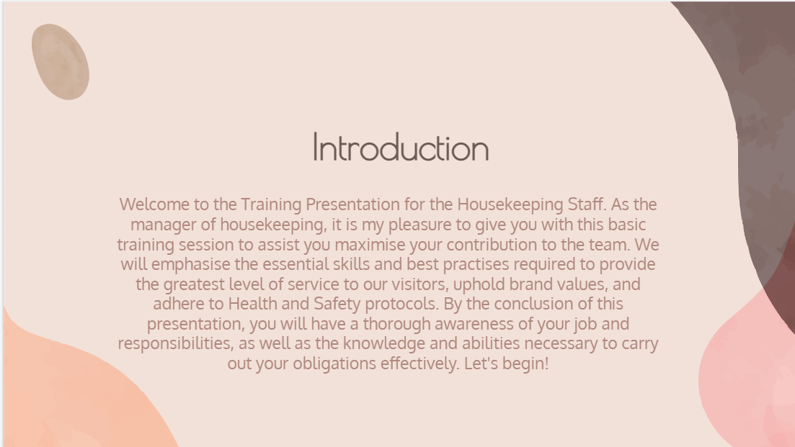

Training Notes:
- Welcome to the housekeeping team training presentation
- Purpose of the presentation: to ensure that we deliver the highest level of service to our guests, maintain brand standards, and adhere to Health and Safety procedures
- Outline of presentation: 10 slides covering key topics and best practices

Understanding the Importance of Housekeeping

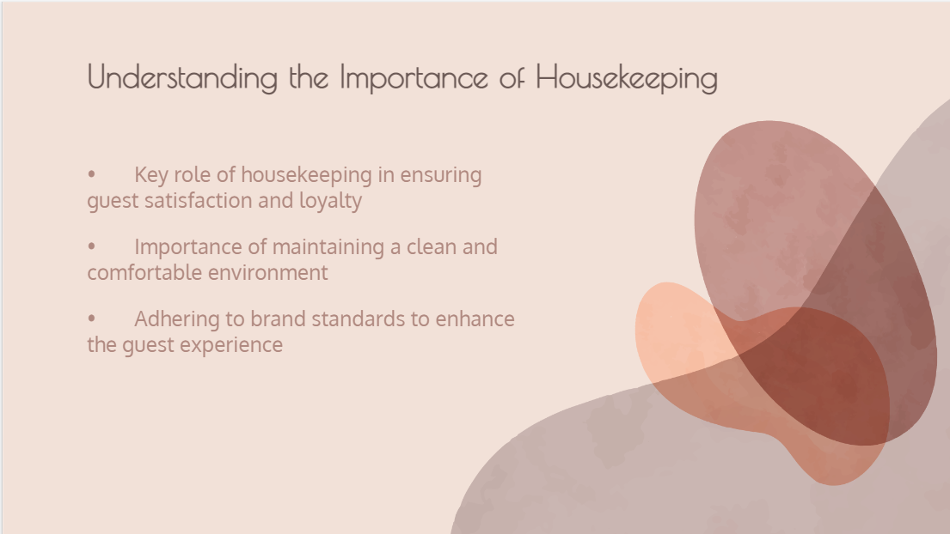

Training Notes:
- Housekeeping is a critical aspect of the hospitality industry
- Housekeeping plays a key role in ensuring guest satisfaction and loyalty
- Importance of maintaining a clean and comfortable environment
- Adhering to brand standards to enhance the guest experience
Health and Safety Procedures

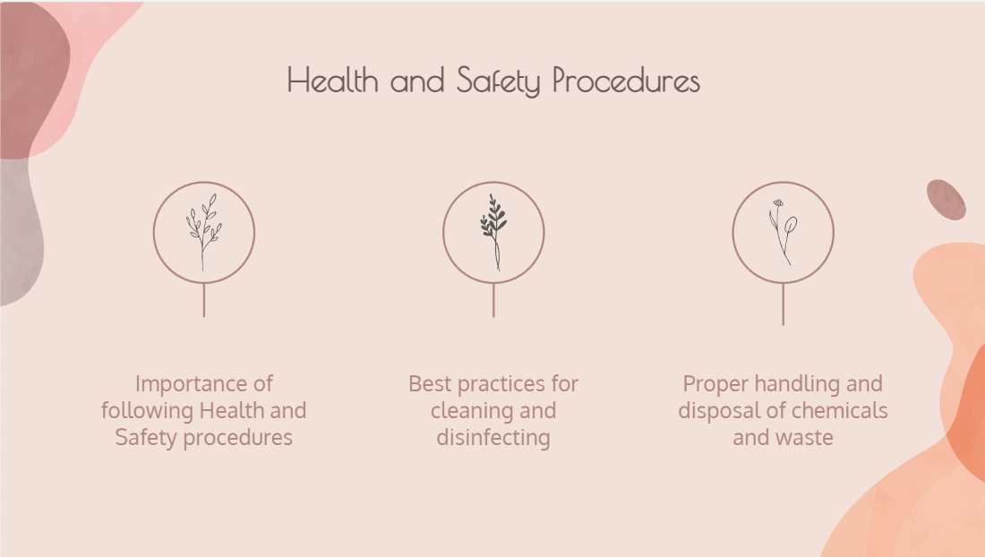

Training Notes:
- Importance of following Health and Safety procedures to ensure guest and staff safety
- Best practices for cleaning and disinfecting to prevent the spread of germs and viruses
- Proper handling and disposal of chemicals and waste to prevent accidents and pollution
Room Preparation and Cleaning

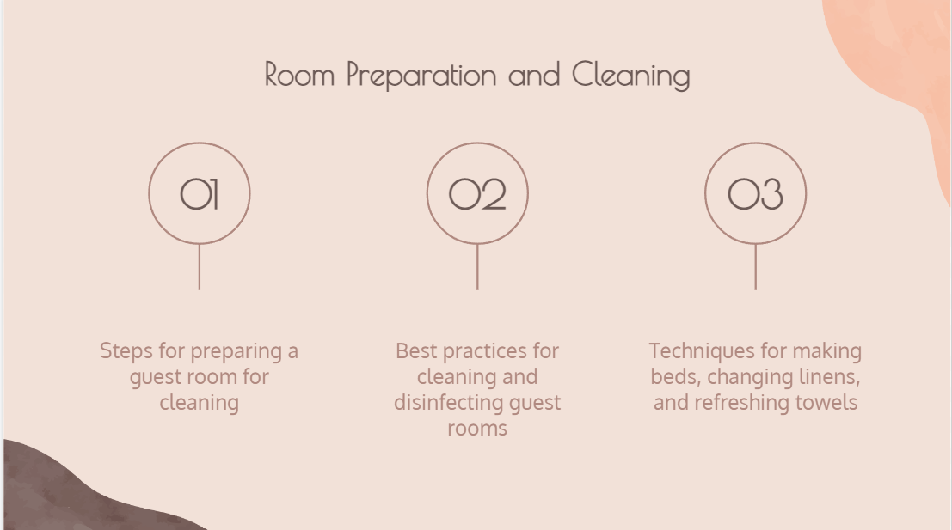

Training Notes:
- Steps for preparing a guest room for cleaning, such as checking for guest belongings and removing trash
- Best practices for cleaning and disinfecting guest rooms, such as using proper cleaning chemicals and equipment
- Techniques for making beds, changing linens, and refreshing towels to ensure guest comfort and satisfaction
Bathroom Cleaning

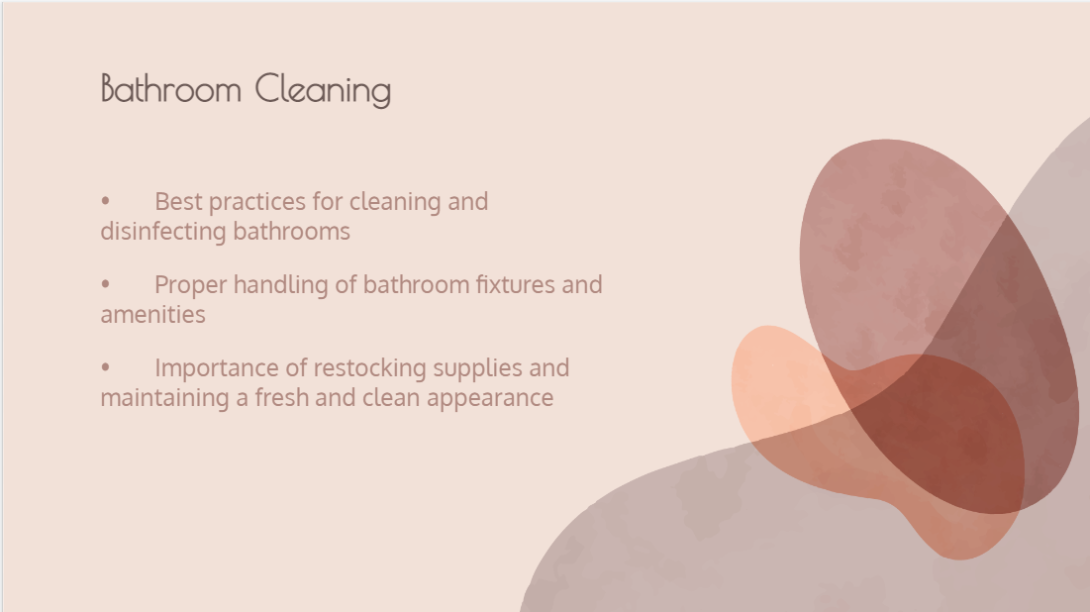

Training Notes:
- Best practices for cleaning and disinfecting bathrooms, such as cleaning from top to bottom and using the right cleaning chemicals for different surfaces
- Proper handling of bathroom fixtures and amenities to prevent damage and contamination
- Importance of restocking supplies and maintaining a fresh and clean appearance to enhance guest satisfaction

Public Areas Cleaning

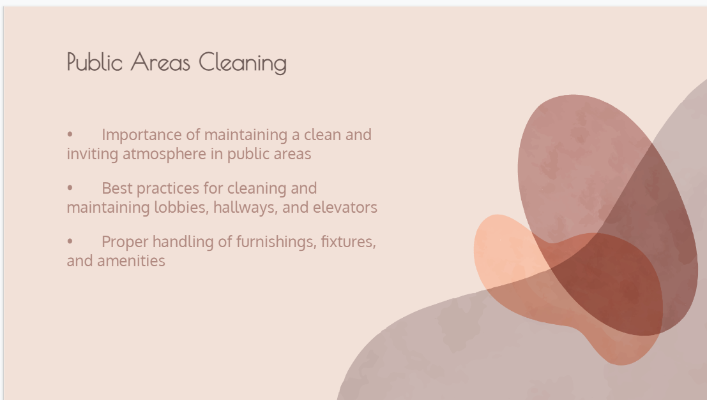

Training Notes:
- Importance of following Health and Safety procedures to ensure guest and staff safety
- Best practices for cleaning and disinfecting to prevent the spread of germs and viruses
- Proper handling and disposal of chemicals and waste to prevent accidents and pollution
Laundry Operations

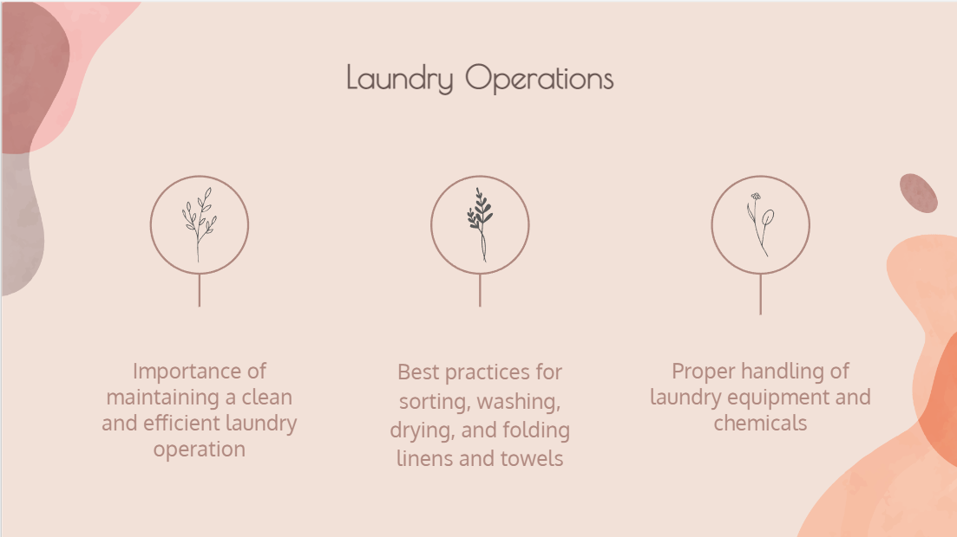

Training Notes:
- Importance of maintaining a clean and efficient laundry operation to ensure a steady supply of clean linens and towels for guests
- Best practices for sorting, washing, drying, and folding linens and towels to ensure cleanliness and durability
- Proper handling of laundry equipment and chemicals to prevent accidents and damage
Communication and Teamwork

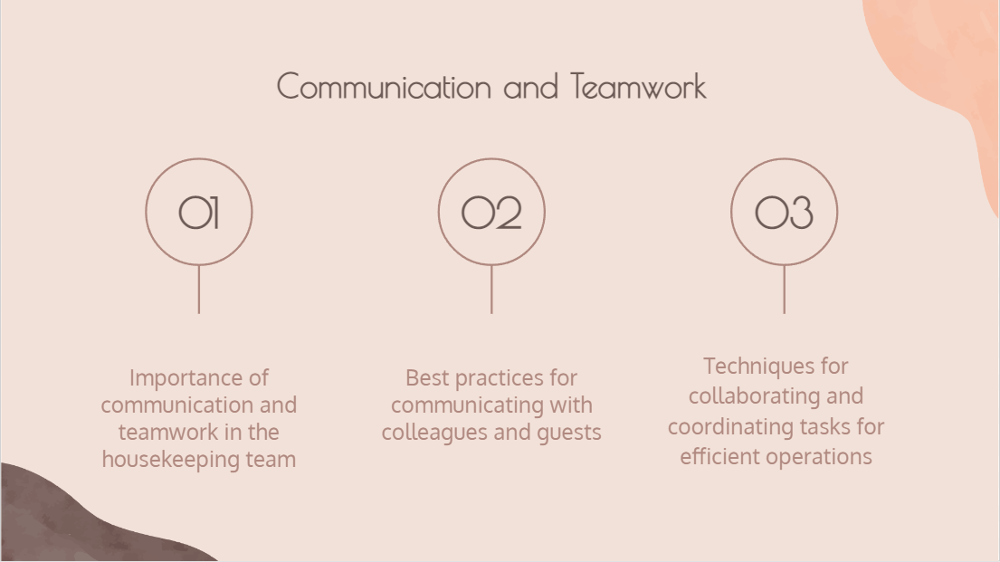

Training Notes:
- Importance of communication and teamwork in the housekeeping team to ensure efficient operations and guest satisfaction
- Best practices for communicating with colleagues and guests, such as using clear and courteous language and actively listening to concerns
- Techniques for collaborating and coordinating tasks for efficient operations, such as dividing cleaning tasks and using checklists
Guest Complaint Handling

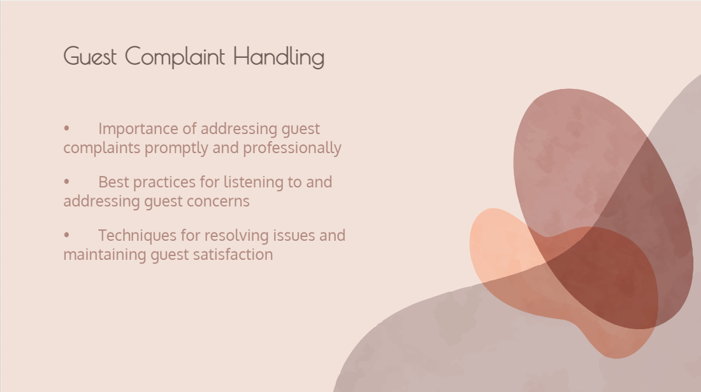

Training Notes:
- Importance of addressing guest complaints promptly and professionally to maintain guest satisfaction and loyalty
- Best practices for listening to and addressing guest concerns, such as acknowledging their concerns and apologizing for any inconveniences
- Techniques for resolving issues and maintaining guest satisfaction, such as offering solutions and following up with guests
Continuous Improvement

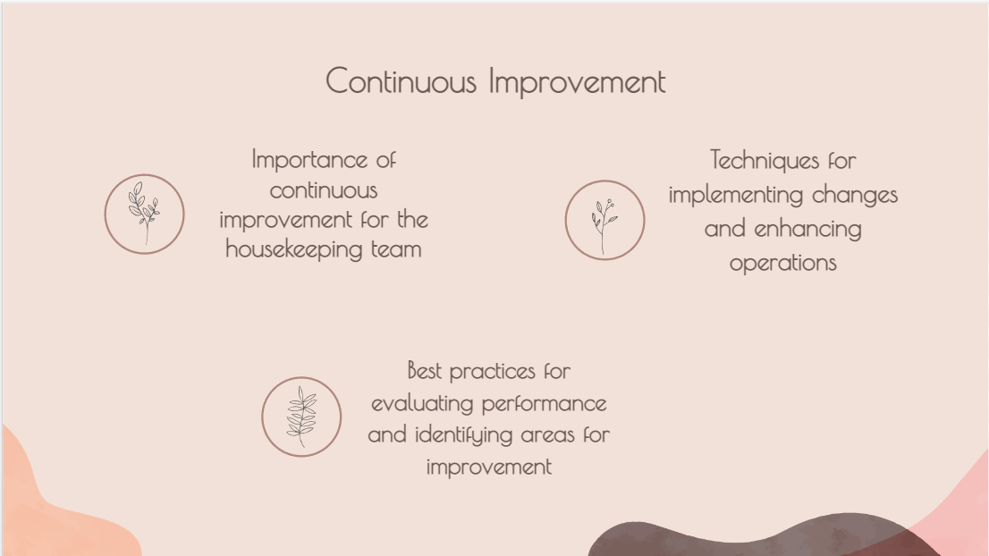

Training Notes:

- Importance of continuous improvement for the housekeeping team to enhance operations and meet guest expectations (Burns & Firn, 2017)
- Best practices for evaluating performance and identifying areas for improvement, such as conducting regular inspections and seeking feedback from colleagues and guests
- Techniques for implementing changes and enhancing operations, such as training and development, process improvement, and technology adoption

References
Burns, T. and Firn, M. (2017) “Key working versus the whole-team approach,” Oxford Medicine Online [Preprint]. Available at: https://doi.org/10.1093/med/9780198754237.003.0005.
Deffie, R. (2021) “Expectations and perceptions of guests staying on hotel linen cleanliness at Star Hotels in berastagi karo regency,” Tourism, Hospitality And Culture Insights Journal, 1(1), pp. 28–42. Available at: https://doi.org/10.36983/thcij.v1i1.281.
Firth, R. (2021) “Conditions of housekeeping,” Housekeeping among Malay Peasants, pp. 1–16. Available at: https://doi.org/10.4324/9781003135364-1.
Lappin, M. (2013) “Leadership, management, team working, and decision making,” Nursing: Decision-Making Skills for Practice [Preprint]. Available at: https://doi.org/10.1093/oso/9780199641420.003.0016.
Marsh, A. and Munyard, P. (2016) “the importance of a dedicated forward thinking housekeeping team working in a clinical environment,” Patient Care [Preprint]. Available at: https://doi.org/10.1136/bmjspcare-2016-001245.134.
“Monitoring cleanliness and defining acceptable cleanliness levels” (2003) Surface Contamination and Cleaning, pp. 31–39. Available at: https://doi.org/10.1201/9789047403289-7.
Tossell, C. (2008) “Collaborative tool for Command and Control Team Effectiveness Studies: Experimental test of interventions to improve performance in command and Control.” Available at: https://doi.org/10.21236/ada496735.
Wei, W. and Lee, H. (2009) “Hotel Revenue Management Theories and Applications,” 2009 International Conference on Business Intelligence and Financial Engineering [Preprint]. Available at: https://doi.org/10.1109/bife.2009.195.
Wood, R.C. (2017) “Facilities management,” Hotel Accommodation Management, pp. 177–190. Available at: https://doi.org/10.4324/9781315169965-14.
“Working with confrontation and conflict negotiation” (2013) Effective Interpersonal and Team Communication Skills for Engineers, pp. 115–134. Available at: https://doi.org/10.1002/9781118514283.ch15.

