Changemakers: Creativity and Value Creation
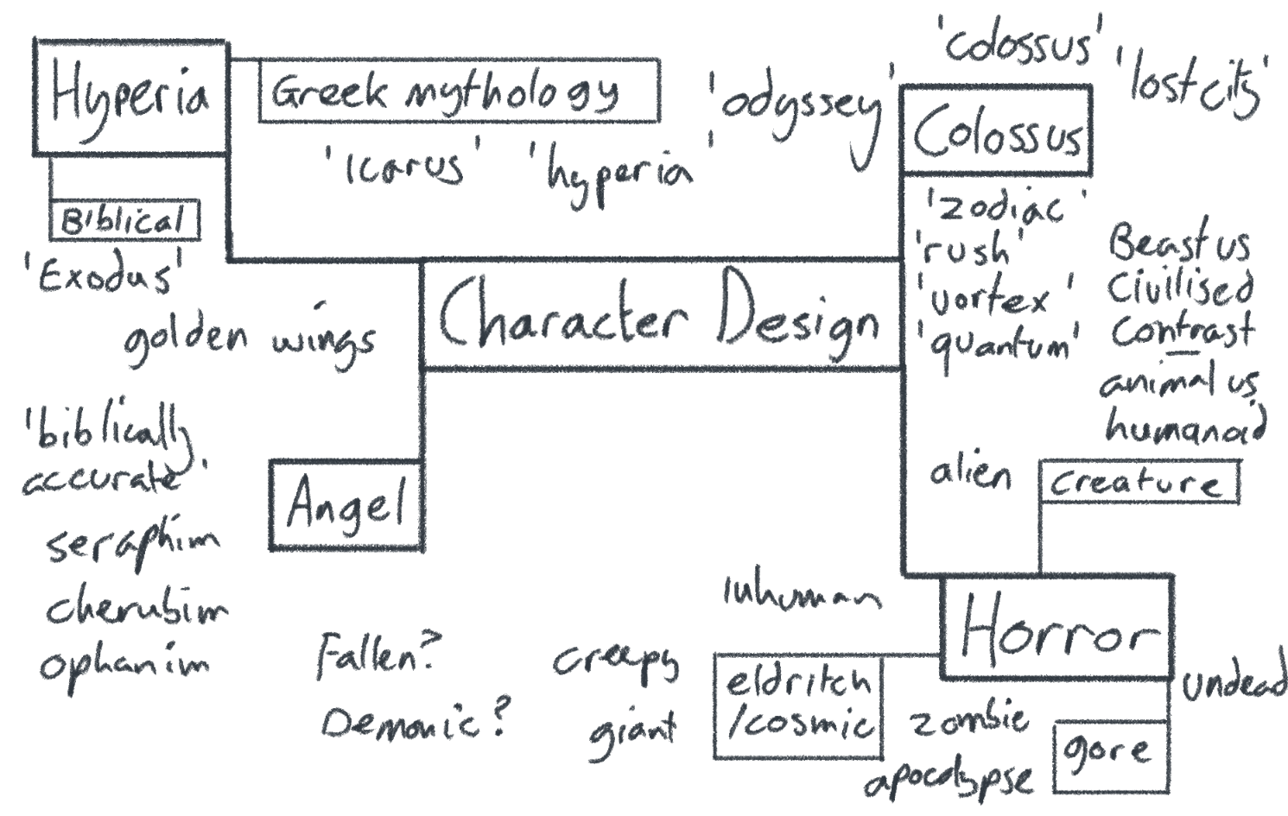
Idea generation
The mind map seen here was created before anything else, taking a few key words that interested me and going forwards from there. In the end, something from each key concept was taken- The later character is based around Colossus at Thorpe Park, and the surrounding Lost City area, but includes themes such as angel-like imagery and other religious and mythological connotations, and the concepts of cosmic horror that can easily go hand in hand with these. All the words in quotation marks (aside from ‘biblically accurate’ which is quoted more for the fact that this is what people often use to refer to the angels listed below) are names in relation to the theme parks themselves, which will be explained briefly below as to make later inclusions of these easier to follow.
Lost City- Themed area in Thorpe Park
Zodiac, Rush, Vortex, Quantum- Flat rides in Lost City
Colossus- Rollercoaster in Lost City
Odyssey- Code name for Colossus used during construction
Hyperia- Rollercoaster currently under construction within another area of Thorpe Park
Exodus- Code name for Hyperia before the official name was announced
Icarus- Possible name for Hyperia before the final name was decided on
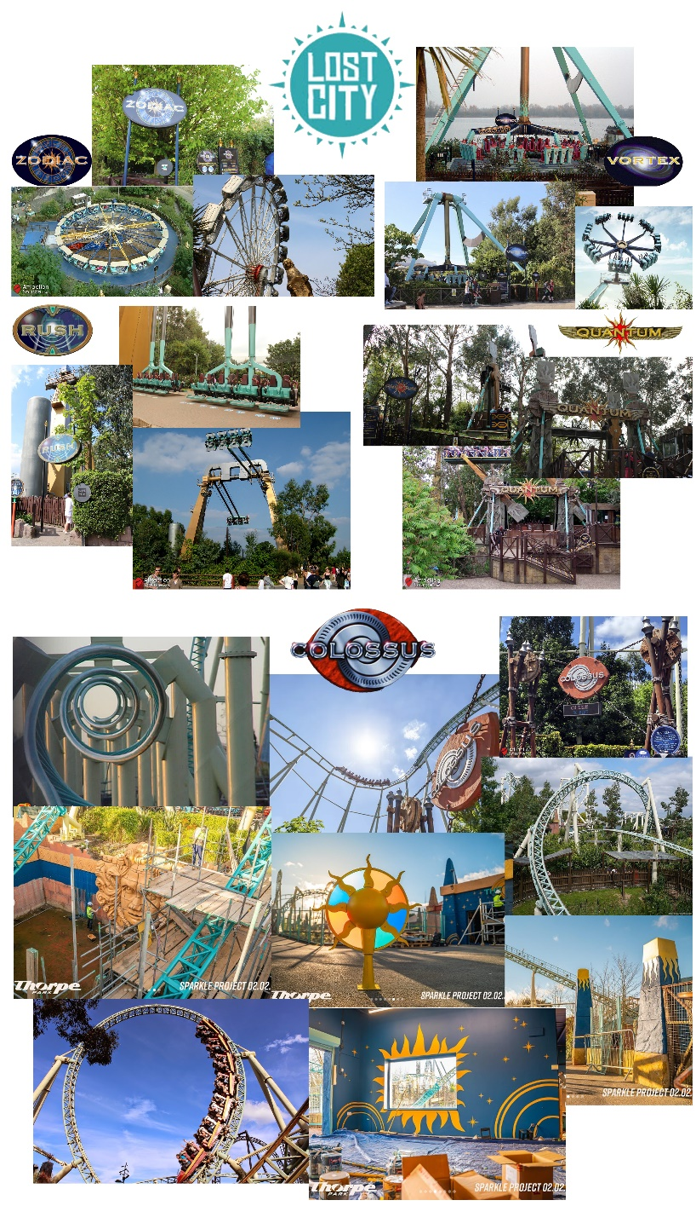
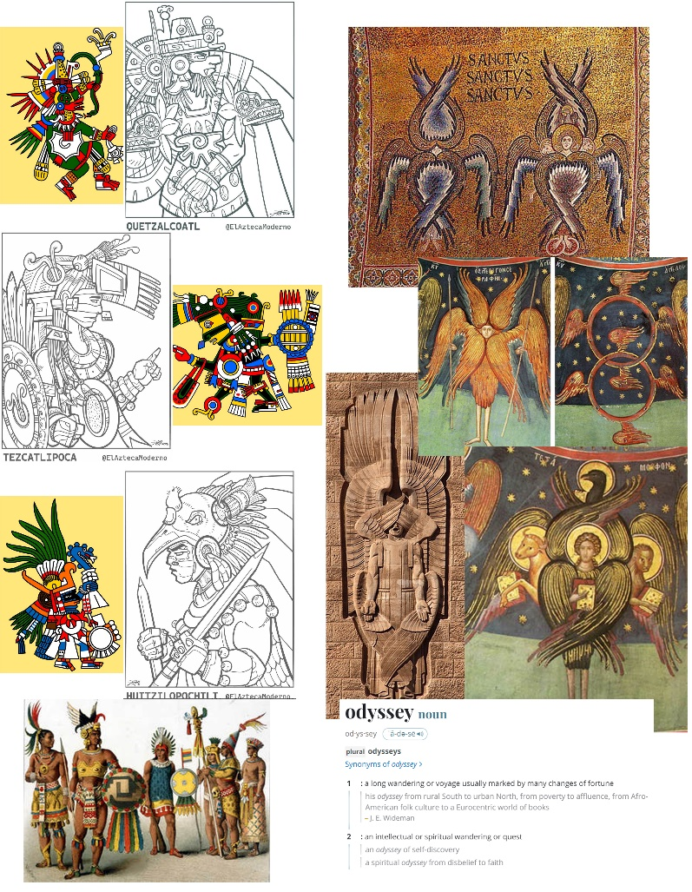
Inspirations and refining ideas
These are the two mood boards created for putting together inspirations and resources for the character. The right-hand board was created first and is more easily explained, being a collage of images surrounding the Lost City. It features all current logos, and images of the flat rides and rollercoaster featured in the area. Several of the Colossus photos are of work currently being undertaken as part of Project Sparkle (a project to make small-scale improvements to facilities and present the rides and areas better)- these show updated theming that will be featured for the 2024 season and are heavily used in the designs where possible (though some of the inspiration comes from previous merchandise using similar visual designs that I own, and are not pictured anywhere, though can be shown on request if it would be useful).
The second board seen on the left is more inspirations for how the character itself could look. The Lost City is based on the idea of an ancient civilisation that’s been uncovered, and so that concept was taken and applied to a real-world instance of this to add more to the inspirations to be used for design and costuming. There are visual hints to some inspirations for the Lost City coming from the Aztec culture, and so from there it was decided that the character would be some sort of deity within this city with inspiration taken from depictions of Aztec gods. The design also includes the idea of this deity being restrained or chained down, based on the chains seen within the theming of Colossus. To not limit design possibilities though, the idea of having two forms for the character was used, one being more human in appearance and one being more within the realm of cosmic horror, its ‘true’ form for when appearing human isn’t necessary. For this, as well as using the rides and theming for creating a design, there is heavy inspiration coming from Abrahamic scripture surrounding angels, specifically Seraphim, Cherubim and Ophanim, as these creatures are described as appearing much more otherworldly and difficult to comprehend with a multitude of interpretations. In the end the design was closest to the idea of an Ophanim (specifically the interpretation of Ophanim and Thrones being different names for the same being, though this is a subject of debate)- the snake like body is intended to mimic the appearance of the rollercoaster track, but also lends to the idea of turning wheels described, the glowing sun/star like appearance of the ‘face’ works well with the idea of being filled with fire or light, and while it only has one eye as opposed to the many eyes described in texts, this one eye is a key feature that’s especially striking in contrast to the rest of the body itself.
Images of the designs will be below.
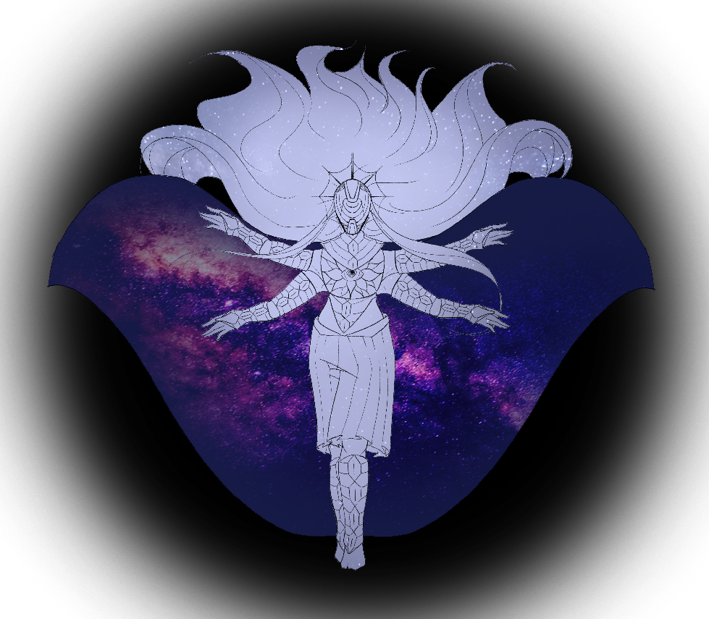
Design 1- Humanoid
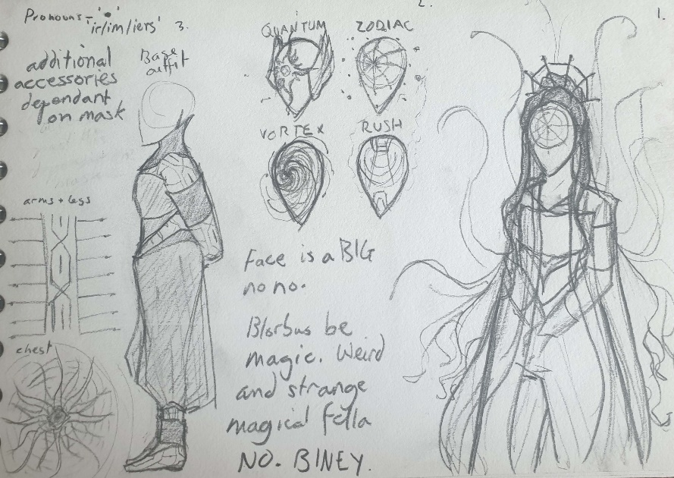

These are the original ideas for the humanoid character created before this assignment, which was used as a basis and redesigned using the concepts and research done. All other art has been done specifically for this assignment, these simply add context.

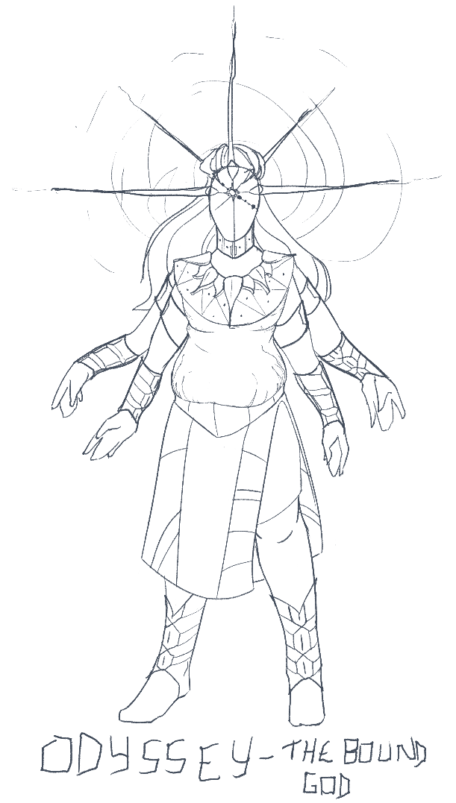
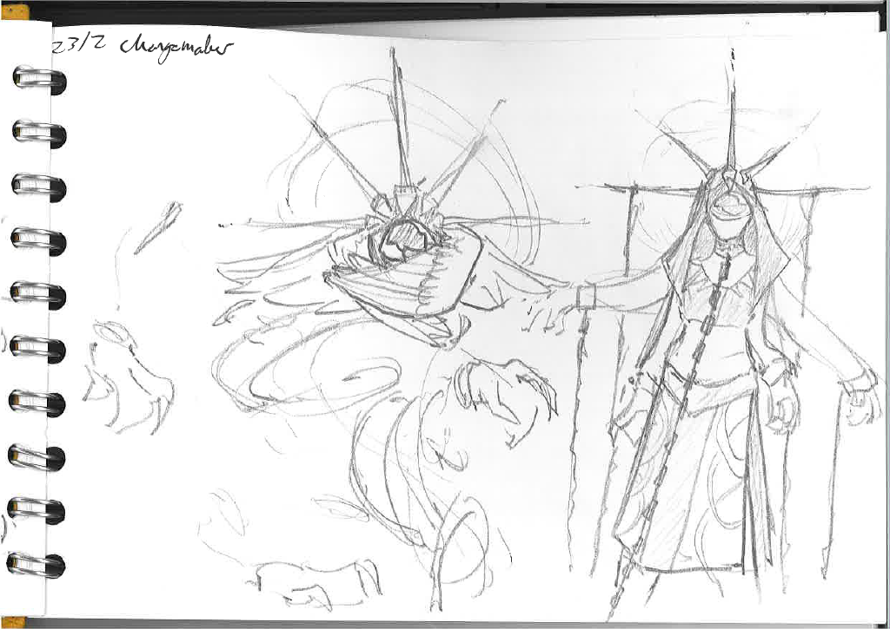

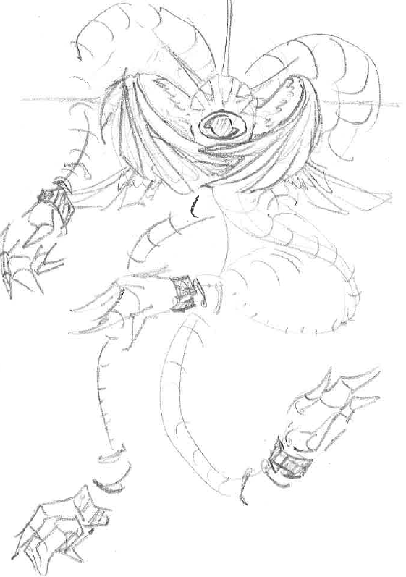
Design 2- Creature

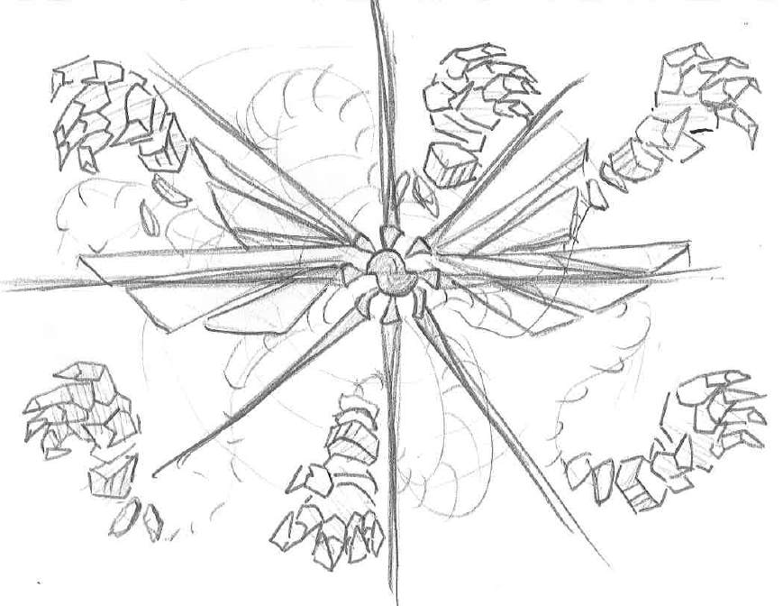

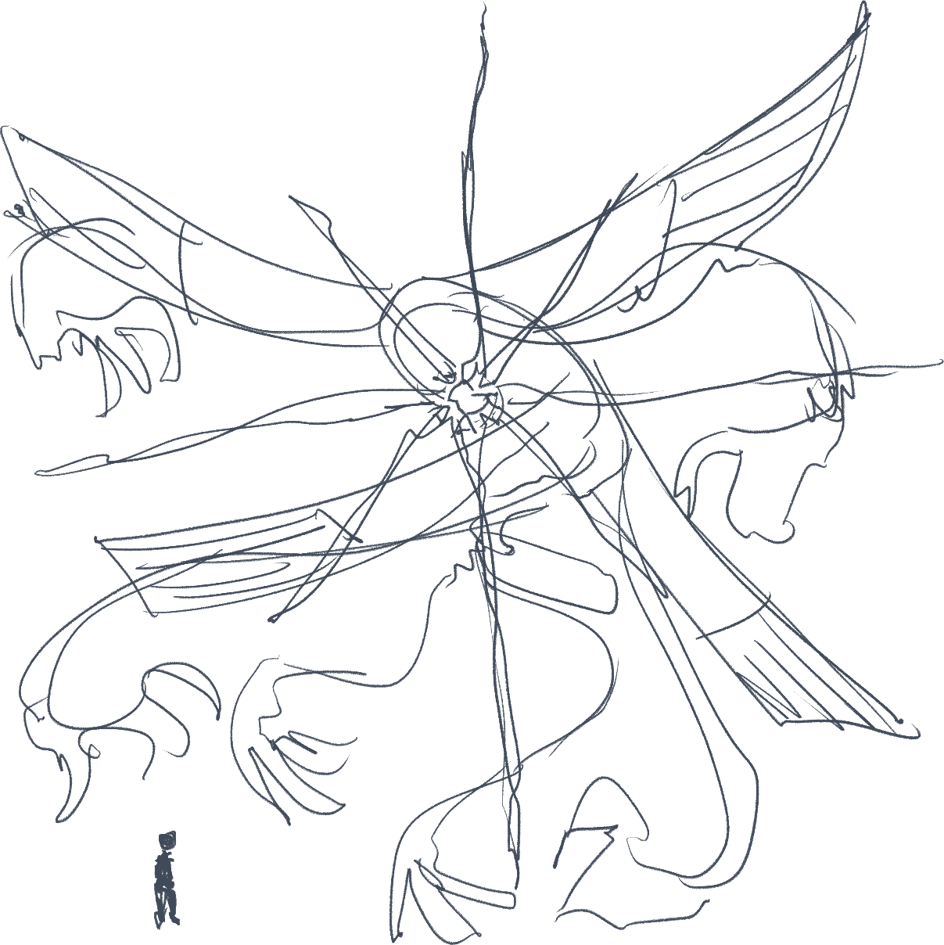
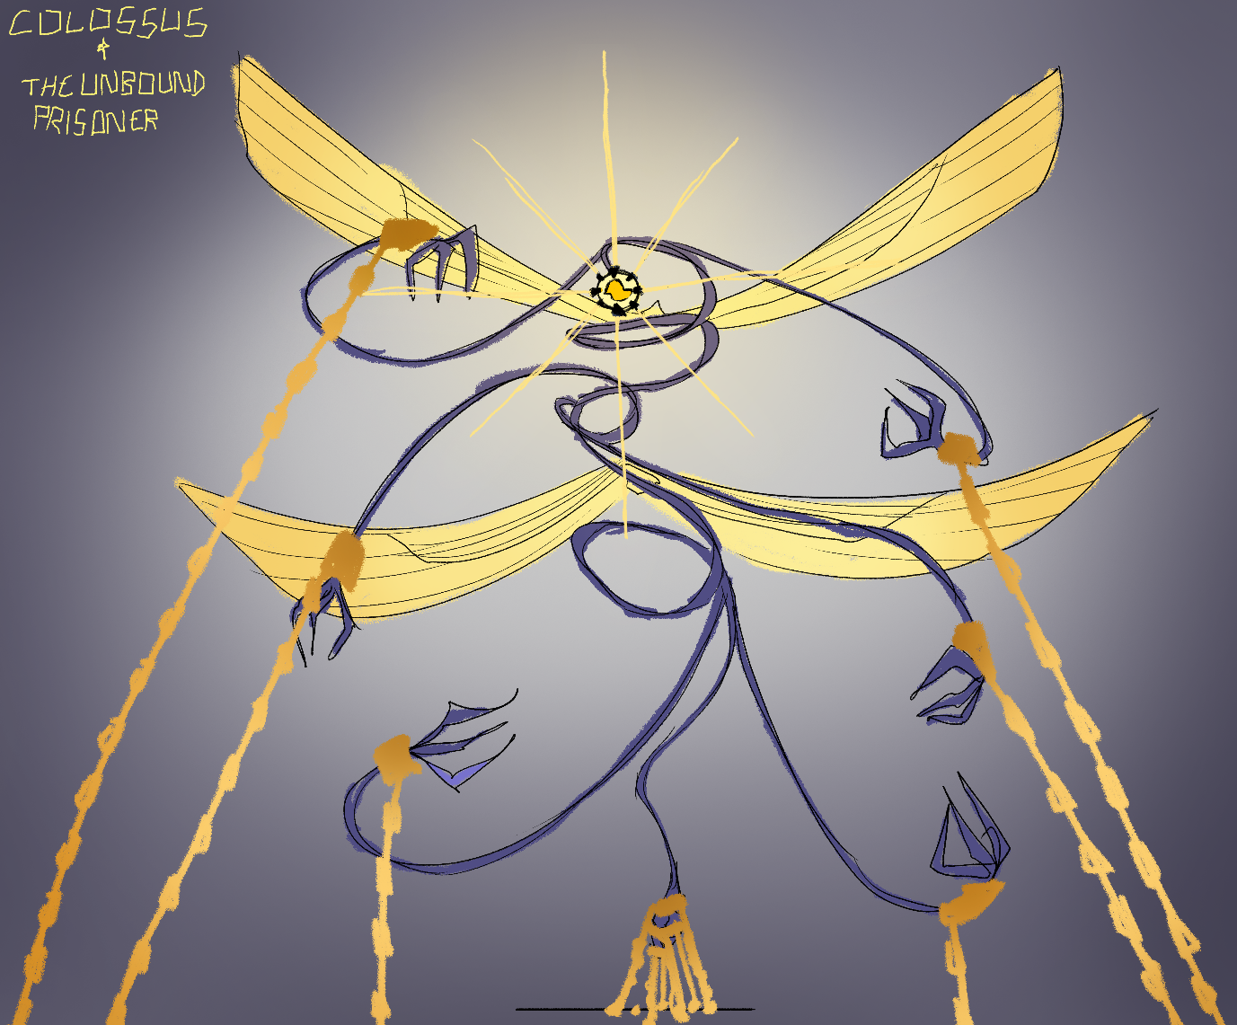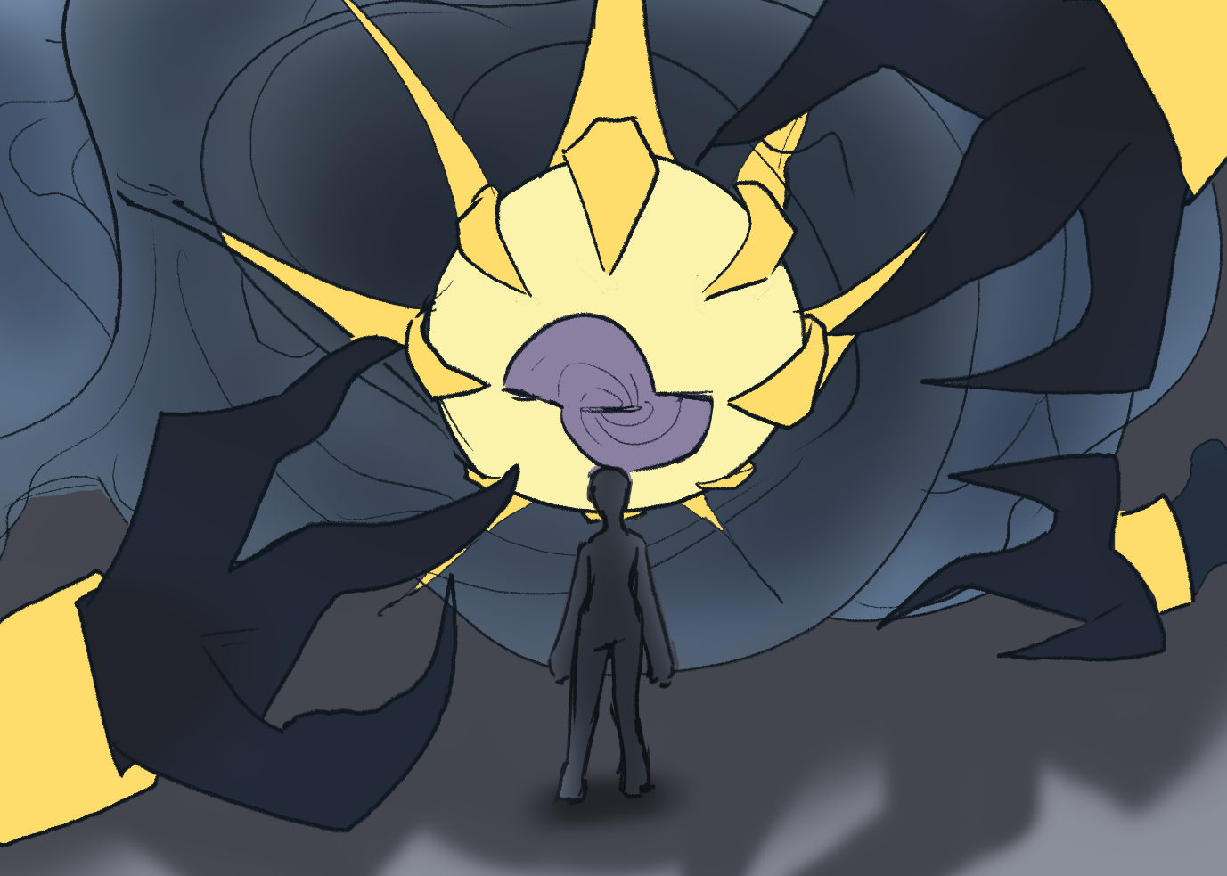
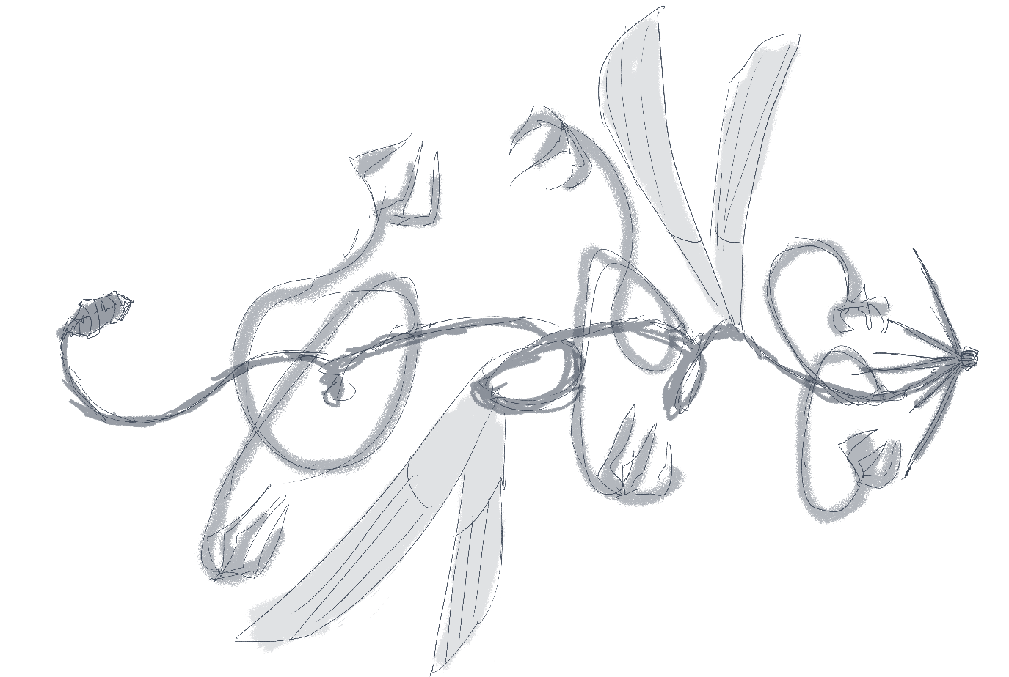
Sources
“History of Thorpe Park - attraction source - theme parks and attractions from another point of view!,” Attraction Source, https://www.attractionsource.com/history/from-the-archives/history-of-thorpe-park/ (accessed Feb. 2024).
“Theme Park Rides & Rollercoasters: Thorpe Park Resort,” Thorpe Park, https://www.thorpepark.com/explore/theme-park/rides/ (accessed Feb. 2024).
“Thorpe Park Official,” Instagram, https://www.instagram.com/thorpeparkofficial/ (accessed Feb. 2024).
“Lost City,” Thorpe Park Mania, https://www.thorpeparkmania.co.uk/area/Lost+City (accessed Feb. 2024).
“UPDATE!,” Instagram, https://www.instagram.com/p/C22yc59txXi/?img_index=8 (accessed Feb. 2024).
“Aztec gods: A gallery,” Mexicolore, https://www.mexicolore.co.uk/aztecs/gods/aztec-gods-a-gallery (accessed Feb. 27, 2024).
D. “DTM” Flores, “Azteca Moderno,” Instagram, https://www.instagram.com/elaztecamoderno/ (accessed Feb. 2024).
“Aztecs and Tenochtitlan,” Aztec clothing, https://aztecsandtenochtitlan.com/aztec-clothing/ (accessed Feb. 2024).
T. Rooks, M. Rorks, H. Marks, and J. Schmieder, “What kind of clothes do the Aztecs wear?,” Aztec Humanities, https://aztechumanities.weebly.com/aztec-clothing.html (accessed Feb. 27, 2024).
D. Smyth, “Who Are the Seraphim and What Are These Angels Powers in the Bible?,” Christianity.com, https://www.christianity.com/wiki/angels-and-demons/who-are-the-seraphim-in-the-bible.html (accessed Feb. 27, 2024).
H. Bolinger, “What do biblically accurate angels really look like?,” Christianity.com, https://www.christianity.com/wiki/angels-and-demons/what-do-angels-look-like.html (accessed Feb. 2024).
L. L. Baker, “Are demons really fallen angels?,” Christianity.com, https://www.christianity.com/wiki/angels-and-demons/are-demons-really-fallen-angels.html (accessed Feb. 2024).
“What is a cherub? the cherubim in the Bible,” Christianity.com, https://www.christianity.com/wiki/angels-and-demons/what-is-a-cherub-the-cherubim-in-the-bible.html (accessed Feb. 2024).
Sandra Cohen-Rose and Colin Rose, “Bas Relief, Jerusalem YMCA,” Flickr, https://www.flickr.com/photos/73416633@N00/5503056704/in/photostream/ (accessed Feb. 2024).
“Ангелы: как изобразить непостижимое?,” На Главную, http://www.nsad.ru/articles/kak-izobrazit-nepostizhimoe (accessed Feb. 2024).
“Names and ranks of Angels,” Holy Resurrection Tucson, https://www.holyresurrectiontucson.org/articles/Names and Ranks of Angels.pdf (accessed Feb. 2024).
W. Hopler, “How thrones angels rank in the angel hierarchy,” Learn Religions, https://www.learnreligions.com/what-are-thrones-angels-123921 (accessed Feb. 2024).
A. Griffin, “Who are the ophanim in the Bible? angels meaning and purpose,” Bible Study Tools, https://www.biblestudytools.com/bible-study/topical-studies/who-are-what-are-the-ophanim-the-wheels-in-the-bible.html (accessed Feb. 2024).
“Odyssey Definition & meaning,” Merriam-Webster, https://www.merriam-webster.com/dictionary/odyssey (accessed Feb. 2024).

