Business Plan for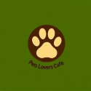

PETS LOVERS CAFÉ
Will be a place where dogs are not only accepted but also appreciated, in contrast to other coffee shops. It offers owners homemade, organic dog treats and a relaxing space

Produced By:

GROUP MEMBERS:
Student Name | Student No.
Ionelia Popoiu | 2243056
Carmen Celina Gheorghe | 2246329
Aniko Takacsne Feher | 2245369

Dated: 14. November 2024.

Module Name: Entrepreneurship
Module Code: BMIH5001
Lecturer Name: Charlotte Joyner

CONTENTS

 |  |  | PAGE
1. | Executive Summary |  | 4.
2. | The Business Idea |  | 6.
3. | The Team |  | 8.
4. | Market Research |  | 13.
5. | Marketing Plan |  | 19.
6. | Key Resources |  | 23.
7. | Finances & Start-Up Support |  | 27.
 | Appendix A  Appendix B  Appendix C  Appendix D  Appendix E  Appendix F  Appendix G  Appendix H  Appendix I |  | SWOT analysis  PEST analysis  Customer profile  Competitor profile  Price list and menu  4PS Marketing Plan  Design  Key suppliers  Financial  Presentation
AI Declaration:

For the menu creator: (Design, 2024).
For the design tool: (Open AI 2024).

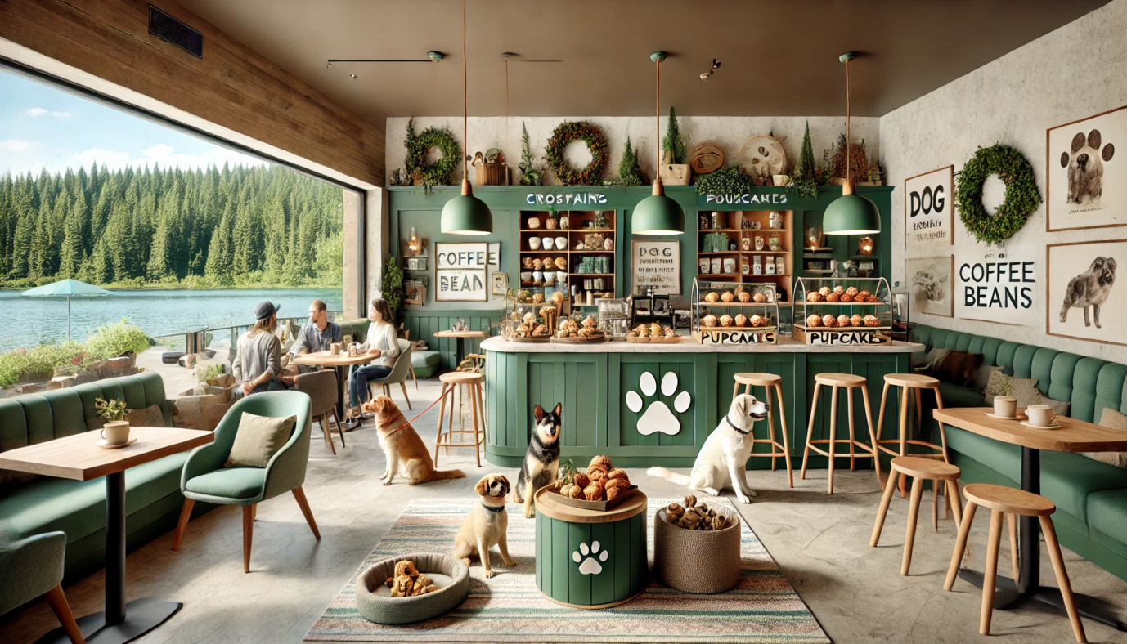
  - EXECUTIVE SUMMARY

Pets Lovers Café is a cozy, dog-friendly spot at Willen Lake in Milton Keynes, created with a love for pets and their owners. Founded by Aniko, Nelly, and Celina, our café isn’t just about great coffee – it’s a space where people and pets can unwind together. We serve premium coffee, fresh pastries, and homemade organic treats for dogs, all with pet-friendly seating that invites everyone to relax. We’re also excited to team up with local organizations like RSPCA Milton Keynes, highlighting our dedication to animal welfare and turning the café into a genuine community gathering spot.

Market Opportunity: Milton Keynes is home to a vibrant pet community, and with over a million visitors drawn to Willen Lake each year, we see plenty of potential! Our main audience includes young professionals, families, and retirees who love spending time with their pets and value quality, welcoming places to do just that. With more people than ever investing in experiences and outings with their pets, Pets Lovers Café is here to fill that niche perfectly.

What Sets Us Apart: Pets Lovers Café is all about offering a one-of-a-kind experience for pets and their people. From our organic dog treats to special pet-friendly events and a loyalty program we call “Paws and Perks,” we aim to build lasting relationships with our guests. Unlike regular cafés and pubs where pets might be an afterthought, we’ve built our space to be a true pet haven. Events like adoption days, pet meet-ups, and social gatherings make us more than just a café – they make us a place where pet lovers can connect and share in something special.

Financial Snapshot: In our first year, we’re aiming for £90,000 from food and drink sales, £6,000 from our membership program, and £4,000 from events – bringing us to a total of £118,000. With these earnings and our initial investments, we’re set to cover our costs and anticipate a profit of £19,548.

Funding Needs: To get the café up and running, we need an initial £5,000 from the founders, a local council (Milton Keynes Council, 2024) grant of £3,000, and a startup loan (British Business Bank, 2023) of £10,000. With these funds, we’ll be able to secure our location, get the necessary equipment, and launch our first marketing efforts to welcome the community through our doors.

Short-Term Goals: In our first year, we’re focused on building our brand around Milton Keynes, growing our Paws and Perks membership program, and setting up an online shop where we’ll offer pet treats and merchandise. By hosting regular events, we’ll have the chance to build stronger connections within the community and create lasting relationships with our customers.

Pets Lovers Café isn’t just a coffee spot – it’s a warm, community-focused place where great service meets a genuine love for pets. We’re looking forward to becoming a favorite destination for pet-loving locals and visitors in Milton Keynes.
2. THE BUSINESS IDEA
2.1 The Product/Service
Pets Lovers Café
Located next to the beautiful Lake Willen in Milton Keynes, it is specially designed for dog owners and their dogs. Unlike traditional coffee shops, it has a comfortable, dog-friendly atmosphere where dogs and owners can enjoy some company. We pride ourselves on making the space as human-friendly as possible, with dog-friendly seating, premium coffee and handmade natural treats that dogs will love.
Target market
Our cafe is the number one destination for dog lovers and people living in the Willen Lake area who want dog-friendly, pet-friendly, quality food.
What we offer
- For owners: A selection of delicious pastries, teas and premium coffees - perfect for relaxing while your dog gets his own treat.
- Dogs: our treats are made fresh using natural ingredients, designed to keep our pets busy and well fed.
- Space: Our cafe has cozy, dog-friendly tables inside and outside, where dogs can hang out and socialize.
- Community impact: We are proud to work with community animal shelters such as RSPCA Milton Keynes and offer treats based on our high standards of quality and animal welfare.
- Public Outreach: Through adoptions, animal welfare initiatives and creating a social environment for pet owners, Pets Lovers Café has become a community gathering place.
2.2 SWOT Analysis Summary
Through our relationship with RSPCA (RSCPA,2023) Milton Keynes, we are able to provide the best, welfare-friendly treats and adoption events available, making it unique for pets and their owners. We’re also planning an online store to reach more pet lovers and provide easy access to our products.
- Points of differentiation: We are close to the community, we specialize in organic, dog-friendly products, and we have a special pet café (Carter and Jones-Evans, 2012).
- Downsides: We’re less popular outside of the pet-owner community, and may cost more to run due to our niche product (Grunert, 2010).
- Chances: Going e-commerce offers us a great opportunity to meet pet owners outside our geographic region.
- Threats: We’re familiar with competition at local level and how the economy might affect consumer behaviour.
Our deep-rooted devotion to pet-ownership and animal welfare means that Pets Lovers Café will continue to have a long-lasting positive impact in Milton Keynes.
(Appendix A - SWOT analysis)

3. THE TEAM

3.1 Key Personnel
Name and Company Position: Celina - Co-Founder, Customer Relations and Marketing Coordinator
Skills and Experience; Role and Responsibilities:
Celina has more than many years of experience in customer service and hospitality, social media management and digital marketing. He is responsible for increasing customer engagement and creating a comfortable, dog-friendly space. Celina is responsible for in-store sales and customer service, oversees our Instagram and Facebook social media accounts, coordinates promotions with RSPCA Milton Keynes and creates loyalty programs to help build customer relationships both in store and online.

Name and Company Position: Nelly - Co-Founder, Barista, and Product Development Lead
Skills and Experience; Role and Responsibilities:
Previously worked as a chef and product designer. Nelly specializes in creating original cafe products and seasonal goods such as dog treats. His task is to prepare food and drinks that exceed the customer's expectations and quality. She also creates recipes for dog treats and other specialty drinks, researches online opportunities, and oversees hygiene and food safety practices. Nelly helps manage our inventory, collaborates in developing seasonal menu items, and helps with our advertising.

Name and Company Position: Aniko - Co-Founder, Accountant, and Operations Manager
Skills and Experience; Role and Responsibilities:
Aniko's accounting and management skills, as well as her knowledge of dogs, make her an indispensable member of our team. Manages accounting, budgeting, payroll, financial reporting, inventory and order management both in-store and online. In addition, Aniko manages personnel tasks, contact with suppliers, digital invoicing, accounting and online transactions to ensure everything runs smoothly.

3.2 Skills Gaps & Key Partners
3.2.1 Additional Staff Requirements (Roles and Responsibilities)
We have realized that we need additional resources in certain areas to facilitate our expansion:

- Kitchen assistant (part-time):
This position helps with cooking, serving and sanitation, allowing the founders to get back to growing.
Job duties: Serving food and drinks, making dog treats, cleaning the kitchen.

- Digital marketing expert (freelance/part-time):
We also need a digital marketing specialist to increase our internet and e-commerce presence. Creating content, running campaigns and tracking engagement – ​​especially social media.

3.2.2 Training and Development

We invest in special training to compensate for skill gaps:
- Aniko:
Food hygiene and safety (level 2) (£25.00) and Shopify E-commerce Essentials Training (£30.00) enable Anikó to perform food safety, inventory management and online sales tasks as well.
- Celina:
Google Digital Garage's Digital Marketing Basics free course will further develop Celina's social media and SEO skills to help improve our online presence (Google Digital Garage, 2023).
- Nelly:
Nelly is trained in food hygiene and safety (level 2) (£25.00) to ensure that all food and treats are safe.
3.2.3 Outsourced Support / Key Partners
We outsource key services to third parties
- Web development and e-commerce:
Our website and online shop are hosted and managed by Fiverr or Upwork freelancers for between £200-£500 (Fiverr, 2023).
- Graphic design:
We use Canva Pro or Fiverr freelancers for branded marketing graphics for £10.99 per month, around £50 for a project (Canva, 2023).
- Legal and Compliance:
Legal and compliance assistance can be provided by Simply Business or a local specialist for approximately £100-£200 (Simply Business, 2023).
4. MARKET RESEARCH
4.1 Market Information, Trends and External Factors

Market Research Report Pets Lovers Café, Willen Lake, Milton Keynes
Overview
With an estimated population of around 287,000 (ONS, 2023) and more than 1 million people visiting Willen Lake each year, Milton Keynes is the perfect location for Pets Lovers Café. With family and pet friendly facilities, Willen Lake provides a regular and loyal customer base, who appreciate quality goods and pet-friendly services, which is what our cafe is all about.
Demographics and demand
The UK has a high rate of pet ownership, with 59% of homes owning a pet (PFMA, 2024). This move towards a pet-friendly environment resonates well with our demographic of pet owners aged 25-55, who want quality, local and pet-friendly living spaces. And in our cafe there are families and young dog owners who like to be in company (Willen Lake, 2023).
Market trends
- Demand for pet-friendly places: With more and more people owning pets (especially after the pandemic), the demand for pet-friendly places is increasing. Pets Lovers Café has the opportunity to provide an environment where pets and their owners are welcome.
- Experiential shopping: People want more experiences – 62% will pay more for something they'll remember (Deloitte, 2023).Our neighborhood parties and pet events capitalize on this trend.
- Organic and healthy: Customers are increasingly looking for health-conscious, organic products that fit perfectly with our interest in making homemade dog treats and high-quality coffees that serve the health-conscious market.

PEST Analysis
- Political: Pets Lovers Café is subject to UK regulations, including the Food Hygiene (England) Regulations 2013 and the Animal Welfare Act 2006 regarding food safety and animal welfare requirements (Food Standards Agency, 2013; UK Government, 2006).
- Economic: Inflation can affect disposable income, but the sensibility of the neighborhood makes the cafe unique as a community center popular with dog owners (ONS, 2024).
- Social: Pet owners increase the demand for pet-friendly businesses. Working with institutions such as the RSPCA increases our public profile (Pet Food Manufacturers Association, 2024).
Technology: E-commerce allows us to serve more people and increase our brand awareness (Statistics, 2024).
(Appendix B – PEST Analysis)

Market Competition and Market Outlook for Pets Lovers Café
Competitor Overview
There are a few coffee shops in Willen Lake, but no coffee shops that cater specifically to pet owners, which leaves a special spot open for Pets Lovers Café. The adjacent Willen Lake Café doesn’t have a dog menu or specials. Pets Lovers Café differentiates itself through pet-themed treats, RSPCA adoption days, and advertising to the pet community.
Key Competitor Insights
- Competitors Strengths: Brand awareness and loyal customers.
- Competitors' Weaknesses: Slight lack of pet amenities, special treats and activities. Google ratings say we need to make dog-friendly environments more accessible.
Legal Compliance
Pets Lovers Café must comply with the UK food, animal welfare and data protection laws. Clear zoning, deep cleaning and signage will assure compliance, alongside consultation with Milton Keynes Council’s Environmental Health Department (Food Standards Agency, 2013; UK Government, 2006; Health and Safety Executive, 1974; Information Commissioner’s Office, 2018).
Customer Viability and Demand
The UK has 59% of families that own pets, so we’re all looking for spaces that can accommodate them. Willen Lake’s seasonal foot traffic and the café’s special menu maintain an established customer base. Pets Lovers Café caters to pet owners and their families, making the community more welcoming and popular during the summer months.
4.2 Customer Profiles
Pets Lovers Café caters to those with pets at heart, who care about the community, and who appreciate a good experience. In our own study, we have identified three main buyer profiles that are suited to what our café offers:
Customer Profile Analysis
- Pet-Loving Young Professionals
They’re a society who cares about convenience, wellbeing, and communities. Since young adults are now more likely to own pets (PFMA, 2024), they naturally gravitate toward the café’s raw food and pet-friendly décor. They’ll also follow us on social media, spreading the word.
- Families with Pets
Families want cheap, pet- and kid-friendly environments. With an outdoor patio overlooking Willen Lake and adoption days, the café makes for a perfect family destination, which is why our "Paws and Perks" membership is so great for this demographic.
- Retired Pet Owners
Renters care about community, leisure and affordability. They are a fan of the café’s serenity and neighbourhood events, often becoming regulars who add to the neighbourhood atmosphere.
Summary
Such descriptions highlight the café’s appeal to many Willen Lake regulars, which promotes strong engagement and repeat business.
(Appendix C – 1. Customer Profiles)

4.3 Competitor Profiles
The Pets Lovers Café will be competing with a number of Milton Keynes-area cafés and pub that serve canine fare. Knowing their strengths and limitations allows us to point out our special features and make ourselves unique in the marketplace.
Competitor Analysis
- Lakeside Pub & Grill
- Strengths: Popular with dogs because of its outdoor dog seating.
- The downsides: No pet menu, no pet events.
- Our Pros: Indoor seating, organic pet food, and exclusive "Pet Meet-Up Days."
- Willen Dragon Brewers Fayre
- Strengths: Family- and dog-friendly with a large garden.
- Bottom Line: Classic pub grub, no pet parties.
- Our Special: Our pet menu, indoor dining, and "Paws and Perks" membership.
- Paws Café
- Strengths: Relaxed atmosphere, canine-friendly seating.
- The downsides: Lack of space and menu.
- Our Advantage: We have a bigger menu, VIP opportunities, and a loyalty program.

Competitive Advantages
- Dog Friendly Services: There is indoor seating and an organic dog menu at our café.
- Community Activities: We have adoption days and "Pet Meet-Up Days" to strengthen our community outreach.
- "Paws and Perks" Membership: This loyalty program promotes frequent visits with special discounts and incentives.
Pets Lovers Café is well-positioned to attract customers who value pets, community, and quality experiences. Our research identifies three main customer profiles, each with unique demographics, behaviors, and values aligned with the café’s offerings.
(Appendix C – 2. Competitor Profiles)
5. MARKETING PLAN
5.1 Price
We have a pricing philosophy at Pets Lovers Café that ensures quality, consistent with Willen Lake’s aggressive pricing, but we keep fresh, healthy pet treats at the forefront of our offering.
- Competitive Benchmarking:
We keep coffee and pastries affordable, though our own natural, home-made dog treats are a little bit more expensive because of their higher quality ingredients (Willen Lake, 2023).
- Quality Perception:
We are here to appeal to dog owners who value pet health. For instance, our organic dog biscuits cost £2.50 per treat or £6.00 for three, and are high quality and well thought out.
- Membership Package:
For £10 a month, we have a "Paws and Perks" scheme where you can get a free drink, pet treats discounts and loyalty points.
Sample Pricing:
- Coffee: £2.50-£3.50
- Dog Biscuit: £2.50 / £6.00
(Appendix D - Price List and Sample Menu)

5.2 Product
Pets Lovers Café Product Name and Product Catalogue
Our products are geared toward both pets and humans and we focus on high quality, local ingredients.
Human Offerings:
- Coffees & Teas: Organic & local beverages.
- Fresh Pastries: A rotating menu with a few dog friendly treats.
Pet Offerings:
- Healthy Snacks: Organic puppies and biscuits.
- Ice Cream for Dogs: Gluten-free, compostable cups.
- Branded Wear: Collars, leashes, bandanas in rustic colors.
Aesthetic & Design:
- Brand Colors: We’ve chosen forest green, beige, and brown to give an organic, homely feel inspired by our passion for nature.
- Packaging: Our packaging is recyclable (Recycled boxes, Cups) and printed with playful dog slogans to give it some whimsy.
- Logo: Our logo resembles paws on a coffee bean, which makes our logo a unique and memorable design for dog owners.
By focusing on quality, sustainability, and community, we’re building a brand that pet owners can trust and feel good about supporting.

5.3 Placement
In-Store Placement and Customer Engagement
Pets Lovers Café is a must-go dog spot at Willen Lake, Milton Keynes. Dog tables, water stations, and monthly community-building events like adoption days and pet meet-ups at the café are all designed to help keep pets connected and loyal.
Future Online Sales and E-commerce
We’re hoping to extend our footprint with an online store selling dog food, products and memberships to owners in the UK. We will advertise our products and connect with the store on social media, such as Instagram and Facebook.
Distribution:
- Local Delivery: Cheap, fast delivery within Milton Keynes.
- Nationwide Shipping: International orders ship in eco-friendly packaging, via an express service.
Through our in-store and online experiences, loyalty points, Pets Lovers Café gives pet parents an opportunity to get to know our brand as comfortable and fun as possible.

5.4 Promotion
Advertising Campaign for Pets Lovers Café
Digital Marketing
- Social Media
- Instagram & Facebook: We’ll promote our pet-friendly spaces, dog treats, and promotions, with "Pet of the Day" ads and hashtags (#PetsLoversCafé). They’ll also provide "10% off first order" promotion to help attract followers.
- Email Marketing
- Monthly Newsletter: Sign up for events, new products and special offers.
- Birthday Offers: Personalised deals, such as a "Birthday Pupcake" for your pets.
- New Customers Intro Series: "Learn about the Magic of Pets Lovers Café".
Traditional Marketing
- Local Flyers/Posters
- Distributed at parks, vet clinics and pet shops to advertise the café and our "Paws and Perks" membership.
- Local Partnerships
- Co-operations with vets and pet shops for collaborative promotions, such as "Pet Health and Wellness," we send samples.
Customer Loyalty
- Paws and Perks Membership
- Members receive discounts, exclusive access to events, and referral rewards for £10 per month.
- Feedback Programs
- Monthly contest for reviews, personal feedback in gratitude.
Grand Opening
Our introductory party will feature giveaways such as 10% off, free dog treats, and "Paw Print Photo Wall" competition to get a free membership.
(Appendix F- Designs)
6. KEY RESOURCES
6.1 Premises
Pets Lovers Café Premises Requirements
In order to operate efficiently, Pets Lovers Café demands a convenient and hospitable environment for both production and client interaction.
- Physical Space Needs:
- Production Space: Small kitchen space for drinks, pastries and pet foods, with space for ingredient storage and hygiene management.
- Sale & Customer Lounge: Comfortable seats for pet parents and their dogs, non-slip flooring and, if possible, outdoor seating during the warmer months.
- A&amp;Storage: A little office for order and stock control and a place to store café items and pets.
- Location & Costs:
One spot right on Willen Lake gets tons of traffic. Rents in the area are between £1,500 and £2,500 per month, according to recent listings on Rightmove (2024).
  - Examples: 1,200 sq ft apartment 5 minutes away from Willen Lake £2,000 per month estimated utilities £500 (MK Council, 2023).
- Estimated Monthly Costs:
  - Rent: £2,000
  - Utilities: £500
  - Total: £2,500
Company Registration:
Registrating as a limited company is £12 online (Gov.uk, 2023), which suits our start-up budget and gives us legal cover.

6.2 Equipment

Essential Equipment for Pets Lovers Café

To keep things in-house, we’ve picked out the essentials: We’ve chosen top-quality tools:

- Coffee and Beverage Equipment

- Espresso Machine: La Marzocco Linea Mini - £3,300 (Coffee Hit UK,2024)
- Grinder: Mazzer Super Jolly - £850 (Bella Barista,2024)
- Drip Brewer: BUNN CCWTF-15 - £450 (Cater-Kwik,2024)
- Food Preparation
- Convection Oven: Unox Bakerlux - £1,200 (Nisbets UK,2024)
- KitchenAid 6.9L Mixer £500 (KitchenAid UK,2024)
- Freezer/Fridge: Polar G-Series - £1,000 (Nisbets UK,2024)
- POS System and Technology
- Point of Sale: Square for Retail - £500 + £49/month (Square UK,2024)
- Wi-Fi Router: TP-Link VR2800 - £120 (Amazon UK,2024)
- Fixtures and Fittings
- For 20-30 people - £1,500 (IKEA UK) Seating and tables : £1,500 for 20-30 people (IKEA UK,2024)
- Pet Accessories: Water bowls, mats - £150 (PetPlanet UK,2024)
- Signage: Vistaprint - £300
- Cleaning and Maintenance
- Pet-Safe Cleaners: £100 (Jangro Online,2024)
- Cleaner : Dyson V11 Animal - £400 (Currys UK,2024)
Total Equipment Cost: £10,450

Additional Pet Treat Equipment
- Professional Oven: Lincat Lynx 400 - £600 (Nisbets UK,2024)
- Mixer for Pet Food: Kenwood Chef 5L - £200 (Kenwood UK,2024)
- Baking Molds & Containers: £90
Total Additional Cost: £890

With this equipment, Pets Lovers Café assures freshness, cleanliness and an animal-friendly atmosphere.

6.3 Key Suppliers
Pets Lovers Café will build on an established community of suppliers to bring the highest quality pet and pet owner products. If we can, we’ll try to choose suppliers locally in Milton Keynes to keep the town running, cut our carbon footprint and keep it fresh.
Essential Vendors for Pets Lovers Café
- Smith’s Coffee Co. – A community-owned, sustainable coffee roaster that believes in freshness and sustainability.
- Vegware – Provides biodegradable packaging that aligns with our sustainable brand.
- PetPlanet UK – Offers pet-safe ingredients, so high-quality treats for health-conscious pet owners.
- Lakeland UK – Provides airtight food containers for storage and safekeeping.
- Coca-Cola Europacific – Offers a variety of popular cold drinks that cater to a wide range of customer tastes.
- British Sugar – Supplies UK-sourced sugar, supporting local agriculture and encouraging sustainable farming.
- Jangro UK – Provides eco-friendly, pet-safe cleaning products to keep our café clean and safe for all visitors.
Conclusion:
With these trusted partners, Pets Lovers Café can maintain high standards in quality, support local businesses, and stay committed to sustainability.
(Appendix G - Key suppliers)
7. FINANCES AND START-UP SUPPORT
Projected Financials for Year 1
EXPENDITURE | Year 1  £
Company Registration | 12
Rent/Rates | 24000
Staff Wages | 40000
Travel/Accomodation
Telephone (mobile) | 240
Broadband | 360
Utilities | 6000
Marketing and materials | 3000
Insurance | 600
Capital Expenditure/Equipment | 11340
Training & Development | 500
Accounting/Legal | 1200
Outside Services | 1000
Stock/Materials Purchases | 10000
Bank Charges | 200
Office Consumables
Loans Repayments
Total Expenditure | £ 98452
INCOME | Year 1  £
Sales A Food and Drink Sales | 90000
Sales B Membership Packages | 6000
Sales C Event Revenue | 4000
Capital Introduced | 5000
Funding | 3000
Loans/Borrowing | 10000
Total Income | £ 118000

YEAR ONE PROFIT/LOSS | £
Total Income | 118000
Total Expenditure | 98452
Profit/Loss | £19548

(Appendix H – Projected Financials for Year 1)
7.1 Financial Summary
Pets Lovers Café Financial Projections
Expenditures
- Rent: £2,000 per month, or £24,000 annually, for a suitable space near Willen Lake (Rightmove, 2024).
- Staff Wages: £40,000 per year for two employees to ensure smooth daily operations (Indeed, 2024).
- Utilities and Internet: £500 per month for utilities and £30 per month for broadband, totaling £6,360 annually (MK Council, BT Business, 2024).
- Marketing: £3,000 annually for social media ads and promotions to increase local awareness (Facebook Ads, 2024).
- Equipment: £11,340 for essential café and pet treat preparation equipment.
- Stock: £10,000 for bulk-purchased ingredients to keep our café stocked (Bidfood, 2024).
- Accounting and Legal: £1,200 per year for accounting software and basic legal services (Xero, 2024).
Income
- Food and Drink Sales: Projected at £90,000 per year from daily sales.
- Memberships: £6,000 annually from “Paws and Perks” memberships.
- Event Revenue: £4,000 from hosting monthly pet-friendly events.
Start-Up Funding
- Founders’ Investment: £5,000 contributed by the founders.
- Grant: £3,000 from Milton Keynes Council to support local businesses (2024).
- Loan: £10,000 from the British Business Bank’s Start-Up Loans program (2023).
Summary
With a projected Year 1 profit of £19,548, Pets Lovers Café is set to cover its initial costs and begin building a stable presence in Milton Keynes’ pet-friendly market.

APPENDICES
Appendix A – SWOT Analysis

Appendix: Comprehensive SWOT Analysis for Pets Lovers Café
Strengths
- Unique Pet-Centered Experience:
We’ve built Pets Lovers Café to provide a place where canines and their humans can sit back and play together in a dog-friendly environment.
- Prime Location:
Placed just off Willen Lake, which is very popular with dog walkers and families, the café gets a lot of natural foot traffic in an environment conducive to pet owners.
- Community Partnerships and Social Responsibility:
By working with organisations such as the RSPCA (RSPCA,2023) on adoption days and other community events, we get to meet animal lovers, forming loyalty and establishing brand awareness. Getting it out online might give these projects even more visibility.
- Potential for Online Growth:
Our online presence would also give us access to people outside our hometown, to sell dog food, products and tickets to events during off-peak hours.

Weaknesses
- Higher Costs for Quality Ingredients:
When we buy high quality ingredients in organic dog treats and premium beverages, it raises our costs and may lower profit margins. Furthermore, establishing and sustaining a high online visibility requires more investment in digital marketing.
- Targeted Market:
We focus so much on dog owners and walkers that it doesn’t open up the opportunity. But, if you are selling general pet supplies and services, then a web shop can serve as a way to reach a wider clientele.
- Regulatory and Compliance Challenges:
As a dog-friendly café, we must follow health and safety protocols, so this may take some additional work. Getting digital also means complying with e-commerce and customer support laws.

Opportunities
- More Product and Service Catalog Through E-commerce:
A virtual store could sell pet food, branding, and subscription boxes, creating new markets. Then, we could create a community online and post pet health info and recommendations to a much larger audience.
- Digital Community Management & Rewards:
Online loyalty points, subscriptions and Q&A sessions can build a loyal community and brand.
- Collaborations and Online Community Building:
We could also use RSPCA partners to promote adoption and pet maintenance online so that we could get our message out across the country and make it more accessible.
- Potential for Geographic Expansion:
If it worked, we might be able to take the brand out of Milton Keynes and make it franchisable or move in other cities down the line.

Threats
- Local and Online Competition:
With rival dog-friendly cafés in the neighbourhood, like Willen Lake (willenlake.org.uk), we must have a digital voice and distinctive online offerings to differentiate ourselves.
- Economic Insecurity and Behavior Changes:
Economic downturns can depress discretionary spending, influencing in-store and online sales. Yet, being online gives us multiple sources of income.
- Operational Complexity and Compliance:
Rules for pet-friendly venues are tight and the data security and compliance for an online shop can add to operational complexity.
- Seasonal Demand Fluctuations:
As an outdoor café, we may lose foot traffic in the winter. Strong digital engagement can counteract this by retaining consumers and providing sales year-round.

This SWOT analysis shows how Pets Lovers Café can leverage internet traffic, social engagement, and generate new revenues. We are using these strengths to position ourselves for long-term growth and expansion in new markets.
Appendix B – PEST Analysis
Political Factors
Pets Lovers Café is required to meet the requirements of the UK laws regarding food safety, animal welfare and employee health. Policies such as the Food Hygiene (England) Regulations 2013 mandate dedicated stalls for animals and cooking, as well as rigorous hygiene guidelines (Food Standards Agency, 2013). We must keep animals safe under the Animal Welfare Act 2006, and risk assessments are required under the Health and Safety at Work Act 1974 in order to safeguard customers, pets and staff (Gov. of the United Kingdom, 2006; Health and Safety Executive, 1974).
Economic Factors
Inflation in the UK has been at an all time high throughout 2024, and stands at around 6-7% at the end of October. As essentials have become more expensive, people have been restricting themselves from purchasing what they do not need, such as in hotels. That pattern could impact customer journeys at Pets Lovers Café, which is why low cost menus and loyalty rewards are vital. By investing in the development of a regular clientele and creating special dog-friendly experiences, the café can sustain business interest even in an era of low profitability (ONS, 2024).
Social Factors
In the UK, people continue to have pets – 59% of households have one in 2024 (PFMA, 2024). This sets the groundwork for pet-loving businesses such as Pets Lovers Café, where owners can take their furry loved ones for some family time. We are affiliated with the RSPCA and adopt a dog. Our reputation is strong and customers trust us.
Technological Factors
The UK’s digital economy is booming, so businesses that sell and engage online are on the rise. According to Statista, e-commerce is on the rise because users value convenience. With the future expansion of Pets Lovers Café’s online shop on platforms such as Shopify, we will be able to market to pet owners outside of Milton Keynes, showcasing our brand products and pet food. In fact, Instagram and social media generally serves us as a means to engage with our followers and create a strong reputation (Statista, 2024).
Appendix C
  - Customer Profile
Customer Profile | Description | Demographics | Values, Behaviors, and Interests
1. Pet-Loving Young Professionals | Young Professionals Who Love Pets Busy professionals who love pets and spend a lot of time at pet-friendly locations. They are health-conscious and tech-savvy. | - Age: 25-35  - Gender: Primarily Female  - Occupation: Business executives, usually office workers.  - Location: Milton Keynes and surrounding districts | - Values: Health, convenience, pet care  - Interests: Social media, exercise, sport, outdoor sports.  - Behaviors: Regular coffee drinkers, pet and quality food purchases, social media users and more likely to blog about their experiences online.
2. Families with Pets | Families with pets Local families with one or more pets who take part in social events where the pet is welcome. They want kid- and pet-friendly destinations. | - Age: 30-50  - Gender: Mixed  - Occupation: Diverse (professionals, trades, casual employees)  - Location: Milton Keynes, regularly visiting Willen Lake | - Values: Family time, community, pet-friendly environments  - Interests: Outdoor activities, social events, children’s activities  - Behaviors: Constantly visit nearby parks and dog parks, spend on family and pet stuff, prioritise affordable high-quality products.
3. Retired Pet Owners and Community Members | Older folks who like social interactions and being with their pets. Generally seeking an urban-like area that accepts pets. | - Age: 60+  - Gender: Mixed  - Occupation: Retired  - Location: Primarily local to Milton Keynes | - Values: Community, relaxation, pet companionship  - Interests: Wildlife, pet care, neighborhood fun.  - Behaviors: Love to work in quiet, chill settings, are loyal to their local businesses, looking for a budget friendly solution.

  - Competitor profile
Competitor | Location | Offerings | Strengths | Weaknesses | Competitive Advantage for Pets Lovers Café
1. Lakeside Pub & Grill | Near Willen Lake | Pub food, drinks, and outdoor dog-friendly seating | Established local pub with a relaxed atmosphere, dog-friendly outdoor space | Limited menu for pet owners looking for healthier pet options, focus is on pub fare rather than café offerings | Pets Lovers Café offers organic dog treats and a pet-specific menu, with a cozy indoor pet-friendly seating area
2. Willen Dragon Brewers Fayre | Near Willen Lake | Family-friendly pub with dog-friendly outdoor seating, standard pub menu | Appeals to families, has dog-friendly outdoor seating | No dedicated dog menu, limited café-style options; focus is on traditional pub food | Pets Lovers Café offers a pet-inclusive atmosphere indoors and features pet-friendly events that go beyond standard dining
3. Paws Café | 10-minute drive from Willen Lake | Pet-focused café with basic pet treats, coffee, and pastries | Specifically targets pet owners, has pet-safe seating, dog treat menu | Small space, limited menu for humans, fewer event offerings | Pets Lovers Café will offer a broader menu, exclusive events like adoption days, and a loyalty program (“Paws and Perks”)

Appendix D -Price List and Sample Menu for Pets Lovers Café

Price List
Item | Description | Price (£)
Coffee | Regular | £2.50
Coffee | Large | £3.50
Herbal Tea | Variety of herbal teas | £2.00
Iced Coffee | Cold brew coffee, various flavors | £3.50
Pastry Selection | Croissants, muffins, and other baked goods | £3.00
Dog Biscuit (Single) | Homemade, organic, pet-safe treat | £2.50
Dog Biscuit (Pack of 3) | Discounted pack of 3 dog biscuits | £6.00
Dog-Friendly Pupcake | Dog cake for canine consumption | £4.00
Doggy Ice Cream | 0% dairy, 100% dog friendly ice cream | £3.50
Paws and Perks Membership | Monthly rewards | £10.00

Sample Menu
Welcome to Pets Lovers Café!
Bringing pet owners and their furry friends together for a memorable café experience at Willen Lake.
Drinks
- Coffee
  - Regular: £2.50
  - Large: £3.50
  - Iced coffee: £3.50
- Herbal Tea
  - Selection of soothing herbal teas: £2.00
Pastries and Sweets
- Fresh Pastry Selection
  - Muffins, croissants, and seasonal baked goods: £3.00
- Dog-Friendly Pupcake
  - Mini cake for dogs, made with pet-safe ingredients: £4.00
- Dog Biscuit
  - Single, homemade, organic treat for dogs: £2.50
  - Pack of 3: £6.00
- Doggy Ice Cream
  - Dairy-free, specially crafted for pets: £3.50
Membership Program
- Paws and Perks Membership
  - Enjoy exclusive benefits for just £10.00/month. Includes a free drink each visit, discounts on dog treats, and priority access to special events.

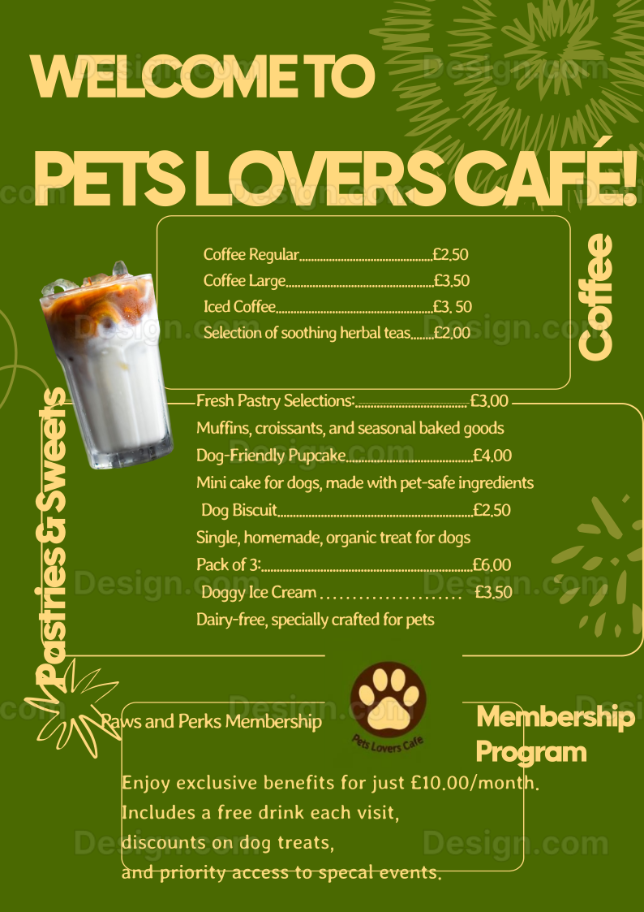

Appendix E - 4PS Marketing Plan
Price

Our aim here at Pets Lovers Café is to keep our prices low while offering a quality, healthy menu. Our prices are similar to other sites on Willen Lake, but we keep the same high standards for quality and health for our dogs and owners.
Pricing Strategy and Justification:
    - Competitive Benchmarking:
We’ve kept coffee and pastry prices at £2.00 to £4.00 to keep up with local cafés. We sell homemade, organic dog treats, priced slightly higher – £2.50 per treat or £6.00 for three – but they’re the extra good value pet owners can be proud of (Willen Lake, 2023).
    - Value Perception:
Our prices are based on premium, vegan ingredients. The "Paws and Perks" membership, available for £10 a month, gives regulars a free drink at the end of every visit, discounts on pet treats and early access to events. The loyalty and return program.
Sample Price List
(For the complete menu see Appendix)
Coffee: £2.50–£3.50
Dog Treat (Single): £2.50
Membership Price – Paws and Perks: £10 per month

Product

All the products we carry at Pets Lovers Café are designed to reflect our dedication to pets and community, for owners and canine companions alike.
Product Range:
- Human Services: High quality coffees, teas, and freshly baked pastries.
- Organic Pet Food: Healthy and safe for pets, including organic pet biscuits, pupcakes and dog-safe ice cream.
- Accessories: Customized pet products, such as collars, bandanas and toys, which bolster our relationship with our pets. As we expand, we will continue to add these services.
Packaging and Design:
We use organic colours and minimal, eco-friendly packaging to give a friendly vibe to our brand. Our pet snacks are packaged in recyclable or biodegradable cardboard bags, all stamped with our Paw Print logo as a nod to quality and sustainability.

Place

While Pets Lovers Café is based at Willen Lake in Milton Keynes, we are also looking to open our doors online to pet owners across the UK.
In-Store Experience:
Our café overlooks the picturesque lake, where dog walkers, local families and those looking for a break are frequent visitors. It’s a pet friendly area with dog walks, water stations, and cuddly places to make everyone feel welcome.
Future Online Distribution:
We’re creating an online store to sell dog treats and membership packs to people outside Milton Keynes. We’ll integrate our Instagram and Facebook into the site so customers can search us online and build brand awareness.

Promotion

Because Pets Lovers Café is a new café, they need to get the word out about the brand, the customers, and the community. We’ll do this through a combination of online and offline campaigns, opening weekend activities, and a loyalty program.
    - Social Media Marketing
- Instagram & Facebook: We’ll run a "Pet of the Month," show off dishes, and push specials. A promo code like "10% off your first order" will help woo new followers, and word of mouth will be one of the most effective tactics.
    - Email Marketing
- Welcome Offer & Monthly Newsletter: Subscribers get a free treat coupon email on first sign up. Our monthly newsletters will alert you of upcoming events, menu updates, and member-only specials.
    - Local Flyers and Posters
Plaques will be placed in parks, pet stores, vet clinics, and animal shelters to distribute to residents. All flyers provide a 10% off on your first visit so new customers can drop by.
    - Customer Loyalty Program
- Paws and Perks Membership: This loyalty program offers frequent customers a free drink on subsequent visits, 10% off treats, and invitations to events. Members can also invite friends for a free product, which encourages recommendation and referrals.
    - Grand Opening Weekend Promotion
- Launch Weekend: We will be offering 10% off everything, free samples of canine treats, and "Paw Print Photo Wall" for social media posts during our opening weekend. Customers who share a picture with the café get entered into a raffle to win a free "Paws and Perks" membership, making us feel like we are about to start this.
Example Message:
"Hola! Welcome to Pets Lovers Café – where pets meet owners! Come join us this weekend at Willen Lake for our grand opening. Treat yourself, Milton Keynes’ first pet-friendly café!"

This 4Ps Marketing Plan explains how to engage with your customers, create a pet-friendly brand, and build customer loyalty both in-store and online.
Top of Form
Bottom of Form

Appendix F - Design
Logo design
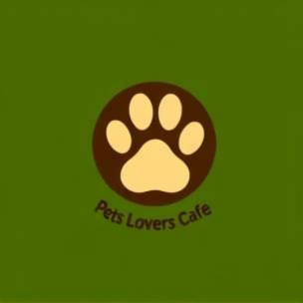
Place design

Flyer1
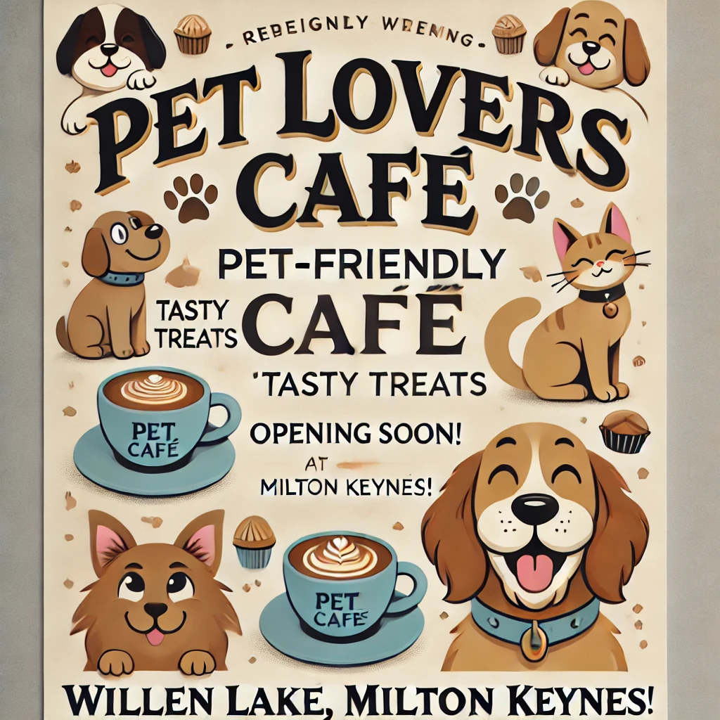

Flyer 2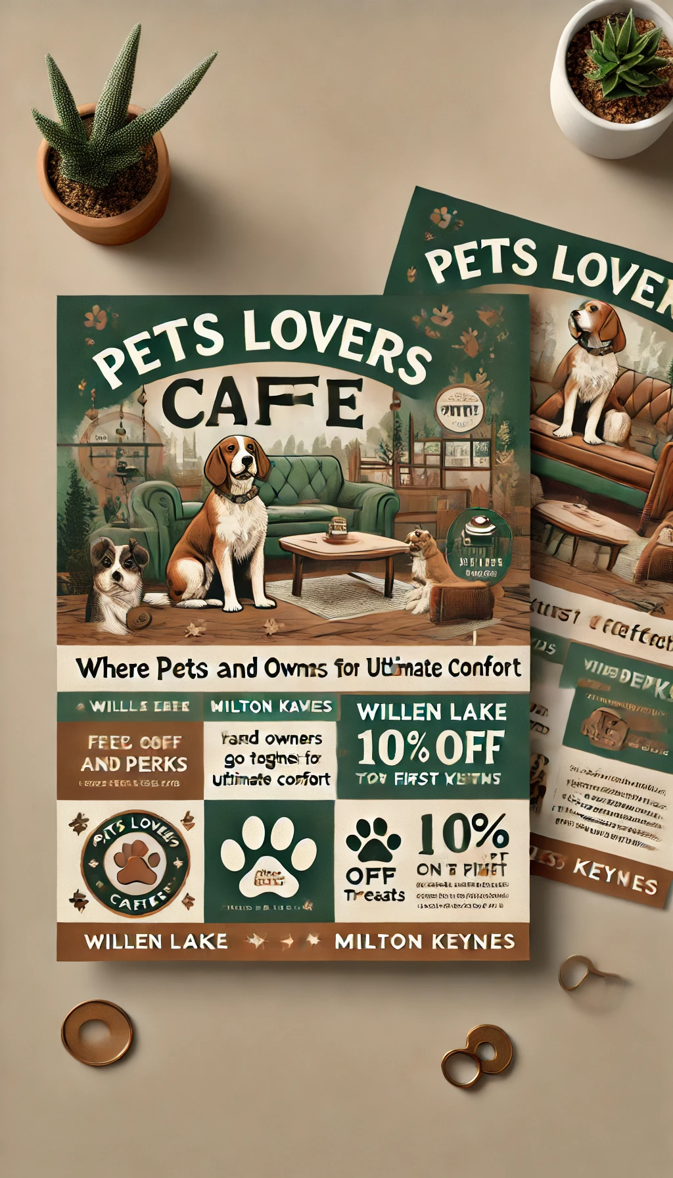
Flyer 3
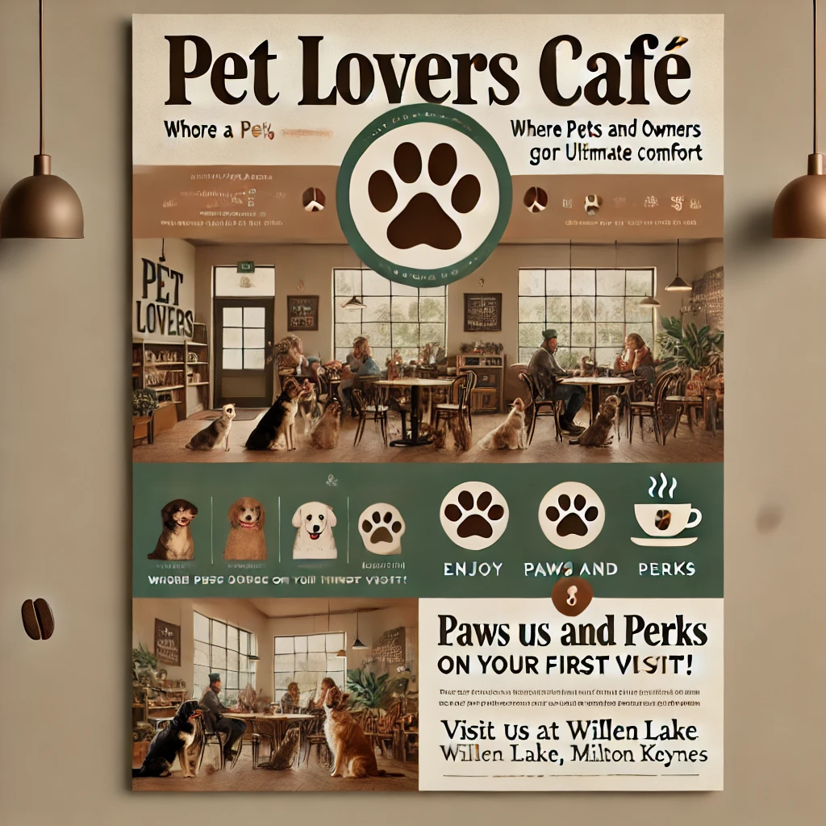

Appendix G – Key suppliers
Supplier | Product/Material | Description | Estimated Cost (£) | Reason for Choice | Link to Supplier
Smith’s Coffee Co. | Locally Roasted Coffee Beans | Provides high-quality, sustainably sourced coffee beans roasted in nearby Bedfordshire. | £15/kg | Supports local business, ethical sourcing, fresh beans | Smith’s Coffee Co.
Bidfood | Bakery Ingredients (flour, sugar, etc.) | Wholesale supplier of key baking ingredients needed for pastries and dog treats. | £10-15 per bulk pack | Reliable, bulk pricing, cost-effective | Bidfood UK
Vegware | Eco-Friendly Packaging | Biodegradable and compostable cups, trays, and bags for serving food and treats. | £0.20 per cup, £0.15 per bag | Eco-friendly, aligns with sustainable values | Vegware
PetPlanet UK | Dog Treat Ingredients | Supplies pet-safe ingredients (e.g., carob powder, oat flour) specific to dog treat production. | £5-10 per ingredient | Specialist for pet-safe ingredients, high quality | PetPlanet UK
Lakeland UK | Airtight Storage Containers | Containers for safely storing pet-safe ingredients and preventing cross-contamination. | £10-15 each | Quality, suitable for food storage, available locally | Lakeland UK
Coca-Cola Europacific Partners | Beverages (Juices, Soft Drinks) | Provides a range of popular cold drinks to complement café offerings. | £1-2 per bottle | Widely recognized brands, reliable supplier | Coca-Cola Europacific
British Sugar | Sugar | Locally sourced sugar for both beverages and baked goods. | £1 per kg | Local sourcing, supports UK industry | British Sugar
Jangro UK | Pet-Safe Cleaning Supplies | Provides eco-friendly, pet-safe cleaning products to ensure high hygiene standards in a pet-friendly space. | £20-25 per pack | Pet-safe, sustainable, aligns with hygiene and safety standards | Jangro UK

Appendix H Fiancial - Projected Financials for Year 1
EXPENDITURE | Year 1 (£) | Explanation and Source
Company Registration | £12 | Company registration fee from Gov.uk (2023).
Rent/Rates | £24,000 | £2,000 per month for commercial rent near Willen Lake (Rightmove, 2024).
Staff Wages | £40,000 | Salary for barista and part-time kitchen help; based on industry rates in Milton Keynes (Indeed, 2024).
Telephone (Mobile) | £240 | Estimated at £20/month for basic business mobile plan (Vodafone, 2024).
Broadband | £360 | Estimated at £30/month (BT Business, 2024).
Utilities | £6,000 | Approx. £500/month for electricity, water, gas (MK Council, 2023).
Marketing and Materials | £3,000 | Social media ads, flyers, local event sponsorships (Facebook Ads, 2024).
Insurance | £600 | Public liability insurance for small businesses (Simply Business, 2024).
Capital Expenditure/Equipment | £11,340 | Includes coffee machine, pet treat oven, furniture; details in Section 6.2.
Training & Development | £500 | Food hygiene course fees and pet care handling courses (Food Standards Agency, 2023).
Accounting/Legal | £1,200 | Accounting software and annual review fees (Xero, 2024).
Outside Services | £1,000 | Occasional repair and maintenance services.
Stock/Materials Purchases | £10,000 | Includes coffee, baking ingredients, pet treat ingredients (Bidfood, 2024).
Bank Charges | £200 | Small business account charges and transaction fees (Barclays, 2024).
Total Expenditure | £98,452

INCOME | Year 1 (£) | Explanation and Source

Sales A: Food & Drink Sales | £90,000 | Based on 50 coffees @ £3, 30 pastries @ £2, 10 dog treats @ £2 each day, 300 days/year.

Sales B: Membership Packages | £6,000 | 50 members at £10/month for 12 months, “Paws and Perks” membership.

Sales C: Event Revenue | £4,000 | Projected income from monthly pet meet-ups, adoption days (average £333/month).

Capital Introduced | £5,000 | Initial investment from founders.

Funding | £3,000 | Local council small business start-up grant (Milton Keynes Council, 2024).

Loans/Borrowing | £10,000 | Start-up loan from British Business Bank’s Start-Up Loans program (British Business Bank, 2023).

Total Income | £118,000

YEAR ONE PROFIT/LOSS
Total Income £118,000
Total Expenditure £98,452
Profit/Loss £19,548|

Appendix I - Power Point Presentation
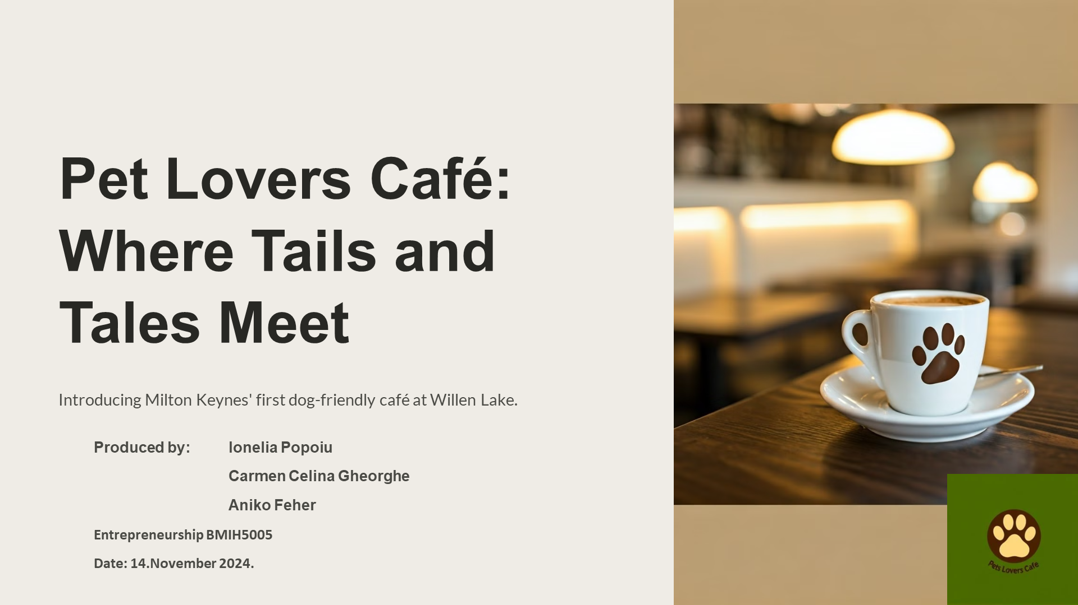
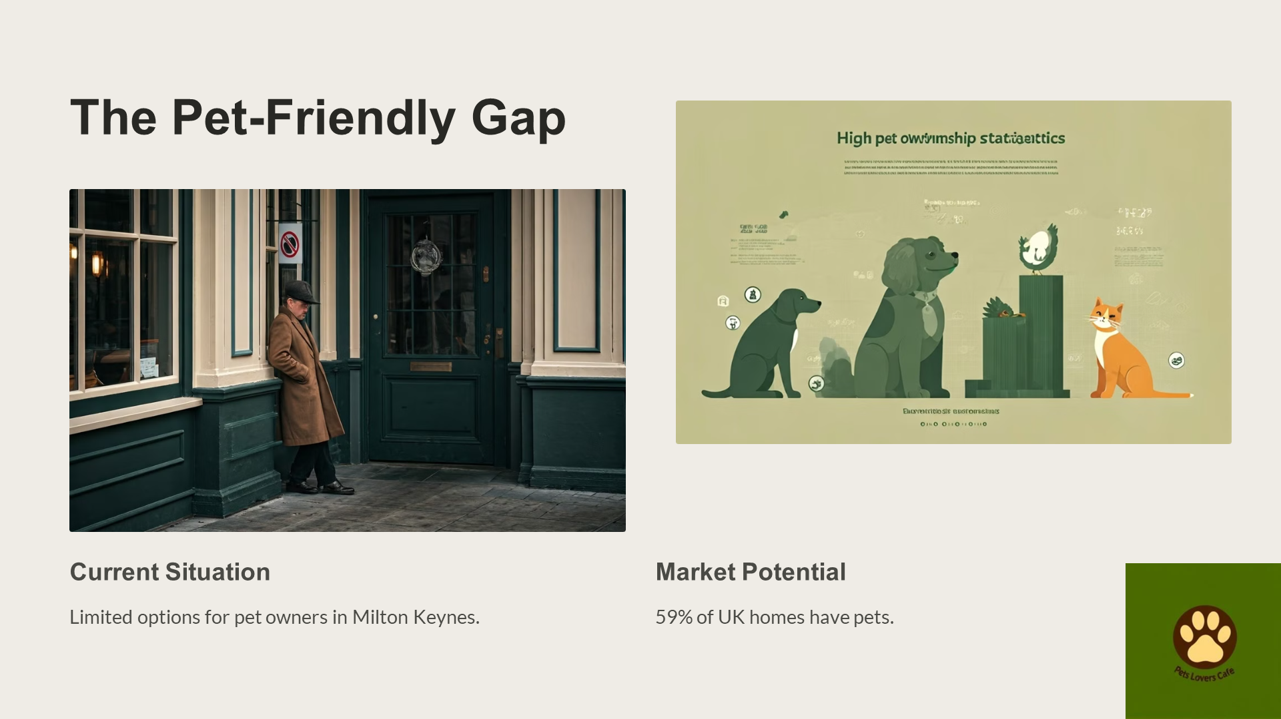
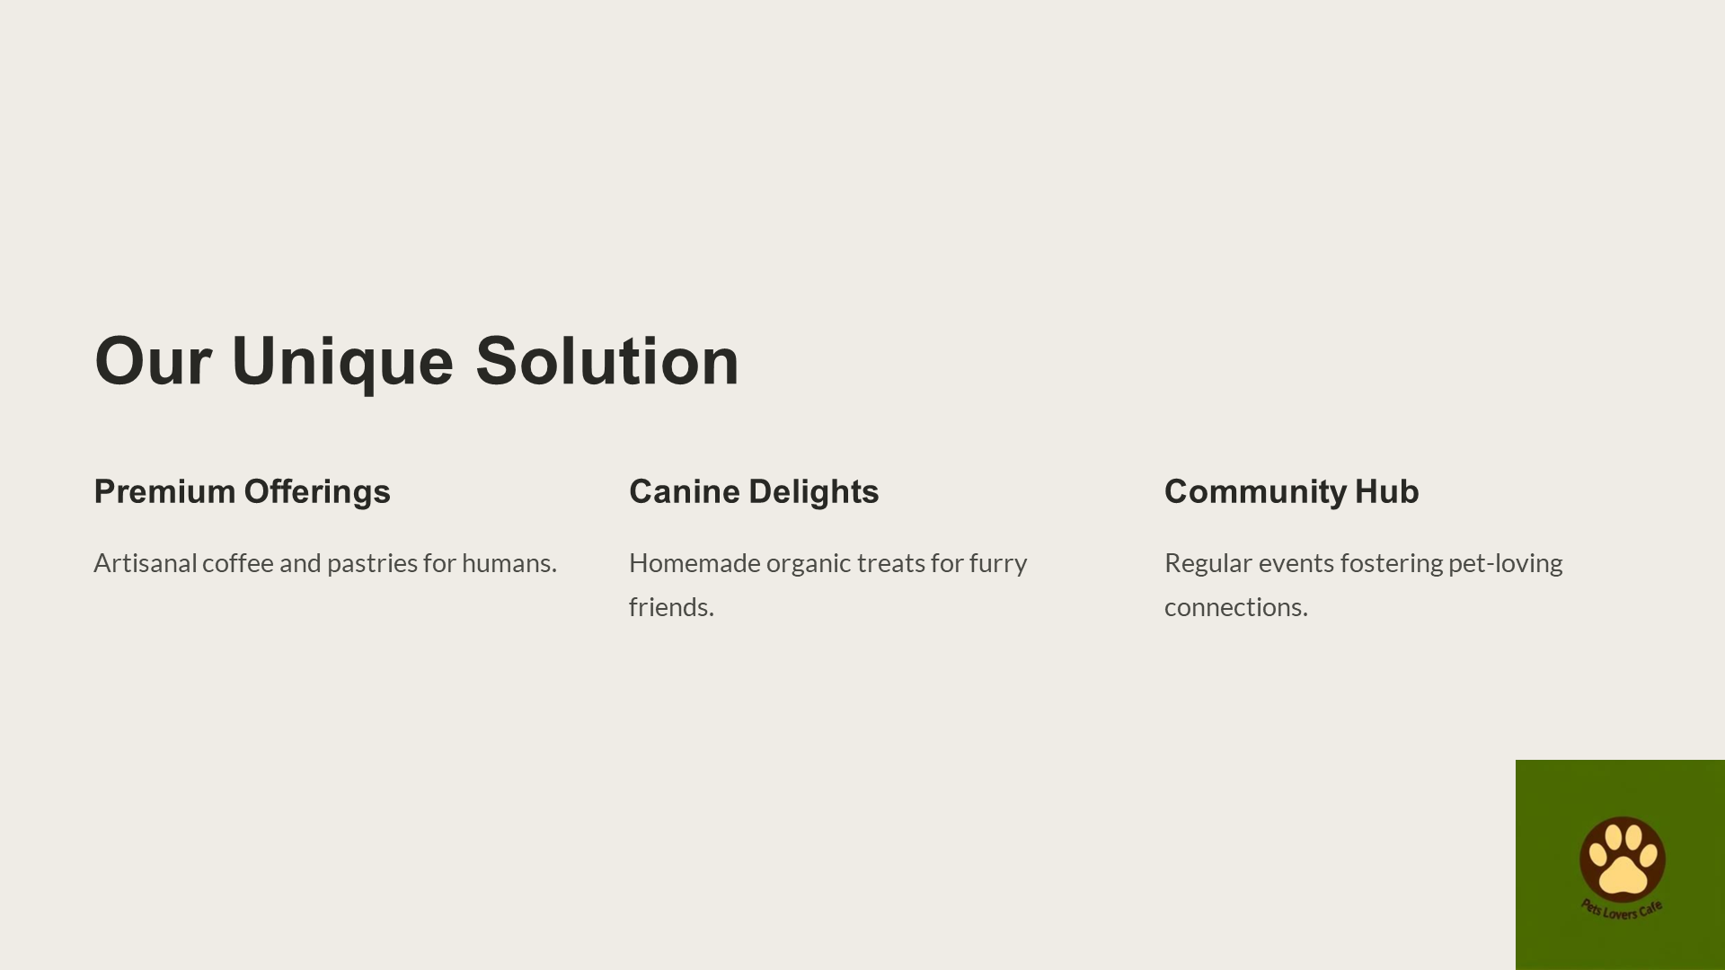
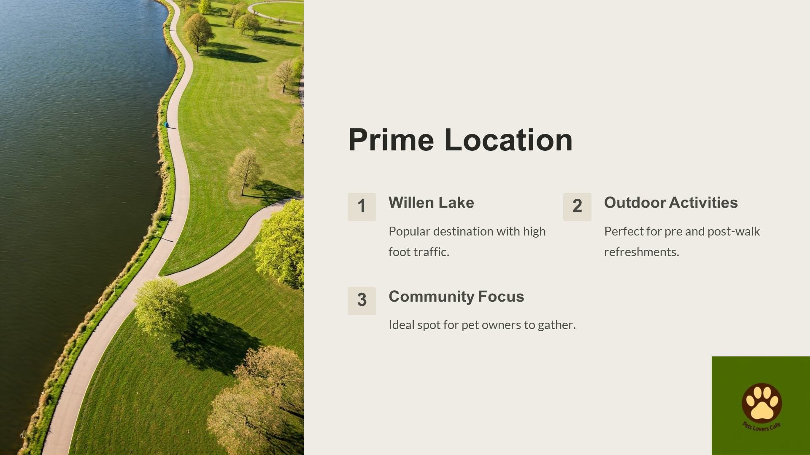
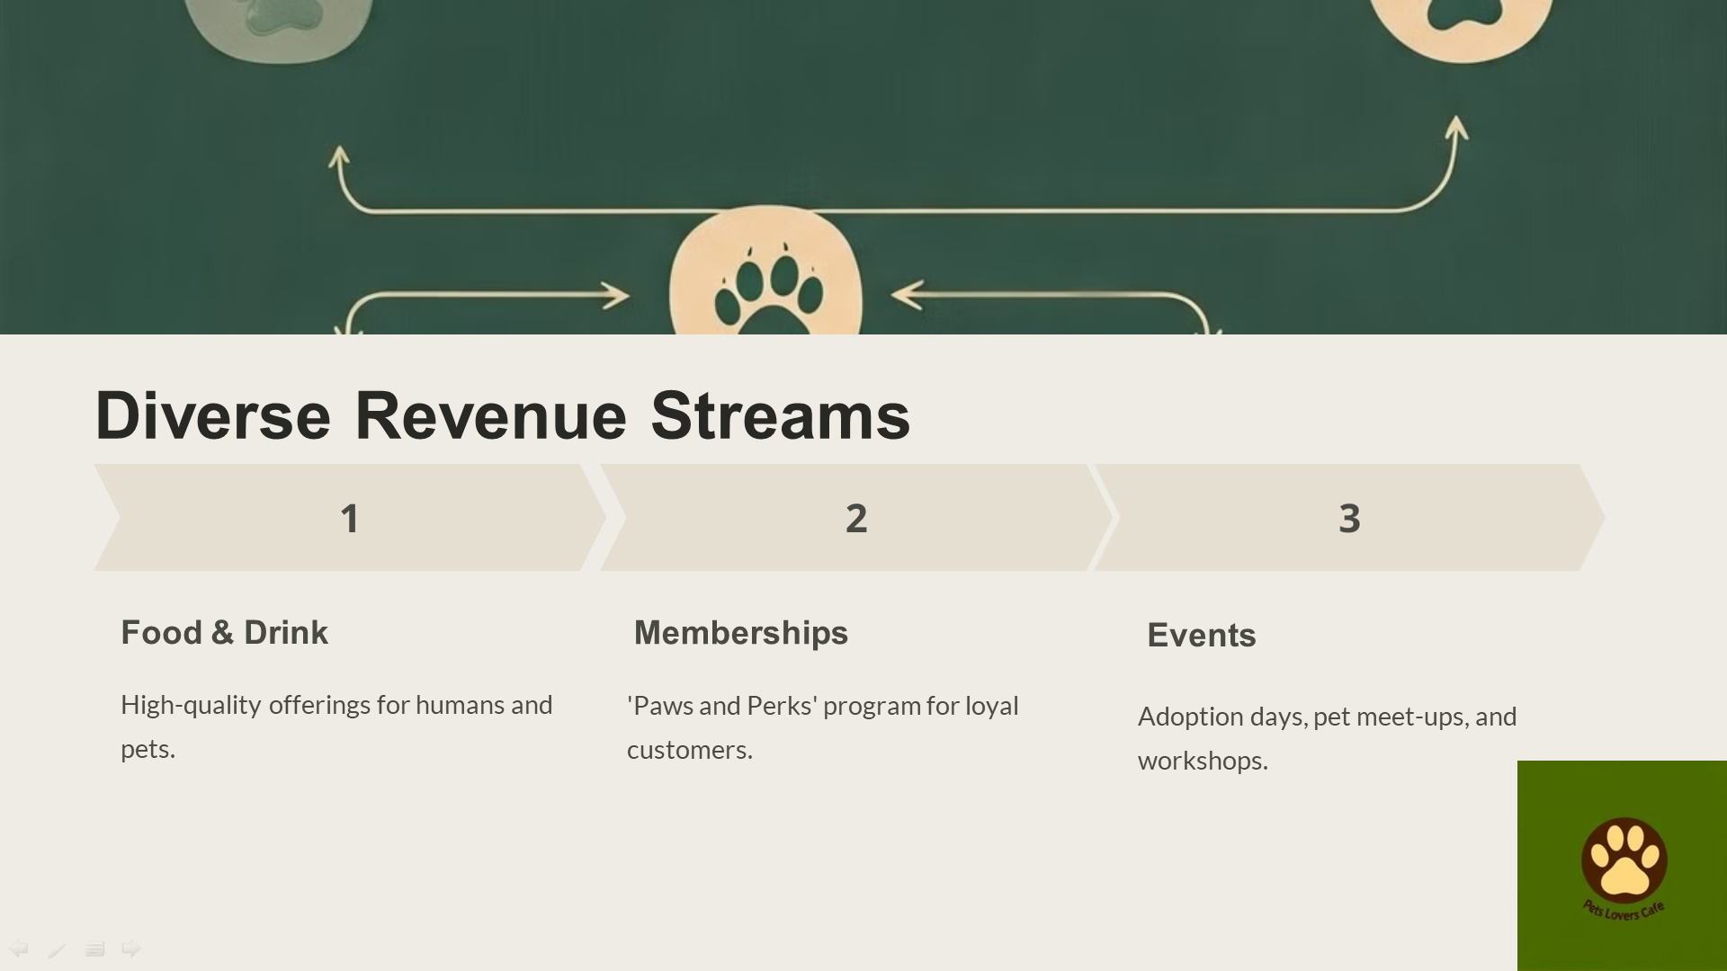
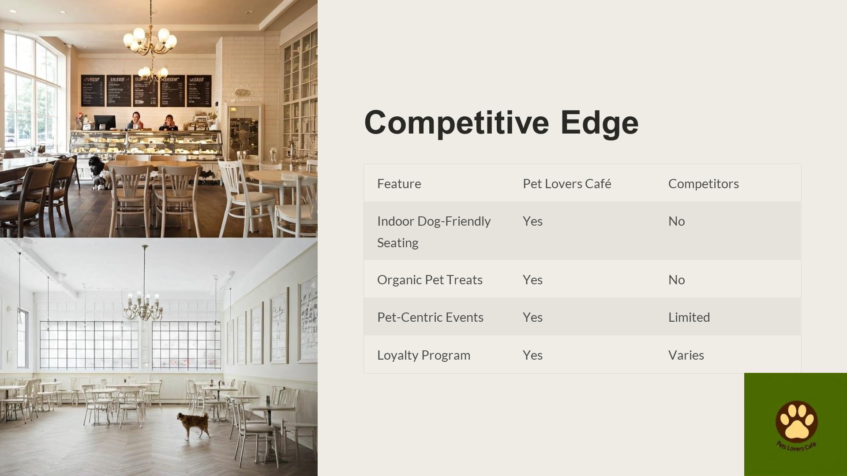
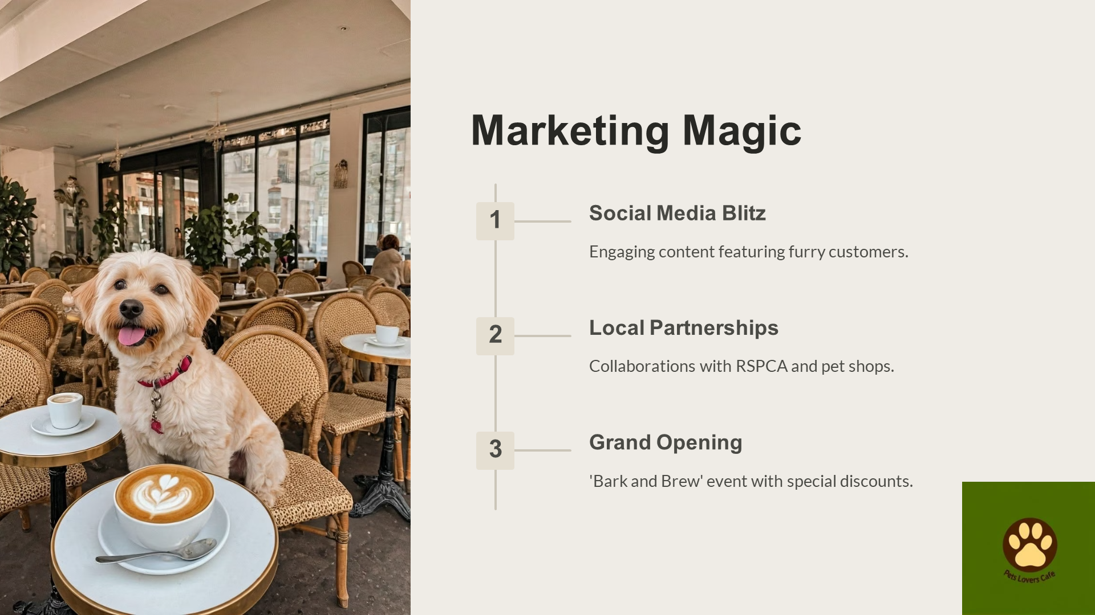
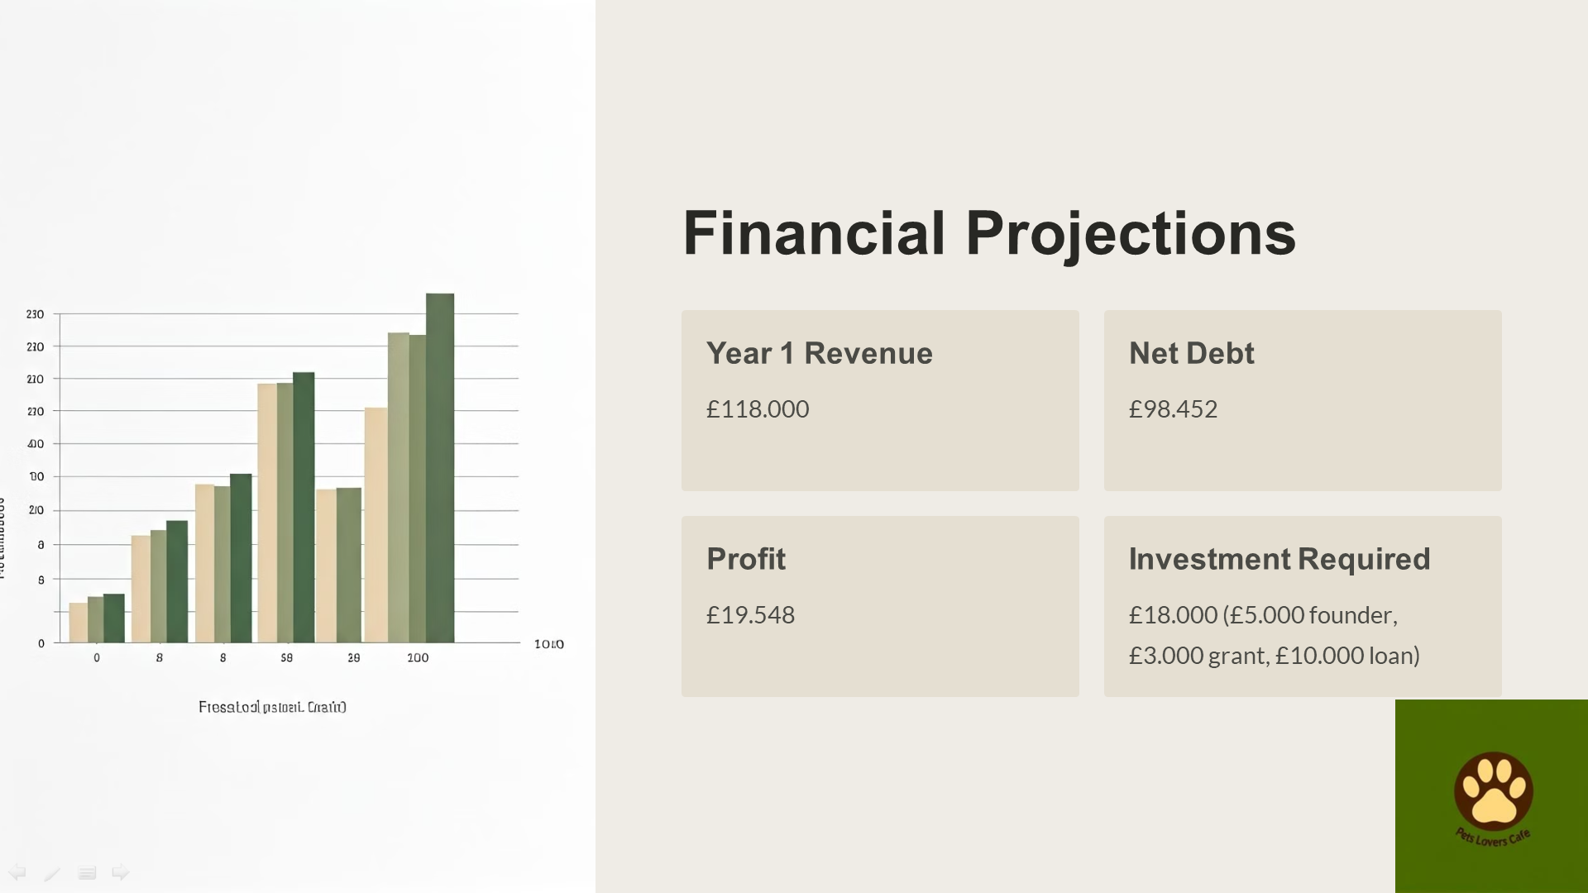
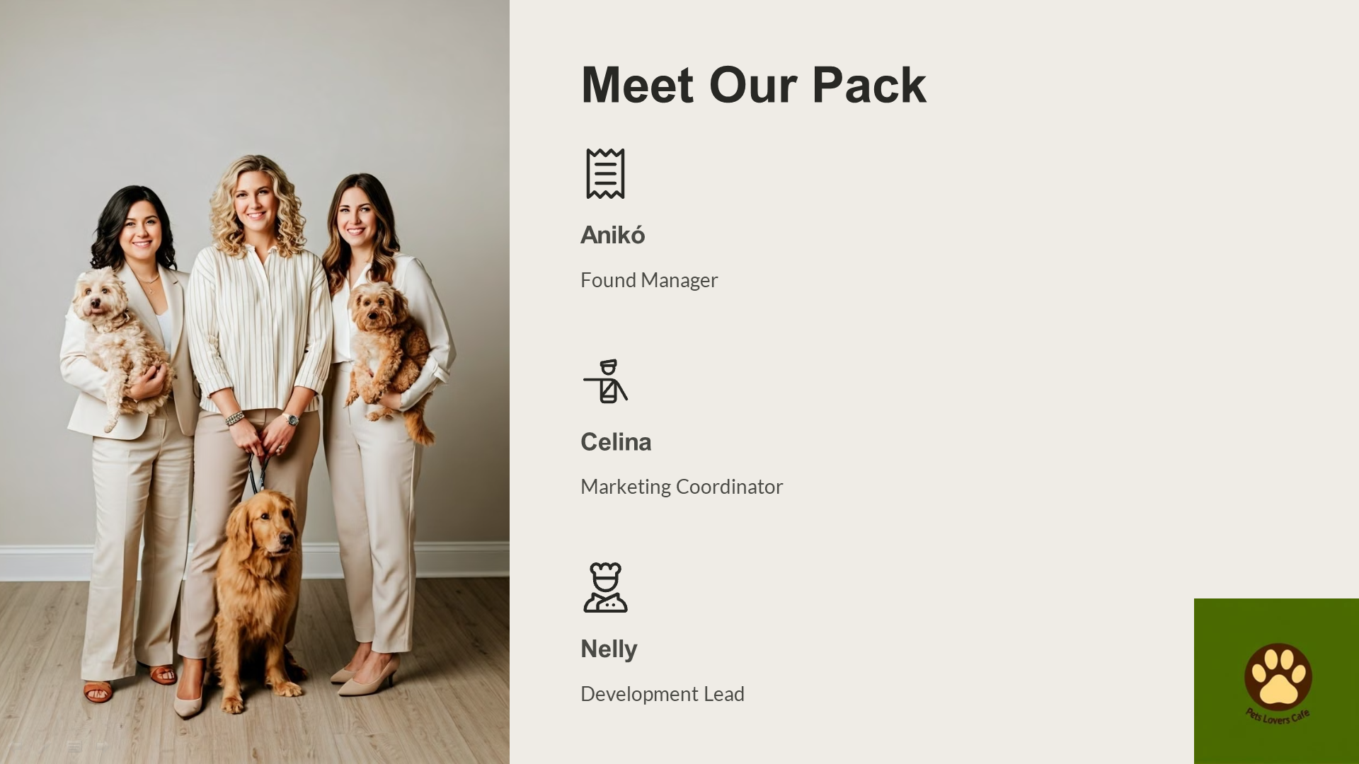
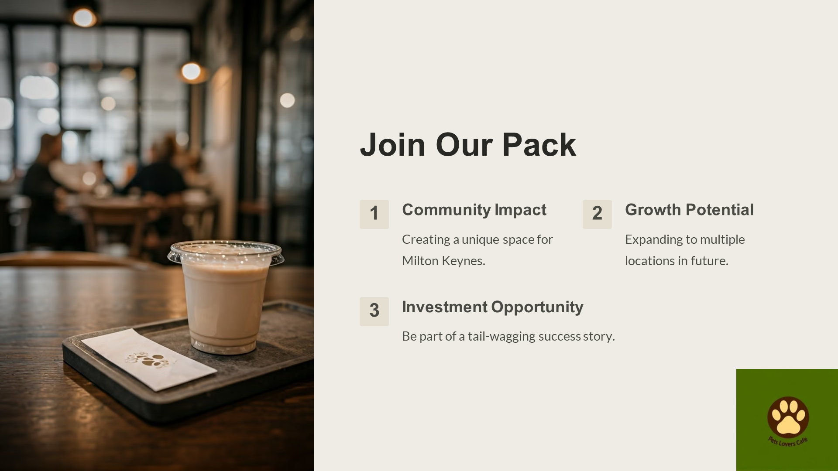

REFERENCE LIST:
- Willen Lake. (2023). Dog walking and café options at Willen Lake. Available at: https://www.willenlake.org.uk [Accessed 17 October 2024].
- RSPCA Milton Keynes. (2023). Local animal shelter information. Available at: https://www.rspcamiltonkeynes.co.uk [Accessed 17 October 2024].
- Carter, S. and Jones-Evans, D. (2012). Enterprise and small business: Principles, practice and policy. Pearson Education.
- Grunert, K.G. (2010). Customer value, satisfaction, and loyalty. In: Handbook of hospitality marketing management. Oxford University Press.
- High Speed Training. (2023). Level 2 food hygiene & safety for catering. Available at: https://www.highspeedtraining.co.uk/food-hygiene/level-2/ [Accessed 24 October 2024].
- Google Digital Garage. (2023). Fundamentals of digital marketing. Available at: https://learndigital.withgoogle.com/digitalgarage [Accessed 24 October 2024].
- Shopify. (2023). E-commerce essentials. Available at: https://www.shopify.com/learn/ecommerce [Accessed 24 October 2024].
- Fiverr. (2023). Freelance web development and e-commerce services. Available at: https://www.fiverr.com [Accessed 24 October 2024].
- Canva. (2023). Graphic design and marketing resources. Available at: https://www.canva.com [Accessed 24 October 2024].
- Simply Business. (2024). Public liability insurance. Available at: https://www.simplybusiness.co.uk [Accessed 24 October 2024].
- Food Standards Agency. (2013). Food Hygiene (England) Regulations 2013. Available at: https://www.food.gov.uk/business-guidance/food-hygiene-regulations [Accessed 24 October 2024].
- Government of the United Kingdom. (2006). Animal Welfare Act 2006. Available at: https://www.legislation.gov.uk/ukpga/2006/45/contents [Accessed 24 October 2024].
- Health and Safety Executive. (1974). Health and Safety at Work Act 1974. Available at: https://www.hse.gov.uk/legislation/hswa.htm [Accessed 24 October 2024].
- Information Commissioner’s Office. (2018). Data Protection Act 2018. Available at: https://ico.org.uk/for-organisations/guide-to-data-protection [Accessed 24 October 2024].
- Office for National Statistics (ONS). (2024). UK inflation report. Available at: https://www.ons.gov.uk [Accessed 24 October 2024].
- Pet Food Manufacturers’ Association (PFMA). (2024). UK pet ownership trends. Available at: https://www.pfma.org.uk [Accessed 24 October 2024].
- Statista. (2024). UK e-commerce statistics. Available at: https://www.statista.com [Accessed 24 October 2024].
- Deloitte. (2023). Consumer experience trends in the UK. Available at: https://www2.deloitte.com [Accessed 24 October 2024].
- Brewers Fayre. (2023). Dog-friendly dining options at Willen Dragon Brewers Fayre. Available at: https://www.brewersfayre.co.uk [Accessed 24 October 2024].
- Google Reviews. (2023). Customer feedback on local cafés. Available at: https://www.google.com [Accessed 24 October 2024].
- Rightmove. (2024). Commercial properties in Milton Keynes. Available at: https://www.rightmove.co.uk [Accessed 24 October 2024].
- Milton Keynes Council (MK Council). (2023). Average utility costs for small businesses. Available at: https://www.milton-keynes.gov.uk [Accessed 24 October 2024].
- Gov.uk. (2023). Register your company. Available at: https://www.gov.uk/register-your-company [Accessed 24 October 2024].
- Coffee Hit UK. (2024). La Marzocco Linea Mini espresso machine. Available at: https://www.coffeehit.co.uk [Accessed 24 October 2024].
- Bella Barista. (2024). Mazzer Super Jolly grinder. Available at: https://www.bellabarista.co.uk [Accessed 24 October 2024].
- Cater-Kwik. (2024). BUNN CWTF-15 drip coffee brewer. Available at: https://www.caterkwik.co.uk [Accessed 31 October 2024].
- Nisbets UK. (2024). Unox Bakerlux Shop Pro convection oven. Available at: https://www.nisbets.co.uk [Accessed 31 October 2024].
- KitchenAid UK. (2024). KitchenAid 6.9L professional mixer. Available at: https://www.kitchenaid.co.uk [Accessed 31 October 2024].
- Square UK. (2024). POS systems for retail. Available at: https://squareup.com/gb/en [Accessed 31 October 2024].
- Amazon UK. (2024). TP-Link Archer VR2800 router. Available at: https://www.amazon.co.uk [Accessed 31 October 2024].
- IKEA UK. (2024). Durable seating and tables. Available at: https://www.ikea.com/gb/en [Accessed 31 October 2024].
- PetPlanet UK. (2024). Pet amenities and accessories. Available at: https://www.petplanet.co.uk [Accessed 31 October 2024].
- Vistaprint UK. (2024). Custom branding and signage. Available at: https://www.vistaprint.co.uk [Accessed 31 October 2024].
- Jangro Online. (2024). Pet-safe cleaning supplies. Available at: https://www.jangro.net [Accessed 31 October 2024].
- Currys. (2024). Dyson V11 Animal vacuum cleaner. Available at: https://www.currys.co.uk [Accessed 31 October 2024].
- Kenwood UK. (2024). Kenwood Chef 5L mixer. Available at: https://www.kenwoodworld.com/uk [Accessed 31 October 2024].
- Lakeland UK. (2024). Airtight storage containers for food safety. Available at: https://www.lakeland.co.uk [Accessed 31 October 2024].
- Smith’s Coffee Co. (2024). Locally roasted coffee beans. Available at: https://www.smithscoffee.co.uk [Accessed 31 October 2024].
- Bidfood UK. (2024). Bakery ingredients and wholesale supplies. Available at: https://www.bidfood.co.uk [Accessed 31 October 2024].
- Vegware. (2024). Eco-friendly packaging options. Available at: https://www.vegware.com [Accessed 31 October 2024].
- Coca-Cola Europacific Partners. (2024). Beverage supplier. Available at: https://www.cokecce.com [Accessed 31 October 2024].
- British Sugar. (2024). Locally sourced sugar. Available at: https://www.britishsugar.co.uk [Accessed 31 October 2024].
- Indeed. (2024). Average wages for café staff in Milton Keynes. Available at: https://www.indeed.co.uk [Accessed 31 October 2024].
- Facebook Ads. (2024). Cost for targeted social media advertising. Available at: https://www.facebook.com/business/ads [Accessed 31 October 2024].
- British Business Bank. (2023). Start-up loans for new businesses. Available at: https://www.british-business-bank.co.uk [Accessed 31 October 2024].
- Designs. (2024). User dashboard. Available at: https://designs.ai/user/dashboard [Accessed 6 November 2024].
- Open AI. (2024). DALL-E 2. Available at: https://openai.com/index/dall-e-2/ [Accessed 6 November 2024].

