LCBB4004 Marketing Fundamentals

Assessment 1 - Blogging to communicate

Student ID: 2115325

Madalina Emilia Stan

Background of the Company
EasyJet plc, stylised as EasyJet, seems to be a UK international moderate airline business with its headquarters at Luton Airport. The company was founded in 1996. With the help of its subsidiary carriers, EasyJet UK, EasyJet Switzerland, as well as EasyJet Europe, the company provides regional and abroad planned flights on some more nearly 1,000 destinations in more than 35 nations. EasyJet plc is a Leading airline that is publicly traded upon this London Stock Exchange as well as being a component of the FTSE 250 Index of leading companies. Simplex Airways seems to be the biggest stakeholder, with such a 15.269 percent ownership in the company. The firm's creator, Greek-Cypriot billionaire Stelios Haji-Ioannou, and his brothers own EasyGroup Enterprises Ltd, the investment company through which they invested. It has around 14,000 employees spread over Europe, with the majority of them headquartered in the United Kingdom.
Ever since its founding in 1995, EasyJet has developed via a mix of purchases and station launches, which have been spurred on by customer interest for minimal air transport. EasyJet had also led to significant growth of this need. It operates upwards of 300 aeroplanes, including those operated by affiliate firms. It does have 29 sites around Eu, with Gatwick becoming by far the biggest. Behind Ryanair, the airline transported upwards of 65 million visitors in 2014, probably the second discount carrier in Europe in terms of total traveller movements, after EasyJet.
EasyJet’s mission statements include sustaining as Europe’s Leading network at key terminals as well as focusing on bringing travelling simple and inexpensive for consumers.

(Figure: Logo of Easy Jet, Source: Shaw, 2016)

Product Strategy
As per Dibb et al (2012), a product seems to be a thing or service that is supplied as a remedy to meet the demands of the client. While designing an item, the company must evaluate the product's life span and prepare for the many obstacles which may occur throughout the various phases of the item's development. When a product enters its final stretch (the revenue drop stage), it is necessary to redesign it in order to re-enter the market plus win back consumers' interest (Krisnanto, 2015).
When it comes to EasyJet, they are engaged in the sale of airline tickets, the provision of car rental services, the provision of the hotel as well as apartment facilities, the provision of travel insurance to consumers, the provision of parking fees, and so on (Groucutt and Hopkins, 2015). To sustain big existing customers, each of these products and solutions should fulfil the high standards of excellence that customers have come to demand from them. Intervals of a plane ticket in terms of solutions, EasyJet offers a broad choice of options. One-way as well as round flights, bundle discounts, and business travel are just a few of the services that the firm provides to its customers. The organisation also offers a variety of additional services, such as automobile rental and aircraft transport. EasyJet offers group bookings for groups of 15 and perhaps more persons at their discretion.
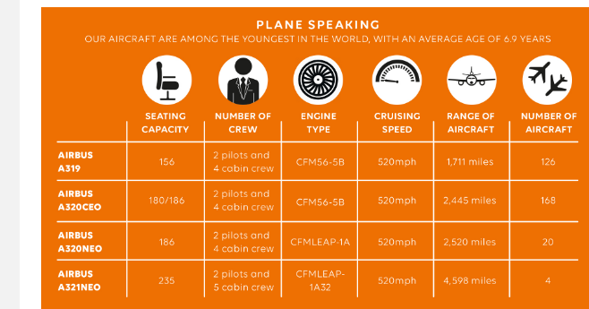
(Figure: Different service features of EasyJet, source: Morrison and Winston, 2010)
Additionally, group bookings give a variety of additional benefits, such receiving the complete team member's chair next to them, dividing the baggage allowance, and invoicing with different credit cards. Users of the EasyJet Plus passport, in a similar vein, are eligible to a number of benefits as described above. Something to keep in mind would be that group bookings are not eligible for any promotional discounts or offers. Due to the fact that EasyJet operates both online and via Teletext, they have really been capable of increasing their revenue while remaining committed to their customers on a virtual level. EasyJet operates both online and through Teletext.
EasyJet markets and distributes its goods underneath the brand name of EasyJet International. It provides items that are extremely unique from its rivals, with a variety of features available to consumers that rivals do not provide. As a result, its items are believed to be one-of-a-kind. Its goods are seen as being of excellent magnitude than those of its rivals by the public. As a result, people are prepared to spend a greater rate on such products and services (Lim, 2021). By offering outstanding customer support at a reasonable rate, the firm has been able to acquire a significant portion of its market share in recent years. It operates a huge fleet of contemporary passenger airliners, which are equipped with amenities such as expanded leg room for comfort, improved fuel economy, and cabin temperature equalisation, all of which contribute to a pleasant travel environment. For this reason, EasyJet keeps a record of current, new and regular clients such that they may concentrate on providing personalised services to a single consumer at any one time.

Pricing strategy:
According to Kotler and Armstrong (2016), the amount the consumer is likely to spend on the goods should be the next part of the marketing process to be considered. This assists in determining the amount of revenue a company will be capable to create. The price of an item is the monetary quantity that a customer must spend in favour to purchase or acquiring an item from a firm. As one of the most essential revenue-generating components of the firm's activities, it must be taken seriously. Selections on pricing should be chosen with the greatest care because they represent a double-edged sword that really should be carefully calibrated (Philip and Gary, 2018). Whenever a price is placed excessively high, it may convey the idea that the product is of high value. Another advantage is that it will enable product distribution across both limited and non-restricted stores simultaneously.
EasyJet appears to be a low-cost U.K. based airline that offers a variety of flight options. However, in actuality, that might be the second-best minimal aeroplane on the globe in 2019, plus it became the top minimal cost aircraft in Europe in 2019. In order to keep operation expenditures to a bare minimum, it undertakes a number of methods to ensure that it can offer consumers competitive pricing. Client service tactics include mailing tickets and flying cards to consumers as well as promoting a range of products to consumers while they are onboard an airline, among other things. According to Belobaba et al., (2015), currently, the pricing method used to determine the price point that will be implemented seems to be a competitive-based pricing approach. This would be due to the fact that there are a huge number of rivals in the sector, which makes it simple to get information about them. Furthermore, for some items, it employs an optional goods pricing model, in which it charges a single price for the main goods while charging different fees for the extras that are included with it. For the things that it offers on the internet, it asks a higher premium. This is due to the fact that shipping expenses have already been incorporated into the value of the commodity. The ultimate product's pricing has been set in stone. Resellers that participate in the channel purchase the goods at a reduced price and profit from their own profitability.

Place strategy:
According to Kotler and Armstrong, (2016), the placement of a firm's sales and service operations is referred to as its "place" throughout the marketing strategy. Among the most significant aspects of marketing strategy seems to be the placement of the business. The placement of a company's product sales is critical since it should have been at a place in which the company's target consumers are. Trying to market to individuals who have no curiosity about the goods or services is a waste of time. As a result, a business should locate and disseminate its goods in a location that is conveniently approachable to the people who could purchase them.
EasyJet makes its wares available for purchase through two distinct distribution routes. Customers may buy straight from the company via its webpage in this case (Zafar, and Habil, 2015). When it comes to distributors, the second option is where the product is sold and distributed around the nation. The company then sells them to its clients. More than 500 outlets around the nation carry its items. With an aggressive marketing approach, it seeks out as many merchants as feasible to carry its goods. As a result, the company guarantees that its goods are accessible to clients throughout the nation. Its Webpages get a lot of traffic and generate a lot of revenue from online purchases (Mintz et al., 2021). Delivery service suppliers have been enlisted in an effort to ensure that the company's online activities can function smoothly. One of the advantages of omni-channel marketing is that consumers may acquire the company's items from both its online and physical storefronts. Its raw ingredients are supplied by a system of more than 500 vendors. Partnering closely with its manufacturers has allowed it to create innovative and appealing consumer characteristics, as well as experiment and collaborate with clients.

Promotional Strategy
According to Kotler and Armstrong (2016), promoting goods, services, or companies is part of the marketing mix which includes both the buyers and suppliers. Instead of just raising revenue, promotion may also be used to improve the company's reputation and attract new clients and customers. Public relations are a term we use to describe this form of advertising. It's impossible for a business to get clients if it doesn't sell its products. Consumers' purchasing decisions are influenced by this tactic as well, which is why it's so prevalent.
As per Williams (2017), as a promotional tool, EasyJet has forged alliances with a number of travel and tourism companies in order to broaden its client base. For frequent clients, the firm also sends personalised emails including unique offers and coupons, urging consumers to provide the organisation an opportunity to deliver better service. This is usually performed to convey to consumers that they are aware of their demands and also that the services are outstanding (Barnes, 2017). In other words, this suggests that EasyJet seems to have a surprise in planned for its customers. This leads to improved client engagement as well as word-of-mouth advertising. For marketing purposes, it employs a wide range of media outlets. TV, as well as radio commercials, are used in the traditional media, which does have a significant audience because of its wide coverage and capacity to draw in huge numbers of people. Since more people are using the online plus social networking sites, it makes sense to advertise on such platforms. It promotes across a variety of social media channels, with a primary concentration on YouTube, Instagram, especially Facebook pages owing to their large monthly use. It seems to have over 100,000 likes or customers following on such sites, which are frequently presented to information published by (Baker and Hart, 2016). Throughout the year, it participates in numerous trade shows and conferences to promote its products.

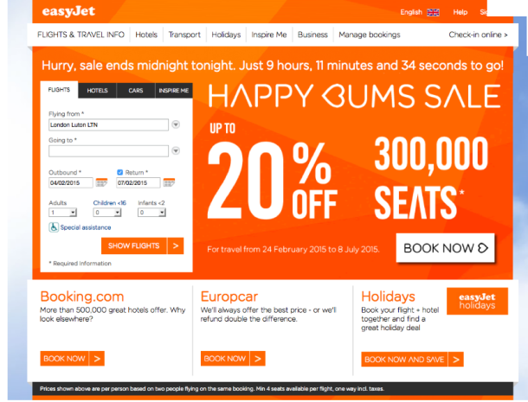
(Figure: Promotional Content of Easy jet, Source: Morrison and Winston, 2010)

References
Baker, M.J. and Hart, S. eds., 2016. The marketing books. Routledge.
Barnes, J., 2017. Measuring service quality in the low-cost airline industry.
Belobaba, P., Odoni, A. and Barnhart, C. eds., 2015. The global airline industry. John Wiley & Sons.
Dibb, S., Simkin, L., Pride, W.M. and Ferrell, O.C., 2012. Marketing: concepts and strategies. Cengage.
Groucutt, J. and Hopkins, C., 2015. Marketing. Macmillan International Higher Education.
Kotler, P. and Armstrong, G., 2016. Principles of Marketing. Sixteenth edition, Global edition. ed. Harlow: Pearson Education
Krisnanto, U., 2015. Marketing Mix is The Only Variable to Choose Brands and Quality? INTERNATIONAL RESEARCH JOURNAL OF BUSINESS STUDIES, 6(3).
Lim, W.M., 2021. A marketing mix typology for integrated care: the 10 Ps. Journal of Strategic Marketing, 29(5), pp.453-469.
Mintz, O., Gilbride, T.J., Lenk, P. and Currim, I.S., 2021. The right metrics for marketing-mix decisions. International Journal of Research in Marketing, 38(1), pp.32-49.
Morrison, S. and Winston, C., 2010. The evolution of the airline industry. Brookings Institution Press.
Philip, K. and Gary, A., 2018. Principle of Marketing (Global Edition) 17th.
Shaw, S., 2016. Airline marketing and management. Routledge.
Williams, G., 2017. The airline industry and the impact of deregulation. Routledge.
Zafar, A. and Habil, H., 2015. The New Semantics Suggested for the Marketing Mix by Millennials.

