Module Code | BMSW4002
Assignment title | Effective Team working for team success
Student Name | Dorina Florentina Lemnrau
ID Student Number | 2114178

Executive Summary
In this report a discussion will be made based on the necessity of cooperation when it comes to teamwork and how the lack of it can lead to failing the project. The main problem being the inability of the team members to communicate effectively, this can also lead to a lot of wasted time. The primary goal of this project is to build a dedicated team and a group that will be able to work correctly for superior results. Cooperation is essential, especially for this project to become successful. In this project it is important for the team to be able to work together, especially thinking about the fact that there are different people meaning diverse backgrounds and cultures. If the team manages to work together, they will be able to be more creative and focused with less stress.

Table of Contents
Introduction 4
Development of an effective team and the theoretical model 4
Tuckman’s Team Development Model 4
Types of roles required for the creation of an effective team 6
Belbin’s Team Roles Model 7
Impact of effective team working on team success 9
Barriers to effective team working identified in the scenario 10
Conclusion 11
Reference 12

Introduction
This project is based on the significance of teamwork and how the lack of communication can lead to failure. At the same time, through this project, it can be proven e how a good communication system can lead to a good communication system can lead to real success. In the next part of the project, there has been a discussion regarding effective team development using some theoretical models, the roles required for the creation of an effective team, how an effective team can contribute to the success of the team, and the constraints of effective team working.
The aim of the report is to have concrete knowledge regarding the effectiveness of team working. The major objectives of the paper include:
- To analyse the advantages of teamwork.
- To develop the roles required for an effective team
- To learn about the impact of effective teamwork
- To know about the obstacles that hinder effective team working.
The accomplishment of the aim and objectives can make the project successful as well.

Development of an effective team and the theoretical model
There can be different models through which an effective team can be formed. Tuckerman's team development model is one of them. Next Plc can use that Tuckerman team development model in order to form an effective team in order to make the launch successful.

Tuckman’s Team Development Model
As a manager of the Next team, it is a thing to be worried about the performance of the team and about the lack of communication among the team members. To manage to build an efficient team it can be thought about the fact that the team development model of Tuckman can be adopted for making the new launch of the children’s wear successful.
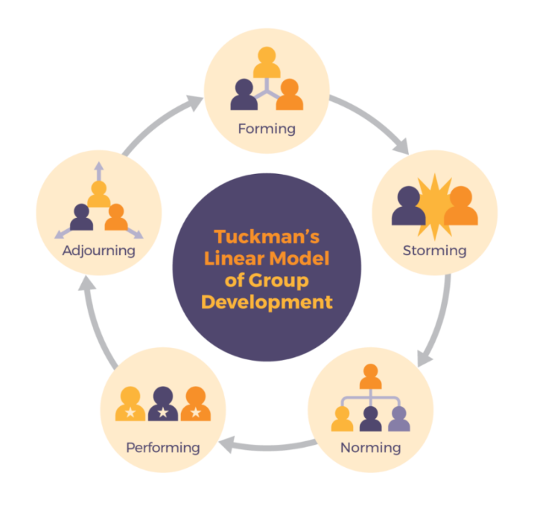
Figure 1: Tuckman's Team Development Model (Source: Bonewrite, 2010)
Forming
At the beginning of the Next Plc team, everybody was new and confused, with diverse types of people everyone didn’t know what to really say or do. The team still doesn’t know how to function together and if they could achieve success as a group (Bonebright, 2010).
Even though the team it is already together for some time, from my perspective the team is unproductive, and it can cause some issues in the storming stage.
Storming
Right now, the team is trying to get to know each other but the issues start to show, when the team doesn’t manage to cooperate because there are different people with different mind-sets and some want to get to the top to become ‘leaders’ of the team and others want to stay below and don’t do as much, this can lead to a lot of conflict and confusion (Fulk, Bell, and Bodie, 2011).
My team seems not to be open to each other; this will make it hard for us as a team to get to the next step which is norming.

Norming
In this step, we will have a much more understanding of how the team should work. Working under the guidance of the team leader, the team can start to see way better results and understand better the responsibilities of this job (Natvig, and Stark, 2016). Therefore, my team started to learn their ability to work together and how to accept criticism, and ask for help when they need it.
Performing
In this step, we are more confident, and we start to believe that we can truly do it. At this moment, each team member of the new project of Next Plc starts to get the confidence and respect needed to be able to continue in a good and healthy environment. This is the moment when each finds out what place they are in and gets an individual task in the project. As a manager, I believe that my way of doing things has started to get productive and we are starting to become more prosperous and confident, and we have managed to have a friendlier workplace. The formation of a successful team needs to have time and patience to get to the top.
Adjuring
At the adjuring stage, teamwork is accomplished and the overall team will break up after the completion of the task (Serenhov, and Kaldera 2021). When it comes to the launching of children’s wear of Next Plc Through effective teamwork, the overall project will be handled properly and after the accomplishment of the successful project launch, the team will be broken up in the adjuring stage.

Types of roles required for the creation of an effective team
There are different types of roles that are required for the creation of an effective team. From my perspective for the formation of a dedicated team, the Belbin model is really known. (Belbin, 2012). Belbin’s Team Roles Model can be used for a better understanding of how the roles inside the new project launch of Next Plc can be formulated. This model offers us a list of nine types of jobs, each having a specific job for each team member that can give us efficient cooperation. The description of how Belbin’s Team Roles Model can be used to formulate an effective team for the new project of Next Plc has been provided below:

Belbin’s Team Roles Model
There are nine components of this model. The components are described below in contrast of the given scenario:
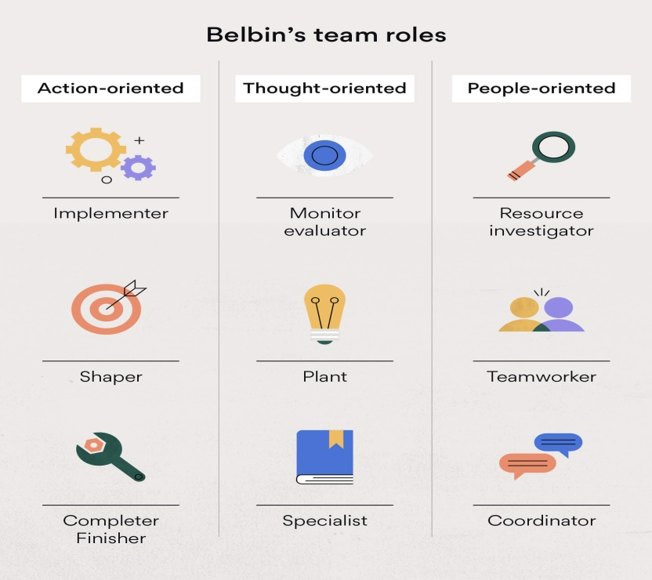
Figure 2: Belbin's Team Roles Model (Source: Belbin, 2004)
Shaper
Shapers are the leaders of the project who drive the others towards the accomplishment of the project (Belbin, 2004). As I am required to lead the team, I need to work as the shaper in the new project of Next Plc It will be my duty to make the subordinates understand the project as well as the goal of the project.
Implementer
Implementers are the subordinates who you are directed by the Shaper. The subordinates who will work alongside me in the project will work as the implementer of the project of Next Plc.
Completer finisher
Completer finishers are the individuals who worked as the fine tuner of the project. In order to make any project successful, fine-tuning is important. There will be some individuals who will what is the fine tuner in the new project of Next Plc.
Plant
The plant is the creative thinker inside the team. Creative thinking and innovation are important factors when it comes to the success factor of a project (Rahmani et al., 2021). The plants may bring some extraordinary ideas that can differentiate the new project of the Next Plc than the other projects which will make the project the successful one.
Monitor evaluator
In order to solve the issues regarding any project, rational thinking is a vital component. The monitor evaluators think rationally and don't get emotional while solving any issue related to the project. In the new project launch, I will work as the monitor in the elevator to take the vital decisions related to solving the issues of the project.
Specialist
Specialists are experts in the field in which the project has been operating (Mostert, 2015). Specialists can share valuable information or recommendations that can improve the overall team effort. In this case, the top-level managers can become the specialist and provide their valuable suggestions in order to make the launch successful.
Coordinator
The coordinator inside the team works as the motivator and the influencer in order to direct the subordinates toward the achievement of the goals. Generally, the coordinator is the leader and holds the overall team together (Flores-Parra, et al., 2018). In the new project of Next Plc I will work as the coordinator to manage the overall team.
Team worker
Team workers work as team players who execute the operation based on the recommendation provided by the coordinator. In the new project of the Next Plc, there will be some team workers who will work according to the need of the project to make it successful.
Resource investigator
Resource investigators work as opportunists and try to search and avail themselves of the opportunities. The resource investigators assist the plant to formulate new ideas for the organization. In the new project of Next Plc the resource investigators will assist the plant as well.
So, based on Belbin’s Team Roles Model, an effective team can be formulated for the new project of Next Plc.

Impact of effective team working on team success
It is an effective team that can enhance the success factor of a particular project as well as the organization. Effective teamwork and also make the new project of Next Plc a successful one. The impact of effective team working on the success of our team has been described below:

Figure 3: impact of Effective Team Working (Source: Nash, and Govier, 2009)
Better problem-solving capability
An effective team can provide a better problem-solving ability to a particular project as well as the organization (Fraser, and Hvolby, 2010). in order to launch the new project of Next Plc regarding children’s wear, some problems may arise such as lack of coordination, ineffective problem-solving ability, etc. however, through the assistance of effective teamwork, the team can have a better problem-solving capability and solve all those above-mentioned issues.
Increasing personal growth
The team members can also improve their skills while working in a group such as enhancement of team working ability, e increasing leadership capability, improving empathy, etc. which helps to grow personally (Nash, and Govier, 2009). While working in a team, the team members shared their ideas and thoughts with other team members and it increases the overall knowledge of the team members regarding the project. In the team member project, the team members can learn about different kinds of things which help them to grow personally and use the knowledge in the future as well. To make the project of Next Plc successful, personal growth of the team members is important because the team members will carry the project towards its goals.
Boosting productivity
An effective team can boost the productivity of the operational procedures of the project (Keogh, Robinson, and Parnell, 2019). As the launching of children’s wear of Next Plc will be a new project for the organization, productivity must be boosted so that it becomes easier for the organization to have a successful launch of the new project. In order to boost productivity, it is essential for the team leaders to motivate and influence the overall team so that they can work for the betterment of the organization and help the organization launch the project efficiently.

Barriers to effective team working identified in the scenario
There are several barriers that have been highlighted in the scenario. The major barrier that has been highlighted in the scenario has been discussed below:

Figure 4: Barriers to effective team working identified in the scenario (Flores-Parra, et al., 2018)
Communication Challenges
It has been one of the most effective challenges for the Next Plc. The barriers regarding communication can hamper the overall project (Lamb, et al., 2013). Due to the challenges regarding communication, many individuals working in the higher rank of Next Plc may not be able to provide their opinion in the meeting. Because of that, their opinions are not at rest in the meeting and it doesn't get the proper value.
Lack of teamwork
It also becomes a major barrier for Next Plc when the organization doesn't work as a team. It is important to acknowledge the importance of team working bi an organization like Next Plc to operate the business properly. The lack of acknowledgment of team effort by the organization in the meeting can make the whole operational procedure ineffective which is a major barrier.
Team conflict
Due to an ineffective communication process in the meeting the team conflict arises between the members working inside the organization of Next Plc. Lack of communication enhances the misunderstanding as well as misinterpretation of the topic discussed in the meeting and the members attending the meeting may not get the appropriate reaction from the meeting (Doyle, 2008). It has also been mentioned in the scenario that due to the team conflict, the meeting becomes a total waste of time. So it is also a major barrier for the organization in terms of effective team working.

Conclusion
This project's foundation is the value of teamwork and how poor communication may result in failure. However, it can also be demonstrated through this initiative how effective communication may result in genuine success. The establishment of successful teams utilizing some theoretical models, the roles necessary for its formation, how an effective team can contribute to the team's success and the barriers to effective teamwork have all been covered in the project's subsequent section.

Reference
- Belbin, R.M., 2012. Team roles at work. Routledge.
- Bonebright, D.A., 2010. 40 years of storming: a historical review of Tuckman's model of small group development. Human Resource Development International, 13(1), pp.111-120.
- Doyle, J., 2008. Barriers and facilitators of multidisciplinary team working: a review. Nursing Children and Young People, 20(2).
- Flores-Parra, J.M., Castañón-Puga, M., Evans, R.D., Rosales-Cisneros, R. and Gaxiola-Pacheco, C., 2018, June. Towards team formation using belbin role types and a social networks analysis approach. In 2018 IEEE Technology and Engineering Management Conference (TEMSCON) (pp. 1-6). IEEE.
- Fraser, K. and Hvolby, H.H., 2010. Effective teamworking: can functional flexibility act as an enhancing factor? An Australian case study. Team Performance Management: An International Journal.
- Fulk, H.K., Bell, R.L. and Bodie, N., 2011. Team management by objectives: Enhancing developing teams' performance. Journal of Management Policy and Practice, 12(3), pp.17-26.
- Keogh, T.J., Robinson, J.C. and Parnell, J.M., 2019. Assessing behavioral styles among nurse managers: Implications for leading effective teams. Hospital topics, 97(1), pp.32-38.
- Lamb, B.W., Taylor, C., Lamb, J.N., Strickland, S.L., Vincent, C., Green, J.S.A. and Sevdalis, N., 2013. Facilitators and barriers to teamworking and patient centeredness in multidisciplinary cancer teams: findings of a national study. Annals of surgical oncology, 20(5), pp.1408-1416.
- Mostert, N.M., 2015. Belbin–the way forward for innovation teams. Journal of Creativity and Business Innovation, 1.
- Nash, S. and Govier, I., 2009. Effective team leadership: techniques that nurses can use to improve teamworking. Nursing Times, 105(19), pp.22-24.
- Natvig, D. and Stark, N.L., 2016. A project team analysis using Tuckman's model of small-group development. Journal of Nursing Education, 55(12), pp.675-681.
- Rahmani, F., Scott-Young, C., Tadayon, A. and van der Walt, J.D., 2021. Team composition in relational contracting (RC) in large infrastructure projects: a Belbin’s team roles model approach. Engineering, Construction and Architectural Management.
- Serenhov, O. and Kaldera Hollu Pathiranage, P.P., 2021. Team Development in Global Virtual Teams: Application of Tuckman’s Team Development model.

