

Caspar Thurston-Smith

Taguchi analysis report

University of Wales Trinity St David
Systems engineering

Beng
Academic Year: 2025-2026

Supervisor: Jenni Steen and Dave Holly April 2026

University of Wales Trinity St David
Ordnance Munitions and Explosives

Beng

Academic Year 2025 - 2026

Caspar Thurston-Smith

Taguchi analysis report

Supervisor: Jenni Steen and Dave Holly April 2026

This thesis is submitted in partial fulfilment of the requirements for the degree of Ordnance Munitions and Explosives
(NB. Remove if the degree award is based solely on examination of the thesis)

© UWTSD year. All rights reserved. No part of this publication may be reproduced without the written permission of the copyright owner.
Academic integrity declaration
I declare that:
- The thesis submitted has been written by me alone.
- The thesis submitted has not been previously submitted to this university or any other.
- That all content, including primary and/or secondary data, is true to the best of my knowledge.
- That all quotations and references have been duly acknowledged according to the requirements of academic research.
I understand that to knowingly submit work in violation of the above statement will be considered by examiners as academic misconduct.

Contents
Introduction 5
Taguchi analysis 5
Methodology & Apparatus 5
Apparatus 5
Methodology 6
Results 8
Conclusions 11
Reflections 11
Bibliography 12
Annex A 13
Annex B 14

Table of tables:
Table 1 7
Table 2 7
Table 3 8
Table 4 9
Table 5 14

Table of Figures:
Figure 1 8
Figure 2 10
Figure 3 10
Figure 4 10
Figure 5 11
Figure 6 11
Figure 7 11
Figure 8 11

Introduction
This report examines an experiment to find out which factors have the greatest effect on the range of a ping pong ball when fired from a rubber band catapult. This report will incorporate the Taguchi analysis methodology to understand which of the variables had the greatest impact on the experiment. It will include a methodology, results, conclusions and reflections with the goal of establishing which factors would best adjust the range of the device. To complete this task in the most effective way the Taguchi methodology was used.

Taguchi analysis
The Taguchi analysis method is the statistical approach used to reduce the noise variations in a process, increase efficiency and design experiments that can identify multiple noise factors at once [1] [2]. This technique has been used for many different applications but in this experiment it shall be used to find the best combination of settings, using the lowest combination of experiments. This is done using orthogonal arrays, these are specific matrix’s allowing for the study of multiple factors and interactions with minimal experiments. [1]

Methodology & Apparatus
Before the methodology can be written, the apparatus and the experiment must be fully understood, it is only once the independent variables (factors) have been identified that the correct orthogonal array can be selected. An orthogonal array is a mathematical matrix used in the taguchi method, it is what allows the study of multiple factors with a minimal number of experiments.

Apparatus
- 1 x ping pong ball
- 1 x 5m tape measure
- 1 x catapult
A team of operators is also required, they will fire the catapult, measure the results and record them accurately.
Figure 1 shows an annotated image of the catapult describing its key features,

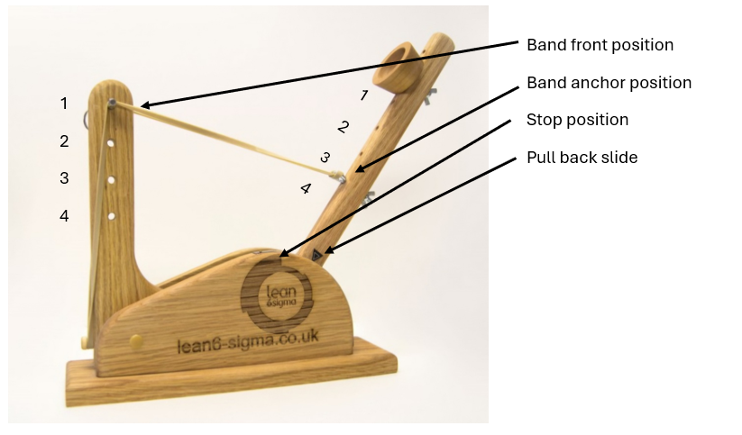
Figure 1
Looking at figure 1 it is important to note that the front band position, Band anchor position, stop position and pull back position are all adjustable and as such can be altered to increase or reduce the range of the catapult. The numbers on the diagram represent which position the adjustable factors are in. The cup holding the ping pong ball was also moved to the top position.

Methodology
Prior to designing the experiment, the apparatus needs to be identified and the taguchi method needs to be applied. The first step in the method is to understand the independent variables.
Independent variables:
- Band front position
- Band anchor position
- Interaction between 1 + 2
- Stop position
- Pull back position
- Interaction between 4 + 5
- Operator

The Taguchi method of designing and experiment states, that to understand how a factor affects performance, you only need to test it at two well-chosen levels [3]. In this instance the highest and lowest possible level will be selected.
Therefore, each independent variable must be split into two levels. In this instance the highest and lowest level have been chosen. Table 1 displays each independent variable and how they have been split. There were several interactions identified as independent variables but as they cannot be modified individually, only through changing multiple of the other independent variables, they have been omitted.
Level | Band front position | Band anchor position | Stop position | Pull back position (angle) | Operator
level 1 | 1 | 2 | 1 | 140 | A
level 2 | 3 | 4 | 3 | 170 | B
Table 1
Once each variable had been split the appropriate orthogonal array had to be chosen.
As there were 7 factors and 2 levels the L8 orthogonal array was chosen. This L8 array is what is used to conduct the methodology for the experiments [4]. The L8 array is displayed in table 2
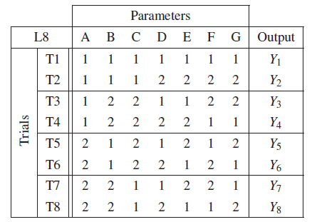
Table 2 [5]

As a result the independent variable can be added to the L8 array. This is done through combining table 1 and table 2. This is how the experiment is designed.
Array Populated
Experiment | 1 | 2 | 3 | 4 | 5 | 6 | 7
Experiment | Band front position | Band Anchor position | AB Interaction | Stop Position | Pull back | BC Interaction | Operator
Experiment 1 | 1 | 2 | 1 | 1 | 140 | 1 | A
Experiment 2 | 1 | 2 | 1 | 3 | 170 | 2 | B
Experiment 3 | 1 | 4 | 2 | 1 | 140 | 2 | B
Experiment 4 | 1 | 4 | 2 | 3 | 170 | 1 | A
Experiment 5 | 3 | 2 | 2 | 1 | 170 | 1 | B
Experiment 6 | 3 | 2 | 2 | 3 | 140 | 2 | A
Experiment 7 | 3 | 4 | 1 | 1 | 170 | 2 | A
Experiment 8 | 3 | 4 | 1 | 3 | 140 | 1 | B
Table 3
Table 3 shows the populated L8 array with the independent variables. As a result table 3 shows the methodology for the experiment.
As a result of the L8 array 8 experiments are required, with 2 operators, and independent variables altered in each experiment. Annex A lays out a point-by-point methodology. There was only one modification to the array instructions that was made. This was to carry out each experiment 3 times and take an average of the result. It was this average that would be included and considered the result of each experiment.

Results
 | Trial 1 | Trial 2 | Trial 3 | Average
Experiment 1 | 83 | 76 | 87 | 82cm
Experiment 2 | 239 | 248 | 183 | 223.33cm
Experiment 3 | 63 | 74 | 86 | 74.33cm
Experiment 4 | 174 | 174 | 179 | 175.67cm
Experiment 5 | 103 | 108 | 104 | 105cm
Experiment 6 | 43 | 43 | 30 | 38.67cm
Experiment 7 | 78 | 74 | 79 | 77cm
Experiment 8 | 51 | 53 | 51 | 51.67cm
Table 4
Within the original template there were a series of graphs that were generated once the tables were populated, these graphs can be used to show how important each variable was, the greater the gradient on the graph, the greater the variables impact on the results.
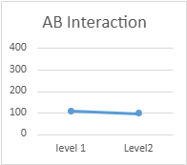
These graphs are displayed in figure 2 – 8:
Figure 4
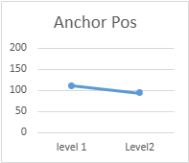
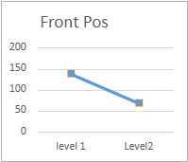
Figure 3
Figure 2

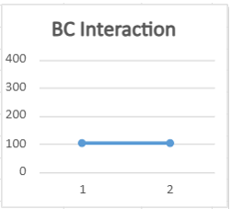
Figure 7
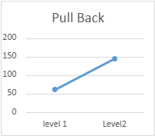
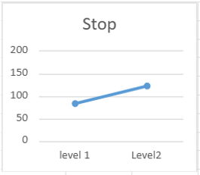
Figure 6
Figure 5
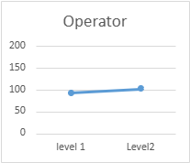
Figure 8

Through examining table 4 experiments 2 and 4 produced results where the projectile travelled the furthest. When examining the methodology in table 3, it can be seen that they have several variables in common. They both share the same: front band position, stop position and pull back position, 1, 3 and 170 respectively. This suggests that these three factors have a significant impact on the outcome of the experiment.
When comparing the experiment with variables that produced the longest range, experiment 2, and the experiment with the shortest result, 6. The only one of the previously identified variables they have in common is the stop position variable. This suggests that of the three previously identified variables, this is the variable with the least effect.
When looking at the graphics created by the spreadsheet (Figure 2 - 8), given as a template for the experiment, it is clear that front position, pull back and stop position had the greatest impact on the distance the ping pong ball travelled. Although stop position has not been identified through comparison of results, when the stop position is lower (further forward) the arm travels for longer and the projectile leaves with greater kinetic energy. This is evidenced when comparing experiment 2 and 5, although experiment 5’s range was smaller than experiment 2, it was still the third furthest result and so proves that the stop position is a significant variable.
As a result it can be suggested that the front position of the rubber band and the pull back are the two most significant variables. To prove that this is the correct result a second experiment was designed. This experiment takes the two key factors and uses a specific method to work out the midpoint between the maximum and minimum range of the catapult. The experiment then requires the catapult to be set to the middle settings and the catapult fired. If the correct factors have been identified the resulting distance should be the same as the calculated midpoint. Annex B gives a full breakdown of the experiment. Once the verification experiment was completed, the resultant distance matched the expected distance and so proved that the correct factors had been identified.

Conclusions
Having examined the analysis, figures and carried out a verification experiment it was clear the factors that have the greatest effect on the range of the rubber band catapult are, the front position of the rubber band and the pull back. Therefore, to modify the range of the catapult, these are the factors that need to be altered.
Given the testing of results, this report can now be used as evidence that the Taguchi methodology does provide an accurate and effective way to design an experiment to get the correct results.

Reflections
Although this report achieved the goal of understanding which factors have the greatest impact on the range of the rubber band catapult, this report has not discussed how human or environmental factors impacted the results.
It is clear that the results are accurate but figure 8 demonstrates that there is a slight difference between the two operators. There is also the question of who was identifying the distance of the result, it is likely there would be variation between who identified the distance the ping pong ball travelled. The idea behind this being that humans by default are different and so inconsistent.
An additional factor not yet considered is noises, ping pong balls are light and so a gust of wind could sway the result considerably. Furthermore, these are catapults which do not have precision engineering behind them and so poor tolerances will allow for variation between firings.
Overall, this report identifies some of the human and environmental factors that could have impacted the experiment, while also providing the expected results. This report makes use of the Taguchi design of experimentation to achieve this and ultimately uses a second experiment to validate the original results. The results of both experiments worked to prove that the taguchi method of designing an experiment works and can/should be used in future.

Bibliography

[1] | SIX, “The Guide to the Taguchi Method: A Robust Quality and Efficient Experimentation,” Six, 8 October 2024. [Online]. Available: https://www.6sigma.us/process-design/taguchi-method/. [Accessed 01 April 2026].
[2] | M. A. Ansari, M. Shariq and F. Mahdi, “Geopolymer concrete for clean and sustainable construction – A state-of-the-art review on the mix design approaches,” Structures, vol. 55, pp. 1045-1070, 2023.
[3] | G. Taguchi, S. Chowdhury and Y. Wu, Taguchi's Quality Engineering Handbook, Wiley, 2007.
[4] | S. Fraley, J. Zalewski, M. Oom and B. Terrien, “14.1: Design of Experiments via Taguchi Methods - Orthogonal Arrays,” University of Michigan, [Online]. Available: https://eng.libretexts.org/Bookshelves/Industrial_and_Systems_Engineering/Chemical_Process_Dynamics_and_Controls_(Woolf)/14%3A_Design_of_Experiments/14.01%3A_Design_of_Experiments_via_Taguchi_Methods_-_Orthogonal_Arrays. [Accessed 16 April 2026].
[5] | A. S. R.-J. Wang and A. Grobler, “TAGUCHIMETHODINELECTRICALMACHINEDESIGN,” SOUTH AFRICAN INSTITUTE OF ELECTRICAL ENGINEERS, vol. 108, p. 150, 2017.

Annex A
This annex details the exact method for carrying out the initial experiment.
Using the aforementioned apparatus the team used the Taguchi methodology, specifically the L8 orthogonal array as seen in table 2 to determine which variables would be set to which level for each experiment. After designing the experiment the team split into the following roles: Two operators(loading and firing the catapult), measuring experts (watching were the ping pong ball lands) and record keepers.
Once everyone was happy with their roles the experiment needed to be set up.
A G clamp was used to secure the catapult onto a table and stop it moving while firing.
Tables were aligned so that there would be a level field to measure the length on.
The tape measure was placed so that the 0 aligned with the end of the catapult, ensuring accurate measurement each time.
The operators familiarised themselves with the catapult and which level was which, for reference see figure 1.
Once the apparatus was set up, the instructions of the experiment were followed depending on the variables required. If required they were changed, the specific operator loaded the ping pong ball and fired the catapult down the tables.
Once the distance the ping pong ball travelled was agreed upon then distance was recorded and each experiment repeated three times.
The mean of each experiment was recorded as the final result for each experiment.

Annex B
This annex gives an explanation and methodology for the verification experiment performed.
Once the two key factors had been identified an additional verification experiment was performed. Key factor 1 was front band position and key factor 2 was pull back position.
 | KF1 | KF2 |  | 1 | 2 | 3 | Ave
Firing 1 | 1 | 140 | range | 40 | 40 | 40 | 40 | KF 1 :1 | KF2 :1
Firing 2 | 3 | 140 | range | 25 | 25 | 23 | 24.33333333 | 117.1666667 | 32.16666667
Firing 3 | 1 | 170 | range | 184 | 205 | 194 | 194.3333333 | KF 1 :2 | KF2 :2
Firing 4 | 3 | 170 | range | 100 | 112 | 108 | 106.6666667 | 65.5 | 150.5
This experiment first required a complete analysis using the 2 key factors at both level 1 and 2. Table 5 displays the formula and results of these trials.
Table 5

The other variables were set to the level that would produce the longest range, as a result operator B was used and the stop was set to position 3.
This gave the results in table 5. Once the averages for each trial were calculated the comparison between key factors could be calculated.
This was done by calculating the mean for all trials where key factor 1 was level 1, and then the same for were key factor 2 was at level 1 and then were key factor 1 was at level 2 and finally for when key factor 2 was at level 2.
This gave the midpoint for each factor.
By adding them together and dividing by the number there are the overall midpoint was identified.
This is the point at which if the key factors are set to their midpoint the ping pong ball should reach this distance.
The expected distance was 91.33cm
The two key factors were then adjusted, KF1 was set to position 2 and KF2 was set to 155. The same operator then loaded and fired the catapult.
The result of this trial was 90cm this was nearly the expected result and given the human and environmental noises, will be considered acceptable. As a result of this experiment, it has been proven the key factors having the most significant effect on the range of the catapult were, pull back position and front position.

