LCBB5005- PROJECT MANAGEMENT (PROJECT 2)
  - Project Management
Essay- Failure of Garden Bridge trust

Student Name: Ana-Maria Budau
Student ID: 2030929

Introduction
With the help of the Cause mapping method, the following report will be introduced. As far as the concerns of the project risks affect the overall project and sometimes lead the project firms to close the project. While some projects are implemented in such a manner that come out as successful projects for the firm. The following essay will be conducted on the Garden bridge project which was the worst failure of the Garden Bridge trust. There are several reasons that come under the failure of the project while on the other hand, the recommendations in order to deal with them are utilized in an optimistic manner so that it will not be repeated in similar projects. The following essay also contains the same scenario about how the Trust project (garden bridge project) is one of the worst projects of the construction and why it is considered to be a failure. With the help of some other examples that projects do not take learning and fail to meet the objectives. The essay is provided for a better understanding of the project scenario and future suggestions for upcoming projects which are similar to that. The essay contains and comprises 3 segments of cause mapping Define (what the project and scenario are?), analyze (What happened to the project that it failed), and solve (what are the lessons and how to solve these issues if it occurs in the future).

Cause mapping method

Define-Overview of the project
The garden bridge project is considered to be a simple as well as an innovative idea- a beautiful fresh public garden floating above the Thames River, connecting the south and North banks (Grevink, 2021). The mission of this trust project is to turn this idea into augmented reality. However, the Garden bridge trust, a registered charity, and a firm limited by guarantee registered in Wales and England, and with such an exemption from the use of the term ltd. This firm was incorporated as a charitable firm in 2013 in such a way to serve transport for London’s High Profile “garden Bridge Project”. The draft business plan by the trust Advised the bridge would be open to the public 18 hours a day. Construction of the bridge is aimed to begin in 2015 and is expected to be completed by 2018. The estimated cost of this bridge was £185 million however this project would not survive (BBC.uk, 2017). From the time of the proposal, this project was always in some controversies.
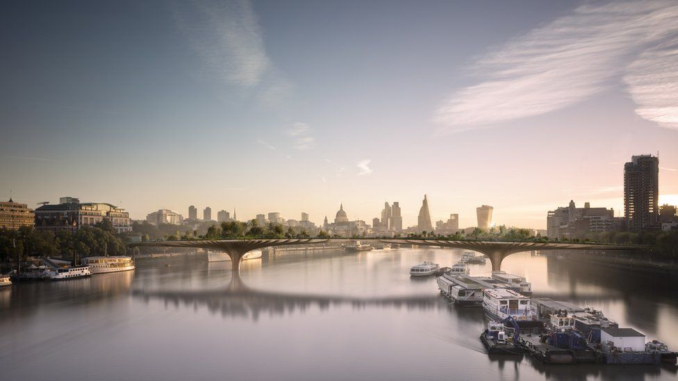
Figure 1: Garden Bridge Project prints captured by Heatherwick Studio
Source: (BBC.uk, 2019)

Time duration
2012- 2019 Construction of the project never started (London.gov.uk, 2019). Appendix 1 stated the overall time segment of the project.

Analyze- Key reasons for the project failure

Poor proposition
From the initiation of the project, the concept of this project has been flawed. At the initial time, the project of the bridge is completely funded as private, with the sponsors corporate aiding to create the idea of Lumely’s and Heatherwick into some reality. A major multinational organization and some well-known firms called Apple was interested to fund the scheme in return for a store. Later it converted deceptive that the donations from the private would not be sufficient & has been obvious that the starting booster of the money from the public was required to embark with the flow of the private cash. Nearly 60 million pounds pledge evenly separated between the TfL and DFT (Transport for London and Department for transport) followed (McIntyre, 2017). The utilized money of the public pitched up a sequence of irrationality, if in the reality the project is developed for the individuals, then why would it be put in an area previously that is abundant by the crossing of rivers? Lumely prohibited locations at Pimlico & Vauxhall over such a location in central London. Raised questions such as why the closure of the bridge from midnight to 6 am each night, and even for the functions which are privately handed every year. Why ban bikes? For a consultant that was senior political, Sam Blainey for the communications firm, the Whitehouse Consultancy, the impression of ending the project was found to be a severe ultimate mistake. At the time of initiation, the component of closing down an infrastructure of public just for the private contributor's use did not sit right (McIntyre, 2017).

Project delays
Delays are majorly caused by the reasons of its failure to finalize the rights of lands and permissions of planning on each side of the proposed project delivered to worsen the uncertainty of funding that could plague the project throughout (Cooke, 2022). In addition to that, the framework of governance executed to serve the project was not fit for the driving purpose, which resulted in non-lucid or clear and poor decisions making at severe stages to resolve these problems (Cooke, 2022). The poor proposition critically affected the project as several delays from the initiation of the project allow the trust to warn that any further hold-ups to this controversial and much-delayed project could look like it has to be scrapped altogether. This would allow the firm to proliferate the spending of the project and lead the project to face the projected shortfall. Initial delays since 2013-14 when NRA and EIA were brought out the circumstances have changed significantly; the garden bridge construction work has been delayed by nearly 1 year and even the work of TTT has been carried forwards by 6 months. Then 18 months have been taken out of the TTT program so that TTT river traffic at the time peak would not happen earlier however it would be further intensified (Assets.publishing.service.gov.uk, 2016). If the project starts in the summer of 2017, as is now being proposed, then the work of constriction cofferdams will coincide with the constriction of the Blackfriar's shaft cofferdam or peak of TTT river traffic.
There were nearly 22 obstacles such as the prospect of judicial review, funding, environmental issues, changing mayor, and many more delaying the project again and again. The reoccur delays can lead to an estimated cost of over 200 million pounds that could affect the trust's financial position too. These obstacles even affect the whole trust and lead the project into a shortfall of funding.

Shortfall in fundraising
The trust has even admitted a shortfall in the gap of funds for the project and has beckoned for the administration to facilitate its continued support. The trust even requested for the administration of 15 million pounds underwriting of this debatable project to be extended by a year to date of September (2017), from the recent £60M funding package. Delays in the land negotiations and issues regarding the planning, the overall cost of this project is expected to proliferate from £175M to £185M. Trust has upstretched merely over £ 69 M of funding from private from years 2013-16. An extra £55.9M is needed to reach the total fundraising. Funding’s from the DfT and TfL would be got the project off on the grounds. Just because of meeting several challenges such as delays and others increase the cost of the funds and affects the funds of the project. The firm would not allocate such huge funds for the completion of the project as the future of the project would be in doubt too (BBC.uk, 2017). The confidence under a plan to construct a bridge across the Thames in London that is coated with plants and greenery has admitted that it is "unable to determine it is a going business." To finish the project, the Garden Bridge Trust needed to be collected an estimated £185 million. But the annual reports reveal a £56 million gap. Still, the work on this project had gone until the closure of the project. Appendix 2 highlights the breakdown of the project cost at the time of closure.

Not eco-friendly
This project requires the felling of mature trees on every side of the river, involving 28 plant trees and more than replacing mature trees (270) which demonstrates why this project is not considered to be environmentally friendly at the initiation of the project (Cooke, 2022).
This project at the time of its initial phases the firm has come under fresh attacks by environmentalists criticizing it as not eco-friendly, which summarizes the proliferating corporatization of the capital funds. This project has been criticized for polluting the environment that put halts and creating problems for the project. The detailed analysis of the investigation done by the Architect journal stated the project as an unnecessary and vast piece of civil engineering with the splashing of urban parsley (Medland, 2018). They claimed that if it has been built then unnecessarily to hold up 10k tonnes of soil to accommodate planting, the mammoth structure of the project is then unwillingly and vigorously environmentally damaging packaging. They claimed that what is the value of the small garden project by devastating public gardens. The proposed site of the Bridge is close to Waterloo Bridge which has the best views of London and is considered to be a key traveller route by bike, bus, and foot from the station waterloo to Westminster and beyond. The case of transport for any fresh bridge in the location which is proposed is very thin to the opinion of being such non-existent just because of that pedestrian link called for in the London plan or any other sort of local authority development plan.

Perplexed campaigns
Those beyond the bridge couldn't decide and were even confused about whether it was for tourism or transport. It concluded that perhaps the proposal had several flaws first from the beginning, the development plan for building the bridge was flimsy, the bridge's intent was ambiguous, the Garden Bridge Trust could only have lifted £69 million in private financing commitments, the last construction costs would therefore surpass £200 million, except for the sum of any potential investment fund for preservation, the bridge project was divisive and unimportant, and the Garden Bridge Trust was improbable to proceed with it (Menteth, 2016). With ongoing risks, the project was not put on hold trust was continued project even though the risk appeared again and again, which can lead to the cost of the project. Just because of the new mayor at that time, Sadiq khan was not in against the project but just because of this confusing campaign, he would deny further spending money on this project (Cockburn, 2018). The continuous flaw of the project was quite unclear for the people that would lead the project to collapse just because of its problems.

Some of the world’s major project failures examples
There are some of the other previous projects which are somewhat the same as the garden bridge project but there is not a single lesson that would learn by the trust. The Millennium dome project was also a failed project it was a dome-shaped megastructure, built in the Greenwich peninsula in London’s southeast funded by three sources such as sponsors, visitors, and the national lottery (Akinradewo et al., 2022). But the lack of vision because of improper planning same as the Garden bridge project and even the poor execution caused lackluster content and led to negative results for the visitors (Algumzi, 2022). These reasons are the common factors of the project criticism and led the project to be financially mismanaged. The project closed on the 31st of December in 2000 because of these reasons.
While the other project failures such as BP oil, the accident from the explosion that occurred in the deep-water horizon project was considered to be one of the greatest or worst ever oil disasters in the history of the current world. This led to the loss of nearly 11 people creating a cloud of smoke in 30 miles of areas where 5 miles were covered by spill only (Figueiredo et al., 2022). The reasons for this project's failure were the extreme geographic location and its weak risk management. These are the results of the absence of planning from the initiation of the project that would allow the firm to face issues because of its project in the Gulf of Mexico.

TOWS analysis of BP oil soil project
Threats  - Arab Spring  - Inappropriate measures  - Limited resources  - Ethical threats | Opportunities  - Energy alternatives  - Competitive Pricing  - High quality  - Territories expansion
Weaknesses  - Poor management  - Negative consumer opinion | Strengths  - Financially Strong  - Brand loyalty  - Diverse geographic experience  - Robust market appearance

Solve- Lesson learned from the project
Several lessons are used by other similar projects not to perform the same steps for their tasks. Primary, the dependency of trust on such few resources of funding, especially from the government, was a strategy of risk. Any fruitful charity requires diverse funding streams. The broad the range of funds, the more credible the project is and the more attractive a proposition it becomes. It's crucial to establish connections with a diverse range of individuals. It is dishonest of the trust to accuse the London Mayor of the program's failure; if a foundation fails since such sponsors do not support it, it is not their fault. No matter how fantastic a concept is, nobody has to finance the project. A better course of action would have been for the trust to hone its relation abilities and re-evaluate its proposal if the Garden Bridge was not receiving the required backing. Atkins, (2017), states that the major lesson learned from this project was to define the problem before considering the solution and even grant the economic case by ensuring that uncertainty is understood. Decision makers of the projects should have to handle risk and uncertainty in such a way as to make efficient investments.
It’s important to consider the environmental effect of the project earlier before initiating it into reality (Ahmed, 2019). The project was built to create a bridge that covers plants and trees but in-depth, it devastates the real environment of the area by destroying various things that could lead the project into various bottlenecks and even the trust to increase its cost for the environmental standards. That is why proper planning is required before taking any such steps that have a big impact.

Conclusion
Considering the facts from the above analysis of the report, it has been analyzed that the garden bridge project was a failed project because of the reasons of fund shortages, increasing costs, project delays, environmental failures, failure in jurisdiction rights, and many more. These can be overcome if the project was introduced on Proper planning basis and the aim of the project was clear. In the last section of the report, suggestions were provided for similar projects to undertake all recommendations before the commencement of the project. These suggestions are critically used by the upcoming similar project in such a way as to deal with the projects in an effective manner.

Recommendations for the similar project
- In the context of the bridge, may a charitable trust set up to bolster the project and offer grant funding would have been further suitable in such a way to avoid taking on the risk and even the accountability of maintaining and serving projects related to infrastructure.
- Every project must be transparent from its initial stages so that there will not be any such kind of activities that will put a halt on the project and results in delays (Willumsen et al., 2019).
- A proper management structure is required in which every single task is defined and everything regarding the project is clear even the aim of the project too.
- The project must only proceed if there is a lucid full life-cycle assessment cost of the project. Risk analysis of the project is required in such a way that a manager of every project must understand the cost which can be expected to arise in the later stages so that a plan is established at the early stages (El-Sayegh et al., 2021).
- Project planning is one of the crucial phases of the project life cycle so that there will not be any such activities that can affect the operations of the project. Contingency planning is even needed o that if any of the plans fails then there would be another option (Boholm, 2019). The proper financial analysis would be required for the project to sustain fruitfully.

References
Ahmed, S., 2019. A review on using opportunities of augmented reality and virtual reality in construction project management. Organization, Technology and Management in Construction: An International Journal, 11(1), pp.1839-1852.
Akinradewo, O., Akinshipe, O. and Aigbavboa, C., 2022. Construction Project Failures Around the World: What Have We Learnt so Far?
Algumzi, A., 2022. Risks and Challenges Associated with NEOM Project in Saudi Arabia: A Marketing Perspective. Journal of Risk and Financial Management, 15(9), p.381.
Assets.publishing.service.gov.uk., 2016. Representation from the public, assets.publishing.service.gov.uk/. Gov.uk. Available at: https://assets.publishing.service.gov.uk/government/uploads/system/uploads/attachment_data/file/541835/Annex_3_Applicants_Response.pdf (Accessed: January 7, 2023).
Atkins, G., 2017. Lessons for Government from the Garden Bridge Fiasco, Public Finance. Public Finance. Available at: https://www.publicfinance.co.uk/opinion/2017/08/lessons-government-garden-bridge-fiasco (Accessed: January 7, 2023).
BBC.uk., 2017. London Garden Bridge's future in doubt, say trustees, BBC News. BBC. Available at: https://www.bbc.com/news/uk-england-london-38584895 (Accessed: January 7, 2023).
BBC.uk., 2019. Failed London Garden Bridge project cost £53m, BBC News. BBC. Available at: https://www.bbc.com/news/uk-england-london-47228698 (Accessed: January 7, 2023).
Boholm, Å., 2019. Lessons of success and failure: practicing risk communication at government agencies. Safety science, 118, pp.158-167.
Cockburn, H., 2018. Garden Bridge: How the vision came crashing down, The Independent. Independent Digital News and Media. Available at: https://www.independent.co.uk/news/long_reads/garden-bridge-london-boris-johnson-thomas-heatherwick-joanna-lumley-timeline-full-story-a8237636.html (Accessed: January 7, 2023).
Cooke, P., 2022. 2023 EPS Jubilee Issue. Global heating and crisis mitigation. European Planning Studies, pp.1-13.
Cooke, P., 2022. Callous Optimism: On Some Wishful Thinking ‘Blowbacks’ Undermining SDG Spatial Policy. Sustainability, 14(8), p.4455.
El-Sayegh, S.M., Manjikian, S., Ibrahim, A., Abouelyousr, A. and Jabbour, R., 2021. Risk identification and assessment in sustainable construction projects in the UAE. International Journal of Construction Management, 21(4), pp.327-336.
Figueiredo, M.G., Alvarez, D., Rotenberg, L. and Adams, R.N., 2022. The Deepwater Horizon oil rig accident, 12 years later: analysis focusing on the collective dimension of work and the organizational factors. Cadernos de Saúde Pública, 38.
Grevink, J., 2021. Towards Living with Water: In search of new perspectives towards living with the increasing risk of flooding in the densifying outer dike area of the urban center of Rotterdam.
London.gov.uk, 2019. Up the garden path: Learning from the Garden Bridge project, London City Hall. London City Hall. Available at: https://www.london.gov.uk/sites/default/files/report_of_the_garden_bridge_working_group.pdf (Accessed: January 7, 2023).
McIntyre, F., 2017. Why London's Garden Bridge Project failed, New Civil Engineer. New Civil Engineer. Available at: https://www.newcivilengineer.com/archive/why-londons-garden-bridge-project-failed-09-10-2017/ (Accessed: January 7, 2023).
Medland, C., 2018. Why we think the 'Garden Bridge' is a bad idea, LinkedIn. LinkedIn. Available at: https://www.linkedin.com/pulse/why-we-think-garden-bridge-bad-idea-chris-medland?trk=portfolio_article-card_title (Accessed: January 7, 2023).
Menteth, W., 2016. Thames Garden Bridge: procurement issues. Project Compass CIC.
Willumsen, P., Oehmen, J., Stingl, V. and Geraldi, J., 2019. Value creation through project risk management. International Journal of Project Management, 37(5), pp.731-749.

Appendices

Appendix 1: Garden Bridge project timeline
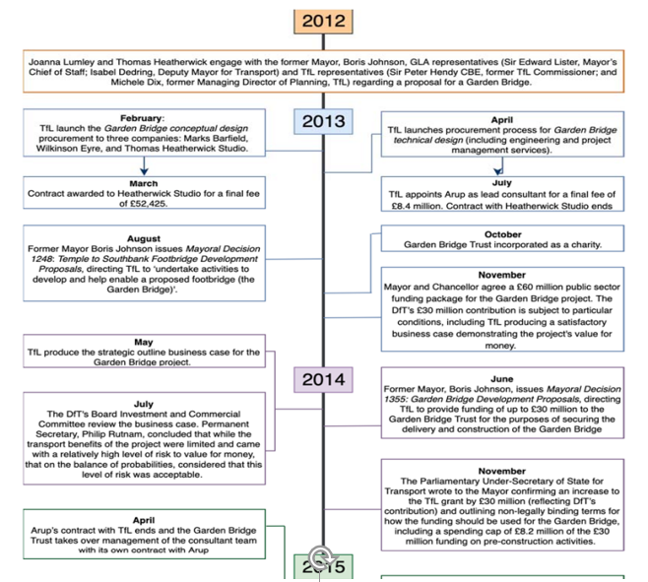
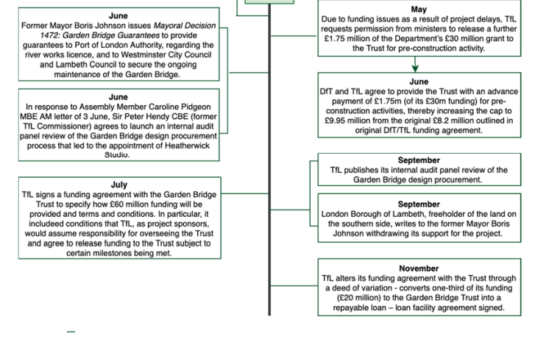
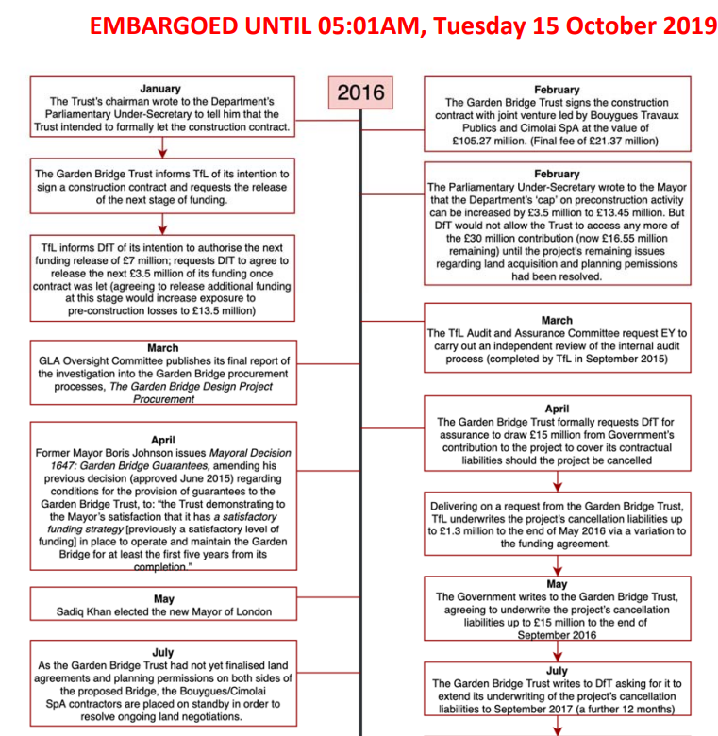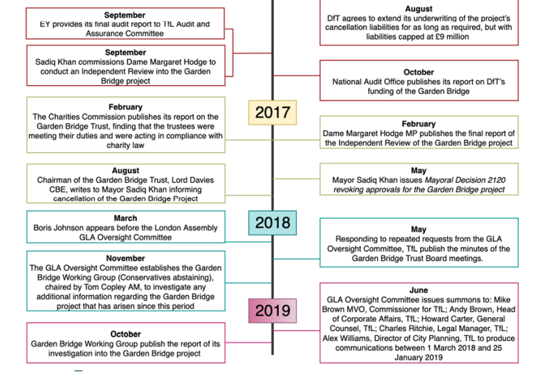

Appendix 2: High-level Breakdown of Garden Bridge project expenditure


