Software Solutions for Business
A portfolio exploring contemporary software solutions for enhancing day-to-day business operations

Student Name: MUHAMMAD ASHIR REHMAN

Student ID:2533747
Table of Contents
1. Introduction 3
2. Task 1: E-commerce Website Builders 3
2.1 Shopify 3
2.2 WooCommerce 4
2.3 Comparing the two and my recommendation 4
3. Task 2: Mind Mapping and a Mind Map of Business Software 4
3.1 What mind mapping is and why businesses use it 5
3.2 A mind map of business software 5
4. Task 3: Microsoft Office Applications 6
4.1 How the four applications work together 6
4.2 Microsoft Word 7
4.3 Microsoft PowerPoint 7
4.4 Microsoft Excel 8
4.5 Microsoft Access 8
4.6 Comparing the four applications 8
4.7 Testing two Excel features (VLOOKUP and IF) 9
5. Task 4: Communication and Collaboration Tools 11
5.1 Zoom (communication) 11
5.2 Trello (collaboration) 12
5.3 Comparing the two tools 12
5.4 Testing a feature of each tool 13
6. Conclusion 16
7. References 17

1. Introduction
Businesses use software to record reports, to store customer data, to make calculations, to have online meetings and to sell their products or services. From human resource management to sales and marketing, software is essential to nearly all day-to-day business operations. It is essential that workers select the appropriate computer software and utilize it appropriately. It enhances businesses to work more efficiently and make better decisions.
This portfolio is to describe and analyse the various business software. It explains the functions of the different tools, their pros, cons and use cases. There are four tasks in the portfolio. Task 1 is a comparison of two tools which are used to build online stores. Task 2 introduces mind mapping and provides a mind map of business software. Task 3 covers the four principal applications in Microsoft Office and experiments with two features in Excel using examples. Task 4 focuses on one communication tool and one collaboration tool and illustrates their use. The common theme of all four tasks is that there is no one software tool that works best in all situations. The most effective combinations are selecting the appropriate tools and using them in combination as necessary.

2. Task 1: E-commerce Website Builders
An e-commerce website builder is a solution that can help a business to establish and operate an ecommerce website without having to develop all the technology from the ground up [1]. The choice of tool that a business decides on is critical as it affects the operational expenses of the shop, its appearance and the ease with which it can be expanded [1]. An important point to keep in mind here is the Technology Acceptance Model (TAM) which states that individuals are more likely to use technology if they believe it is easy to use and useful [2]. Let's look at two of the most popular builders, Shopify and WooCommerce, that approach their businesses in two entirely different ways.

2.1 Shopify
Shopify is a paid, all-in-one tool. It provides all of these in one package, including web hosting, security and an easy-to-use drag-and-drop store builder [3] for a monthly fee. The greatest advantage is that it is very user-friendly. Shopify takes the hard and technical aspects out of the picture as there are no servers to manage, no code to write so even a non-technical owner can launch a shop quickly [1, 2]. It also features a large app store of add-ons and built-in tools such as Shopify Payments, and newer AI features [3]. There is a downside to this and that downside is cost. The monthly charge can become significant as well as additional charges per sale (unless using Shopify Payments) [1] with the growth of the business. Shopify pays for speed and simplicity however you pay off over time.

2.2 WooCommerce
WooCommerce goes the other way. It is a complimentary, open-source plugin for WordPress sites. The main feature of it is flexibility. The Resource-Based View (RBV) is a helpful concept here, as it suggests a business can derive an advantage from resources that are valuable, rare and difficult to imitate [4]. WooCommerce allows the business to tweak pretty much anything and retain full control over their website, data and code, so they can create a store that is truly theirs [1]. The downside is, this freedom requires more skill. The business must host, secure, update and repair the issues and that is difficult without IT support [1]. So WooCommerce is a more hands-on and flexible option, but it requires more of its users.

2.3 Comparing the two and my recommendation
Table 1 is a comparison of the two builders. The answer isn't “better” in either case, it depends on the business. Shopify is the faster of the two, and requires less technical expertise, while WooCommerce has more control and offers long-term flexibility. While most studies compare these platforms based on features and short-term setup, we lack information on their impact to a business over several years. The suggestion I'm going to give you is this, if you're a small start-up looking to get online quickly and risk-free, you should go with Shopify, and if you're a business with some technical know-how, you're looking to build your own shop and have more control over costs as you grow, you should go with WooCommerce.
Table 1: Comparison of Shopify and WooCommerce (based on [1], [3]).
What to compare | Shopify (paid, all-in-one) | WooCommerce (free, open-source)
How it is hosted | Fully hosted no servers to manage | You host it yourself as a WordPress add-on
Ease of use (TAM) | High drag-and-drop, little technical skill | Medium needs WordPress and hosting setup
Customisation (RBV) | Medium themes and apps within set limits | High full access to code and data
Cost and growth | Monthly fee plus possible sale fees; steady but rising | Free add-on, but you pay for hosting and extras; varies a lot

3. Task 2: Mind Mapping and a Mind Map of Business Software

3.1 What mind mapping is and why businesses use it
Mind Mapping is a method of note taking and organising ideas in a pictorial format rather than a list. You place the main idea in the centre and then branches out to related ideas, smaller branches and key words to those ideas [5]. The concept was popularized by Tony Buzan who suggested that the brain connects ideas in a network rather than a linear fashion, and that a colourful web diagram was more representative of how the brain works than a simple list [5].
Mind mapping can be useful in a business in several ways. It helps people to generate ideas by allowing them to think in branches around a topic; it helps to make a big problem more manageable by dividing it into branches; and it helps with planning by visualizing the relationship between tasks, people, and goals [6] [7]. Research indicates that people can better understand and remember ideas when they are visually mapped [6] [7]. This renders mind maps useful in meetings, for planning a project or whenever a team is attempting to decide on a plan of action.
However, mind maps are not without their flaws. Eppler equates mind maps with “concept maps” and notes that each of these has its drawbacks: mind maps are quick and good for generating ideas, but at the same time are not good at representing complex relationships between many things, or strict logic [6]. A challenge is that a mind map is a personal one, which is only fully comprehensible to its creator, and thus does not work well for sharing purposes [6]. Moreover, most of the studies are on students, and therefore there is limited knowledge of the impact of mind maps on actual business decisions [7]. Mind mapping is a useful thinking tool, which can be used with caution and in conjunction with more formal tools where precision is required.

3.2 A mind map of business software
The mind map in figure 1 shows examples of the types of software a business may use on a day-to-day basis. Its centre is “Software Solutions for Business,” and they branch out into eight groups, e-commerce and website builders; office and productivity; communication; collaboration and project management; accounting and finance; customer relationship management (CRM); cloud storage and sharing, design and marketing. Each group comes up with some example tools. As seen on the map, there are so many tools that a modern business depends on, and it serves as a simple guide to the tools discussed in the remainder of this portfolio.
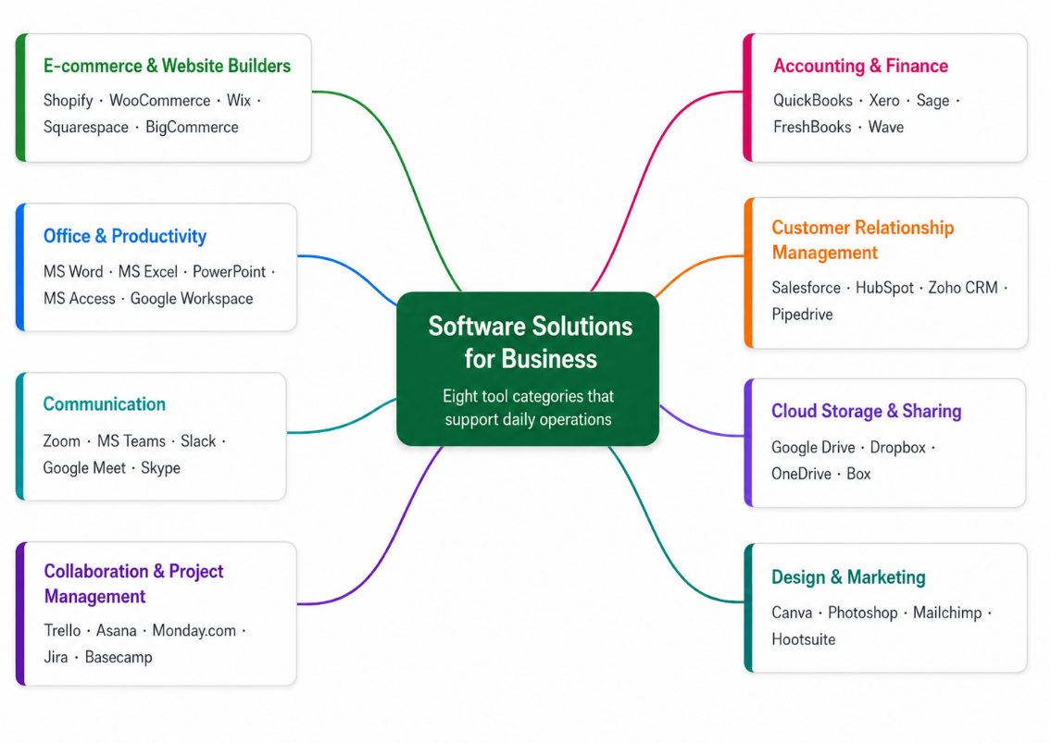
Figure 1: A mind map of business software, grouped into eight categories (author’s own).

4. Task 3: Microsoft Office Applications
This task explores the four principal Microsoft Office applications Word, PowerPoint, Excel and Access, which can be utilized for creating, storing, presentation and analysis of information. It describes what each is good at and what each is bad at and subsequently tests 2 Excel features with a real example.

4.1 How the four applications work together
In most organisations, the primary suite of office applications is Microsoft Office. Rather than viewing the programs as one large package, it is good to think of lining them up in the ‘information lifecycle', that is, the cycle information goes through when it is created, then stored, then analysed, then presented (Figure 2). Each program is designed for a particular step. For instance, in nearly every facet of a business people will use a spreadsheet as their initial tool when dealing with numbers [8].
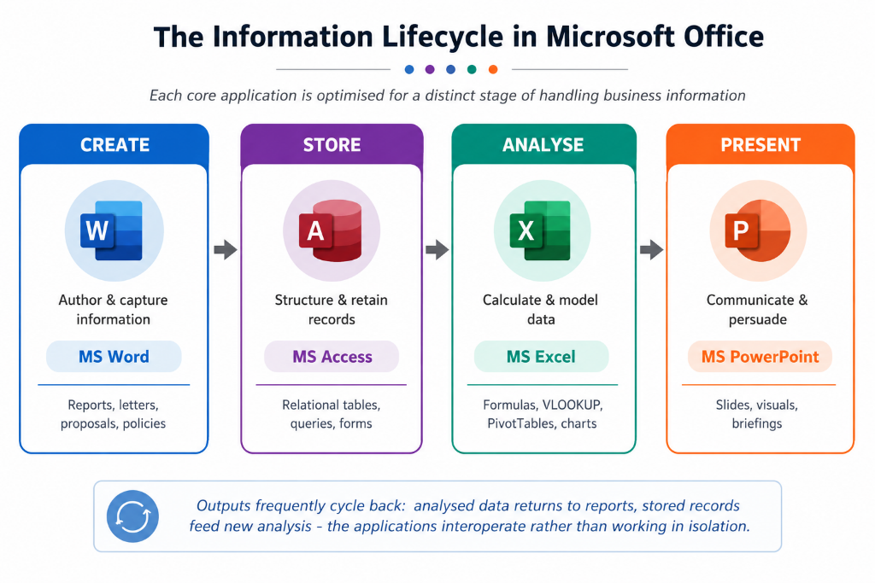
Figure 2: The four Microsoft Office programs mapped to the information lifecycle (author’s own).

4.2 Microsoft Word
Word is used to create, edit and format text documents like reports, letters or policies. Styles and templates, spell and grammar checking, Track Changes and Comments, Mail Merge, and support for tables and images are some of its key features. The main benefit of this is that users can create professional, uniform documents and collaborate with comments and change tracking. But, when it comes to choosing software for various business activities, there are some disadvantages of Microsoft Word that organisations should consider. It is not suitable for heavy number crunching, where one may consider using Microsoft Excel or Microsoft Access. Moreover, even though the Track Changes and Comments can facilitate teamwork, there might be formatting inconsistencies, version control issues, and editing conflicts, especially in longer reports that allow for multiple contributors. With the number of images, tables, references, and other embedded objects, large documents can also be slow to process and hard to navigate, which will diminish productivity. Also, Word lacks many analytic and automation capabilities when compared to other Microsoft Office applications, and businesses may have to resort to other applications to get certain jobs done efficiently. Therefore, although Microsoft Word is one of the key elements in creating the best business documents, it is best not used as a stand-alone application but with others in the Microsoft Office application suite. Organisations that select the appropriate software for the task can improve efficiency, decrease mistakes, and make well-informed business decisions.

4.3 Microsoft PowerPoint
PowerPoint is used to create slides to present ideas, with text, visuals, charts and animation. It includes the following features, slide templates, transitions, speaker notes, and presenter tools. The advantage of it is that it allows you to rapidly create a clear, visual talk, useful for explaining and persuading. However, it also has a well-documented drawback. According to Tufte, PowerPoint's traditional format of short bullet points, rigid formatting, and scant information can make complex ideas too simple, and can even obscure information when applied to important decisions [9]. The lesson is: the tool dictates the message it can make things clear, or it can turn a careful argument into a series of unrelated points. However, the success of PowerPoint is really more about how the PowerPoint is created and delivered, and less about the software itself. Too much text, too many unnecessary issues with the slides, too many unnecessary animations, and overuse of templates can turn off the audience and cause a distraction from the presenter's message. Studies show that the most effective presentations are the ones that accompany the speaker's words rather than the ones that substitute for them and deliver too much information at once [9]. So, in company settings, key decisions should be accompanied by an in-depth report, a spreadsheet, or additional documents not just slides from a presentation. Therefore, PowerPoint should be seen as a communication tool, to support discussion and not replace detailed analysis and evidence-based decision making [9].

4.4 Microsoft Excel
Excel is a spreadsheet application that can be used to store numbers and tables, to perform calculations and to analyse and chart numbers and tables. It has formulas and many functions (like IF, VLOOKUP, and SUMIFS), PivotTables, charts, conditional formatting, and “what if” capabilities such as Goal Seek. Its advantages are flexibility and ease of access: it's used in budgets, reports, and for quick analysis in nearly every job, and often serves as a starting point for more in-depth data manipulation [8], [10]. But that same ease of use is also its biggest risk. Much of the research has found that there are surprisingly many errors in everyday spreadsheets, Data and calculations are intertwined in a single grid and often spreadsheets do not receive the care and attention required by proper software and are not carefully checked, which leads to poor decisions [10]. While Excel is a great tool, it requires diligent design, testing and rules particularly when spreadsheets are large or shared.

4.5 Microsoft Access
Access is a desktop database program. It stores data in linked tables and allows you to create queries, forms and reports. It can be based on Codd's “relational model”, which stores data in tables linked together using keys and reduces data duplication and ensuring accuracy [12]. Access is a simple visual database development tool that does not require advanced programming skills and can be used as an intermediary tool between a spreadsheet and a full company database for small and medium businesses [13]. Access also has more tools for maintaining order than Excel, is better able to manage multiple linked sets of data stored in a database and is more efficient for multiple simultaneous users entering data, thus eliminating the replicated data and errors that can result from large spreadsheets [13]. Limits are size (not built for very large datasets), number of users at the same time (a server database such as SQL Server would be required) and it's not as easy to learn as the other three. Nevertheless, for small to medium-sized businesses, Microsoft Access can be an excellent choice, but for rapidly growing or large enterprise businesses, it might not be the best option. However, performance can become an issue as data volumes and the number of users grows, and this is when organisations need to move to a more powerful database management system, like Microsoft SQL Server. Moreover, although Access makes it easier to avoid advanced programming skills, a proper understanding of relational database design concepts, such as data normalisation, relationships, and indexing, is still needed for efficient database design to achieve high performance and data integrity [12], [14]. Microsoft Access is thus better thought of as a temporary solution for a small business until a more robust enterprise database platform can be adopted and is best suited as such.

4.6 Comparing the four applications
A comparison of the four programs is shown in Table 2. They complement one another, not supplant each other. Some of their functions overlap: For instance, both Excel and Access have tables to store data, and they are both useful for different purposes. Many business challenges are best addressed by using a combination of programs such as keeping the data in Access, doing analysis in Excel, and reporting on the data in Word or PowerPoint than by relying on one single program to do it all [10].
Table 2: Comparison of the four core Microsoft Office applications.
Application | Main job | Key features | Key benefits | Key limitations
Word | Create and format documents | Styles, templates, track changes, mail merge | Professional, consistent documents; easy teamwork | Weak for number work and large datasets
PowerPoint | Present and communicate | Slides, transitions, speaker notes, charts | Fast, clear visual talks; aids persuasion | Can make complex ideas too simple [9]
Excel | Analyse and model data | Formulas, IF, VLOOKUP, PivotTables, charts | Flexible, easy analysis and modelling | Error-prone; weak control at scale [10]
Access | Store and manage data | Linked tables, queries, forms, reports | Organised, low-repetition, multi-user data | Limited size/users; harder to learn

4.7 Testing two Excel features (VLOOKUP and IF)
To illustrate these concepts, I created a toy Excel spreadsheet for a fictional online store “BrightLeaf Organics” to experiment with two capabilities. Fourteen orders are listed in the workbook, each containing a product, the category, the number of units sold and the price of the unit and is provided as a separate workbook. I tried two features, VLOOKUP and IF. There was no real data used, and no personal data, consistent with the brief. In Figure 3, the entire workbook is displayed.
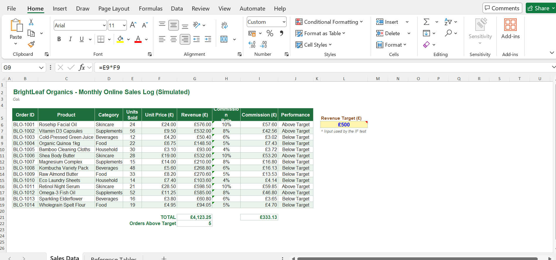
Figure 3: The BrightLeaf Organics workbook. Revenue multiplies Units by Unit Price; the Commission Rate column is filled by VLOOKUP; and the Performance column is filled by IF.
Feature 1: VLOOKUP. VLOOKUP (“vertical lookup”) searches for a value in the first column of a table and returns a value from another column in the same row. The commission rate has been provided for each product category in a separate table (Figure 4). In the formula, the formula =VLOOKUP(D6,CommissionTable,2,FALSE) looks up the category for each order from the CommissionTable and returns the corresponding commission rate (see Figure 5). The word FALSE causes Excel to perform an exact match and by naming the table (CommissionTable) the formula remains easy to read. This demonstrates how VLOOKUP can automatically join two tables, which is a very common business task, and replace a slow and error prone manual look-up. Its biggest drawback along with the research into spreadsheet mistakes – is that VLOOKUP fails if the table with the look-up column is moved or if a category is misspelled, although using an exact match and a named table mitigates this risk [10].
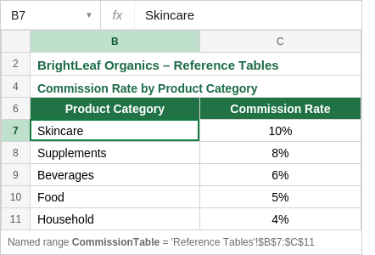
Figure 4: The reference table on the ‘Reference Tables’ sheet, saved as the named range CommissionTable — the source VLOOKUP reads from.
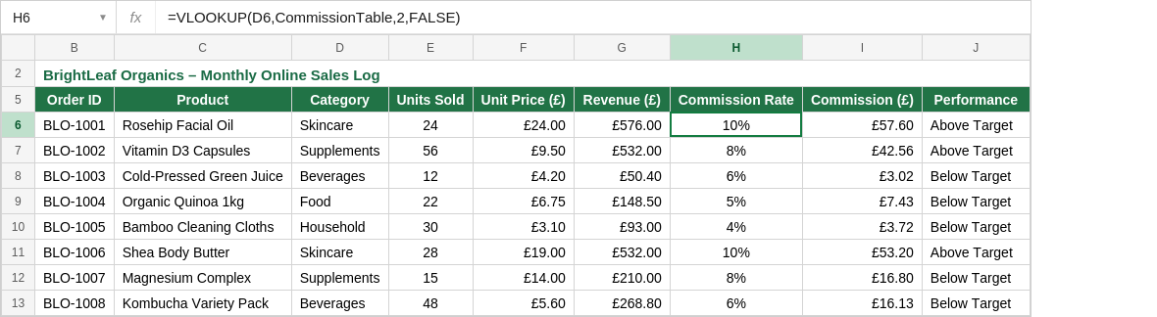
Figure 5: VLOOKUP in cell H6. The formula bar shows =VLOOKUP(D6,CommissionTable,2,FALSE); the Commission Rate column returns each category’s rate.
Feature 2: IF. IF function returns one value if a condition is true and another if it is false. This uses =IF(G6>=$L$6,“Above Target”,“Below Target”) to compare each order's revenue with a revenue target stored in a separate cell (£500 in cell L6) and return the text 'Above Target' or 'Below Target' (Figure 6). By leaving the target in its own cell, rather than writing the actual number directly into the formula, every result will be updated independently if the manager changes the target, making the spreadsheet easier to read and safer (good spreadsheet design!) [10]. Of the fourteens orders, five were Above Target, nine were Below Target. Combined with IF, VLOOKUP transforms a simple list into a little decision-making tool.
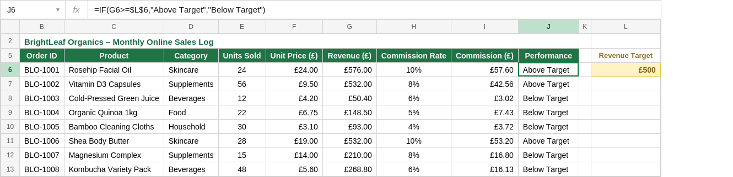
Figure 6: The IF function in cell J6. The formula bar shows =IF(G6>=$L$6,…); the Performance column compares each order with the £500 target in cell L6.

5. Task 4: Communication and Collaboration Tools
With the rise of remote working and hybrid teams, communication and collaboration tools have become essential in the way businesses operate. They offer obvious advantages but come with certain costs [14] [15]. In this section, one communication tool: Zoom, and one collaboration tool: Trello are examined.

5.1 Zoom (communication)
Zoom is a cloud-based video conferencing platform for meetings, webinars and remote collaboration. Main features are good-quality video and audio, meeting scheduling with integration to a calendar, screen sharing, breakout rooms, recording, and in-meeting chat. It is most important feature is the ability to communicate face-to-face over any distance, allowing for relationship-building and decisions that are not possible through text alone [14]. An economic benefit of the shift to remote work during the pandemic was the use of services, such as Zoom, which were essential to maintaining the operations of these businesses, but also added a certain amount of stress on workers [14]. There are definite restrictions in Zoom. In one study, Yang et al. analysed more than 60,000 workers and concluded that the shift to a full remote, screen-based approach to work led to a more "silo mentality" and fewer Realtime information sharing opportunities [15]. There's also Zoom fatigue, which refers to the exhaustion of prolonged eye contact, self-visibility and sitting still [16] adds Bailenson. While video calls can be a great alternative (and they are!) to face-to-face meetings, they are not a no-cost means of communicating, as they require extra equipment.

5.2 Trello (collaboration)
Trello is a web-based tool for managing tasks and working together. It's modelled after the Kanban method, which uses cards that move through columns (“lists”) of To Do, In Progress, and Done. It has all the additional features like boards, lists and cards, checklists, due dates, colour coded labels, member assignment, comments, attachments and automation. The big advantage of it is visibility a team-wide shared board means everyone can see who is working on what and how much work has been accomplished, which can help with coordination even when team members aren't working around each other at the same time or in the same location. The literature on digital-workplace tools explains that tools such as those can provide new methods for workgroups to communicate, coordinate, and share information, independent of location and time [17]. Disadvantages are that Trello's simplicity (terrific for little work) can end up being limiting for larger, more complicated projects with a great deal of dependencies, where a more full project-management software can offer even more framework, and that boards can become cluttered and outdated if no one is dedicated to maintaining them.

5.3 Comparing the two tools
Table 3 makes a comparison between the two tools. For instance, communication and collaboration tools complement each other; Zoom is great for live, rich conversation but is not a tool for managing the work, while Trello is great for organising the work, but it is not a tool for live conversation. The best teams employ both.
Table 3: Comparison of Zoom (communication) and Trello (collaboration).
What to compare | Zoom (communication) | Trello (collaboration)
Main purpose | Live video and audio meetings | Organising tasks and workflow over time
Main strength | Real-time, face-to-face talk across distance | Shared view of tasks, progress, and who owns what
Main limitation | Zoom fatigue; siloed teams if over-used [15], [16] | Little structure for large, complex projects
Best used for | Meetings, briefings, remote decisions | Coordinating projects and tasks across a team

5.4 Testing a feature of each tool
Below I tested one feature of each tool, again using made-up, non-private data for BrightLeaf Organics.
Zoom scheduling a meeting. I chose to use the ‘Schedule Meeting’ facility to create a weekly marketing meeting (figure 7). The dialog allows me to add the name of the event, date, start time and end time, time zone, and it allows me to pick the frequency at which the event repeats, and it allows me to automatically generate a meeting ID. I designated Ashir Rehman as the host and added the agenda of the meeting. When saved, this will be listed in the “Upcoming” section and include a link for them to click to join the meeting, as well as a “Copy Invitation” button to share (Figure 8). This demonstrates the ease of setting up a recurring meeting, calendar syncing and how to share access in a secure manner through a scheduling link and an auto-generated meeting ID.
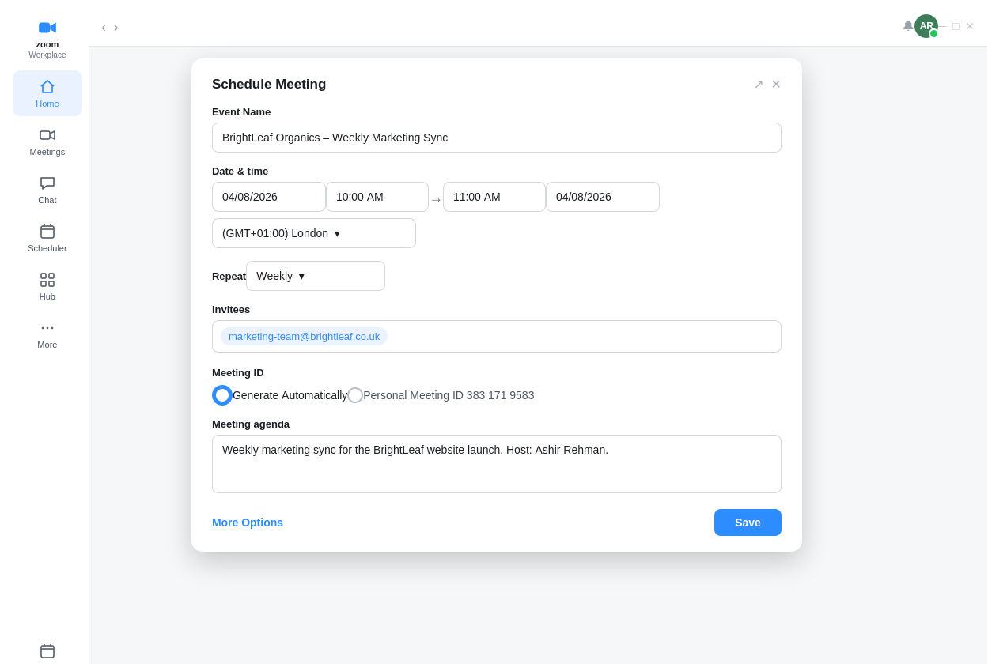
Figure 7: Zoom ‘Schedule Meeting’ dialog the event name, date and time, repeat option, and auto-generated meeting ID, with Ashir Rehman as the host.
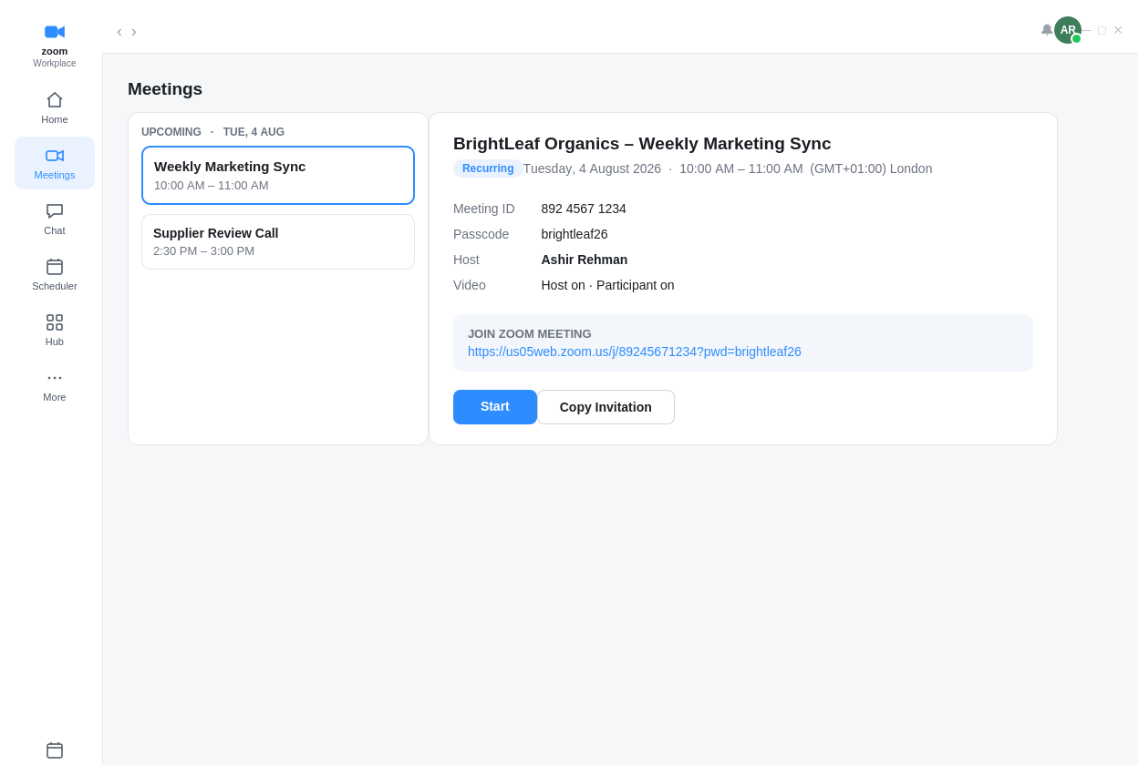
Figure 8: The scheduled meeting in Zoom’s ‘Meetings’ view, showing the host (Ashir Rehman), the join link, and the ‘Copy Invitation’ button.
Trello: building a Kanban board. I have designed a BrightLeaf website launch management board (Figure 9). I created tasks using cards and placed them in four separate lists: To Do, In Progress, Review, and Done, which were organized with colour-coded labels, due dates and assigned members to see the status at a glance. When a card is opened, its detail is displayed: a description, a checklist of smaller tasks, a due date, the members and a comment thread for coordinating. This is an example of how Trello can be used to break down a large project into an obvious and simple workflow to keep a team organized and on track, regardless of their location.
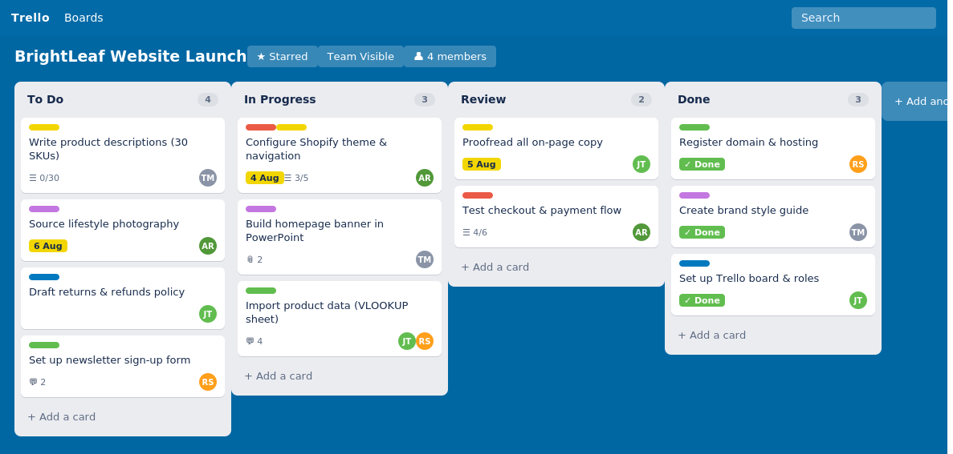
Figure 9: A Trello board for the BrightLeaf website launch, with cards sorted across To Do, In Progress, Review, and Done.
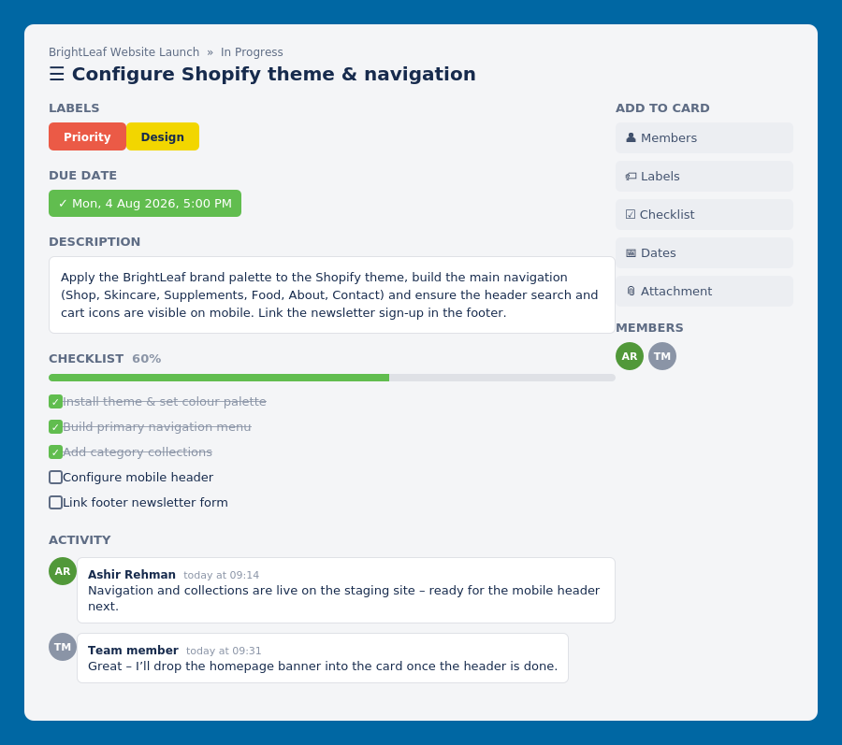
Figure 10: A Trello card in detail — description, checklist (60% done), due date, members, and a comment thread used for coordinating.

6. Conclusion
In this portfolio a variety of business software have been discussed and their strengths and weaknesses compared. It revealed that online shop builders such as Shopify and WooCommerce trade convenience for flexibility; that mind mapping is a great personal thinking device but should not be the only one used; and that communication and collaboration tools like Zoom and Trello have advantages but also their constraints, from Zoom fatigue to cluttered boards. All tasks are based on this theme: No tool is best for everything. Value is in matching tool with the job and combining tools. A working Excel model, the use of Zoom, and Trello demonstrate how the ideas were translated to real, usable skills. The takeaway for businesses is that software purchases alone are not enough they need to be backed by good design, good rules, and good users to reap the benefits it can provide.

7. References
[1] A. Babayev, “Choosing the right e-commerce platform: Strategic considerations for small businesses,” International Journal for Multidisciplinary Research, vol. 6, no. 6, 2024. [Online]. Available: https://www.ijfmr.com/papers/2024/6/29308.pdf
[2] F. D. Davis, “Perceived usefulness, perceived ease of use, and user acceptance of information technology,” MIS Quarterly, vol. 13, no. 3, pp. 319–340, 1989, doi: 10.2307/249008.
[3] G. Srivastava, N. Agrawal, D. Jindal, and Jyoti, “Redefining online retail: The Shopify revolution,” BSSS Journal of Management, vol. 16, no. 1, pp. 157–167, 2025.
[4] J. Barney, “Firm resources and sustained competitive advantage,” Journal of Management, vol. 17, no. 1, pp. 99–120, 1991, doi: 10.1177/014920639101700108.
[5] T. Buzan and B. Buzan, The Mind Map Book: How to Use Radiant Thinking to Maximise Your Brain’s Untapped Potential. London: BBC Books, 1996.
[6] M. J. Eppler, “A comparison between concept maps, mind maps, conceptual diagrams, and visual metaphors as complementary tools for knowledge construction and sharing,” Information Visualization, vol. 5, no. 3, pp. 202–210, 2006, doi: 10.1057/palgrave.ivs.9500131.
[7] N. N. Weerasekara et al., “Harnessing knowledge-based concepts for streamlined mind mapping in academic study,” International Journal of Engineering and Management Research, vol. 13, no. 5, 2023, doi: 10.31033/ijemr.13.5.4.
[8] C. Rebman, Q. Booker, H. Wimmer, S. Levkoff, M. McMurtrey, and L. M. Powell, “An industry survey of analytics spreadsheet tools adoption: Microsoft Excel vs Google Sheets,” Information Systems Education Journal, vol. 21, no. 5, pp. 29–42, 2023.
[9] E. R. Tufte, The Cognitive Style of PowerPoint: Pitching Out Corrupts Within, 2nd ed. Cheshire, CT: Graphics Press, 2006.
[10] P.-L. Poon, M. F. Lau, Y. T. Yu, and S.-F. Tang, “Spreadsheet quality assurance: A literature review,” Frontiers of Computer Science, vol. 18, no. 2, art. 182203, 2024, doi: 10.1007/s11704-023-2384-6.
[11] R. Grenci, “Introducing business analytics in context: An Excel project to analyze product and sales data for inventory purchase decisions,” Decision Sciences Journal of Innovative Education, vol. 20, no. 3, 2022, doi: 10.1111/dsji.12277.
[12] E. F. Codd, “A relational model of data for large, shared data banks,” Communications of the ACM, vol. 13, no. 6, pp. 377–387, 1970, doi: 10.1145/362384.362685.
[13] J. Eckstein and B. R. Schultz, Introductory Relational Database Design for Business, with Microsoft Access. Hoboken, NJ: Wiley, 2018.
[14] E. Battisti, S. Alfiero, and E. Leonidou, “Remote working and digital transformation during the COVID-19 pandemic: Economic–financial impacts and psychological drivers for employees,” Journal of Business Research, vol. 150, pp. 38–50, 2022, doi: 10.1016/j.jbusres.2022.06.010.
[15] L. Yang et al., “The effects of remote work on collaboration among information workers,” Nature Human Behaviour, vol. 6, no. 1, pp. 43–54, 2022, doi: 10.1038/s41562-021-01196-4.
[16] J. N. Bailenson, “Nonverbal overload: A theoretical argument for the causes of Zoom fatigue,” Technology, Mind, and Behavior, vol. 2, no. 1, 2021, doi: 10.1037/tmb0000030.
[17] J. N. Lane, P. M. Leonardi, N. S. Contractor, and L. A. DeChurch, “Teams in the digital workplace: Technology’s role for communication, collaboration, and performance,” Small Group Research, vol. 55, no. 1, pp. 139–183, 2024, doi: 10.1177/10464964231200015.

