Jose M. Lopete
ID-1808701

PART 1

Question 1 ALGORITM
1st HOT WATER
2nd ADD LARGE MUG
2nd JAR OF GROUD INSTAND COFEE
3rd READY CARTON OF MILK
4th OPEN BAG SUGAR
5TH ADD TEA BAG
6TH ADD METAL-TEA SPOON

Question 2
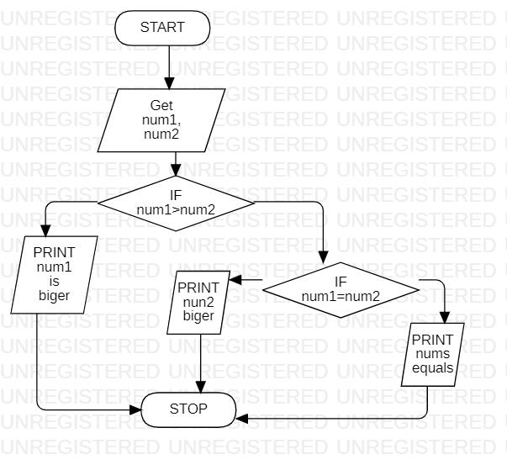
NO
YES
YES
NO

PART 2

Question 1
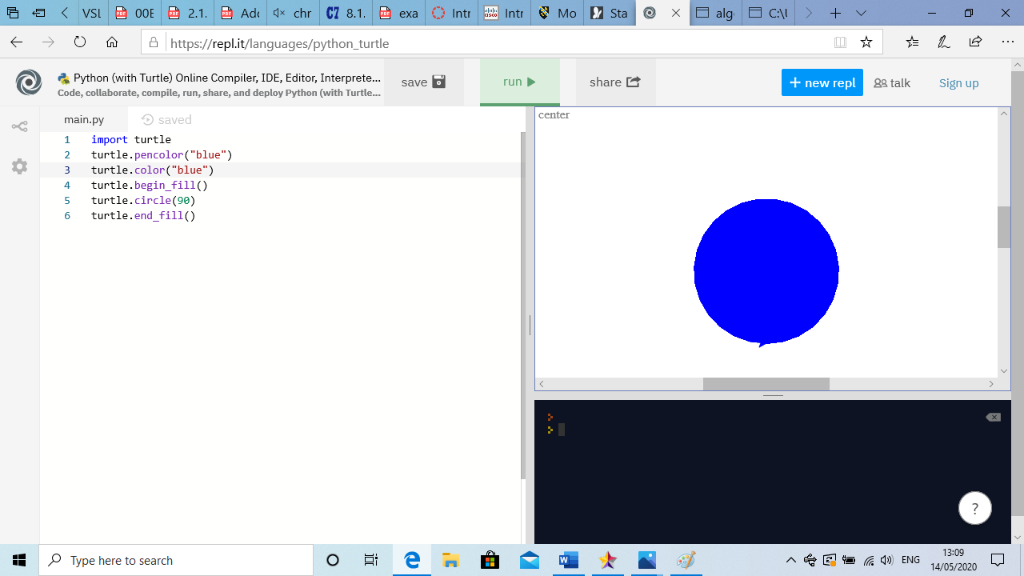

Question 2
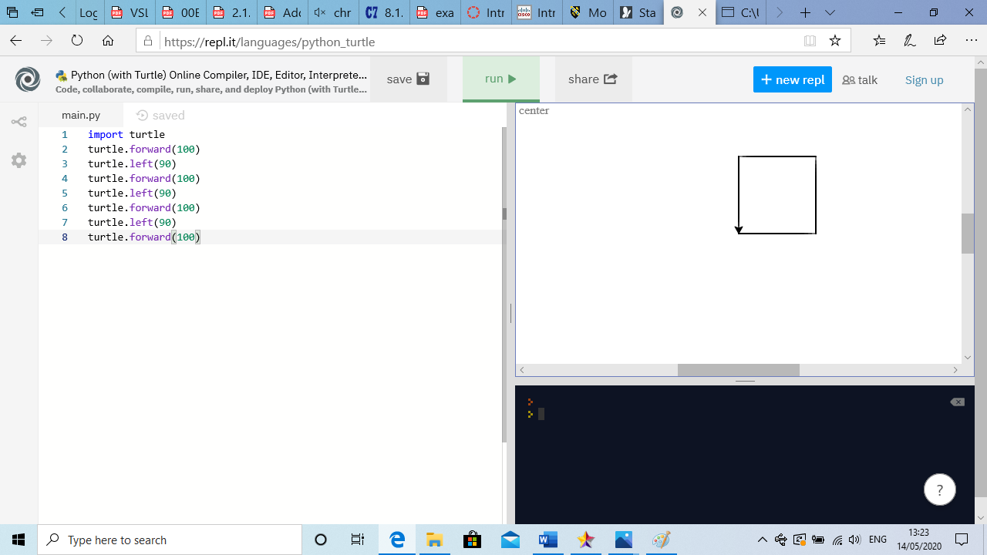

Question 4


