Title page 1
Sefia Bibi
Student Number: 2014087
Module Name: Psychology for Health and Social Care
Module Code: BMHP4003
Lecture Name: Rebecca Kavanagh
Assignment Title: Case Study Report


Contents Page 2

Table of Contents
Title page…………………………………………………………………PAGE 1
Contents page……………………………………………………..........PAGE 2
Introduction………………………………………………………………PAGE 3
Social Identity Theory…………………………………………………..PAGE 3
Social categorisation……………………………………………….PAGE 4
Social identification…………………………………………………PAGE 4
Social comparison………………………………………………….PAGE 4
Attribution Theory……………………………………………………….PAGE 4/5
Frustration Aggression Hypothesis………………………………….PAGE 6
Conclusion and Recommendation……………………………………PAGE 7
References……………………………………………………………….. PAGE 8

Page 3

Introduction
This is a report to the practice manager regarding the recent complaint about a service user who was being verbally abusive towards a member of staff. In this report I am going to describe the possible causes of the behaviour of both the staff and service user. I am going to use psychological theories which are the social identity theory, attribution theory and Frustration aggression hypothesis. I am also going to talk about the service user’s condition and whether this matter should be taken further or not.
The service user has been diagnosed with Emery-Dreifuss Muscular Dystrophy, this causes cramping pain in his legs when he sits for a period of time so therefore he prefers to stand, he also becomes breathless. He also has been suffering with anxiety, depression due to this he has attempted suicide.
The statistical information relating to rates of suicide within this age group is 6.9 in every 100,000 in 2020.
Social Identity Theory
The social identity theory was developed in 1970s by Henri Tajfel who was the greatest contributor in the psychology to social identity theory. Social identity is an individual person’s sense of who they are and the knowledge that he/she belongs to, certain social groups together with some emotional and value significance to the different group membership, self-conception as a group member. Moreover it was assisted that social identity was based on esteem needs and that by joining social groups to form a certain self-concept based on the characteristics. The social identity theory takes the edge of what we are uncertain about and it helps us to define the things that we do and why we do them. Since its conception, SIT has evolved developed and is now often seen as a ‘grand theory’ or a meta-theory. I have used the social identity theory as the service user used to do the training for football, due to his condition, Emery-Dreifuss Muscular Dystrophy he cannot do the training anymore because of his condition. This made him worse as he already suffering with anxiety and depression and suicide attempted. The service user is suffering with anxiety and depression and being in the groups for football and being with the time that helped him with his anxiety depression as he was going out regular and having conversation with others. And not by doing any of this has resulted him in frustration, aggression behaviour.

Page 4

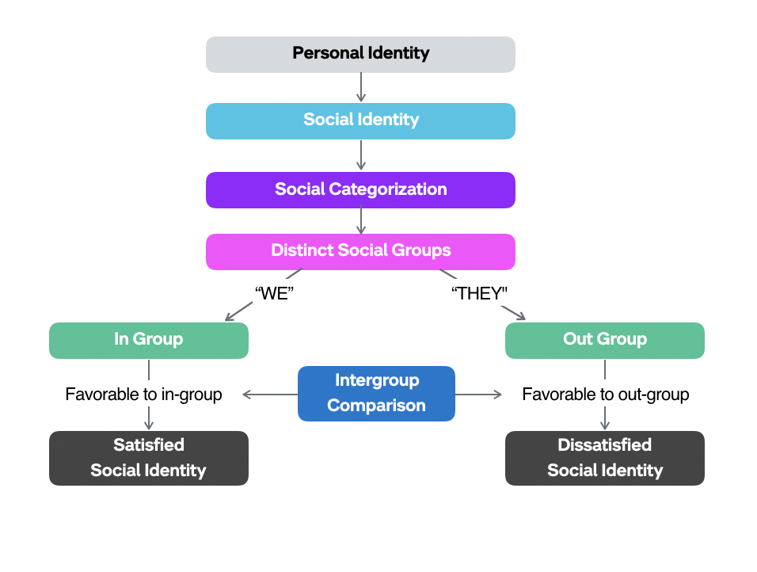There are three main processes to social identity theory.
Social Categorisation
You can keep people to a level that would give us the details and knowledge so that we can use the information to help us deal with complex social situations. In this categorization it’s looked at like black or white and Manchester united and Aston villa any person can be in any group.
Social Identification
Social identification is the study of the interplay between personal and social identities it tells you who they are in terms of the groups and where they belong. Some of the social identifications are; Race, Gender, religion, their beliefs and disabilities. There is also the emotional significance of group membership for the individuals.
Social Comparison
Social Comparison is when we compare ourselves to those in our peer groups or with somebody whom we are similar too and know themselves by evaluating their own attitudes, abilities and traits in comparison with others. ‘in-group’ (our own group) versus ‘outgroup’ the groups we compare our own group to.
Attribution Theory
Attribution theory was introduced by Fritz Heider (1958) it was designed for people to explain how others behaviour makes them think and what was the cause of the behaviour or the event, it assumes to who people try to determine why people do what they do and the cause of the behaviour. Behaviour can be classed as either internal or external. The theory attempts to explain the interpretive process by which individuals make correction about what caused their behaviour and the behaviour of someone else’s after. As a human we have a strong desire to know and describe our experiences. When we come across certain experiences, such as someone acting aggressively and being rude towards us, then we try
Page 5
to think and work out why it happened and explain the behaviour using self-generated theory. To be able to understand the behaviour of someone is major as it allows us to see how that person may act in the future, this allows us to have control over that person and decide on how we are going to act or behave towards them next time. Therefore the search for casual explanations about the social world around us offers us great comfort as it brings orders to our lives and gives us a feeling of being in control of our own destiny and for this reason, a key question about attribution theory is why did he/she do that?
I have used this theory for the service user as this was designed for people to explain how others behaviour makes them think and what was the cause of it. Due to service user’s conditions and losing his football training has caused his behaviour. Being depressed and frustrated can lead to different behaviour. For the reception member of staff is for her to think about what caused his behaviour to be like that or to speak to him in a quite area. As a human being we judge people sometime wrongly as we are not aware of what’s going on with that person.
Heiders theory of naïve Psychology he viewed people as naïve psychologists/scientists who observe other people’s behaviour to generate their own common-sense theories, he based his theory of naive in three principles.

Principle 1
Individuals think that behaviour is not random it is caused by something or sort of motivation. Heider and Simmel (1944) conducted research that demonstrated the tenancy, people were shown short animation that depicted a number of geometric shapes moving around.
Principle 2
Humans collect evidence to try to generate and support their casual theories, e.g. by observing someone who has lost their temper in a number of different situations with number of different people before deciding that they are an angry person.
Principle 3
By attribute behaviour internally or externally. Internally could be that a person is behaving in a different way because of their personal factors.
Externally could be that the person is behaving in a certain way because of the circumstances or the place. In other words we conclude that the person or individual does not normally behave in this way, that there was something about the situation they were in and that made them act out-of-character.

Page 6
Frustration aggression Hypothesis
FAH was first developed by Dollard et al, (1939) it was the first attempts of model and explain aggression in humans. Dollard et al said that the only way to reduce aggression is to engage in an activity which would release it and we would feel better because we have got it off our chest. He also said that if we experience frustration this can lead to aggression. If we experience aggression is a cathartic release of the build-up of frustration.
Principally the hypothesis suggests that the aggression can occur due to frustration being experienced. People proposed that if an individual is frustrated by an encounter or an object then they will respond with aggressive behaviour if appropriate to do so.
When someone is unable to express or communicate their frustration with aggressive behaviour then the individuals may redirect this aggressive energy towards to different objects or situation this is referred to as displaced aggressive. Dollard et al also mentioned that the frustrations generate aggressive inclinations to the degree that they arouse negative affect.
I think this theory relates to the service user as this has happened to the service user by losing his football training and has anxiety depression this has led him to take his frustration aggression anger out of someone else. This has caused him to swear at a member of staff several times. As too the staff member this could have been resolved by taking the service user to a quiet room and having a chat with him to see how things are or what’s going on.
.

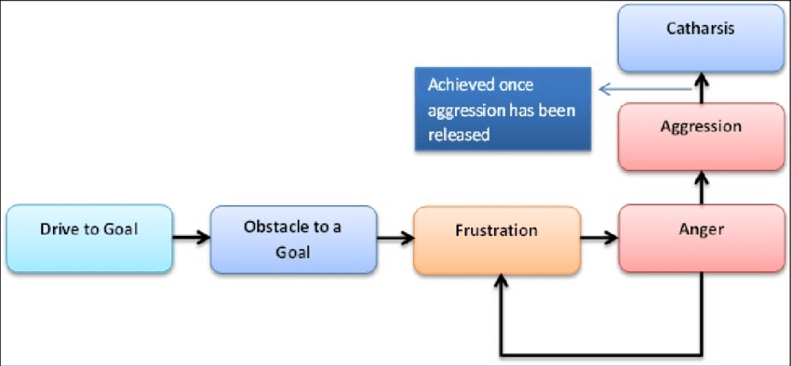

Page 7

Recommendation and Conclusion
In this section I am going talk about the service user and the member of staff.
In my opinion the service user suffers from a few conditions and he is not being able to do the training for football and keep his independence, this had a big effect on him and has been suffering with anxiety, depression and has been persuaded to seek counselling after a suicide attempt. This all got too much for him and it resulted in him taking his anger and frustration out of the receptionist who has recently taken up this post of part time and has been ensuring that the service users are complying with the Covid -19 government guidance.
In my opinion I think that the manager should speak to the member of staff and enquire to what exactly happened, and then also ask the service user what happened and reassure him and explain that the member of staff has to follow the rules too, also maybe explain to him that he is not allowed to shout and swear at members of staff as this is not acceptable. And also to get more training in for the staff member as she is new to the job role and needs training on how to deal with these sort of situations.

Page 8

References

- https://www.statista.com/statistics/289102/suicide-rate-in-the-united-kingdom-uk-by-age/
- Turner, J. C. (1982). Towards a cognitive redefinition of the social group. In H. Tajfel (E d.), Social identity and intergroup relations. Cambridge: Cambridge University Press.
- Heider, F., & Simmel, M. (1944). An experimental study of apparent behaviour. American Journal of Psychology, 57(2), 243-259
- Forsterling. (2001). Attribution : an introduction to theories, research, and applications. Psychology Press.
- Capozza, & Brown, R. (2000). Social identity processes trends in theory and research. SAGE.
- https://www.tutor2u.net/psychology/reference/frustration-aggression-hypothesis
- https://www.google.com/url?sa=i&url=https%3A%2F%2Fwww.researchgate.The-Frustration-Aggression-theory
- Berkowitz. (1989). Frustration-Aggression Hypothesis: Examination and Reformulation. Psychological Bulletin, 106(1), 59–73. https://doi.org/10.1037/0033-2909.106.1.59

