

GREEN CITIES

What would Shiraz City need to do to become a Green City?

School of Architecture, Built and Natural Environment
Course: BSc Architecture

Name: Mohammad Shirazi
Student Number: 1706557

Module code: M6X01986
Word count: 10,000 words
Date: 2021.07.23


Copyright statement

The copyright of this dissertation rests with the University of Wales, Trinity Saint David. No information derived from this dissertation shall be published without the prior written consent of the University.

Signed: | Mohammad Shirazi
Date: | 2021.07.23

Author’s Declaration
I declare that the work in this dissertation was carried out in accordance with the regulations of the University of Wales, Trinity Saint David. The work is original except where indicated by special references in the text and no part of the dissertation has been submitted for any other degree.

Any views expressed in the dissertation are those of the author and in no way represent those of the University of Wales, Trinity Saint David.

The dissertation has not been presented to any other University for examination either in the United Kingdom or overseas.

I hereby give permission for my work, if accepted, to be available for photocopying and inter-library loan, and for the title and summary to be made available to outside organisations.

Signed: | Mohammad Shirazi
Date: | 2021.07.23
Acknowledgements

I would like to express my deepest appreciation to my supervisors, Professor Ian Standen and Dr Elizabeth Walder, for their kindness, patience, encouragement, and invaluable guidance while, over a period of time, I struggled with a certain problem and some aspects of this research. It was impossible to finish this research without their generous help. I would also like to thank my wife, who was in a difficult situation but did not stop supporting me throughout my studies at the University of Wales Trinity Saint David's.

Abstract

After the formation and development of cities, they have attracted a large percentage of the world's population during the last hundred years. For the first time in history, the number of people living in cities has exceeded the number of people living outside the cities. According to the Population Division, the UN estimates that by 2030, more than 68% of the world's population (2030:nearly 5.8 billion) will live in urban areas. Although cities occupy only about 3% of the world's land surface, they are responsible for more than 75% of greenhouse gases.

The increasing use of fossil fuels, the effects of greenhouse gases, urban traffic, waste problems, water, air, and noise pollution, increasing urban population have had unpleasant effects on the environment. With the advancement of knowledge and awareness, human beings have realized that some environmental damages are irreparable, which is the main cause of global warming and the destruction of the environment and consequently affects human life itself.

In order to prevent the impact of cities and such damages, the sustainable development approach was introduced in the 1980s. After several decades, with the expansion of sustainable development in various scientific fields, the idea of green cities and their indicators was formed according to the principle of sustainable development. Many activists, experts and researchers confirm that the idea of green cities is one of the most effective human ideas to reduce CO2 emissions and environmental impacts.

Using a comparative and descriptive-analytical method, the paths and successes of Copenhagen to become a carbon-free city will be examined, and the possibility of its application in Shiraz will be discussed. In this research, various sources such as library resources and online resources have been used to obtain the information needed in the discussion. In the following, while reviewing the methods, initiatives and solutions used by Copenhagen along the path to meet various challenges and based on the opportunities and potential in the city of Shiraz, an adaptive proposal for this city will be analyzed.

Table of Contents

PAGE TITLE Arial 11 Bold CAPITALISATION | PAGE NO
Copyright statement | 1
Author’s Declaration | 2
Acknowledgments | 3
Abstract | 4
List of Illustrations | 6
List of Tables
Introduction | 8
Methodology | 9
Selection of case studies
Chapter 1: Measuring greenness  - Set of indicators for measuring greenness  - Copenhagen the model of green city  - Check the performance of Shiraz city  - External factors that may influence Shiraz city  - Other challenges that Shiraz city may have  - Can Shiraz city be as successful as Copenhagen in terms of the green city  - Analysis of responses from the questionnaire that sent to Copenhagen and Shiraz city | 25
Chapter 3: Title of chapter
Chapter 3 Title of chapter
Last chapter: Analysis and comparison of case studies
Conclusion | 51
Bibliography | 56
Appendix A:
Appendix B:
Appendix C:
Table of Contents

PAGE TITLE Arial 11 Bold CAPITALISATION | PAGE NO
Copyright statement | 1
Author’s Declaration | 2
Acknowledgments | 3
Abstract | 4
List of Illustrations
List of Tables
Introduction
Methodology Arial 11
Selection of case studies
Chapter 1: Title of chapter Arial 11 Bold
Chapter 3: Title of chapter Arial 11 Bold
Chapter 3 Title of chapter Arial 11 Bold
Last chapter: Analysis and comparison of case studies Arial 11 Bold
Conclusion Arial 11 Bold
Bibliography Arial 11 Bold
Appendix A: Title Arial 11 Bold
Appendix B: Title Arial 11 Bold
Appendix C: Title Arial 11 Bold

List of Illustrations

PAGE TITLE | PAGE NO
Figure 1 - the three main elements of sustainability | 11
Figure 2 - an ideal future city (green city) which show, solar panels, wind turbine and green mobility | 14
Figure 3 - The location of Shiraz City among a few ranges of mountains (Derak Mountain, Sorkh Mountain) | 16
Figure 3.1 - Shiraz and a natural border | 16
Figure 4 - an Elamite clay tablets contain Shiraz city's name | 17
Figure 5 - Shiraz annual weather, 2020-2021 by author | 17
Figure 6 - Shiraz's gardens and their characteristics | 18
Figure 7- population history since1961 until 2021 | 19
Figure 8 - Shiraz population density in its 11 districts | 19
Figure 9 - population history since1961 until 2021 | 19
Figure 10- Shiraz population in different groups of age | 19
Figure 11-Iran's fossil Co2 emissions by sector | 22
Figure 12 odd and even plates by the author | 23
Figure 13 - Copenhagen’s CO2 reduction sectors by author | 29
Figure 14 - Copenhagen’s CO2 reduction sectors by author | 30
Figure 15 - Copenhagen’s CO2 reduction sectors by author | 30
Figure 16 - Copenhagen’s CO2 reduction sectors by author | 31
Figure 17 - Copenhagen’s CO2 reduction sectors by author | 32
Figure 18 – Iran CO2 production in detail | 33
Figure 19 - Copenhagen and Shiraz's participant by gender | 37
Figure 20 - Type of accommodation | 37
Figure 21 – age range of Copenhagen and shiraz city residents | 38
Figure 22 – education level of Copenhagen and Shiraz city residents | 38
Figure 23 – global warming impact on the residents of the two cities | 39
Figure 24 – global warming impact on the next generations | 39
Figure 25 – concern about environmental issues | 40
Figure 26– willingness of residents to participate in sustainability activities | 40
Figure 27 – willingness of residents to participate in sustainability activities | 41
Figure 28 – having a bicycle and how frequently they use it | 41
Figure 29 – Cycling mileage | 42
Figure 30 – Distance from work/school/university and distance from city canter | 42
Figure 31 – working from home | 43
Figure 32 – commuting to work/school/university | 44
Figure 33 – energy conservation | 44
Figure 34 – willingness of residents to participate in sustainability activities | 45
Figure 35 – energy saving initiatives | 45
Figure 36 – use of green spaces | 46
Figure 37 – use of green spaces and importance of green spaces | 46
Figure 38 – willingness and ability of growing their own plant/fruit/vegs | 47
Figure 39 – Shopping organic food and willingness of buying it | 47
Figure 40 – supporting local businesses or buying cheaper items | 48
Figure 41 – supporting local businesses or buying cheaper items | 48
Figure 42 – water saving initiatives | 49
Figure 43 – waste production and quality of recycling | 49
Figure 44 – amount of noise | 50
Figure 45– air pollution and its sources | 50
Figure 46 – quality of air in Copenhagen and Shiraz city | 51
Figure 47 – willingness and ability of growing their own plant/fruit/vegs | 51
Figure 3: title of illustration Arial 11

List of Tables

PAGE TITLE Arial 11 Bold CAPITALISATION | PAGE NO
Figure A: title of table Arial 11
Figure B: title of table Arial 11
Figure C: title of table Arial 11

Introduction

From the beginning of creation, human beings have taken refuge in nature to meet their needs and, over time, based on their needs, they have made changes in nature and the environment.

The passage of time, the increase of the planet's inhabitants, discovery and use of coal, invention of the steam engine, industrial revolution, and the continuous increase of the quality of human life have caused humans to make more changes in the environment and its surroundings frequently.

In addition to these frequent changes that have led to the production and increase of greenhouse gases, excessive consumption of natural resources, production of waste (solid, liquid and nuclear) and disruption of ecosystems are just some of human's activities that cause instability in the environment which some of them are irreparable.

To this end, and with increasing awareness and knowledge to prevent further damage to the ecosystem and solve existing problems, leading and developed countries have constantly been looking for appropriate solutions.

Scientists and researchers first introduced the sustainable development approach in the 1980s, and it became the subject of the 21st century. The United Nations set sustainable development as the 21st century regional and local agenda.

Subsequently, the approach and idea of Sustainable cities, eco-cities, smart cities, and green cities were inspired by sustainable development, all of which have almost the same meaning but are slightly different from each other in terms of the objectives they pursue.

Methodology

A variety of methods are used to gather the needed information in order to gain the knowledge to answer the question of this dissertation. Nevertheless, due to the vastness and multidimensionality of the research topic (social, economic, and environmental) and since it is not possible to address all these dimensions, in this research by considering different definitions of the green city and given the importance of environmental dimensions in achieving the goals of green cities, environmental dimensions have been further researched and studied.

As mentioned earlier, the topic of green cities is part of the sustainable development and today's agenda of different countries and their governments.
As the science, knowledge, information, and findings related to this subject are updated daily, and due to the Coronavirus pandemic, that limited access to libraries, online sources allow the author to use extensive information and data included in it. Therefore, most of the content and information collected from online sources, reputable magazines, articles, newspapers, official statistics, and government websites have been prepared and analyzed. In addition to such resources, library resources, documentaries, interviews where possible, and the creation of google forms questionnaires sent via email to the residents of Copenhagen and Shiraz separately, are used as secondary resources.

Also, in the following, the steps taken to answer the question of this article will be mentioned separately:

- Understanding the generalities of the subject and finding a comprehensive definition that includes the various aspects and dimensions of the green city.

- Narrowing the topic of discussion and addressing only environmental issues, and specifying the scope of research to provide the possibility of responding to it.

- Finding a comprehensive and ideal role model for inspiration and comparing their current and past situation or performance.

- Determining and specifying a set of tools to determine and measure the amount of greenness and performance of the two cities.

- Analyzing the case study and the desired city and measuring their greenness and performance.

- Since achieving part of the goals of the green city (environmental sector) requires green behaviour and public participation (social sector), so the production of a questionnaire to measure the willingness of citizens of Shiraz and Copenhagen to cooperate, as well as measurement and comparison the theoretical and practical dimension of the green city is done in this way.

- Finally, using descriptive-analytical methods, descriptive comparisons and comparative analysis, the obtained data and information are analyzed. Its output can form a framework based on the principles of green cities to turn Shiraz into a green and carbon-free city.

Aims:

Checking the possibility, challenges, and the way that a conventional city with dispersed growth shape with producing a high level of CO2 (Shiraz City) to become a green city which is sustainable and eco-friendly city.

Objectives:

- Define the green city definition and its concept.
- Define a set of indicators as a frame board.
- Choose one or more green cities as a role model and check the path that they have taken and their responses to the challenges and Environment (measuring its greenness based on the indicators).
- Measure Shiraz city greenness and find its strengths and weaknesses based on the indicators.
- Consider the challenges and limitations that Shiraz City might have in the future.
- Compare the data and information from the two cities and, according to the path that the role model took, set the targets, and prioritize the goals.

Green City concept and definition

Green City is a multidimensional concept which involves economic, environmental, and social aspects. The concept is not new; in fact, it is an extension of sustainable development within the urban context. The Green City has the same components that are known in sustainable development as three interconnected pillars (economic, social, and environmental).

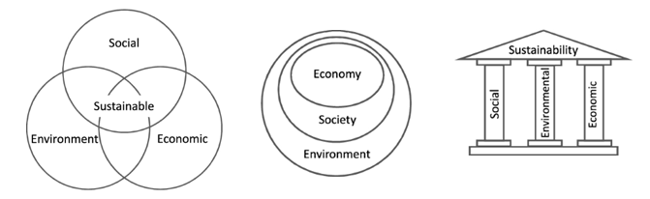
Figure 1 the three main elements of sustainability

There are over 100 definitions to answer what green cities are and how they perceive in the 21st century.

Nevertheless, in recent years, with the emergence of the green movement of cities and the formation of voluntary competitions such as the European Green Capital Award and the set of indicators to measure their greenness, clearer definitions of green cities are provided.

In order to achieve a comprehensive definition, by using different literature sources, many definitions of "green city" have been reviewed and analyzed to determine the commonalities among them. In the following, several important definitions of Green City have cited.

Roseland in his article, addresses the issue of Eco-cities, or sustainable communities, as a goal for community development. However, he believes it is situated in a complex array of relevant variations (sustainable urban development, sustainable development, sustainable communities, community economic development, sustainable cities, appropriate technology, bioregionalism, social ecology, green movement, green cities/ communities).

In his article, Kahn describes green cities with clean climate, water, and pleasant parks and streets. He believes that green cities are resistant to natural disasters and that the risk of major infectious diseases is low in such cities. He also points out that green cities encourage green behavior such as public transportation and their environmental impact is relatively low.

'Green Cities into Practice' book describes the green cities as those that are environmentally friendly. it mentioned that greening of cities requires some factors such as:
controlling diseases and their health burden, chemical and physical hazards reduction, high-quality urban environments development for all, minimizing transfers of environmental costs to areas outside the city, progress towards sustainable consumption

European Landscape Contractors Association (ELCA, 2011) mentioned that the Green City is a model for the future, green city should create urban structures with environments with considering life-quality. Sustainable green development of cities is a task which develop continuously and requires integrated and coordinated regional activities for all disciplines.

Lewis believes that green cities should minimize environmental impact and maximize opportunities to improve and support the natural environment. Green Cities are energy efficient and reduce reliance on fossil energy sources. green cities reduce waste, and they include green and resilient infrastructure which have low-carbon transport, and water cycle management, in such cities life quality is higher than other cities.

Brilhante pointed to the other aspect of green city that the green city is one of the latest responses to the diverse efforts and research conducted to address the problems caused by the dispersed model of city development and to help cities to become more greener, less dispersed, and more liveable while the three elements of sustainability have important role.

in other definition of Sustainable city or Eco-city (also 'Green-city')a green city described as a city which designed with consideration of environmental impact and its required inputs such as energy, water and food, and waste output of heat, air pollution, CO₂, and water pollution are less.

Almost all of the reviewed definitions have brought the environment to the frontline, and environment-related issues are by far the most mentioned issues in green city definitions, concepts, and methods. In some cases, a definition did not propose, but a benchmark method developed in which a group of qualitative and quantitative indicators focused mostly on environmental performance and infrastructure issues.

The human responsibility in using and organizing natural resources to prevent environmental pollution is evident. Society has a vital role in green cities because only through green behaviour minimizing environmental impact and maximizing opportunities to improve and support the natural environment is possible.

Since March 2020, the world and its inhabitants have been plagued by the Covid-19 pandemic. By mid-July 2021, due to the Coronavirus pandemic, 186 million infected cases have been reported (WHO, July2021). Also, about four million deaths have been registered due to Covid-19.

For this reason, in some definitions, Wellbeing is considered as the third side or dimension of a green city. According to the world's current situation (coronavirus outbreak), the definition that achieves healthy and safe city results from covering the city's resilience to natural disasters to the risk of major infectious disease outbreaks (Mark Kahn, 2006) can be more comprehensive.

How the green city perceived in 21st century

The Green Movement, known as part of sustainable development, was formed in the 1980s, while climate change was one of its main concerns. The green movement caused the emergence of new terms such as green city, green food, green energy, green mobility, green behaviour. In all these terms, the adjective green is used as clean, organic, harmless, and environmentally friendly.

A green city, also known as a sustainable city or an environmental city, is a city where energy consumption, water and non-renewable resources are kept to a minimum. People living in such cities have the least possible energy consumption, water and waste of food and heat. As a result, air pollution and the production of harmful gases such as methane or CO2 are very low. The term sustainable city was first coined in 1987 by Register in his book, Building Cities for a Healthy Future, on sustainable cities.

Later, companies were founded to design such cities. In a green city (sustainable city), indexes such as co2, energy, transport, water, waste, sanitation, air quality, environmental governance, green areas, and land use will be monitored carefully. A set of indicators will examine the successes and shortcomings of sustainable environmental development in the target city.

The green city performance should be such that it has the least dependence on surroundings and its resources, in a way that supplies its needed energy from renewable energy sources (such as solar and wind energy). Leave the slightest environmental pressure and footprint around, so the environment will naturally be able to revive in a short time. The land is used properly, and soil pollution is minimized. Waste from activities is appropriately managed. Compost is generated from waste, and other non-recyclable waste is converted into energy in a defined process. As a general result, the impact of the city on climate change is minimized.

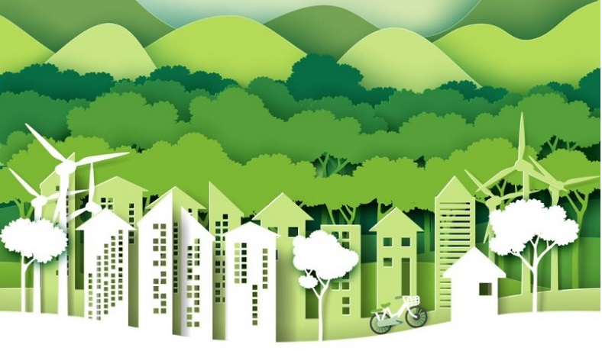

Figure 2 - an ideal future city (green city)

Shiraz city

why shiraz city chosen?

Since the author has been living in Shiraz for about 30 years and has witnessed many problems in this city in areas such as transportation, high dependence on fossil fuels, relative air pollution and environmental problems, therefore, in this study, the possibility of applying the principles of green cities in Shiraz has been examined.

Geographical location:

According to the latest divisions of the country, Iran has 31 provinces and 451 cities, of which Shiraz, the capital of Fars province, is the fifth-largest city and the sixth most populous city in the country.It is located in the southwest of the country, on the relative centrality of the South Zagros Mountains in a relatively fertile area.

The city has a rectangular shape with a length of about 40 km and a different width between 15 to 30 km with a total area of ​​240 square kilometres (the area of ​​Shiraz city is about 10343 square kilometres). Its altitude is from 1484 to 1541 above sea level, which varies in different parts of the city.

In terms of roughness, it can be said that almost all-around Shiraz are covered by high mountains. The mountains around the city define a complete natural border around it. In the past, this topographic situation played an important defence role. Recently, it has a significant effect on air circulation and pollution control. This topographic feature has been the main element that shapes the city, and for this reason, the city's growth has been asymmetric and more transverse.

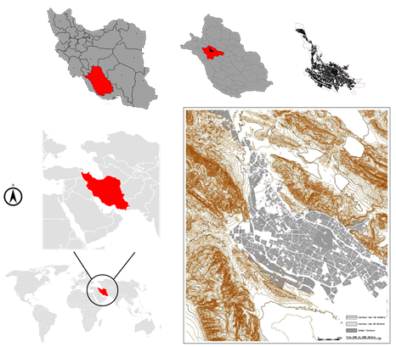 | 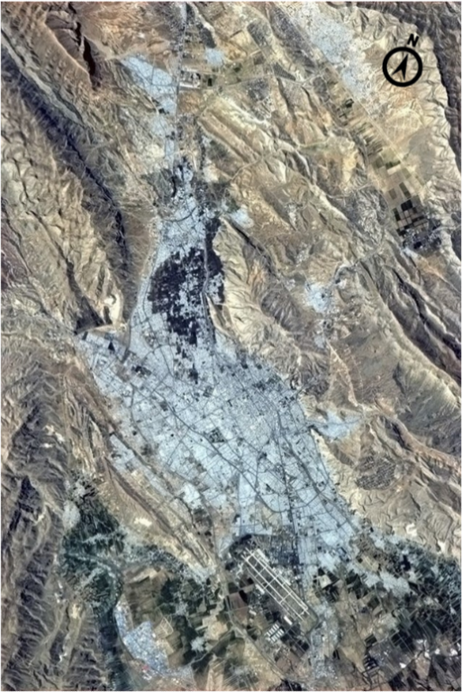
Figure 3 - The location of Shiraz City | Figure 3.1 - Shiraz and a natural border

History and background

In the past, the city was known as Shahraz, Tirazis and Shahr-e-Raz (Mystery City). The first mention of Shiraz's name on Elamite clay tablets dates back to 2000 BC when it was found in June 1970 while digging to build a brick kiln in the city's southwest corner.

This city has been the capital of Iran in three different periods, the last time being for 40 years (between 1750-1789); it is also referred to as the capital of the Persian Empire. Shiraz was the third city in Iran after Tehran and Tabriz, where a municipality was established in 1916.

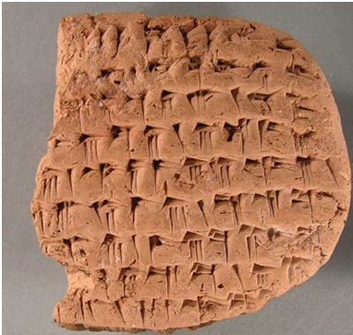
Figure 4 - an Elamite clay tablets contain Shiraz city's name

Climate

The city's climate is a pleasant four full seasons and different from the southern and southwestern parts of the country. The average rainfall in Shiraz is about 350 mm per year, and during a year, snowfall may be seen two or three times. Summers in Shiraz are almost hot and dry with a maximum temperature of 42 degrees Celsius, but there are cold winters with a minimum temperature of -7 degrees Celsius. In general, Shiraz is located in an area with an almost semi-arid climate.

With having more than 3285 hours of solar radiation per year, which is equivalent to 140 full sunny days (138 * 24) or an average of 9 hours of sunshine per day during a year (365 * 9), Shiraz has outstanding potential for solar energy production.
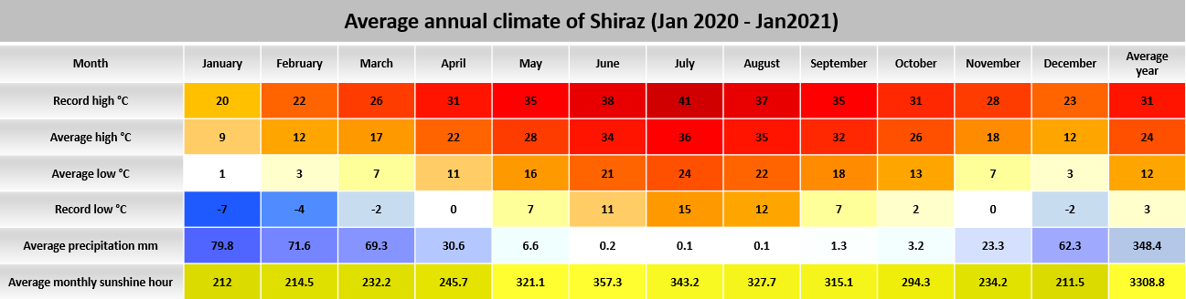
Figure 5 - Shiraz annual weather, 2020-2021 by author

Culture and language

Shiraz has been named the Cultural Capital of Iran (in 2001) due to its numerous and valuable archaeological and historical monuments and its important role in the cultural fields (poetry, art and customs) (Khoobnazar, 2001(. Also, in Iran, May 5 has been named Shiraz Day. Poetry, wine, garden, flowers and oranges are other titles of this city. As many famous poets lived in this city, it has made Shiraz famous as a city of poetry.

Another symbol of this city is the garden. Garden has a special place in Iranian culture, and Shiraz has long been famous for having many beautiful gardens. The vineyards in Shiraz have made Shiraz world-famous for its wine. A number of gardens in Shiraz are historically significant and are also considered as important tourist centres.

The people of Shiraz speak the official language of Iran (Persian or Farsi) with the Shirazi dialect. Two great modern Persian poets from Shiraz, Hafez and Saadi, have greatly influenced the language and other aspects of the culture and life of the people of this city.

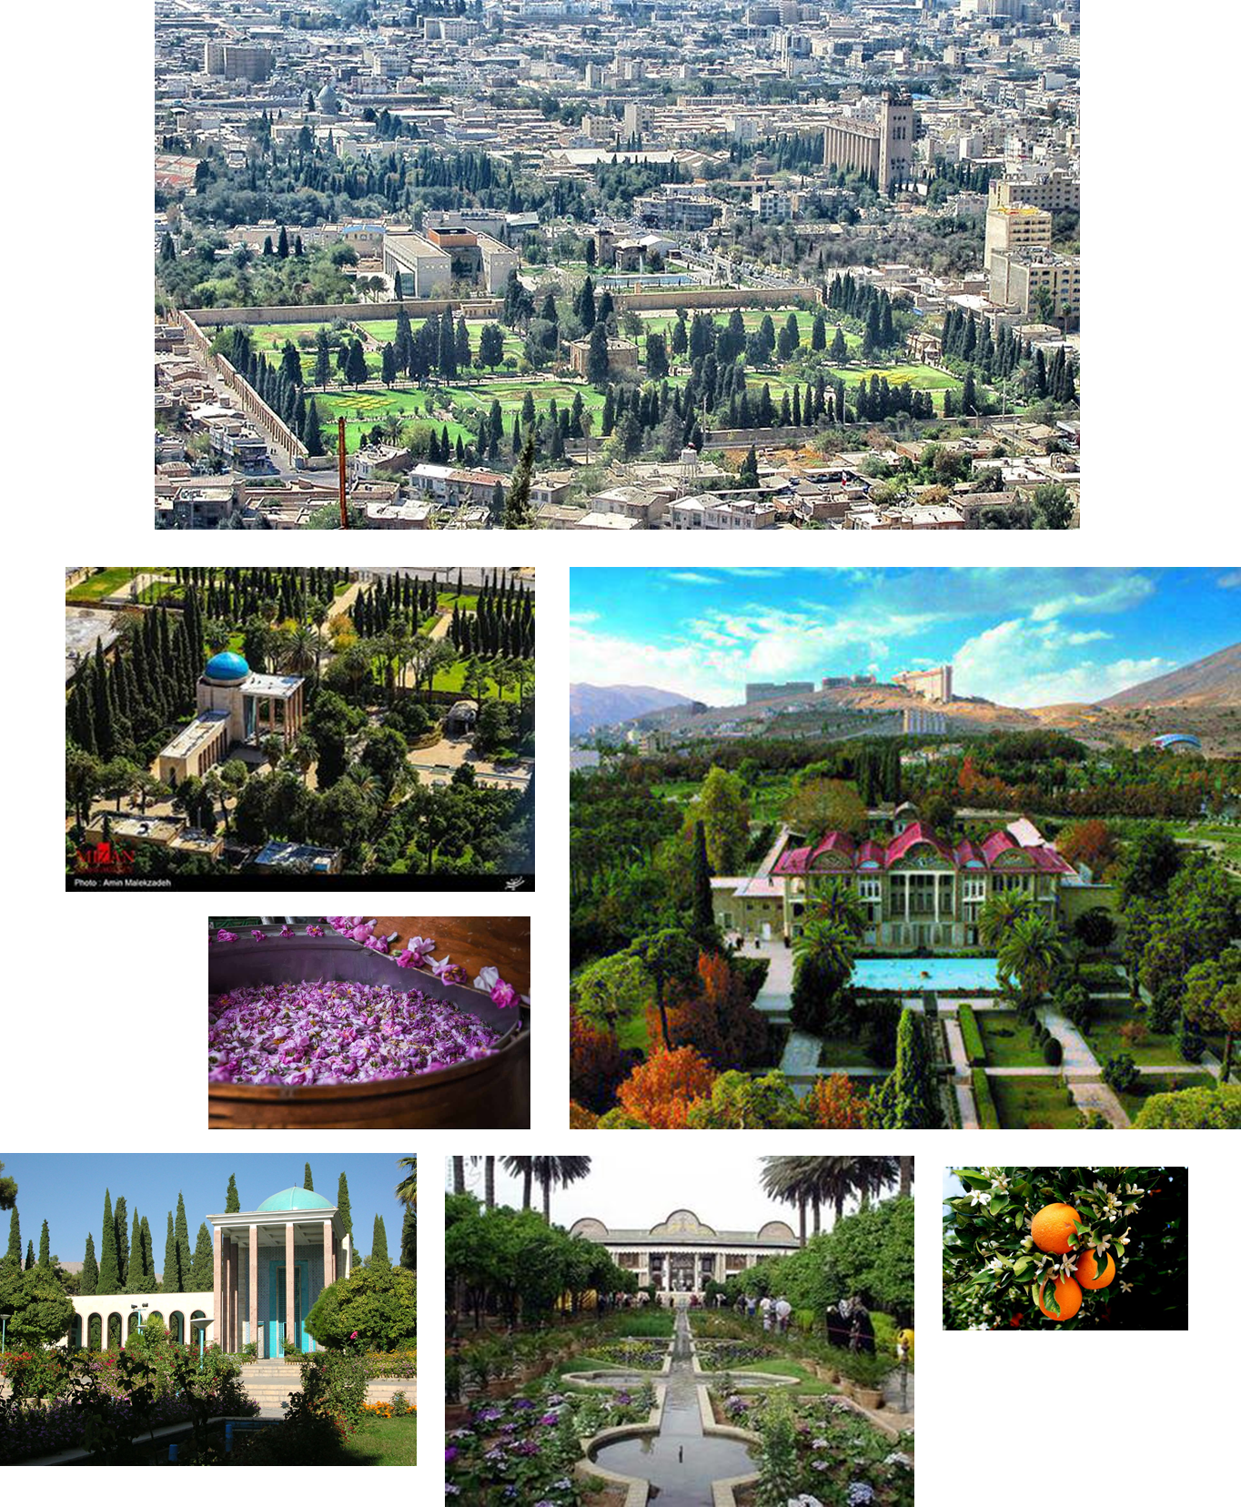
Figure 6 - Shiraz's gardens and their characteristics
Population

In the general census of population and housing, which is conducted every five years with the aim of determining the country's population by the Office for National Statistics, in the last official census (2016), the population of Shiraz was about 1,565,000. Nevertheless, unofficial figures before the 2021 census (likely to be delayed due to the Coronavirus pandemic) put the population of Shiraz at 1,720,000, indicating a 9.1 per cent increase in the city's population. Shiraz is divided into 11 independent urban areas and has an average density of 7165 people per square kilometres.

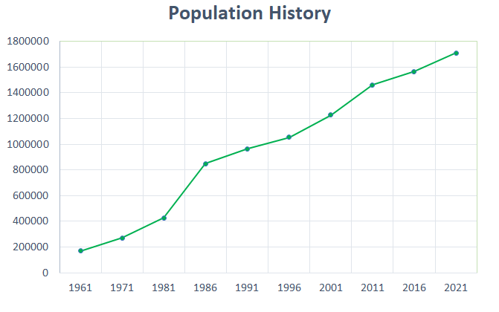 | 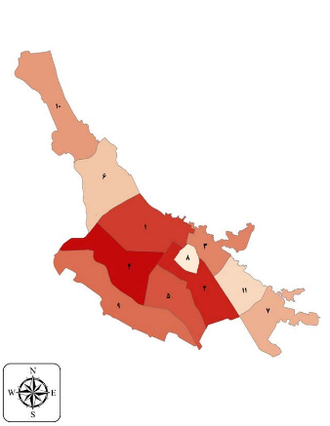
Figure 7- population history since1961 until 2021 | Figure 8 – Shiraz population density in its 11 districts
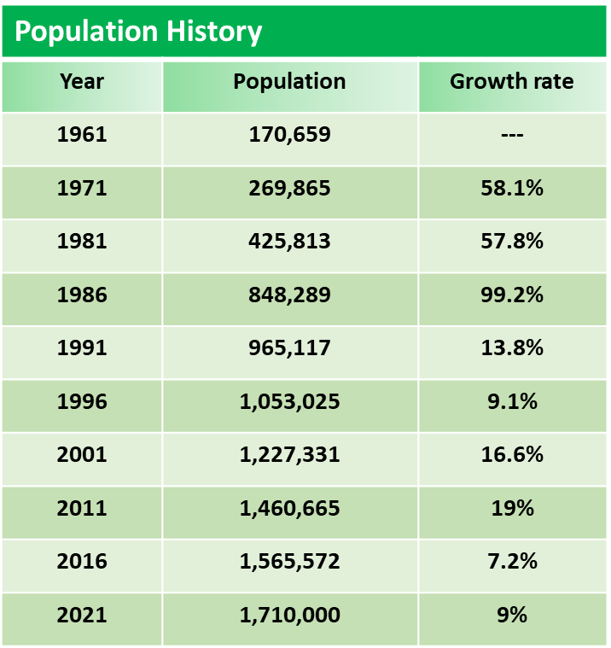 | 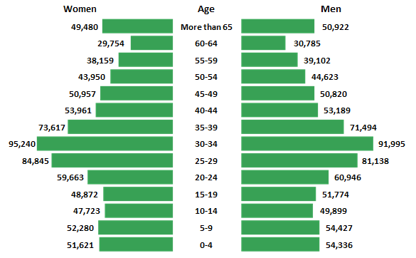
Figure 9 - population history since1961 until 2021 | Figure 10- Shiraz population in different groups of age

Copenhagen as a comparative model of green city for Shiraz City

Transforming a conventional nineteenth-century city with many issues and problems, such as high level of CO2 emissions and dispersed growth shape, into a green city with the least environmental impact, which can be able to meet the needs of current and future generations, requires up-to-date science, knowledge, and methods as well as a comprehensive model.

Therefore, in order to understand the different aspects of this transition, a similar successful green city scheme with full details, such as framework, indicators, targets, legislations, challenges, budget, investments, time and efforts as the taken path should be analyzed and learn from its initiatives, perfections and mistakes. As Albert Einstein put it, "Learn from yesterday, live for today and hope for tomorrow."

A case study can be a starting point of any scheme, or it can also serve as a link or reference, which can help in explaining the project with ease. The design chosen for the case study does not necessarily have to be a true representation of the new project.

Numerous reasons and factors have been influential in choosing Copenhagen as the comparative model for Shiraz city, some of the most important of which will be mentioned.

- Copenhagen will be the first carbon-neutral city in the world in 2025. Achieving this goal was set in 2009 as a 16-year plan while CO2 production was 8.83 tons per capita, a situation similar to the current condition of Shiraz city with 9.4 tons CO2 per capita.

- By analyzing and comparing existing and previous Copenhagen statistics and data in areas such as transportation, energy production, energy consumption and energy efficiency through improving infrastructure and buildings, valuable results are obtained that show the significant progress of this city in those areas. Exactly the same areas that Shiraz city has many problems and needs improvement.

- Seven years after Copenhagen was chosen as the Green Capital of Europe, much information and data are available on the initiatives, methods and experiences used along the sustainability process. From how to use and exploit natural benefits properly and adapt to the environment to face various challenges and prioritize and respond to them.

Shiraz City’s future aspiration

Under the Paris Agreement, 196 countries, including Iran, pledged to reduce their greenhouse gas emissions by 4 percent annually, which resulted from industrial activities and the use of fossil fuels.

It should be noted that economic growth and GDP is directly dependent on fuel and energy consumption. It means that a country will have to consume more fuel to improve its GDP, and this is for developing countries such as Iran, where fossil fuels are their primary energy sources, is very challenging.

In addition to Iran's commitment to reducing greenhouse gas emissions and regardless of having the world's second-largest gas reserves and fourth-largest oil reserves, like many governments, the Iranian government believes that only through sustainable development can the needs of current and future generations be met. Therefore, Iranians have a great desire and will to align with the leading countries in the field of sustainable development and the use of renewable energy as the primary fuel.

In order to achieve this goal in 2015, the Cabinet of Ministers approved a plan that announced a 4% reduction in CO2. Also, in another part of the enactment, the government revealed the details of its voluntary intentions to reduce CO2 by another 8% if the problems are resolved.

So, Shiraz(as one of the cities in Iran that is dependent on fossil fuel), inspired by Copenhagen, can achieve the goal of being a carbon-neutral city, in such a way that this goal can be divided into short-term, mid-term and long-term goals.

According to Figure 6, almost 45% of Iran's fossil fuel consumption is spent on buildings and transportation, so short-term goals can include reducing the city's dependence on fossil fuel in these two sectors by about 40-50% reduction. This reduction can be achieved through less fossil fuel consumption, energy efficiency and clean energy production.

Medium-term goals can include creating and improving infrastructure and minimizing fossil fuel consumption in the industrial and agricultural sectors, accounting for about 50-55% of the country's fuel consumption.

Finally, long-term goals can include continuing to improve conditions and adapting to the principles of green cities, which can lead Shiraz to be a carbon-free city.

Figure 11-Iran's fossil Co2 emissions by sector

Relevant legislation of Iran to reduce co2 and protect the environment

- According to the country's constitution, determining and announcing the general policies of the country is the responsibility of the Supreme Leader (Iran Constitution, Chapter 8, Article 110). Therefore, in addition to development plans, which are usually 5-year plans, in order to orient and achieve the annual goals, the leader names each year with a name and a slogan. For example, 2008 referred to the year of innovation and prosperity, or 2009 to the year of consumption pattern reform, respectively, innovation, saving and optimal consumption in the energy sector and national capital.

- In 1991, the building sector accounted for about 40% of the country's total energy consumption (Annual Energy Statistics 1991). In this regard, to reduce the amount of energy consumed (fossil fuels) and reduce CO2 emission, sections 18 and 19 of the National Building Regulations of Iran under the headings of insulation, acoustics and sound control (Section 18) between 1991 and 1995 and energy conservation (Section 19) between 1995 and 1999 were developed in a complementary process, and its implementation became mandatory(National Regulations Sections 18 and 19 and Description).

- After the building sector, the second rank of energy consumption belongs to transportation, which accounts for about 24% of the country's total energy consumption. Therefore, to control fuel consumption in the transportation sector, the government proceeded to fuel quotas (targeted fuel consumption plan). According to reports and the announcement of Vakilzadeh (the CEO of NIOPDC), this has led to a reduction in fuel consumption of 8 to 10 percent in the short term, which is projected to decrease 20 to 25 percent in the long term. Traffic congestion plan, which is known as even and odd plan, was also other measures to reduce traffic, fuel consumption and air pollution.

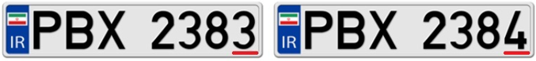
Figure 12 odd and even plates by the author

- Given the intensity of energy consumption in Iran, which is between 2 and 5 times the EU average consumption, in the Fifth and Sixth Development Plans (which are five-year plans), the government specifically seeks to reduce fossil fuel consumption and replace the required energy with Renewable energy. Also, investment (by the private and public sectors) in the field of sustainable development and renewable energy is one of the urgencies of these programs.

Chapter 1: Measuring greenness

Set of indicators for measuring greenness

In the previous sections, it was explained that the green city is part of sustainable development. So, achieving the goals of a green city, or in other words, turning a city into a green city is possible only by pursuing the three main components of sustainable development (economic, social, and environmental).

Due to the capacity and scope of this research (10,000 words ±10%), It is not possible to address all aspects of the green city. (while the author does not have sufficient competence and knowledge to analyze the economic and social sectors). Also, since environment-related issues are by far the most often presented issues (more than any other issue and problem) in green city definitions, concepts and methods, this research examines only the environmental aspects of the green city.

Green city indicators are used as a method for driving greening development and sustainable development. As cities are different in terms of population size, geographical location, available resources and climate, several different sets and frameworks exist. However, they mainly have eight to ten categories (eight to ten categories in the environment section) and many subcategories (based on the organization's objectives, subcategories can be varied). These tools can be very useful in measuring and checking the performance of green cities.
Figure X shows the European Green City Index (indicators) that were used through this research (For measuring Copenhagen and Shiraz City).

The indicators of European green city index:

- CO2
- Energy
- Buildings
- Transport
- Water
- Waste and Land use
- Air Quality
- Environmental governance

Table 1 shows the indicators, sub indicators, their type(quantitative or qualitative) and their weighting for assessing and measuring the greenness of a city.

Indicators | Sub Indicators | Type | Weighting | Description | Normalization technique
CO2 | CO2 emissions | Quantitative | 33% | Total CO2 emissions, in tonnes/head. | Min-max.
CO2 | CO2 intensity | Quantitative | 33% | Total CO2 emissions, in grams per | Min-max; lower benchmark of 1,000 grams
CO2 |  |  |  | unit of real GDP (2000 base year). | inserted to prevent outliers.
CO2 | CO2 reduction | Qualitative | 33% | An assessment of the ambitiousness | Scored by Economist Intelligence Unit analysts
CO2 | strategy |  |  | of CO2 emissions reduction strategy. | on a scale of 0 to 10.
Energy | Energy consumption | Quantitative | 25% | Total final energy consumption,(gigajoules/head) | Min-max.
Energy | Energy intensity | Quantitative | 25% | Total final energy consumption,(megajoules- | Min-max; lower benchmark of 8MJ/€GDP
Energy |  |  |  | /unit) of real GDP (in euros, base year 2000). | inserted to prevent outliers.
Energy | Renewable energy | Quantitative | 25% | The percentage of total energy derived from | Scored against an upper benchmark of
Energy | consumption |  |  | renewable sources, as a share of the city's total | 20% (EU target).
Energy |  |  |  | energy consumption, in terajoules.
Energy | Clean and efficient | Qualitative | 25% | An assessment of the extensiveness of policies | Scored by Economist Intelligence Unit analysts
Energy | energy policies |  |  | promoting the use of clean and efficient energy. | on a scale of 0 to 10.
Building | Energy consumption | Quantitative | 33% | Total final energy consumption in the residential | Min-max.
Building | of residential buildings |  |  | sector, per square metre of residential floor space.
Building | Energy-efficient | Qualitative | 33% | An assessment the extensiveness of cities’ energy | Scored by Economist Intelligence Unit analysts
Building | buildings standards |  |  | efficiency standards for buildings. | on a scale of 0 to 10.
Building | Energy-efficient | Qualitative | 33% | An assessment of the extensiveness of efforts to | Scored by Economist Intelligence Unit analysts
Building | buildings initiatives |  |  | promote energy efficiency of buildings. | on a scale of 0 to 10.
Transport | Use of non-car | Quantitative | 29% | The total percentage of the working population | Converted to a scale of 0 to 10.
Transport | transport |  |  | travelling to work on public transport, bike or foot.
Transport | Size of non-car | Quantitative | 14% | Length of cycling lanes and the public transport | Min-max. Upper benchmarks of 4 km/km2 and
Transport | transport network |  |  | network, in km per square metre of city area. | 5 km/km2 inserted to prevent outliers.
Transport | Green transport | Qualitative | 29% | An assessment of the extensiveness of efforts to | Scored by Economist Intelligence Unit analysts
Transport | promotion |  |  | increase the use of cleaner transport. | on a scale of 0 to 10.
Transport | Congestion reduction | Qualitative | 29% | An assessment of efforts to reduce vehicle traffic | Scored by Economist Intelligence Unit analysts
Transport | policies |  |  | within the city. | on a scale of 0 to 10.
Water | Water consumption | Quantitative | 25% | Total annual water consumption, in cubic metres/head | Min-max.
Water | Water system leakages | Quantitative | 25% | Percentage of water lost in the water distribution system. | Scored against an upper target of 5%.
Water | Wastewater treatment | Quantitative | 25% | Percentage of dwellings connected to the sewage | Scored against an upper benchmark of 100%
Water |  |  |  | system. | and a lower benchmark of 80%.
Water | Water efficiency | Qualitative | 25% | An assessment of the comprehensiveness of | Scored by Economist Intelligence Unit analysts
Water | and treatment policies |  |  | measures to improve the efficiency of water | on a scale of 0 to 10.
Water |  |  |  | usage and the treatment of wastewater.
Waste & | Municipal waste | Quantitative | 25% | Total annual municipal waste collected, in | Scored against an upper benchmark of 300 kg (EU target).
Waste & | production |  |  | kg per head. | A lower benchmark of 1,000 kg inserted to prevent outliers.
land use | Waste recycling | Quantitative | 25% | Percentage of municipal waste recycled. | Scored against an upper benchmark of 50% (EU target).
land use | Waste reduction | Qualitative | 25% | An assessment of the extensiveness of measures | Scored by Economist Intelligence Unit analysts
land use | and policies |  |  | to reduce the overall production of waste, | on a scale of 0 to 10.
land use |  |  |  | and to recycle and reuse waste.
land use | Green land use | Qualitative | 25% | An assessment of the comprehensiveness of policies to contain | Scored by Economist Intelligence Unit analysts
land use | policies |  |  | the urban sprawl and promote the availability of green spaces. | on a scale of 0 to 10.
Air quality | Nitrogen dioxide | Quantitative | 20% | Annual daily mean of NO2 emissions. | Scored against a lower benchmark of 40 ug/m3 (EU target).
Air quality | Ozone | Quantitative | 20% | Annual daily mean of O3 emissions. | Scored against a lower benchmark of 120 ug/m3 (EU target).
Air quality | Particulate matter | Quantitative | 20% | Annual daily mean of PM10 emissions. | Scored against a lower benchmark of 50 ug/m3 (EU target).
Air quality | Sulphur dioxide | Quantitative | 20% | Annual daily mean of SO2 emissions. | Scored against a lower benchmark of 40 ug/m3 (EU target).
Air quality | Clean air policies | Qualitative | 20% | An assessment of the extensiveness of policies to | Scored by Economist Intelligence Unit analysts
Air quality |  |  |  | improve air quality. | on a scale of 0 to 10.
Environmental  governance | Green action plan | Qualitative | 33% | An assessment of the ambitiousness and | Scored by Economist Intelligence Unit analysts
Environmental  governance |  |  |  | comprehensiveness of strategies to improve and | on a scale of 0 to 10.
Environmental  governance |  |  |  | monitor environmental performance.
Environmental  governance | Green management | Qualitative | 33% | An assessment of the management of | Scored by Economist Intelligence Unit analysts
Environmental  governance |  |  |  | environmental issues and commitment to | on a scale of 0 to 10.
Environmental  governance |  |  |  | achieving international environmental standards.
Environmental  governance | Public participation | Qualitative | 33% | An assessment of the extent to which citizens may | Scored by Economist Intelligence Unit analysts
Environmental  governance | in green policy |  |  | participate in environmental decision-making. | on a scale of 0 to 10.
Table 1 - European green city index table by Author

Copenhagen the model of green city

The Paris Agreement in December 2015 committed 171 countries, including Denmark, to reduce CO2 emissions. Earlier, Copenhagen started the journey of becoming a green city in 2009 by setting the ambitious goal of Carbon neutrality by 2025, which make Copenhagen the world's first carbon-neutral city.

Copenhagen Climate Plan (2009) aimed to reduce 20% of 2005's CO2 emission by 2015 in a 10-year plan. The goal was achieved six years later, in 2011, when CO2 emissions were reduced by 21 % compared to 2005.

It is worth noting that in parallel with Copenhagen Climate Plan, the Danish government had been set a target of reducing 70% of its 1990 carbon levels by 2030, but efforts towards meeting the country's target were judged insufficient (The Guardian, March 2021). However, carbon emissions have reduced by more than 40% from 1990 until 2019, while there has been a 45% increase over the same period between 1960-1990.

The Danish Council on Climate Change predicted another 7.2 million tons of CO2 reduction by 2030. However, the sum of these reductions would only be enough for a 54% reduction in emissions of 1990, but as there is still a long way to go towards the goal, this emphasizes the great challenge that Danish society has set for itself.

CPH 2025 Climate Plan:

As mentioned, to achieve the goal of carbon neutrality, Copenhagen set a holistic plan (2009) which is a collection of initiatives and specific goals within four areas, which are known as the CPH 2025 Pillars.
the pillars are:

- Energy consumption
- Energy production
- Green mobility
- City administration
Figure 13 - Copenhagen’s CO2 reduction sectors by author

Energy consumption:

Under the Energy Consumption pillar, actions were taken to reduce energy consumption in Copenhagen and achieve energy efficiency by improving district heating and other facilities operations and by the improvement of energy efficiency by refurbishment process and new construction projects.

Monitoring energy consumption and optimizing building performance (in the energy consumption section) is ongoing by installing Photovoltaics panels on buildings and retrofitting buildings which currently heated by oil.

major goals for 2025:

- 20 % reduction in heat consumption, compared to 2010.
- 20 % reduction of electricity consumption in commercial and service companies, compared to 2010.
- 10 % reduction of electricity consumption in households, compared to 2010.
- Installation of solar cells corresponding to 1 % of electricity consumption in 2025.

Figure 14 - Copenhagen’s CO2 reduction sectors by author

Energy production:

Under the Energy Production pillar, the main aims are converting the city’s supplies of town gas, district heating and cooling; water and wastewater, including wastewater treatment, are the keys to carbon neutrality and energy efficiency.

Moreover, focusing on the conversion of the electricity system to a renewable system is the other action taken. Increasing the energy production in wind power and solar energy, waste management, and biogas production are the pursued actions to reduce greenhouse gases.

Major goals for 2025:

- District heating in Copenhagen is carbon neutral.
- Electricity production is based on wind and biomass and exceeds total electricity consumption in Copenhagen.
- Plastic waste from households and businesses is separated.
- Bio gasification of organic waste

Figure 15 - Copenhagen’s CO2 reduction sectors by author
Mobility:

Under the Mobility pillar, the actions taken focused on reducing greenhouse gas emissions from the transport sector, the actions divided into two groups: one contains road traffic and the other contain other modes of transport. The conversion of buses and harbour buses are an example of mobility improvement.

The City of Copenhagen financed (in some parts wholly and some parts partly) the conversion of bus lanes to electric buses or to other types of buses with the same positive effects (in terms of having zero carbon emissions), which resulted a significant less street noise and local air pollution reduction.

major goals for 2025:

- 75 % of all trips in Copenhagen are on foot, by bike or public transport.
- 50 % of trips to work or school in Copenhagen are by bike.
- 20 % more passengers use public transport, compared to 2009.
- Public transport is carbon neutral.
- 20-30 % of all light vehicles runs on new fuels such as electricity, hydrogen, biogas, or bioethanol.
- 30-40 % of all heavy vehicles runs on new fuels.

Figure 16 - Copenhagen’s CO2 reduction sectors by author

City Administration Initiatives:

The actions involve the city’s vehicles, buildings, and procurement, as well as actions focused on improving of greenery areas and afforestation outside Copenhagen and building up climate-related knowledge and resourcefulness, particularly among young people.

The city’s effort related to energy-efficiency actions of energy systems in its own buildings is an example of these ongoing efforts.

major goals for 2025:

- reduce energy consumption in municipal buildings by 40 %, compared to 2010.
- municipal new build up to 2015 meets the requirements of the 2015 classification and up to 2020 new build meets the requirements of the 2020 classification.
- the City of Copenhagen’s vehicles run on electricity, hydrogen, or biofuels.
- the energy consumption for street lighting in Copenhagen is halved, compared to 2010.
- a total of 60,000 sq m solar panels on existing municipal buildings and municipal new build is installed.

Figure 17 - Copenhagen’s CO2 reduction sectors by author

Check the performance of Shiraz City:

Transport:

Due to the growth of urbanization and population as well as the increase of migration from the surrounding cities, the availability of cheap fuel and land and the inadequacy of a comprehensive plan in the last few decades, Shiraz City has had dispersed and uncontrolled growth. The dispersed population growth caused long distances so that the distance from the west to the east of Shiraz reaches 40-45 km.

The dispersed population growth and the formation of long distances formed the city's transportation system based on car use. In recent years, several highways have been built to shorten and improve access routes as a short-term solution.

Shiraz transportation system includes metro, buses, and taxis. However, due to the high level of CO2 and to reduce air pollution and traffic, the mayor of Shiraz (Pak Fetrat, 2015) announced, since 2016, the reform of the transportation system would be on the municipality's agenda.

Also, Shiraz Municipality informed (in 2016) that sustainable development in the transportation sector (developing the subway, design and construction of trams and construction of new routes for electric buses) is one of the goals and priorities of the municipality.

However, due to the high costs of metro development, which is estimated at around 40 million Euros per kilometre, the priority is to replace buses with electric buses, to design and build several tram routes (the implementation of each kilometre is estimated at around 10 million Euros) and then Metro development. Since 2009, converting the fuel of buses and taxis to gas (CNG) as a short-term solution has been one of the actions of the municipality in the past few years, although the transportation system still has many problems.

As shown in Figure 18, in Iran, transportation and buildings are the second-largest sources of CO2 emissions. In recent years, almost all metropolises in Iran have faced problems related to transportation and air pollution caused by it.
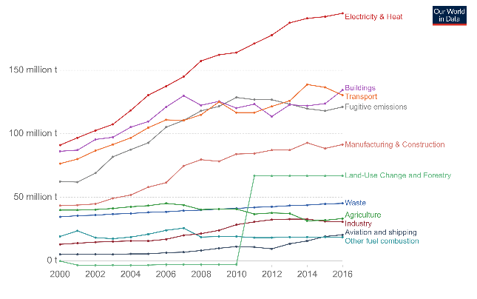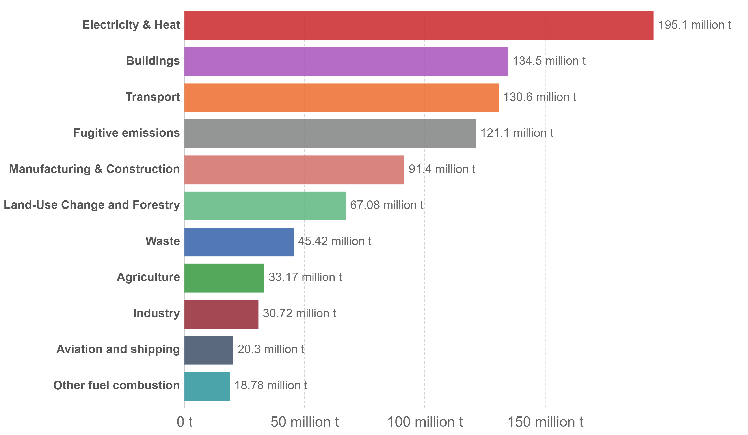
Figure 18 – Iran CO2 production in detail

External factors that may influence Shiraz City:

Regarding the most important internal factor that not only affects the plans and programs of Shiraz but also the country's plans, the US sanctions against Iran can be mentioned.

Since 1979 and the darkening of Iran-US relations, the United States has imposed economic, trade, scientific and military sanctions against Iran. In 2015, due to the signing of the JCPOA agreement by two countries, some of these sanctions were lifted, but again in 2018, the United States unilaterally cancelled the JCPOA agreement. The US intensified the sanctions to the point that Iran's main source of revenue, which was from oil sales, fell sharply (from 2.5 million barrels of oil to only 180,000 barrels). Many development projects and infrastructure projects ran into serious problems; Some contracts were cancelled due to late payments, or Iran was forced to cancel them due to lack of budget.

Due to non-fulfilment of obligations, heavy compensations were paid, and large sums of Iranian assets were suspended (Nearly 100 billion US Dollars) in other countries, all of which caused serious and, in some cases, irreparable damage to the Iranian economy and the country's infrastructure.

All development projects and projects related to sustainable development and CO2 reduction that required a lot of investment were abandoned or stopped due to the lack of funds.

Other challenges that Shiraz City may have:

Limited proportional city growth:
Since the city of Shiraz is located between several mountain ranges and there is no possibility of further transverse growth for the city, the city may grow longitudinally., therefore, this will cause the distance between north to south with the distance from east to west of the city is out of proportion; also, traffic routes will increase more, and some urban services will face problems.

Country and city dependence on oil revenues:
Although Iran's economy has been far less dependent on oil sales and revenues over the past few years, much of the country's budget is still financed through oil sales. However, possible fluctuations in the oil market (oil prices) or problems such as sanctions can pose serious problems for urban budgeting or the implementation of local or urban projects.

Extensive annual migrations:
With the increase of urbanization as well as global warming and the annual increase of temperature, Shiraz becomes an ideal destination for the surrounding cities and southern cities of the country, which usually experiences temperatures above 45 and 50 degrees in hot seasons, and in the future Shiraz may be the witness of a large number of migrates.

Droughts and extreme heat:
Lack of rain and recent droughts and extreme heat in summer reduce the possibility of implementing similar schemes with green mobility (bike schemes) as a transportation option during the hot hours of the day.

Dust problems:
Dam construction activities and subsequent drying of wetlands in Iran's western neighbours, industrial activities, over-exploitation of natural resources and reduced rainfall in Iran and Shiraz have caused dust in the sky that negatively affects human health and even plants. Although in the last few years, with the implementation of projects such as afforestation and the construction of natural dams, the dust has been controlled to some extent, but the problem of dust still persists.

Can shiraz city be as successful as Copenhagen in terms of the Green city?

Given global warming and environmental issues, being a green city is a necessity, not a choice. All cities on the planet must take responsibility for the planet and cooperate to solve environmental problems. So Shiraz city, like Copenhagen, whether it wants to or not, must follow this path. Moreover, it would be better if the city has a daily increase in population and needs to improve and develop its infrastructure to choose sustainable and carbon-free development to avoid paying extras costs in the future.

Given that Copenhagen is proving that it is possible to simultaneously develop the city and its infrastructure, improve the quality of life and protect the environment by relying on sustainable development principles. It is conceivable that another city with different locations and climatic conditions can achieve the goal of carbon neutrality by following the principles of sustainable development and comprehensive planning and public participation.

The key to achieving the goal is to establish a balance and proportion between the goals. For example, in Copenhagen, the city administration has a key role in achieving the goals. In addition, despite having a comprehensive plan, every few years, the city administration and the Danish government review the plan (CPH Climate plan) and goals and correct them if necessary to ensure the correct implementation of the process. So proper resource management, having a comprehensive plan with realistic goals and principles, and public cooperation along with the suitable investment at the right time can significantly guarantee success.

Analysis of the responses from the questionnaire that sent to Copenhagen and shiraz City

A series of questionnaire were sent to by email to the residents of Copenhagen and Shiraz City, in the following section the responses will analyze based on the green city indicators.
The full questionnaire can be found in appendix A and B for reference.

The 1st question of appendix A and B ask the participant about their gender, and figure 15 shows the result.
Figure 19 - Copenhagen and Shiraz's participant by gender
The 2nd question of appendix A and B ask the participant about the type of accommodation, the graph shows that the type of accommodation that the two city’s resident have almost the same and they mostly live in flats and houses.
Figure 20 - Type of accommodation

The 3rd question of appendix A and B ask the participant about their age range, and as the graph shows that the residents of both city mostly between 19-60 years of age.
Figure 21 – age range of Copenhagen and shiraz city residents

The 4th question of appendix A and B ask the participant about the resident's education level, and undergraduate has the highest number. There are only a few residents of Shiraz city who did not have a university education.
Figure 22 – education level of Copenhagen and Shiraz city residents

The 5th question of appendix A and B ask the participant about Global warming impact on their life; the amount of impact that they felt means that how important global warming is, and it shows that the implementation of the green city is necessary.
Figure 23 – global warming impact on the residents of the two cities

The 6th question of appendix A and B ask the participant about Global warming impact on the next generation, and their responses confirm that actions must be taken quickly as global warming and its effect on the environment (in some cases) are irrecoverable.
Figure 24 – global warming impact on the next generations

The 7th question of appendix A and B ask the participant about the level of concern they have about the environment issues. Their responses show that the residents of both cities are concerned about the environment issues, global warming, and the future.
Figure 25 – concern about environmental issues

The 8th question of appendix A and B ask the participant about their willingness to participate in sustainability activities. As the graph shows, more than one-third of Copenhagen would like to participate in sustainable activities, which is why Copenhagen would achieve carbon neutrality by 2025.
Figure 26– willingness of residents to participate in sustainability activities

The 9th and 10th question of appendix A and B ask the participant about owning a car and how often they use their car. As the two graphs show, the number of people who do not have a car in Copenhagen is more than the same group in Shiraz, but a simple comparison shows why shiraz city have more traffic, air pollution, and fossil fuel consumption. While nearly one-third of Copenhagen never use a car, more than 40% of Shiraz residents use their car daily.
Figure 27 – willingness of residents to participate in sustainability activities

The 11th and 12th questions of appendix A and B ask the participant about owning a bicycle and how often they use their bike. As the two graphs show, the number of people who have and use their bike in Copenhagen is more than the same group in Shiraz. However, a simple comparison shows how green mobility and the bike scheme work properly. Copenhagen residents can take advantage of the green mobility in their city. However, about shiraz city, nearly two-thirds of people do not have a bike, and 55% of people never use it; one reason for not having and using a bike can be the weather condition which in Figure 5 shows Shiraz weather through warm seasons.
Figure 28 – having a bicycle and how frequently they use it

The 13th question of appendix A and B ask the participant about the use of bike and how many miles they cycle every day; the graph below shows that all of Copenhagener cycle every day, but more than half of Shiraz residents do not cycle at all.
Figure 29 – Cycling mileage

The 14th and 15th questions of appendix A and B ask the participant about their house distance from city centre and work/school/university, as the graphs show the of Copenhagen’s residents journey is shorter and the distance that Shiraz city’s residents take and this data can confirm the dispersed growth shape of Shiraz city and also show that Copenhagen has better urban planning as the distances are shorter.
Figure 30 – Distance from work/school/university and distance from city center

The 16th question of appendix A and B ask the participant about working online; as this question has been asked in the Coronavirus pandemic period, the answer cannot be so accurate because the nature of some jobs is not online. However, as the pandemic forces people to work online, they answer that they work online. Working online has many pros and cons, but as this research has a limitation, it is impossible to answer that comprehensively.
Figure 31 – working from home

The 17th question of appendix A and B ask the participant about commuting people to work/school/university. The responses from the residents of both cities show the options they have and how they choose their transportation type. As the graph below shows the residents of Copenhagen mostly choose green mobility options, but Shiraz City’s residents prefer personal vehicle over the other options, and it is one of the reasons that Shiraz City need to improve its transportation system profoundly.
Figure 32 – commuting to work/school/university

The 18th question of appendix A and B ask the participant about the importance of energy conservation in their home; the majority of residents showed that energy conservation is important to them.
Figure 33 – energy conservation

The 19th and 20th questions of appendix A and B ask the participant about the heating system and how often they turn it off. As the graphs show, Copenhagen residents mostly use the electric heating system for their homes, but Shiraz City, as discussed before, mainly uses fossil fuel for heating systems. Once again, these data confirm that shiraz city needs to start its sustainable development as soon as possible.
Figure 34 – willingness of residents to participate in sustainability activities

The 21st question of appendix A and B ask the participant about the use of energy-saving initiatives. The graph below shows that Copenhagen residents use saving tips to reduce their impact on the environment. However, cheap energy price (fossils fuels prices in Iran is much cheaper than the other countries ) in Shiraz City confirm that some residents are not concern about energy saving.
Figure 35 – energy saving initiatives

The 22nd and 23rd questions of appendix A and B ask the participant about using green spaces and how often they use them. The graphs show that the usage of Copenhagen residents is much higher than Shiraz City usage; one of the main reasons is that the quality of green space in Copenhagen is much higher than Shiraz city’s green space, and it could be because of the location and the climate of the cities.
Figure 36 – use of green spaces

The 24th and 25th questions of appendix A and B ask the participant about using green spaces (aim) and how important green spaces are to both cities' residents. As the graphs show, the answers are nearly the same and both cities’ residents use green spaces mostly to relax and enjoy nature, and both green spaces are really important to both cities residents.
Figure 37 – use of green spaces and importance of green spaces

The 26th questions of appendix A and B ask the participant about the willingness and ability to grow their own plant/fruit(organic) and organic shopping food. As the graphs show, both city residents have nearly the same desire to grow their own plant/vegs/fruit.
Figure 38 – willingness and ability of growing their own plant/fruit/vegs

The 27th and 28th questions of appendix A and B ask the participant about shopping for organic food and willingness of buying them. The graphs below show that the desire of Copenhagen residents is much higher than Shiraz city's, and a reason for this result can be related to the residents' income as organic food is always far more expensive than standard foods.
Figure 39 – Shopping organic food and willingness of buying it

The 29th and 30th questions of appendix A and B ask the participant to buy local food and support businesses that boost sustainable goals and buy cheaper items. A few questions come together as they cover each other. These graphs show that in Copenhagen, people prefer to buy more locally to support businesses, but again in Shiraz city, there is no such desire as local food usually is more expensive than other types of foods.
Figure 40 – supporting local businesses or buying cheaper items

The 31st and 32nd questions of appendix A and B ask the participant about the experience of water shortage and the quality of water. As the graphs show, there is a huge difference in the result as almost 95% of Copenhagen never experienced water shortage and believe the quality of water is fine, but in Shiraz City, 45% of people has the experience of water shortage in their lives. Also, most of them believe that the quality of water is good and acceptable. The result of these two graphs show that sustainable development has a positive result on the residents of Copenhagen.
Figure 41 – supporting local businesses or buying cheaper items
The 33rd questions of appendix A and B ask the participant about the use of water-saving initiatives, the responses in Copenhagen show that sustainable development has been implemented in every aspect as saving water and energy is one of the sub-indicators of green cities; also, the Shiraz city responses can be acceptable for a city which aims to start its sustainable development.
Figure 42 – water saving initiatives

The 34th and 35th questions of appendix A and B ask the participant about the role of each resident in producing less waste and the quality of waste management. In terms of each resident role in waste production, the two cities’ residents have the same perspective but in terms of operation of waste management Shiraz City’s residents believe the local authorities should have better planning and performance the resident of Copenhagen, a city which rewarded the European Green Capital title in 2014 confirm that their city and residents have good cooperation with each other.
Figure 43 – waste production and quality of recycling

The 36th questions of appendix A and B ask the participant about the amount of noise, which can show the quality of the building and its performance in terms of acoustic insulation and the generated amount of noise which can have many reasons.
The answers are shown that the buildings in Shiraz have good performance, and the amount of noise in Shiraz is less than the amount that the Copenhagen residents believe they have.
Figure 44 – amount of noise

The 37th and 38th questions of appendix A and B ask the participant about Air pollution and the source of air pollutants. As expected, Copenhagen, the city that will be the first carbon-neutral city in the world, have far better performance from the point of view of Copenhagen residents. The graphs and data about Shiraz show the necessity of sustainable development implementation.
Figure 45– air pollution and its sources

The 39th questions of appendix A and B ask the participant about the air quality in their city. As expected, Copenhagen has better air quality performance. It is the result of the carbon reduction process since 1990, but fossil fuel consumption in Shiraz City multiplied in the same period.
Figure 46 – quality of air in Copenhagen and Shiraz city

The 40th questions of appendix A and B ask the participant about receiving initiatives on proper recycling process from local authorities, again Copenhagen have a better performance and Shiraz city need to improve the recycling plans to its resident quality of life.
Figure 47 – willingness and ability of growing their own plant/fruit/vegs
Conclusion:

During this research and according to the studies and analyzes performed on Copenhagen and the principles of green cities, very valuable information was obtained.
Findings start from sustainable development; one of the characteristics of sustainable development is its flexibility and adaptability to different places and climatic situations.

Sustainability and greenness of cities, with the balance between the three integrated factors of sustainable development, and city administration (lawmaking, decision-making and control of the sustainability process) as the fourth dimension (a dimension whose importance in the implementation of green cities is clearly palpable), can be possible.

Balancing these principles regarding the conditions and potential of the desired location is the key to success. The role of city administration in maintaining this balance is vital; for instance, the success of a successful project in Copenhagen in another city in Asia, Like Shiraz, with different climatic, spatial, cultural, and climatic conditions, is not guaranteed. Unless the principles that led the project to success in Copenhagen are thoroughly examined, analyzed and, as far as possible, adapted to the conditions and potential of Shiraz city and enable its implementation. Suppose a plan or initiative in Copenhagen is practical or successful. In that case, it will not necessarily be successful in Shiraz, so the plan or initiative needs to be adopted or, if necessary, replaced with another plan or initiative to have the same result.

recommended actions:

By examining the performance of Shiraz and comparing it with Copenhagen, a specific path can be determined or drawn for this city to achieve the goal of being carbon neutral.

Energy production:

Since the primary energy source in Shiraz is fossil fuels (oil and gas) and the consumption of fossil fuels is the main cause of CO2 emissions, replacing fossil fuels with renewable energy sources should be the first priority of Shiraz.

Energy efficiency:
Less and more efficient fuel consumption means less production and less need for energy production (both fossil and renewable energy), reducing the need for infrastructure development and energy production. Since about a quarter of Shiraz energy is consumed in the buildings sector, retrofitting, and improving the buildings for greater energy efficiency can be the second priority in Shiraz.

Transportation:
As noted during this research, approximately 22% of the city's energy is consumed in the transportation sector. Since the transportation system of Shiraz has several problems, its modification can have a significant impact on reducing air pollution, CO2, and noise. While a large amount of budget is spent annually to provide the fuel needed in the transportation sector, less fuel consumption in the transportation sector also means savings in governmental costs, which could be the third priority of Shiraz.

Bibliography: Published Works
Anon., (2021) Case Study for Shiraz - The Green City. Available at: https://use.metropolis.org/case-studies/shiraz-the-green-city (Accessed: 27 April 2021)

Anon., (2009) ‘Iran’s first solar power plant comes on stream’, Tehran Times, 11 January. Available at: https://www.tehrantimes.com/news/186558/Iran-s-first-solar-power-plant-comes-on-stream (Accessed: 27 April 2021)

Anon., (2016) ‘Survey reveals high Danish climate aspirations’, Orsted, 03 May. Available at: https://orsted.com/en/media/newsroom/news/2016/05/survey-reveals-high-danish-climate-aspirations (Accessed: 16 March 2021)

Artmann, M., Kohler, M., Meinel, G., Gan, J., and Loja, L C., (2019) ‘How smart growth and green infrastructure can mutually support each other - A conceptual framework for compact and green cities’, Elsevier, 96(2), pp. 10-22. Available at: https://www.sciencedirect.com/science/article/pii/S1470160X17304144 (Accessed: 18 May 2021)

Asian Development Bank, (2015) Green City Development Tool kit. Available at: Green City Development Tool Kit (adb.org) (Accessed: 17 March 2021)

Auditor General for Scotland, (2007) Sustainable waste management. Available at: Sustainable waste management | Audit Scotland (audit-scotland.gov.uk) (Accessed: 17 March 2021)

Ben-Eli, M., (2005) ‘Sustainability: Definition and Five Core Principles’, The Sustainability Laboratory, pp. 1-9 Available at: SL5CorePrinciples.pdf (sustainabilitylabs.org) (Accessed: 10 March 2021)

Brilhante, O., and Klaas, J., (2018) ‘Green City Concept and a Method to Measure Green City Performance over Time Applied to Fifty Cities Globally: Influence of GDP, Population Size and Energy Efficiency’, MDPI Sustainability, pp 1-23. Available at: https://www.mdpi.com/2071-1050/10/6/2031 (Accessed: 10 March 2021)

Campbell, S., (1996) ‘Green Cities, Growing Cities, Just Cities? Urban Planning and the Contradictions of Sustainable Development’, APA Journal, 62(3), pp. 296-312. Available at: Campbell1.pdf (vanderbilt.edu) (Accessed: 10 March 2021)

Cohen, N., and Robbins, P., (2011) Green Cities: An A-to-Z Guide. United States of America: SAGE Publications, Inc

Economist Intelligence Unit (sponsored by Siemens), (2009) ‘European Green City Index Assessing the environmental impact of Europe’s major cities. Available at: https://assets.new.siemens.com/siemens/assets/api/uuid:fddc99e7-5907-49aa-92c4-610c0801659e/european-green-city-index.pdf (Accessed: 21 April 2021)

European Landscape Contractors Association, (2012) Green City Europe - for a better life in European cities. Available at: RZ_1061_BG_0032_ELCA-Broschuere.indd (alci.ie) (Accessed: 17 March 2021)

Gehl, J., (2010) Cities for people. Washington: Island Press

Gehl, J., and Gemzoe, L., (2003) New city spaces. 3rd edn. Copenhagen: The Danish Architectural Press

Holy Bible, (2011) Old Testament, Genesis, Chapter 3, verse 7. New International Version. Colorado, USA: Biblica.

Keiner, M., (2005) ‘History, definition(s) and models of sustainable development. Available at: History, definition(s) and models of sustainable development - Research Collection (ethz.ch) (Accessed: 02 April 2021)

Luxford, C., (2019) ‘The Future’s Green for Copenhagen’, Culture Trip. Available at: https://theculturetrip.com/europe/denmark/copenhagen/articles/the-futures-green-for-copenhagen/ (Accessed: 16 March 2021)

Mclaren, D., and Agyeman, J., (2016) ‘Case Study: Copenhagen: A Case for Truly Smart and Sustainable Cities’, January, in Sharing Cities, pp.137-143. Available at: https://www.researchgate.net/publication/308542883_Case_Study_Copenhagen_A_Case_for_Truly_Smart_and_Sustainable_Cities (Accessed: 16 March 2021)

Moghani Rahimi, B., and Porbar, Z., (2013) ‘Climate and Architecture of Shiraz’ Science and Knowledge Publications, pp 64-67 Available at: اقلیم و معماری شیراز (sepehr.org) (Accessed: 23 March 2021)

Mosleh, L., and Zamani-Miandashti, N., (2013) ‘An Investigation of Objectives and Problems of Shiraz Green Belt’, in International Journal of Advanced Biological and Biomedical Research, Volume 1, Issue 10, Autumn 2013, pp. 1246-1252 Available at: http://www.ijabbr.com/issue_1266_1440.html

Osborn, F J., (1971) Green-Belt Cities. United State of America: The Johns Hopkins University Press and the Society for the History of Technology

Pedersen, P V., Klint, J., and Terkelsen, E., (2013) ‘Green solar cities’, The Danish Association of Sustainable Cities and Buildings, pp.1-32 Available at: Green Solar Cities - Google Books (Accessed: 02 April 2021)

Petersen, R., (2019) ‘Denmark is world champion in UN sustainable development goals’, Copenhagen Capacity, 5 August. Available at: https://www.copcap.com/news/denmark-is-world-champion-in-un-sustainable-development-goals (Accessed: 27 April 2021)

Robertson, D., (2019) ‘Inside Copenhagen’s race to be the first carbon-neutral city’, The Guardian, 11 February. Available at: https://www.theguardian.com/cities/2019/oct/11/inside-copenhagens-race-to-be-the-first-carbon-neutral-city (Accessed: 27 April 2021)

Roseland, M., (1997) ‘Dimension of eco-city’, Elsevier science Ltd, 14(4), pp. 197-202. Available at: (PDF) Dimensions of the eco-city | Mark Roseland - Academia.edu (Accessed: 20 March 2021)

Soltani, A., and Sharifi, E., 2012. ‘A case study of sustainable urban planning principles in Curitiba (Brazil) and their applicability in Shiraz (Iran)’, International Journal of Development and Sustainability Online, Volume 1 Number 2 (2012): pp. 120-134. Available at: https://core.ac.uk/download/pdf/25988023.pdf (Accessed: 3 May 2021)

Van Mathiesen, B., Auken, I., and Skibsted J M., (2019) ‘This is how Copenhagen plans to go carbon-neutral by 2025’, World Economic Forum. Available at: https://www.weforum.org/agenda/2019/05/the-copenhagen-effect-how-europe-can-become-heat-efficient/ (Accessed: 14 May 2021)

Bibliography: Unpublished Works

Moradi Kashkooli, H., (2020) Sustainable Smart City Planning A Case Study in city of Shiraz (Iran), District 1st (Ghodoosi). Unpublished Master’s Degree Thesis in Architecture for Sustainable Design for Politecnico of Torino, Italy: Available at: https://webthesis.biblio.polito.it/13640/1/tesi.pdf (14 May 2021)

Appendix A: Questionnaire for Shiraz city residents
The following questionnaire was sent by email to the residents of Shiraz City to collect some supportive information for this research. The questions were advised by the author of this dissertation.
1. What is your gender?
2. Where do you currently live?
3. What is your age?
4. What is the highest educational attainment/ degree or level of education you have completed?
5. How much do you think global warming and environmental issues will affect you personally?
6. How much do you think global warming and environmental issues will impact or harm future generation?
7. How concerned are you about environmental issues?
8.How willing are you to participate in sustainability activities?
9. Do you own a car?
10. If you have or use a car - How often do you use it?
11. Do you own or have access to a bicycle?
12.How often do you use a bicycle?
13.How many kilometers do you cycle every day?
14.How far do you live from your workplace/school/university?
15.How far do you live from city centre?
16.Do you work from home?
17.How do you commute to work/school/university?
18.Is energy conservation in your home important?
19.How is your home heated?
20.How often do you turn the heating down or off when you go out for a few hours or when you go to bed at night?
21.It is estimated that coal will run out within the next 110 years, and gas much earlier, in just 54 years. Are you aware of any energy saving initiatives run by the government or local councils?
22.Do you use (visit) local greenspaces (parks, gardens, public spaces, landscape around buildings) daily?
23.If yes, how much time do you spend there?
24.What do you use urban greenspaces for?
25.How important is green spaces for people’s wellbeing in your area?
26.Are you willing/able to or do you grow any plant (or vegetable/fruit) in your home?
27.Do you ever buy what is termed as 'Organic' food?
28.Given the choice would you prefer to spend more for organic food? (Absent from pesticides and additives)
29.Do you go out of your way to buy locally sourced food?
30.Do you shop locally or look for where you can buy items cheaper?
31.Do you experience water shortages?
32.How would you evaluate the quality of your drinking water?
33.Do you follow any advice or tips to reduce the amount of water you use?
34.How important do you think each person's role can be in producing less waste and recycling?
35.How would you evaluate the quality of recycling and waste management process in Copenhagen?
36. How do you rate the intensity of externally generated noise in your neighbourhood? (Vehicles/people/machinery etc)
37.Do you think that there is a lot of air pollution in your area?
38.Are you aware of any air polluting sources near your home? Such as....
39.How would you evaluate the quality of air in your city?
40.Do you receive guidance from the local authority regarding ethical and sustainable household waste disposal? Such as glass, paper and food waste streams.
Are you familiar with sustainability and its meaning implications for the planet?
It is estimated that coal and fossil fuels will run out in the next 110 years and gas much sooner in just 54 years. How much are you concern about this issue and meeting the needs of future generations?
Does the amount of air pollution affect the type of transport/vehicle you choose?
Do you think that the level of knowledge and awareness of people about the importance of sustainability can affect the type of transport they choose? (Considering weather conditions such as cold and rainy weather or hot and summer weather)
How sustainability is important to you personally? Cop

Appendix B: Questionnaire for Copenhagen residents
The following questionnaire was sent by email to the residents of Copenhagen to collect some supportive information for this research. The questions were advised by the author of this dissertation.
1. What is your gender?
2. Where do you currently live?
3. What is your age?
4. What is the highest educational attainment/ degree or level of education you have completed?
5. How much do you think global warming and environmental issues will affect you personally?
6. How much do you think global warming and environmental issues will impact or harm future generation?
7. How concerned are you about environmental issues?
8.How willing are you to participate in sustainability activities?
9. Do you own a car?
10. If you have or use a car - How often do you use it?
11. Do you own or have access to a bicycle?
12.How often do you use a bicycle?
13.How many kilometers do you cycle every day?
14.How far do you live from your workplace/school/university?
15.How far do you live from city centre?
16.Do you work from home?
17.How do you commute to work/school/university?
18.Is energy conservation in your home important?
19.How is your home heated?
20.How often do you turn the heating down or off when you go out for a few hours or when you go to bed at night?
21.It is estimated that coal will run out within the next 110 years, and gas much earlier, in just 54 years. Are you aware of any energy saving initiatives run by the government or local councils?
22.Do you use (visit) local greenspaces (parks, gardens, public spaces, landscape around buildings) daily?
23.If yes, how much time do you spend there?
24.What do you use urban greenspaces for?
25.How important is green spaces for people’s wellbeing in your area?
26.Are you willing/able to or do you grow any plant (or vegetable/fruit) in your home?
27.Do you ever buy what is termed as 'Organic' food?
28.Given the choice would you prefer to spend more for organic food? (Absent from pesticides and additives)
29.Do you go out of your way to buy locally sourced food?
30.Do you shop locally or look for where you can buy items cheaper?
31.Do you experience water shortages?
32.How would you evaluate the quality of your drinking water?
33.Do you follow any advice or tips to reduce the amount of water you use?
34.How important do you think each person's role can be in producing less waste and recycling?
35.How would you evaluate the quality of recycling and waste management process in Copenhagen?
36. How do you rate the intensity of externally generated noise in your neighbourhood? (Vehicles/people/machinery etc)
37.Do you think that there is a lot of air pollution in your area?
38.Are you aware of any air polluting sources near your home? Such as....
39.How would you evaluate the quality of air in your city?
40.Do you receive guidance from the local authority regarding ethical and sustainable household waste disposal? Such as glass, paper and food waste streams.
41.How sustainability is important to you personally? Cop

report from the United Nation's Department of Social Affairs and Economics
In 2001, during the presidency of Seyyed Mohammad Khatami, Shiraz was named the cultural capital of Iran.
National Iranian Oil Products Distribution Company

