Game design and asset creation 2 written evaluation.

Introduction
This report is to provide an evaluation of my role and performance while working on our group project called Pirates Edge, a pirate themed 2D/3D third person side scroller game targeted at speedrun/platform game lovers. The game is a speedrun, platformer game where the player plays as Pinkey Stete (the main character) who is being chased by a Kraken. Along the level the player will encounter various obstacles such as barrels and tentacles which will slow down the player if they hit them. If the player manages to reach the end of the level without getting caught by the Kraken then they complete the level. In the level the player can collect coins which can be used at the end of the level to buy power ups such as a rum bottle, which gives a speed boost and a cannon which launches the player.

My role in the group
In the group there were 4 roles, design, art, animation and tech. On the design team was Beth but since there was little design work needed, she joined the art team and later went on to do sound design. On the art team is Josh who created all the 3D assets, on the animation team was me and Erin and on the tech team was Mariusz and Ryan who were in charge of putting everything together.

In the beginning I was the only animator but since it was such a big role Erin joined me from the art role to help with animating. When doing the animations I was in charge of the sketching and linearting of the animation which I would then send to Erin for her to colour. Once the frames had been coloured I would do any touch up colouring if it was needed and then shade the animation frames and send them to Mariusz who would then implement them into the game.

Doing the animations this way had advantages such as splitting up the work and making it more manageable and allowing us to do more animations than what would have been possible if there was only one of us but also had disadvantages as it meant that we were both reliant on each other to get the work done or else we wouldn't be able to complete our share of the work. This was a big issue when doing the animations as we both would have to wait with nothing else to do while the other person completed their share of the work.

Communication was a major factor in splitting up the work this way. We had to be sure to communicate with each other to say when we are working on a specific animation, when we expect to have each animation done, when a part of the work had been finished so the other person can start on the next bit etc. we maintained communication with each other by using discord to keep each other up to date with the status of work and used both discord and google drive to send work to each other.

Research
When doing my animations for the game I would start with researching different forms of said animation such as looking at running and jumping frames, looking at how things bend and move for the tentacles and many other things. The majority of research I did was from a book called ‘the animator’s survival kit’ (Williams. R, 2009) (see figs 1-4 for reference). As well as this book I also looked up how the things in my animations would move in real life and slowed down the videos so I could see frame by frame how things would move.
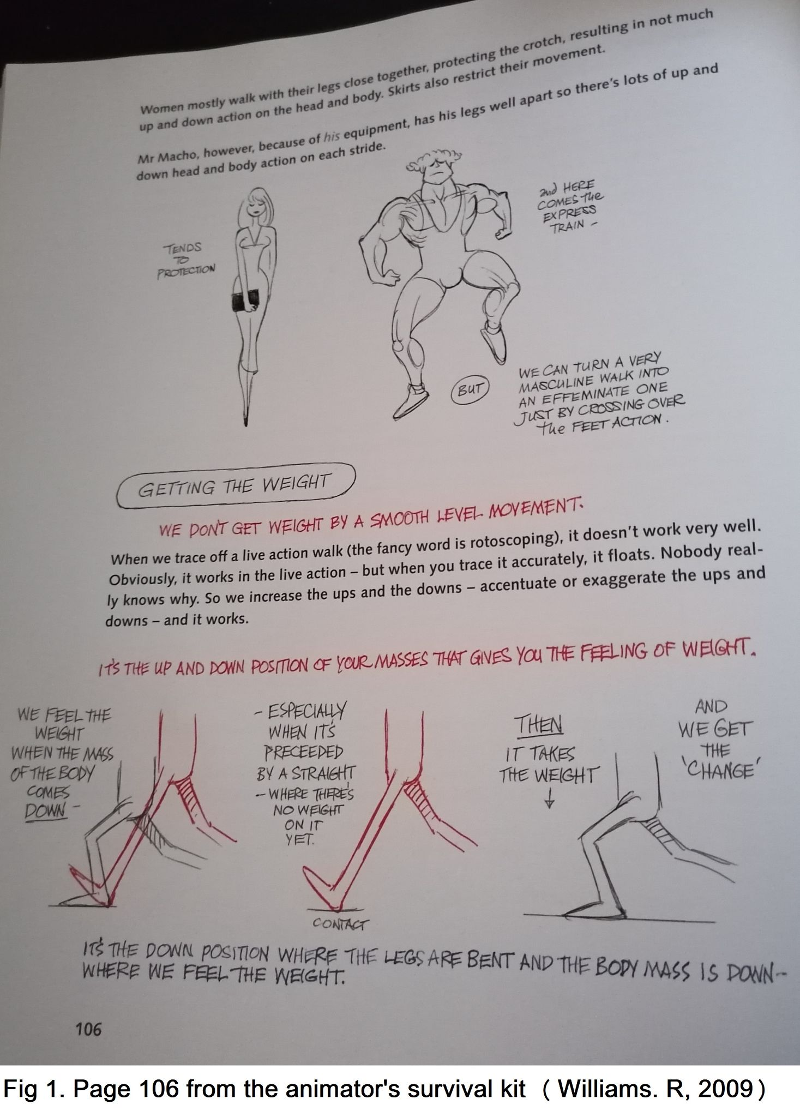
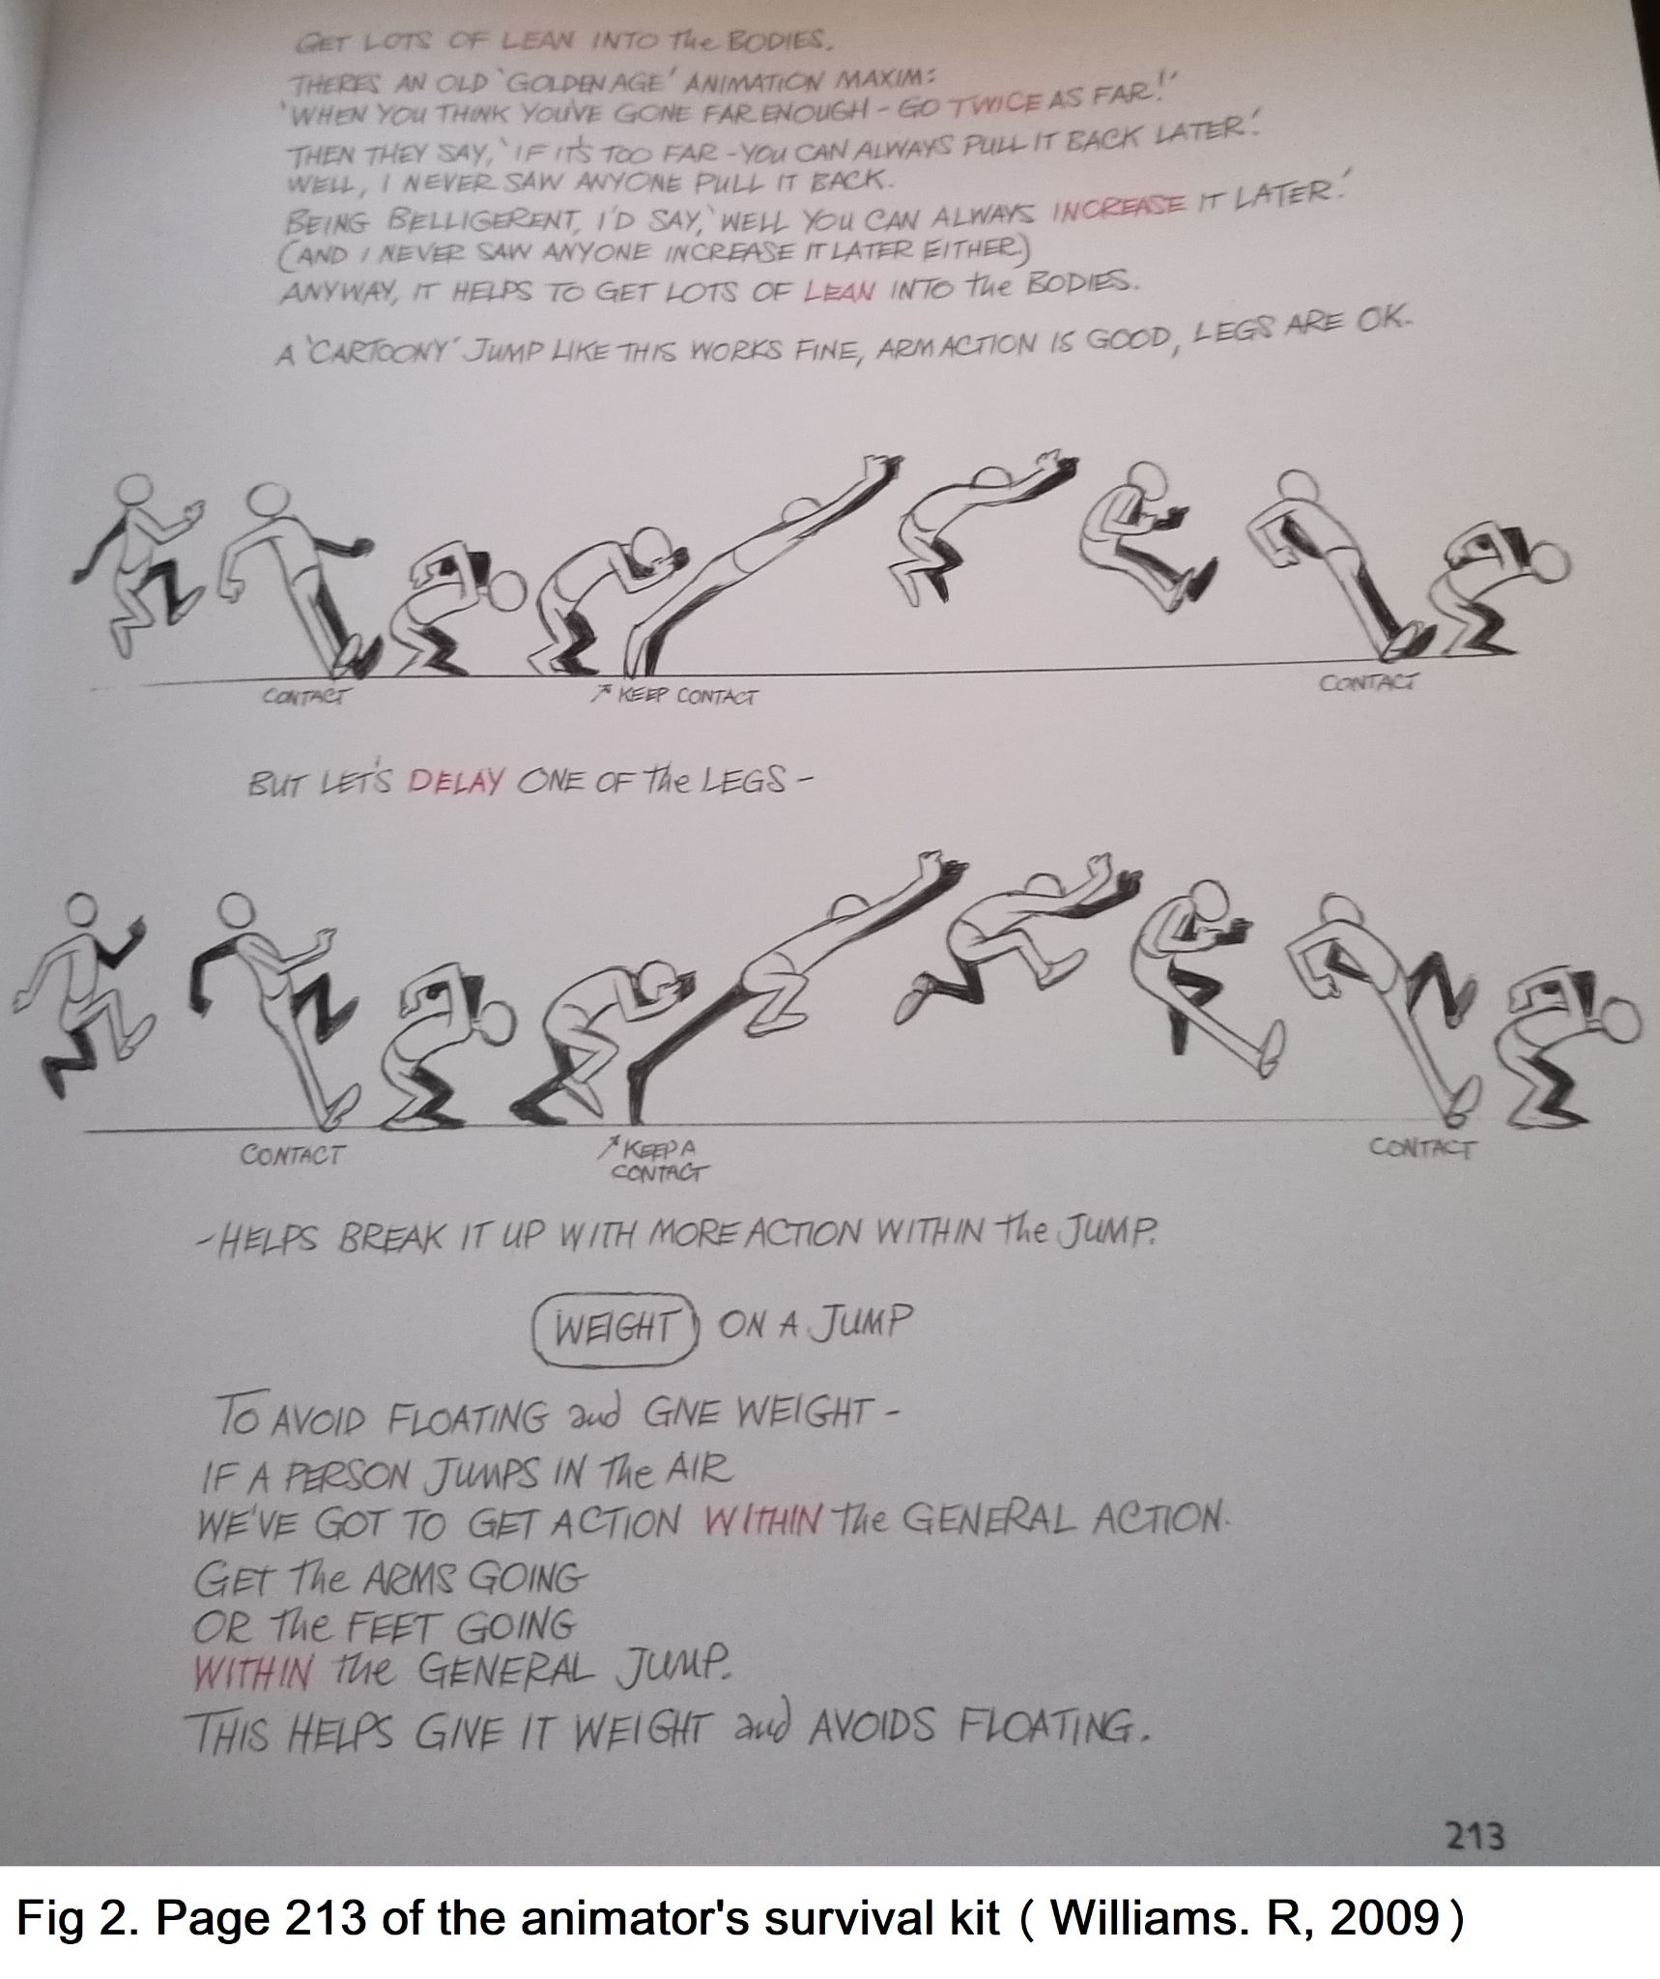
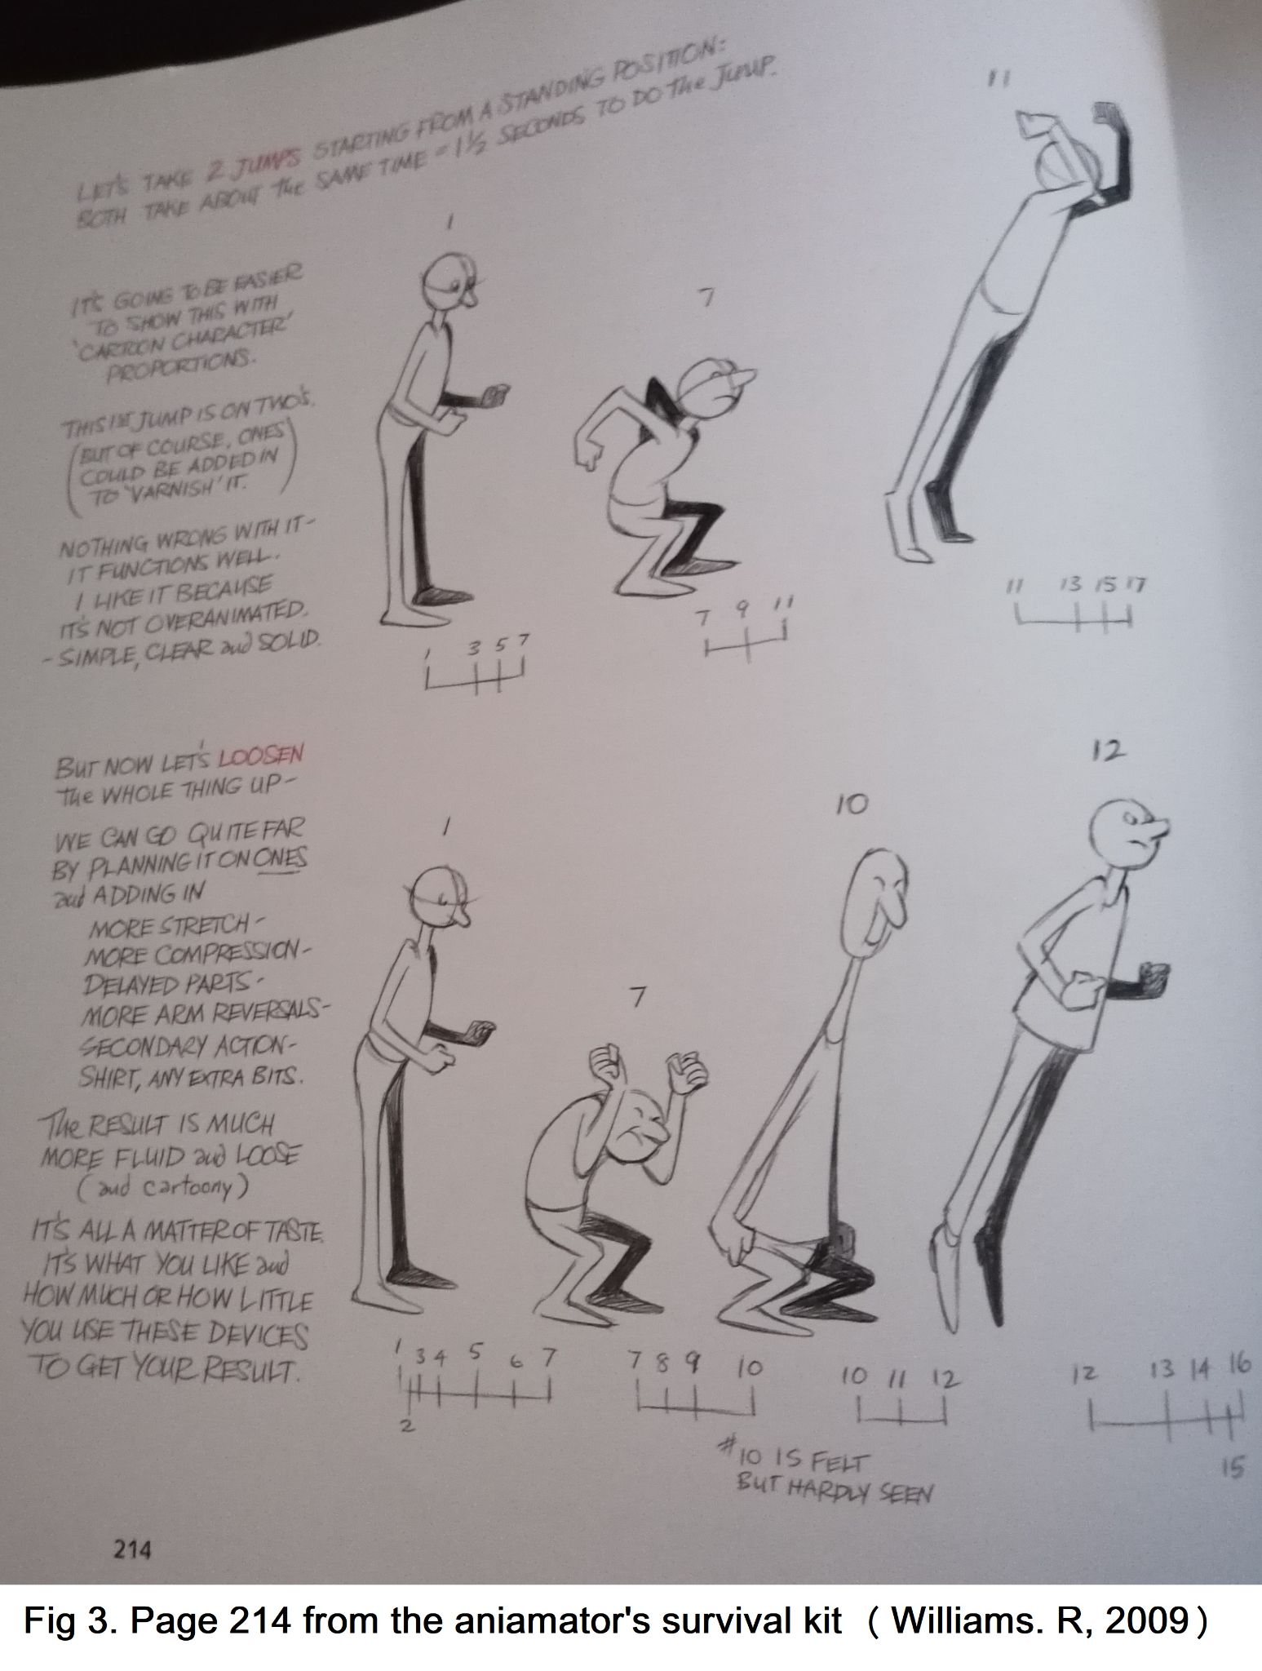
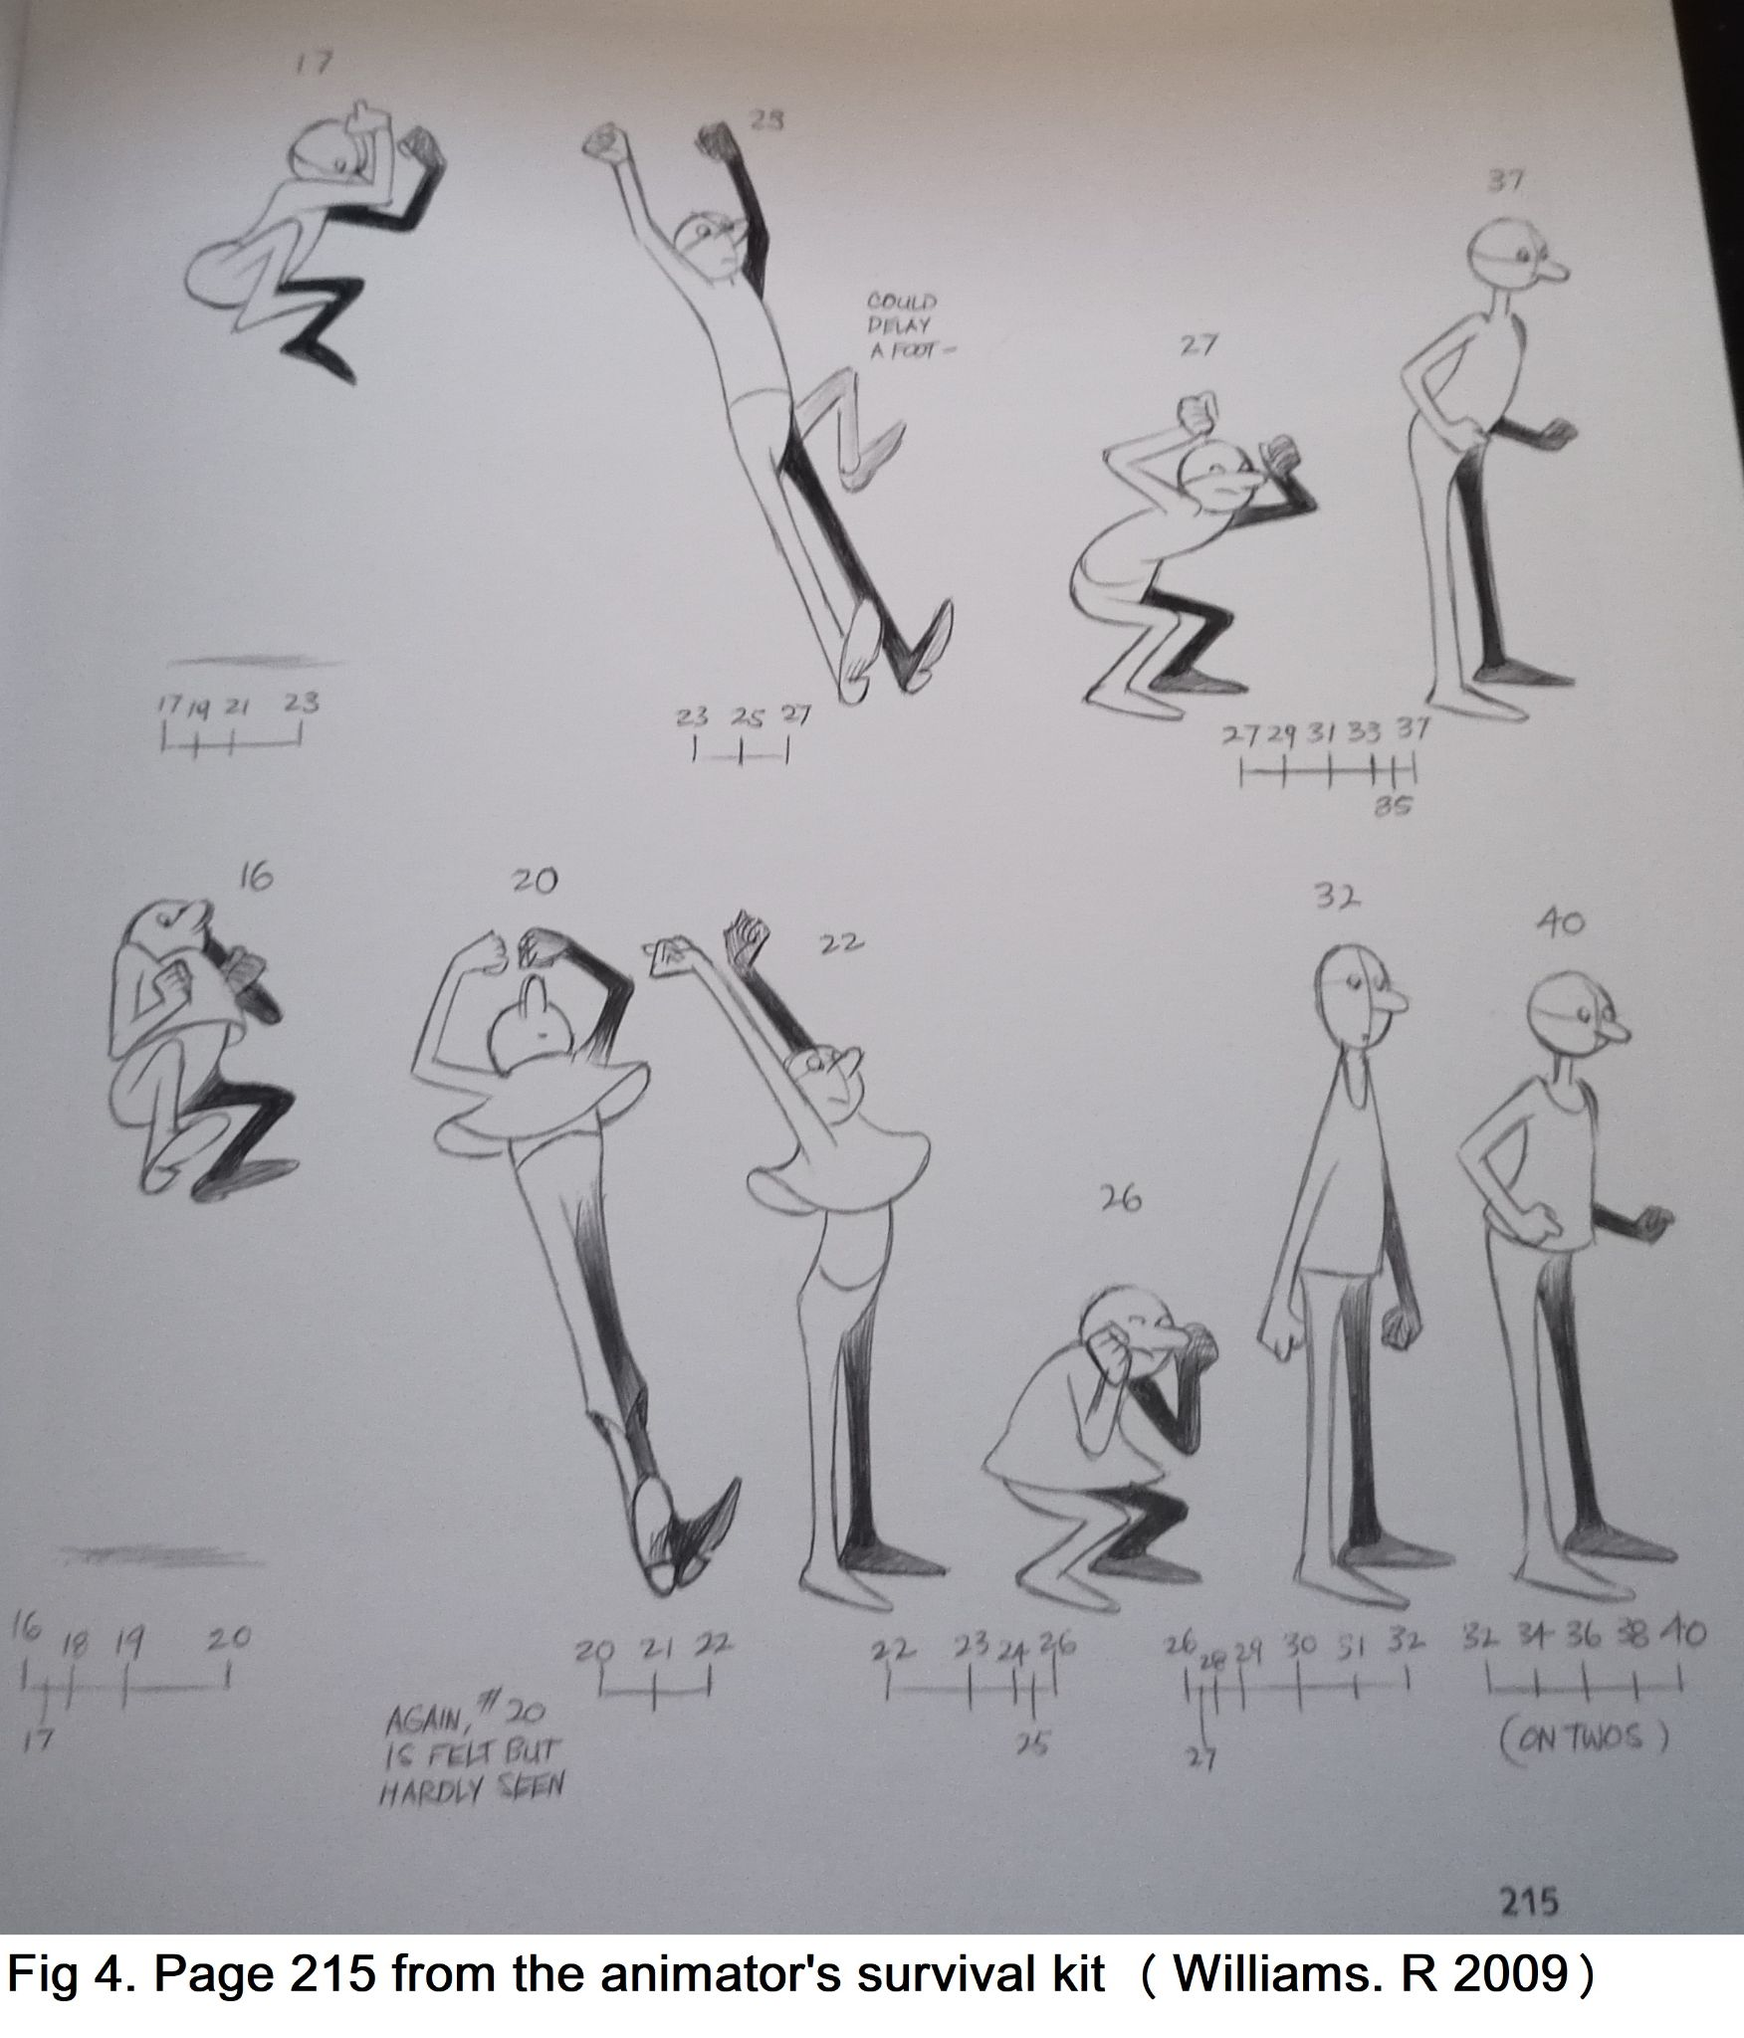

What i've done
As stated above I was one of the animators in the group who focused on the sketching, line art and shading of all the 2D animations. When doing the animations I used a drawing program called Krita to do them as krita is a free and easy to use program with built in animation settings. Below is a list of all the animations I have done for the project:

Pinkey Stete animations:
- Idle animation. The idle animation is a simple animation made to make the main character Pinkey Stete look more alive when standing still by giving him subtle movements. The idle animation is 8 frames long (see fig 5 for reference) but has repeated frames to make the animation seem more subtle and drawn out.

For this animation I had to recolour it as when it was given to me to begin shading I noticed the colours were slightly more vibrant than the other animations so I recoloured it to keep it consistent with the other animations and it would take too long to send it back to Erin and wait to get it back to shade.

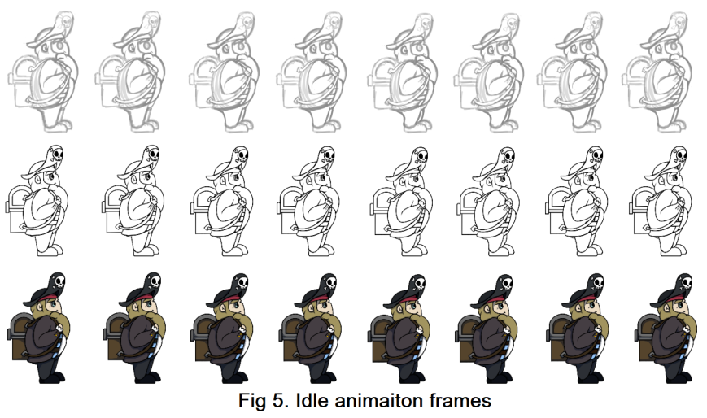
The colouring mistake was simply human error as a colour palette guide was provided to everyone in the group; it just wasn't used for this first animation for some reason. This mistake could maybe have been prevented with better communication and ensuring that whoever is colouring follows the colour palette guide properly.

- Run animation. The run animation (see fig 6 for reference) is 13 frames long and runs at 24 frames per second. When doing the run animation I tried to animate it in a way to emphasize Pinkey Stete’s character design. With short stubby legs and a big round body I made it so that when he's running he is taking small steps with his body dipping lower than normal in a run animation to exaggerate the movement and show his weight which I learned from page 106 (see fig 1 for reference) of ‘the animator’s survival kit’ (Williams. R, 2009). Doing it this way made it so while he's only taking small steps it still looks like he is running.
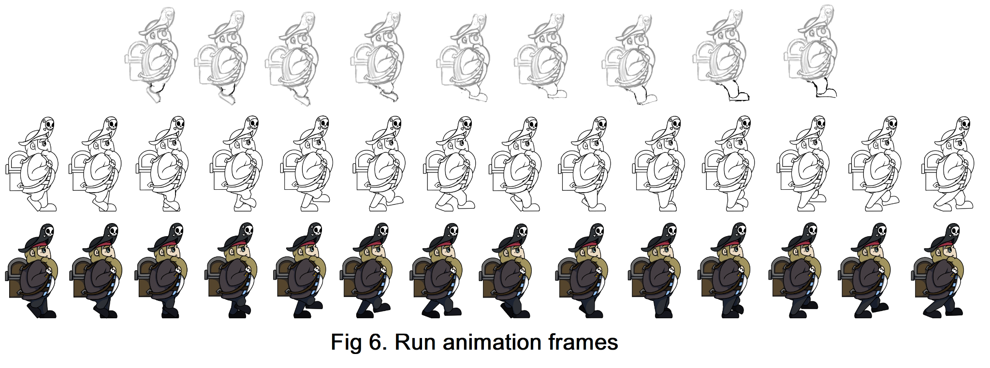
- Jump animation. The jump animation (see fig 7 for reference) is 18 frames long and contains some of the run animation frames to help blend it into the run animation and make the transition between the two animations more smooth when playing the game.

When doing the jump animation I used techniques called squashing and stretching to do it. In the animation after jumping and starting to come down Pinkey Stete brings his legs up close to his body and when he lands he bends his knees and his body continues to go down for a few frames (called squashing) before he straightens again to go into a run (called stretching). I've done it this way to emphasize his weight and body shape more like with the short but fast steps in the run animation. Doing it this way shows that when he lands he has to bend and crouch so that his body can absorb the shock from landing. This is shown on page 213 (see fig 2 for reference) of ‘the animator’s survival kit’ (Williams. R, 2009).
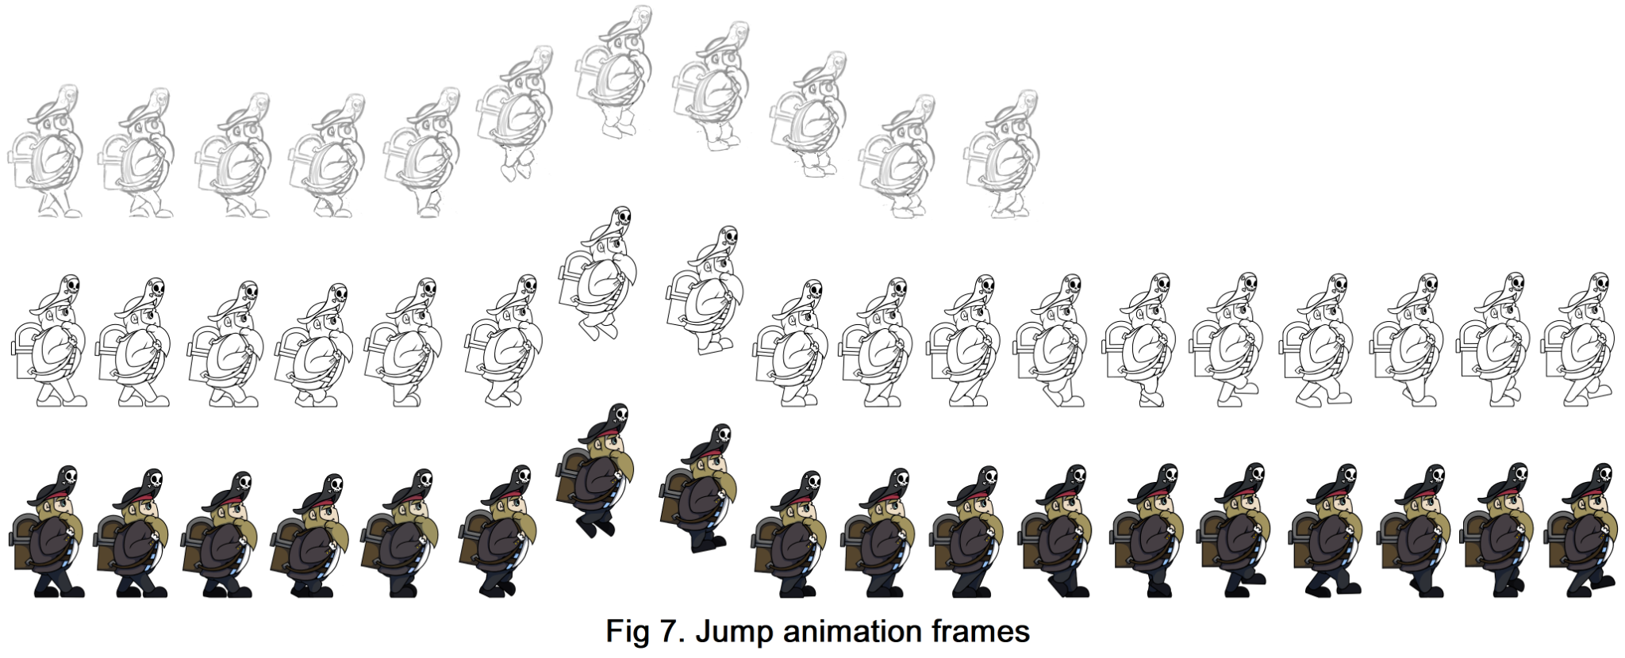
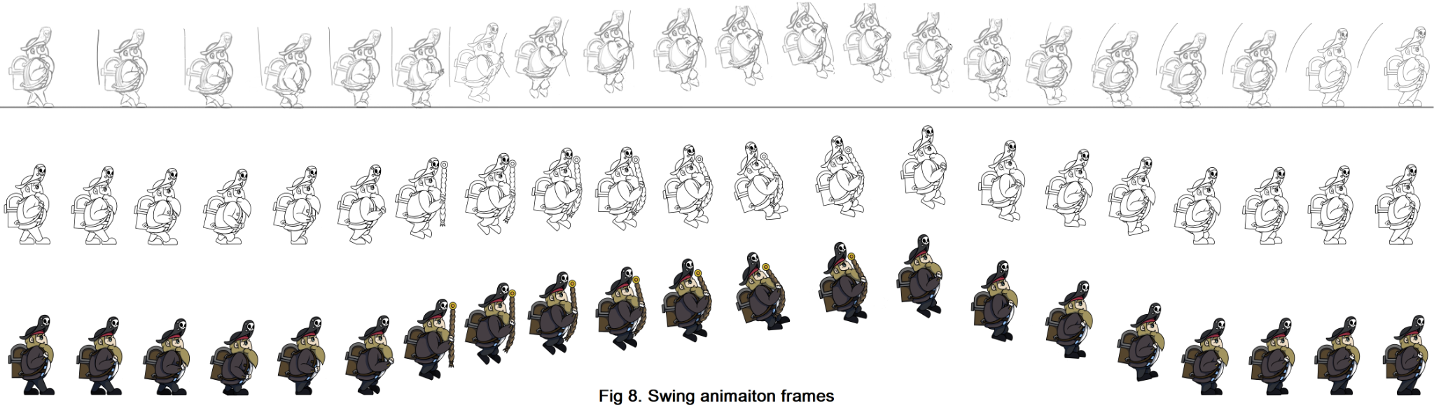
- Swing animation. The swing animation (see fig 8 for reference) is 21 frames long and is very similar to the jump animation (and includes squashing and stretching) but involves Pinkey Stete grabbing a 2D rope and swinging on it. In this animation there is stretch and squash like the jump animation but also secondary actions (the arms moving to grab the rope) and frame delays there is a delay before the jump and while in the air before coming down. By implementing these the resulting animation is more fluid and loose and makes it seem that by swinging he's going a longer distance and exaggerates how fast he's going. This is shown on page 214-215 (see fig 3 and 4 for reference) of ‘the animator’s survival kit’ (Williams. R, 2009).

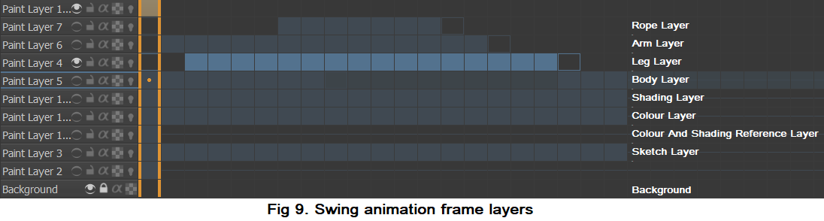
Because in the swing animation Pinkey Stete is interacting with an object and there is so much movement I had to break up this animation so that each moving piece was on a separate layer, one for the rope, one for the body, one for the legs and one for the arms (see fig 9 for reference).

- Blink animation. The blink animation (see fig 10 for reference) is a small animation I did on the side while waiting for more coloured frames from Erin. The blink animation is the only one apart from the idle animation which I had to recolour that I fully did by myself (I did the sketch, the lineart, the colouring and the shading).

The blink animation is 7 frames long and is for the top of the game screen where it will be used as a guide of sorts and say tips to the player when they start the game (e.g. it will explain the buttons/power ups etc.)
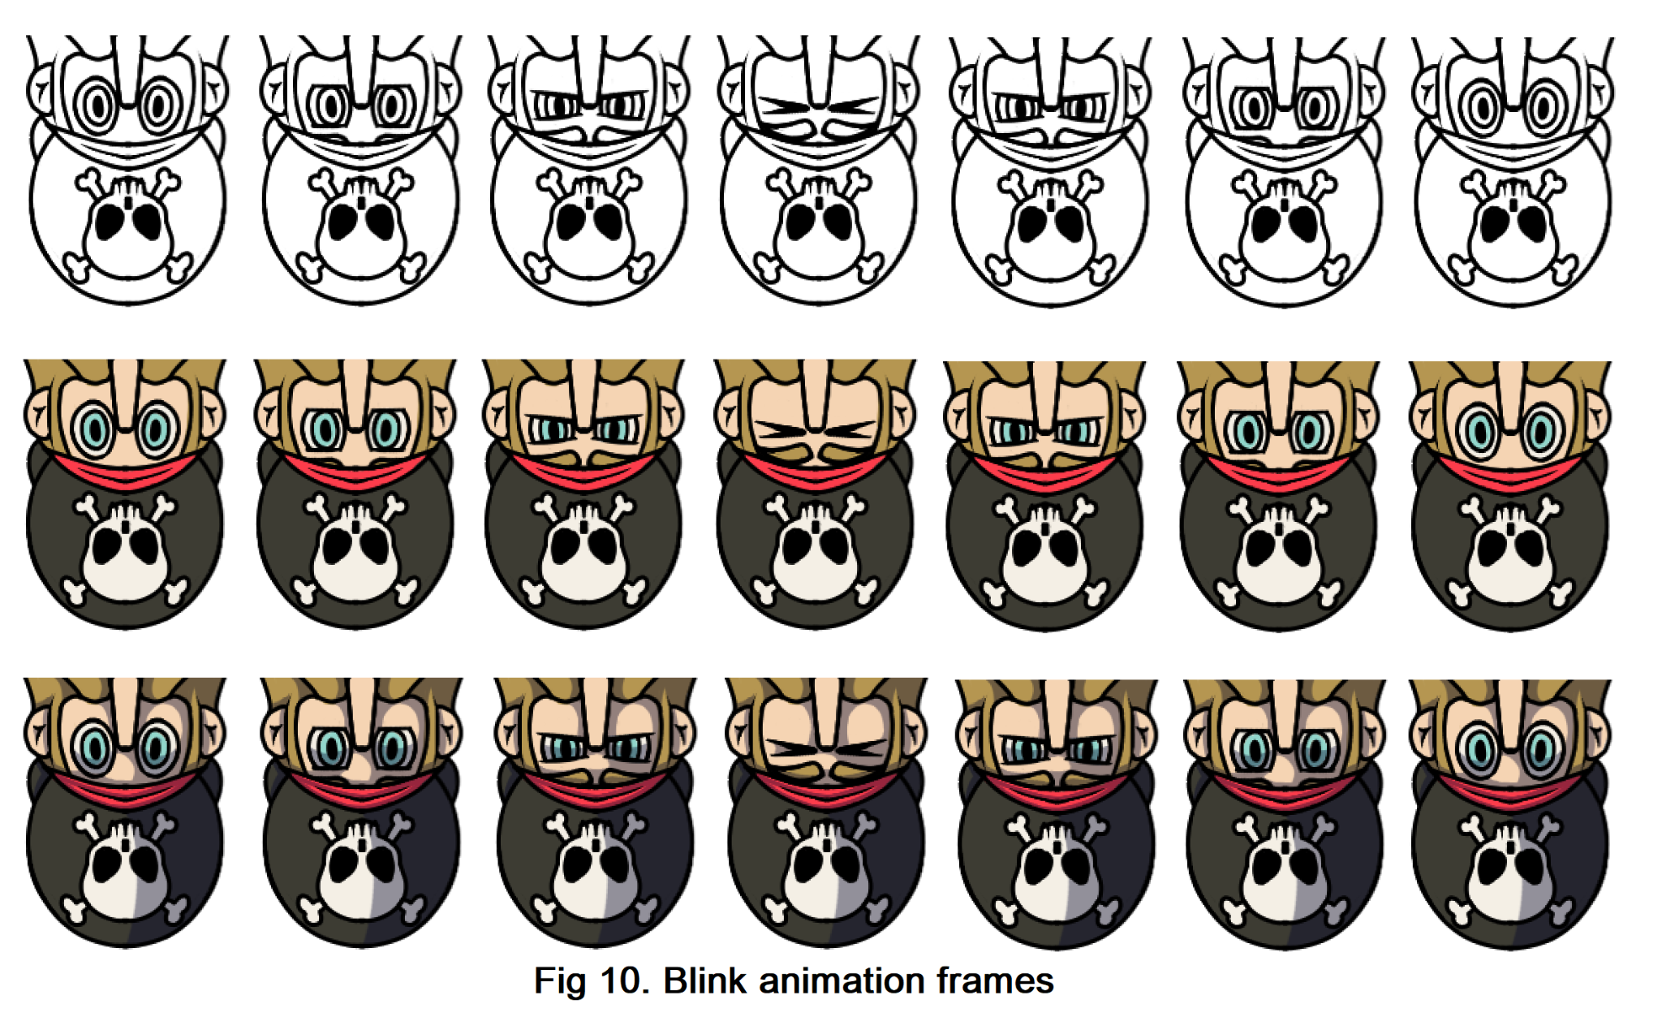
Kraken animations:
- Default tentacle animation. The default tentacle animation (see fig 11 for reference) is 11 frames long and is the main tentacle for the game. It is this animation that transitions into the grabbing player animation and the trying to grab player animations.
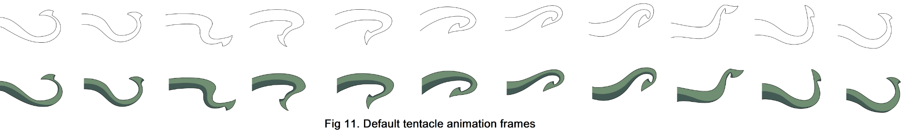
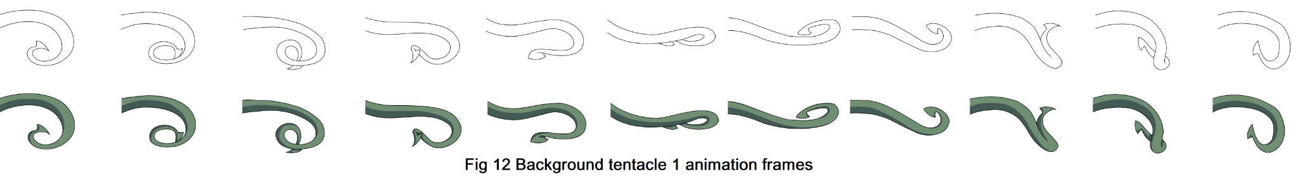
- Background tentacles 1 and 2. The two background tentacles (see fig 12 for tentacle 1 and fig 13 for tentacle 2 for reference) are both 11 frames long like the default tentacle and are there to give some variation in the tentacle movements. These two tentacles can be swapped out with the default tentacle to chase Pinkey Stete or can be placed coming out of the water in the water.
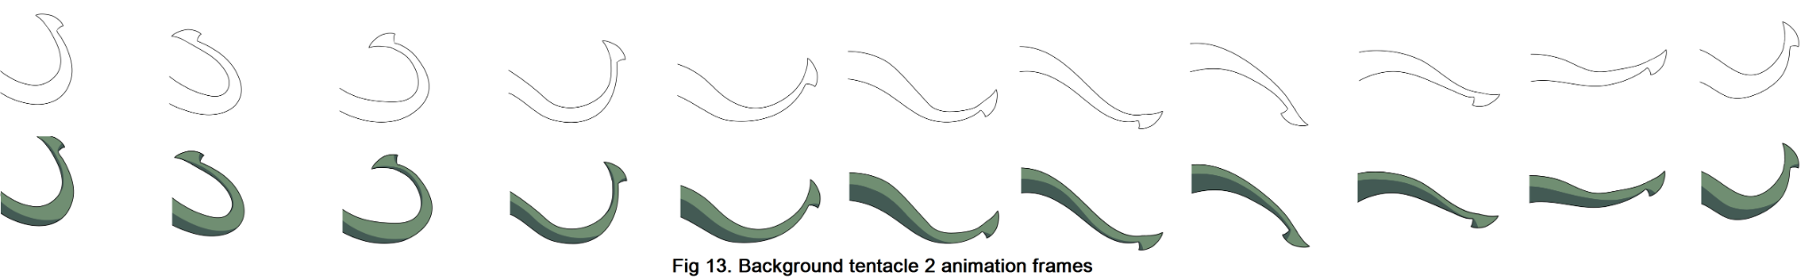
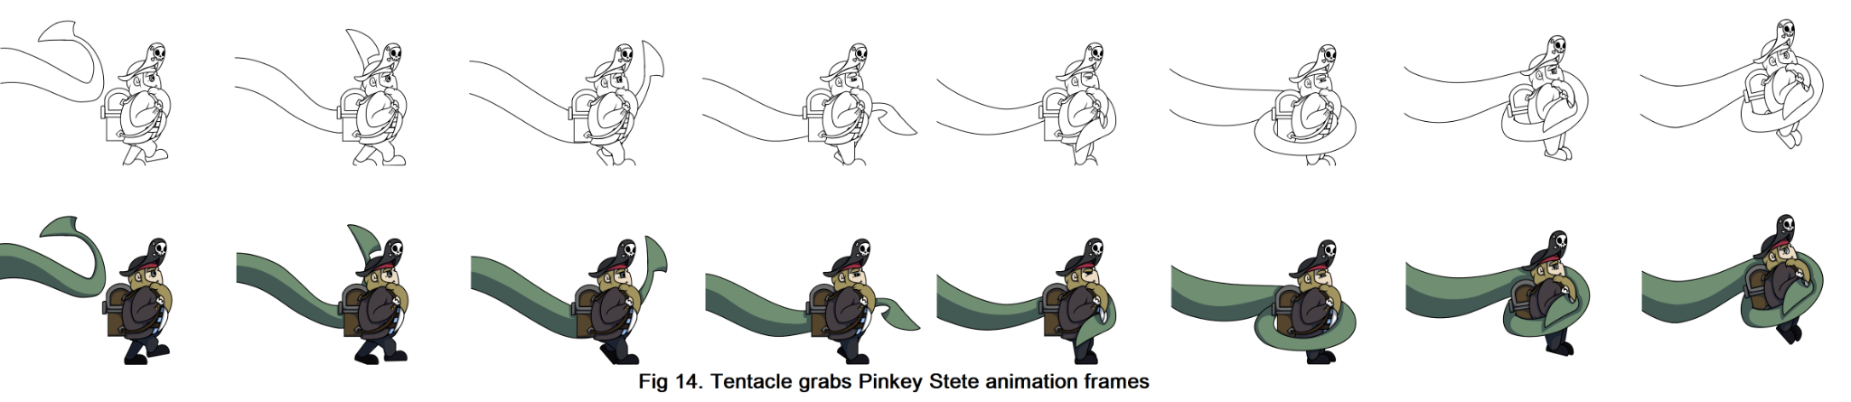
- Tentacle grabs Pinkey Stete. The tentacle grabs Pinkey Stete animation (see fig 14 for reference) is 8 frames long and is the game over animation, when Pinkey Stete hits the Kraken’s hit box this animation plays and the default tentacle animation will switch to this one which grabs Pinkey Stete. This animation like the swing animation involved a lot of movement to animate so I broke each moving part into a different layer to make it easier to animate (one for the tentacle, one for Pinkey Stete’s body and one for his leg and eye movements).
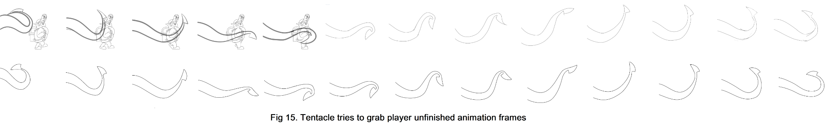
- Tentacle tries to grab Pinkey Stete. This animation (see fig 15 for reference) is 13 frames long and was supposed to be a faint attack on Pinkey Stete when he comes close to the Krakens hitbox. When sketching the movements for this animation I used some of the frames from the grab Pinkey Stete animation sketch so that the movement in the beginning is similar making the player think it's going to get grabbed but misses. Unfortunately this animation was not finished in time in order to be implemented into the game due to delays in frame colouring.

Asset animations:
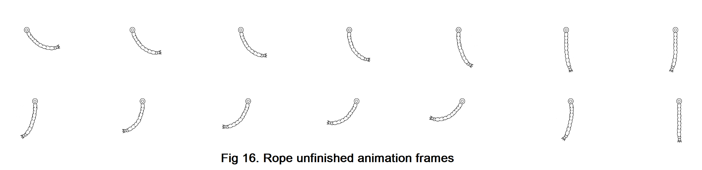
- Rope after swing animation. This animation (see fig 16 for reference) is 43 frames long (with multiple repeated frames) to show the rope continuing to swing before slowing down after the swing animation. Originally there was going to be another animation like the rope swing but it got cut out in the end due to there not being enough time to do both. Unfortunately like the tries to grab animation, due to colouring delays it was not completed in time.

For all the animations done I did the initial sketch, line art, colour touch ups and shading for the animations, the only animations I coloured was the blinking animation and the idle animation which I had to recolour due to the colours in the animation being more vibrant than with the other animations.

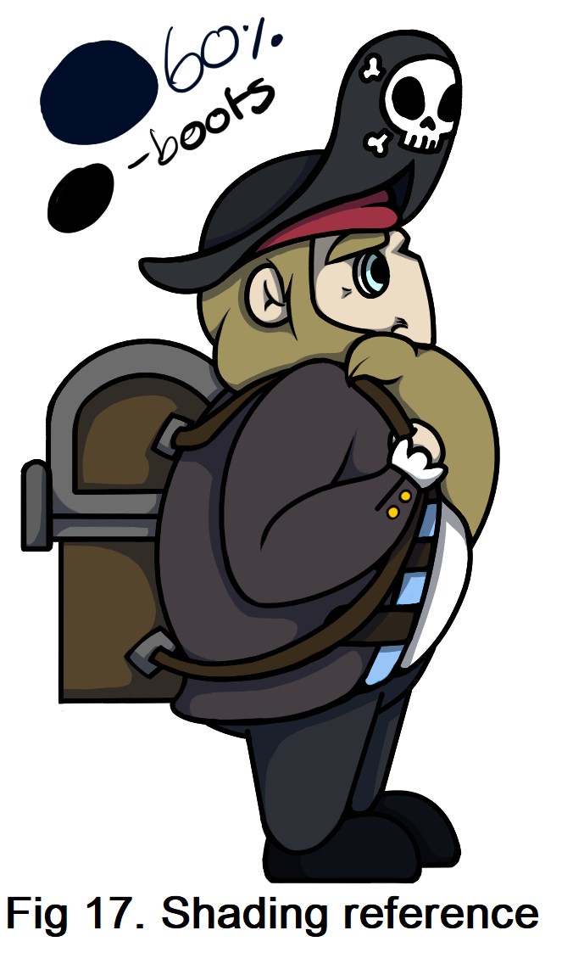
When shading (see fig 17 for reference) I used a dark blue shading colour for almost all the animations and a black shading colour for Pinkey Stete’s boots as they were almost black and the dark blue shading would either not show up or would look more like highlights than shading on the dark boots. For the shading I would draw on all the shading with 100% opacity so when I play it through to check for any issues it would be easier to see and then after when im happy with it I would go through with an eraser tool a 60% opacity and rub out the shading on each frame so that it was see through.
In addition to this I also helped others with their project work by helping them with research and other things such as helping Beth with looking at different sound effects. I was also one of the leaders in the group and helped keep people organized and on track with work by arranging meetings, checking in on people and writing notes during meetings for people to follow and assigning tasks that needed to be done such as updating Gantt charts etc.

Group Productivity
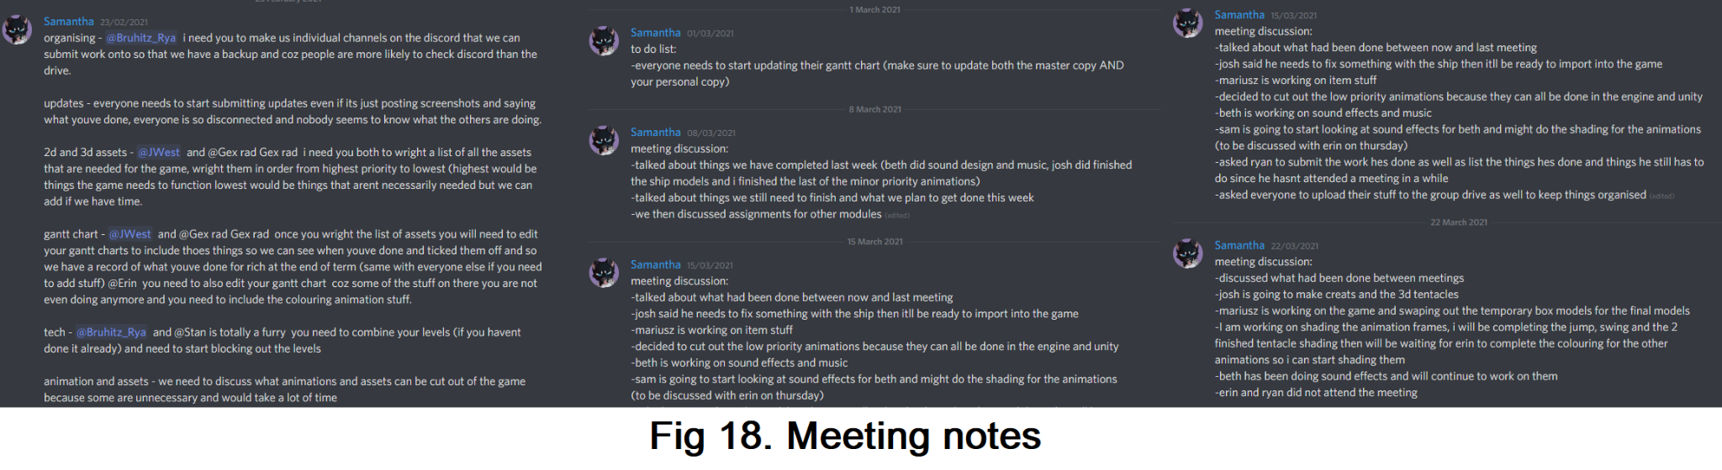
In the group we had meetings every Monday and Thursday (and also sometimes Friday if there is an emergency such as if a group decision needs to be made urgently like when the group was struggling to decide on an art direction, this meeting helped us decide and allowed us to continue working sooner than if we waited for the next meeting) where we would discuss what work had been done, what was left to do and what everyone is currently doing. During these meetings I would write notes (see fig 18 for reference) on what had been discussed and what needed doing that week for everyone to review in case someone had missed the meeting or if people needed to look back and see what was discussed.

When looking at our work we all made a Gantt chart (see fig 19 for reference and see appendix for link to the Gantt chart) with the help of our tutor and used that as a sort of diary/checklist on what was being done and when. When we had finished a piece of work it would be uploaded to our shared google drive so that the whole group could access it, we also uploaded work and/or progress screenshots onto the group discord so that everyone could see what had been done. We were all also sure to notify people if they were dependent on a piece of work we were doing when pieces of work had been done so they could do their part with it.
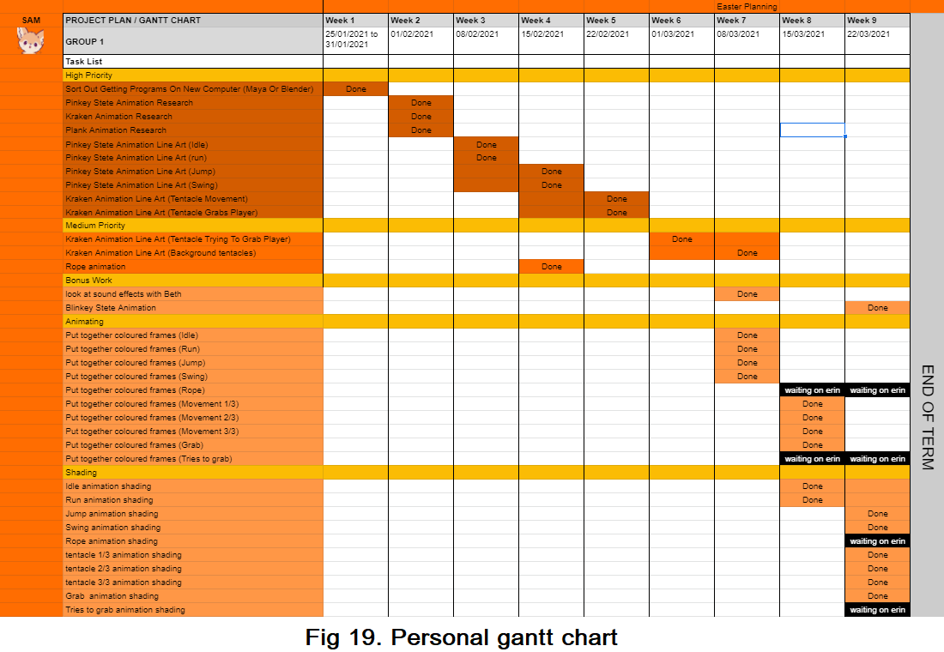
In the last few weeks before the deadline the group did playtesting on the game and we also got the other group to play test it to see how different people would play it and see where we needed to improve the game. During the first playtesting we discovered that at the beginning of the game the speed of the Kraken was too fast and it was hard to get away but after going through ⅓ of the level the kraken was so far behind that the player could easily finish the game. This was resolved by ensuring the kraken always stays within a certain distance of the player so that it cannot be outrun completely.

Conclusion
In conclusion I believe we worked quite well as a group. Even though we had a group member have to leave near the end and some group members had to miss multiple meetings due to medical reasons we all worked hard to keep in touch with each other and help each other out.In the end we have ended up with a really cool game which everyone has worked hard on.

The game is almost exactly how we imagined it would be, it is engaging and exciting to play and meets the criteria for the game. We have all worked hard together even with those issues and not being able to come together and see each other and work together closer due to the coronavirus and the university closing due to lockdown.

If I were to do this project again I would look more on the roles of the people in the group as in the second term people had to shuffle around due to lack of work in their roles (e.g. Beth had to switch from the design to the art role since there was little to no design work needed in term 2 and Erin switched from art to the animation role with me to help with the animations since there were so many). I would also insist on playtesting the game sooner so that we all could get a sense of the game and see in what areas we would need to improve sooner so we would have time to make those corrections.

Bibliography
William. R, (2009) The Animator’s Survival Kit, Extended Edition, Faber and Faber Limited, Book.
Last accessed on: 21/04/21

Appendix
Gantt chart: https://docs.google.com/spreadsheets/d/1sz2P0dLmCqrEHZ2ypeuvdwaIpVasab1YyMyJDsvA73g/edit#gid=1166443342

