Module Name: Understanding Organisational Structure and Culture
Module Code: LCBB4009
Assessment: Individual Presentation
Topic: Organisational Structure Design
Case Study: Sainsbury's
Student Name: Rares Constantinescu
Student Number: 2516174
Submission Date:23.3.2026

Table of Contents
Slide 1: Outline 3
Slide 2: Organisational Structure 4
Slide 3: Functional Structure 5
Slide 4: Divisional Structure 6
Slide 5: Matrix Structure 7
Slide 6: Conclusion 8
Reference List 9

Slide 1: Outline
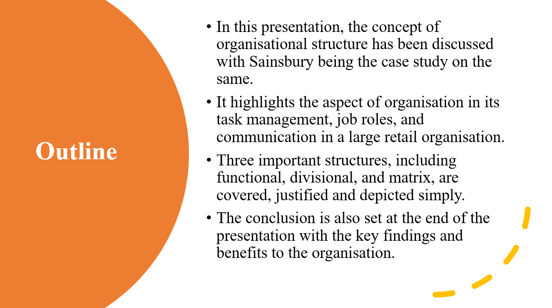
In this presentation, the structure of organisations will be described using the case of Sainsbury. It shall begin by defining the organisational structure and its significance to business in a short manner. Subsequently, it will make comments on three major forms of structures: functional, divisional and matrix. It will also explain how each structure will work in the case of Sainsbury's in simple examples. Finally, it shall also conclude the key arguments and mention the reason why structure is important to the success of a business.

Slide 2: Organisational Structure
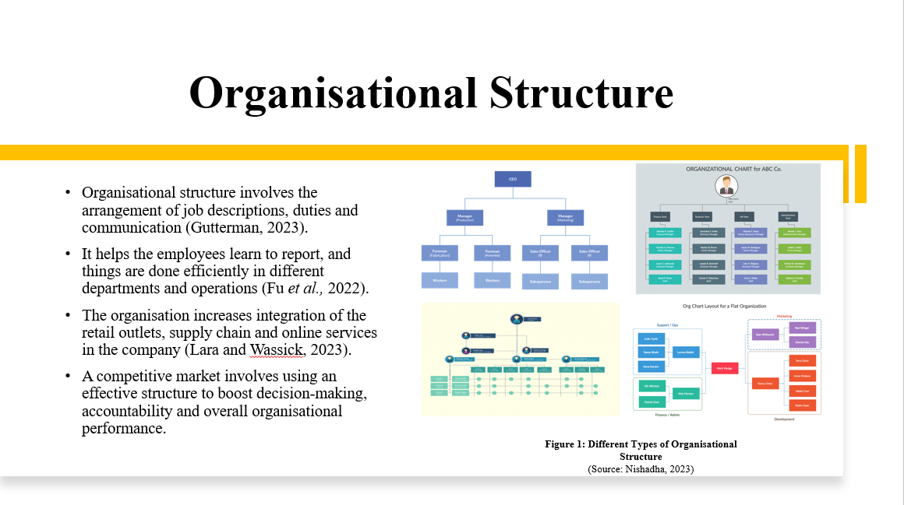
Organisational structure can be described as a manner through which the roles, duties and communication are structured. The structure is applied to control different departments of an organisation, such as the retail department, the supply chain department, and the online service department, in an organisation such as Sainsbury, which is large. It brings out the reporting lines and decision-making process. An effective structure will help in improving coordination and reducing confusion among the employees. It also helps in the efficient running of the company and responsiveness to the market changes in the competitive retail market.

