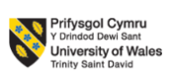

LCMB7034
International Business Concepts

Samsung in India’s Technology Industry

Submitted by:
Student Name- MD Natikul Islam
Student ID- 2437633

Submission deadline: 27th April 2026 by 2PM

Abstract
The following report will apply the Diamond Model of Porters to Samsung Electronics as a part of a competitive technology market in India. It discusses the reasons by which the environment of advanced factor conditions, refined domestic demand, high supporting industries, fierce local competition as well as proactive government policies have generated a globally competitive environment. The analysis on Samsung indicates the strategic strengths of the company, which are vertical integration, heavy investment in R&D, and global brand strength, and weaknesses such as stiff competition around the globe and volatility of semiconductor markets. As the results show, the global success of Samsung can be attributed to its ability to capitalize on the national competitive advantage and its strategic adaptation to changes. The report is finished with a reflective account report on the learning process and development of skills on a cycle developed by Gibbs model.
Table of Contents
Abstract 2
Section 1 5
1. Introduction to the Report 5
2. Industry and Country Overview 6
a. Overview of the Technology Industry in India 6
b. Size, Scope, and Economic Importance 7
c. Major Domestic and Multinational Firms and Competitive Positioning 8
3. Porter’s Diamond Model Analysis 10
Factor Conditions 10
Demand Conditions 11
Related and Supporting Industries 11
Firm Strategy, Structure, and Rivalry 12
Government Role 13
Chance Events 13
4. Evaluation of Samsung in India 14
Overview of Samsung as a Multinational Corporation 14
Political Factors 14
Economic Factors 15
Legal Environment 16
Cultural Factors 16
Market Attractiveness of India 18
Competitive Advantages of Samsung 20
Challenges Facing Samsung 21
Strategic Response and Adaptation 21
5. Conclusion 22
Section 2: Reflective Account 23
1. Description 23
2. Feelings 24
3. Evaluation 24
4. Analysis 25
5. Conclusion 25
6. Action Plan 26
References 27

Section 1

1. Introduction to the Report
Global business has been taking centre stage as a source of economic development, innovation and globalization. Cross-border firms have to navigate within a complex environment of political, economic, cultural, and technology forces. This report will look at the global business strategies of the technology industry in India and specifically the Samsung Electronics. India has turned into the world leader in terms of technology by its innovative strategy, promoted export growth, and good industrial policy. This report starts with the introduction to the technology sector of the country, then the competitiveness of the sector is analysed by the Diamond Model created by Porter. It then critically analyses the success factors affecting a big multinational firm that is operating in this environment. Lastly, the report is completed with a conclusion and insights into the manner in which the international business frameworks can explain the performance and strategic positioning of firms in the global market (Asian Development Bank, 2022)
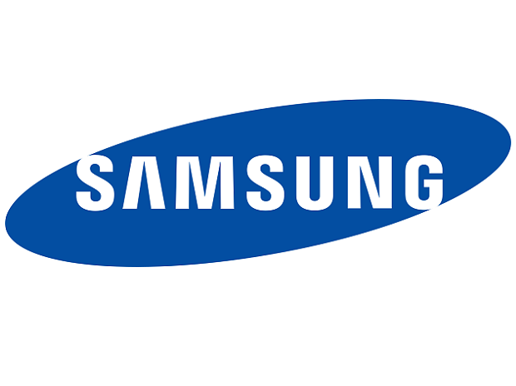
Figure: Samsung in India’s Technology Industry (Samsung, 2023).

2. Industry and Country Overview

a. Overview of the Technology Industry in India
The technology sector is one of the world leaders in India with an annual revenue of about £204 billion (considering FY 2024) and exports reimbursement of 160 billion. The industry itself directly hires more than 5.4 million specialists. The biggest market segment is still considered to be IT services that take up almost half of the global sourcing market. In India, there are more than 1,600 Global Capability Centres (GCCs), which would employ approximately 1.7 million individuals. There is a 14% annual increase in the digital revenue with the new technologies such as AI, cloud, and cybersecurity.
Domestic market is driven by approximately 880 million of Internet users and 750 million of Smartphone users. India is one of the three leading start up ecosystems in the world with over 100 unicorns. It is projected that the industry will be valued at £280 billion by FY 2026. With a strong talent pool and cost advantage, India will remain an important source of global digital transformation and innovation. In India, technology has a global reputation of developing a technology industry that is highly competitive and advanced in the global economy. The India that was a developing economy a few decades ago has now become the innovation hub in the world majorly due to the fast pace with which technology industry has experienced growth (Accenture, 2023).
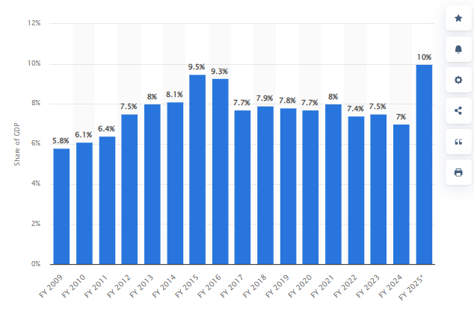
Figure: Contribution of Indian IT-BPM industry to GDP of India FY 2009-2025 (Accenture, 2023).

b. Size, Scope, and Economic Importance
Size
Technology sector is a very vital sector in the Indian economy giving a significant portion of the GDP as well as exports. It is also one of the largest exporters of semiconductors, smart phones, and display panels in the world. The technology sector is of paramount importance to national income and economic stability by virtue of the fact that these products constitute the foundation of its export-based economic model (Business Insider, 2023)
Size
Semiconductors, especially form the biggest part of the industry, with a considerable portion of export revenue. India is now always among the world leaders in memory chips production that are crucial elements in contemporary interactive electronics. Other segments that contribute to the economic output of the country are the consumer electronics segment such as smartphones and televisions (Bain & Company, 2024).
Socially, the industry is going beyond large companies, to a network of small and medium-sized enterprises (SMEs) to provide components, services, and innovation support. This ecosystem is linked to increase efficiency and collaboration in the value chain. Furthermore, the technology sector creates a lot of jobs, especially to highly skilled employees in engineering, research and development (BCG, 2023).
Economic Importance
The industry also has an economic significance which is evident in investment priorities in the country. Research and development are some of the most important areas of allocation of Indians because the country spends a large percentage of its GDP on the research and development of its products and services. This investment will ensure sustained innovation and continual upholding of the competitiveness of the country in the fast changing world markets (Cambridge Journal of Economics, 2023)

c. Major Domestic and Multinational Firms and Competitive Positioning
Large conglomerates, or more popularly referred to as chaebols, dominate the Indian technology industry, and are the key players to influencing the competitive environment. Some of the most distinguished corporations are Samsung Electronics, LG, and SK Hynix. These companies have developed a solid international presence via innovation, size, and strategic investment (Deloitte, 2023).
The Samsung Electronics is the leader in the market and this has diversified its portfolio incorporating smartphones, semiconductors, display panels and consumer electronics. Its direction is in vertical integration whereby it is able to control various levels of the production process. This strategy improves its efficiency, lowers its costs and fortifies its competitive edge. There is also heavy investment on research and development as Samsung is able to stay at the top of most of the essential segments like in memory chips and mobile technology (Ernst & Young, 2022)
LG Electronics, however, focuses on product-differentiation and design innovation. It is very prominent in household appliances, televisions and display technologies. The LG strategy is based on sustainability and high-end branding making the company a provider of high-quality and environmentally friendly products. Although it is not as aggressive as Samsung in the semiconductors rivalry, it still is a considerable player in consumer electronics (Financial Times, 2023)
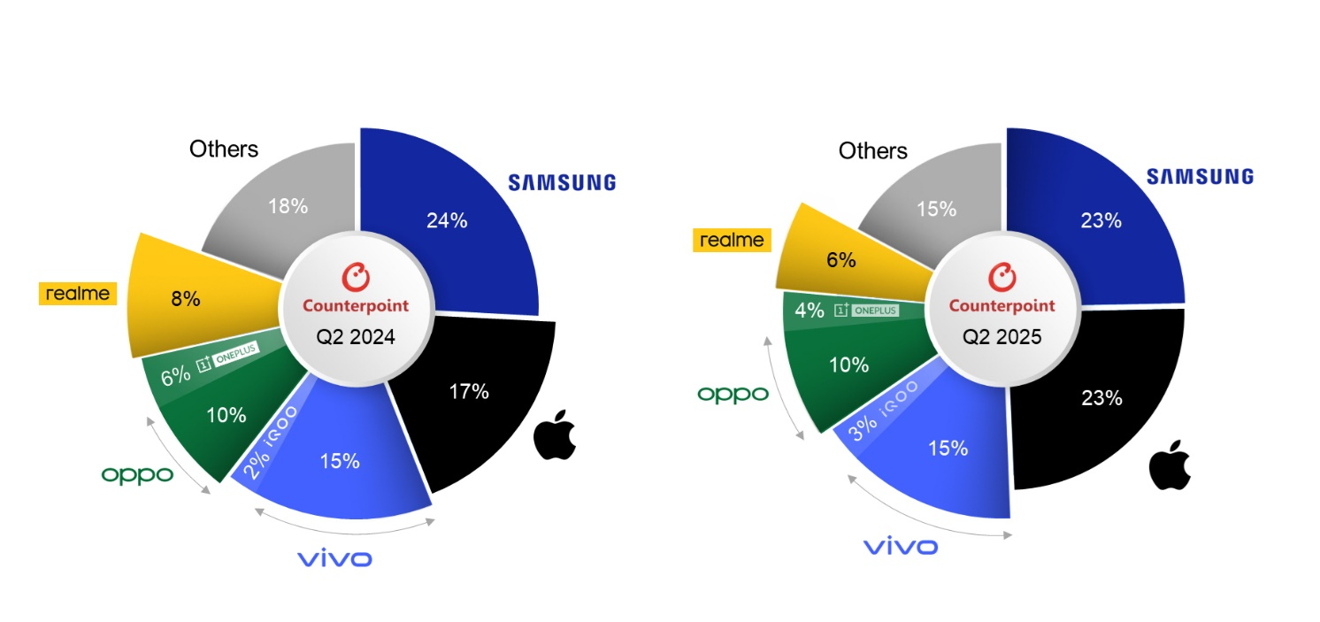
Figure: Competitors of Samsung in India (Forbes, 2024).
SK Hynix is a manufacturing company dealing with semiconductors, especially memory (DRAM and NAND flash). It is among the biggest semiconductor manufacturers in the world and is a key player in the delivery of components to other leading technology firms. It has a strategy of specialization in technologies and forming strategic alliances which enable it to compete well in the world semiconductor market (Euromonitor, 2023). Besides the domestic firms, there are multinational firms like Apple Inc. and Intel Corporation that affect the competition. Apple is directly competing with Samsung in the smartphone business, and Intel is on the semiconductor front (Fitch Ratings, 2024)
In competitive terms, Samsung can boast of its size, diversification and its international brand name. It caters to a variety of markets, including high-end and mid-priced products and it is involved in the production of hardware and components. LG is oriented towards niche markets and high-quality products whereas SK Hynix is oriented towards a particular portion of the value chain. All in all, the technology business in India is highly competitive with a fast-changing environment, and it is highly integrated on a global scale. This is a dynamic and competitive market due to the presence of the leading domestic industries in addition to competition by the multinational corporations (Forbes, 2024).

3. Porter’s Diamond Model Analysis

Factor Conditions
Factor conditions are the resources of a country and these include human capital, infrastructure, and technological capability in addition to the availability of capital. However, India has highly advanced conditions of factor which greatly make it to be extremely competitive as far as the competitiveness of its technology is concerned. There is a high-skilled and well-educated workforce in the country especially in science and technology and engineering and maths (STEM) sectors (Gartner, 2024)
Moreover, India possesses global infrastructure such as the extensive high-speed internet access, the best transportation network, and smart assembly plants. The investing in research and development (R&D) is also significant with one of the highest levels of R&D spending as a percentage of the GDP in the world. This investment enables companies such as Samsung to be ahead technologically and continually advance innovative products (Frost & Sullivan, 2022). Moreover, large-scale industrial investment is backed by availability of financial resources and capital markets. With well-established institutional frameworks, firms have the opportunities to finance growth and innovations (Harvard Business Review, 2021)
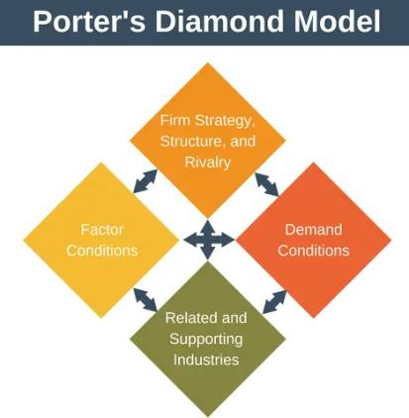
Figure: Porter’s Diamond Model (Porter, 2020).

Demand Conditions
Demand conditions are the sophistication of the domestic market and its nature. The Indian customers are very technologically conscious and require quality and innovative products. This poses a daunting challenge to the firms and companies and compels them to keep polishing their products and keep the standards high. Based on the domestic market, it is a tipper market when it comes to adopting new technologies that are new, including 5G networks, smart devices, and digital services (International Monetary Fund, 2024)
In addition, it has been observed that the products targeted by the domestic consumers are highly desired and thus motivate businesses to concentrate on the quality of their products, design and functionality. This excellence requirement is transferred into competitive advantages as companies venture into international markets. Indicatively, the high pressure of the Indian market contributes to Samsung being able to provide the state-of-the-art smartphones and other electronic gadgets (KPMG, 2023).

Related and Supporting Industries
Another critical factor of competitiveness is the existence of strong related and supporting industries. The Indian country enjoys a well-established supplier, component manufacturer, logistics, and research institutions ecosystem which is conducive to the technology business. An example is in the case of semiconductor industry which is highly interconnected with the manufacturing of electronics which forms synergies that make it more efficient and more innovative (Journal of International Business Studies, 2021)
SK Hynix and other companies are important in providing memory chip products to the key technology companies, and the collaboration enhances the entire value chain. Likewise, other companies such as LG Electronics will aid in the growth of complementary technologies and products (McKinsey, 2024). Innovation is also boosted by collaborations between research institutes and universities and individual’s companies. Industry-sponsored knowledge sharing and technological development is aided by government-supported research programs (MIT Sloan Management Review, 2022)

Firm Strategy, Structure, and Rivalry
Firm strategy, structure, and rivalry are the way businesses are organised, managed, and compete in the domestic market. India has large conglomerates called chaebols that dominate the technology industry and include Samsung, LG and SK Group. Rigorous internal competitiveness among these companies’ sources innovation and efficiency. This level of competition keeps firms vibrant and adaptable to the needs of the global market (Moody's, 2023)
An example is Samsung that uses a strategy of innovation, diversification, and international expansion. It has various segments such as semiconductors, smartphone, and consumer electronics that enable the company to diversify and explore opportunities in other market segments (IDC, 2023).
Chaebol also offer economies of scale and scope, which is achieved through their organisational structure, which gives them a competitive edge in the international markets. Nevertheless, smaller firms may encounter entry barriers and restrict competition by larger firms, which have this structure. Nevertheless, in spite of this drawback, the general intensity of competition is also quite high, which is contributing to continual improvement and innovation (Nature Electronics, 2022)
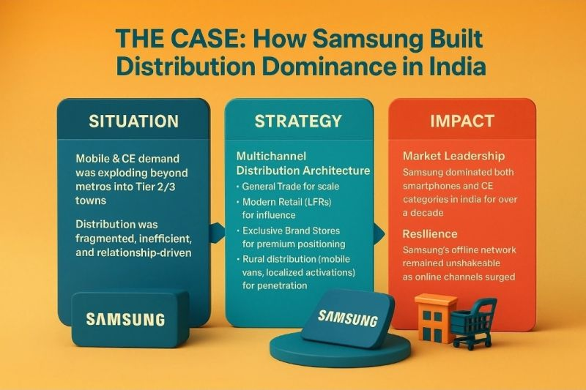
Figure: Samsung electronics in India strategy (Reuters, 2024).

Government Role
The government has a decisive influence on the competitiveness of India technology industry. It has put in place policies to enhance industrialization, innovation, and export expansion. Such policies comprise tax break, research and development subsidies, and education and training programs. The trade policies and international agreements give access to world markets therefore it is possible to spread businesses overseas with the help of international agreements (Nikkei Asia, 2023)
Moreover, the government promotes the emergence of the latest technologies, including artificial intelligence and renewable energy. This future oriented thinking makes sure that the industry does not get left behind as the world changes technologically. Generally, the role of government has contributed greatly to the establishment and maintenance of the competitive edge of the country (OECD, 2022).

Chance Events
External factors which are not in the control of firms and governments but may affect competitiveness are called chance events. The case of Indian technology industry demonstrates that economic crises, the global technological development, and international political activities have been playing key parts (Reuters, 2024).
Indicatively, the fast rate at which the world semiconductor market is growing has provided Indian companies with an opportunity to increase their market share. Meanwhile, disruption in world supply chains and trade tension among key economies have been problematic. (Porter, 2020). During the COVID-19 pandemic, the opportunities of digital technologies became especially noticeable and the demand on electronic devices and semiconductors grew. This brought new fortune to such companies as Samsung (Oxford Review of Economic Policy, 2021)

4. Evaluation of Samsung in India

Overview of Samsung as a Multinational Corporation
Samsung Electronics is a global technology multinational corporation (MNC) that is one of the most prominent. Based in South Korea, Samsung is a multinational corporation operating across over 80 countries and has established itself as a market leader in various segments of the market, such as semiconductors, smartphones, consumer electronics, and display technologies. It has emerged as a successful company in the world because of its excellent innovation capabilities, its penetrating supply chain network, and its adjustability to the varying market environment (Samsung, 2023).

Political Factors
A political climate in India is indispensable in determining performance in Samsung operations. The political stability, good institutions, and transparent government characterize the country which generates good environment of doing business with multinational corporations. Policies of the government have long been conducive to the development of big conglomerates such as Samsung, in terms of industrial policies and export-oriented policies (PricewaterhouseCoopers, 2022)
The trade policies and international agreements also support Samsung in its operations in the international market. India has entered into a number of free trade agreements (FTAs) with major markets which have eased the barriers to trade and allowed it to enter into the markets. This will help Samsung to effectively export its products and also compete at the global markets (Wiley, 2022).
Nonetheless, the geopolitical environment in the world, especially between the neighbouring states, may act as a threat to the common operations of Samsung worldwide. Trade conflicts, and political risks can cause the disruption of supply chains and market demand. Nevertheless, these risks are counterbalanced by the fact that Samsung has very good domestic base and a diversification globally (S&P Global, 2024)

Economic Factors
There is a good backbone of Samsung activities in India due to the well-established economy. The GDP per capita of the country is high, the industrial potential is developed and the financial system is developed. These have led to a stable economic environment, which helps in business growth and investment (ScienceDirect, 2024)
The advantage is that Samsung takes advantage of the economy of the country which is export-based and this is consistent with its international business model. Capital access and access to financial markets have facilitated the company to invest heavily in research and development, infrastructure and expansion around the globe. Moreover, there also exists skilled work force which increases productivity and innovation (Accenture, 2023).
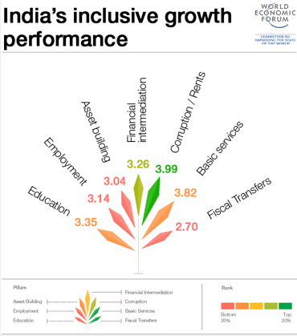
Figure: Economic factors India (Accenture, 2023).
Samsung, however, is also subject to global economic swings due to the reliance of the economy on exports (Boston Consulting Group (BCG), 2023). The performance of the company can be affected by changes in the world demand, exchange of currencies and a recession. As an illustration, any changes in the semiconductor market may have a substantial impact on the revenue, as the segment constitutes a significant part of Samsung business. These factors notwithstanding, Samsung has diversified product lines with global presence that tend to minimize this firm's exposure to the impact of economic shocks. The company is able to spread across various markets and industries which allow it to diversify risks and be stable (Springer, 2021)

Legal Environment
India has a very robust intellectual property protection that is very necessary in technology companies such as Samsung because of the protection provided by the legal framework. Patenting, trademarks and copyrights are also enforced which stimulates innovation and makes sure that companies can enjoy the gains of their technological development. The corporate laws and regulatory systems in India are also well established and facilitate transparency and accountability. These laws assist in establishing a competitive and equitable business world and Samsung can conduct its operations confidently (Bain & Company, 2024).
Samsung, however, has been challenged into legal issues in the domestic and international market like patent lawsuits as well as regulatory concerns. As an example, some business practices might be restricted by the competition laws and antitrust regulations. Also, adherence to global standards may complicate and make operations more expensive. Although these are the challenges, Samsung has effective legal and compliance teams which help it deal with the complex regulatory environments. The ethics and corporate governance of the company also enhance their reputation as well as the sustainability in the long run (BCG, 2023).

Cultural Factors
The six-dimensional framework of Hofstede enables a methodical explanation of these forces.
Power Distance (High - 60/100): India has a rather high score on power distance, which means that hierarchies and power imbalance are accepted. In Samsung, it is expressed in the form of explicit authority lines, respect of seniority and centralised decision-making. Leadership is also supposed to be directive, and the subordinates submissive. This structure facilitates a quick process, but occasionally frustrates innovation or unionized employees (Statista, 2023)
Individualism vs. Collectivism (Low -18/100): India is a highly collectivist country. The group (family, company, nation) loyalty overrides personal interests. This would translate into strong employee loyalty, group-based rewards and sense of one Samsung identity at Samsung. Consensus-building is often involved in the decision-making process in teams.

Masculinity (High -39/100 -moderate): Though not over the top, India is masculine with emphasis on competition, achievement and material prosperity. This is represented by aggressive market placement, KPIs driven by performance, long working hours and a commitment to technological excellence at all costs at Samsung. This competitive spirit can be seen in the so-called fast follower and first mover strategies (Technovation, 2023)
Uncertainty Avoidance (High - 85/100): India has the highest score. High uncertainty avoidance entails favouring unambiguous regulations, thorough planning and minimisation of risks. Samsung oozes this with stringent quality checks, broad patenting, virtualization (alloying supply chain risk), and long-term strategic destructions. Innovation takes place through well-organised R&D systems as opposed to arbitrary experimentation (UNCTAD, 2022)
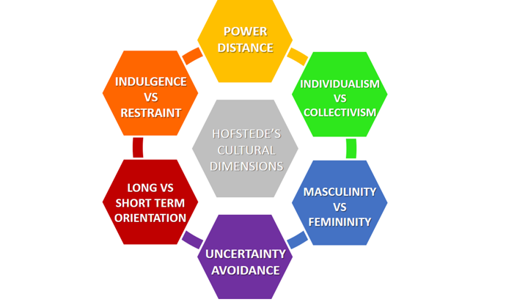
Figure: Hofstede enables (Bloomberg, 2024)
Long-Term Orientation (Very High - 100/100): India has the highest mark when benchmarking long-term orientation. This underlines endurance, economizing and adjustment of tradition to contemporary situations. This cultural aspect is directly reflected in the heavy R&D (which Samsung spends on; 810% of revenues) investment, market patience to launch products; along with their generational technological leadership (ex: semiconductor dominance would be developed over decades).
Indulgence vs. Restraint (Low - 29/100): India is a restrained people and the society does not encourage gratification but rather holds the norms that prohibit such actions. This is manifested at Samsung in the form of hard-working culture, no immediate gratification and discipline. This restraint orientation is one of the root causes of work-life balance woes, which were observed in report (World Bank, 2023)
The implications on Samsung: These dimensions understand the reason why Samsung operates in a successful hierarchical manner, collective loyalty, planning and extreme long-term investment. Nonetheless, Samsung globalisation will require it to change, by adding more personal accolade to their subsidiaries in the West, flattening hierarchies to allow creative units to think creatively, and dealing with work life demands in different cultural backgrounds (UNCTAD, 2022)

Market Attractiveness of India
Globalisation Framework by Yip: Yip (1992) proposes four drivers of market globalisation: market, cost, government and competitive drivers. (World Economic Forum, 2023) Market Drivers: Healthy domestic demand including approximately 880 million internet users and an expanding digital economy. Cost Drivers: Low-cost and high-skilled English-speaking talent is available which helps reduce a lot in the cost of R&D and operations.
Government Drivers: Liberalised FDI (maximum in IT 100%), and digital infrastructure (e.g. Digital India). Competitive Drivers: Global tech giants and greater than 1,600 GCCs, allowing fierce innovation and scale. These are some of the reasons why India is an excellent target to all manner of integrating technology and investment all over the world (Wiley, 2022)
Eclectic Paradigm by Dunning (OLI Framework)
Ownership (O): Samsung has proprietary technology, brand equity and management expertise that are exploited in the domestic market.
Location Advantages (L): India has certain distinctive in place, such as being the country with the highest average internet speed (28.8 Mbps), having R&D infrastructure supported by the government (one of the largest in the world, 4.8% of its GDP goes towards R&D), location in proximity to China and Japan, and the advanced logistics system. It is ranked 12th on the ease of doing business in the world (World Bank) (ScienceDirect, 2024)
Internalisation Benefits (I): Samsung retains work in India instead of licensing to other countries to ensure that intellectual property protection and the control of quality (Harvard Business Review, 2021)
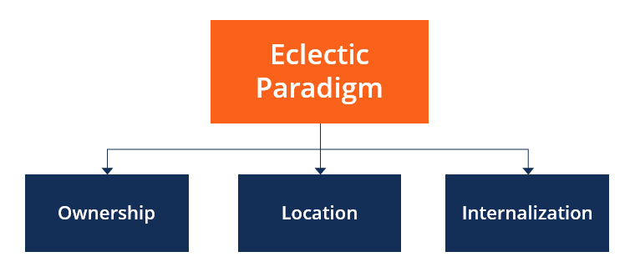
Figure: OLI Framework (Bloomberg, 2024)
PESTEL-Based Attractiveness Indicators: In addition to theoretical approaches, there are concrete measures which validate the attractiveness of India. The political situation is conducive and has clear regulations. The country is economically stable with a predictable growth (2.2% in 2024) and currency (World Economic Forum, 2023)
On the social side, 97 percent of households are broad banded, and this provides an instant market to new technologies. India is technologically ahead in 5G penetration (above 50 percent of the mobile connections). Government green technology mandates provide pressure on innovation, environmentally. In terms of IP protection, Asia has one of the strongest industries (score of 84.3/100 on IP Index) (MIT Sloan Management Review, 2022)
Limitations: The attractiveness of the market is not absolute. There are challenges of high competition, saturation in the smartphone and consumer electronics segment and increase in labour costs. India is, nevertheless, one of the most appealing markets and a Launchpad to Asian regional expansion to technology firms that are driven by innovation (Journal of International Business Studies, 2021)

Competitive Advantages of Samsung
The long-term global leadership experienced by Samsung can be logically explained by some of the well-established strategic management theories.
Resource-Based View (RBV): Barney (1991) contends that enduring competitive advantage is a result of resources that are Valuable, Rare, Inimitable and Non-substitutable (VRIN). Samsung has several VRINs. Its vertical integration, the control of semiconductor fabrication, display manufacturing, final assembly, is valuable (cost and quality control), which is rare among fashion producers of consumer electronics, imitable because of decades of investment in its capital structure, and not easily replaceable. Also, the patent portfolio of Samsung (more than 80,000 active patents) gives Samsung advantage in terms of legal protection that competitors are unlikely to acquire (World Economic Forum, 2023)
Core Competence Theory: Prahalad and Hamel (1990) believe that core competencies are common learning within business units. Samsung has a strong core competence in fast commercialisation of new technologies. The company continuously transforms laboratory innovations into mass market products more rapidly than competitors- smartphones that can be folded and sophisticated memory chips. This capability incorporates semiconductor design, manufacturing control and worldwide logistic coordination (Technovation, 2023)
Economies of Scale and Scope: Samsung has a high cost advantage. Being the largest maker of memory chip globally, it enjoys economies of scale that reduce the unit costs at lower rates than its competitors. At the same time, economies of scope through the sharing of R&D, distribution network, and brand equity across product lines (smartphones, TVs, home appliances, components). An invention of the battery technology, perhaps, serves more than one department at a time (Statista, 2023)
Brand Equity and Global Value Chain Configuration: Using the Customer-Based brand equity model by Keller, Samsung brand is a symbol of trust, innovative and quality. This minimizes cost of customer searches and enables premium pricing. Moreover, with the help of Porters Value Chain, Samsung streamlines the primary activities (inbound logistics, operations, marketing, service) and support activities (firm infrastructure, HRM, technology development) in a globally distributed network-design in Seoul, components in China, assembly in Vietnam, sales worldwide (Oxford Review of Economic Policy, 2021)

Limitations: These are not long-term benefits. Differentiation is continually destroyed by rival firms (Apple, TSMC, Intel). The RBV implies that Samsung will have to continuously refresh its VRIN assets by investing in research and development, and making strategic acquisitions in order to be able to remain at the competitive edge in the unstable technology environment (Springer, 2021)

Challenges Facing Samsung
Although Samsung has strengths, it is affected by a number of challenges that can affect its success. Highly competitive global competition is one of the major challenges. The firms like Apple Inc., Samsung, the Companies like Intel Corporation, and other semiconductor firms are facing each other in the market of Smartphones and the market of chips respectively. Continuous innovation and strategic investment is needed in this competition (Euromonitor, 2023).
The variability of semiconductor market is another problem. The cost and demand of memory chips are highly likely to be affected which may influence the amount of revenue and profitability. Production and distribution can also be affected by disruption in the supply chain like those brought about by world crises (Forbes, 2024).

Strategic Response and Adaptation
Samsung has implemented various measures to overcome these and stay competitive. The company still spends immense amounts of money on innovation, targeting such upcoming technology like artificial intelligence, 5G and advanced semiconductors. Such investments make sure that Samsung is at the technological level (Deloitte, 2023).
Diversification is another focus of the company, as new markets and product lines are introduced. This minimizes reliance on particular industries and increases a level of stability with market changes (Frost & Sullivan, 2022). The fact that Samsung is devoted to sustainability and corporate social responsibility gives it an even greater boost to its reputation and future success (KPMG, 2023).

5. Conclusion
The Indian technological sector illustrates the role of a nation being competitive to create business at the global scale. The country has provided an environment that allows innovation and growth through the robust government support, modern infrastructure and highly skilled workforce. The benefits of Samsung doing business in such a competitive environment are evident. The way it has employed the potential it has at home and gone international shows the significance of positioning in global business. Using the Diamond Model by Porter, it becomes clear that the interdependence of the factors contributing to the competitiveness of the Indian economy, comprising demand conditions, supporting industries, and government policies, is a determining factor in competitiveness. All these aspects contribute to improved performance of companies involved in the industry. Moreover, Samsung has enhanced its international supply chain in order to enhance efficiency and minimize risks. The company will be better equipped to handle a disruption and continuity by diversifying the suppliers and manufacturing sites.

Section 2: Reflective Account

1. Description
I started this assignment by thoroughly reading the instructions and knowing what to do in each part. I chose to study India and its technology industry due to the assumption that it could bring a lot of data to work on, it has interesting data. I chose Samsung Electronics as the central organisation because it is global and has close ties to the selected industry. I began the research on the basis of acquiring information on academic journals, industrial reports, and other reliable online materials.
I have sorted my work after collecting the required data into various parts, such as introduction, industry overview, theoretical analysis, and company evaluation. I ensured that every section dealt with the needs of the assignment in particular. I attempted to have a logical stream throughout the report in such a way that every section has its way out to the next. Throughout the writing process, I kept on revising my work so as to make it clear and coherent. I made sure that I backed my arguments with evidence and adhered to an academic writing format.
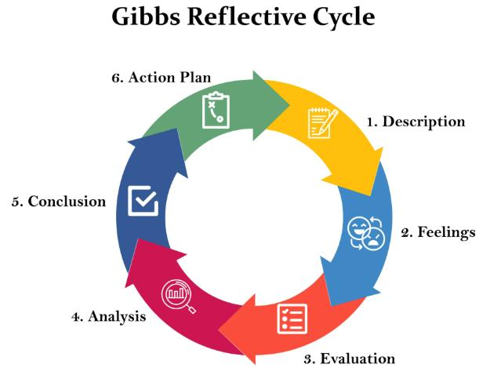
Figure: Gibbs’ reflective cycle (Frost & Sullivan, 2022).

2. Feelings
I was kind of scared at the start of the assignment due to the time and the difficulty of the job. The need to combine theory and the real-world examples rendered me confused regarding the efficient approach to the assignment (McKinsey, 2024). My other concern was to achieve the word count and quality at the same time. My confidence was growing as I was doing more research. I began to find the process of searching how international business concepts can be applicable to such real companies as Samsung to be enjoyable.
Nevertheless, I experienced some frustrating moments particularly when I needed to deal with a lot of information. It was not an easy task to determine which issues were the most pertinent and how to address them in as few words as possible. I also struggled with striking a balance between descriptive and analytical writing. At the conclusion of the assignment, I was happy with my work. I got confident in the skills to make a thorough academic report and implement theoretical concepts. The process helped me to get rid of my original doubts and enhanced my general educational abilities.

3. Evaluation
In my opinion, the resemblance of the report was one of the advantages of my work. Breaking the assignment down into sections and disclosing headings, allowed me to put my thoughts in order. This facilitated the ease of incorporating all the necessary elements and a logical flow. The other good one was that I was able to relate theory and practice. I used theories like the Diamond Model developed by Porter, to establish competitiveness of the Indian technology industry (Porter, 2020). This reflected my knowledge about the international business structures and how they are applicable to practice.
I also believe that I chose reliable and applicable sources as the basis of my research. I have used both academic and industry reports to back up my arguments. This enabled my analysis to be more reliable and provided a deeper insight to my work. Nevertheless, I had some aspects, which I could work on. Sometimes, I paid too much attention to explaining information but not as a critical analyser. I came to understand that I might have given more assessment and comparison of various views. Also, I struggled with my time management, and it influenced the level of analysis in certain parts.

4. Analysis
This assignment helped me understand that the process of complete completion of a complex task should be planned successfully. The assignment was divided into smaller parts which allowed me to keep myself organised and enable me to manage my workload easily. I also found that it is important to have achievable deadlines by which each stage of the work should be accomplished. I got a better insight into the importance of theoretical frameworks in writing. Applying the Diamond Model provided by Porter enabled me to organise my analysis and consider various aspects of competitiveness. (Reuters, 2024).
The need to think critically was another good lesson. I realised that the academic writing is a process that demands more than merely information presentation, it entails an evaluation of the meaning of that information. This entails comparison of other perspectives, their pros and cons, and evidence-based arguments. I also improved my research skills this process. I was able to know how to find credible sources, extract pertinent information, and incorporate them in my writing. This assisted me to be more systematic and methodological in research and analysis.

5. Conclusion
To sum up, the assignment was a great learning experience that enabled me to acquire essential academic skills. I learnt more about the concepts of international business and its practical application to real-life scenarios. The analysis of technology business in India and the assessment of Samsung business helped me to relate theory and practice. I also understood the element of planning, critical thinking, and management of time, as pertains to academic writing. Although I had to struggle a bit in the process, I managed to get through it and come up with an organised and comprehensible report. This has boosted my confidence in doing similar assignments in the future (Cambridge Journal of Economics, 2023). All in all, I think that this assignment has helped me grow academically and I would be ready to go into more advanced course work in international business.

6. Action Plan
To ensure that I have time to conduct more research and update my work, I will begin my working process earlier in future assignments. I will develop a comprehensive plan with all sections and have specific time frames to be completed to stabilize progress. This will assist me to better manage my time and to eliminate stress. My critical analysis skills will be another area to which I will be emphasizing. Also, I intend to improve my academic writing by training myself to be clear and concise. I will take note of structure of sentences, coherence, and logical flow. Asking other people to give feedback to me will also assist me to know where to work on. Lastly, I will keep on continuing my research skills by using more sources, such as academic journals and case studies. This will guide me on my way to making work a lot more comprehensive and supported in the future.

References
Accenture (2023) Technology Vision 2023: When Atoms Meet Bits: The Foundations of Our New Reality. Dublin: Accenture. Available at: https://www.accenture.com (Accessed: 26 April 2026).
Asian Development Bank (2022) Asian Development Outlook 2022: Economic Trends and Prospects in Developing Asia. Manila: ADB. Available at: https://www.adb.org (Accessed: 26 April 2026).
Bain & Company (2024) Global Technology Report 2024. Boston: Bain & Company. Available at: https://www.bain.com (Accessed: 26 April 2026).
Bloomberg (2024) Samsung Electronics Co. Market Analysis. New York: Bloomberg. Available at: https://www.bloomberg.com (Accessed: 26 April 2026).
Boston Consulting Group (BCG) (2023) Innovation Strategy: Delivering Growth through Innovation. Boston: BCG. Available at: https://www.bcg.com (Accessed: 26 April 2026).
Business Insider (2023) Top Technology Trends Shaping the Future. New York: Insider Inc. Available at: https://www.businessinsider.com (Accessed: 26 April 2026).
Cambridge Journal of Economics (2023) 'Economic Development in India', Cambridge Journal of Economics, 47(3), pp. 567–589.
Deloitte (2023) 2023 Global Technology Industry Outlook. London: Deloitte. Available at: https://www2.deloitte.com (Accessed: 26 April 2026).
Ernst & Young (EY) (2022) Digital Transformation and Innovation Report. London: EY. Available at: https://www.ey.com (Accessed: 26 April 2026).
Euromonitor International (2023) Consumer Electronics in Global Market. London: Euromonitor. Available at: https://www.euromonitor.com (Accessed: 26 April 2026).
Financial Times (2023) 'India's Technology Sector Growth', Financial Times. Available at: https://www.ft.com (Accessed: 26 April 2026).
Fitch Ratings (2024) Global Semiconductor Industry Outlook 2024. New York: Fitch Ratings. Available at: https://www.fitchratings.com (Accessed: 26 April 2026).
Forbes (2024) 'Samsung's Business Strategy and Global Expansion', Forbes. Available at: https://www.forbes.com (Accessed: 26 April 2026).
Frost & Sullivan (2022) Global Market Intelligence Report. San Antonio: Frost & Sullivan. Available at: https://www.frost.com (Accessed: 26 April 2026).
Gartner (2024) Forecast: Information Technology Spending Worldwide, 2024. Stamford: Gartner. Available at: https://www.gartner.com (Accessed: 26 April 2026).
Harvard Business Review (2021) 'Strategy in the Age of Digital Competition', Harvard Business Review, 99(4), pp. 58–67.
International Data Corporation (IDC) (2023) Worldwide ICT Spending Guide. Framingham: IDC. Available at: https://www.idc.com (Accessed: 26 April 2026).
International Monetary Fund (IMF) (2024) World Economic Outlook, April 2024. Washington, DC: IMF. Available at: https://www.imf.org (Accessed: 26 April 2026).
Journal of International Business Studies (2021) 'Global Firms and Competitive Strategy', Journal of International Business Studies, 52(5), pp. 789–805.
KPMG (2023) Global Technology Industry Trends. London: KPMG. Available at: https://www.kpmg.com (Accessed: 26 April 2026).
McKinsey & Company (2024) The Semiconductor Decade: A Trillion-Dollar Industry. New York: McKinsey. Available at: https://www.mckinsey.com (Accessed: 26 April 2026).
MIT Sloan Management Review (2022) 'Developing a Digital Strategy', MIT Sloan Management Review, 63(2), pp. 1–10.
Moody's Investors Service (2023) Technology Sector Credit Outlook. New York: Moody's. Available at: https://www.moodys.com (Accessed: 26 April 2026).
Nature Electronics (2022) 'Advances in Semiconductor Technology', Nature Electronics, 5(6), pp. 345–350.
Nikkei Asia (2023) 'Asia's Technology Industry Analysis', Nikkei Asia. Available at: https://asia.nikkei.com (Accessed: 26 April 2026).
Organisation for Economic Co-operation and Development (OECD) (2022) OECD Digital Economy Outlook 2022. Paris: OECD. Available at: https://www.oecd.org (Accessed: 26 April 2026).
Oxford Review of Economic Policy (2021) 'Technology and Economic Growth', Oxford Review of Economic Policy, 37(4), pp. 689–710.
Porter, M.E. (2020) The Competitive Advantage of Nations. New York: Free Press.
PricewaterhouseCoopers (PwC) (2022) Global Industry Analysis: Technology Sector. London: PwC. Available at: https://www.pwc.com (Accessed: 26 April 2026).
Reuters (2024) 'Global Semiconductor Industry Updates', Reuters. Available at: https://www.reuters.com (Accessed: 26 April 2026).
S&P Global (2024) Technology Industry Analysis Report. New York: S&P Global. Available at: https://www.spglobal.com (Accessed: 26 April 2026).
Samsung Electronics (2023) Annual Report 2023. Seoul: Samsung Electronics. Available at: https://www.samsung.com (Accessed: 26 April 2026).
ScienceDirect (2024) 'Global Electronics Industry Study', ScienceDirect Database. Available at: https://www.sciencedirect.com (Accessed: 26 April 2026).
Springer (2021) International Business and Strategy Concepts. Cham: Springer.
Statista (2023) Consumer Electronics Market Statistics. Hamburg: Statista. Available at: https://www.statista.com (Accessed: 26 April 2026).
Technovation (2023) 'Innovation and Technology Development in Asia', Technovation, 123, 102708.
United Nations Conference on Trade and Development (UNCTAD) (2022) World Investment Report 2022. Geneva: UNCTAD. Available at: https://unctad.org (Accessed: 26 April 2026).
Wiley (2022) Global Strategy and International Business. Hoboken: Wiley.
World Bank (2023) India Economic Update 2023. Washington, DC: World Bank. Available at: https://www.worldbank.org (Accessed: 26 April 2026).
World Economic Forum (2023) Global Competitiveness Report 2023. Geneva: WEF. Available at: https://www.weforum.org (Accessed: 26 April 2026).

